**Top Interview Questions – Medium**

Introduction

This is LeetCode's official curated list of Top classic interview questions to help you land your dream job. Our top interview questions are divided into the following series:

1. [Easy Collection](https://leetcode.com/explore/interview/card/top-interview-questions-easy/)
2. [Medium Collection](https://leetcode.com/explore/interview/card/top-interview-questions-medium/)
3. [Hard Collection](https://leetcode.com/explore/interview/card/top-interview-questions-hard/)

to help you master Data Structure & Algorithms and improve your coding skills.

Just like any other skills, coding interview is one area where you can greatly improve with [deliberate practice](https://en.wikipedia.org/wiki/Practice_(learning_method)#Deliberate_practice).

Most of the classic interview questions have multiple solution approaches. For the best practice result, we strongly advise you to go through this list at least a second time, or even better - a *third time*.

By the second attempt, you may discover some new tricks or new methods. By the third time, you should find that your code appear to be more concise compared to your first attempt. If so, congratulations!

**Remember:** Deliberate practice does not mean looking for answers and memorizing it. You won't go very far with that approach. The more you are able to solve a problem yourself without any reference to answers, the more you will improve.

## Array and Strings

Array and String type of questions were asked in interviews frequently. You will most likely encounter one during your interviews.

We recommend: Group Anagrams, Longest Substring Without Repeating Characters, Longest Palindromic Substring and Missing Ranges.

  3Sum

 Set Matrix Zeroes

 Group Anagrams

 Longest Substring Without Repeating Characters

 Longest Palindromic Substring

 Increasing Triplet Subsequence

 Missing Ranges

**3Sum**

Given an array nums of *n* integers, are there elements *a*, *b*, *c* in nums such that *a* + *b* + *c* = 0? Find all unique triplets in the array which gives the sum of zero.

Notice that the solution set must not contain duplicate triplets.

**Example 1:**

**Input:** nums = [-1,0,1,2,-1,-4]

**Output:** [[-1,-1,2],[-1,0,1]]

**Example 2:**

**Input:** nums = []

**Output:** []

**Example 3:**

**Input:** nums = [0]

**Output:** []

**Constraints:**

* 0 <= nums.length <= 3000
* -105 <= nums[i] <= 105

   Hide Hint #1

So, we essentially need to find three numbers x, y, and z such that they add up to the given value. If we fix one of the numbers say x, we are left with the two-sum problem at hand!

   Hide Hint #2

For the two-sum problem, if we fix one of the numbers, say

x

, we have to scan the entire array to find the next number

y

which is

value - x

where value is the input parameter. Can we change our array somehow so that this search becomes faster?

   Hide Hint #3

The second train of thought for two-sum is, without changing the array, can we use additional space somehow? Like maybe a hash map to speed up the search?

## Solution

This problem is a follow-up of Two Sum, and it is a good idea to first take a look at [Two Sum](https://leetcode.com/articles/two-sum/) and [Two Sum II](https://leetcode.com/articles/two-sum-ii-input-array-is-sorted/). An interviewer may ask to solve Two Sum first, and then throw 3Sum at you. Pay attention to subtle differences in problem description and try to re-use existing solutions!

Two Sum, Two Sum II and 3Sum share a similarity that the sum of elements must match the target exactly. A difference is that, instead of exactly one answer, we need to find all unique triplets that sum to zero.

Before jumping in, let's check the existing solutions and determine the best conceivable runtime (BCR) for 3Sum:

1. [Two Sum](https://leetcode.com/articles/two-sum/) uses a hashmap to find complement values, and therefore achieves \mathcal{O}(N)O(*N*) time complexity.
2. [Two Sum II](https://leetcode.com/articles/two-sum-ii-input-array-is-sorted/) uses the two pointers pattern and also has \mathcal{O}(N)O(*N*) time complexity for a sorted array. We can use this approach for any array if we sort it first, which bumps the time complexity to \mathcal{O}(n\log{n})O(*n*log*n*).

Considering that there is one more dimension in 3Sum, it sounds reasonable to shoot for \mathcal{O}(n^2)O(*n*2) time complexity as our BCR.

#### **Approach 1: Two Pointers**

We will follow the same two pointers pattern as in [Two Sum II](https://leetcode.com/articles/two-sum-ii-input-array-is-sorted/). It requires the array to be sorted, so we'll do that first. As our BCR is O(n^2), sorting the array would not change the overall time complexity.

To make sure the result contains unique triplets, we need to skip duplicate values. It is easy to do because repeating values are next to each other in a sorted array.

If you are wondering how to solve this problem without sorting the array, go over the ["No-Sort"](https://leetcode.com/problems/3sum/solution/#approach3) approach below. There are cases when that approach is preferable, and your interviewer may probe your knowledge there.

After sorting the array, we move our pivot element nums[i] and analyze elements to its right. We find all pairs whose sum is equal -nums[i] using the two pointers pattern, so that the sum of the pivot element (nums[i]) and the pair (-nums[i]) is equal to zero.

As a quick refresher, the pointers are initially set to the first and the last element respectively. We compare the sum of these two elements to the target. If it is smaller, we increment the lower pointer lo. Otherwise, we decrement the higher pointer hi. Thus, the sum always moves toward the target, and we "prune" pairs that would move it further away. Again, this works only if the array is sorted. Head to the [Two Sum II](https://leetcode.com/articles/two-sum-ii-input-array-is-sorted/) solution for the detailed explanation.

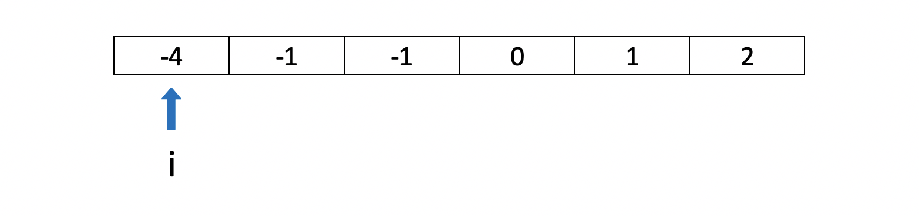

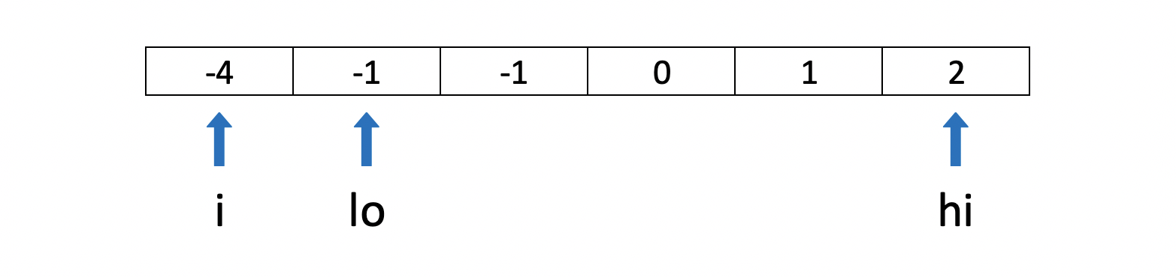

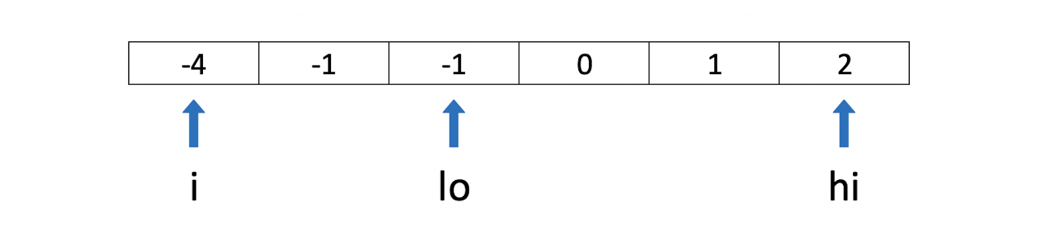

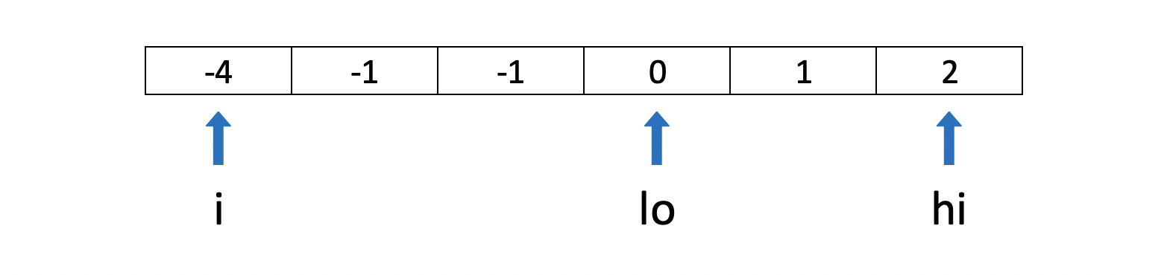

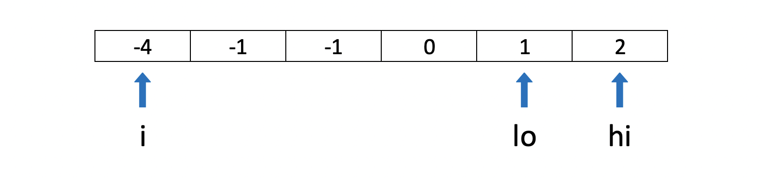

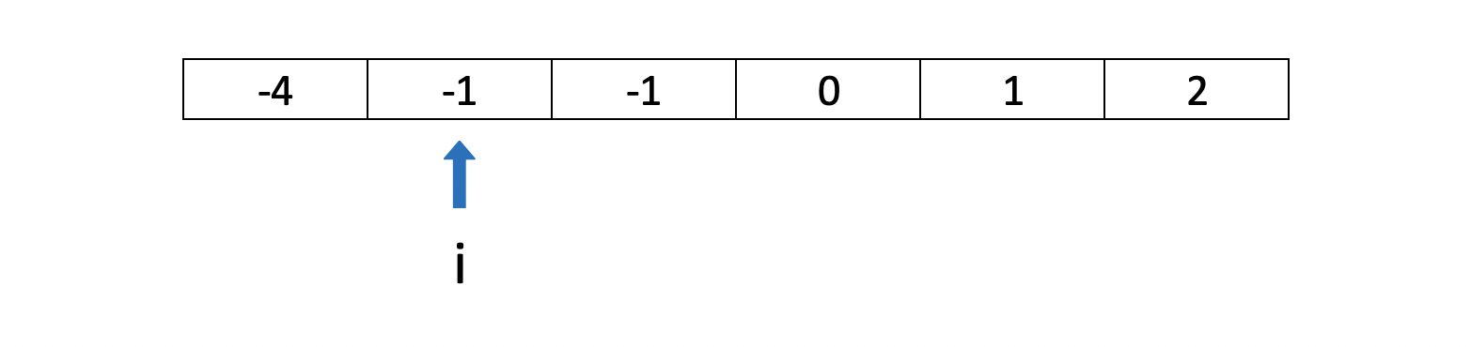

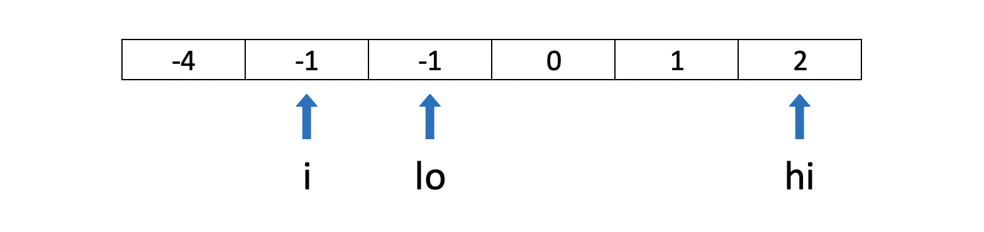

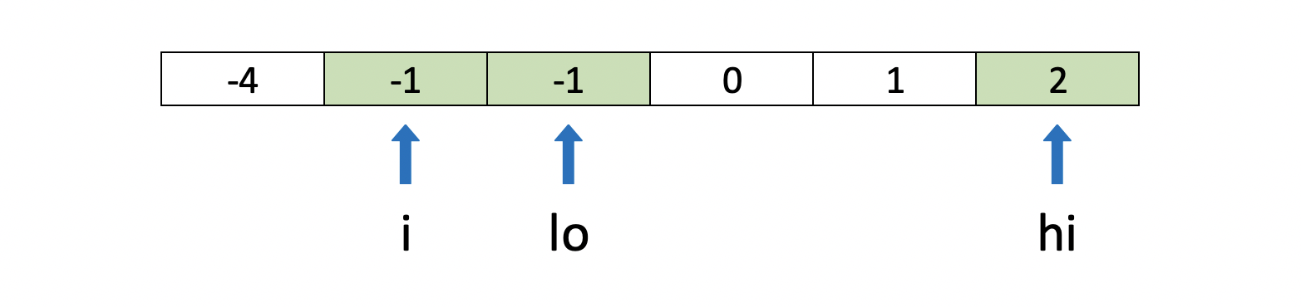

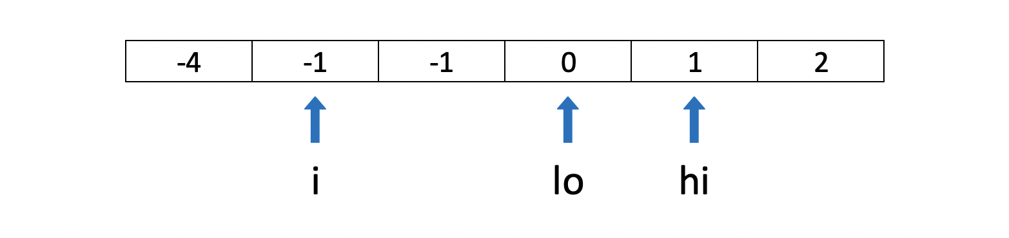

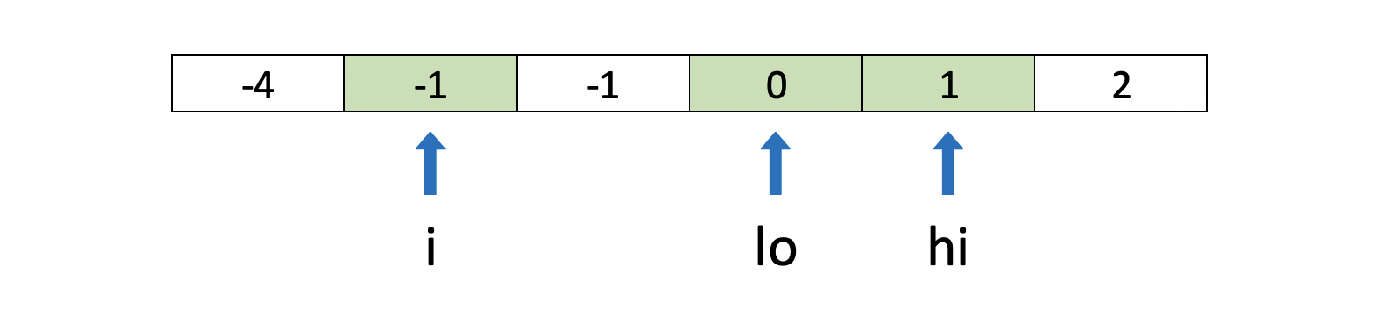

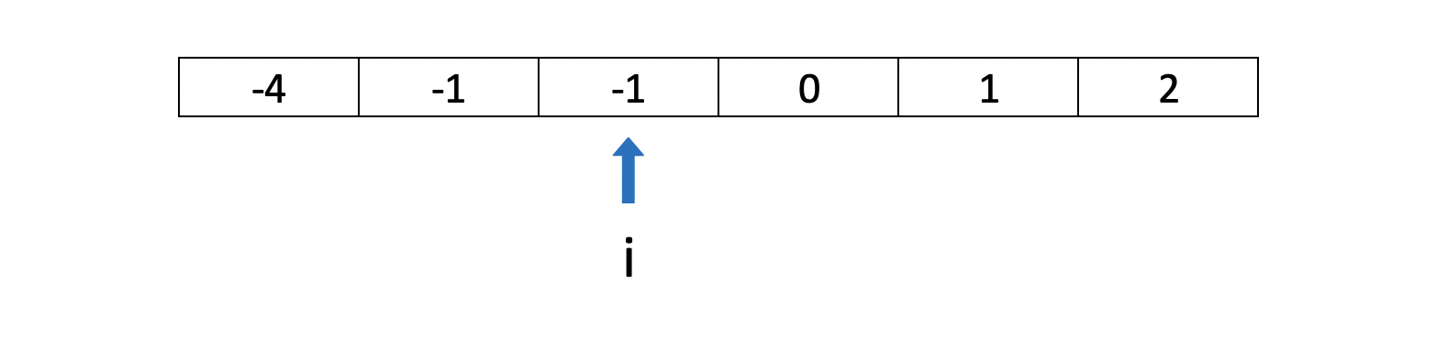

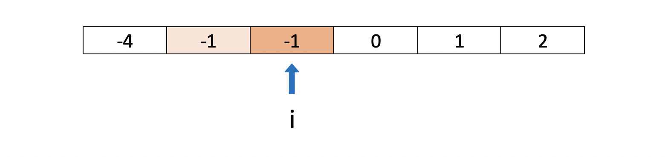

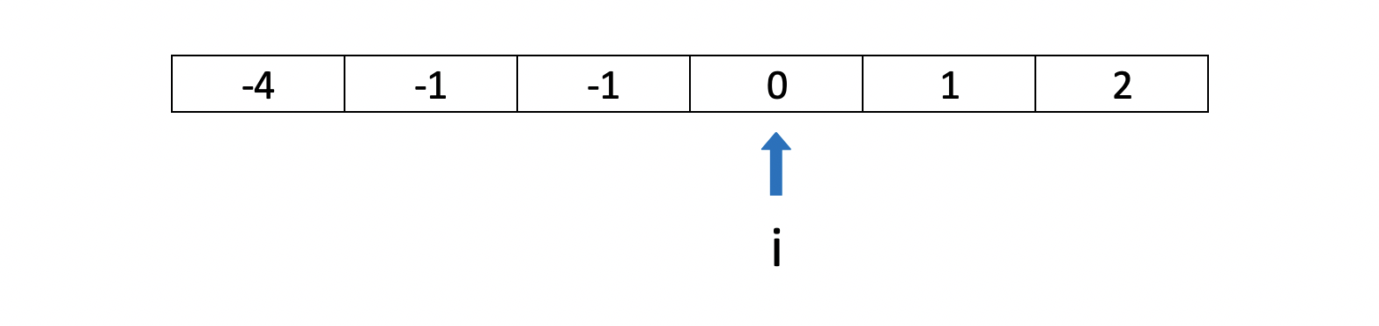

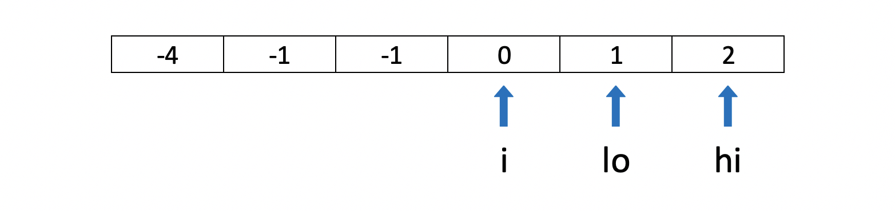

**Algorithm**

The implementation is straightforward - we just need to modify twoSumII to produce triplets and skip repeating values.

1. For the main function:
   * Sort the input array nums.
   * Iterate through the array:
     + If the current value is greater than zero, break from the loop. Remaining values cannot sum to zero.
     + If the current value is the same as the one before, skip it.
     + Otherwise, call twoSumII for the current position i.
2. For twoSumII function:
   * Set the low pointer lo to i + 1, and high pointer hi to the last index.
   * While low pointer is smaller than high:
     + If sum of nums[i] + nums[lo] + nums[hi] is less than zero, increment lo.
     + If sum is greater than zero, decrement hi.
     + Otherwise, we found a triplet:
       - Add it to the result res.
       - Decrement hi and increment lo.
       - Increment lo while the next value is the same as before to avoid duplicates in the result.
3. Return the result res.

|  |
| --- |
| class Solution {  public List<List<Integer>> threeSum(int[] nums) {  Arrays.sort(nums);  List<List<Integer>> res = new ArrayList<>();  for (int i = 0; i < nums.length && nums[i] <= 0; ++i)  if (i == 0 || nums[i - 1] != nums[i]) {  twoSumII(nums, i, res);  }  return res;  }  void twoSumII(int[] nums, int i, List<List<Integer>> res) {  int lo = i + 1, hi = nums.length - 1;  while (lo < hi) {  int sum = nums[i] + nums[lo] + nums[hi];  if (sum < 0) {  ++lo;  } else if (sum > 0) {  --hi;  } else {  res.add(Arrays.asList(nums[i], nums[lo++], nums[hi--]));  while (lo < hi && nums[lo] == nums[lo - 1])  ++lo;  }  }  }  } |

**Complexity Analysis**

* Time Complexity: O(n^2). twoSumII is O(*n*), and we call it *n* times.

Sorting the array takes O(*n*log*n*), so overall complexity is O(n\log{n} + n^2). This is asymptotically equivalent to O(n^2).

* Space Complexity: from O(log*n*) to O(*n*), depending on the implementation of the sorting algorithm. For the purpose of complexity analysis, we ignore the memory required for the output.

### **Approach 2: Hashset**

Since triplets must sum up to the target value, we can try the hash table approach from the [Two Sum](https://leetcode.com/articles/two-sum/) solution. This approach won't work, however, if the sum is not necessarily equal to the target, like in [3Sum Smaller](https://leetcode.com/problems/3sum-smaller/) and [3Sum Closest](https://leetcode.com/problems/3sum-closest/).

We move our pivot element nums[i] and analyze elements to its right. We find all pairs whose sum is equal -nums[i] using the [Two Sum: One-pass Hash Table](https://leetcode.com/articles/two-sum/#approach-3-one-pass-hash-table) approach, so that the sum of the pivot element (nums[i]) and the pair (-nums[i]) is equal to zero.

To do that, we process each element nums[j] to the right of the pivot, and check whether a complement -nums[i] - nums[j] is already in the hashset. If it is, we found a triplet. Then, we add nums[j] to the hashset, so it can be used as a complement from that point on.

Like in the approach above, we will also sort the array so we can skip repeated values. We provide a different way to avoid duplicates in the ["No-Sort"](https://leetcode.com/problems/3sum/solution/#approach3) approach below.

**Algorithm**

The main function is the same as in the [Two Pointers](https://leetcode.com/problems/3sum/solution/#approach1) approach above. Here, we use twoSum (instead of twoSumII), modified to produce triplets and skip repeating values.

1. For the main function:
   * Sort the input array nums.
   * Iterate through the array:
     + If the current value is greater than zero, break from the loop. Remaining values cannot sum to zero.
     + If the current value is the same as the one before, skip it.
     + Otherwise, call twoSum for the current position i.
2. For twoSum function:
   * For each index j > i in A:
     + Compute complement value as -nums[i] - nums[j].
     + If complement exists in hashset seen:
       - We found a triplet - add it to the result res.
       - Increment j while the next value is the same as before to avoid duplicates in the result.
     + Add nums[j] to hashset seen
3. Return the result res.

|  |
| --- |
| class Solution {  public List<List<Integer>> threeSum(int[] nums) {  Arrays.sort(nums);  List<List<Integer>> res = new ArrayList<>();  for (int i = 0; i < nums.length && nums[i] <= 0; ++i)  if (i == 0 || nums[i - 1] != nums[i]) {  twoSum(nums, i, res);  }  return res;  }  void twoSum(int[] nums, int i, List<List<Integer>> res) {  var seen = new HashSet<Integer>();  for (int j = i + 1; j < nums.length; ++j) {  int complement = -nums[i] - nums[j];  if (seen.contains(complement)) {  res.add(Arrays.asList(nums[i], nums[j], complement));  while (j + 1 < nums.length && nums[j] == nums[j + 1])  ++j;  }  seen.add(nums[j]);  }  }  } |

* Time Complexity: O(n^2). twoSum is O(*n*), and we call it *n* times.

Sorting the array takes O(*n*log*n*), so overall complexity is O(n\logn + n^2). This is asymptotically equivalent to O(n^2).

* Space Complexity: O(*n*) for the hashset.

#### **Approach 3: "No-Sort"**

What if you cannot modify the input array, and you want to avoid copying it due to memory constraints?

We can adapt the hashset approach above to work for an unsorted array. We can put a combination of three values into a hashset to avoid duplicates. Values in a combination should be ordered (e.g. ascending). Otherwise, we can have results with the same values in the different positions.

**Algorithm**

The algorithm is similar to the hashset approach above. We just need to add few optimizations so that it works efficiently for repeated values:

1. Use another hashset dups to skip duplicates in the outer loop.
   * Without this optimization, the submission will time out for the test case with 3,000 zeroes. This case is handled naturally when the array is sorted.
2. Instead of re-populating a hashset every time in the inner loop, we can use a hashmap and populate it once. Values in the hashmap will indicate whether we have encountered that element in the current iteration. When we process nums[j] in the inner loop, we set its hashmap value to i. This indicates that we can now use nums[j] as a complement for nums[i].
   * This is more like a trick to compensate for container overheads. The effect varies by language, e.g. for C++ it cuts the runtime in half. Without this trick the submission may time out.

|  |
| --- |
| class Solution {  public List<List<Integer>> threeSum(int[] nums) {  Set<List<Integer>> res = new HashSet<>();  Set<Integer> dups = new HashSet<>();  Map<Integer, Integer> seen = new HashMap<>();  for (int i = 0; i < nums.length; ++i)  if (dups.add(nums[i])) {  for (int j = i + 1; j < nums.length; ++j) {  int complement = -nums[i] - nums[j];  if (seen.containsKey(complement) && seen.get(complement) == i) {  List<Integer> triplet = Arrays.asList(nums[i], nums[j], complement);  Collections.sort(triplet);  res.add(triplet);  }  seen.put(nums[j], i);  }  }  return new ArrayList(res);  }  } |

**Complexity Analysis**

* Time Complexity: O(n^2). We have outer and inner loops, each going through *n* elements.

While the asymptotic complexity is the same, this algorithm is noticeably slower than the previous approach. Lookups in a hashset, though requiring a constant time, are expensive compared to the direct memory access.

* Space Complexity: O(*n*) for the hashset/hashmap.

For the purpose of complexity analysis, we ignore the memory required for the output. However, in this approach we also store output in the hashset for deduplication. In the worst case, there could be O(n^2) triplets in the output, like for this example: [-k, -k + 1, ..., -1, 0, 1, ... k - 1, k]. Adding a new number to this sequence will produce n / 3 new triplets.

#### **Further Thoughts**

This is a well-known problem with many variations and its own [Wikipedia page](https://en.wikipedia.org/wiki/3SUM).

For an interview, we recommend focusing on the Two Pointers approach above. It's easier to get it right and adapt for other variations of 3Sum. Interviewers love asking follow-up problems like [3Sum Smaller](https://leetcode.com/problems/3sum-smaller/) and [3Sum Closest](https://leetcode.com/problems/3sum-closest/)!

**Set Matrix Zeroes**

Given an *m* x *n* matrix. If an element is **0**, set its entire row and column to **0**. Do it [**in-place**](https://en.wikipedia.org/wiki/In-place_algorithm).

**Follow up:**

* A straight forward solution using O(*mn*) space is probably a bad idea.
* A simple improvement uses O(*m* + *n*) space, but still not the best solution.
* Could you devise a constant space solution?

**Example 1:**

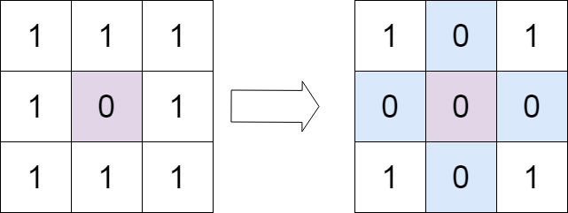

**Input:** matrix = [[1,1,1],[1,0,1],[1,1,1]]

**Output:** [[1,0,1],[0,0,0],[1,0,1]]

**Example 2:**

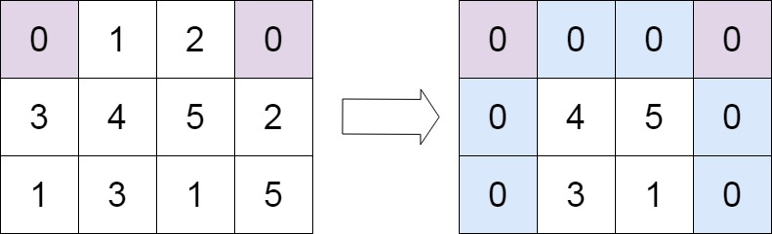

**Input:** matrix = [[0,1,2,0],[3,4,5,2],[1,3,1,5]]

**Output:** [[0,0,0,0],[0,4,5,0],[0,3,1,0]]

**Constraints:**

* m == matrix.length
* n == matrix[0].length
* 1 <= m, n <= 200
* -231 <= matrix[i][j] <= 231 - 1

 Hide Hint #1

If any cell of the matrix has a zero we can record its row and column number using additional memory. But if you don't want to use extra memory then you can manipulate the array instead. i.e. simulating exactly what the question says.

   Hide Hint #2

Setting cell values to zero on the fly while iterating might lead to discrepancies. What if you use some other integer value as your marker? There is still a better approach for this problem with 0(1) space.

   Hide Hint #3

We could have used 2 sets to keep a record of rows/columns which need to be set to zero. But for an O(1) space solution, you can use one of the rows and and one of the columns to keep track of this information.

   Hide Hint #4

We can use the first cell of every row and column as a flag. This flag would determine whether a row or column has been set to zero.

## Solution

The question seems to be pretty simple but the trick here is that we need to modify the given matrix in place i.e. our space complexity needs to O(1)*O*(1).

We will go through two different approaches to the question. The first approach makes use of additional memory while the other does not.

#### **Approach 1: Additional Memory Approach**

**Intuition**

If any cell of the matrix has a zero we can record its row and column number. All the cells of this recorded row and column can be marked zero in the next iteration.

**Algorithm**

1. We make a pass over our original array and look for zero entries.
2. If we find that an entry at [i, j] is 0, then we need to record somewhere the row i and column j.
3. So, we use two sets, one for the rows and one for the columns.

|  |
| --- |
| if cell[i][j] == 0 {  row_set.add(i)  column_set.add(j)  } |

1. Finally, we iterate over the original matrix. For every cell we check if the row r or column c had been marked earlier. If any of them was marked, we set the value in the cell to 0.

|  |
| --- |
| if r in row_set or c in column_set {  cell[r][c] = 0  } |

|  |
| --- |
| class Solution {  public void setZeroes(int[][] matrix) {  int R = matrix.length;  int C = matrix[0].length;  Set<Integer> rows = new HashSet<Integer>();  Set<Integer> cols = new HashSet<Integer>();  // Essentially, we mark the rows and columns that are to be made zero  for (int i = 0; i < R; i++) {  for (int j = 0; j < C; j++) {  if (matrix[i][j] == 0) {  rows.add(i);  cols.add(j);  }  }  }  // Iterate over the array once again and using the rows and cols sets, update the elements.  for (int i = 0; i < R; i++) {  for (int j = 0; j < C; j++) {  if (rows.contains(i) || cols.contains(j)) {  matrix[i][j] = 0;  }  }  }  }  } |

**Complexity Analysis**

* Time Complexity: *O*(*M*×*N*) where M and N are the number of rows and columns respectively.
* Space Complexity: *O*(*M*+*N*).

#### **Approach 2: O(1) Space, Efficient Solution**

**Intuition**

Rather than using additional variables to keep track of rows and columns to be reset, we use the matrix itself as the indicators.

The idea is that we can use the **first cell** of every row and column as a **flag**. This flag would determine whether a row or column has been set to zero. This means for every cell instead of going to *M*+*N* cells and setting it to zero we just set the flag in two cells.

|  |
| --- |
| if cell[i][j] == 0 {  cell[i][0] = 0  cell[0][j] = 0  } |

These flags are used later to update the matrix. If the first cell of a row is set to zero this means the row should be marked zero. If the first cell of a column is set to zero this means the column should be marked zero.

**Algorithm**

1. We iterate over the matrix and we mark the first cell of a row i and first cell of a column j, if the condition in the pseudo code above is satisfied. i.e. if cell[i][j] == 0.
2. The first cell of row and column for the first row and first column is the same i.e. cell[0][0]. Hence, we use an additional variable to tell us if the first column had been marked or not and the cell[0][0] would be used to tell the same for the first row.
3. Now, we iterate over the original matrix starting from second row and second column i.e. matrix[1][1] onwards. For every cell we check if the row r or column c had been marked earlier by checking the respective first row cell or first column cell. If any of them was marked, we set the value in the cell to 0. Note the first row and first column serve as the row_set and column_set that we used in the first approach.
4. We then check if cell[0][0] == 0, if this is the case, we mark the first row as zero.
5. And finally, we check if the first column was marked, we make all entries in it as zeros.

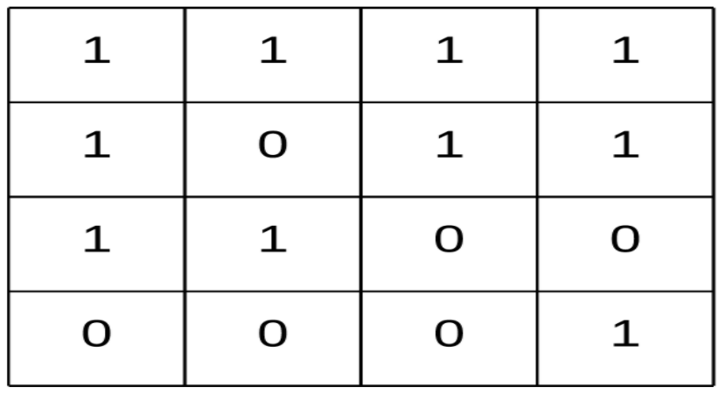 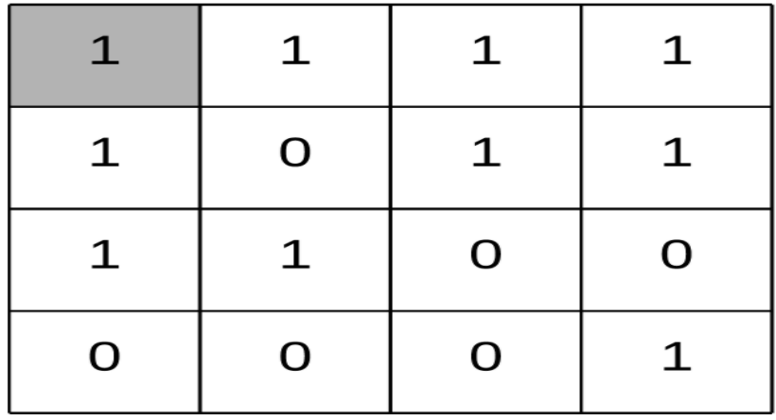

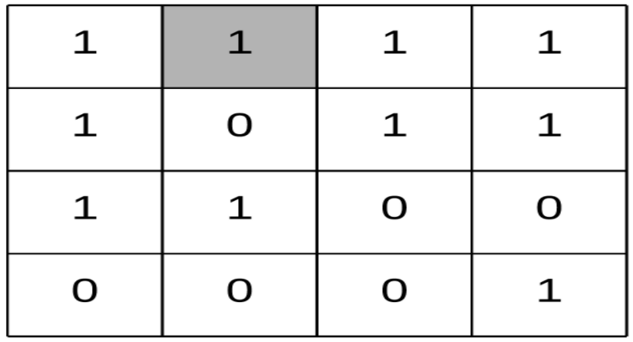 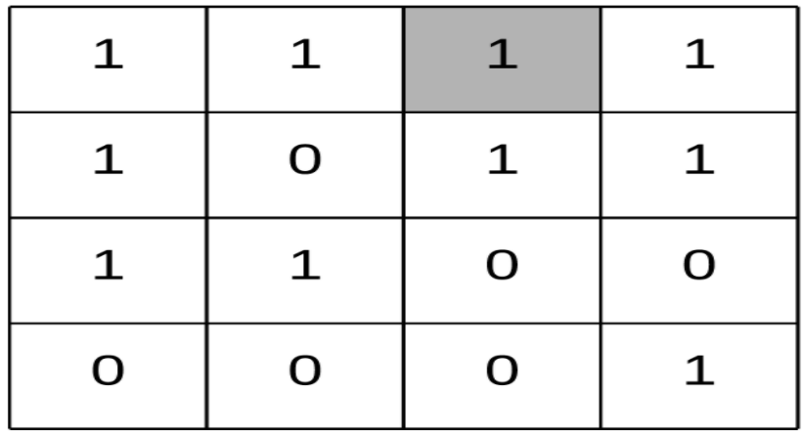

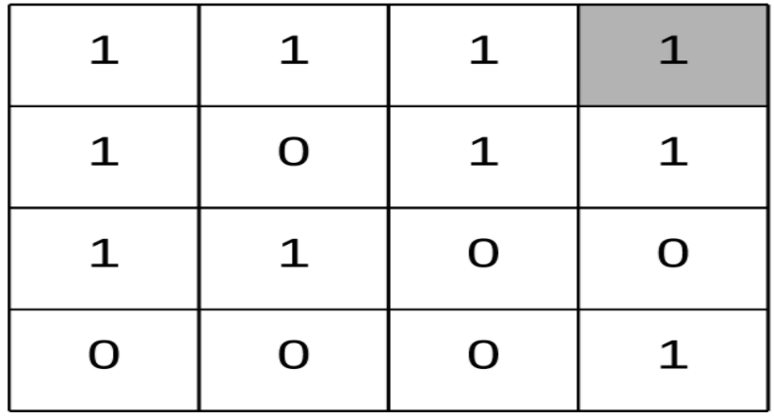 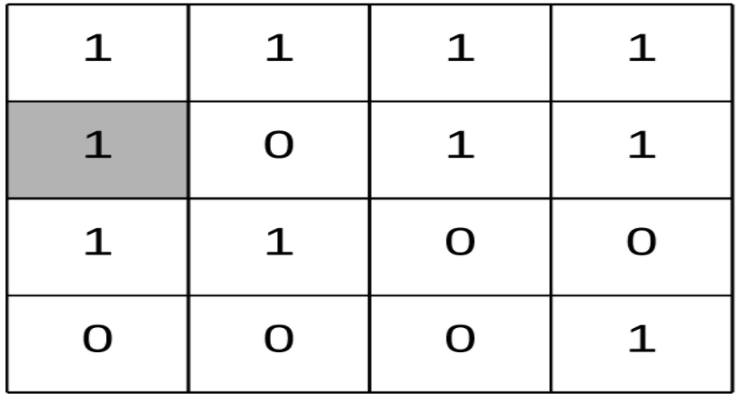

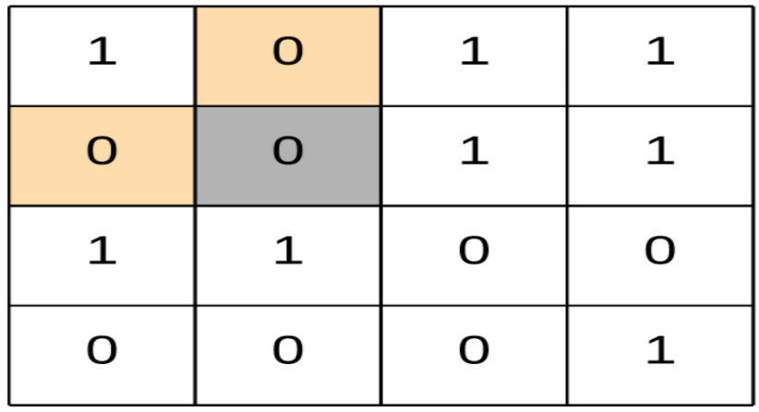 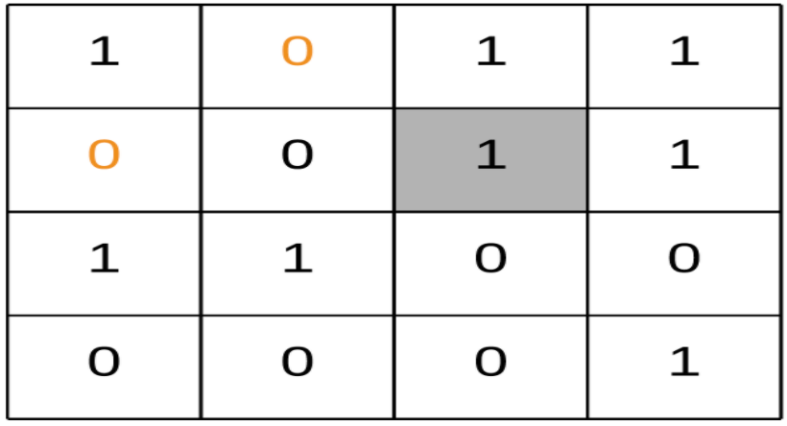

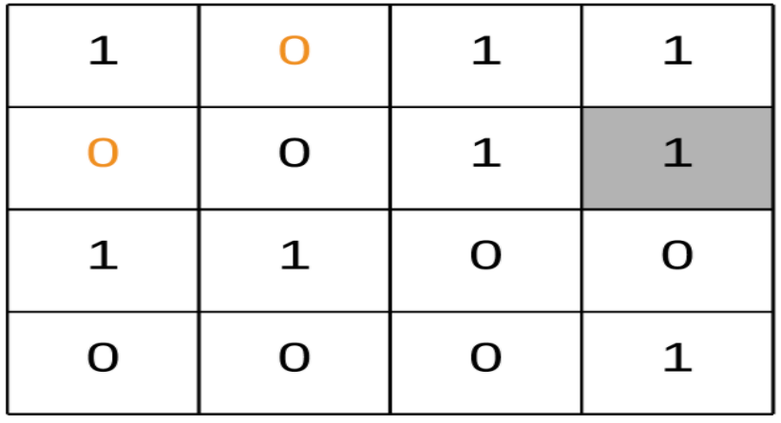 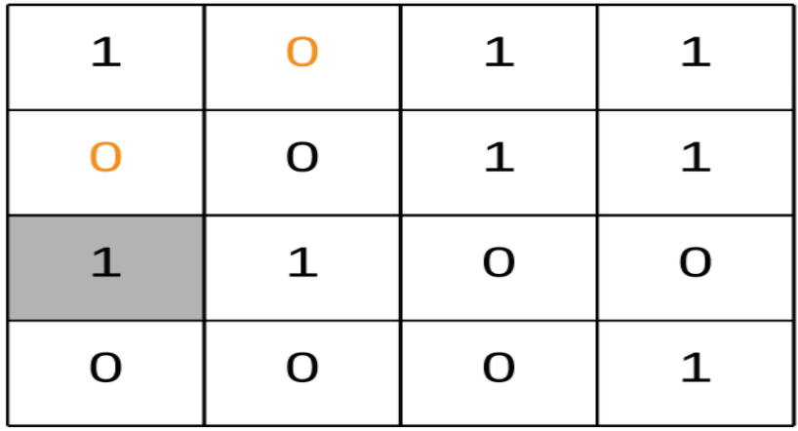

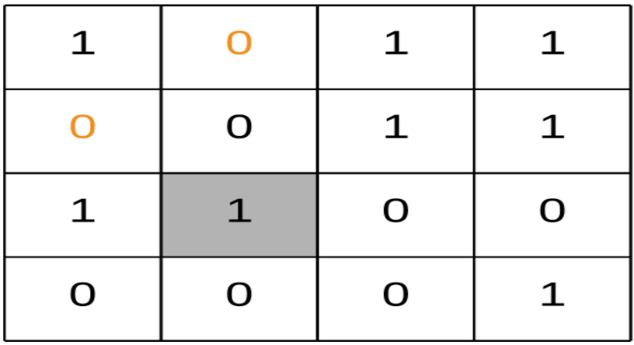 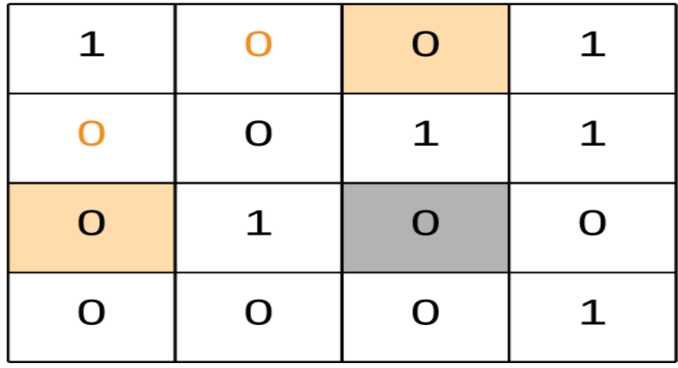

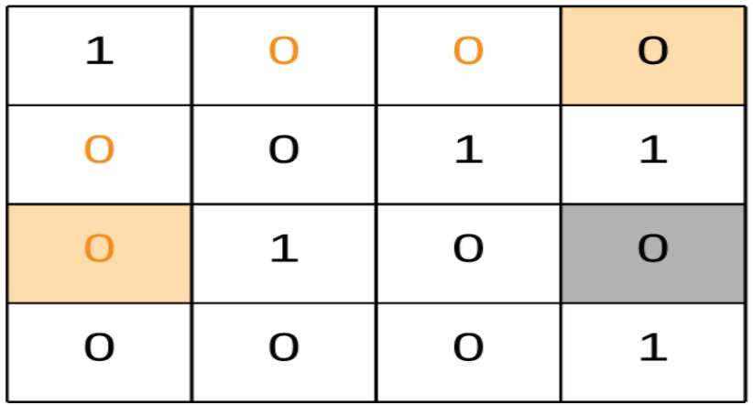 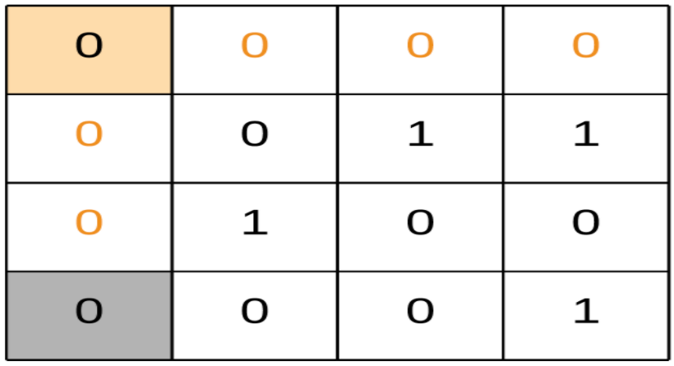

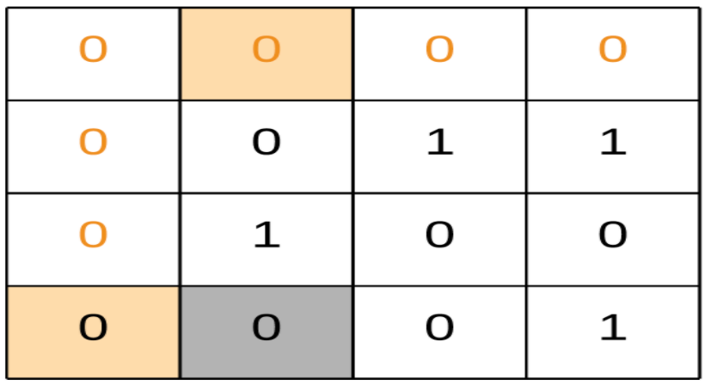 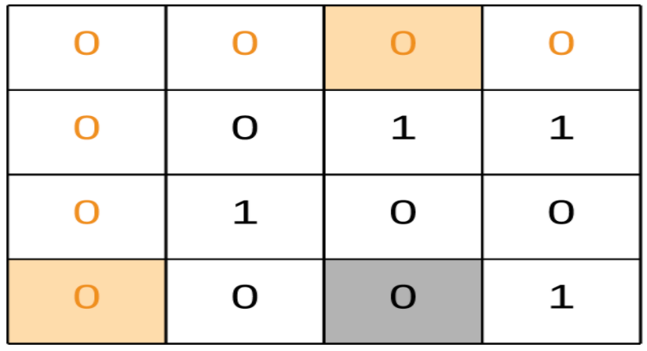

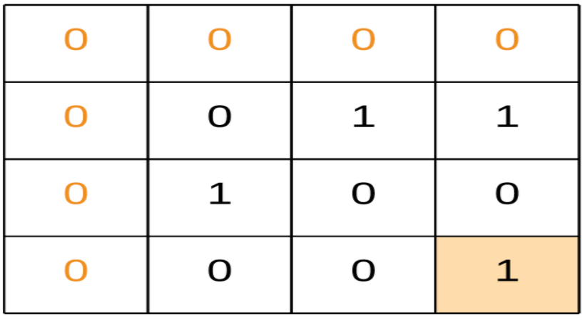 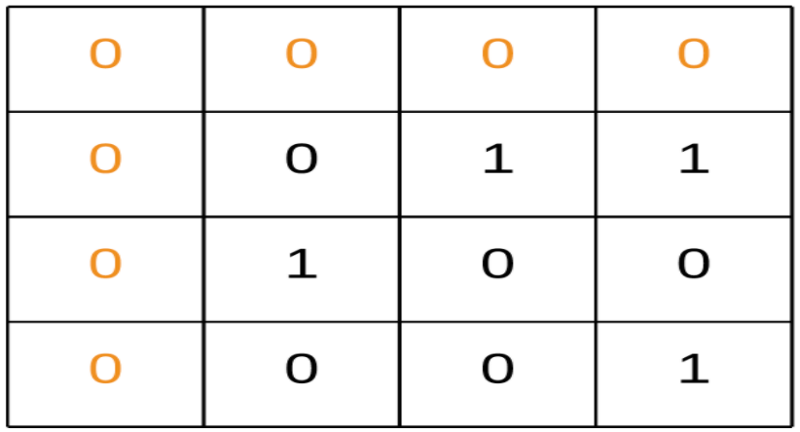

In the above animation we iterate all the cells and mark the corresponding first row/column cell incase of a cell with zero value.

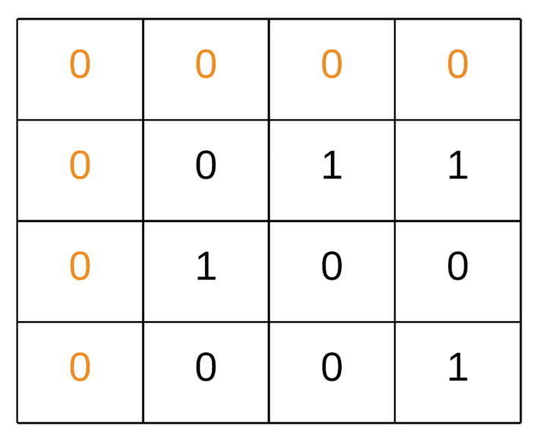

We iterate the matrix we got from the above steps and mark respective cells zeroes.

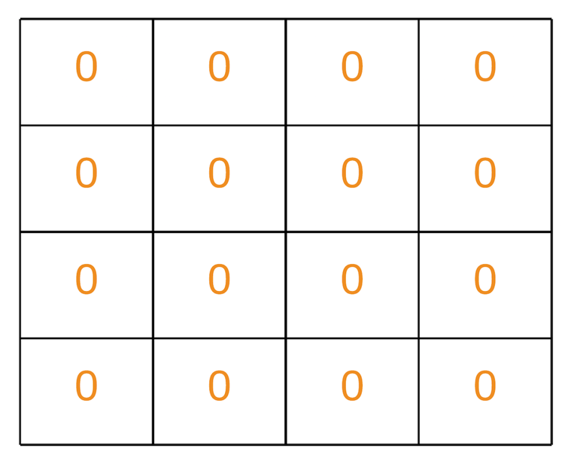

|  |
| --- |
| class Solution {  public void setZeroes(int[][] matrix) {  Boolean isCol = false;  int R = matrix.length;  int C = matrix[0].length;  for (int i = 0; i < R; i++) {  // Since first cell for both first row and first column is the same i.e. matrix[0][0]  // We can use an additional variable for either the first row/column.  // For this solution we are using an additional variable for the first column  // and using matrix[0][0] for the first row.  if (matrix[i][0] == 0) {  isCol = true;  }  for (int j = 1; j < C; j++) {  // If an element is zero, we set the first element of the corresponding row and column to 0  if (matrix[i][j] == 0) {  matrix[0][j] = 0;  matrix[i][0] = 0;  }  }  }  // Iterate over the array once again and using the first row and first column, update the elements.  for (int i = 1; i < R; i++) {  for (int j = 1; j < C; j++) {  if (matrix[i][0] == 0 || matrix[0][j] == 0) {  matrix[i][j] = 0;  }  }  }  // See if the first row needs to be set to zero as well  if (matrix[0][0] == 0) {  for (int j = 0; j < C; j++) {  matrix[0][j] = 0;  }  }  // See if the first column needs to be set to zero as well  if (isCol) {  for (int i = 0; i < R; i++) {  matrix[i][0] = 0;  }  }  }  } |

**Complexity Analysis**

* Time Complexity : *O*(*M*×*N*)
* Space Complexity : *O*(1)

**Group Anagrams**

Given an array of strings strs, group **the anagrams** together. You can return the answer in **any order**.

An **Anagram** is a word or phrase formed by rearranging the letters of a different word or phrase, typically using all the original letters exactly once.

**Example 1:**

**Input:** strs = ["eat","tea","tan","ate","nat","bat"]

**Output:** [["bat"],["nat","tan"],["ate","eat","tea"]]

**Example 2:**

**Input:** strs = [""]

**Output:** [[""]]

**Example 3:**

**Input:** strs = ["a"]

**Output:** [["a"]]

**Constraints:**

* 1 <= strs.length <= 104
* 0 <= strs[i].length <= 100
* strs[i] consists of lower-case English letters.

#### **Approach 1: Categorize by Sorted String**

**Intuition**

Two strings are anagrams if and only if their sorted strings are equal.

**Algorithm**

Maintain a map ans : {String -> List} where each key \text{K}K is a sorted string, and each value is the list of strings from the initial input that when sorted, are equal to \text{K}K.

In Java, we will store the key as a string, eg. code. In Python, we will store the key as a hashable tuple, eg. ('c', 'o', 'd', 'e').

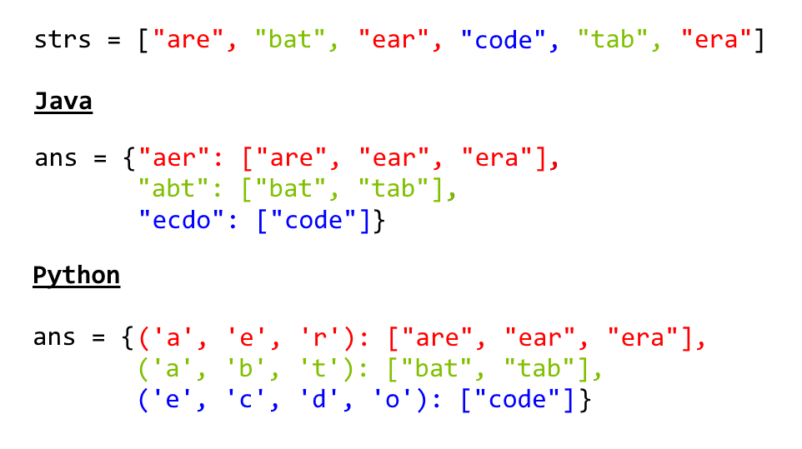

|  |
| --- |
| class Solution {  public List<List<String>> groupAnagrams(String[] strs) {  if (strs.length == 0) return new ArrayList();  Map<String, List> ans = new HashMap<String, List>();  for (String s : strs) {  char[] ca = s.toCharArray();  Arrays.sort(ca);  String key = String.valueOf(ca);  if (!ans.containsKey(key)) ans.put(key, new ArrayList());  ans.get(key).add(s);  }  return new ArrayList(ans.values());  }  } |

**Complexity Analysis**

* Time Complexity: *O*(*NK*log*K*), where *N* is the length of strs, and *K* is the maximum length of a string in strs. The outer loop has complexity *O*(*N*) as we iterate through each string. Then, we sort each string in *O*(*K*log*K*) time.
* Space Complexity: *O*(*NK*), the total information content stored in ans.

#### **Approach 2: Categorize by Count**

**Intuition**

Two strings are anagrams if and only if their character counts (respective number of occurrences of each character) are the same.

**Algorithm**

We can transform each string s into a character count, count, consisting of 26 non-negative integers representing the number of a's, b's, c's, etc. We use these counts as the basis for our hash map.

In Java, the hashable representation of our count will be a string delimited with '**#**' characters. For example, abbccc will be #1#2#3#0#0#0...#0 where there are 26 entries total. In python, the representation will be a tuple of the counts. For example, abbccc will be (1, 2, 3, 0, 0, ..., 0), where again there are 26 entries total.

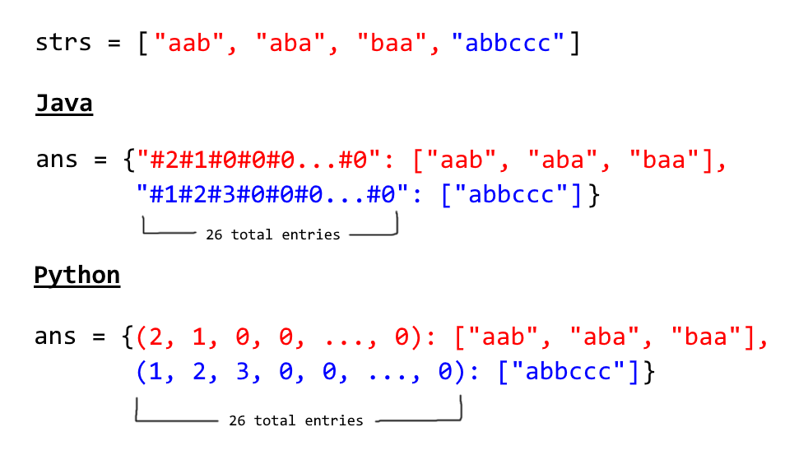

|  |
| --- |
| class Solution {  public List<List<String>> groupAnagrams(String[] strs) {  if (strs.length == 0) return new ArrayList();  Map<String, List> ans = new HashMap<String, List>();  int[] count = new int[26];  for (String s : strs) {  Arrays.fill(count, 0);  for (char c : s.toCharArray()) count[c - 'a']++;  StringBuilder sb = new StringBuilder("");  for (int i = 0; i < 26; i++) {  sb.append('#');  sb.append(count[i]);  }  String key = sb.toString();  if (!ans.containsKey(key)) ans.put(key, new ArrayList());  ans.get(key).add(s);  }  return new ArrayList(ans.values());  }  } |

**Complexity Analysis**

* Time Complexity: *O*(*NK*), where *N* is the length of strs, and *K* is the maximum length of a string in strs. Counting each string is linear in the size of the string, and we count every string.
* Space Complexity: *O*(*NK*), the total information content stored in ans.

**Longest Substring Without Repeating Characters**

Given a string s, find the length of the **longest substring** without repeating characters.

**Example 1:**

**Input:** s = "abcabcbb"

**Output:** 3

**Explanation:** The answer is "abc", with the length of 3.

**Example 2:**

**Input:** s = "bbbbb"

**Output:** 1

**Explanation:** The answer is "b", with the length of 1.

**Example 3:**

**Input:** s = "pwwkew"

**Output:** 3

**Explanation:** The answer is "wke", with the length of 3.

Notice that the answer must be a substring, "pwke" is a subsequence and not a substring.

**Example 4:**

**Input:** s = ""

**Output:** 0

**Constraints:**

* 0 <= s.length <= 5 * 104
* s consists of English letters, digits, symbols and spaces.

## Solution Article

#### **Approach 1: Brute Force**

**Intuition**

Check all the substring one by one to see if it has no duplicate character.

**Algorithm**

Suppose we have a function boolean allUnique(String substring) which will return true if the characters in the substring are all unique, otherwise false. We can iterate through all the possible substrings of the given string s and call the function allUnique. If it turns out to be true, then we update our answer of the maximum length of substring without duplicate characters.

Now let's fill the missing parts:

1. To enumerate all substrings of a given string, we enumerate the start and end indices of them. Suppose the start and end indices are *i* and *j*, respectively. Then we have 0≤*i*<*j*≤*n* (here end index *j* is exclusive by convention). Thus, using two nested loops with *i* from 0 to *n*−1 and *j* from *i*+1 to *n*, we can enumerate all the substrings of s.
2. To check if one string has duplicate characters, we can use a set. We iterate through all the characters in the string and put them into the set one by one. Before putting one character, we check if the set already contains it. If so, we return false. After the loop, we return true.

|  |
| --- |
| public class Solution {  public int lengthOfLongestSubstring(String s) {  int n = s.length();  int ans = 0;  for (int i = 0; i < n; i++)  for (int j = i + 1; j <= n; j++)  if (allUnique(s, i, j)) ans = Math.max(ans, j - i);  return ans;  }  public boolean allUnique(String s, int start, int end) {  Set<Character> set = new HashSet<>();  for (int i = start; i < end; i++) {  Character ch = s.charAt(i);  if (set.contains(ch)) return false;  set.add(ch);  }  return true;  }  } |

**Complexity Analysis**

* Time complexity : O(n^3).

To verify if characters within index range [*i*,*j*) are all unique, we need to scan all of them. Thus, it costs *O*(*j*−*i*) time.

For a given i, the sum of time costed by each *j*∈[*i*+1,*n*] is

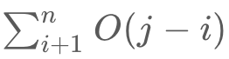

Thus, the sum of all the time consumption is:



* Space complexity : *O*(*min*(*n*,*m*)). We need *O*(*k*) space for checking a substring has no duplicate characters, where *k* is the size of the Set. The size of the Set is upper bounded by the size of the string *n* and the size of the charset/alphabet *m*.

#### **Approach 2: Sliding Window**

**Algorithm**

The naive approach is very straightforward. But it is too slow. So how can we optimize it?

In the naive approaches, we repeatedly check a substring to see if it has duplicate character. But it is unnecessary. If a substring *sij*​ from index *i* to *j*−1 is already checked to have no duplicate characters. We only need to check if *s*[*j*] is already in the substring *sij*​.

To check if a character is already in the substring, we can scan the substring, which leads to an O(n^2) algorithm. But we can do better.

By using HashSet as a sliding window, checking if a character in the current can be done in *O*(1).

A sliding window is an abstract concept commonly used in array/string problems. A window is a range of elements in the array/string which usually defined by the start and end indices, i.e. [*i*,*j*) (left-closed, right-open). A sliding window is a window "slides" its two boundaries to the certain direction. For example, if we slide [*i*,*j*) to the right by 1 element, then it becomes [*i*+1,*j*+1) (left-closed, right-open).

Back to our problem. We use HashSet to store the characters in current window [*i*,*j*) (*j*=*i* initially). Then we slide the index *j* to the right. If it is not in the HashSet, we slide *j* further. Doing so until s[j] is already in the HashSet. At this point, we found the maximum size of substrings without duplicate characters start with index *i*. If we do this for all i*i*, we get our answer.

|  |
| --- |
| public class Solution {  public int lengthOfLongestSubstring(String s) {  int n = s.length();  Set<Character> set = new HashSet<>();  int ans = 0, i = 0, j = 0;  while (i < n && j < n) {  // try to extend the range [i, j]  if (!set.contains(s.charAt(j))){  set.add(s.charAt(j++));  ans = Math.max(ans, j - i);  }  else {  set.remove(s.charAt(i++));  }  }  return ans;  }  } |

**Complexity Analysis**

* Time complexity : *O*(2*n*)=*O*(*n*). In the worst case each character will be visited twice by i*i* and *j*.
* Space complexity : *O*(*min*(*m*,*n*)). Same as the previous approach. We need *O*(*k*) space for the sliding window, where *k* is the size of the Set. The size of the Set is upper bounded by the size of the string *n* and the size of the charset/alphabet *m*.

#### **Approach 3: Sliding Window Optimized**

The above solution requires at most 2n steps. In fact, it could be optimized to require only n steps. Instead of using a set to tell if a character exists or not, we could define a mapping of the characters to its index. Then we can skip the characters immediately when we found a repeated character.

The reason is that if *s*[*j*] have a duplicate in the range [*i*,*j*) with index *j*′, we don't need to increase *i* little by little. We can skip all the elements in the range [*i*,*j*′] and let *i* to be *j*′+1 directly.

**Java (Using HashMap)**

|  |
| --- |
| public class Solution {  public int lengthOfLongestSubstring(String s) {  int n = s.length(), ans = 0;  Map<Character, Integer> map = new HashMap<>(); // current index of character  // try to extend the range [i, j]  for (int j = 0, i = 0; j < n; j++) {  if (map.containsKey(s.charAt(j))) {  i = Math.max(map.get(s.charAt(j)), i);  }  ans = Math.max(ans, j - i + 1);  map.put(s.charAt(j), j + 1);  }  return ans;  }  } |

**Java (Assuming ASCII 128)**

The previous implements all have no assumption on the charset of the string s.

If we know that the charset is rather small, we can replace the Map with an integer array as direct access table.

Commonly used tables are:

* int[26] for Letters 'a' - 'z' or 'A' - 'Z'
* int[128] for ASCII
* int[256] for Extended ASCII

|  |
| --- |
| public class Solution {  public int lengthOfLongestSubstring(String s) {  int n = s.length(), ans = 0;  int[] index = new int[128]; // current index of character  // try to extend the range [i, j]  for (int j = 0, i = 0; j < n; j++) {  i = Math.max(index[s.charAt(j)], i);  ans = Math.max(ans, j - i + 1);  index[s.charAt(j)] = j + 1;  }  return ans;  }  } |

**Complexity Analysis**

* Time complexity : *O*(*n*). Index *j* will iterate *n* times.
* Space complexity (HashMap) : *O*(*min*(*m*,*n*)). Same as the previous approach.
* Space complexity (Table): *O*(*m*). m*m* is the size of the charset.

**Longest Palindromic Substring**

Given a string s, return *the longest palindromic substring* in s.

**Example 1:**

**Input:** s = "babad"

**Output:** "bab"

**Note:** "aba" is also a valid answer.

**Example 2:**

**Input:** s = "cbbd"

**Output:** "bb"

**Example 3:**

**Input:** s = "a"

**Output:** "a"

**Example 4:**

**Input:** s = "ac"

**Output:** "a"

**Constraints:**

* 1 <= s.length <= 1000
* s consist of only digits and English letters (lower-case and/or upper-case),

Hide Hint #1

How can we reuse a previously computed palindrome to compute a larger palindrome?

Hide Hint #2

If “aba” is a palindrome, is “xabax” a palindrome? Similarly is “xabay” a palindrome?

Hide Hint #3

Complexity based hint:  
If we use brute-force and check whether for every start and end position a substring is a palindrome we have O(n^2) start - end pairs and O(n) palindromic checks. Can we reduce the time for palindromic checks to O(1) by reusing some previous computation.

## Summary

This article is for intermediate readers. It introduces the following ideas: Palindrome, Dynamic Programming and String Manipulation. Make sure you understand what a palindrome means. A palindrome is a string which reads the same in both directions. For example, *S* = "aba" is a palindrome, *S* = "abc" is not.

## Solution

#### **Approach 1: Longest Common Substring**

**Common mistake**

Some people will be tempted to come up with a quick solution, which is unfortunately flawed (however can be corrected easily):

Reverse *S* and become *S*′. Find the longest common substring between *S* and'*S*′, which must also be the longest palindromic substring.

This seemed to work, let’s see some examples below.

For example, *S* = "caba", *S*′ = "abac".

The longest common substring between *S* and *S*′ is "aba", which is the answer.

Let’s try another example: *S* = "abacdfgdcaba", *S*′ = "abacdgfdcaba".

The longest common substring between *S* and *S*′ is "abacd". Clearly, this is not a valid palindrome.

**Algorithm**

We could see that the longest common substring method fails when there exists a reversed copy of a non-palindromic substring in some other part of *S*. To rectify this, each time we find a longest common substring candidate, we check if the substring’s indices are the same as the reversed substring’s original indices. If it is, then we attempt to update the longest palindrome found so far; if not, we skip this and find the next candidate.

This gives us an O(n^2) Dynamic Programming solution which uses O(n^2) space (could be improved to use O(n) space). Please read more about Longest Common Substring [here](http://en.wikipedia.org/wiki/Longest_common_substring).

#### **Approach 2: Brute Force**

The obvious brute force solution is to pick all possible starting and ending positions for a substring, and verify if it is a palindrome.

**Complexity Analysis**

* Time complexity : O(n^3). Assume that *n* is the length of the input string, there are a total of 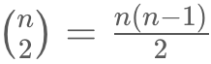 such substrings (excluding the trivial solution where a character itself is a palindrome). Since verifying each substring takes *O*(*n*) time, the run time complexity is O(n^3).
* Space complexity : *O*(1).

#### **Approach 3: Dynamic Programming**

To improve over the brute force solution, we first observe how we can avoid unnecessary re-computation while validating palindromes. Consider the case "ababa". If we already knew that "bab" is a palindrome, it is obvious that "ababa" must be a palindrome since the two left and right end letters are the same.

We define *P*(*i*,*j*) as following:

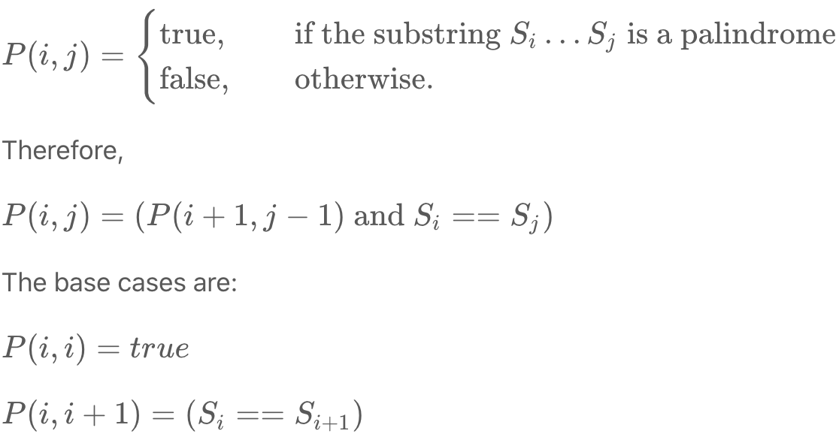  
  
This yields a straight forward DP solution, which we first initialize the one and two letters palindromes, and work our way up finding all three letters palindromes, and so on...

**Complexity Analysis**

* Time complexity : O(n^2). This gives us a runtime complexity of O(n^2).
* Space complexity : O(n^2). It uses O(n^2) space to store the table.

**Additional Exercise**

Could you improve the above space complexity further and how?

#### **Approach 4: Expand Around Center**

In fact, we could solve it in O(n^2) time using only constant space.

We observe that a palindrome mirrors around its center. Therefore, a palindrome can be expanded from its center, and there are only 2*n*−1 such centers.

You might be asking why there are 2*n*−1 but not *n* centers? The reason is the center of a palindrome can be in between two letters. Such palindromes have even number of letters (such as "abba") and its center are between the two 'b's.

|  |
| --- |
| public String longestPalindrome(String s) {  if (s == null || s.length() < 1) return "";  int start = 0, end = 0;  for (int i = 0; i < s.length(); i++) {  int len1 = expandAroundCenter(s, i, i);  int len2 = expandAroundCenter(s, i, i + 1);  int len = Math.max(len1, len2);  if (len > end - start) {  start = i - (len - 1) / 2;  end = i + len / 2;  }  }  return s.substring(start, end + 1);  }  private int expandAroundCenter(String s, int left, int right) {  int L = left, R = right;  while (L >= 0 && R < s.length() && s.charAt(L) == s.charAt(R)) {  L--;  R++;  }  return R - L - 1;  } |

**Complexity Analysis**

* Time complexity : O(n^2). Since expanding a palindrome around its center could take *O*(*n*) time, the overall complexity is O(n^2).
* Space complexity : *O*(1).

#### **Approach 5: Manacher's Algorithm**

There is even an *O*(*n*) algorithm called Manacher's algorithm, explained [here in detail](https://en.wikipedia.org/wiki/Longest_palindromic_substring#Manacher's_algorithm). However, it is a non-trivial algorithm, and no one expects you to come up with this algorithm in a 45 minutes coding session. But, please go ahead and understand it, I promise it will be a lot of fun.

## Manacher's algorithm[[edit](https://en.wikipedia.org/w/index.php?title=Longest_palindromic_substring&action=edit&section=1)]

To find a longest palindrome in a string in *linear time*, an algorithm may take advantage of the following characteristics or observations about a palindrome and a sub-palindrome:

1. The left side of a palindrome is a mirror image of its right side.
2. (Case 1) A third palindrome whose center is within the right side of a first palindrome will have exactly the same length as a second palindrome anchored at the mirror center on the left side, if the second palindrome is within the bounds of the first palindrome by at least one character (not meeting the left bound of the first palindrome). Such as "dacabacad", the whole string is the first palindrome, "aca" in the left side as second palindrome, "aca" in the right side as third palindrome. In this case, the second and third palindrome have exactly the same length.
3. (Case 2) If the second palindrome meets or extends beyond the left bound of the first palindrome, then the distance from the center of the second palindrome to the left bound of the first palindrome is exactly equal to the distance from the center of the third palindrome to the right bound of the first palindrome.
4. To find the length of the third palindrome under Case 2, the next character after the right outermost character of the first palindrome would then be compared with its mirror character about the center of the third palindrome, until there is no match or no more characters to compare.
5. (Case 3) Neither the first nor second palindrome provides information to help determine the palindromic length of a fourth palindrome whose center is outside the right side of the first palindrome.
6. It is therefore desirable to have a palindrome as a reference (i.e., the role of the first palindrome) that possesses characters farthest to the right in a string when determining from left to right the palindromic length of a substring in the string (and consequently, the third palindrome in Case 2 and the fourth palindrome in Case 3 could replace the first palindrome to become the new reference).
7. Regarding the time complexity of palindromic length determination for each character in a string: there is no character comparison for Case 1, while for Cases 2 and 3 only the characters in the string beyond the right outermost character of the reference palindrome are candidates for comparison (and consequently Case 3 always results in a new reference palindrome while Case 2 does so only if the third palindrome is actually longer than its guaranteed minimum length).
8. For even-length palindromes, the center is at the boundary of the two characters in the middle.

### Pseudocode**[**[**edit**](https://en.wikipedia.org/w/index.php?title=Longest_palindromic_substring&action=edit&section=2)**]**

given string S

string S' = S with a bogus character (eg. '|') inserted between each character (including outer boundaries)

array P = [0,...,0] // To store the lengths of the palindrome for each center point in S'

// note: length(S') = length(P) = 2 × length(S) + 1

// Track the following indices into P or S'

R = 0 // The next element to be examined; index into S

C = 0 // The largest/left-most palindrome whose right boundary is R-1; index into S

i = 1 // The next palindrome to be calculated; index into P

**define** L = i − (R − i) // Character candidate for comparing with R; index into S

**define** i' = C − (i − C) // The palindrome mirroring i from C; index into P

**while** R < length(S'):

**If** i is within the palindrome at C (Cases 1 and 2):

Set P[i] = P[i'] // note: recall P is initialized to all 0s

// Expand the palindrome at i (primarily Cases 2 and 3; can be skipped in Case 1,

// though we have already shown that S'[R] ≠ S'[L] because otherwise the palindrome

// at i' would have extended at least to the left edge of the palindrome at C):

**while** S'[R] == S'[L]:

increment P[i]

increment R

**If** the palindrome at i extends past the palindrome at C:

update C = i

**Else** increment i

**return** max(P)

This diverges a little from Manacher's original algorithm primarily by deliberately declaring and operating on R in such a way to help show that the runtime is in fact linear. You can see in the pseudo-code that R, C and i are all monotonically increasing, each stepping through the elements in S' and P. (the end condition was also changed slightly to not compute the last elements of P if R is already at the end - these will necessarily have lengths less than P[C] and can be skipped).

The use of S' provides a couple of simplifications for the code: it provides a string aligned to P allowing direct use of the pointers in both arrays and it implicitly enables the inner while-loop to double-increment P[i] and R (because every other time it will be comparing the bogus character to itself).

## Manacher算法[[编辑](https://zh.wikipedia.org/w/index.php?title=%E6%9C%80%E9%95%BF%E5%9B%9E%E6%96%87%E5%AD%90%E4%B8%B2&action=edit&section=4)]

要在线性时间内找出字符串的最长回文子串，这个算法必须利用回文和子回文的这些特点和观察

1. 回文的左边是右边的镜像
2. （情况1）如“dacabacad”中有三个回文。整体是第一个，左侧“aca”是第二个，右侧“aca”是三个。可总结规律：如果一个回文串中有三个回文子串（包括自身），且小回文串没有触碰到大回文的边界，那么其中两个小回文串长度相等。
3. （情况2）接上文，如果左侧小回文串触碰或超越大回文边界，那这个左侧小回文中心到大回文的左边界，等于右侧小回文中心到大回文的右边界。
4. 为了计算右侧小回文的长度（对于情况2），大回文串右侧边界的下一个元素应该和其与右侧小回文串中心对称的元素比较。直到不匹配为止。
5. （情况3）若有一个回文子串的中心在大回文串外，那么现有的3个回文子串无法判断第4回文串的位置。
6. 因此有回文串参照的情况比较理想（大回文串即为很好的参照）。情况2中的右侧回文串和情况3中的第四回文串可以代替原有大回文串。
7. 复杂度计算：情况1不需要比较，情况2、3在手动语言转换规则中检测到错误需比较右侧最外侧元素和其与当前参照回文串的对称元素。情况3会返回一个新的参照物，而情况2在手动语言转换规则中检测到错误有在右侧回文串比左侧对应回文串长时才会产生新的参照。
8. 对于偶数长度的回文，回文中心在中间两个字母之间。

### [Java](https://zh.wikipedia.org/wiki/Java)**[**[**编辑**](https://zh.wikipedia.org/w/index.php?title=%E6%9C%80%E9%95%BF%E5%9B%9E%E6%96%87%E5%AD%90%E4%B8%B2&action=edit&section=9)**]**

*// 生成新的辅助String, eg: abc123成为#a#b#c#1#2#3#2#1#*

**public** **static** char[] manacherStringString(String str) {

char[] c = str.toCharArray();

char[] res = **new** char[c.length * 2 + 1];

int index = 0;

**for** (int i = 0; i != res.length; i++) {

*// 两个一样效果, 填充符号"#"*

res[i] = (i % 2) == 0 ? '#' : c[index++];

*// res[i] = (i & 1) == 0 ? '#' : c[index++];*

}

**return** res;

}

*// 返回最长回文串长度*

**public** **static** int maxLcpsLength(String str) {

**if** (str == **null** || str.length() == 0) {

**return** 0;

}

char[] charArr = manacherStringString(str);

*// 辅助回文长度数组, 表示最多能扩充多少*

int[] pArr = **new** int[charArr.length];

*// 中心点*

int C = -1;

*// 最右边界*

int R = -1;

int max = Integer.MIN_VALUE;

**for** (int i = 0; i != charArr.length; i++) {

*// i在右边界内, i`到C的长度和到i到R的距离, 哪个小, 哪个就是起码成为回文的区域*

*// 否则为1, 自身*

pArr[i] = R > i ? Math.min(pArr[2 * C - i], R - i) : 1;

*// 检查边界*

**while** (i + pArr[i] < charArr.length && i - pArr[i] > -1) {

**if** (charArr[i + pArr[i]] == charArr[i - pArr[i]]) {

*// 左右字母相等, 扩1, 直到不能扩为止*

pArr[i]++;

} **else** {

*// 不能扩*

**break**;

}

}

*// 如果大于R, 那更新回文右边界和中心点*

**if** ((i + pArr[i]) > R) {

R = i + pArr[i];

C = i;

}

*// 如果需要, 则更新max*

max = Math.max(max, pArr[i]);

}

*// 返回最大回文长度*

**return** max - 1;

}

**Increasing Triplet Subsequence**

Given an integer array nums, return true*if there exists a triple of indices*(i, j, k)*such that*i < j < k*and*nums[i] < nums[j] < nums[k]. If no such indices exists, return false.

**Example 1:**

**Input:** nums = [1,2,3,4,5]

**Output:** true

**Explanation:** Any triplet where i < j < k is valid.

**Example 2:**

**Input:** nums = [5,4,3,2,1]

**Output:** false

**Explanation:** No triplet exists.

**Example 3:**

**Input:** nums = [2,1,5,0,4,6]

**Output:** true

**Explanation:** The triplet (3, 4, 5) is valid because nums[3] == 0 < nums[4] == 4 < nums[5] == 6.

**Constraints:**

* 1 <= nums.length <= 105
* -231 <= nums[i] <= 231 - 1

**Follow up:** Could you implement a solution that runs in O(n) time complexity and O(1) space complexity?

## Solution

#### **Approach 1: Linear Scan**

**Intuition**

The idea is to keep track of the first two numbers in increasing order and find the last number which will be bigger than the first two numbers. Here, the first and second smallest numbers can be updated with conditional checks while scanning nums.

first_num = second_num = some very big number

for n in nums:

if n is smallest number:

first_num = n

else if n is second smallest number:

second_num = n

else n is bigger than both first_num and second_num:

# We have found our triplet, return True

# After loop has terminated

# If we have reached this point, there is no increasing triplet, return False

Let's take a look at two cases where nums is sorted:

* If nums is sorted in descending order, you will always end up in this first if block (and thus, repeatedly updating first_num). Finally, False will be returned after the loop has been terminated.
* If nums is sorted in ascending order, you will first update first_num as soon as you see the first number in nums and when you encounter another number in nums, you will update the second_nums since this new number would be bigger than the value stored in first_num. After these two variables have been populated, all you need to look for is another number which is bigger than first_num and second_num. As soon as you find that number, the first if and the second else if blocks will be skipped, and you will end up in the last else block and True will be returned immediately.

This works not only for sorted cases described above but also for cases where the numbers are unsorted. First, find the smallest number and store it in first_num, and then find the second smallest number and store it in second_num. However, there is no guarantee that another number you encounter in nums will be greater than first_num and second_num. This new number can even be smaller than then first_num (in that case, you will have to update first_num with this new value) or second_num (in that case, you will have to update second_num with this new value). As long as you encounter those cases, you keep on updating your first_num and second_num. As soon as you encounter a number which is greater than **both** first_num and second_num, you have found your last number to complete the increasing triplet subsequence. At that point, you can immediately return True.

However, there is an important logic that is quite important to grasp. Let's take nums = [10,20,3,2,1,1,2,0,4] for an example:

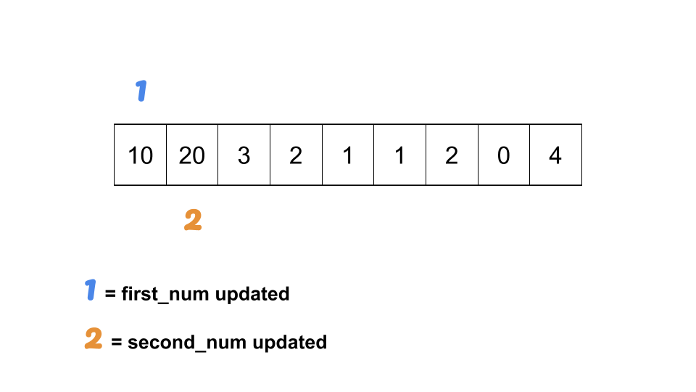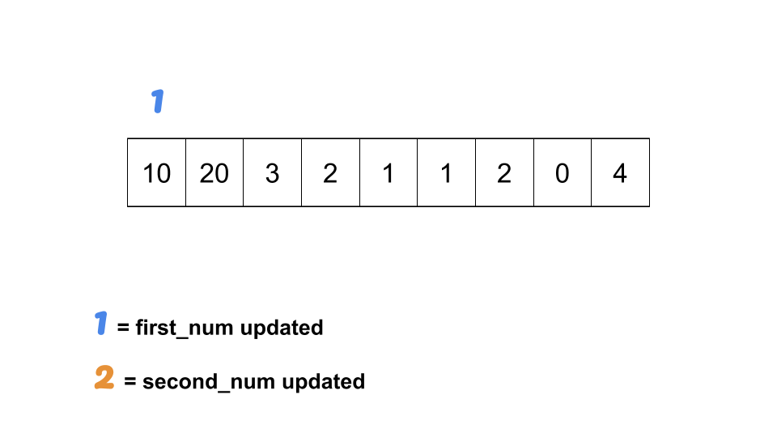

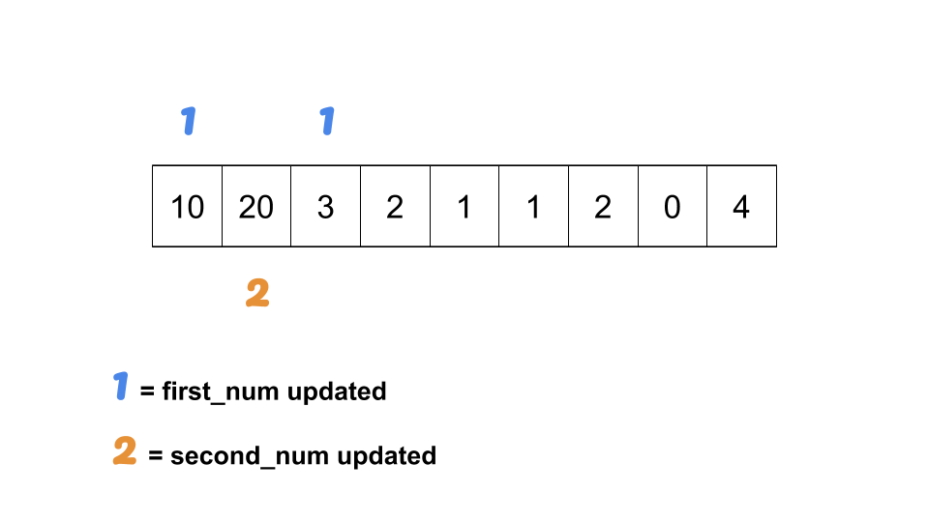

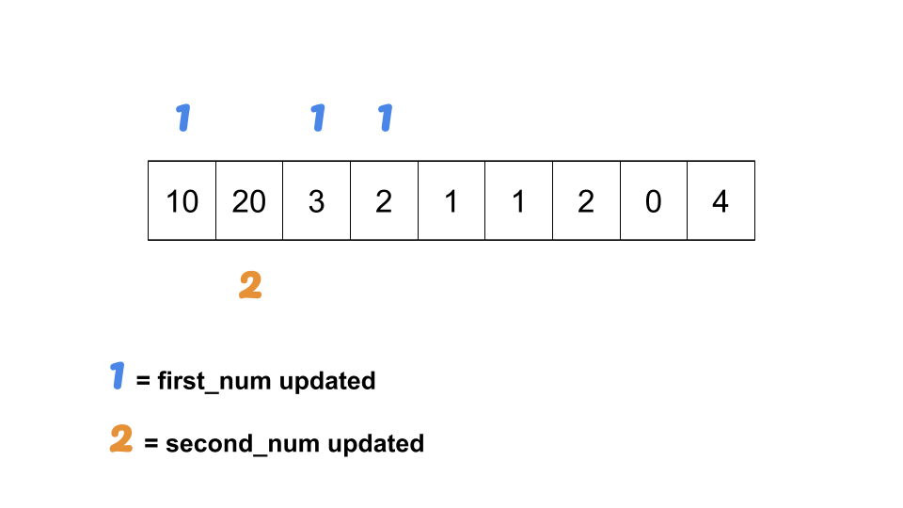

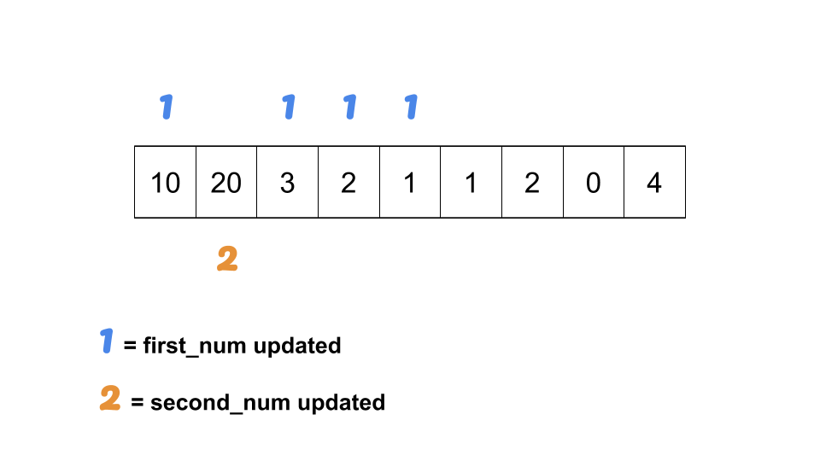

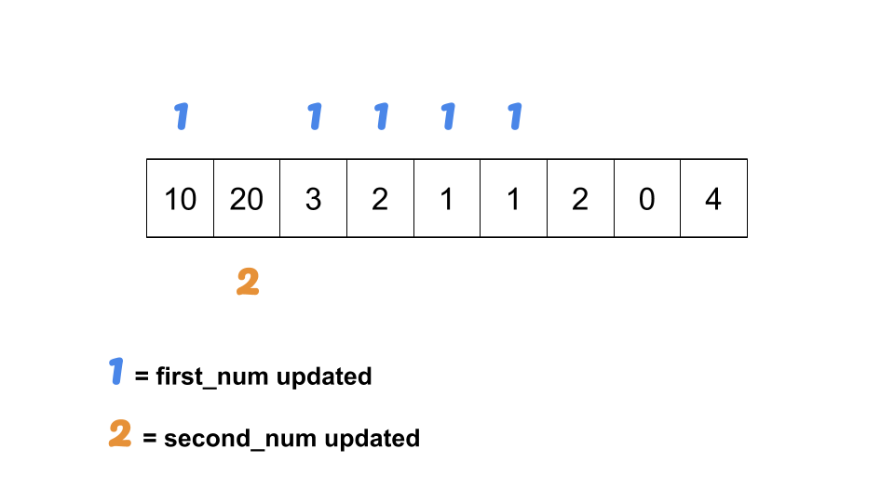

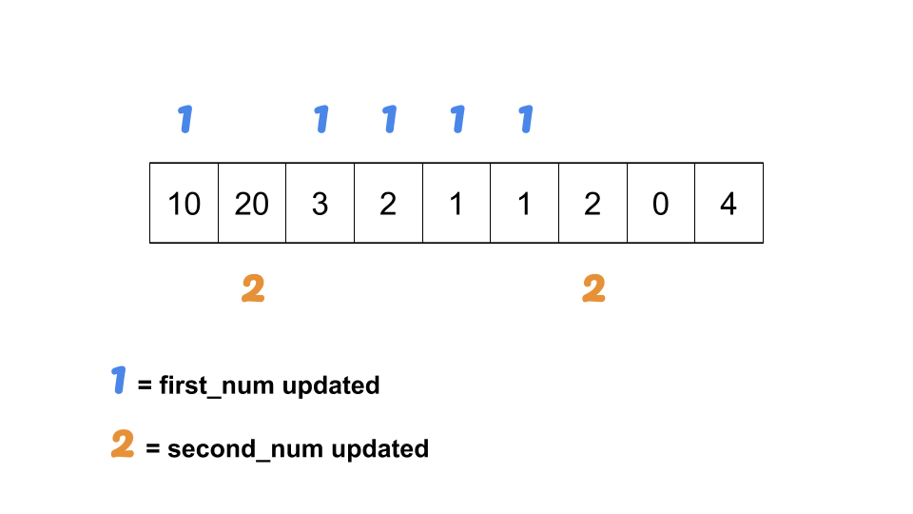

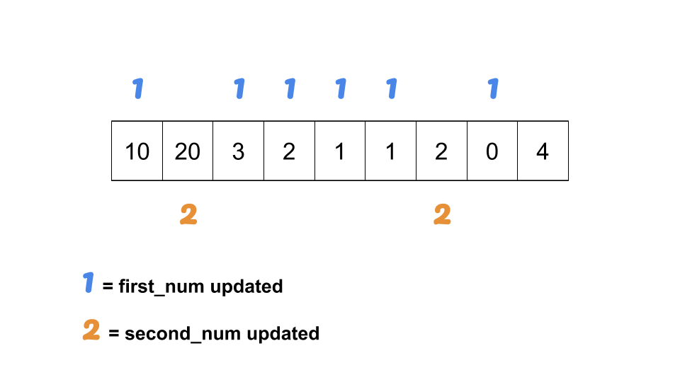

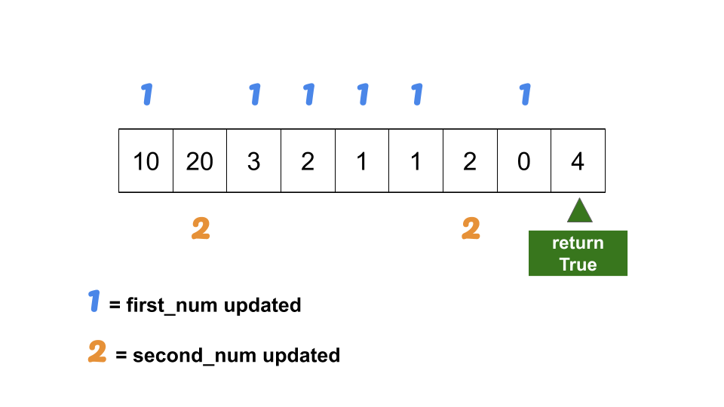

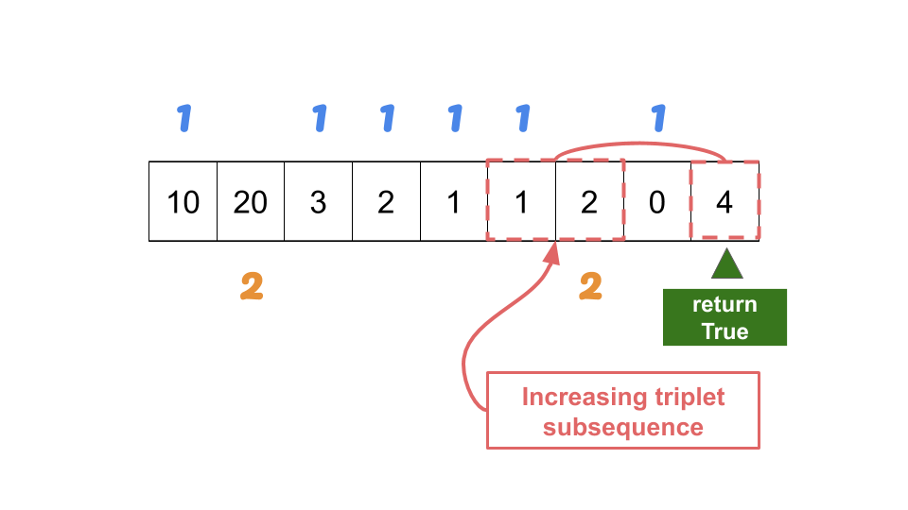

In the above example, the point where you have reached 0 and subsequently updating first_num = 0 can make you confused as you might think that this no longer is a subsequence (since second_num = 2 comes before first_num = 0). Of course, since we have updated the first_num, if we want to return the actual subsequence, we might need to have another placeholder variable that will hold the previously recorded first_num before it is updated. However, for this problem, we are only looking for the *existence of* a valid increasing triplet subsequence, even though first_num and second_num are out of order, we don't need to worry about it.

To make this more illustrative, observe the following example.

nums = [1,2,0,3] # should return True

1. first_num = 1
2. second_num = 2
3. first_num = 0
4. return True

The increasing triplet subsequence is 1, 2, and 3. Even though first_num is updated in Line 3, second_num is never updated again. However, you can tell that **there exists another number before second_num which is definitely BIGGER than the last updated first_num but SMALLER than second_num**. This is a very important observation. Therefore, you can safely say that there exists an increasing triplet subsequence as soon as you see a number which is bigger than the *last updated* first_num and second_num even though that last updated first_num is not one of the actual numbers of the increasing triplet subsequence.

**Implementation**

|  |
| --- |
| class Solution {  public boolean increasingTriplet(int[] nums) {  int first_num = Integer.MAX_VALUE;  int second_num = Integer.MAX_VALUE;  for (int n: nums) {  if (n <= first_num) {  first_num = n;  } else if (n <= second_num) {  second_num = n;  } else {  return true;  }  }  return false;  }  } |

**Complexity Analysis**

* Time complexity : *O*(*N*) where *N* is the size of nums. We are updating first_num and second_num as we are scanning nums.
* Space complexity : *O*(1) since we are not consuming additional space other than variables for two numbers.

**Missing Ranges**

You are given an inclusive range [lower, upper] and a **sorted unique** integer array nums, where all elements are in the inclusive range.

A number x is considered **missing** if x is in the range [lower, upper] and x is not in nums.

Return *the****smallest sorted****list of ranges that****cover every missing number exactly***. That is, no element of nums is in any of the ranges, and each missing number is in one of the ranges.

Each range [a,b] in the list should be output as:

* "a->b" if a != b
* "a" if a == b

**Example 1:**

**Input:** nums = [0,1,3,50,75], lower = 0, upper = 99

**Output:** ["2","4->49","51->74","76->99"]

**Explanation:** The ranges are:

[2,2] --> "2"

[4,49] --> "4->49"

[51,74] --> "51->74"

[76,99] --> "76->99"

**Example 2:**

**Input:** nums = [], lower = 1, upper = 1

**Output:** ["1"]

**Explanation:** The only missing range is [1,1], which becomes "1".

**Example 3:**

**Input:** nums = [], lower = -3, upper = -1

**Output:** ["-3->-1"]

**Explanation:** The only missing range is [-3,-1], which becomes "-3->-1".

**Example 4:**

**Input:** nums = [-1], lower = -1, upper = -1

**Output:** []

**Explanation:** There are no missing ranges since there are no missing numbers.

**Example 5:**

**Input:** nums = [-1], lower = -2, upper = -1

**Output:** ["-2"]

**Constraints:**

* -109 <= lower <= upper <= 109
* 0 <= nums.length <= 100
* lower <= nums[i] <= upper
* All the values of nums are **unique**.

## Solution Article

#### **Approach 1: Linear Scan**

**Intuition and Algorithm**

Since the input array, nums, is sorted ascendingly and all the elements in it are within the given [lower, upper] bounds, we can simply check consecutive elements to see if they differ by one or not. If they don't, then we have found a missing range.

* When nums[i] - nums[i-1] == 1, we know that there are no missing elements between nums[i-1] and nums[i].
* When nums[i] - nums[i-1] > 1, we know that [nums[i-1] + 1, nums[i] - 1] range of elements are missing.

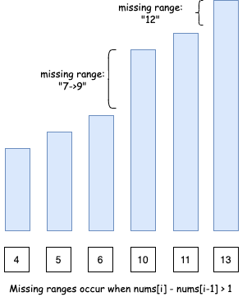

However, there are two edge cases:

* Case 1: If we don't start with lower as the first element of the array, we will need to consider [lower, num[0] - 1] missing range as well.

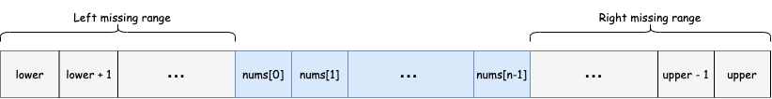

* Case 2: Similarly, if we don't end with upper as the last element of the array, we will need to consider [nums[n-1] + 1, upper] missing range as well. Note n here is the length of the input array nums.

|  |
| --- |
| class Solution {  public List<String> findMissingRanges(int[] nums, int lower, int upper) {  int n = nums.length;  if (n == 0) {  return Collections.singletonList(formatRange(lower, upper));  }  List<String> missingRanges = new ArrayList<>();  // Edge case 1) Missing ranges at the beginning  if (nums[0] > lower) {  missingRanges.add(formatRange(lower, nums[0] - 1));  }  // Missing ranges between array elements  for (int i = 1; i < n; ++i) {  if (nums[i] - nums[i - 1] > 1) {  missingRanges.add(formatRange(nums[i - 1] + 1, nums[i] - 1));  }  }  // Edge case 2) Missing ranges at the end  if (nums[n - 1] < upper) {  missingRanges.add(formatRange(nums[n - 1] + 1, upper));  }  return missingRanges;  }  // formats range in the requested format  String formatRange(int lower, int upper) {  if (lower == upper) {  return String.valueOf(lower);  } else {  return lower + "->" + upper;  }  }  } |

**Complexity Analysis**

* Time complexity : *O*(*N*), where *N* is the length of the input array. This is because we are only iterating over the array once.
* Space complexity : *O*(*N*) if we take the output into account and *O*(1) otherwise, where *N* is the length of the input array. This is because we could have a missing range between each of the consecutive element of the input array. Hence, our output list that we need to return will be of size *N*.

## Linked List

Linked List problems are relatively easy to master. Do not forget the [Two-pointer technique](https://leetcode.com/articles/two-pointer-technique/), which not only applicable to Array problems but also Linked List problems as well.

Another technique to greatly simplify coding in linked list problems is the dummy node trick.

We recommend: Add Two Numbers and Intersection of Two Linked Lists.

 Add Two Numbers

 Odd Even Linked List

 Intersection of Two Linked Lists

**Add Two Numbers**

You are given two **non-empty** linked lists representing two non-negative integers. The digits are stored in **reverse order**, and each of their nodes contains a single digit. Add the two numbers and return the sum as a linked list.

You may assume the two numbers do not contain any leading zero, except the number 0 itself.

**Example 1:**

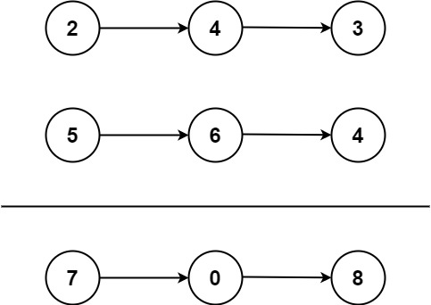

**Input:** l1 = [2,4,3], l2 = [5,6,4]

**Output:** [7,0,8]

**Explanation:** 342 + 465 = 807.

**Example 2:**

**Input:** l1 = [0], l2 = [0]

**Output:** [0]

**Example 3:**

**Input:** l1 = [9,9,9,9,9,9,9], l2 = [9,9,9,9]

**Output:** [8,9,9,9,0,0,0,1]

**Constraints:**

* The number of nodes in each linked list is in the range [1, 100].
* 0 <= Node.val <= 9
* It is guaranteed that the list represents a number that does not have leading zeros.

**Odd Even Linked List**

Given a singly linked list, group all odd nodes together followed by the even nodes. Please note here we are talking about the node number and not the value in the nodes.

You should try to do it in place. The program should run in O(1) space complexity and O(nodes) time complexity.

**Example 1:**

**Input:** 1->2->3->4->5->NULL

**Output:** 1->3->5->2->4->NULL

**Example 2:**

**Input:** 2->1->3->5->6->4->7->NULL

**Output:** 2->3->6->7->1->5->4->NULL

**Constraints:**

* The relative order inside both the even and odd groups should remain as it was in the input.
* The first node is considered odd, the second node even and so on ...
* The length of the linked list is between [0, 10^4].

**Intersection of Two Linked Lists**

Write a program to find the node at which the intersection of two singly linked lists begins.

For example, the following two linked lists:

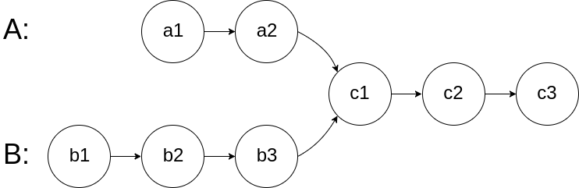

begin to intersect at node c1.

**Example 1:**

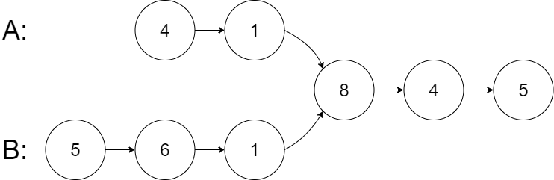

**Input:** intersectVal = 8, listA = [4,1,8,4,5], listB = [5,6,1,8,4,5], skipA = 2, skipB = 3

**Output:** Reference of the node with value = 8

**Input Explanation:** The intersected node's value is 8 (note that this must not be 0 if the two lists intersect). From the head of A, it reads as [4,1,8,4,5]. From the head of B, it reads as [5,6,1,8,4,5]. There are 2 nodes before the intersected node in A; There are 3 nodes before the intersected node in B.

**Example 2:**

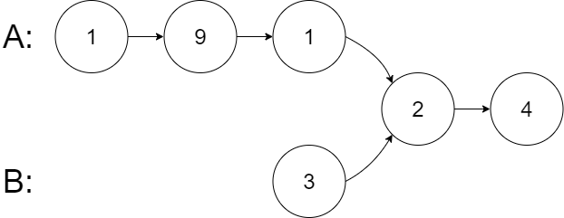

**Input:** intersectVal = 2, listA = [1,9,1,2,4], listB = [3,2,4], skipA = 3, skipB = 1

**Output:** Reference of the node with value = 2

**Input Explanation:** The intersected node's value is 2 (note that this must not be 0 if the two lists intersect). From the head of A, it reads as [1,9,1,2,4]. From the head of B, it reads as [3,2,4]. There are 3 nodes before the intersected node in A; There are 1 node before the intersected node in B.

**Example 3:**

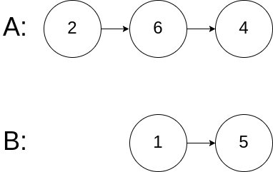

**Input:** intersectVal = 0, listA = [2,6,4], listB = [1,5], skipA = 3, skipB = 2

**Output:** null

**Input Explanation:** From the head of A, it reads as [2,6,4]. From the head of B, it reads as [1,5]. Since the two lists do not intersect, intersectVal must be 0, while skipA and skipB can be arbitrary values.

**Explanation:** The two lists do not intersect, so return null.

**Notes:**

* If the two linked lists have no intersection at all, return null.
* The linked lists must retain their original structure after the function returns.
* You may assume there are no cycles anywhere in the entire linked structure.
* Each value on each linked list is in the range [1, 10^9].
* Your code should preferably run in O(n) time and use only O(1) memory.

**Trees and Graphs**

Tree is a special type of graphs, so the two usual techniques used to traverse a graph are also applicable to trees.

We recommend: Binary Tree Inorder Traversal, Populating Next Right Pointers in Each Node and Number of Islands.

Note that some of the tree problems can also be asked in n-ary tree format, so make sure you know what an n-ary tree is.

**Note:** Although Number of Islands is not a tree problem, it can be represented as a graph and therefore we categorize it as a graph problem.

 Binary Tree Inorder Traversal

 Binary Tree Zigzag Level Order Traversal

 Construct Binary Tree from Preorder and Inorder Traversal

 Populating Next Right Pointers in Each Node

 Kth Smallest Element in a BST

 Inorder Successor in BST

 Number of Islands

**Binary Tree Inorder Traversal**

Given the root of a binary tree, return *the inorder traversal of its nodes' values*.

**Example 1:**

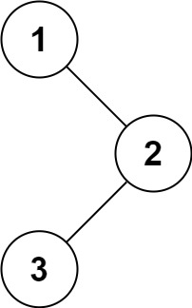

**Input:** root = [1,null,2,3]

**Output:** [1,3,2]

**Example 2:**

**Input:** root = []

**Output:** []

**Example 3:**

**Input:** root = [1]

**Output:** [1]

**Example 4:**

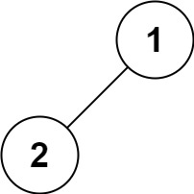

**Input:** root = [1,2]

**Output:** [2,1]

**Example 5:**

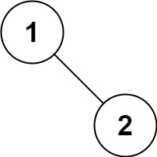

**Input:** root = [1,null,2]

**Output:** [1,2]

**Constraints:**

* The number of nodes in the tree is in the range [0, 100].
* -100 <= Node.val <= 100

**Follow up:**

Recursive solution is trivial, could you do it iteratively?

**Binary Tree Zigzag Level Order Traversal**

Given a binary tree, return the *zigzag level order* traversal of its nodes' values. (ie, from left to right, then right to left for the next level and alternate between).

For example:  
Given binary tree [3,9,20,null,null,15,7],

3

/ \

9 20

/ \

15 7

return its zigzag level order traversal as:

[

[3],

[20,9],

[15,7]

]

## Solution

#### **Approach 1: BFS (Breadth-First Search)**

**Intuition**

Following the description of the problem, the most intuitive solution would be the BFS (Breadth-First Search) approach through which we traverse the tree level-by-level.

The default ordering of BFS within a single level is from left to right. As a result, we should adjust the BFS algorithm a bit to generate the desired zigzag ordering.

One of the keys here is to store the values that are of the same level with the deque (double-ended queue) data structure, where we could add new values on either end of a queue.

So if we want to have the ordering of **FIFO** (first-in-first-out), we simply append the new elements to the tail of the queue, i.e. the late comers stand last in the queue. While if we want to have the ordering of **FILO** (first-in-last-out), we insert the new elements to the head of the queue, i.e. the late comers jump the queue.

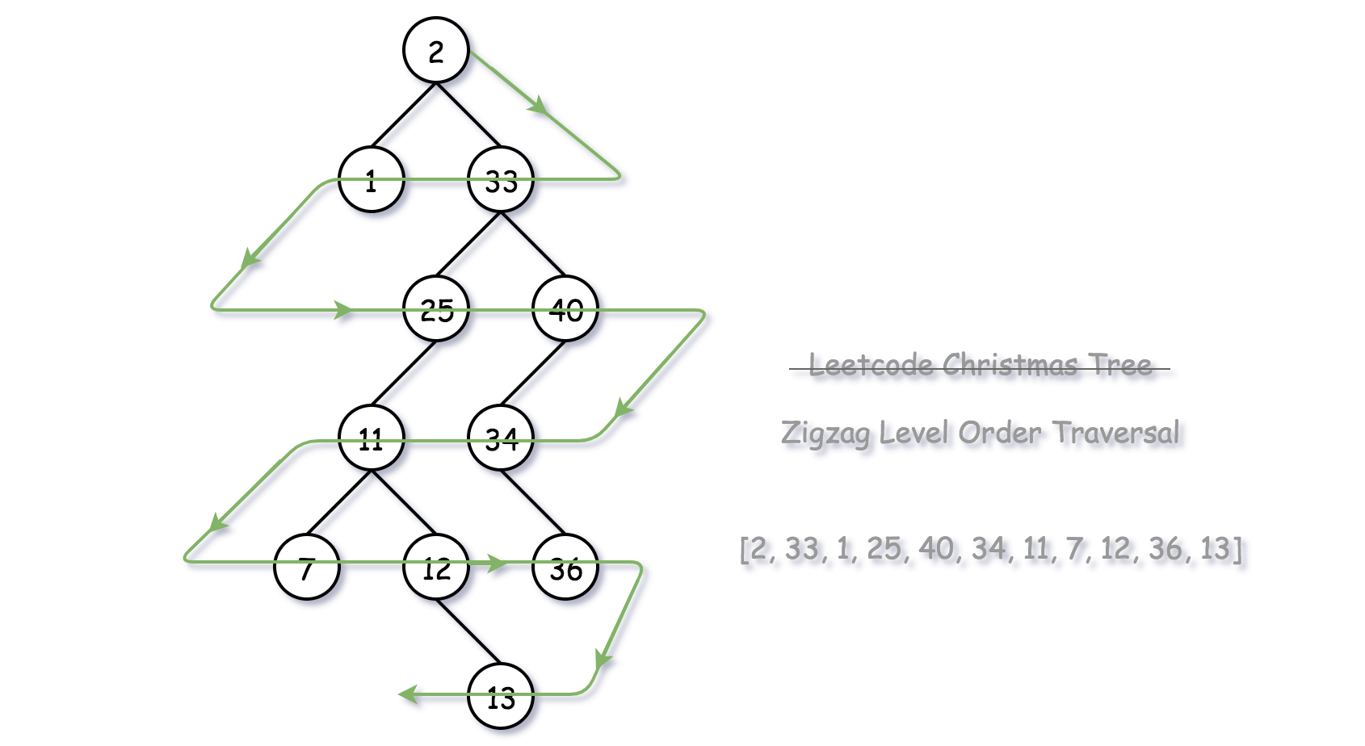

**Algorithm**

There are several ways to implement the BFS algorithm.

* One way would be that we run a two-level nested loop, with the outer loop iterating each level on the tree, and with the inner loop iterating each node within a single level.
* We could also implement BFS with a single loop though. The trick is that we append the nodes to be visited into a queue and we separate nodes of different levels with a sort of **delimiter** (e.g. an empty node). The delimiter marks the end of a level, as well as the beginning of a new level.

Here we adopt the second approach above. One can start with the normal BFS algorithm, upon which we add a touch of zigzag order with the help of deque. For each level, we start from an empty deque container to hold all the values of the same level. Depending on the ordering of each level, i.e. either from-left-to-right or from-right-to-left, we decide at which end of the deque to add the new element:

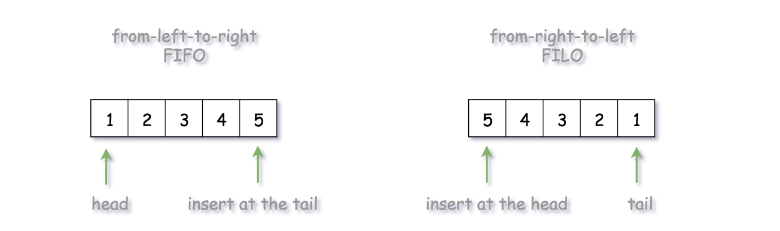

* For the ordering of from-left-to-right (FIFO), we append the new element to the **tail** of the queue, so that the element that comes late would get out late as well. As we can see from the above graph, given an input sequence of [1, 2, 3, 4, 5], with FIFO ordering, we would have an output sequence of [1, 2, 3, 4, 5].
* For the ordering of from-right-to-left (FILO), we insert the new element to the **head** of the queue, so that the element that comes late would get out first. With the same input sequence of [1, 2, 3, 4, 5], with FILO ordering, we would obtain an output sequence of [5, 4, 3, 2, 1].

|  |
| --- |
| /**  * Definition for a binary tree node.  * public class TreeNode {  * int val;  * TreeNode left;  * TreeNode right;  * TreeNode(int x) { val = x; }  * }  */  class Solution {  public List<List<Integer>> zigzagLevelOrder(TreeNode root) {  if (root == null) {  return new ArrayList<List<Integer>>();  }  List<List<Integer>> results = new ArrayList<List<Integer>>();  // add the root element with a delimiter to kick off the BFS loop  LinkedList<TreeNode> node_queue = new LinkedList<TreeNode>();  node_queue.addLast(root);  node_queue.addLast(null);  LinkedList<Integer> level_list = new LinkedList<Integer>();  boolean is_order_left = true;  while (node_queue.size() > 0) {  TreeNode curr_node = node_queue.pollFirst();  if (curr_node != null) {  if (is_order_left)  level_list.addLast(curr_node.val);  else  level_list.addFirst(curr_node.val);  if (curr_node.left != null)  node_queue.addLast(curr_node.left);  if (curr_node.right != null)  node_queue.addLast(curr_node.right);  } else {  // we finish the scan of one level  results.add(level_list);  level_list = new LinkedList<Integer>();  // prepare for the next level  if (node_queue.size() > 0)  node_queue.addLast(null);  is_order_left = !is_order_left;  }  }  return results;  }  } |

Note: as an alternative approach, one can also implement the normal BFS algorithm first, which would generate the ordering of from-left-to-right for each of the levels. Then, at the end of the algorithm, we can simply **reverse** the ordering of certain levels, following the zigzag steps.

**Complexity Analysis**

* Time Complexity: O(*N*), where *N* is the number of nodes in the tree.
  + We visit each node once and only once.
  + In addition, the insertion operation on either end of the deque takes a constant time, rather than using the array/list data structure where the inserting at the head could take the O(*K*) time where *K* is the length of the list.
* Space Complexity: O(*N*) where *N* is the number of nodes in the tree.
  + The main memory consumption of the algorithm is the node_queue that we use for the loop, apart from the array that we use to keep the final output.
  + As one can see, at any given moment, the node_queue would hold the nodes that are at most across two levels. Therefore, at most, the size of the queue would be no more than 2⋅*L*, assuming *L* is the maximum number of nodes that might reside on the same level. Since we have a binary tree, the level that contains the most nodes could occur to consist all the leave nodes in a full binary tree, which is roughly L = N/2​. As a result, we have the space complexity of 2 * N/2 = N in the worst case.

#### **Approach 2: DFS (Depth-First Search)**

**Intuition**

Though not intuitive, we could also obtain the BFS traversal ordering via the DFS (Depth-First Search) traversal in the tree.

The trick is that during the DFS traversal, we maintain the results in a global array that is indexed by the level, i.e. the element array[level] would contain all the nodes that are at the same level. The global array would then be referred and updated at each step of DFS.

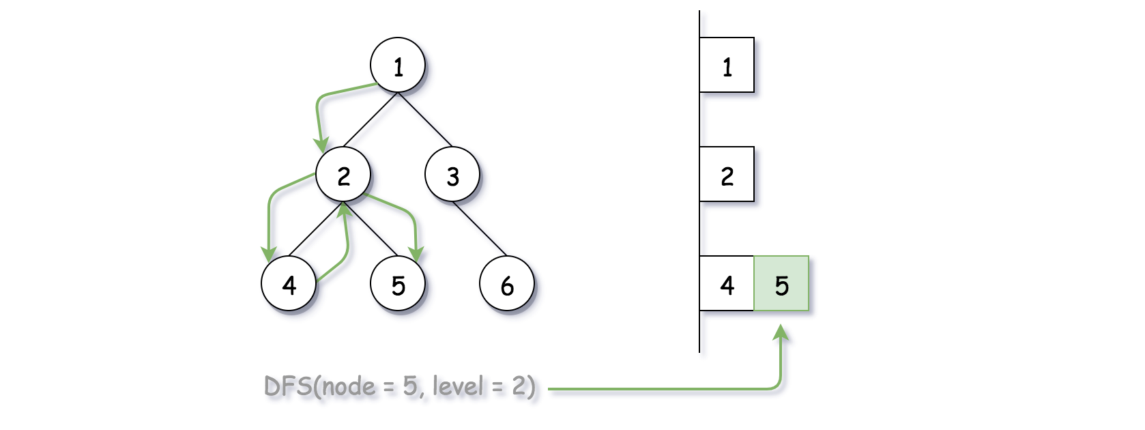

Similar with the above modified BFS algorithm, we employ the deque data structure to hold the nodes that are of the same level, and we alternate the insertion direction (i.e. either to the head or to the tail) to generate the desired output ordering.

**Algorithm**

Here we implement the DFS algorithm via recursion. We define a recursive function called DFS(node, level) which only takes care of the current node which is located at the specified level. Within the function, here are three steps that we would perform:

* If this is the first time that we visit any node at the level, i.e. the deque for the level does not exist, then we simply create the deque with the current node value as the initial element.
* If the deque for this level exists, then depending on the ordering, we insert the current node value either to the head or to the tail of the queue.
* At the end, we recursively call the function for each of its child nodes.

|  |
| --- |
| /**  * Definition for a binary tree node.  * public class TreeNode {  * int val;  * TreeNode left;  * TreeNode right;  * TreeNode(int x) { val = x; }  * }  */  class Solution {  protected void DFS(TreeNode node, int level, List<List<Integer>> results) {  if (level >= results.size()) {  LinkedList<Integer> newLevel = new LinkedList<Integer>();  newLevel.add(node.val);  results.add(newLevel);  } else {  if (level % 2 == 0)  results.get(level).add(node.val);  else  results.get(level).add(0, node.val);  }  if (node.left != null) DFS(node.left, level + 1, results);  if (node.right != null) DFS(node.right, level + 1, results);  }  public List<List<Integer>> zigzagLevelOrder(TreeNode root) {  if (root == null) {  return new ArrayList<List<Integer>>();  }  List<List<Integer>> results = new ArrayList<List<Integer>>();  DFS(root, 0, results);  return results;  }  } |

It might go without saying that, one can also implement the DFS traversal via ***iteration*** rather than recursion, which could be one of the followup questions by an interviewer.

**Complexity Analysis**

* Time Complexity: O(*N*), where *N* is the number of nodes in the tree.
  + Same as the previous BFS approach, we visit each node once and only once.
* Space Complexity: O(*H*), where *H* is the height of the tree, *i.e.* the number of levels in the tree, which would be roughly log2​*N*.
  + Unlike the BFS approach, in the DFS approach, we do not need to maintain the node_queue data structure for the traversal.
  + However, the function recursion would incur additional memory consumption on the *function call stack*. As we can see, the size of the call stack for any invocation of DFS(node, level) would be exactly the number of level that the current node resides on. Therefore, the space complexity of our DFS algorithm is O(log2​*N*) which is much better than the BFS approach.

**Construct Binary Tree from Preorder and Inorder Traversal**

Given preorder and inorder traversal of a tree, construct the binary tree.

**Note:**  
You may assume that duplicates do not exist in the tree.

For example, given

preorder = [3,9,20,15,7]

inorder = [9,3,15,20,7]

Return the following binary tree:

3

/ \

9 20

/ \

15 7

## Solution

#### **How to traverse the tree**

There are two general strategies to traverse a tree:

* Breadth First Search (BFS)

We scan through the tree level by level, following the order of height, from top to bottom. The nodes on higher level would be visited before the ones with lower levels.

* Depth First Search (DFS)

In this strategy, we adopt the depth as the priority, so that one would start from a root and reach all the way down to certain leaf, and then back to root to reach another branch.

The DFS strategy can further be distinguished as preorder, inorder, and postorder depending on the relative order among the root node, left node and right node.

On the following figure the nodes are numerated in the order you visit them, please follow 1-2-3-4-5 to compare different strategies.

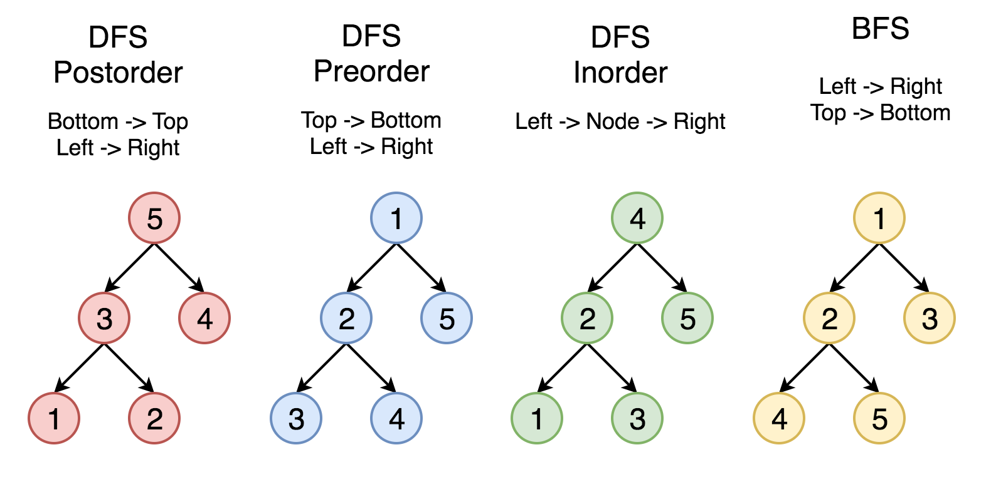

Here the problem is to construct a binary tree from its preorder and inorder traversal.

#### **Approach 1: Recursion**

**Tree definition**

First of all, here is the definition of the TreeNode which we would use.

|  |
| --- |
| // Definition for a binary tree node.  public class TreeNode {  int val;  TreeNode left;  TreeNode right;  TreeNode(int x) {  val = x;  }  } |

**Algorithm**

As discussed above the preorder traversal follows Root -> Left -> Right order, that makes it very convenient to construct the tree from its root.

Let's do it. The first element in the *preorder* list is a root. This root splits *inorder* list into left and right subtrees. Now one have to pop up the root from preorder list since it's already used as a tree node and then repeat the step above for the left and right subtrees.

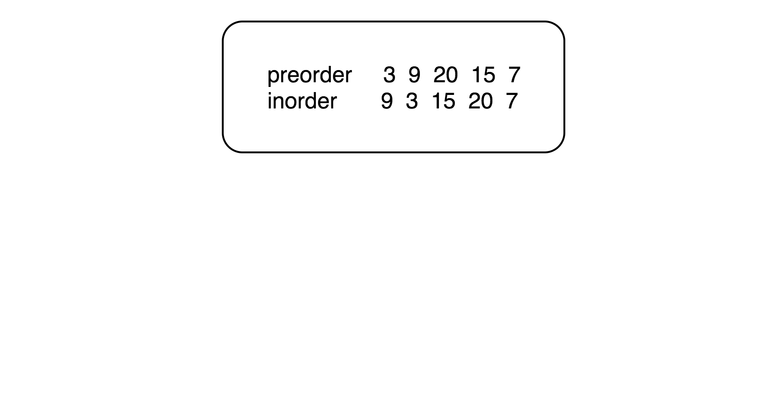

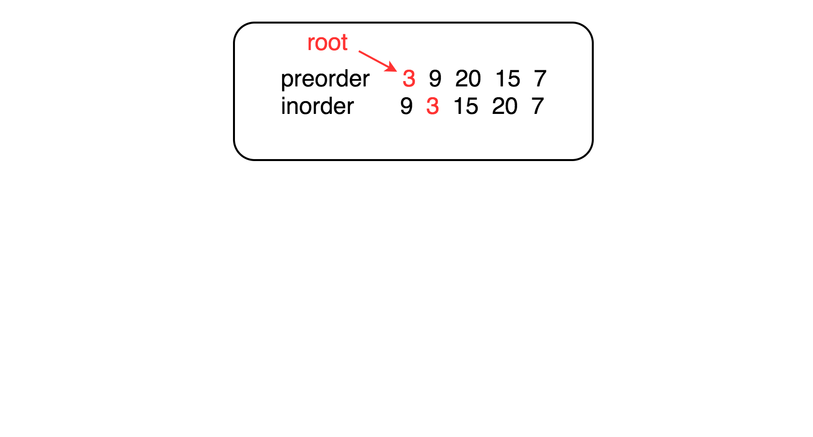

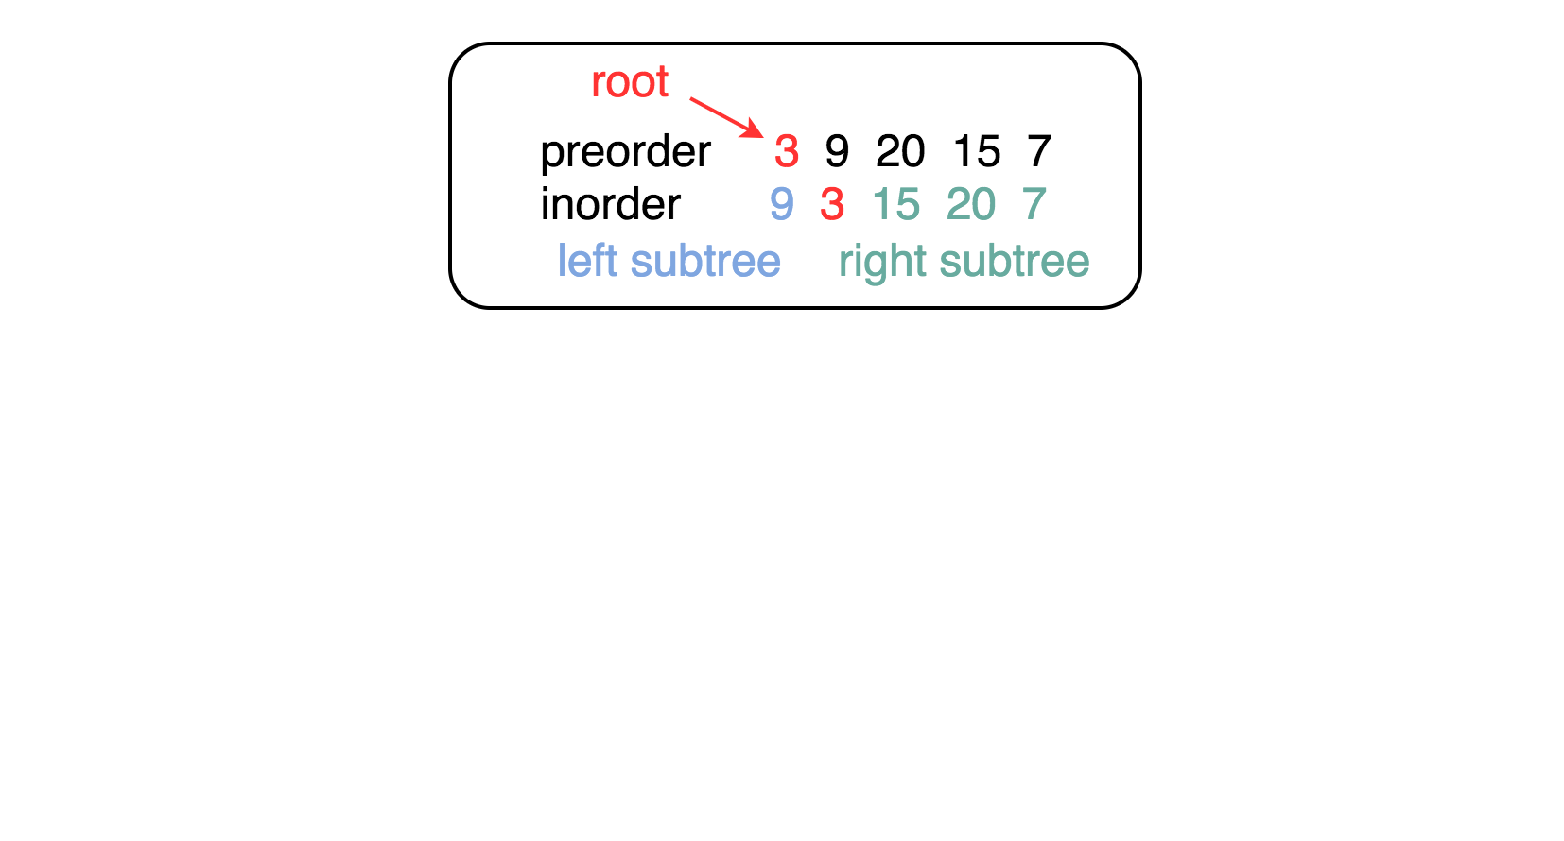

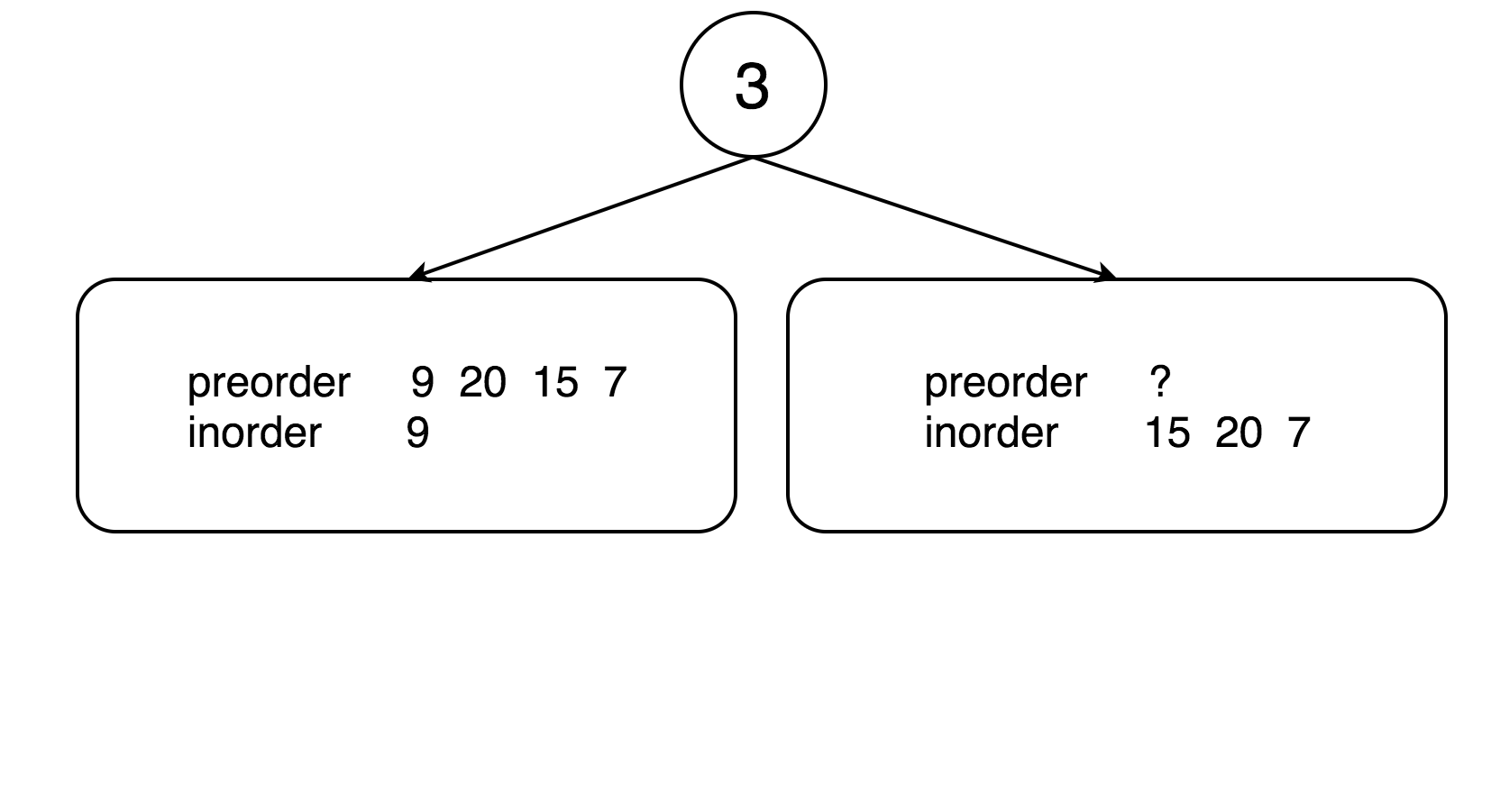

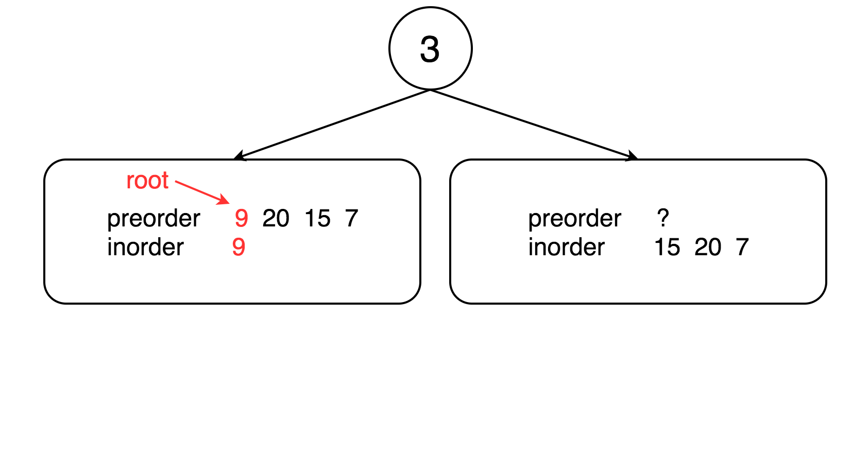

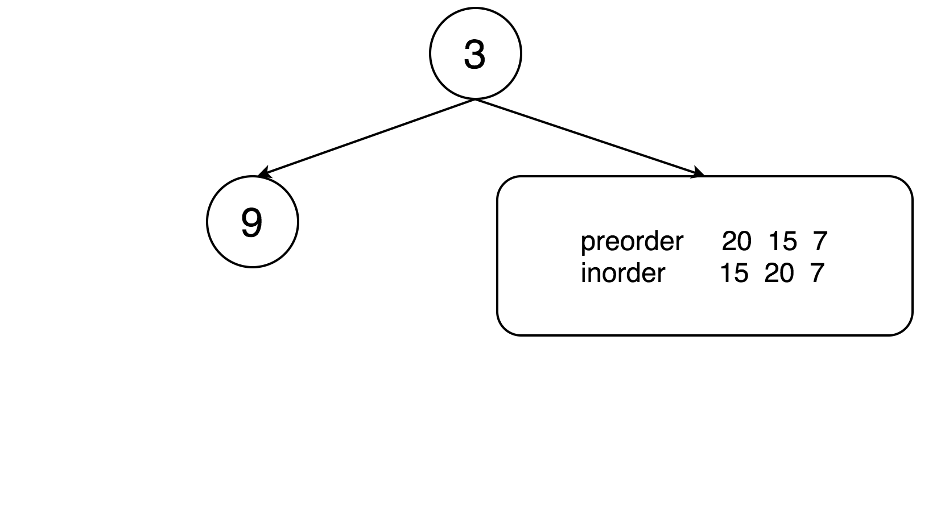

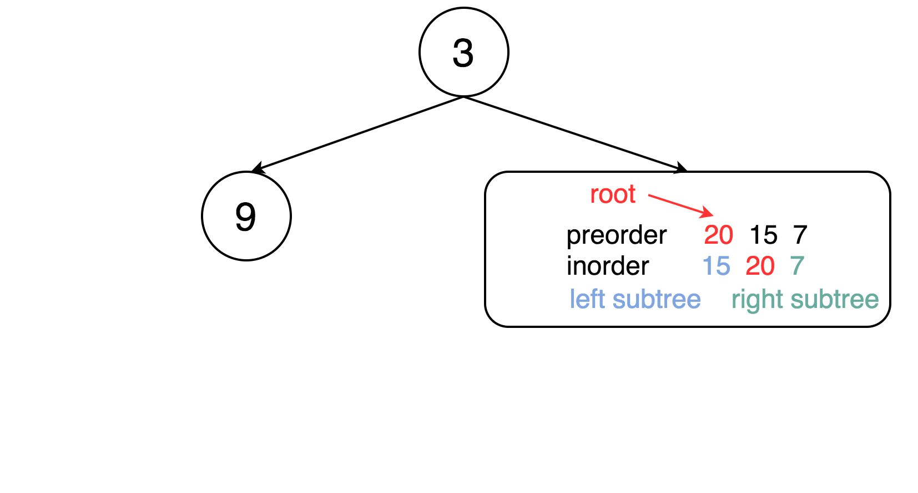

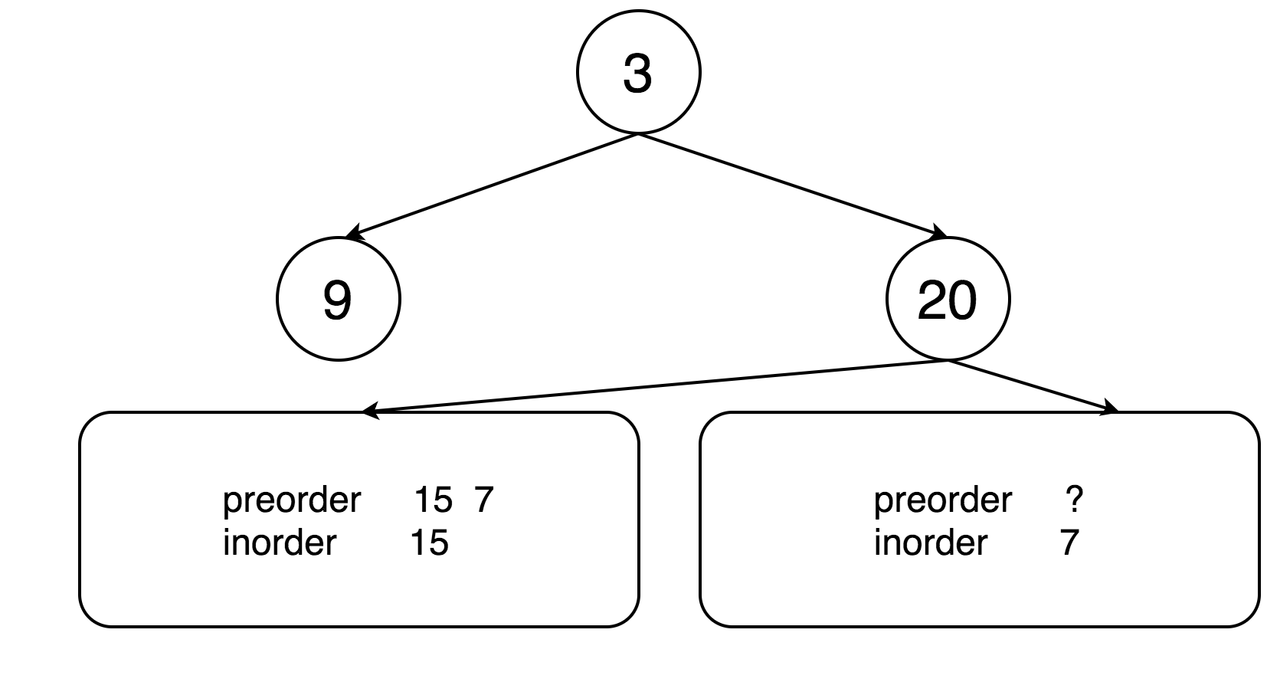

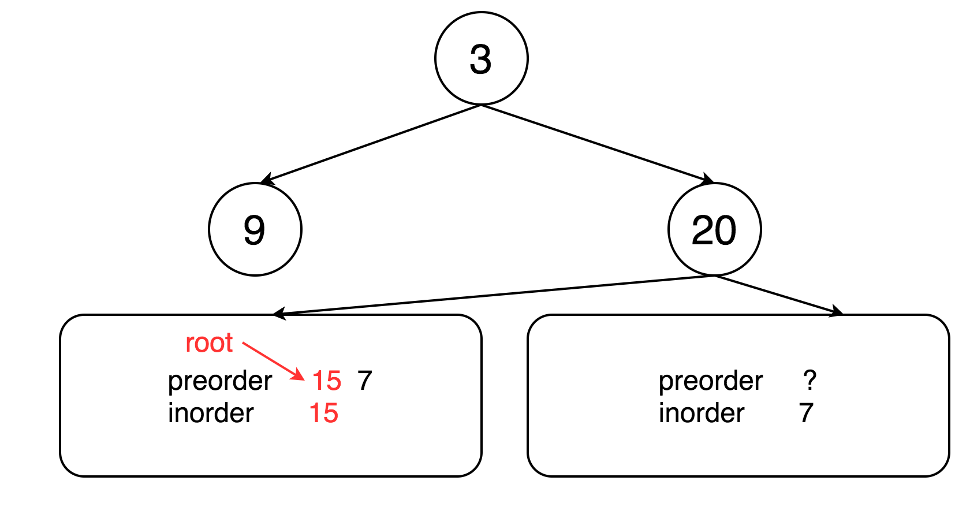

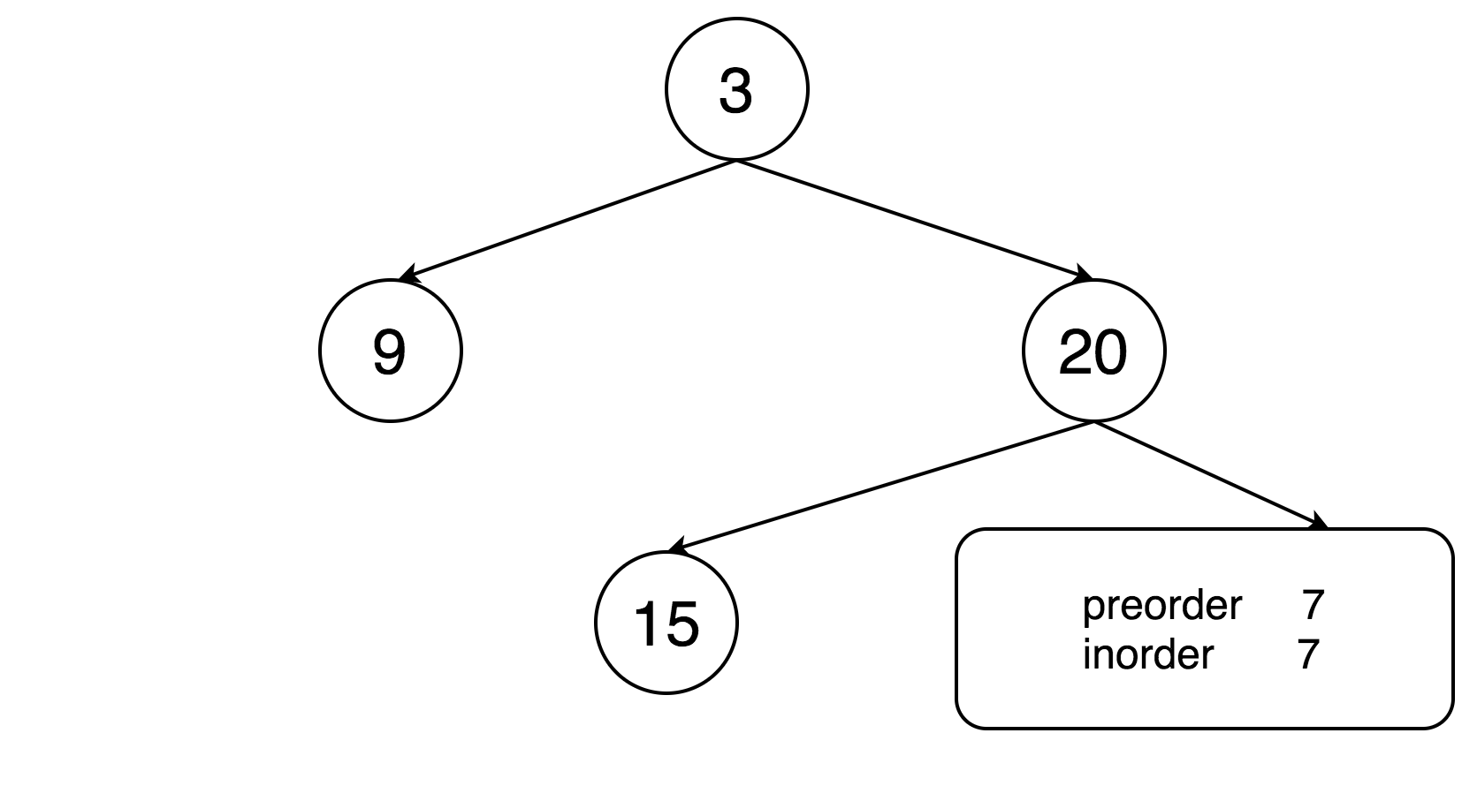

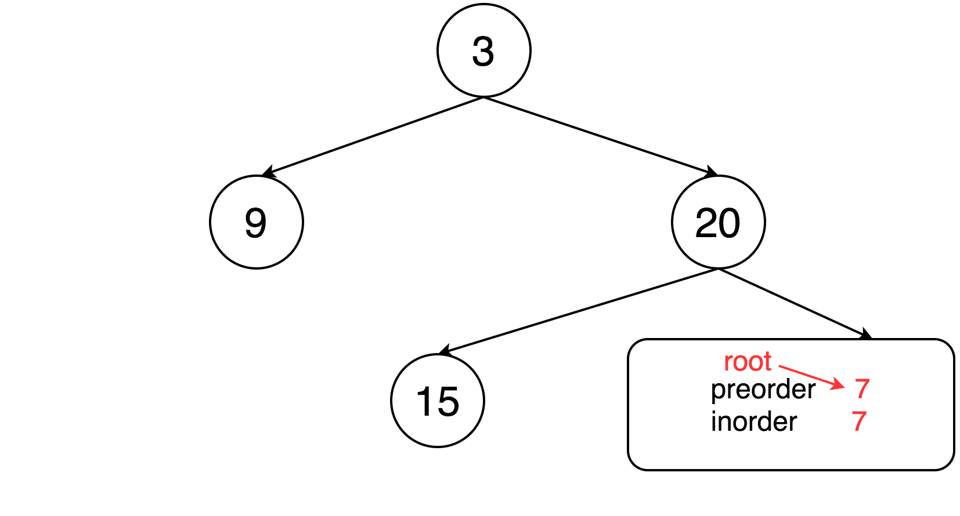

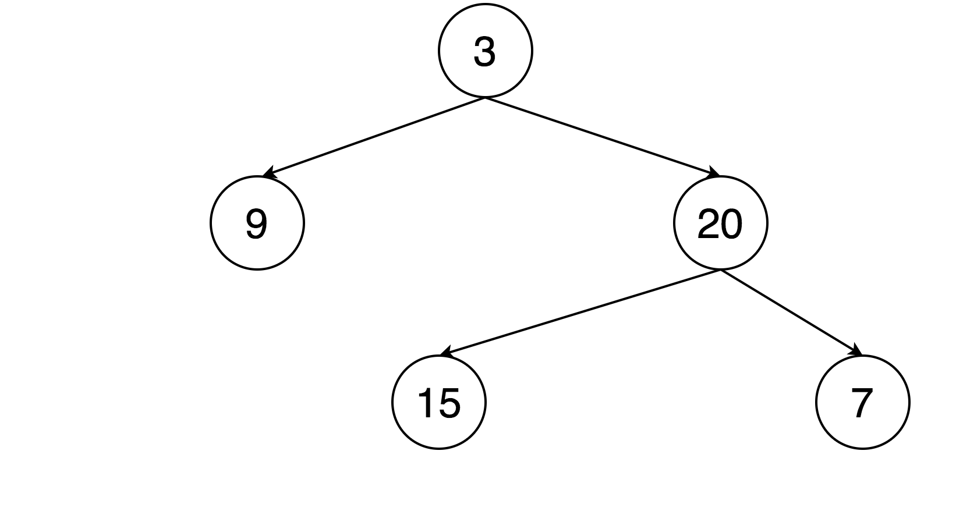

|  |
| --- |
| class Solution {  // start from first preorder element  int pre_idx = 0;  int[] preorder;  int[] inorder;  HashMap<Integer, Integer> idx_map = new HashMap<Integer, Integer>();  public TreeNode helper(int in_left, int in_right) {  // if there is no elements to construct subtrees  if (in_left == in_right)  return null;  // pick up pre_idx element as a root  int root_val = preorder[pre_idx];  TreeNode root = new TreeNode(root_val);  // root splits inorder list  // into left and right subtrees  int index = idx_map.get(root_val);  // recursion  pre_idx++;  // build left subtree  root.left = helper(in_left, index);  // build right subtree  root.right = helper(index + 1, in_right);  return root;  }  public TreeNode buildTree(int[] preorder, int[] inorder) {  this.preorder = preorder;  this.inorder = inorder;  // build a hashmap value -> its index  int idx = 0;  for (Integer val : inorder)  idx_map.put(val, idx++);  return helper(0, inorder.length);  }  } |

**Complexity analysis**

* Time complexity : O(*N*). Let's compute the solution with the help of [master theorem](https://en.wikipedia.org/wiki/Master_theorem_(analysis_of_algorithms)) 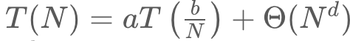 The equation represents dividing the problem up into a*a* subproblems of size 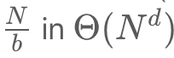 time. Here one divides the problem in two subproblemes a = 2, the size of each subproblem (to compute left and right subtree) is a half of initial problem b = 2, and all this happens in a constant time d = 0. That means that log*b*​(*a*)>*d* and hence we're dealing with [case 1](https://en.wikipedia.org/wiki/Master_theorem_(analysis_of_algorithms)#Case_1_example) that means  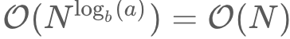time complexity.
* Space complexity : O(*N*), since we store the entire tree.

**Populating Next Right Pointers in Each Node**

You are given a **perfect binary tree** where all leaves are on the same level, and every parent has two children. The binary tree has the following definition:

struct Node {

int val;

Node *left;

Node *right;

Node *next;

}

Populate each next pointer to point to its next right node. If there is no next right node, the next pointer should be set to NULL.

Initially, all next pointers are set to NULL.

**Follow up:**

* You may only use constant extra space.
* Recursive approach is fine, you may assume implicit stack space does not count as extra space for this problem.

**Example 1:**

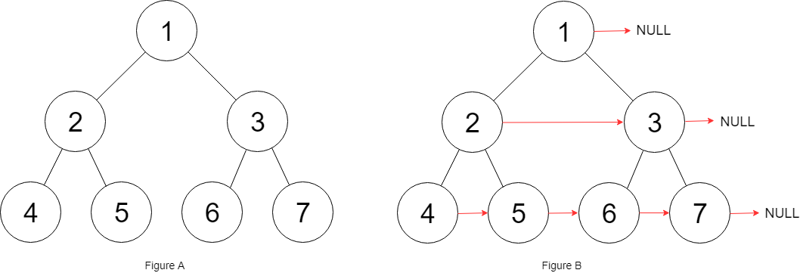

**Input:** root = [1,2,3,4,5,6,7]

**Output:** [1,#,2,3,#,4,5,6,7,#]

**Explanation:** Given the above perfect binary tree (Figure A), your function should populate each next pointer to point to its next right node, just like in Figure B. The serialized output is in level order as connected by the next pointers, with '#' signifying the end of each level.

**Constraints:**

* The number of nodes in the given tree is less than 4096.
* -1000 <= node.val <= 1000

## Solution

#### **Approach 1: Level Order Traversal**

**Intuition**

There are two basic kinds of traversals on a tree or a graph. One is where we explore the tree in a depth first manner i.e. one branch at a time. The other one is where we traverse the tree breadth-wise i.e. we explore one level of the tree before moving on to the next one. For trees, we have further classifications of the depth first traversal approach called preorder, inorder, and the postorder traversals. Breadth first approach to exploring a tree is based on the concept of the level of a node. The level of a node is its depth or distance from the root node. We process all the nodes on one level before moving on to the next one.

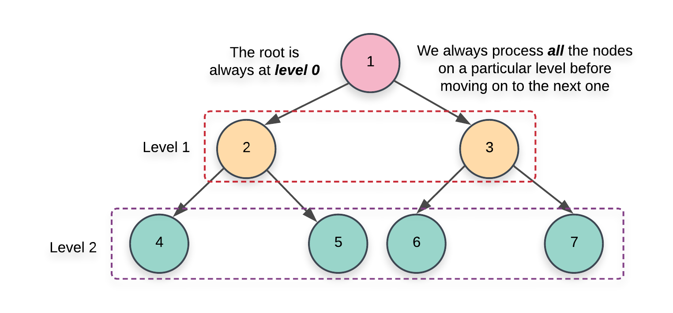

Now that we have the basics out of the way, it's pretty evident that the problem statement strongly hints at a breadth first kind of a solution. We need to link all the nodes together which lie on the same level and the level order or the breadth first traversal gives us access to all such nodes.

**Algorithm**

1. Initialize a queue, Q which we will be making use of during our traversal. There are multiple ways to implement the level order traversal especially when it comes to identifying the level of a particular node.
   1. We can add a pair of (node, level)(*node*,*level*) to the queue and whenever we add the children of a node, we add \text (node.left, \;\; parent\_level + 1)(*node*.*left*,*parent*_*level*+1) and (node.right,\;\; parent\_level + 1)(*node*.*right*,*parent*_*level*+1). This approach wouldn't be very efficient for our algorithm since we need all the nodes on the same level and we would need another data structure just for that.

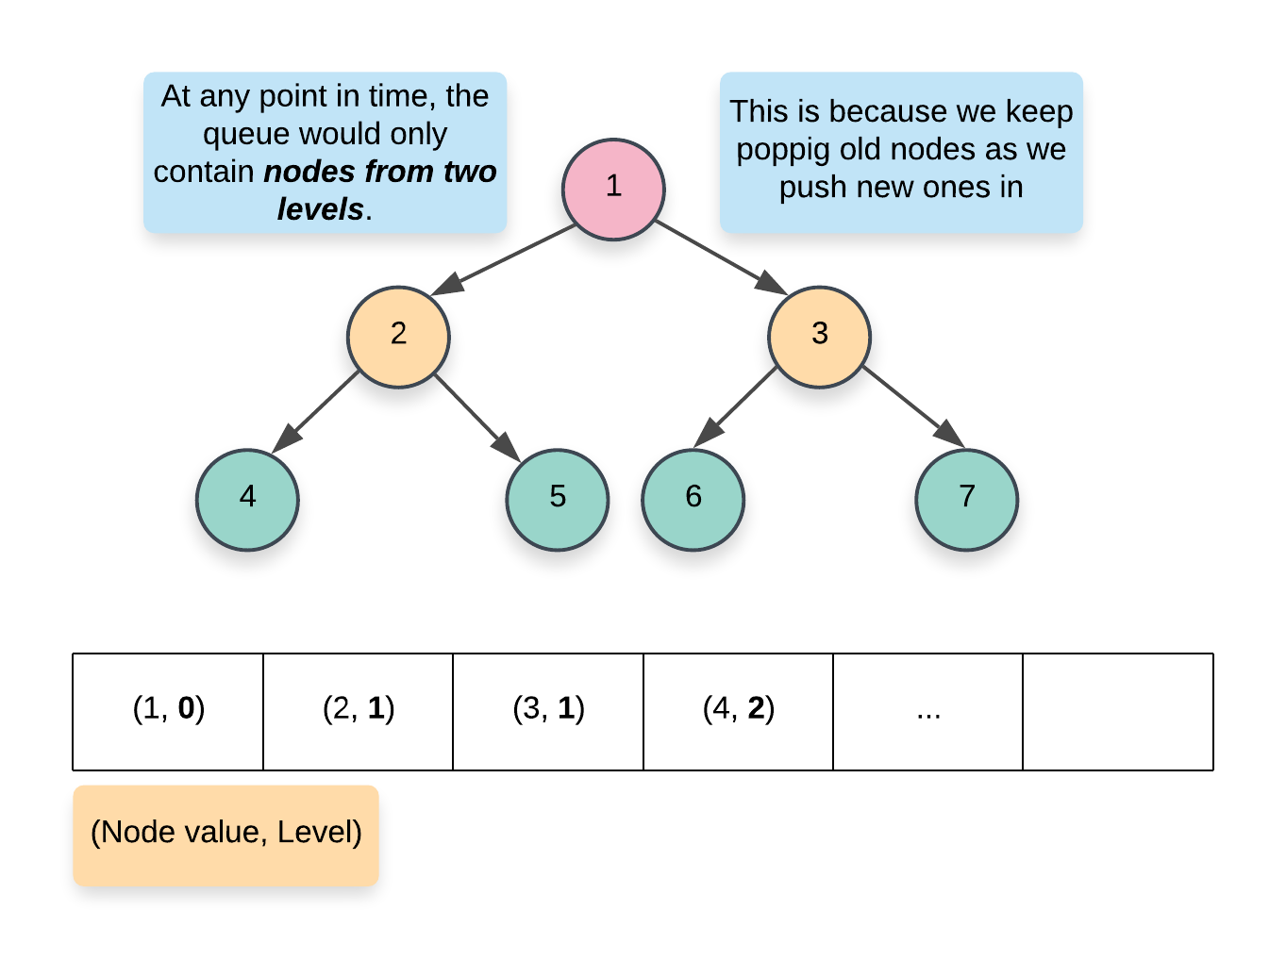

* 1. A more memory efficient way of segregating the same level nodes is to use some demarcation between the levels. Usually, we insert a NULL entry in the queue which marks the end of the previous level and the start of the next level. This is a great approach but again, it would still consume some memory proportional to the number of levels in the tree.

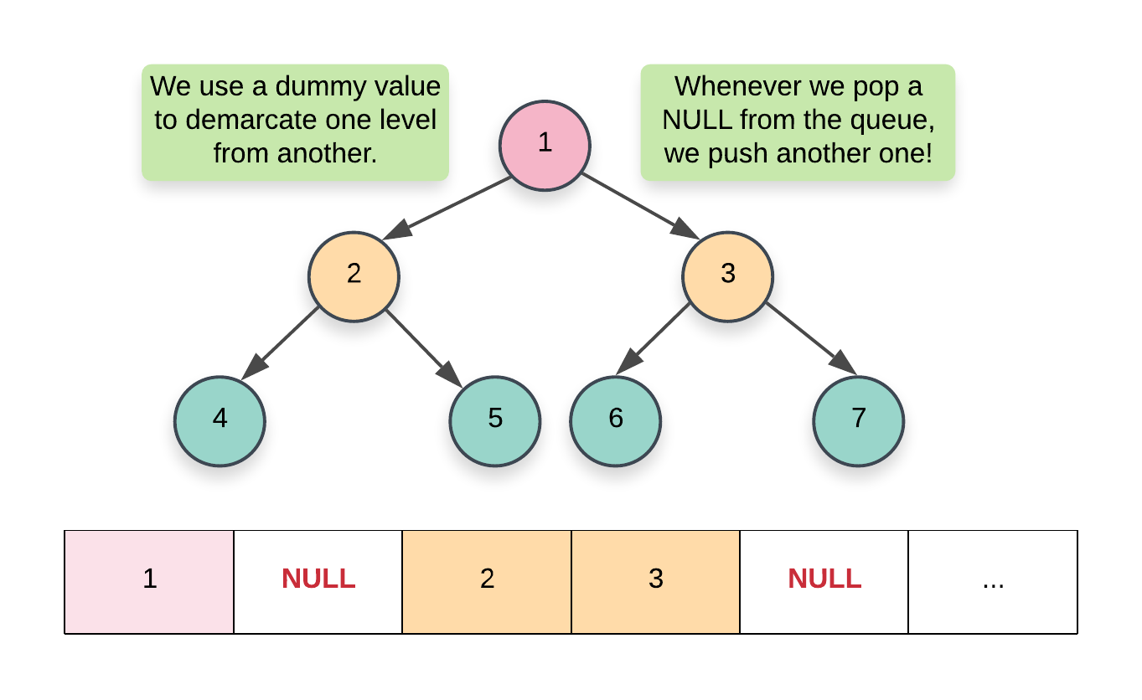

* 1. The approach we will be using here would have a nested loop structure to get around the requirement of a NULL pointer. Essentially, at each step, we record the size of the queue and that always corresponds to ***all*** the nodes on a particular level. Once we have this size, we only process these many elements and no more. By the time we are done processing size number of elements, the queue would contain ***all*** the nodes on the next level. Here's a pseudocode for the same:

|  |
| --- |
| while (!Q.empty())  {  size = Q.size()  for i in range 0..size  {  node = Q.pop()  Q.push(node.left)  Q.push(node.right)  }  } |

1. We start off by adding the root of the tree in the queue. Since there is just one node on the level 0, we don't need to establish any connections and can move onto the while loop.

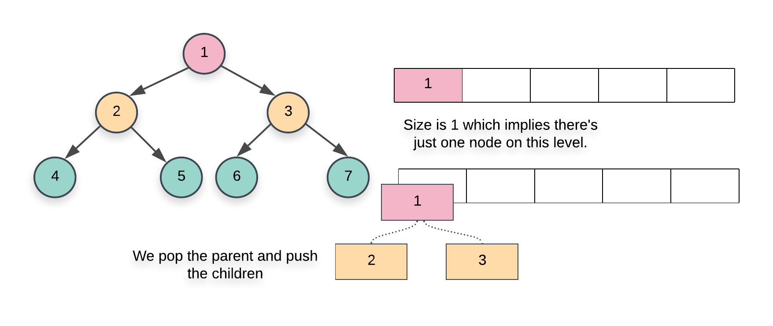

1. The first while loop from the pseudocode above essentially iterates over each level one by one and the inner for loop iterates over all the nodes on the particular level. Since we have access to all the nodes on the same level, we can establish the next pointers easily.
2. When we pop a node inside the for loop from the pseudocode above, we add its children at the back of the queue. Also, the element at the head of the queue is the next element in order, on the current level. So, we can easily establish the new pointers.

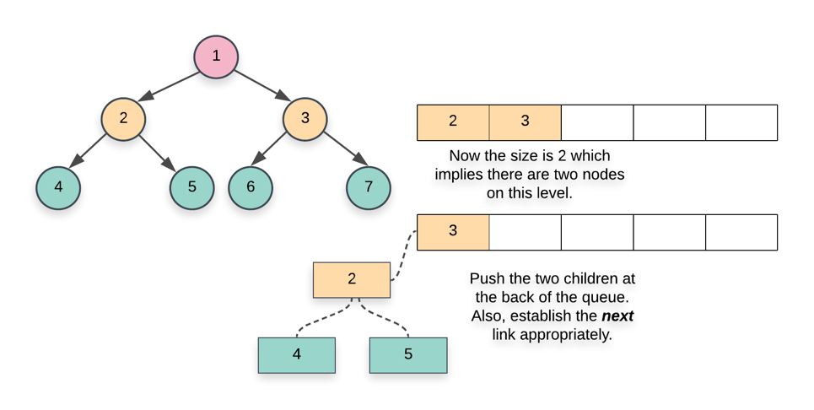

|  |
| --- |
| class Solution {  public Node connect(Node root) {    if (root == null) {  return root;  }    // Initialize a queue data structure which contains  // just the root of the tree  Queue<Node> Q = new LinkedList<Node>();  Q.add(root);    // Outer while loop which iterates over  // each level  while (Q.size() > 0) {    // Note the size of the queue  int size = Q.size();    // Iterate over all the nodes on the current level  for(int i = 0; i < size; i++) {    // Pop a node from the front of the queue  Node node = Q.poll();    // This check is important. We don't want to  // establish any wrong connections. The queue will  // contain nodes from 2 levels at most at any  // point in time. This check ensures we only  // don't establish next pointers beyond the end  // of a level  if (i < size - 1) {  node.next = Q.peek();  }    // Add the children, if any, to the back of  // the queue  if (node.left != null) {  Q.add(node.left);  }  if (node.right != null) {  Q.add(node.right);  }  }  }    // Since the tree has now been modified, return the root node  return root;  }  } |

**Complexity Analysis**

* Time Complexity: *O*(*N*) since we process each node exactly once. Note that processing a node in this context means popping the node from the queue and then establishing the next pointers.
* Space Complexity: *O*(*N*). This is a perfect binary tree which means the last level contains *N*/2 nodes. The space complexity for breadth first traversal is the space occupied by the queue which is dependent upon the maximum number of nodes in particular level. So, in this case, the space complexity would be *O*(*N*).

#### **Approach 2: Using previously established next pointers**

**Intuition**

Let's look at the two types of next pointer connections we need to establish for a given tree.

1. This first case is the one where we establish the next pointers between the two children of a given node. This is the easier of the two cases since both the children are accessible via the same node. We can simply do the following to establish this connection.

node.left.next = node.right

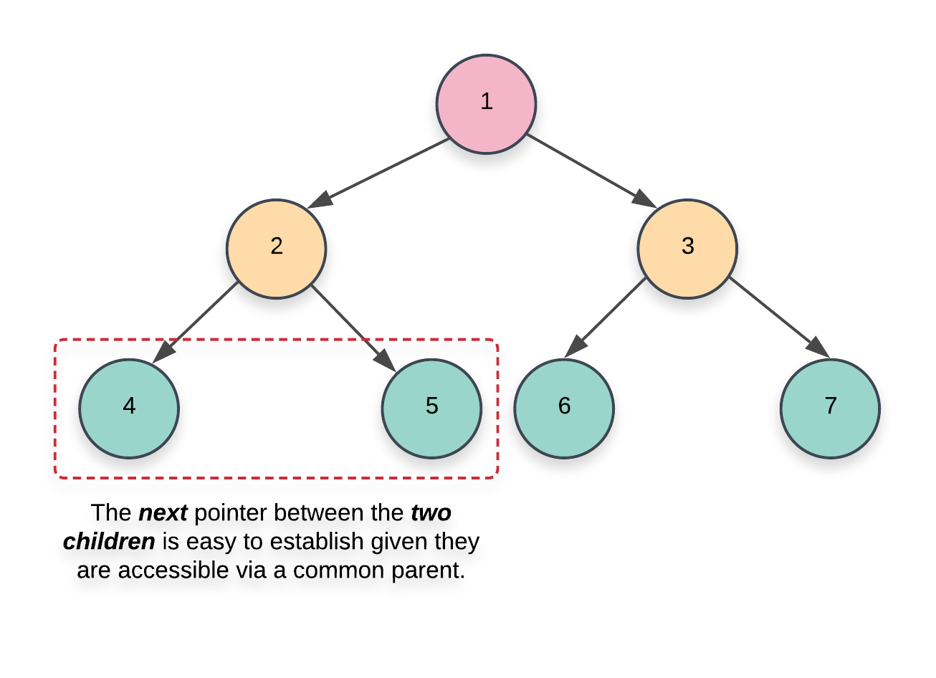

1. This next case is not too straightforward to handle. In addition to establishing the next pointers between the nodes having a common parent, we also need to set-up the correct pointers between nodes which have a different parent.

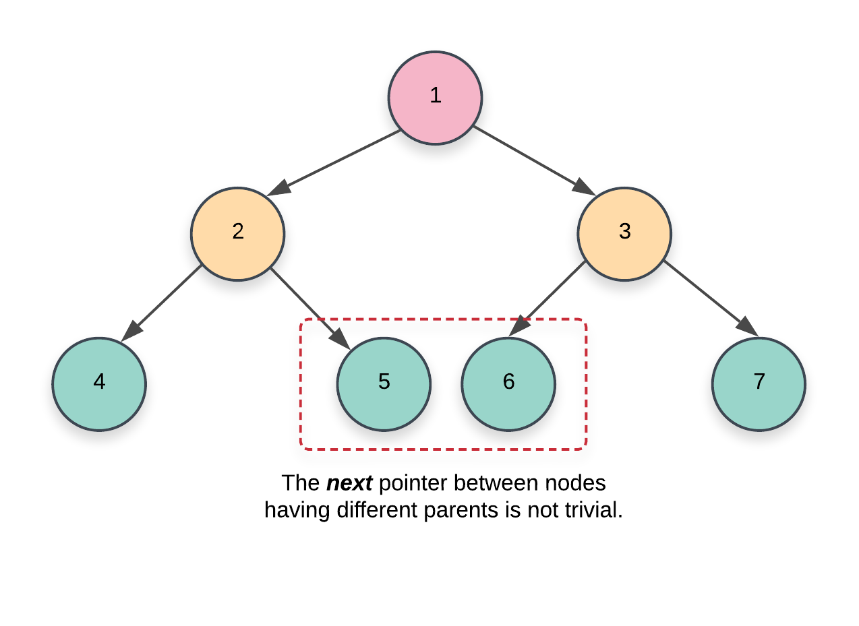

If we simply had the parent pointers available with each node, this problem would have been trivial to solve. However, we don't have any such pointers available. The basic idea for this approach is based on the fact that:

We only move on to the level N+1 when we are done establishing the next pointers for the level N. Since we have access to all the nodes on a particular level via the next pointers, we can use these next pointers to establish the connections for the next level or the level containing their children.

**Algorithm**

1. We start at the root node. Since there are no more nodes to process on the first level or level 0, we can establish the next pointers on the next level i.e. level 1. An important thing to remember in this algorithm is that we establish the next pointers for a level *N* while we are still on level *N*−1 and once we are done establishing these new connections, we move on to *N* and do the same thing for *N*+1.
2. As we just said, when we go over the nodes of a particular level, their next pointers are already established. This is what helps get rid of the queue data structure from the previous approach and helps save space. To start on a particular level, we just need the leftmost node. From there on out, its just a linked list traversal.
3. Based on these ideas, our algorithm will have the following pseudocode:

|  |
| --- |
| leftmost = root  while (leftmost.left != null)  {  head = leftmost  while (head.next != null)  {  1) Establish Connection 1  2) Establish Connection 2 using next pointers  head = head.next  }  leftmost = leftmost.left  } |

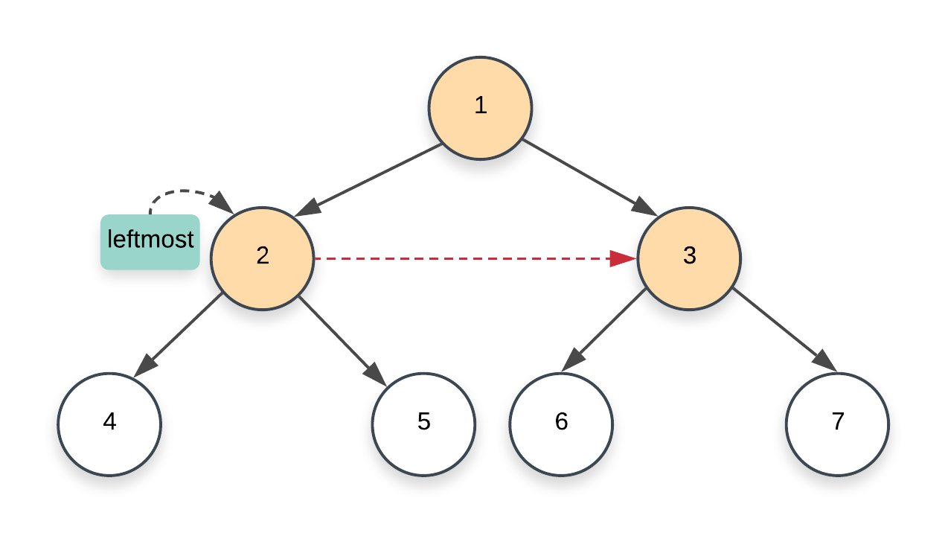

1. The Connection 1 and Connection 2 mentioned above correspond to the two kinds of connections we looked at earlier on in the intuition section of this approach.
   1. The first one is fairly simple to establish given that it's between the two nodes having a common parent. So, we could simply do something like this to link the two children:

node.left.next = node.right

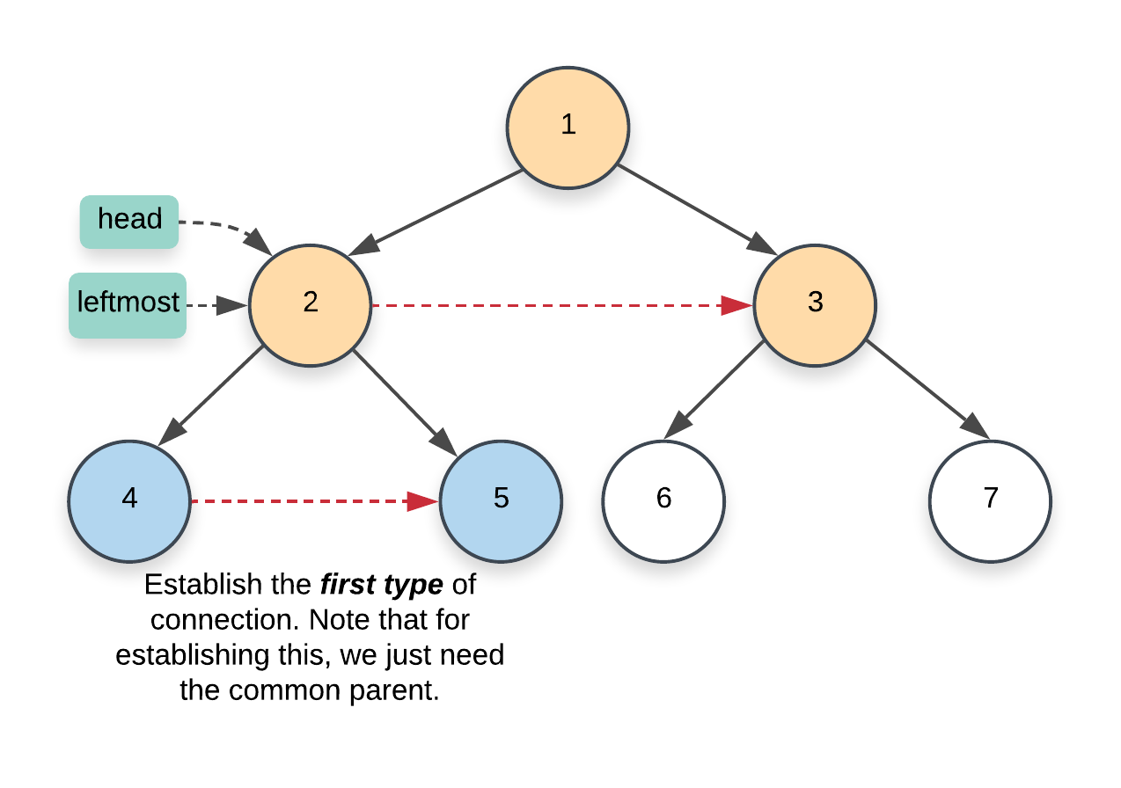

* 1. For the second type of connection, we have to make use of the next pointers on the current level. Remember that this second type of connection is between nodes that have different parents. More specifically, it's the link between the right child of a node and the left child of the next node. Since we already have the next pointers set up on the current level, we use this to set up the correct pointers on the next level.

node.right.next = node.next.left

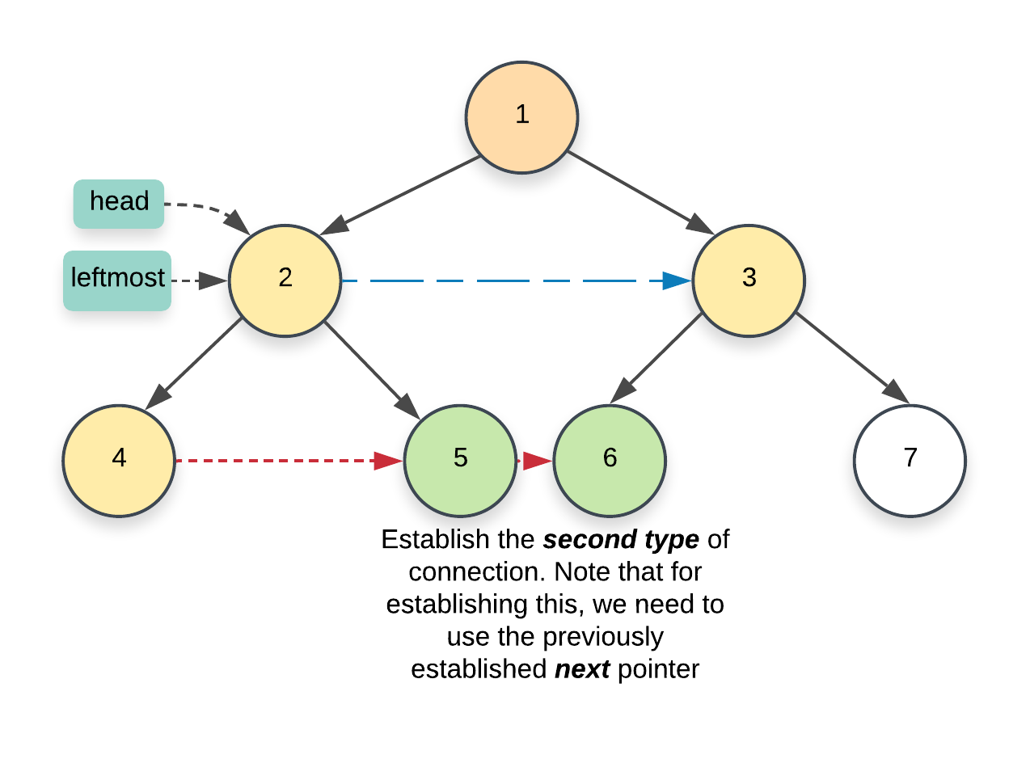

1. Once we are done with the current level, we move on to the next one. One last thing that's left here is to update the leftmost node. We need that node to start traversal on a particular level. Think of it as the head of the linked list. Since this is a perfect binary tree, the leftmost node will always be the left child of the current leftmost node. The only nodes which don't have any children are the ones on the final level and these would be the leaves of the tree.

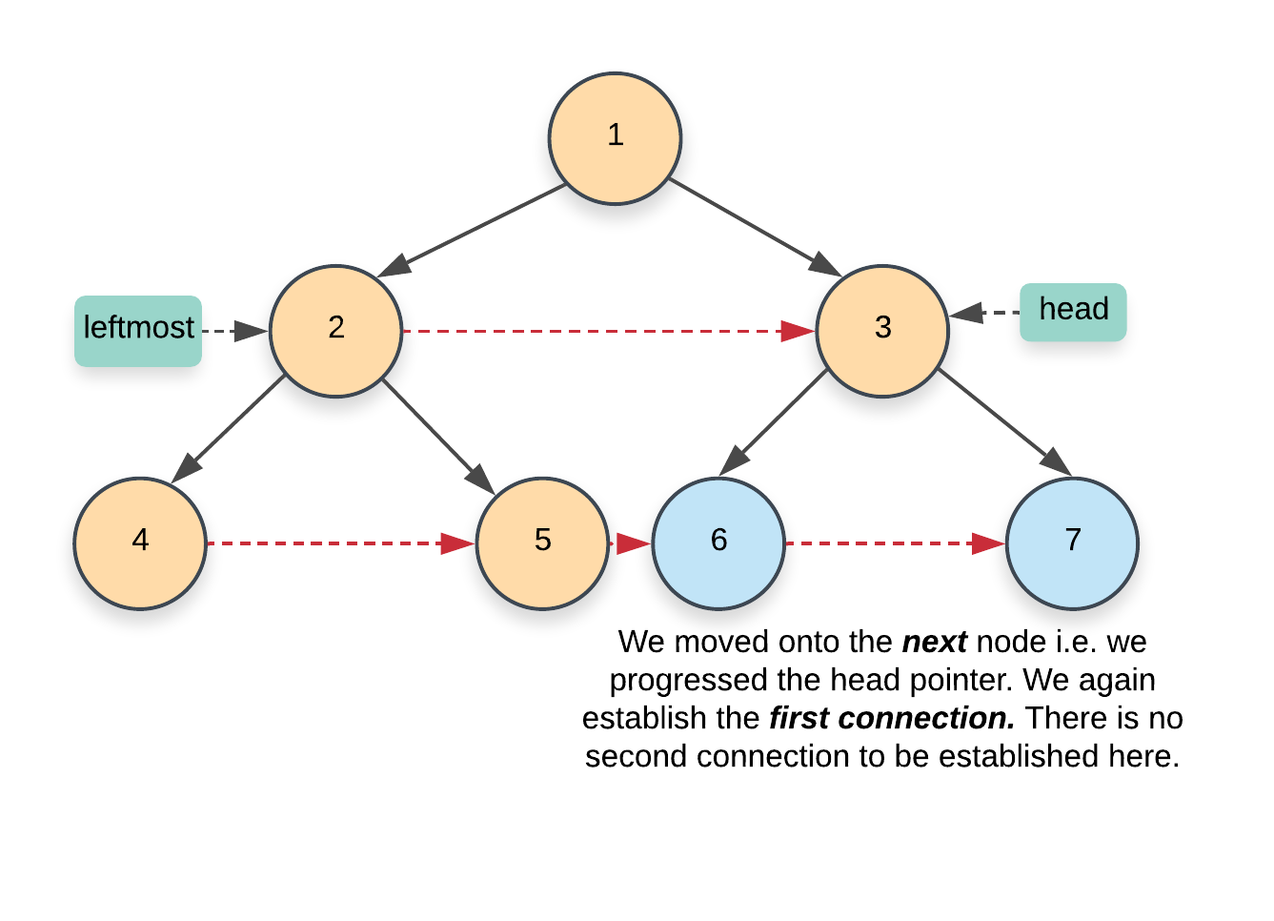

|  |
| --- |
| class Solution {  public Node connect(Node root) {    if (root == null) {  return root;  }    // Start with the root node. There are no next pointers  // that need to be set up on the first level  Node leftmost = root;    // Once we reach the final level, we are done  while (leftmost.left != null) {    // Iterate the "linked list" starting from the head  // node and using the next pointers, establish the  // corresponding links for the next level  Node head = leftmost;    while (head != null) {    // CONNECTION 1  head.left.next = head.right;    // CONNECTION 2  if (head.next != null) {  head.right.next = head.next.left;  }    // Progress along the list (nodes on the current level)  head = head.next;  }    // Move onto the next level  leftmost = leftmost.left;  }    return root;  }  } |

**Complexity Analysis**

* Time Complexity: *O*(*N*) since we process each node exactly once.
* Space Complexity: *O*(1) since we don't make use of any additional data structure for traversing nodes on a particular level like the previous approach does.

**Kth Smallest Element in a BST**

Given the root of a binary search tree, and an integer k, return *the* kth (**1-indexed**) *smallest element in the tree*.

**Example 1:**

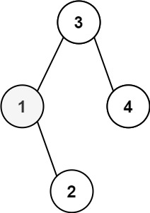

**Input:** root = [3,1,4,null,2], k = 1

**Output:** 1

**Example 2:**

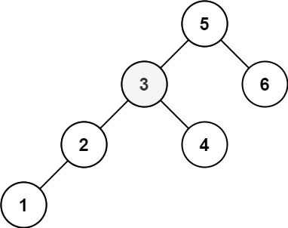

**Input:** root = [5,3,6,2,4,null,null,1], k = 3

**Output:** 3

**Constraints:**

* The number of nodes in the tree is n.
* 1 <= k <= n <= 104
* 0 <= Node.val <= 104

**Follow up:** If the BST is modified often (i.e., we can do insert and delete operations) and you need to find the kth smallest frequently, how would you optimize?

   Hide Hint #1

Try to utilize the property of a BST.

   Hide Hint #2

Try in-order traversal. (Credits to @chan13)

   Hide Hint #3

What if you could modify the BST node's structure?

   Hide Hint #4

The optimal runtime complexity is O(height of BST).

## Solution

#### **How to traverse the tree**

There are two general strategies to traverse a tree:

* Depth First Search (DFS)

In this strategy, we adopt the depth as the priority, so that one would start from a root and reach all the way down to certain leaf, and then back to root to reach another branch.

The DFS strategy can further be distinguished as preorder, inorder, and postorder depending on the relative order among the root node, left node and right node.

* Breadth First Search (BFS)

We scan through the tree level by level, following the order of height, from top to bottom. The nodes on higher level would be visited before the ones with lower levels.

On the following figure the nodes are numerated in the order you visit them, please follow 1-2-3-4-5 to compare different strategies.

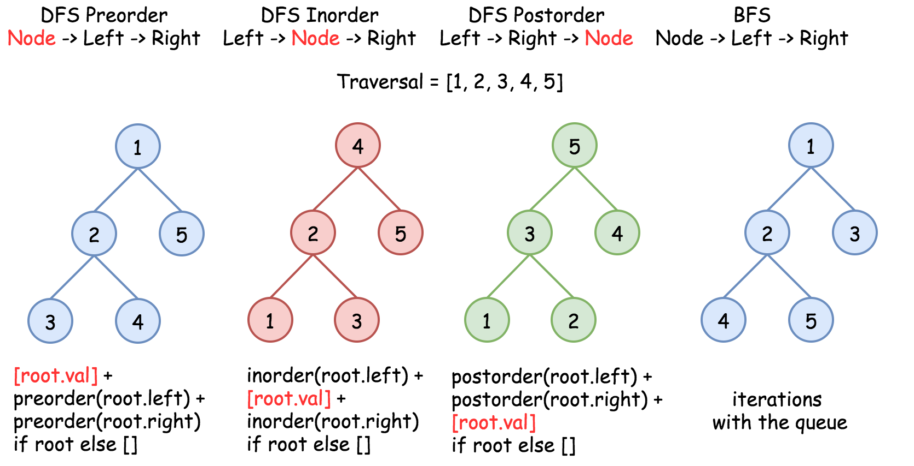

To solve the problem, one could use the property of BST : inorder traversal of BST is an array sorted in the ascending order.

#### **Approach 1: Recursive Inorder Traversal**

It's a very straightforward approach with \mathcal{O}(N)O(*N*) time complexity. The idea is to build an inorder traversal of BST which is an array sorted in the ascending order. Now the answer is the k - 1th element of this array.

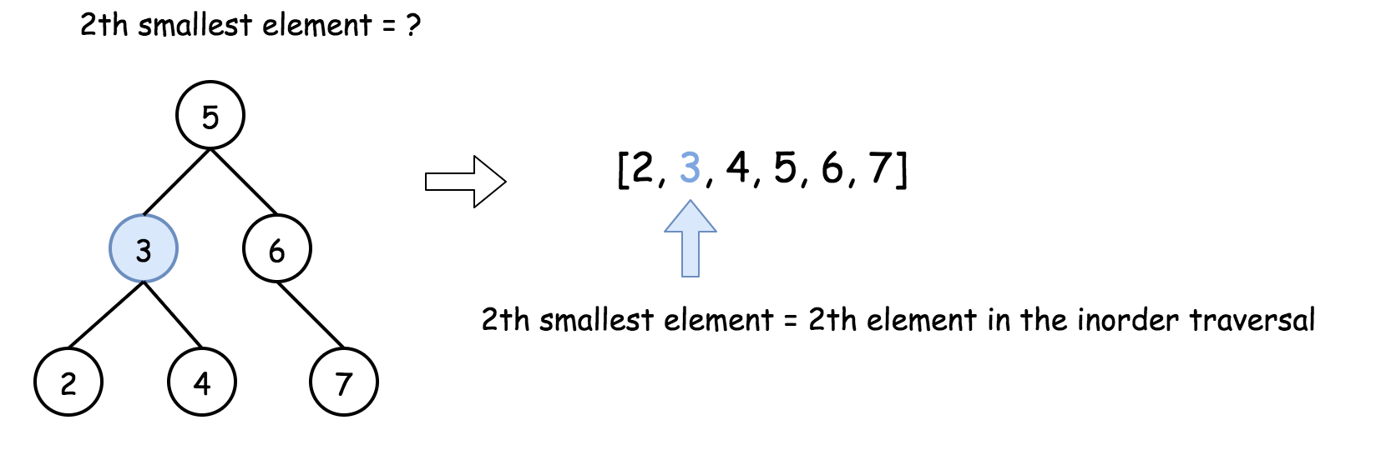

|  |
| --- |
| class Solution {  public ArrayList<Integer> inorder(TreeNode root, ArrayList<Integer> arr) {  if (root == null) return arr;  inorder(root.left, arr);  arr.add(root.val);  inorder(root.right, arr);  return arr;  }  public int kthSmallest(TreeNode root, int k) {  ArrayList<Integer> nums = inorder(root, new ArrayList<Integer>());  return nums.get(k - 1);  }  } |

**Complexity Analysis**

* Time complexity : O(*N*) to build a traversal.
* Space complexity : O(*N*) to keep an inorder traversal.

#### **Approach 2: Iterative Inorder Traversal**

The above recursion could be converted into iteration, with the help of stack. This way one could speed up the solution because there is no need to build the entire inorder traversal, and one could stop after the kth element.

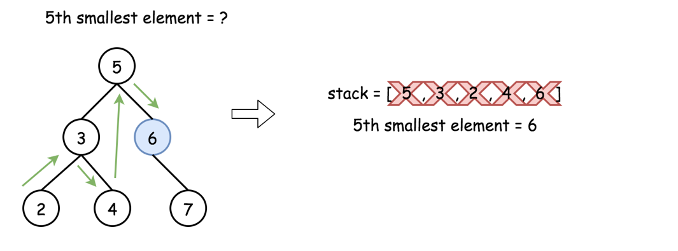

|  |
| --- |
| class Solution {  public int kthSmallest(TreeNode root, int k) {  LinkedList<TreeNode> stack = new LinkedList<TreeNode>();  while (true) {  while (root != null) {  stack.add(root);  root = root.left;  }  root = stack.removeLast();  if (--k == 0) return root.val;  root = root.right;  }  }  } |

**Complexity Analysis**

* Time complexity: O(*H*+*k*), where *H* is a tree height. This complexity is defined by the stack, which contains at least *H*+*k* elements, since before starting to pop out one has to go down to a leaf. This results in O(log*N*+*k*) for the balanced tree and O(*N*+*k*) for completely unbalanced tree with all the nodes in the left subtree.
* Space complexity: O(*H*) to keep the stack, where *H* is a tree height. That makes O(*N*) in the worst case of the skewed tree, and O(log*N*) in the average case of the balanced tree.

#### **Follow up**

What if the BST is modified (insert/delete operations) often and you need to find the kth smallest frequently? How would you optimize the kthSmallest routine?

[Insert](https://leetcode.com/articles/insert-into-a-bst/) and [delete](https://leetcode.com/articles/delete-node-in-a-bst/) in a BST were discussed last week, the time complexity of these operations is O(*H*), where H*H* is a height of binary tree, and *H*=log*N* for the balanced tree.

Hence without any optimisation insert/delete + search of kth element has O(2*H*+*k*) complexity. How to optimise that?

That's a design question, basically we're asked to implement a structure which contains a BST inside and optimises the following operations :

* Insert
* Delete
* Find kth smallest

Seems like a database description, isn't it? Let's use here the same logic as for [LRU cache](https://leetcode.com/articles/lru-cache/) design, and combine an indexing structure (we could keep BST here) with a double linked list.

Such a structure would provide:

* O(*H*) time for the insert and delete.
* O(*k*) for the search of kth smallest.

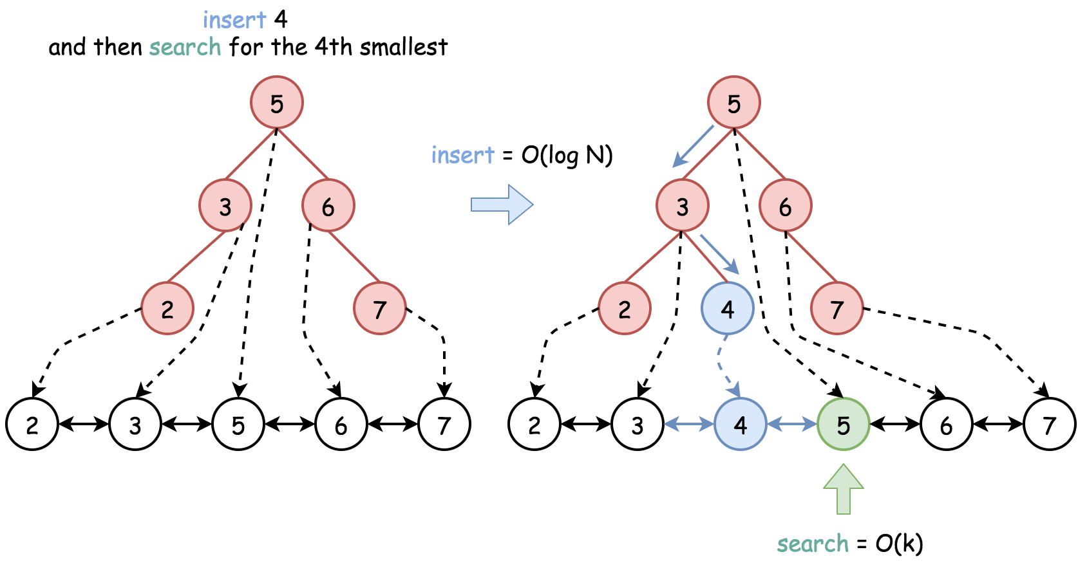

The overall time complexity for insert/delete + search of kth smallest is O(*H*+*k*) instead of O(2*H*+*k*).

**Complexity Analysis**

* Time complexity for insert/delete + search of kth smallest: O(*H*+*k*), where *H* is a tree height. O(log*N*+*k*) in the average case, O(*N*+*k*) in the worst case.
* Space complexity : O(*N*) to keep the linked list.

**Inorder Successor in BST**

Given a binary search tree and a node in it, find the in-order successor of that node in the BST.

The successor of a node p is the node with the smallest key greater than p.val.

**Example 1:**

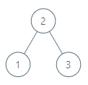

**Input:** root = [2,1,3], p = 1

**Output:** 2

**Explanation:** 1's in-order successor node is 2. Note that both p and the return value is of TreeNode type.

**Example 2:**

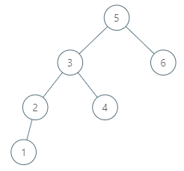

**Input:** root = [5,3,6,2,4,null,null,1], p = 6

**Output:** null

**Explanation:** There is no in-order successor of the current node, so the answer is null.

**Note:**

1. If the given node has no in-order successor in the tree, return null.
2. It's guaranteed that the values of the tree are unique.

## Solution

#### **Approach 1: Iterative Inorder Traversal**

[Inorder traversal of BST is an array sorted in the ascending order](https://leetcode.com/articles/delete-node-in-a-bst/).

Successor is the smallest node in the inorder traversal after the current one.

There could be two situations :

1. If the node has a right child, the successor is somewhere lower in the tree, see red nodes on the Fig. below.
2. Otherwise, the successor is somewhere upper in the tree, see blue nodes on the Fig.

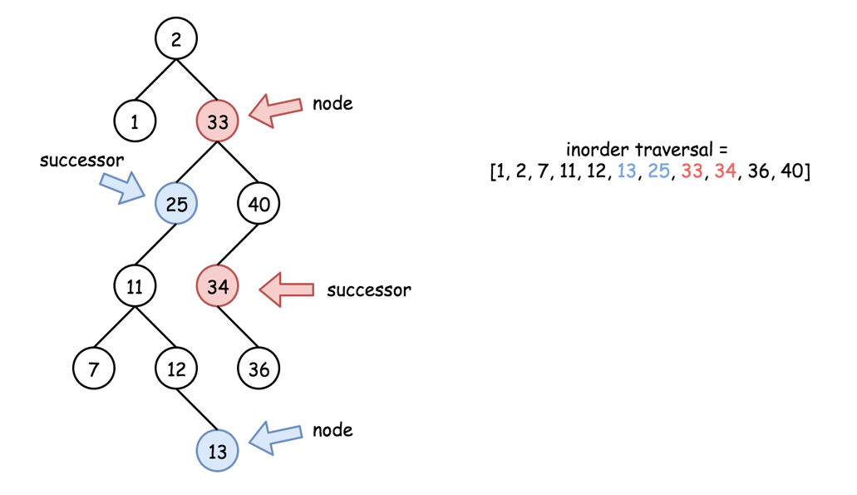

Let's first check the simple case 1. To find a successor, go one step right and then left till you can.

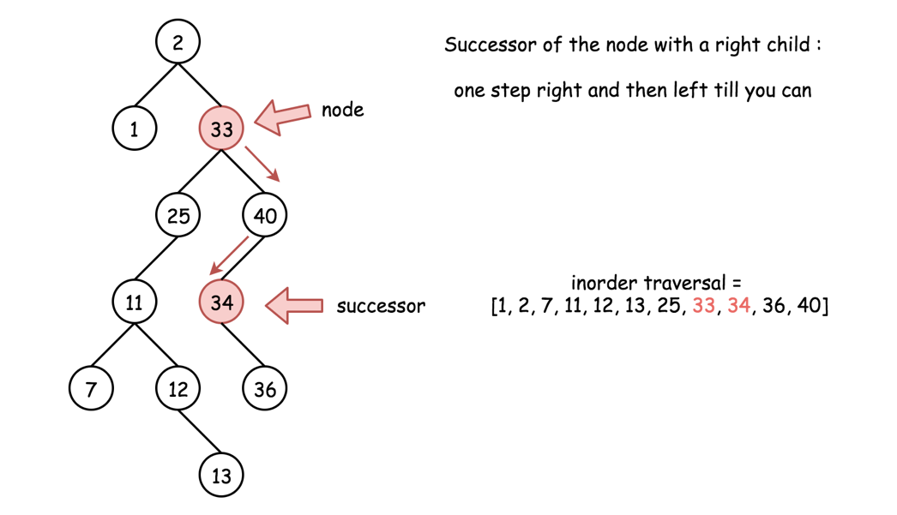

This approach has \mathcal{O}(H_p)O(*Hp*​) time complexity, where H_p*Hp*​ is a height of the node p*p*.

Now let's consider the case 2. There is no access to the parent nodes here, and hence one has to traverse the tree starting from the root and not from the node.

[Inorder traversal could be implemented in three different ways: recursive, iterative and Morris](https://leetcode.com/articles/recover-binary-search-tree/). Here it's better to choose the iterative traversal in order to optimise the performance and minimize the space at the same time.

Iterative inorder traversal is simple: go left till you can, and then one step right. Repeat till the end of nodes in the tree.

The idea is to keep just one previous node during the inorder traversal. If that previous node is equal to p, then the current node is a successor of p.

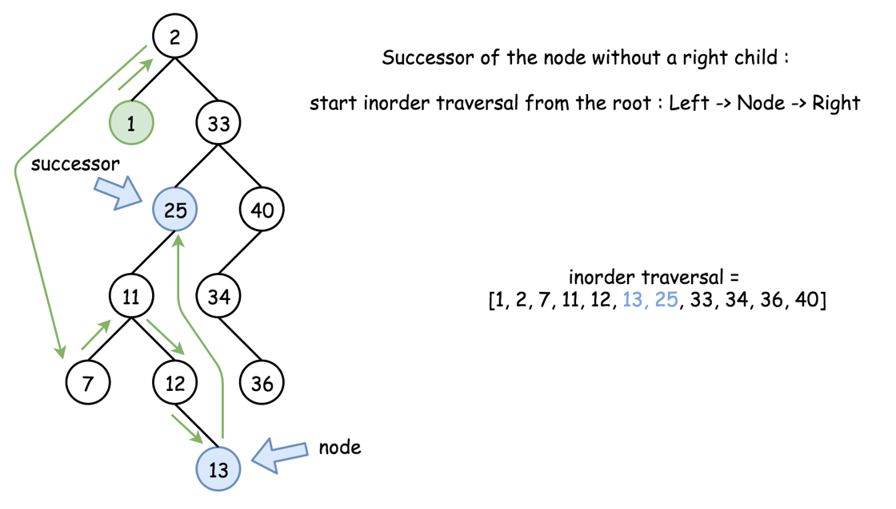

This approach has O(*H*) time complexity, where *H* is a tree height. Basically, this approach is universal and could be used for the case 1 as well. We simply don't do that because the approach 1 is faster.

**Algorithm**

* If the node has a right child, go one step right and then left till you can. Return the successor.
* Otherwise, implement iterative inorder traversal. While there are still nodes in the tree or in the stack:
  + Go left till you can, adding nodes in stack.
  + Pop out the last node. If its predecessor is equal to p, return that last node. Otherwise, save that node to be the predecessor in the next turn of the loop.
  + Go one step right.
* If we're here that means the successor doesn't exit. Return null.

**Implementation**

|  |
| --- |
| class Solution {  public TreeNode inorderSuccessor(TreeNode root, TreeNode p) {  // the successor is somewhere lower in the right subtree  // successor: one step right and then left till you can  if (p.right != null) {  p = p.right;  while (p.left != null) p = p.left;  return p;  }  // the successor is somewhere upper in the tree  ArrayDeque<TreeNode> stack = new ArrayDeque<>();  int inorder = Integer.MIN_VALUE;  // inorder traversal : left -> node -> right  while (!stack.isEmpty() || root != null) {  // 1. go left till you can  while (root != null) {  stack.push(root);  root = root.left;  }  // 2. all logic around the node  root = stack.pop();  // if the previous node was equal to p  // then the current node is its successor  if (inorder == p.val) return root;  inorder = root.val;  // 3. go one step right  root = root.right;  }  // there is no successor  return null;  }  } |

**Complexity Analysis**

* Time complexity : O(*Hp*​) in the best case, when node p has a right child. Here *Hp*​ is a height of node p. O(*H*) in the worst case of no right child. Here *H* is a tree height.
* Space complexity : O(1) in the best case, when node p has a right child. Otherwise, up to O(*H*) to keep the stack.

**Number of Islands**

Given an m x n 2d grid map of '1's (land) and '0's (water), return *the number of islands*.

An **island** is surrounded by water and is formed by connecting adjacent lands horizontally or vertically. You may assume all four edges of the grid are all surrounded by water.

**Example 1:**

**Input:** grid = [

["1","1","1","1","0"],

["1","1","0","1","0"],

["1","1","0","0","0"],

["0","0","0","0","0"]

]

**Output:** 1

**Example 2:**

**Input:** grid = [

["1","1","0","0","0"],

["1","1","0","0","0"],

["0","0","1","0","0"],

["0","0","0","1","1"]

]

**Output:** 3

**Constraints:**

* m == grid.length
* n == grid[i].length
* 1 <= m, n <= 300
* grid[i][j] is '0' or '1'.

**Backtracking**

Here are some of the best backtracking interview questions.

Letter Combinations of a Phone Number and Generate Parentheses are both great interview questions. Also make sure you are able to write code to generate permutations / subsets (combinations), those are great backtracking exercises too.

 Letter Combinations of a Phone Number

 Generate Parentheses

 Permutations

 Subsets

 Word Search

**Letter Combinations of a Phone Number**

Given a string containing digits from 2-9 inclusive, return all possible letter combinations that the number could represent. Return the answer in **any order**.

A mapping of digit to letters (just like on the telephone buttons) is given below. Note that 1 does not map to any letters.

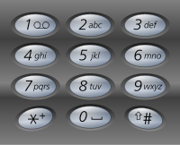

**Example 1:**

**Input:** digits = "23"

**Output:** ["ad","ae","af","bd","be","bf","cd","ce","cf"]

**Example 2:**

**Input:** digits = ""

**Output:** []

**Example 3:**

**Input:** digits = "2"

**Output:** ["a","b","c"]

**Constraints:**

* 0 <= digits.length <= 4
* digits[i] is a digit in the range ['2', '9'].

## Solution

#### **Approach 1: Backtracking**

[Backtracking](https://en.wikipedia.org/wiki/Backtracking) is an algorithm for finding all solutions by exploring all potential candidates. If the solution candidate turns to be not a solution (or at least not the last one), backtracking algorithm discards it by making some changes on the previous step, i.e. backtracks and then try again.

Here is a backtrack function backtrack(combination, next_digits) which takes as arguments an ongoing letter combination and the next digits to check.

* If there is no more digits to check that means that the current combination is done.
* If there are still digits to check :
  + Iterate over the letters mapping the next available digit.
    - Append the current letter to the current combination combination = combination + letter.
    - Proceed to check next digits : backtrack(combination + letter, next_digits[1:]).

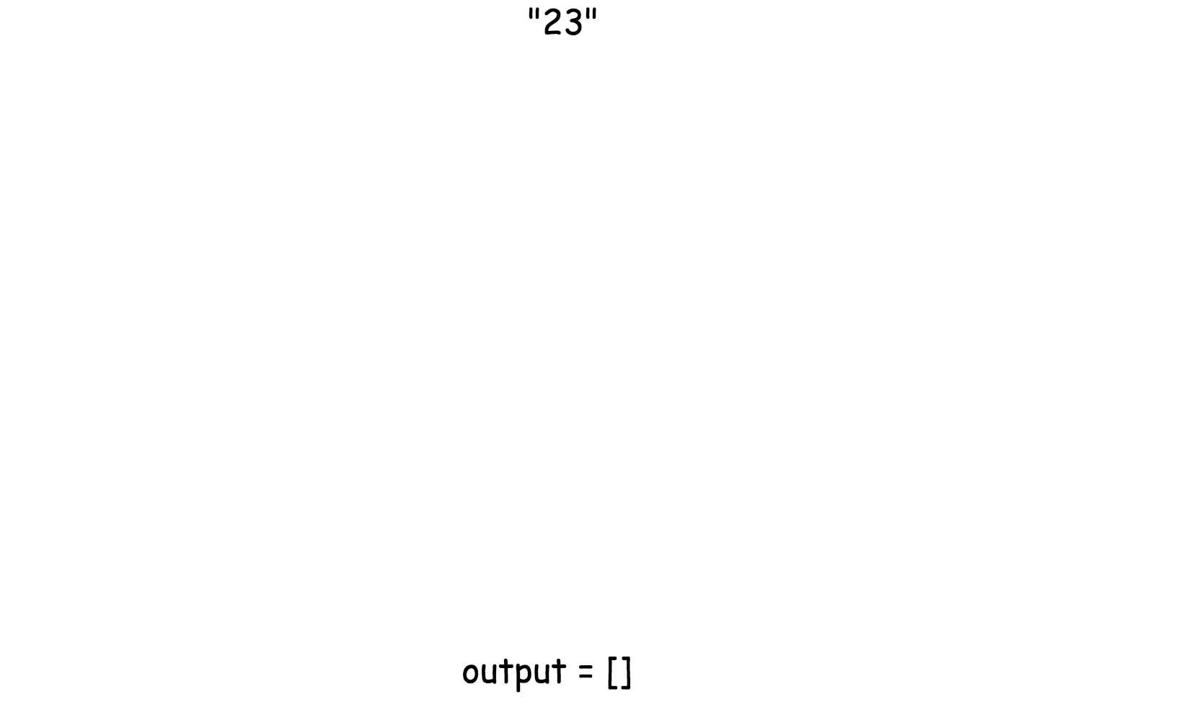

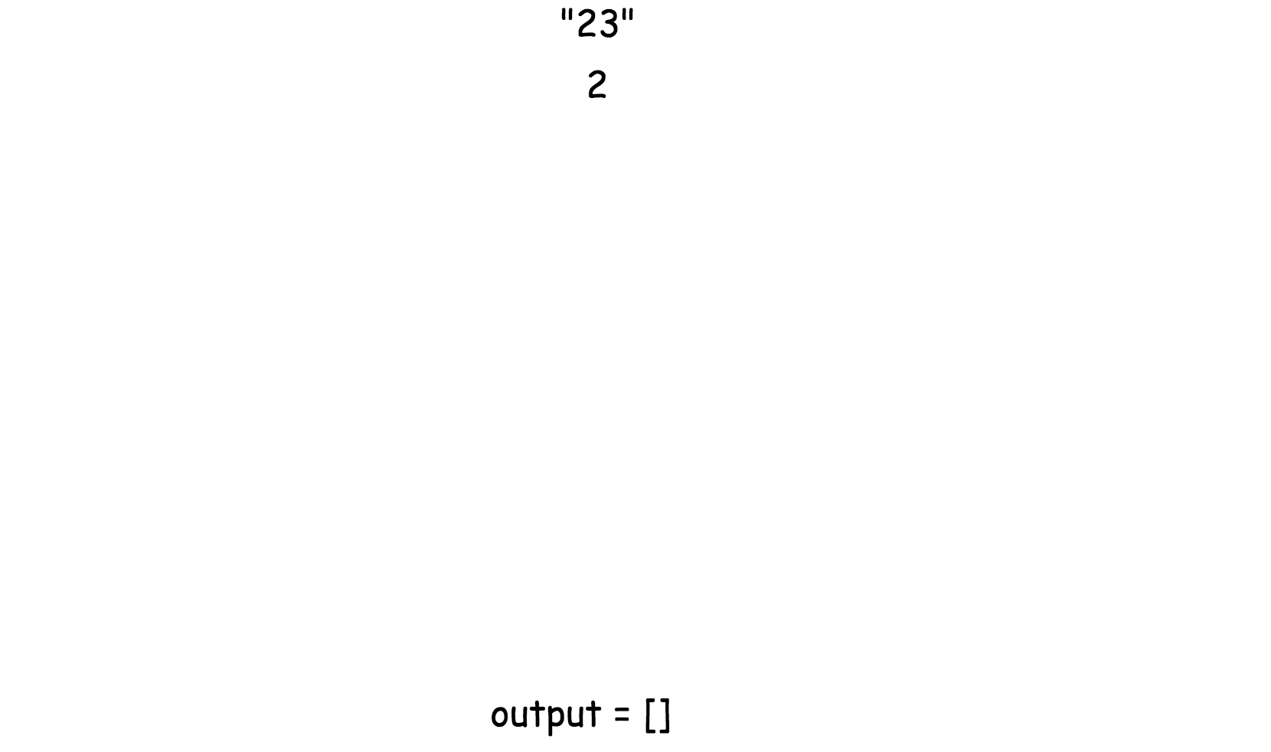

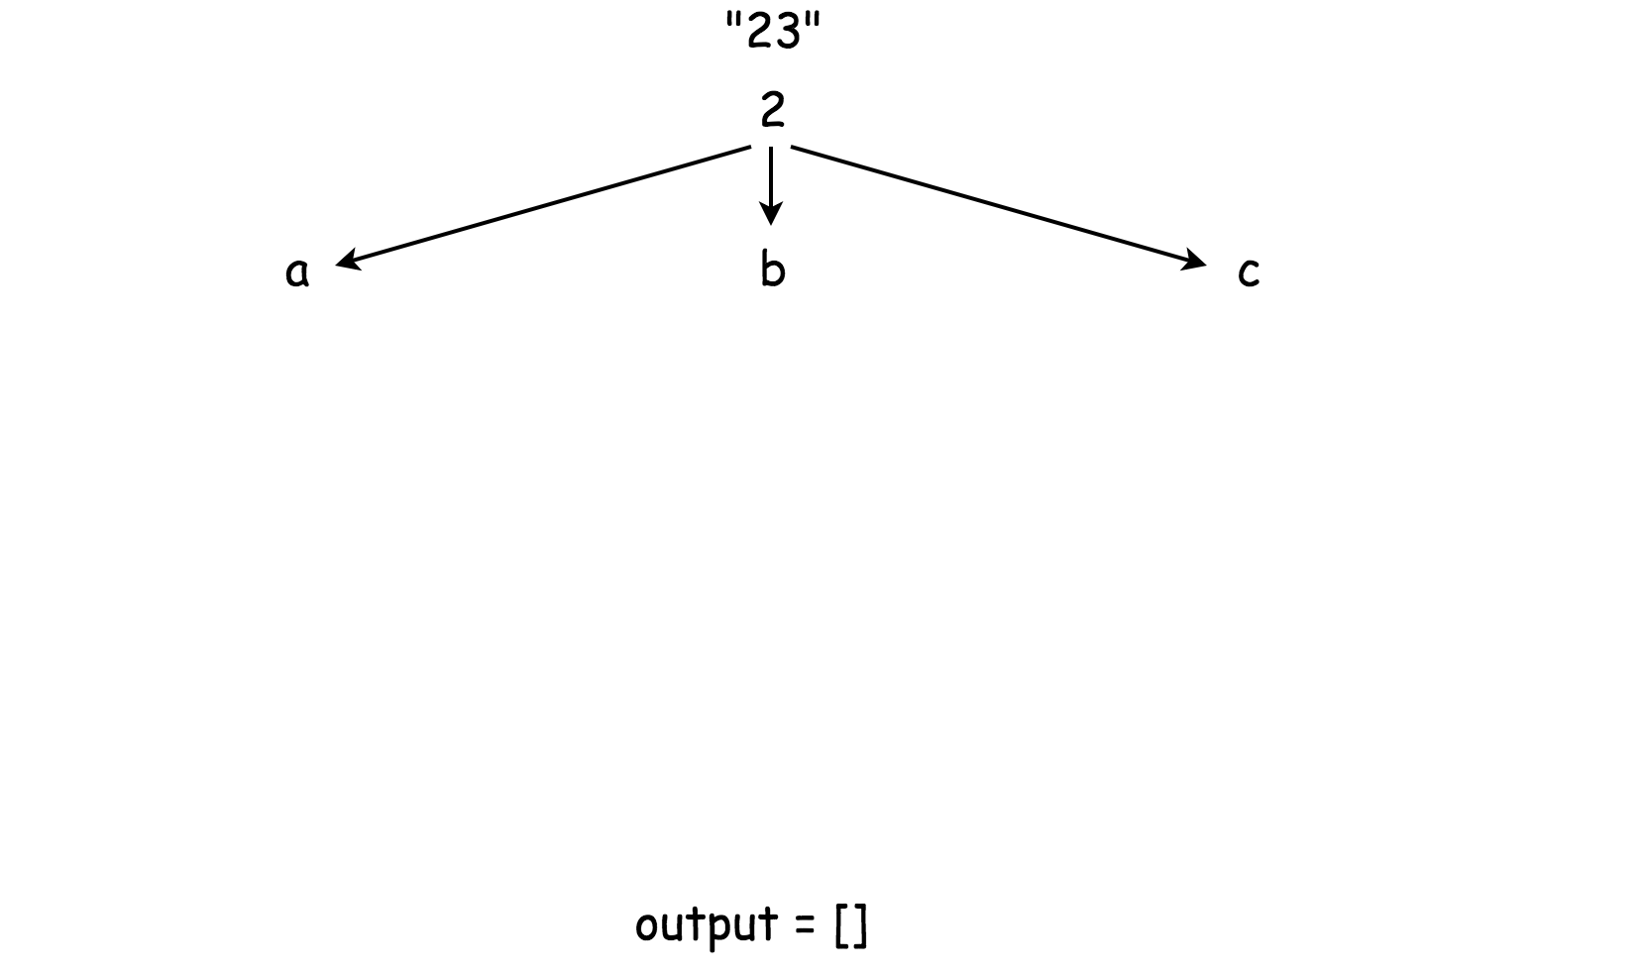

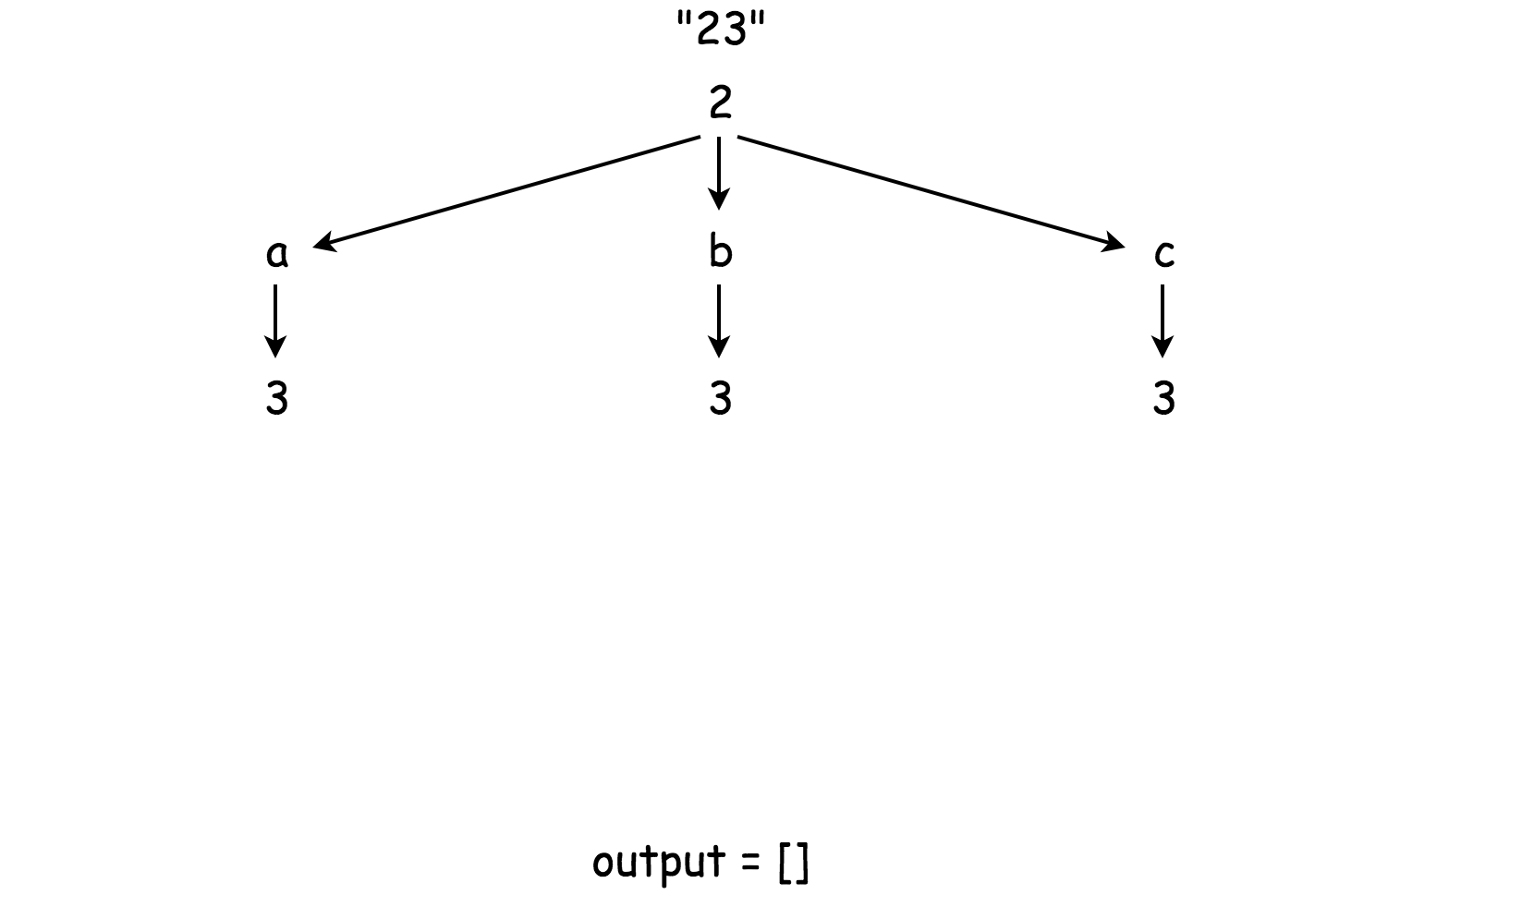

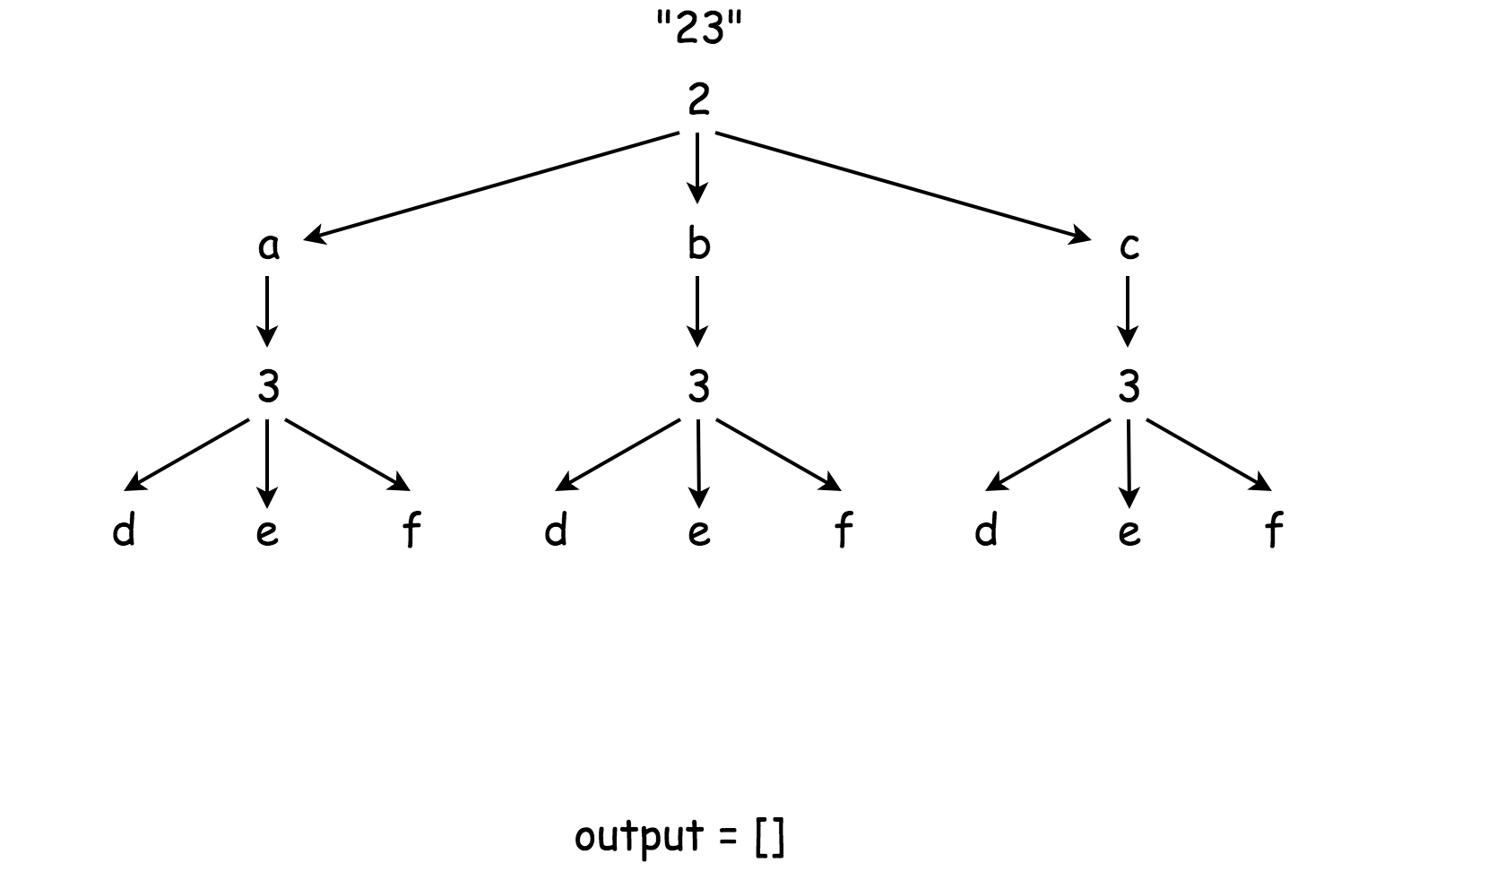

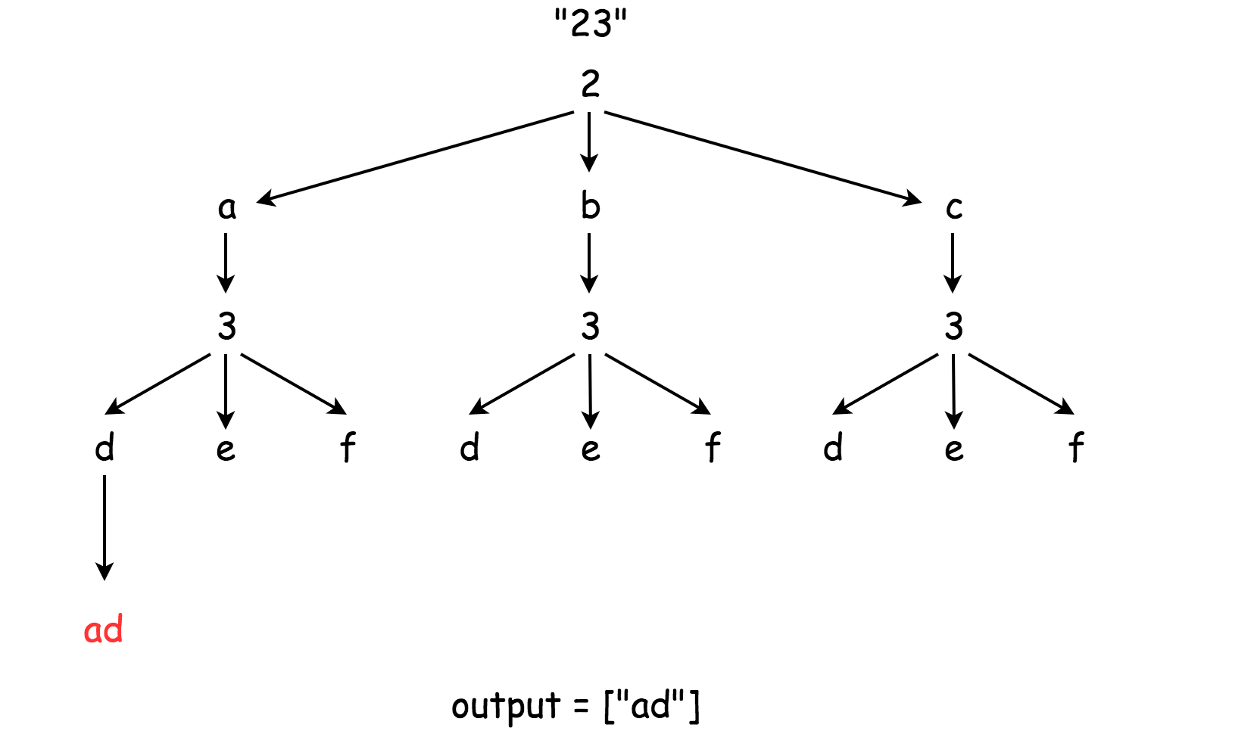

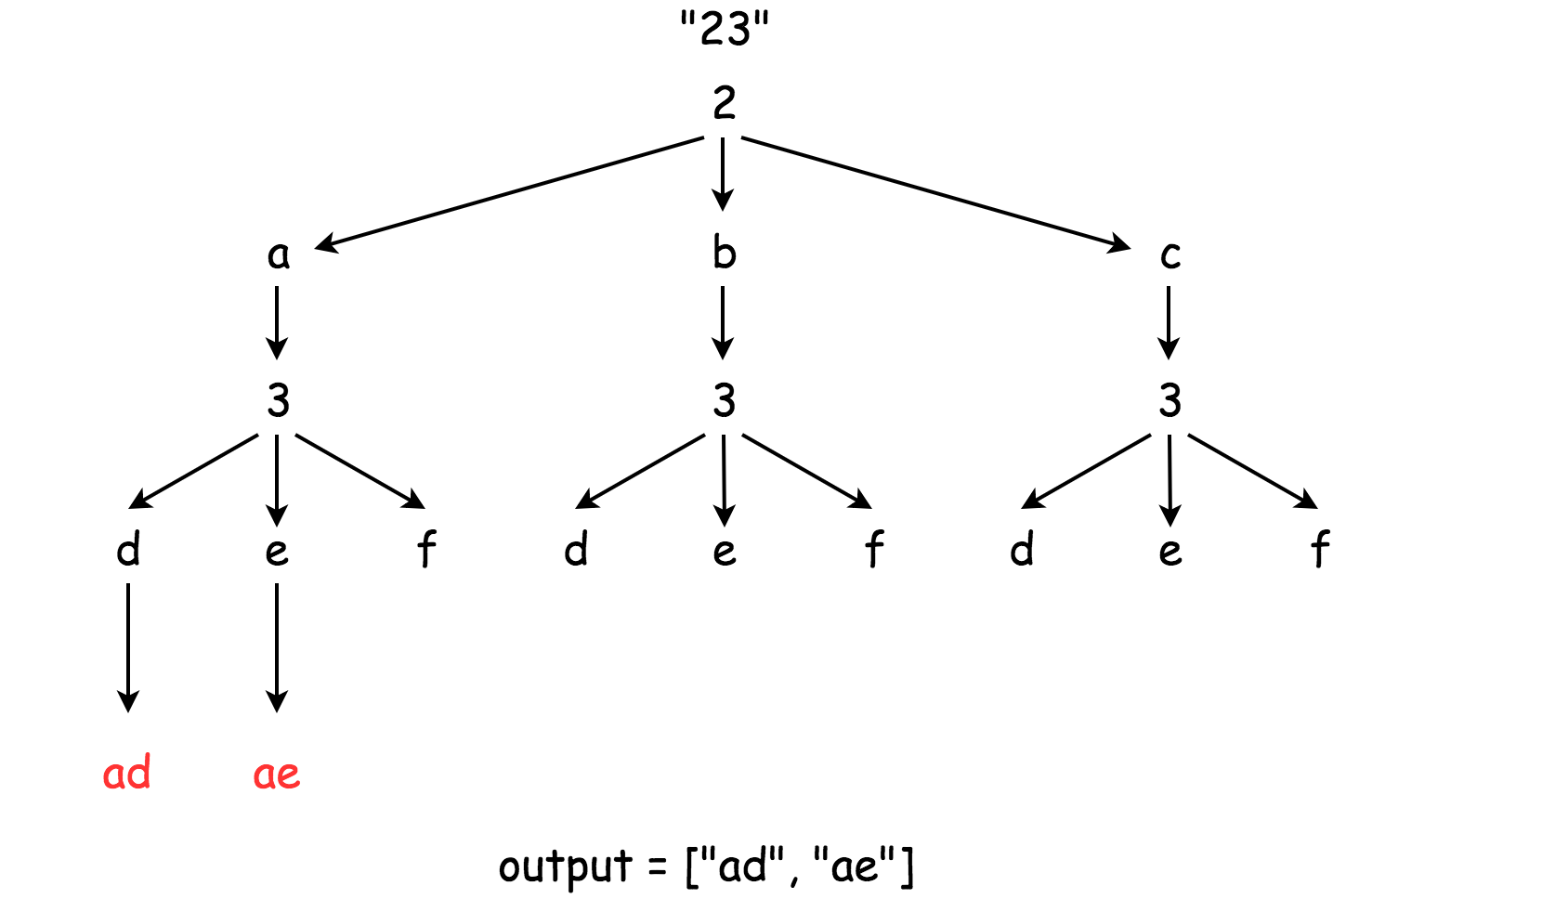

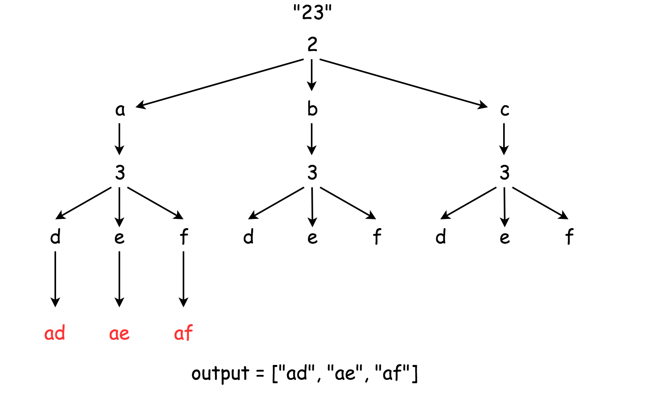

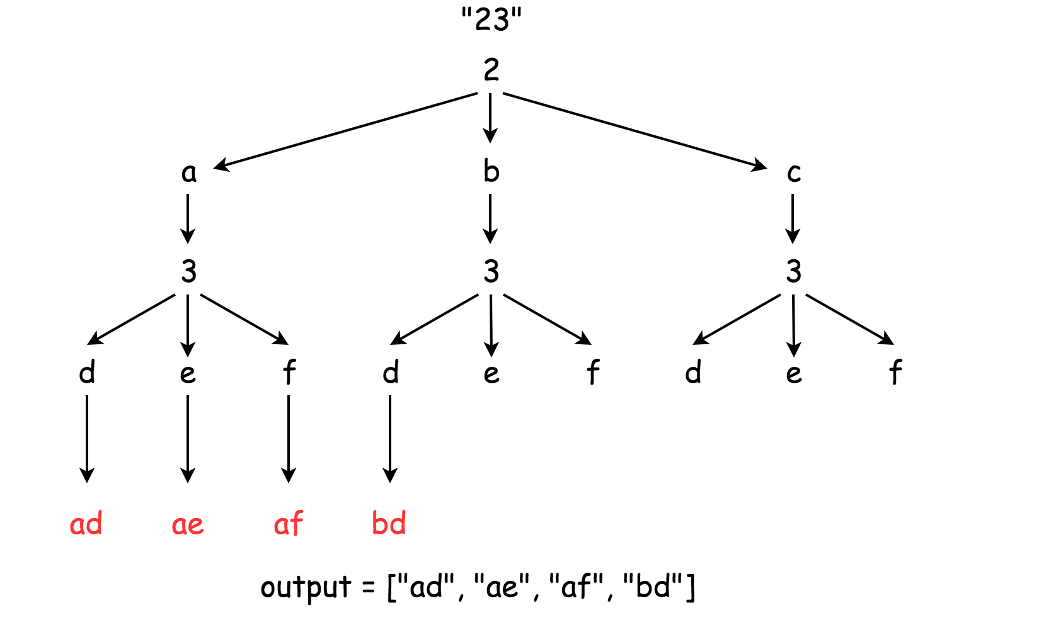

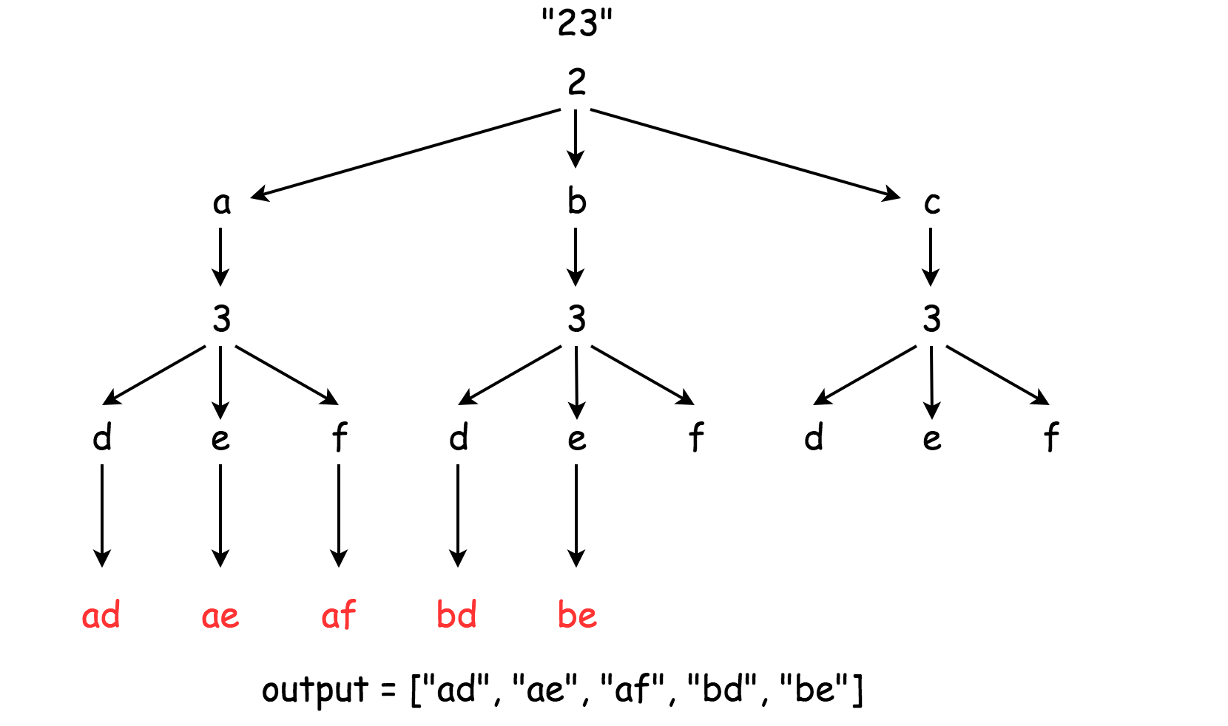

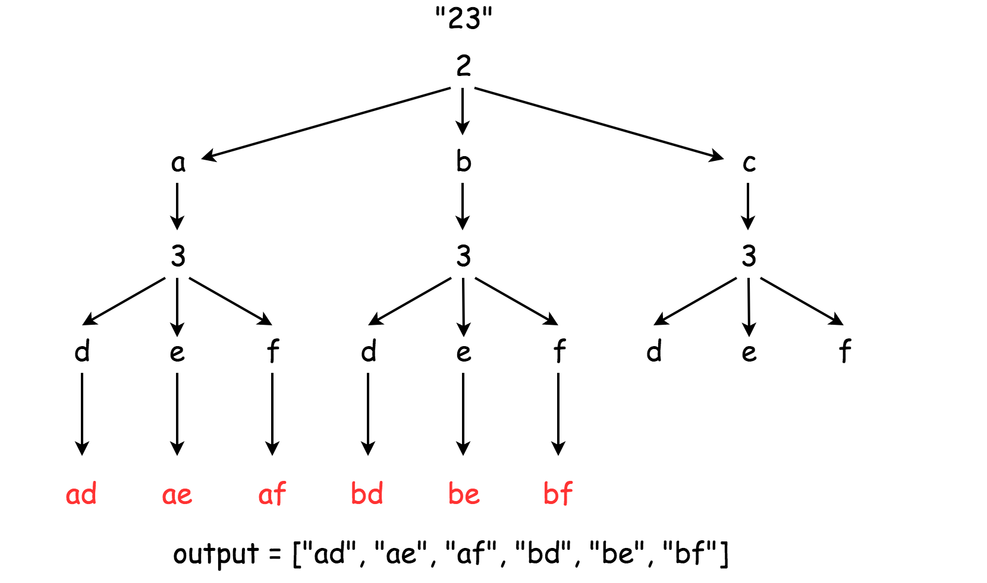

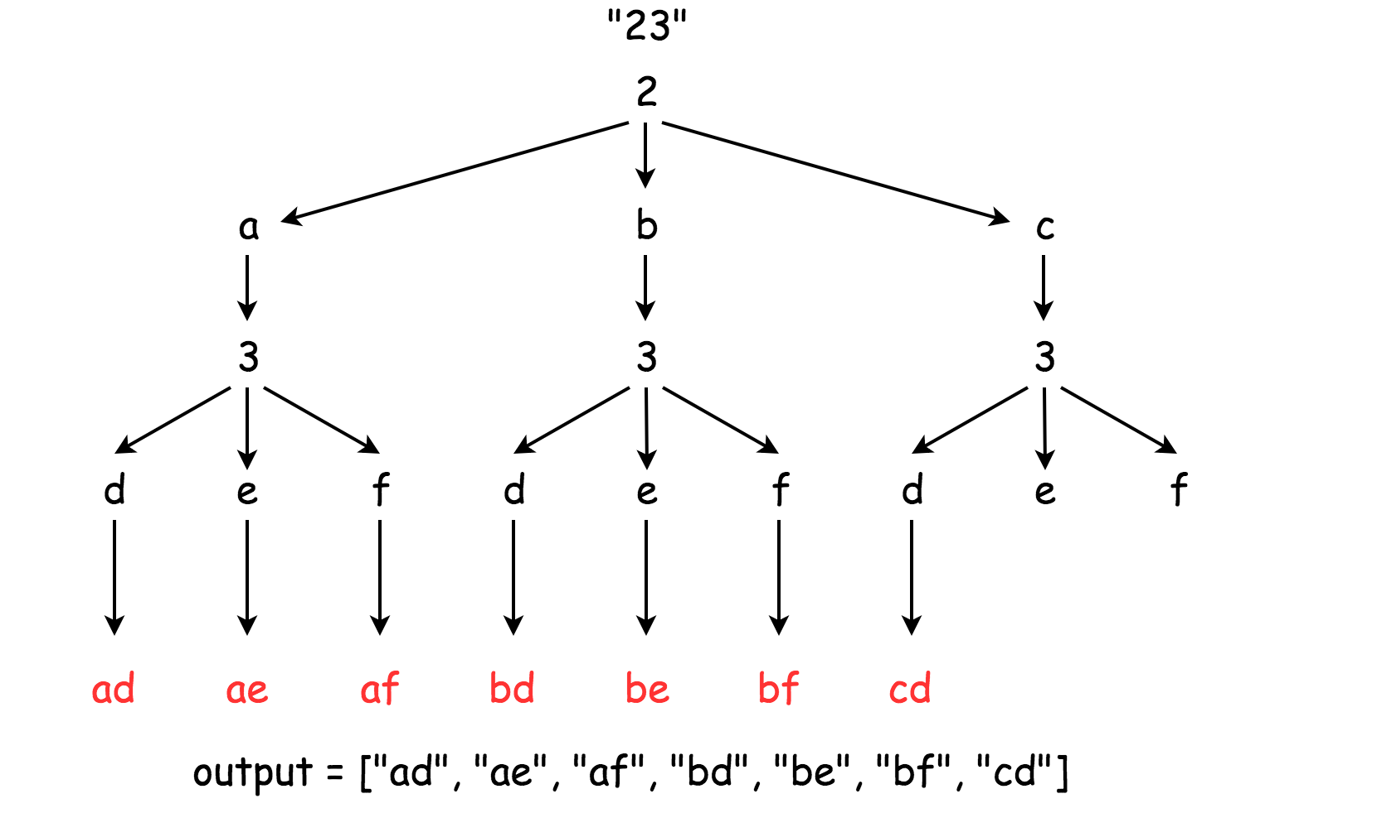

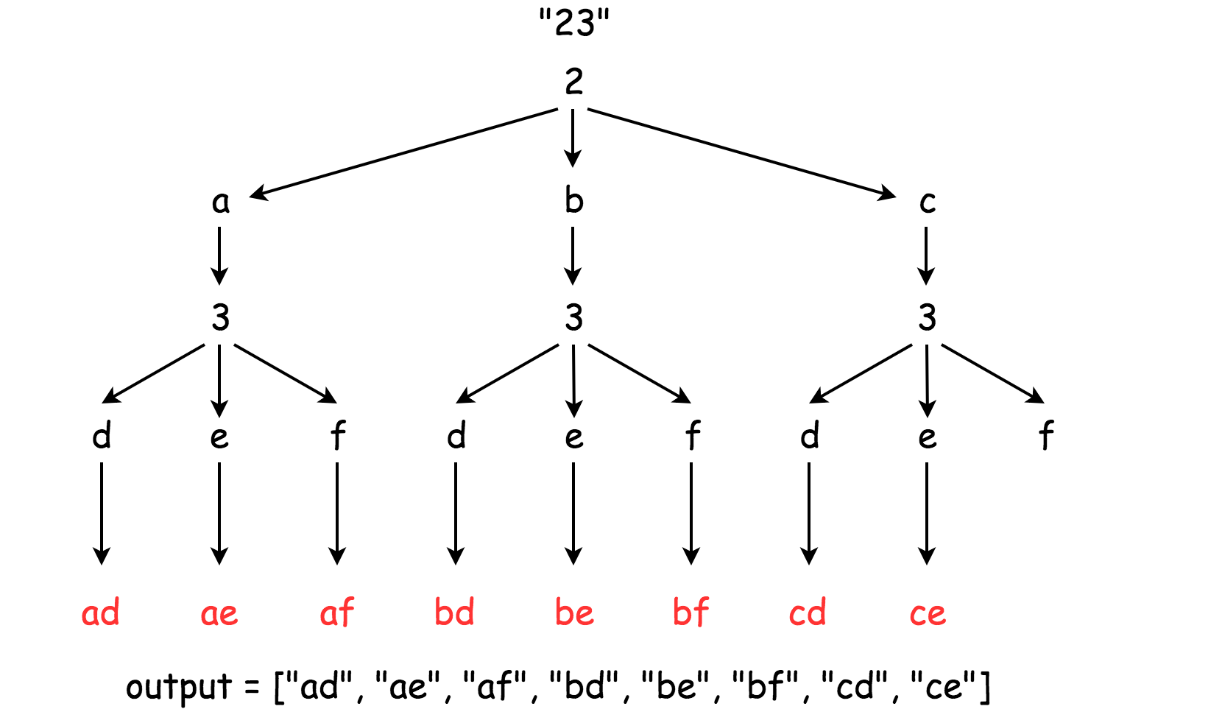

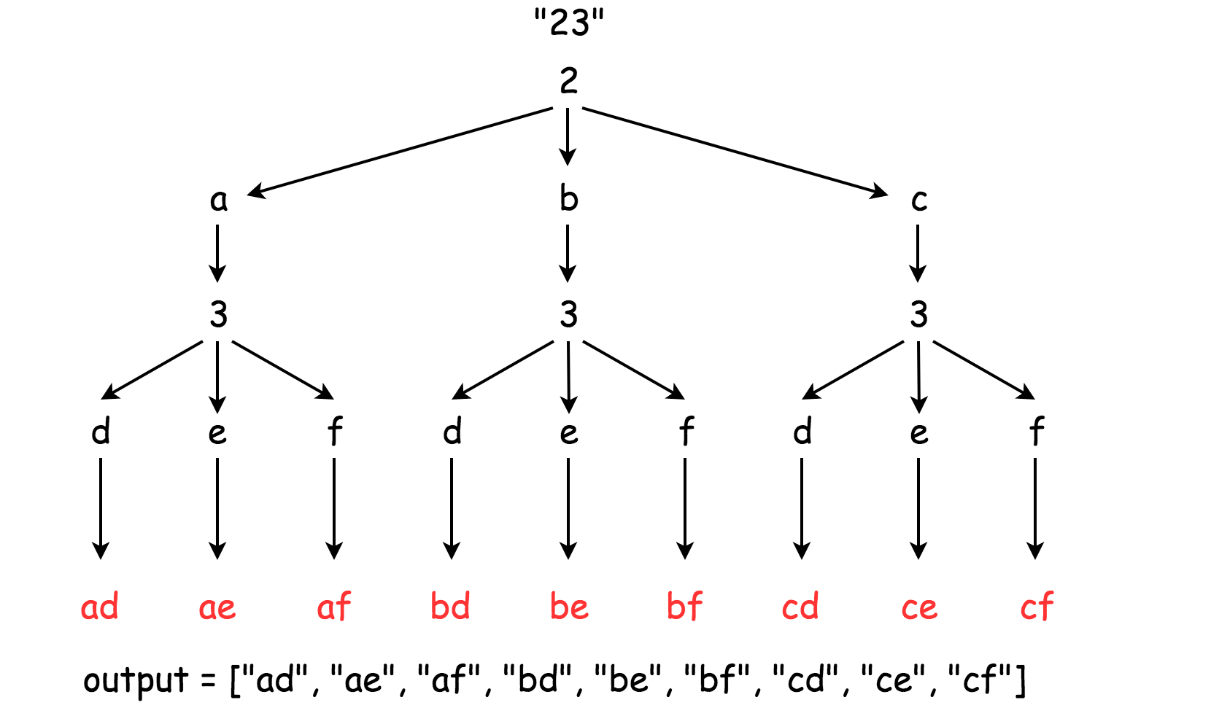

|  |
| --- |
| class Solution {  Map<String, String> phone = new HashMap<String, String>() {{  put("2", "abc");  put("3", "def");  put("4", "ghi");  put("5", "jkl");  put("6", "mno");  put("7", "pqrs");  put("8", "tuv");  put("9", "wxyz");  }};  List<String> output = new ArrayList<String>();  public void backtrack(String combination, String next_digits) {  // if there is no more digits to check  if (next_digits.length() == 0) {  // the combination is done  output.add(combination);  }  // if there are still digits to check  else {  // iterate over all letters which map  // the next available digit  String digit = next_digits.substring(0, 1);  String letters = phone.get(digit);  for (int i = 0; i < letters.length(); i++) {  String letter = phone.get(digit).substring(i, i + 1);  // append the current letter to the combination  // and proceed to the next digits  backtrack(combination + letter, next_digits.substring(1));  }  }  }  public List<String> letterCombinations(String digits) {  if (digits.length() != 0)  backtrack("", digits);  return output;  }  } |

**Complexity Analysis**

* Time complexity : O(3^N * 4^M) where N is the number of digits in the input that maps to 3 letters (*e.g.* 2, 3, 4, 5, 6, 8) and M is the number of digits in the input that maps to 4 letters (*e.g.* 7, 9), and N+M is the total number digits in the input.
* Space complexity : O(3^N * 4^M) since one has to keep 3^N * 4^M solutions.

**Generate Parentheses**

Given n pairs of parentheses, write a function to *generate all combinations of well-formed parentheses*.

**Example 1:**

**Input:** n = 3

**Output:** ["((()))","(()())","(())()","()(())","()()()"]

**Example 2:**

**Input:** n = 1

**Output:** ["()"]

**Constraints:**

* 1 <= n <= 8

#### **Approach 1: Brute Force**

**Intuition**

We can generate all 2^{2n} sequences of '(' and ')' characters. Then, we will check if each one is valid.

**Algorithm**

To generate all sequences, we use a recursion. All sequences of length n is just '(' plus all sequences of length n-1, and then ')' plus all sequences of length n-1.

To check whether a sequence is valid, we keep track of balance, the net number of opening brackets minus closing brackets. If it falls below zero at any time, or doesn't end in zero, the sequence is invalid - otherwise it is valid.

|  |
| --- |
| class Solution {  public List<String> generateParenthesis(int n) {  List<String> combinations = new ArrayList();  generateAll(new char[2 * n], 0, combinations);  return combinations;  }  public void generateAll(char[] current, int pos, List<String> result) {  if (pos == current.length) {  if (valid(current))  result.add(new String(current));  } else {  current[pos] = '(';  generateAll(current, pos+1, result);  current[pos] = ')';  generateAll(current, pos+1, result);  }  }  public boolean valid(char[] current) {  int balance = 0;  for (char c: current) {  if (c == '(') balance++;  else balance--;  if (balance < 0) return false;  }  return (balance == 0);  }  } |

**Complexity Analysis**

* Time Complexity : O(22nn). For each of 22n sequences, we need to create and validate the sequence, which takes *O*(*n*) work.
* Space Complexity : O(22nn). Naively, every sequence could be valid. See [Approach 3](https://leetcode.com/problems/generate-parentheses/solution/#approach-3-closure-number) for development of a tighter asymptotic bound.

#### **Approach 2: Backtracking**

**Intuition and Algorithm**

Instead of adding '(' or ')' every time as in [Approach 1](https://leetcode.com/problems/generate-parentheses/solution/#approach-1-brute-force), let's only add them when we know it will remain a valid sequence. We can do this by keeping track of the number of opening and closing brackets we have placed so far.

We can start an opening bracket if we still have one (of n) left to place. And we can start a closing bracket if it would not exceed the number of opening brackets.

|  |
| --- |
| class Solution {  public List<String> generateParenthesis(int n) {  List<String> ans = new ArrayList();  backtrack(ans, "", 0, 0, n);  return ans;  }  public void backtrack(List<String> ans, String cur, int open, int close, int max){  if (cur.length() == max * 2) {  ans.add(cur);  return;  }  if (open < max)  backtrack(ans, cur+"(", open+1, close, max);  if (close < open)  backtrack(ans, cur+")", open, close+1, max);  }  } |

**Complexity Analysis**

Our complexity analysis rests on understanding how many elements there are in generateParenthesis(n). This analysis is outside the scope of this article, but it turns out this is the n-th Catalan number 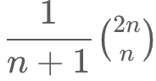, which is bounded asymptotically by 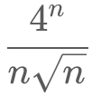​.

* Time Complexity : 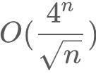, Each valid sequence has at most n steps during the backtracking procedure.
* Space Complexity : , as described above, and using *O*(*n*) space to store the sequence.

#### **Approach 3: Closure Number**

**Intuition**

To enumerate something, generally we would like to express it as a sum of disjoint subsets that are easier to count.

Consider the closure number of a valid parentheses sequence S: the least index >= 0 so that S[0], S[1], ..., S[2*index+1] is valid. Clearly, every parentheses sequence has a unique closure number. We can try to enumerate them individually.

**Algorithm**

For each closure number c, we know the starting and ending brackets must be at index 0 and 2*c + 1. Then, the 2*c elements between must be a valid sequence, plus the rest of the elements must be a valid sequence.

|  |
| --- |
| class Solution {  public List<String> generateParenthesis(int n) {  List<String> ans = new ArrayList();  if (n == 0) {  ans.add("");  } else {  for (int c = 0; c < n; ++c)  for (String left: generateParenthesis(c))  for (String right: generateParenthesis(n-1-c))  ans.add("(" + left + ")" + right);  }  return ans;  }  } |

**Complexity Analysis**

* Time and Space Complexity : . The analysis is similar to [Approach 2](https://leetcode.com/problems/generate-parentheses/solution/#approach-2-backtracking).

**Permutations**

Given an array nums of distinct integers, return *all the possible permutations*. You can return the answer in **any order**.

**Example 1:**

**Input:** nums = [1,2,3]

**Output:** [[1,2,3],[1,3,2],[2,1,3],[2,3,1],[3,1,2],[3,2,1]]

**Example 2:**

**Input:** nums = [0,1]

**Output:** [[0,1],[1,0]]

**Example 3:**

**Input:** nums = [1]

**Output:** [[1]]

**Constraints:**

* 1 <= nums.length <= 6
* -10 <= nums[i] <= 10
* All the integers of nums are **unique**.

## Solution

#### **Approach 1: Backtracking**

[Backtracking](https://en.wikipedia.org/wiki/Backtracking) is an algorithm for finding all solutions by exploring all potential candidates. If the solution candidate turns to be not a solution (or at least not the last one), backtracking algorithm discards it by making some changes on the previous step, i.e. backtracks and then try again.

Here is a backtrack function which takes the index of the first integer to consider as an argument backtrack(first).

* If the first integer to consider has index n that means that the current permutation is done.
* Iterate over the integers from index first to index n - 1.
  + Place i-th integer first in the permutation, i.e. swap(nums[first], nums[i]).
  + Proceed to create all permutations which starts from i-th integer : backtrack(first + 1).
  + Now backtrack, i.e. swap(nums[first], nums[i]) back.



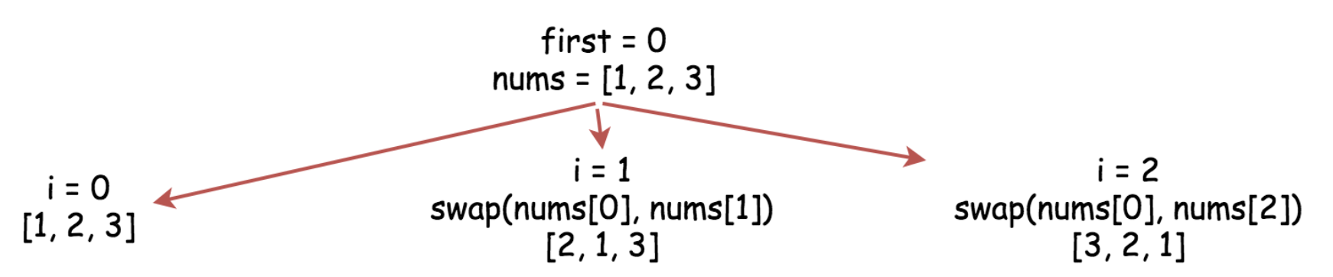

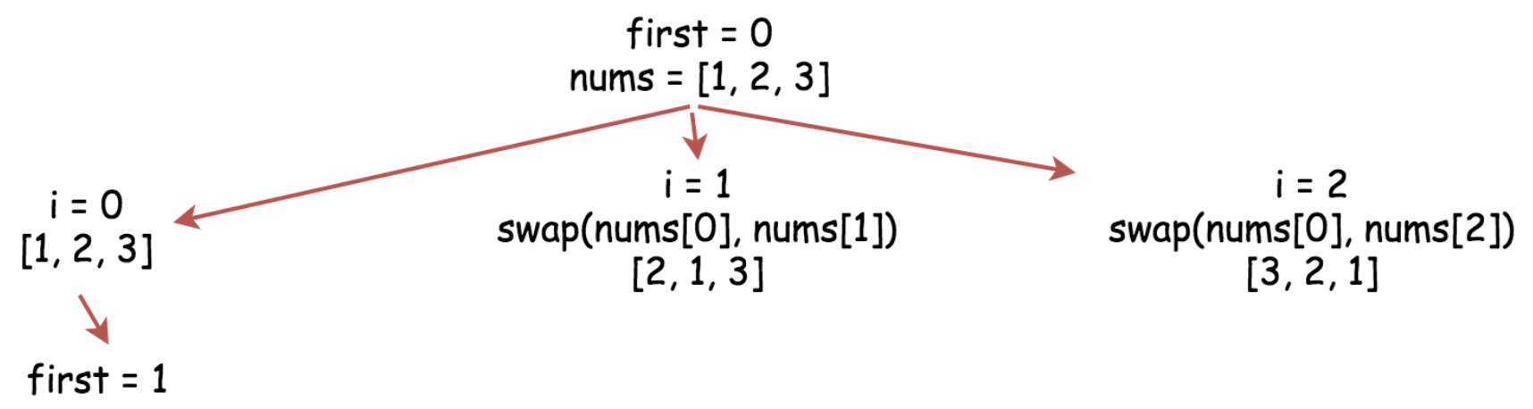

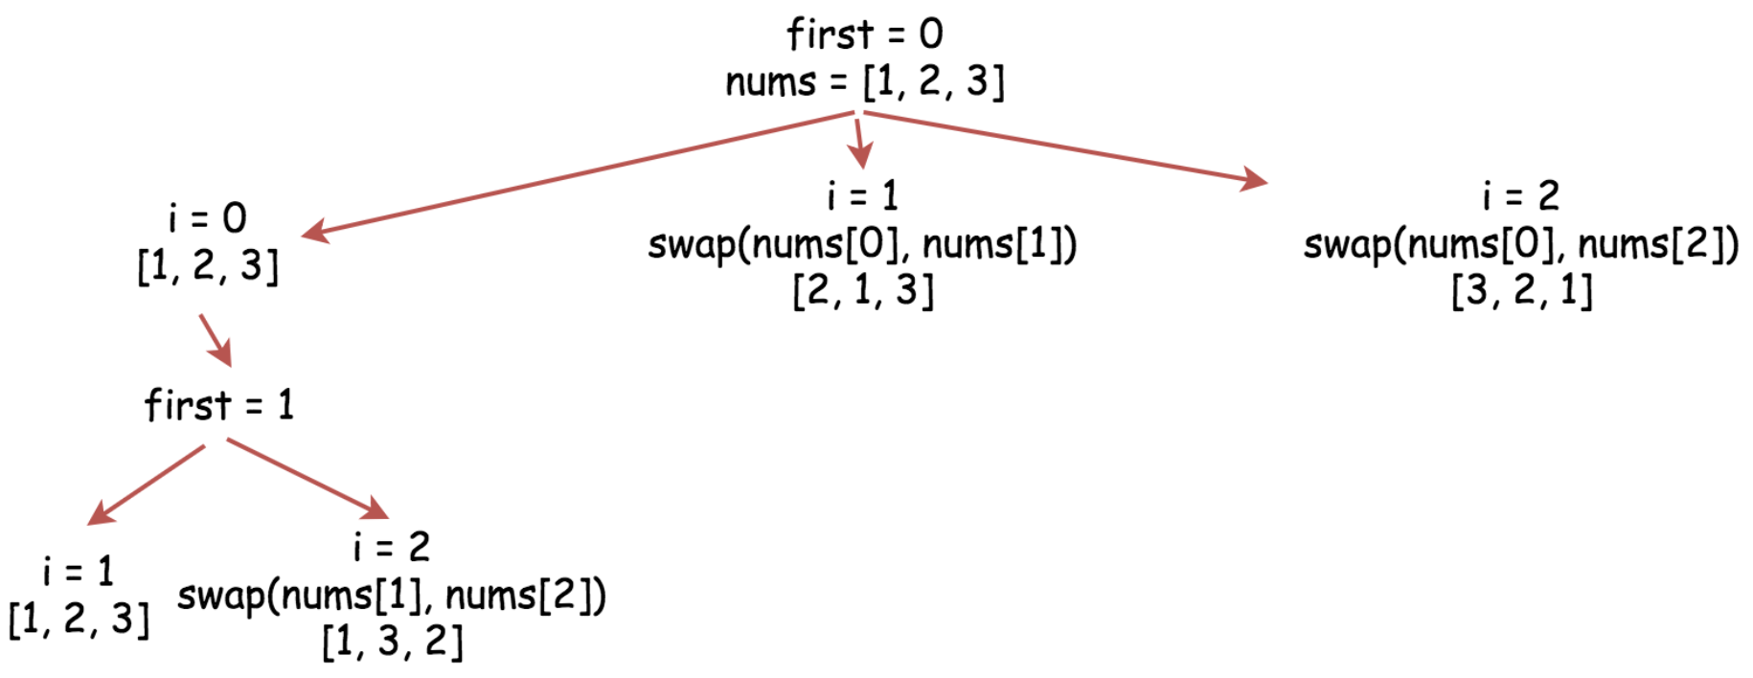

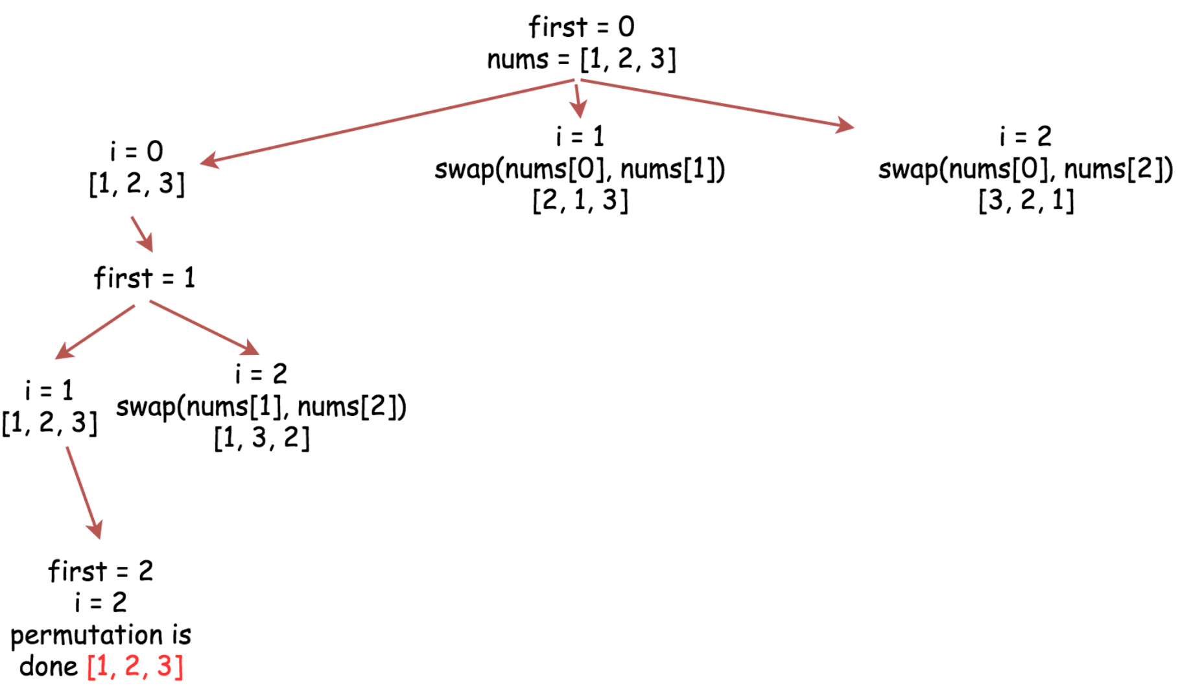

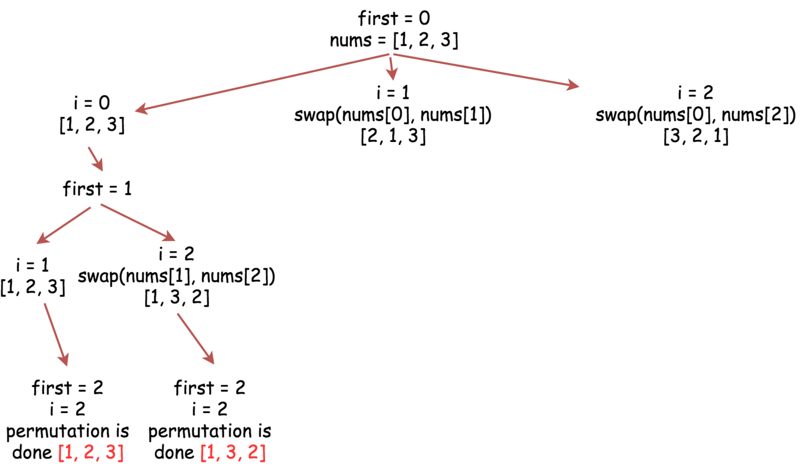

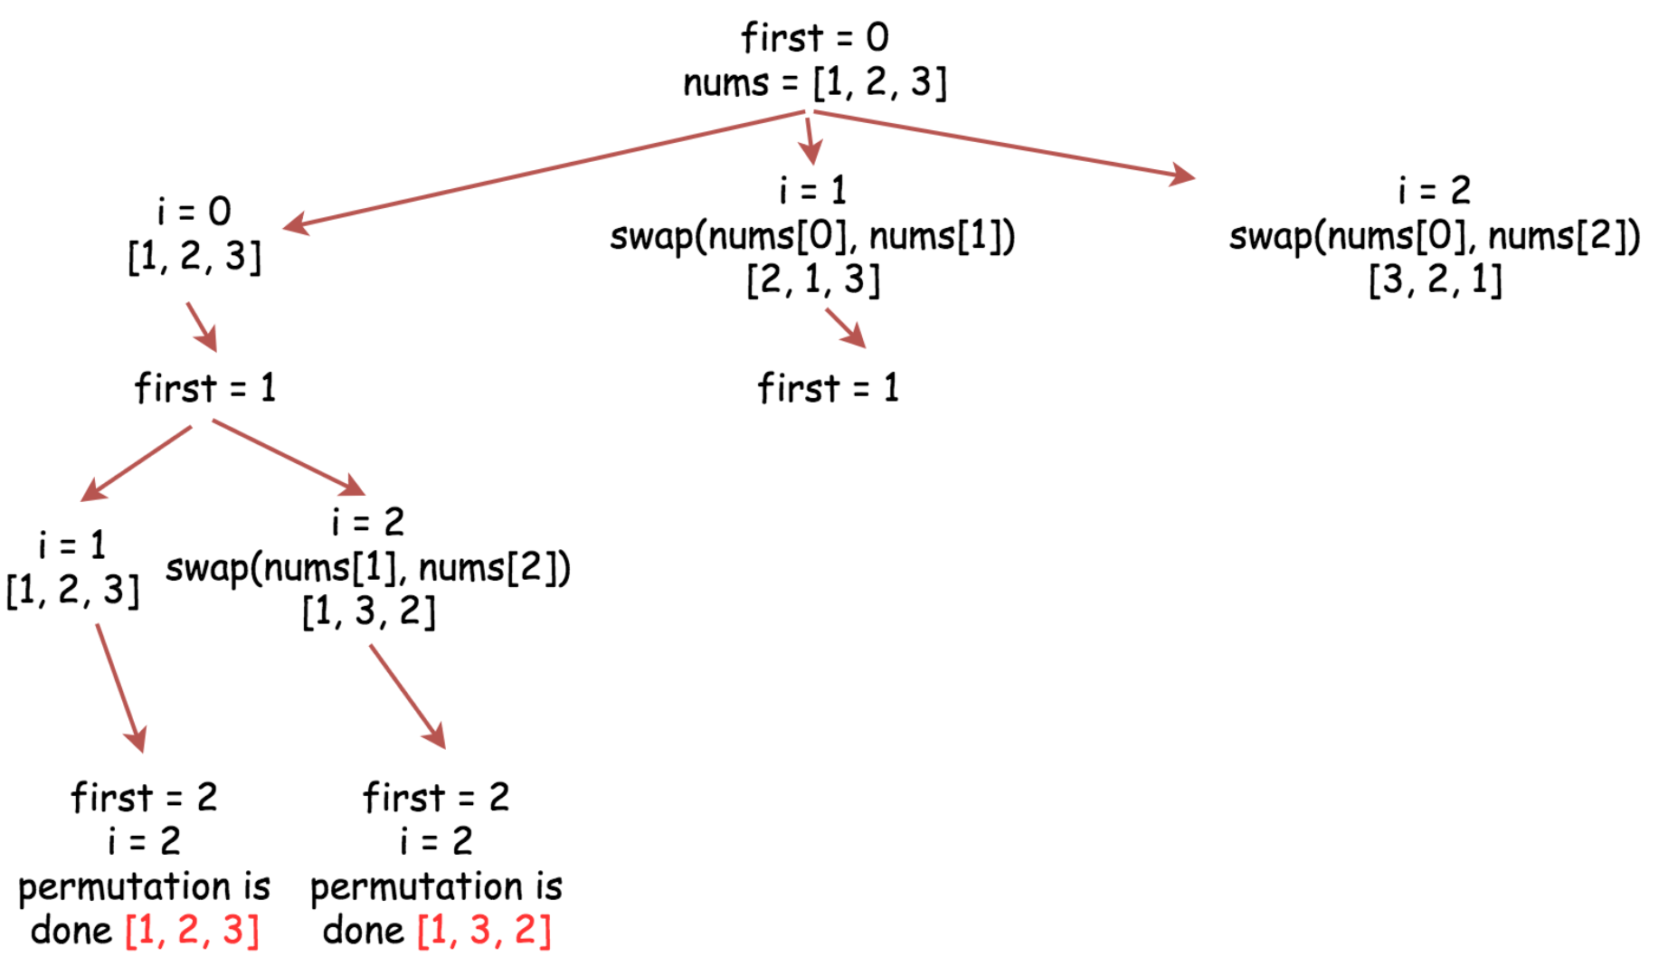

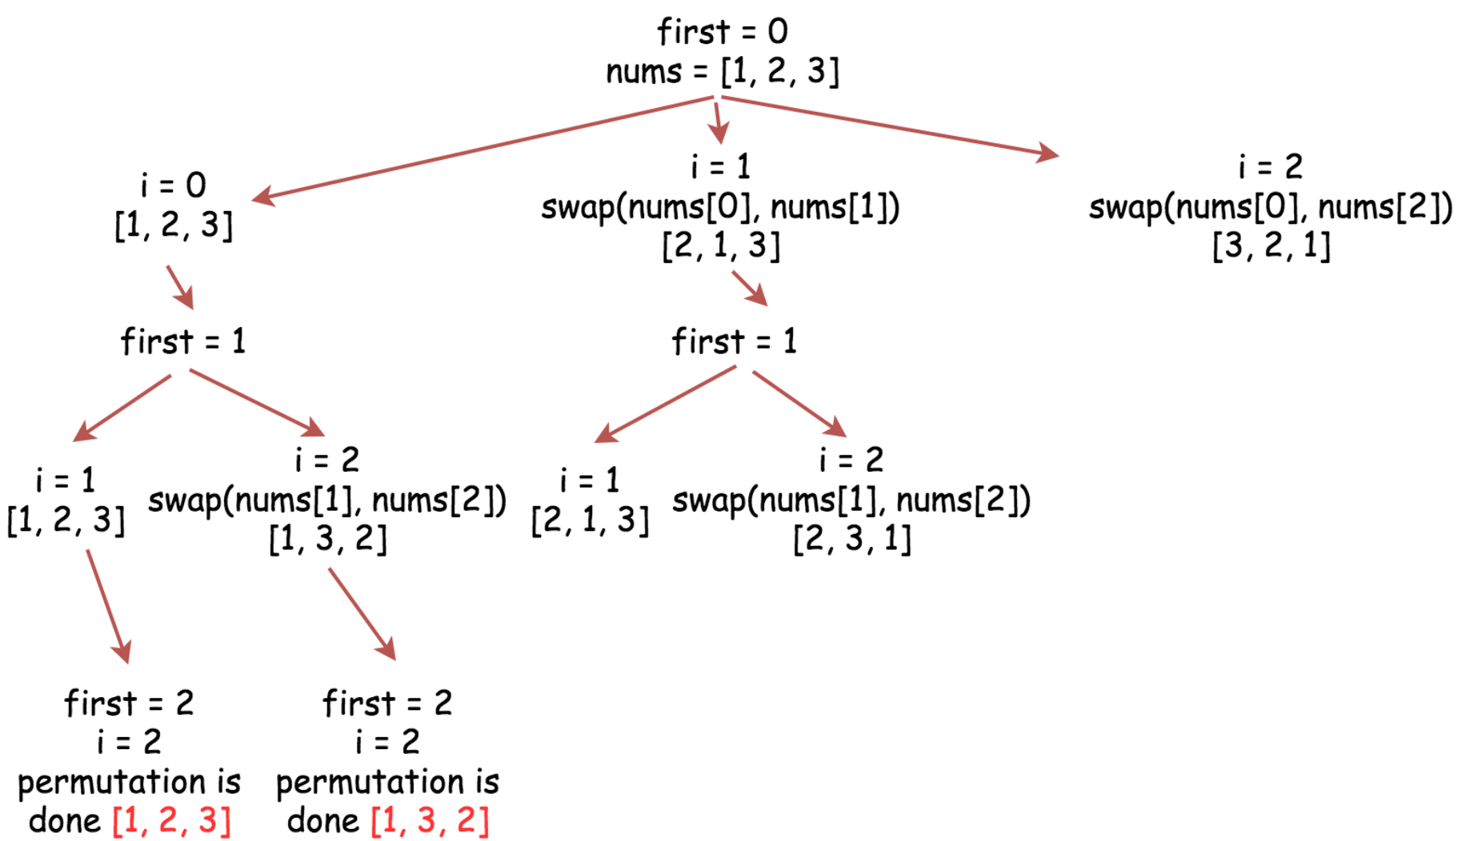

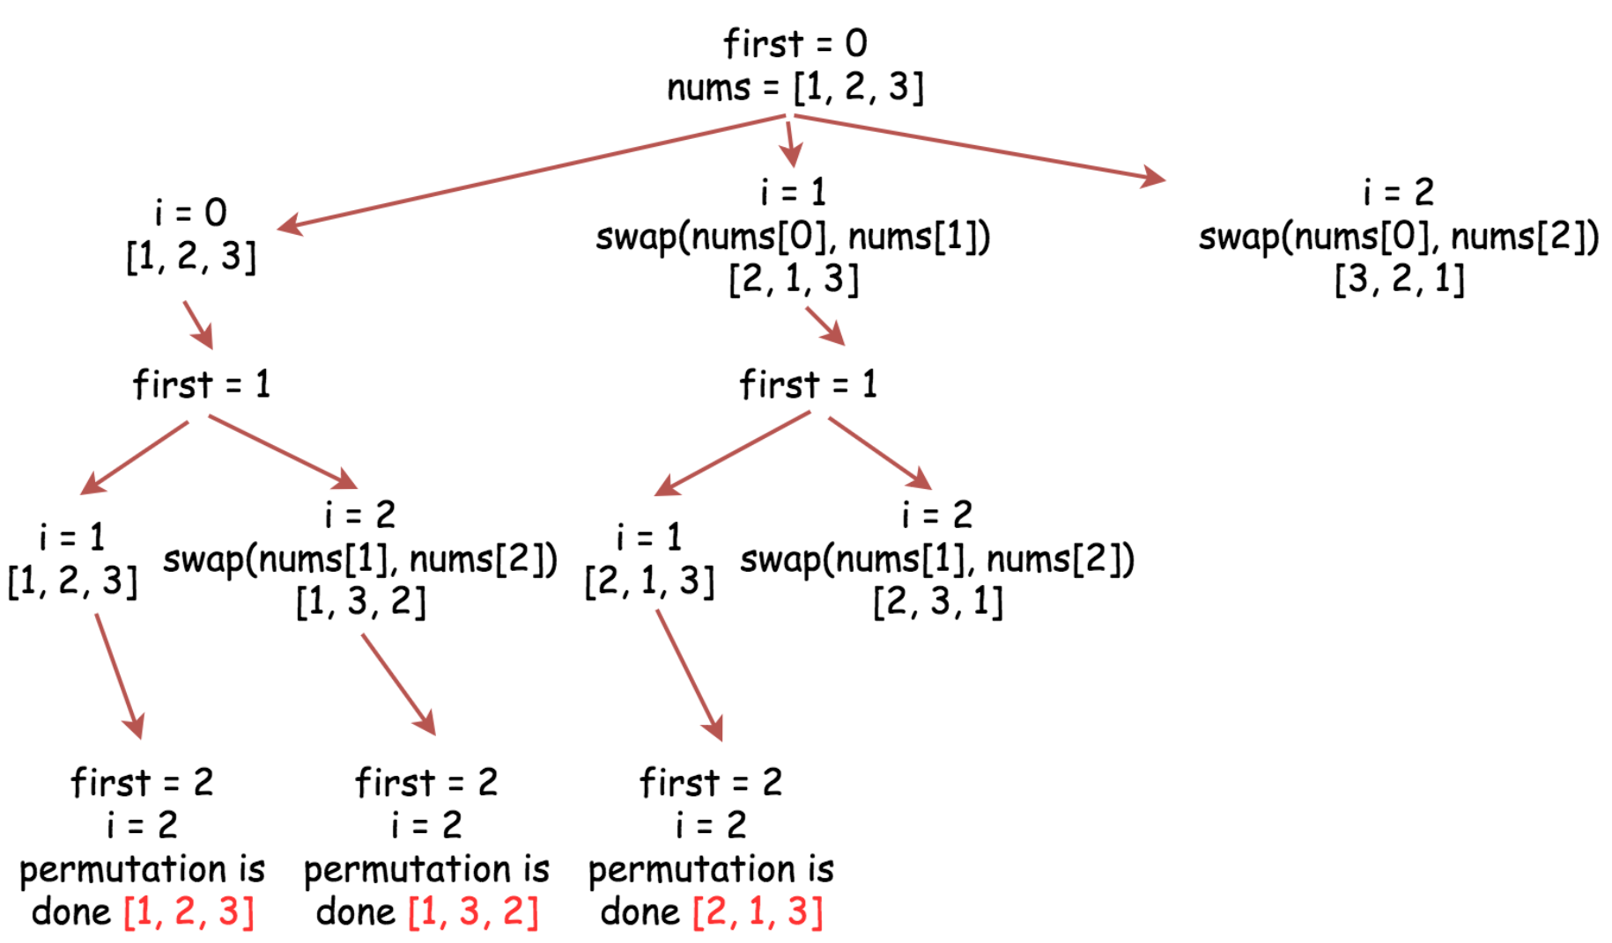

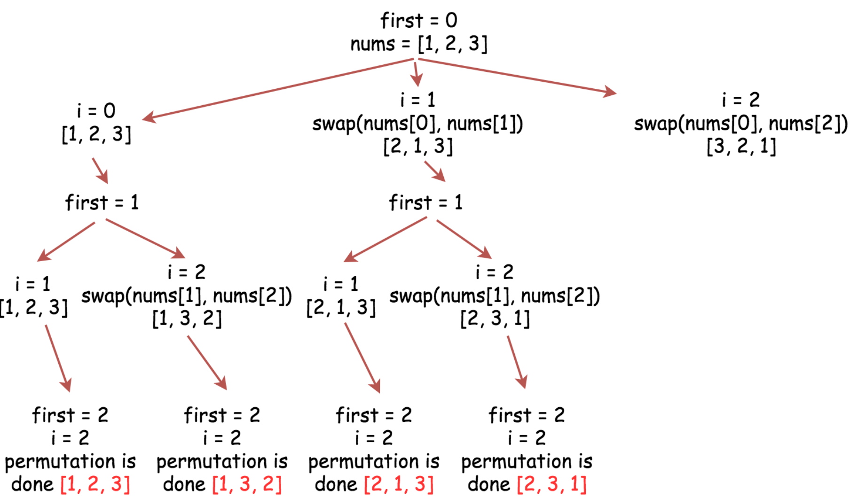

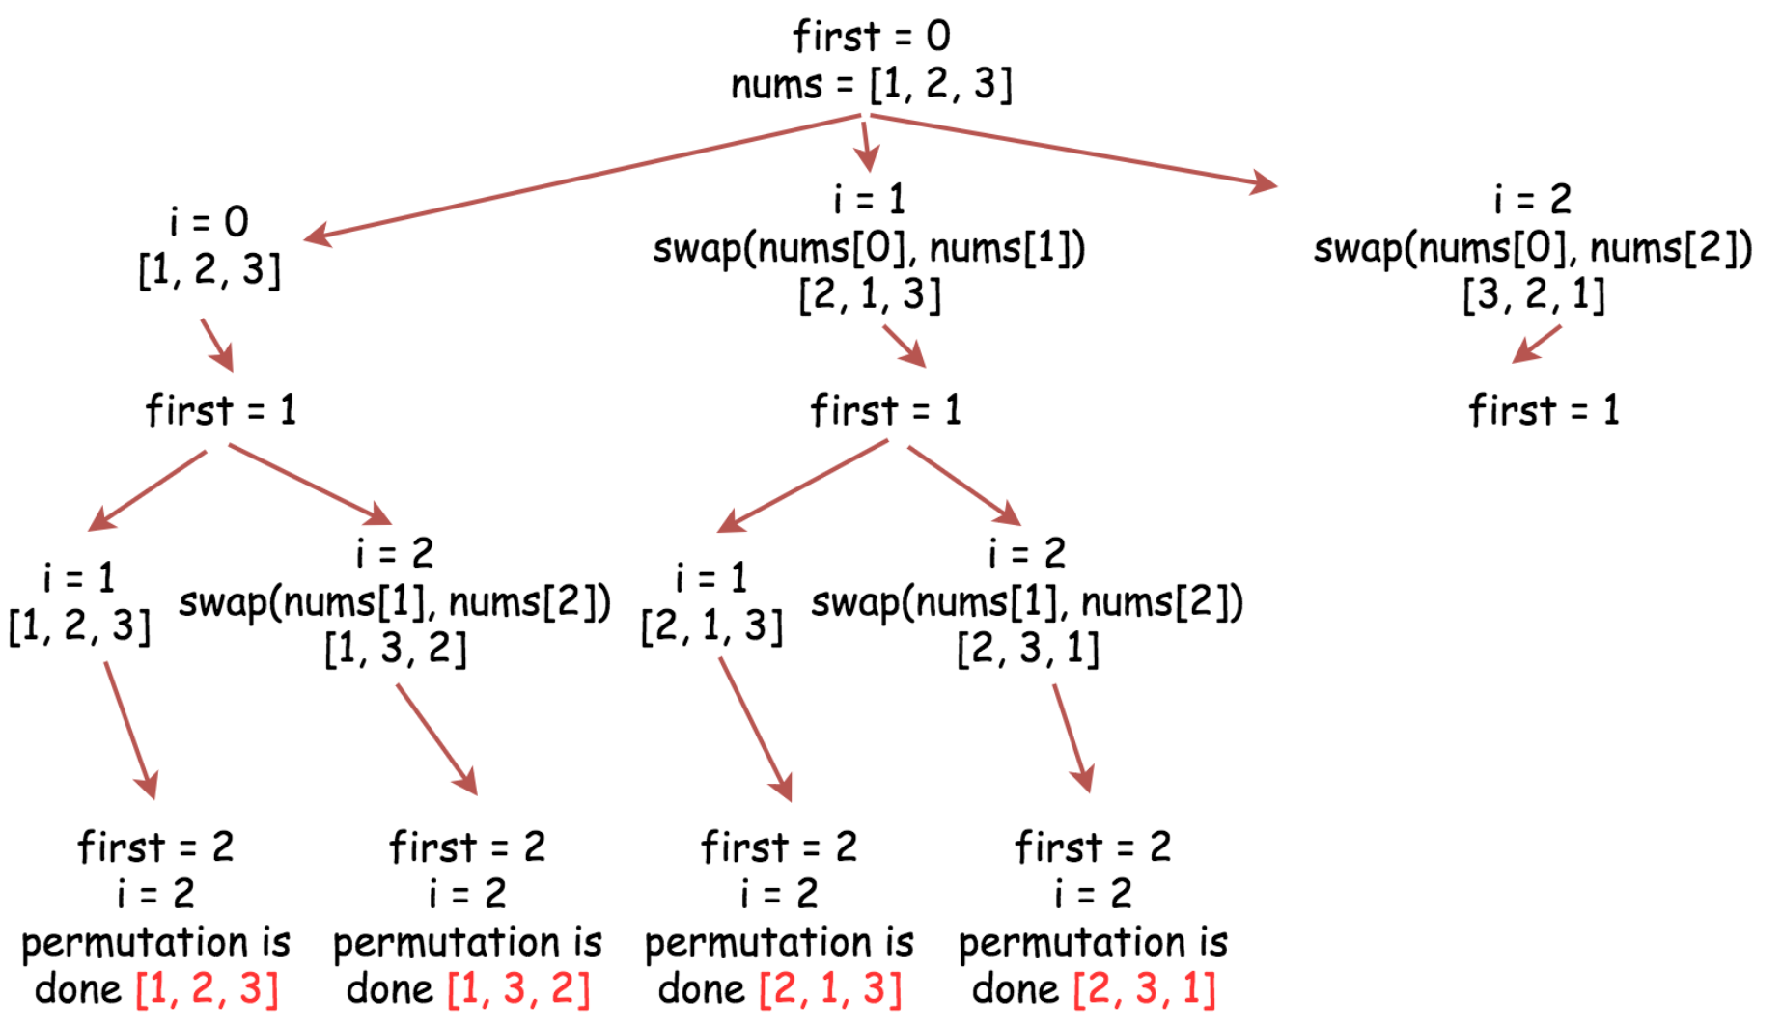

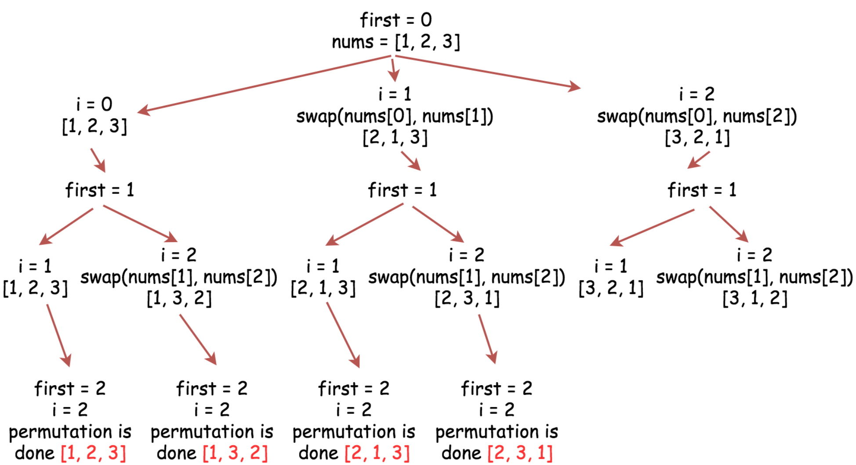

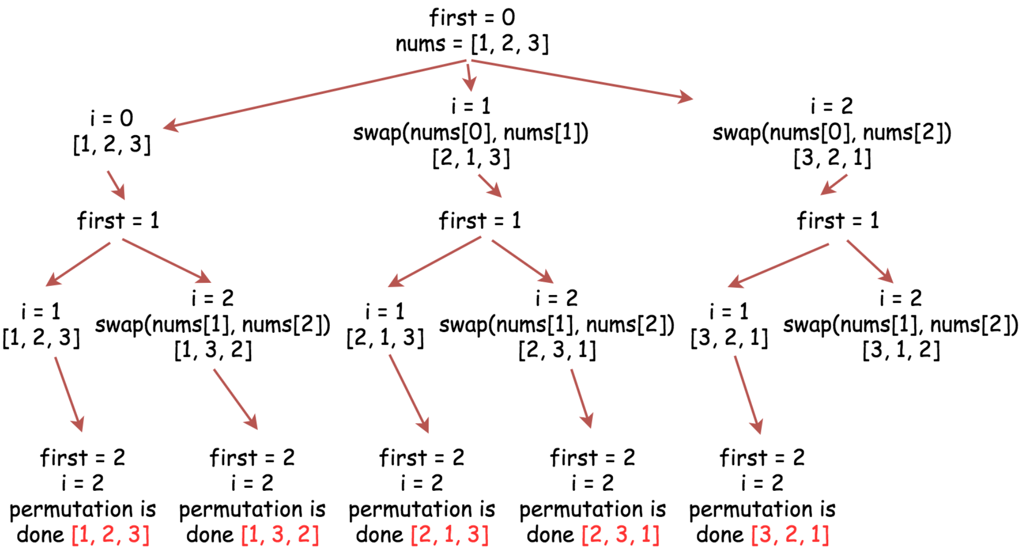

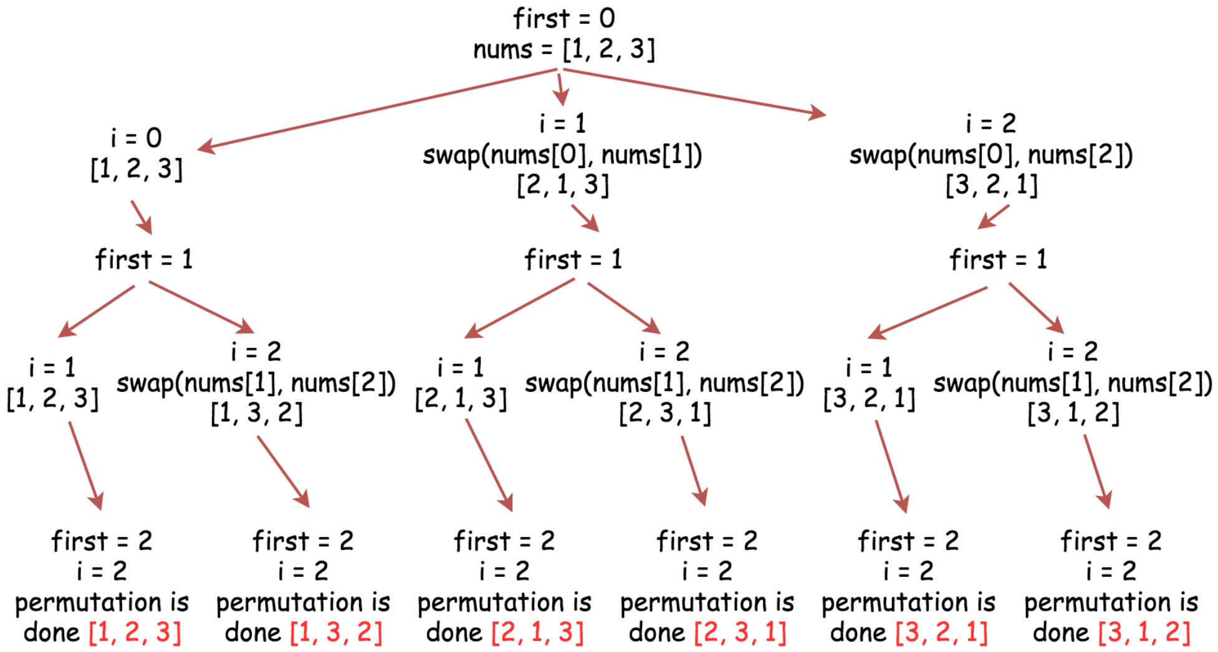

|  |
| --- |
| class Solution {  public void backtrack(int n,  ArrayList<Integer> nums,  List<List<Integer>> output,  int first) {  // if all integers are used up  if (first == n)  output.add(new ArrayList<Integer>(nums));  for (int i = first; i < n; i++) {  // place i-th integer first  // in the current permutation  Collections.swap(nums, first, i);  // use next integers to complete the permutations  backtrack(n, nums, output, first + 1);  // backtrack  Collections.swap(nums, first, i);  }  }  public List<List<Integer>> permute(int[] nums) {  // init output list  List<List<Integer>> output = new LinkedList();  // convert nums into list since the output is a list of lists  ArrayList<Integer> nums_lst = new ArrayList<Integer>();  for (int num : nums)  nums_lst.add(num);  int n = nums.length;  backtrack(n, nums_lst, output, 0);  return output;  }  } |

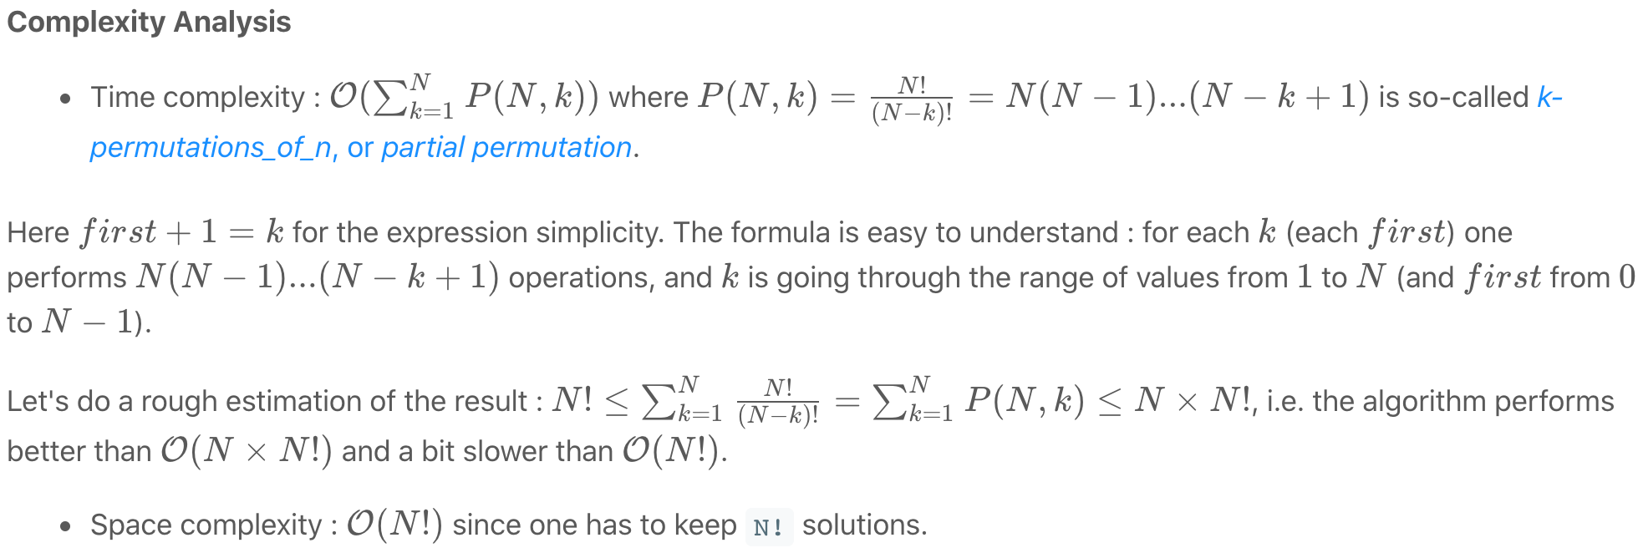

**Subsets**

Given an integer array nums of **unique** elements, return *all possible subsets (the power set)*.

The solution set **must not** contain duplicate subsets. Return the solution in **any order**.

**Example 1:**

**Input:** nums = [1,2,3]

**Output:** [[],[1],[2],[1,2],[3],[1,3],[2,3],[1,2,3]]

**Example 2:**

**Input:** nums = [0]

**Output:** [[],[0]]

**Constraints:**

* 1 <= nums.length <= 10
* -10 <= nums[i] <= 10
* All the numbers of nums are **unique**.

## Solution

#### **Solution Pattern**

Let us first review the problems of Permutations / Combinations / Subsets, since they are quite similar to each other and there are some common strategies to solve them.

First, their solution space is often quite large:

* [Permutations](https://en.wikipedia.org/wiki/Permutation#k-permutations_of_n): *N*!.
* [Combinations](https://en.wikipedia.org/wiki/Combination#Number_of_k-combinations): 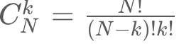​
* Subsets: 2^N, since each element could be absent or present.

Given their exponential solution space, it is tricky to ensure that the generated solutions are ***complete*** and ***non-redundant***. It is essential to have a clear and easy-to-reason strategy.

There are generally three strategies to do it:

* Recursion
* Backtracking
* Lexicographic generation based on the mapping between binary bitmasks and the corresponding  
  permutations / combinations / subsets.

As one would see later, the third method could be a good candidate for the interview because it simplifies the problem to the generation of binary numbers, therefore it is easy to implement and verify that no solution is missing.

Besides, this method has the best time complexity, and as a bonus, it generates lexicographically sorted output for the sorted inputs.

#### **Approach 1: Cascading**

**Intuition**

Let's start from empty subset in output list. At each step one takes new integer into consideration and generates new subsets from the existing ones.

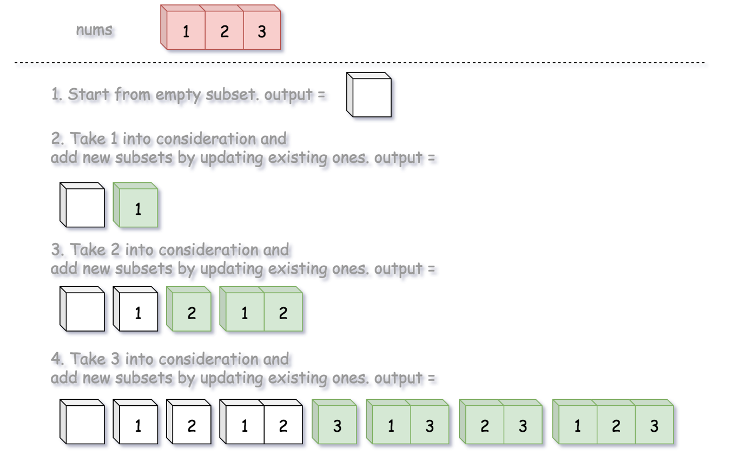

|  |
| --- |
| class Solution {  public List<List<Integer>> subsets(int[] nums) {  List<List<Integer>> output = new ArrayList();  output.add(new ArrayList<Integer>());  for (int num : nums) {  List<List<Integer>> newSubsets = new ArrayList();  for (List<Integer> curr : output) {  newSubsets.add(new ArrayList<Integer>(curr){{add(num);}});  }  for (List<Integer> curr : newSubsets) {  output.add(curr);  }  }  return output;  }  } |

**Complexity Analysis**

* Time complexity: (N * 2^N) to generate all subsets and then copy them into output list.
* Space complexity: O(N * 2^N). This is exactly the number of solutions for subsets multiplied by the number *N* of elements to keep for each subset.
  + For a given number, it could be present or absent (i.e. binary choice) in a subset solution. As as result, for *N* numbers, we would have in total 2^N choices (solutions).

#### **Approach 2: Backtracking**

**Algorithm**

Power set is all possible combinations of all possible lengths, from 0 to n.

Given the definition, the problem can also be interpreted as finding the power set from a sequence.

So, this time let us loop over the length of combination, rather than the candidate numbers, and generate all combinations for a given length with the help of backtracking technique.

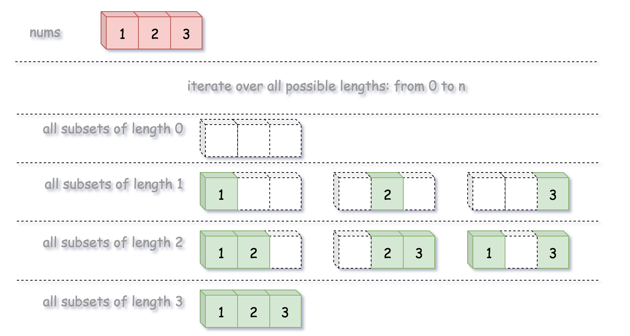

[Backtracking](https://en.wikipedia.org/wiki/Backtracking) is an algorithm for finding all solutions by exploring all potential candidates. If the solution candidate turns to be not a solution (or at least not the last one), backtracking algorithm discards it by making some changes on the previous step, i.e. backtracks and then try again.

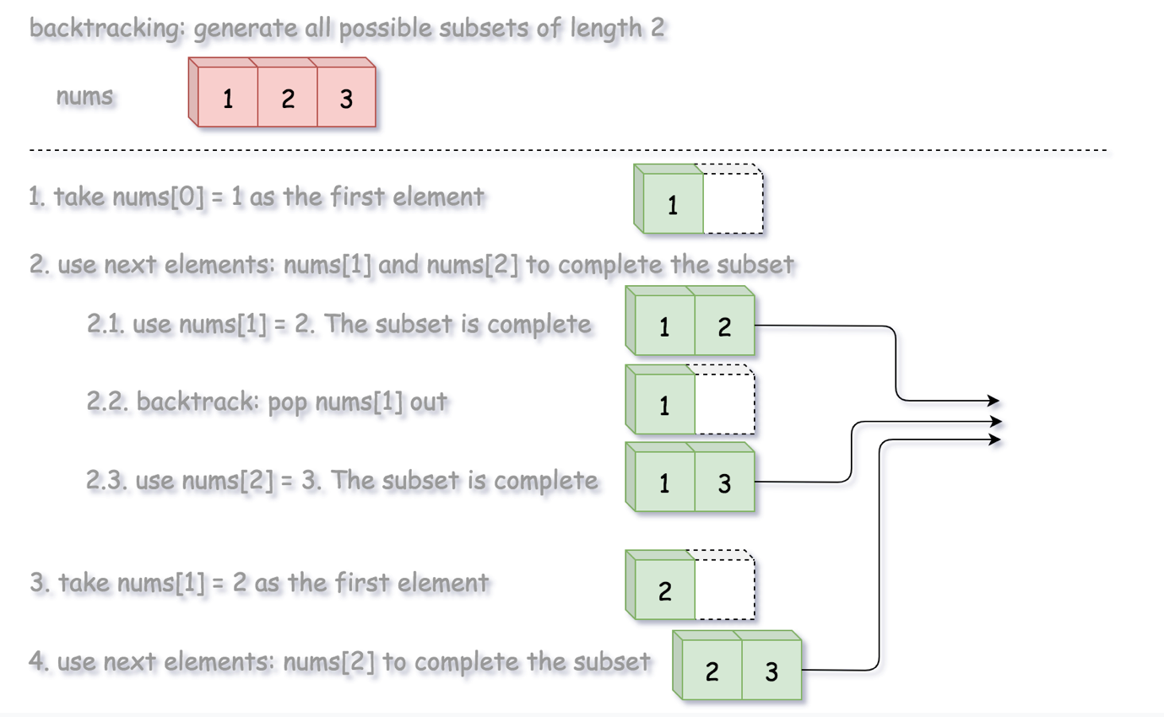

**Algorithm**

We define a backtrack function named backtrack(first, curr) which takes the index of first element to add and a current combination as arguments.

* If the current combination is done, we add the combination to the final output.
* Otherwise, we iterate over the indexes i from first to the length of the entire sequence n.
  + Add integer nums[i] into the current combination curr.
  + Proceed to add more integers into the combination : backtrack(i + 1, curr).
  + Backtrack by removing nums[i] from curr.

**Implementation**

|  |
| --- |
| class Solution {  List<List<Integer>> output = new ArrayList();  int n, k;  public void backtrack(int first, ArrayList<Integer> curr, int[] nums) {  // if the combination is done  if (curr.size() == k)  output.add(new ArrayList(curr));  for (int i = first; i < n; ++i) {  // add i into the current combination  curr.add(nums[i]);  // use next integers to complete the combination  backtrack(i + 1, curr, nums);  // backtrack  curr.remove(curr.size() - 1);  }  }  public List<List<Integer>> subsets(int[] nums) {  n = nums.length;  for (k = 0; k < n + 1; ++k) {  backtrack(0, new ArrayList<Integer>(), nums);  }  return output;  }  } |

**Complexity Analysis**

* Time complexity: O(N * 2^N) to generate all subsets and then copy them into output list.
* Space complexity: (N * 2^N) to keep all the subsets of length *N*, since each of *N* elements could be present or absent.

#### **Approach 3: Lexicographic (Binary Sorted) Subsets**

**Intuition**

The idea of this solution is originated from [Donald E. Knuth](https://www-cs-faculty.stanford.edu/~knuth/taocp.html).

The idea is that we map each subset to a bitmask of length n, where 1 on the ith position in bitmask means the presence of nums[i] in the subset, and 0 means its absence.

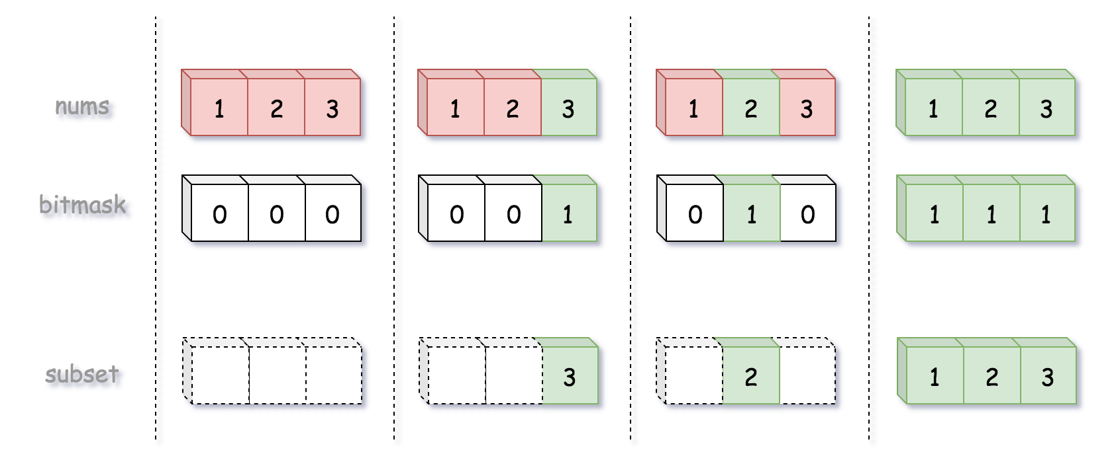

For instance, the bitmask 0..00 (all zeros) corresponds to an empty subset, and the bitmask 1..11 (all ones) corresponds to the entire input array nums.

Hence to solve the initial problem, we just need to generate n bitmasks from 0..00 to 1..11.

It might seem simple at first glance to generate binary numbers, but the real problem here is how to deal with [zero left padding](https://en.wikipedia.org/wiki/Padding_(cryptography)#Zero_padding), because one has to generate bitmasks of fixed length, i.e. 001 and not just 1. For that one could use standard bit manipulation trick:

|  |
| --- |
| int nthBit = 1 << n;  for (int i = 0; i < (int)Math.pow(2, n); ++i) {  // generate bitmask, from 0..00 to 1..11  String bitmask = Integer.toBinaryString(i | nthBit).substring(1); |

or keep it simple stupid and shift iteration limits:

|  |
| --- |
| for (int i = (int)Math.pow(2, n); i < (int)Math.pow(2, n + 1); ++i) {  // generate bitmask, from 0..00 to 1..11  String bitmask = Integer.toBinaryString(i).substring(1); |

**Algorithm**

* Generate all possible binary bitmasks of length n.
* Map a subset to each bitmask: 1 on the i*th* position in bitmask means the presence of nums[i] in the subset, and 0 means its absence.
* Return output list.

**Implementation**

|  |
| --- |
| class Solution {  public List<List<Integer>> subsets(int[] nums) {  List<List<Integer>> output = new ArrayList();  int n = nums.length;  for (int i = (int)Math.pow(2, n); i < (int)Math.pow(2, n + 1); ++i) {  // generate bitmask, from 0..00 to 1..11  String bitmask = Integer.toBinaryString(i).substring(1);  // append subset corresponding to that bitmask  List<Integer> curr = new ArrayList();  for (int j = 0; j < n; ++j) {  if (bitmask.charAt(j) == '1') curr.add(nums[j]);  }  output.add(curr);  }  return output;  }  } |

**Complexity Analysis**

* Time complexity: O(N * 2^N) to generate all subsets and then copy them into output list.
* Space complexity: O(N * 2^N) to keep all the subsets of length *N*, since each of *N* elements could be present or absent.

**Word Search**

Given an m x n board and a word, find if the word exists in the grid.

The word can be constructed from letters of sequentially adjacent cells, where "adjacent" cells are horizontally or vertically neighboring. The same letter cell may not be used more than once.

**Example 1:**

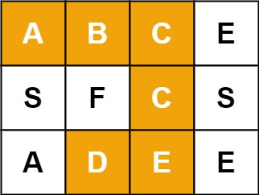

**Input:** board = [["A","B","C","E"],["S","F","C","S"],["A","D","E","E"]], word = "ABCCED"

**Output:** true

**Example 2:**

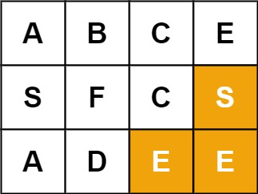

**Input:** board = [["A","B","C","E"],["S","F","C","S"],["A","D","E","E"]], word = "SEE"

**Output:** true

**Example 3:**

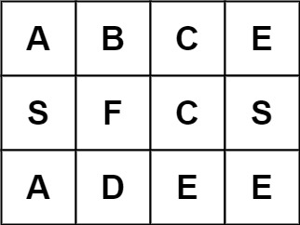

**Input:** board = [["A","B","C","E"],["S","F","C","S"],["A","D","E","E"]], word = "ABCB"

**Output:** false

**Constraints:**

* m == board.length
* n = board[i].length
* 1 <= m, n <= 200
* 1 <= word.length <= 103
* board and word consists only of lowercase and uppercase English letters.

## Solution

#### **Approach 1: Backtracking**

**Intuition**

This problem is yet another 2D grid traversal problem, which is similar with another problem called [489. Robot Room Cleaner](https://leetcode.com/articles/robot-room-cleaner/).

Many people in the [discussion forum](https://leetcode.com/problems/word-search/discuss/) claimed that the solution is of ***DFS*** (Depth-First Search). Although it is true that we would explore the 2D grid with the DFS strategy for this problem, it does not capture the entire nature of the solution.

We argue that a more accurate term to summarize the solution would be ***backtracking***, which is a methodology where we mark the current path of exploration, if the path does not lead to a solution, we then revert the change (i.e. backtracking) and try another path.

As the general idea for the solution, we would walk around the 2D grid, at each step we mark our choice before jumping into the next step. And at the end of each step, we would also revert our marking, so that we could have a clean slate to try another direction. In addition, the exploration is done via the DFS strategy, where we go as further as possible before we try the next direction.

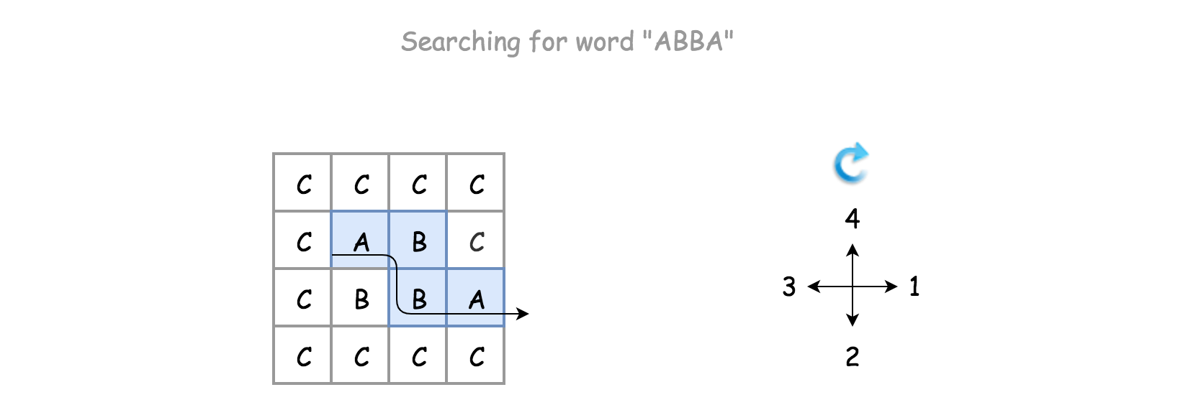

**Algorithm**

There is a certain code pattern for all the algorithms of backtracking. For example, one can find one template in our [Explore card of Recursion II](https://leetcode.com/explore/learn/card/recursion-ii/472/backtracking/2793/).

The skeleton of the algorithm is a loop that iterates through each cell in the grid. For each cell, we invoke the backtracking function (i.e. backtrack()) to check if we would obtain a solution, starting from this very cell.

For the backtracking function backtrack(row, col, suffix), as a DFS algorithm, it is often implemented as a recursive function. The function can be broke down into the following four steps:

* Step 1). At the beginning, first we check if we reach the bottom case of the recursion, where the word to be matched is empty, i.e. we have already found the match for each prefix of the word.
* Step 2). We then check if the current state is invalid, either the position of the cell is out of the boundary of the board or the letter in the current cell does not match with the first letter of the word.
* Step 3). If the current step is valid, we then start the exploration of backtracking with the strategy of DFS. First, we mark the current cell as visited, e.g. any non-alphabetic letter will do. Then we iterate through the four possible directions, namely up, right, down and left. The order of the directions can be altered, to one's preference.
* Step 4). At the end of the exploration, we revert the cell back to its original state. Finally we return the result of the exploration.

We demonstrate how it works with an example in the following animation.

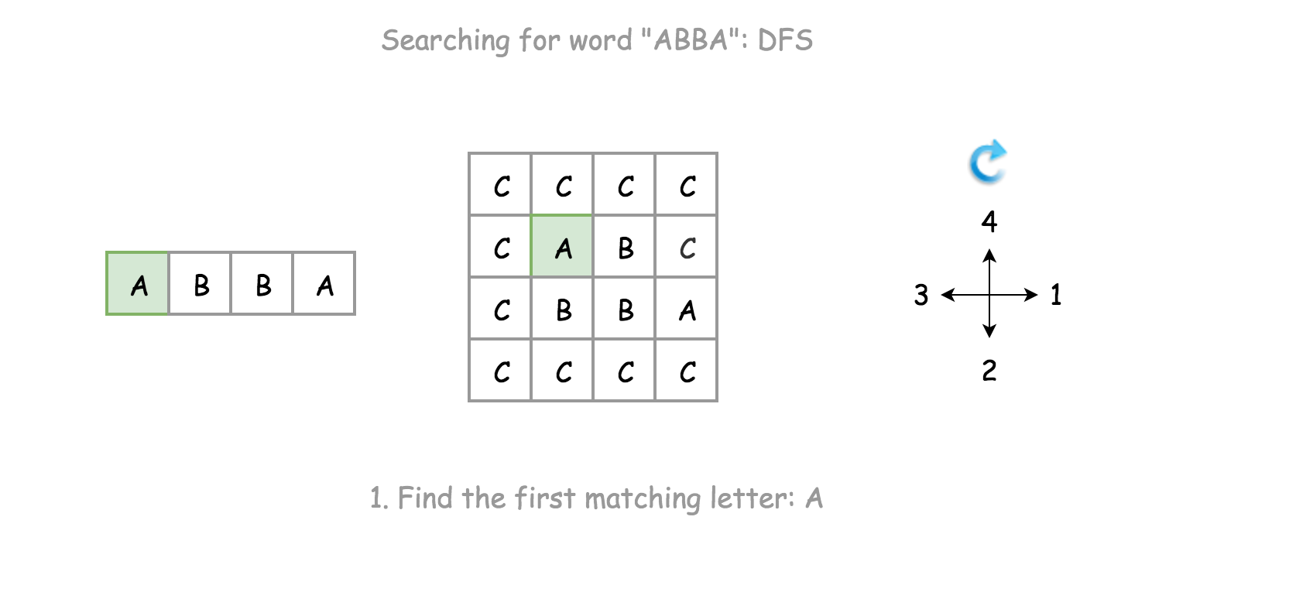

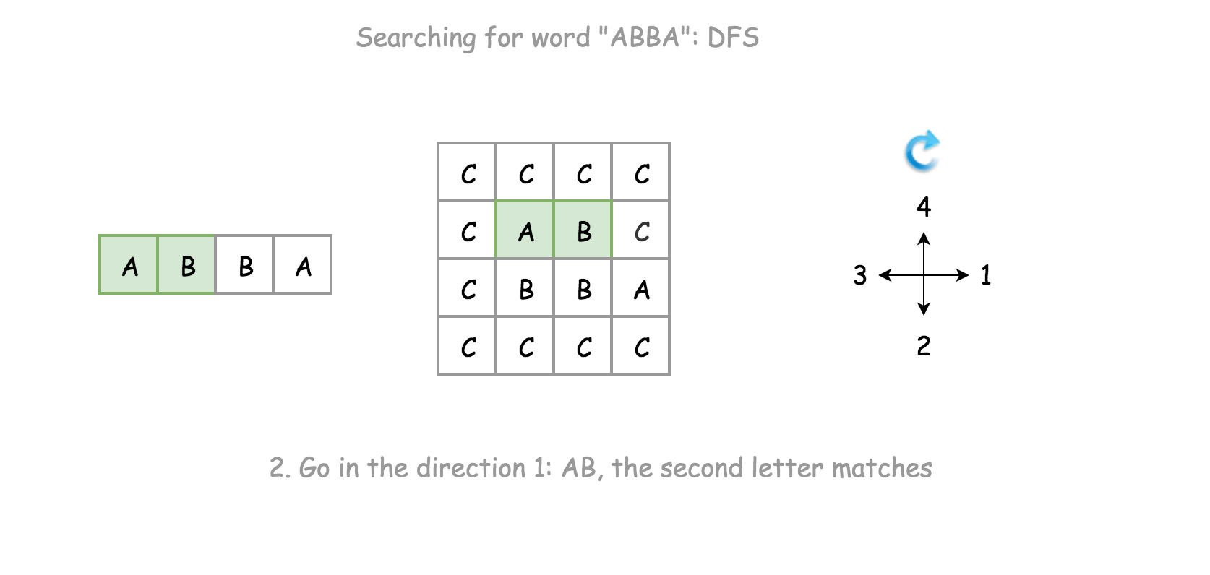

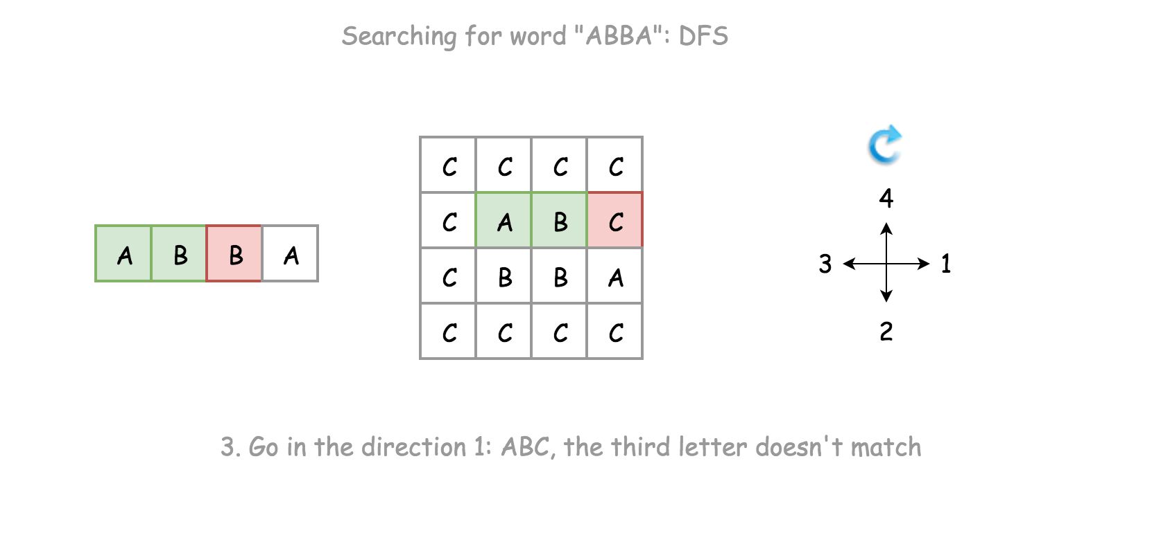

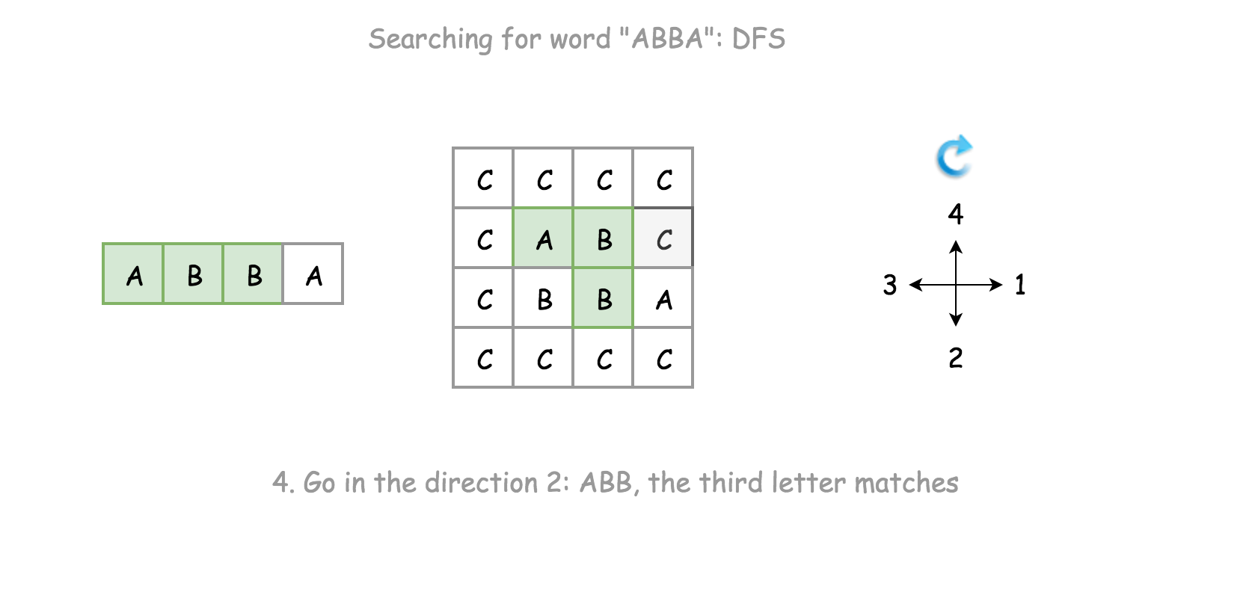

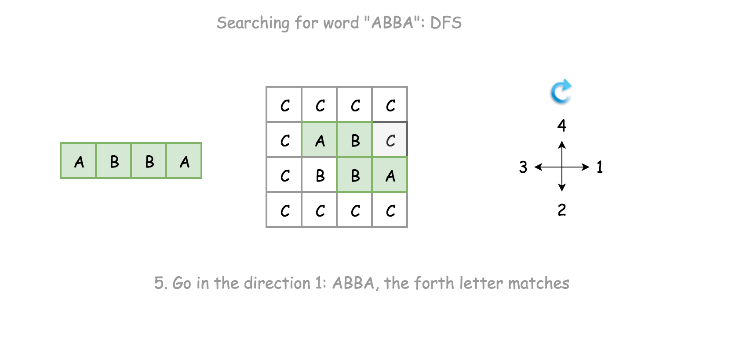

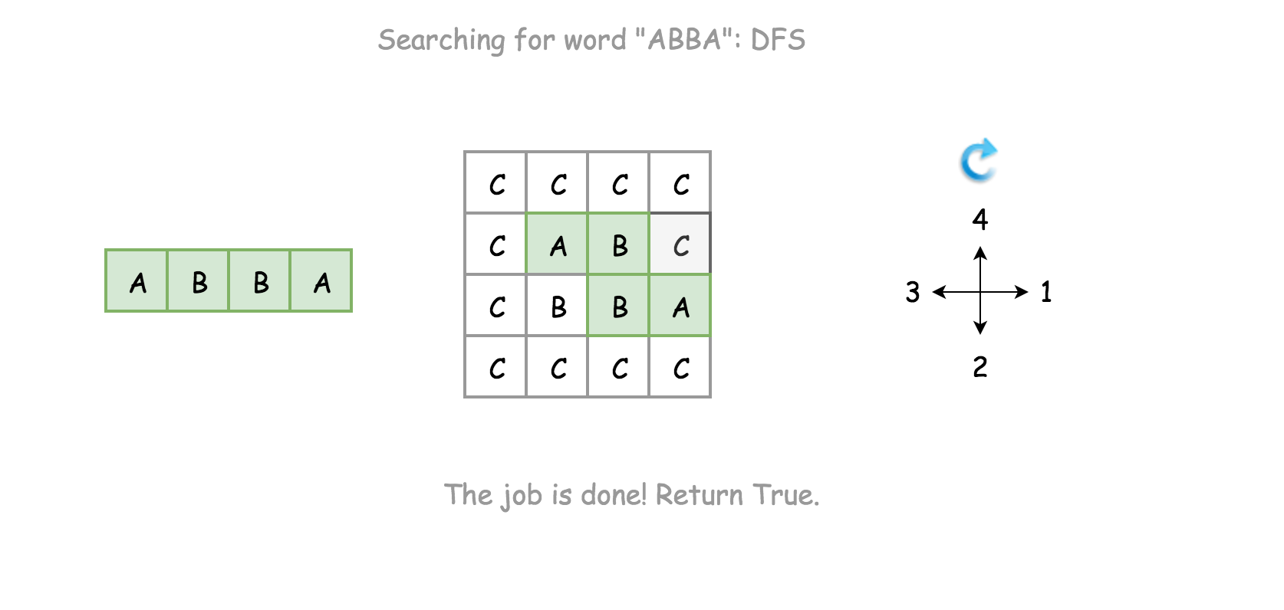

|  |
| --- |
| class Solution {  private char[][] board;  private int ROWS;  private int COLS;  public boolean exist(char[][] board, String word) {  this.board = board;  this.ROWS = board.length;  this.COLS = board[0].length;  for (int row = 0; row < this.ROWS; ++row)  for (int col = 0; col < this.COLS; ++col)  if (this.backtrack(row, col, word, 0))  return true;  return false;  }  protected boolean backtrack(int row, int col, String word, int index) {  /* Step 1). check the bottom case. */  if (index >= word.length())  return true;  /* Step 2). Check the boundaries. */  if (row < 0 || row == this.ROWS || col < 0 || col == this.COLS  || this.board[row][col] != word.charAt(index))  return false;  /* Step 3). explore the neighbors in DFS */  boolean ret = false;  // mark the path before the next exploration  this.board[row][col] = '#';  int[] rowOffsets = {0, 1, 0, -1};  int[] colOffsets = {1, 0, -1, 0};  for (int d = 0; d < 4; ++d) {  ret = this.backtrack(row + rowOffsets[d], col + colOffsets[d], word, index + 1);  if (ret)  break;  }  /* Step 4). clean up and return the result. */  this.board[row][col] = word.charAt(index);  return ret;  }  } |

**Notes**

There are a few choices that we made for our backtracking algorithm, here we elaborate some thoughts that are behind those choices.

Instead of returning directly once we find a match, we simply break out of the loop and do the cleanup before returning.

Here is what the alternative solution might look like.

|  |
| --- |
| protected boolean backtrack(int row, int col, String word, int index) {  /* Step 1). check the bottom case. */  if (index >= word.length())  return true;  /* Step 2). Check the boundaries. */  if (row < 0 || row == this.ROWS || col < 0 || col == this.COLS  || this.board[row][col] != word.charAt(index))  return false;  /* Step 3). explore the neighbors in DFS */  // mark the path before the next exploration  this.board[row][col] = '#';  int[] rowOffsets = {0, 1, 0, -1};  int[] colOffsets = {1, 0, -1, 0};  for (int d = 0; d < 4; ++d) {  if (this.backtrack(row + rowOffsets[d], col + colOffsets[d], word, index + 1))  // return without cleanup  return true;  }  /* Step 4). clean up and return the result. */  this.board[row][col] = word.charAt(index);  return false;  } |

As once notices, we simply return True if the result of recursive call to backtrack() is positive. Though this minor modification would have no impact on the time or space complexity, it would however leave with some "side-effect", *i.e.* the matched letters in the original board would be altered to #.

Instead of doing the boundary checks before the recursive call on the backtrack() function, we do it within the function.

This is an important choice though. Doing the boundary check within the function would allow us to reach the bottom case, for the test case where the board contains only a single cell, since either of neighbor indices would not be valid.

**Complexity Analysis**

* Time Complexity: 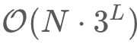 where *N* is the number of cells in the board and *L* is the length of the word to be matched.
  + For the backtracking function, initially we could have at most 4 directions to explore, but further the choices are reduced into 3 (since we won't go back to where we come from). As a result, the execution trace after the first step could be visualized as a 3-ary tree, each of the branches represent a potential exploration in the corresponding direction. Therefore, in the worst case, the total number of invocation would be the number of nodes in a full 3-nary tree, which is about 3^L.
  + We iterate through the board for backtracking, *i.e.* there could be *N* times invocation for the backtracking function in the worst case.
  + As a result, overall the time complexity of the algorithm would be .
* Space Complexity: O(*L*) where *L* is the length of the word to be matched.
  + The main consumption of the memory lies in the recursion call of the backtracking function. The maximum length of the call stack would be the length of the word. Therefore, the space complexity of the algorithm is O(*L*).

**Sorting and Searching**

These problems deal with sorting or searching in a sorted structure.

We recommend: Sort Colors, Search for a Range, Merge Intervals, Search in Rotated Sorted Array, Meeting Rooms II and Search a 2D Matrix II.

Sort Colors

 Top K Frequent Elements

 Kth Largest Element in an Array

 Find Peak Element

 Search for a Range

 Merge Intervals

 Search in Rotated Sorted Array

 Meeting Rooms II

 Search a 2D Matrix II

**Sort Colors**

Given an array nums with n objects colored red, white, or blue, sort them [**in-place**](https://en.wikipedia.org/wiki/In-place_algorithm)so that objects of the same color are adjacent, with the colors in the order red, white, and blue.

We will use the integers 0, 1, and 2 to represent the color red, white, and blue, respectively.

**Example 1:**

**Input:** nums = [2,0,2,1,1,0]

**Output:** [0,0,1,1,2,2]

**Example 2:**

**Input:** nums = [2,0,1]

**Output:** [0,1,2]

**Example 3:**

**Input:** nums = [0]

**Output:** [0]

**Example 4:**

**Input:** nums = [1]

**Output:** [1]

**Constraints:**

* n == nums.length
* 1 <= n <= 300
* nums[i] is 0, 1, or 2.

**Follow up:**

* Could you solve this problem without using the library's sort function?
* Could you come up with a one-pass algorithm using only O(1) constant space?

Hide Hint #1

A rather straight forward solution is a two-pass algorithm using counting sort.

   Hide Hint #2

Iterate the array counting number of 0's, 1's, and 2's.

   Hide Hint #3

Overwrite array with the total number of 0's, then 1's and followed by 2's.

## Solution

#### **Approach 1: One Pass**

**Intuition**

The problem is known as [Dutch National Flag Problem](https://en.wikipedia.org/wiki/Dutch_national_flag_problem) and first was proposed by [Edsger W. Dijkstra](https://en.wikipedia.org/wiki/Edsger_W._Dijkstra). The idea is to attribute a color to each number and then to arrange them following the order of colors on the Dutch flag.

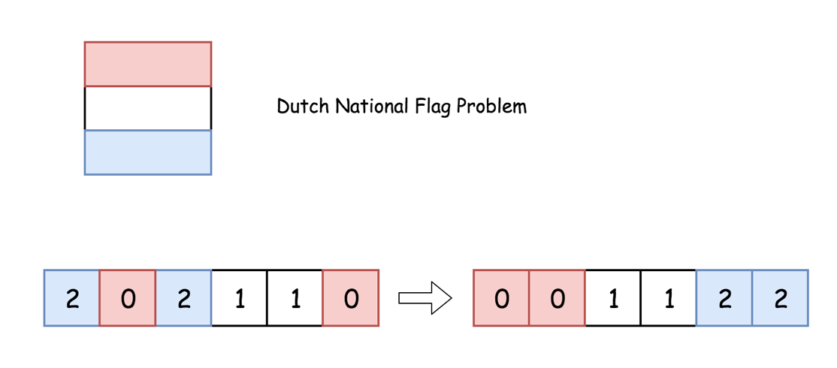

Let's use here three pointers to track the rightmost boundary of zeros, the leftmost boundary of twos and the current element under the consideration.

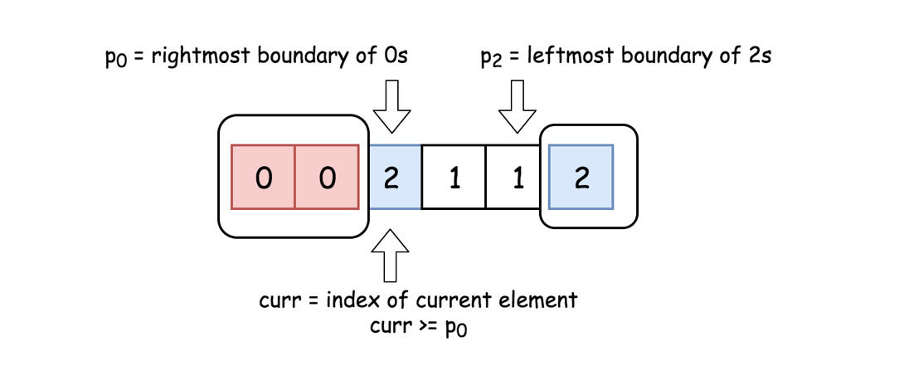

The idea of solution is to move curr pointer along the array, if nums[curr] = 0 - swap it with nums[p0], if nums[curr] = 2 - swap it with nums[p2].

**Algorithm**

* Initialise the rightmost boundary of zeros : p0 = 0. During the algorithm execution nums[idx < p0] = 0.
* Initialise the leftmost boundary of twos : p2 = n - 1. During the algorithm execution nums[idx > p2] = 2.
* Initialise the index of current element to consider : curr = 0.
* While curr <= p2 :
  + If nums[curr] = 0 : swap currth and p0th elements and move both pointers to the right.
  + If nums[curr] = 2 : swap currth and p2th elements. Move pointer p2 to the left.
  + If nums[curr] = 1 : move pointer curr to the right.

**Implementation**

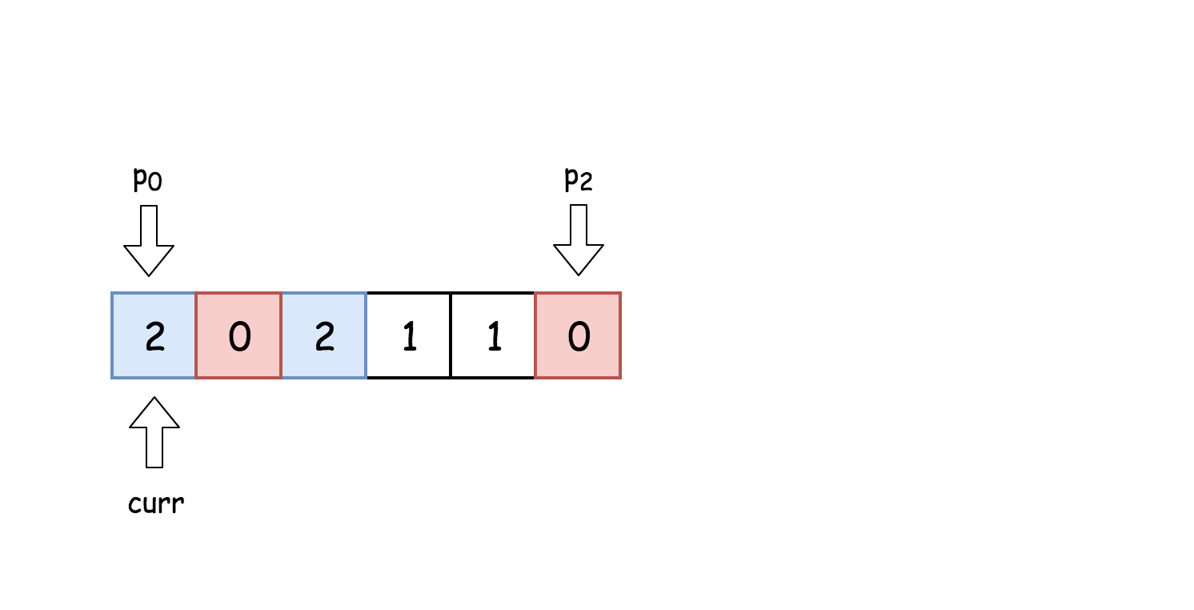

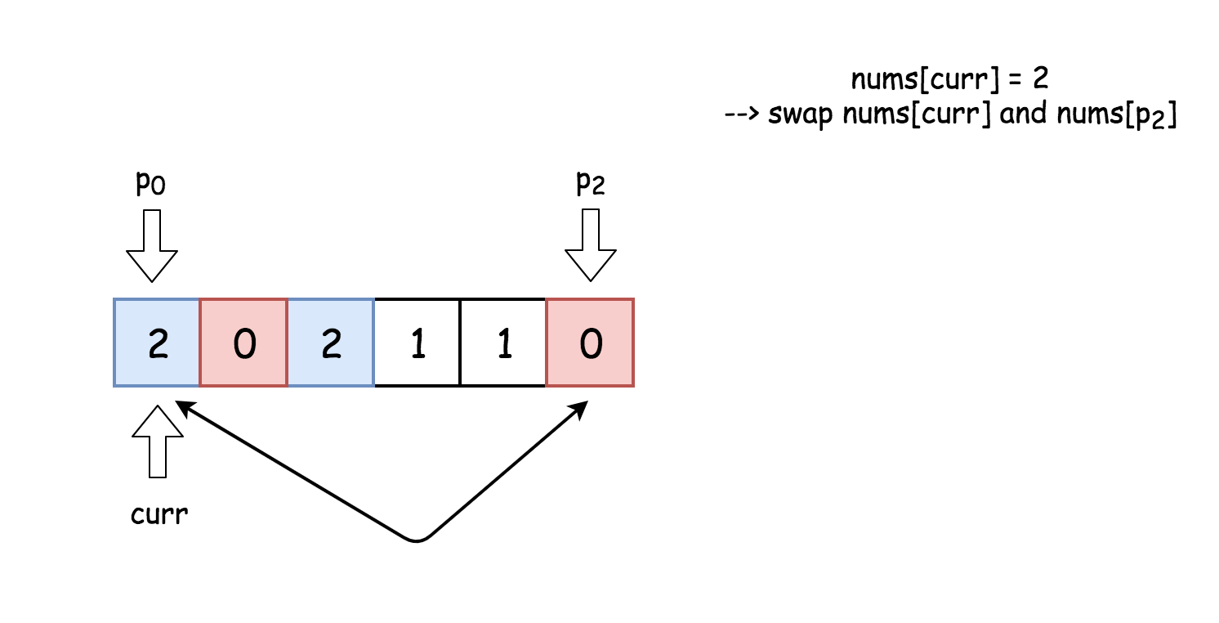

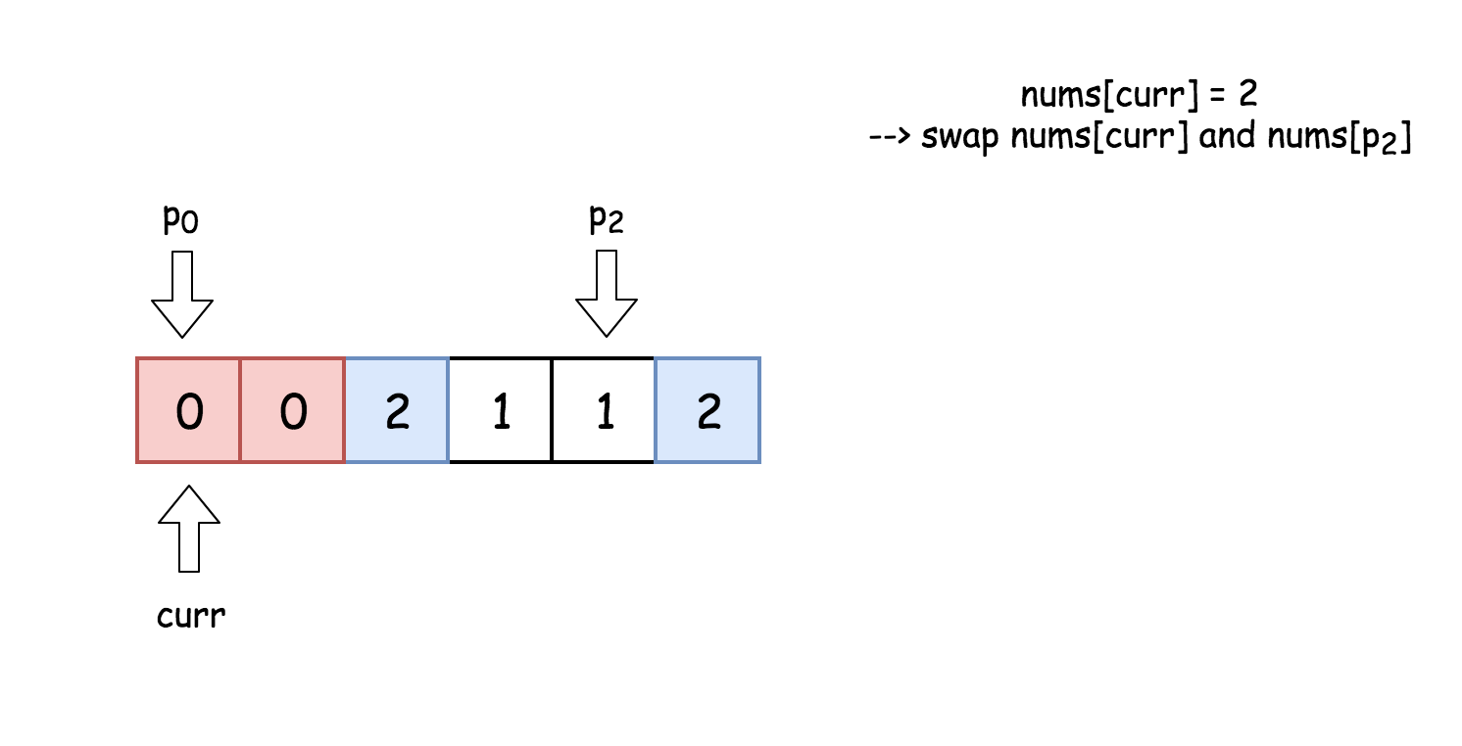

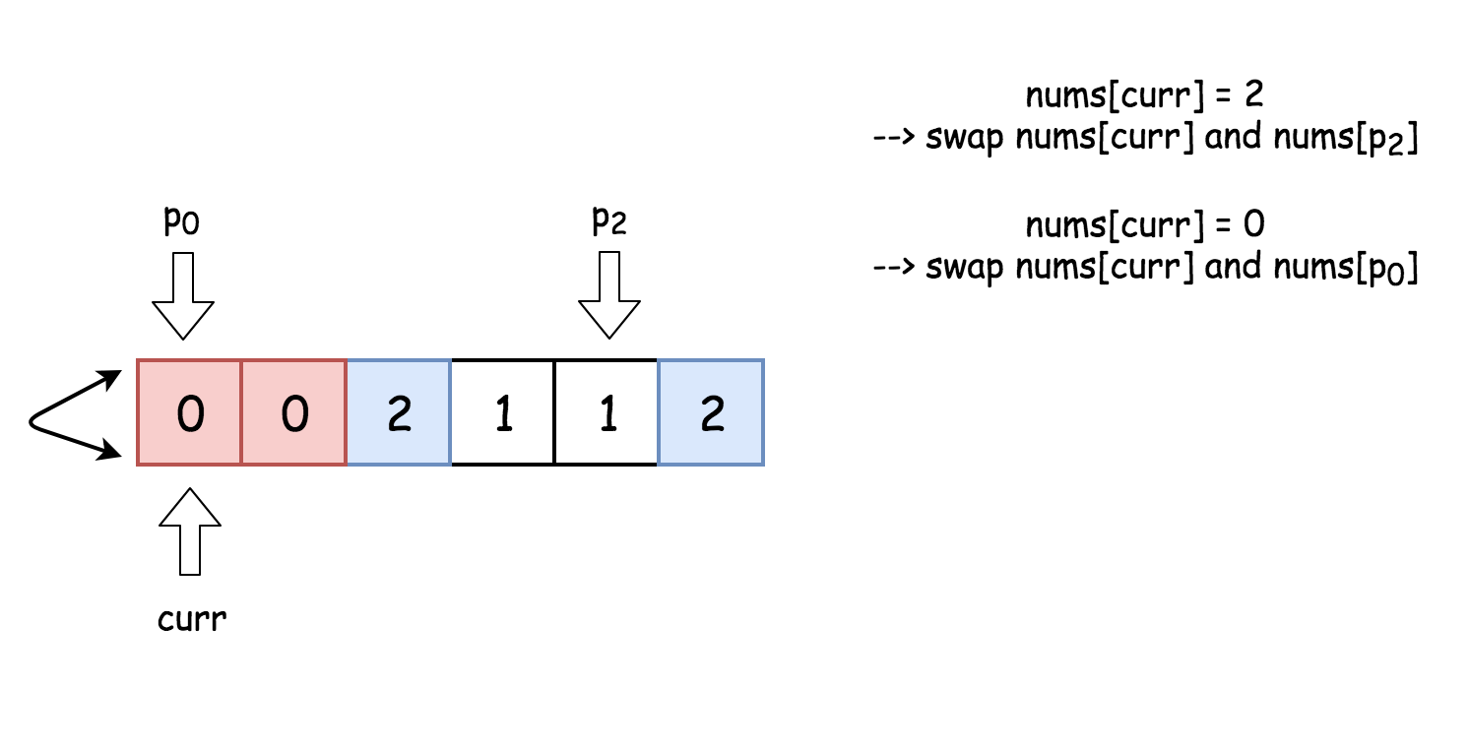

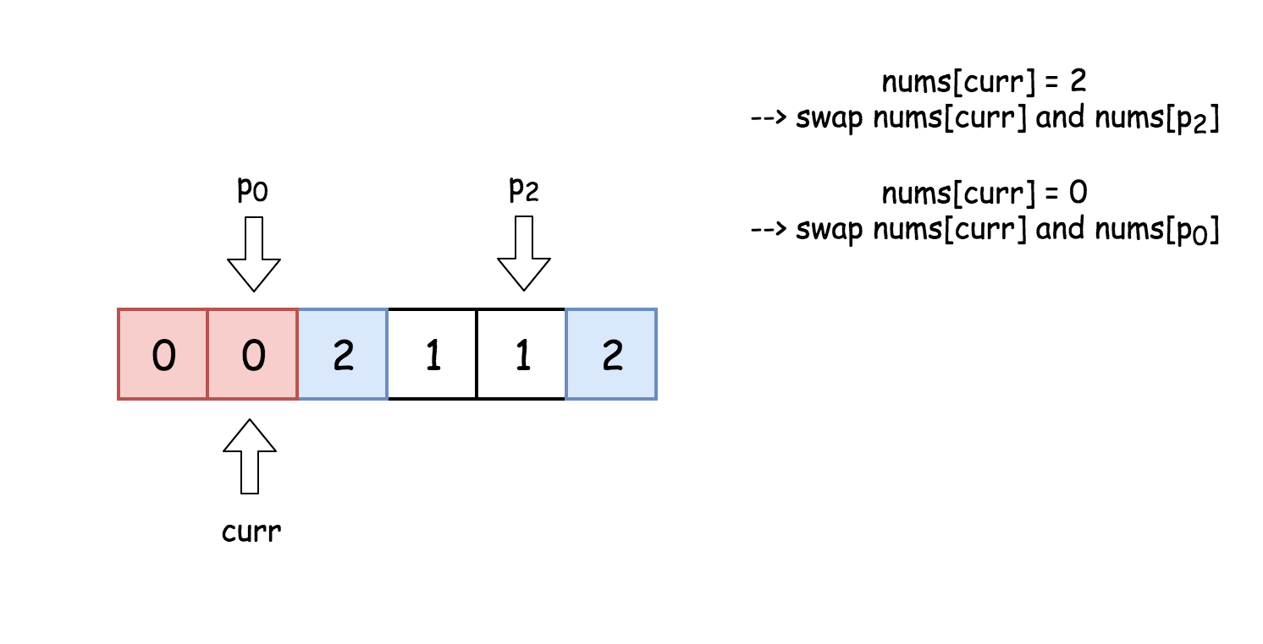

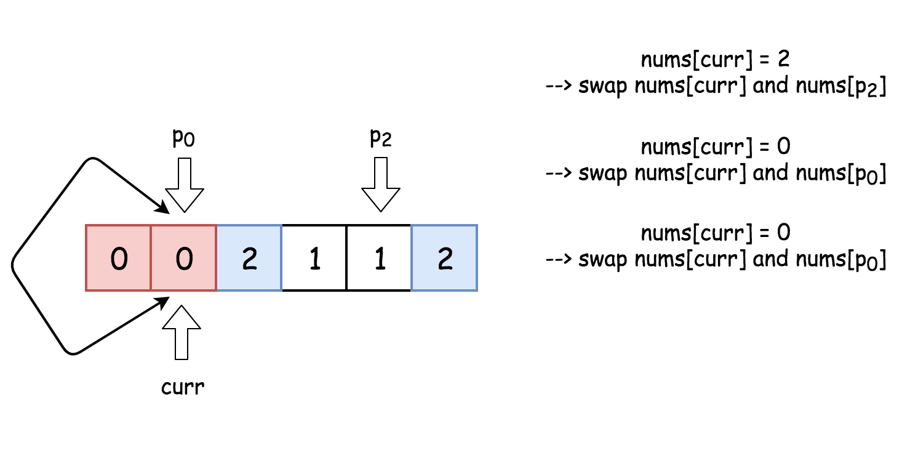

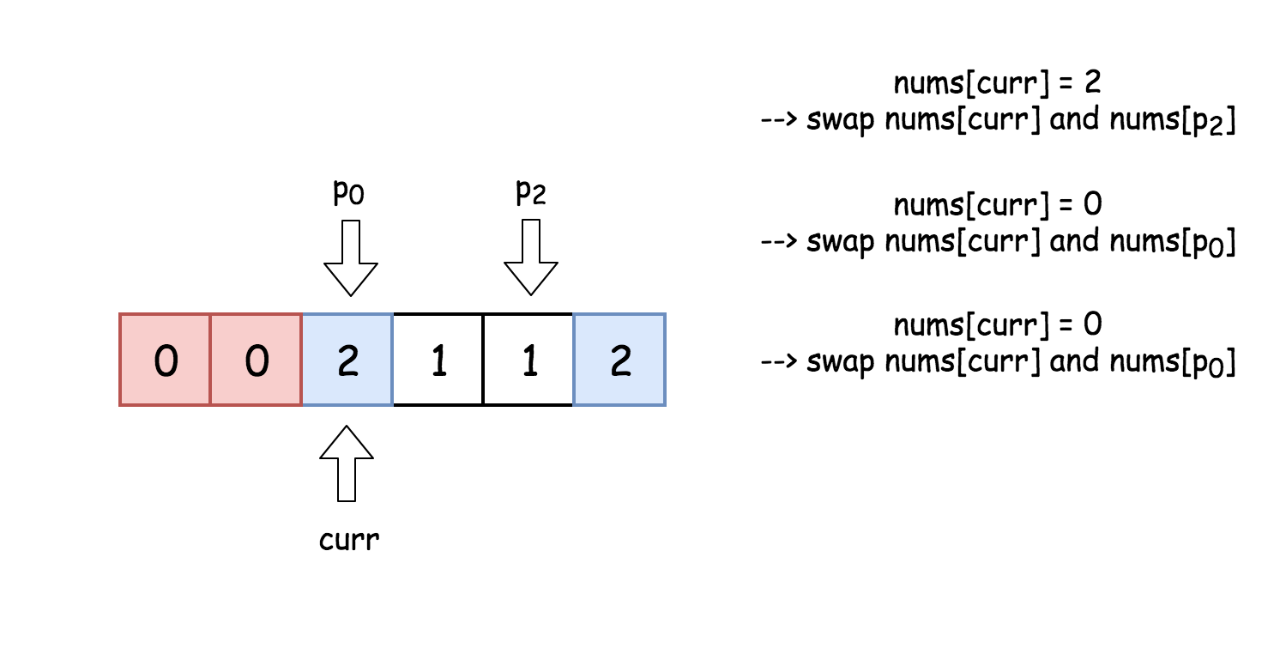

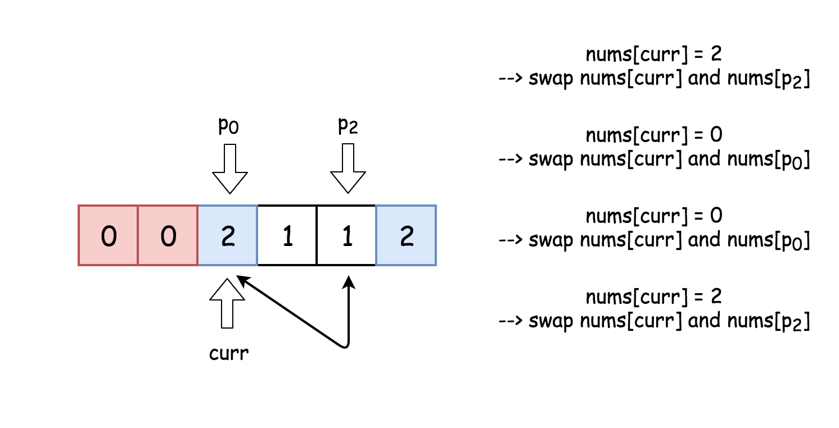

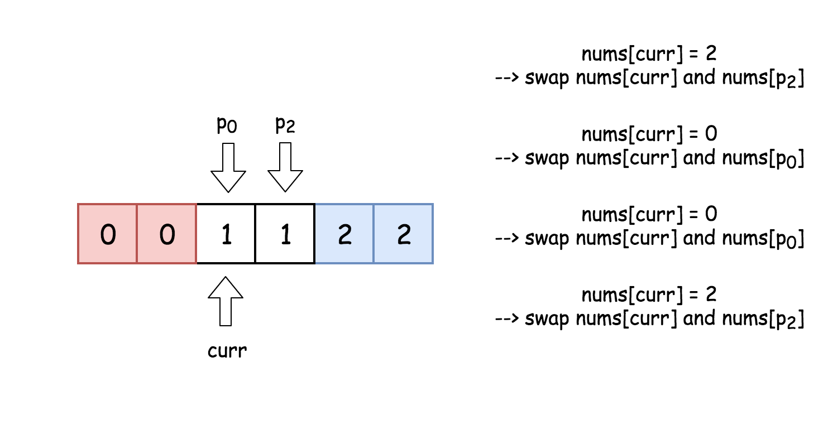

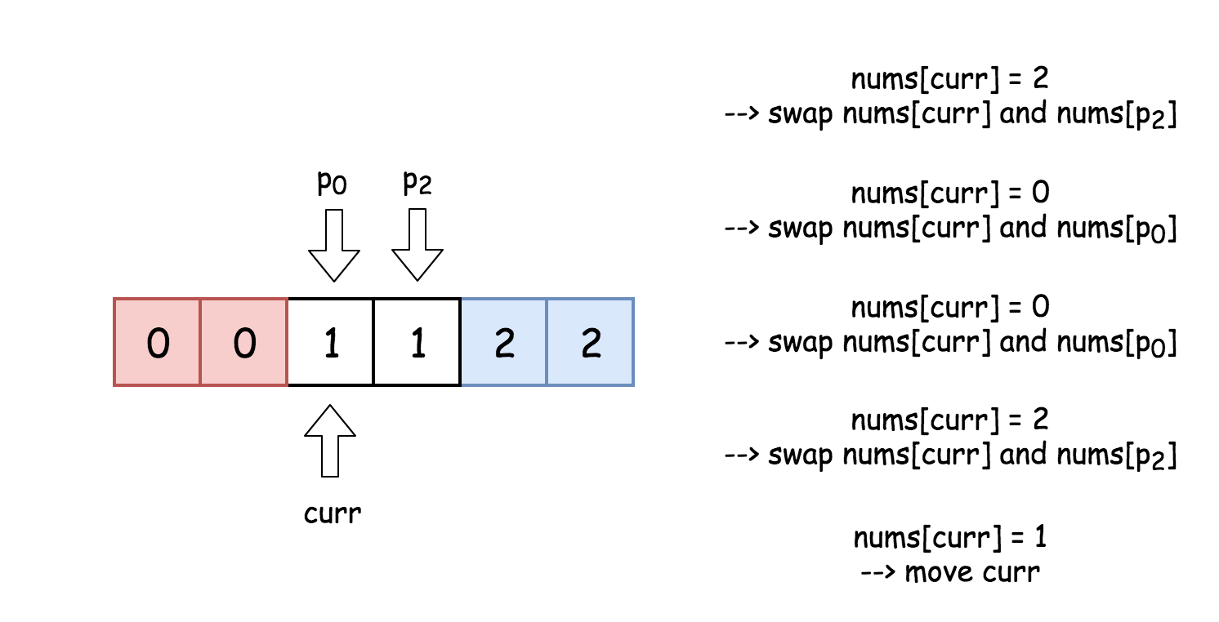

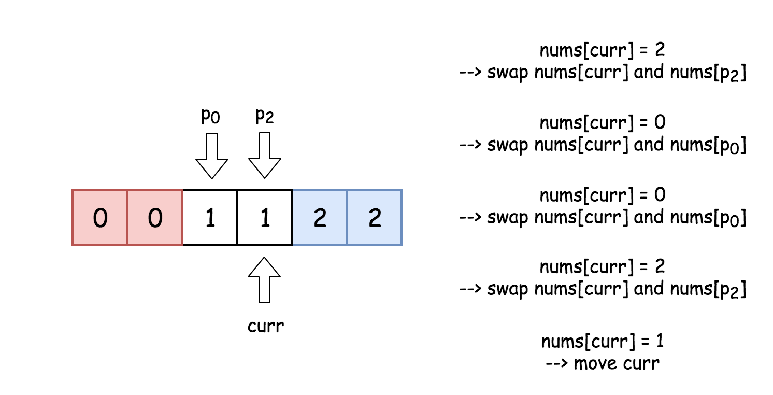

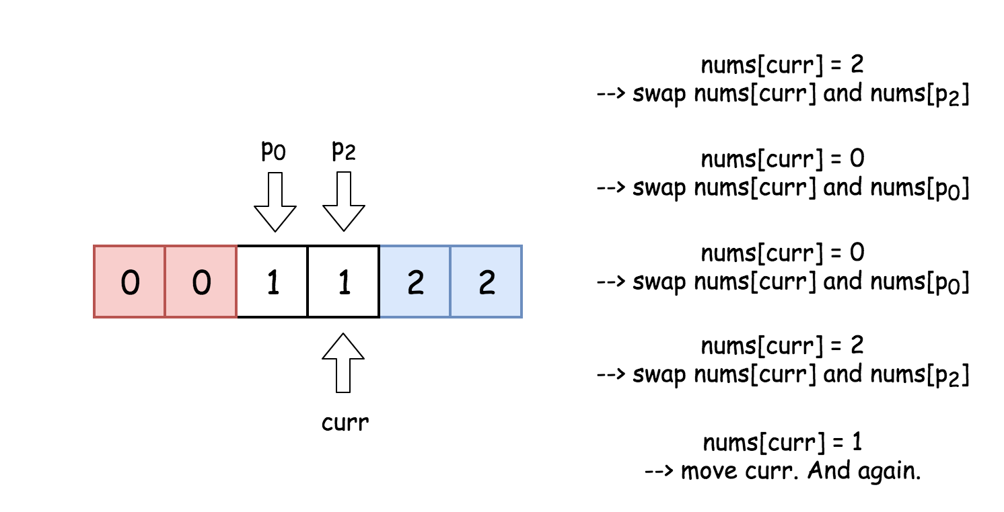

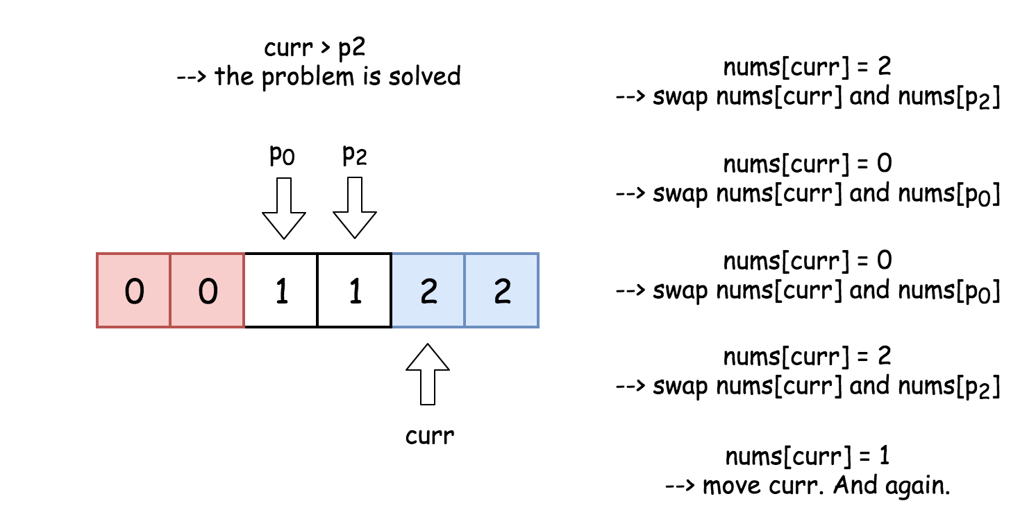

|  |
| --- |
| class Solution {  /*  Dutch National Flag problem solution.  */  public void sortColors(int[] nums) {  // for all idx < i : nums[idx < i] = 0  // j is an index of element under consideration  int p0 = 0, curr = 0;  // for all idx > k : nums[idx > k] = 2  int p2 = nums.length - 1;  int tmp;  while (curr <= p2) {  if (nums[curr] == 0) {  // swap p0-th and curr-th elements  // i++ and j++  tmp = nums[p0];  nums[p0++] = nums[curr];  nums[curr++] = tmp;  }  else if (nums[curr] == 2) {  // swap k-th and curr-th elements  // p2--  tmp = nums[curr];  nums[curr] = nums[p2];  nums[p2--] = tmp;  }  else curr++;  }  }  } |

**Complexity Analysis**

* Time complexity : O(*N*) since it's one pass along the array of length *N*.
* Space complexity : O(1) since it's a constant space solution.

It is actually a dual-pivot partitioning sub-routine of quick sort algorithm. Following is a well organized java code.

|  |
| --- |
| public void sortColors(int[] nums) {  int lo = 0, hi = nums.length - 1, i = 0;    while (i <= hi) {  if (nums[i] == 0) swap(nums, lo++, i++);  else if (nums[i] == 2) swap(nums, i, hi--);  else if (nums[i] == 1) i++;  }  }  private void swap(int[] nums, int i, int j) {  int t = nums[i];  nums[i] = nums[j];  nums[j] = t;  } |

**Top K Frequent Elements**

Given a non-empty array of integers, return the ***k*** most frequent elements.

**Example 1:**

**Input:** nums = [1,1,1,2,2,3], k = 2

**Output:** [1,2]

**Example 2:**

**Input:** nums = [1], k = 1

**Output:** [1]

**Note:**

* You may assume *k* is always valid, 1 ≤ *k* ≤ number of unique elements.
* Your algorithm's time complexity **must be** better than O(*n* log *n*), where *n* is the array's size.
* It's guaranteed that the answer is unique, in other words the set of the top k frequent elements is unique.
* You can return the answer in any order.

## Solution

#### **Approach 1: Heap**

Let's start from the simple [heap](https://en.wikipedia.org/wiki/Heap_(data_structure)) approach with O(*N*log*k*) time complexity. To ensure that O(*N*log*k*) is always less than O(*N*log*N*), the particular case *k*=*N* could be considered separately and solved in O(*N*) time.

**Algorithm**

* The first step is to build a hash map element -> its frequency. In Java, we use the data structure HashMap. Python provides dictionary subclass Counter to initialize the hash map we need directly from the input array.  
  This step takes O(*N*) time where N is a number of elements in the list.
* The second step is to build a heap of size k using N elements. To add the first k elements takes a linear time O(*k*) in the average case, and O(log1+log2+...+log*k*)=O(*logk*!)=O(*k*log*k*) in the worst case. It's equivalent to [heapify implementation in Python](https://hg.python.org/cpython/file/2.7/Lib/heapq.py#l16). After the first k elements we start to push and pop at each step, N - k steps in total. The time complexity of heap push/pop is O(log*k*) and we do it N - k times that means O((*N*−*k*)log*k*) time complexity. Adding both parts up, we get O(*N*log*k*) time complexity for the second step.
* The third and the last step is to convert the heap into an output array. That could be done in O(*k*log*k*) time.

In Python, library heapq provides a method nlargest, which [combines the last two steps under the hood](https://hg.python.org/cpython/file/2.7/Lib/heapq.py#l203) and has the same O(*N*log*k*) time complexity.

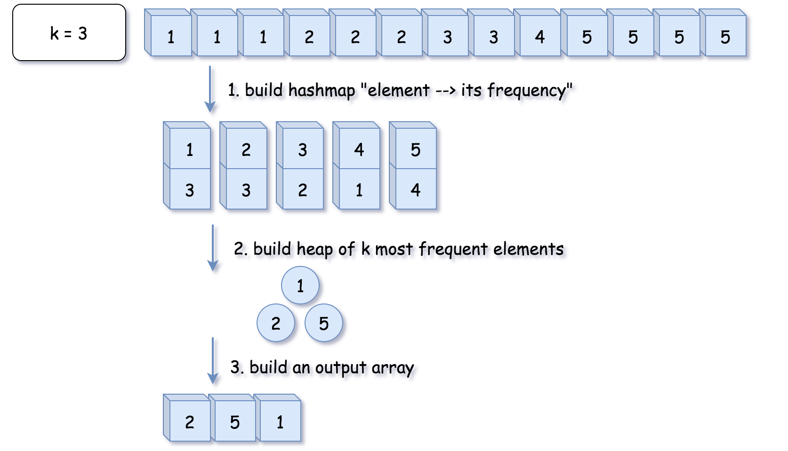

**Implementation**

|  |
| --- |
| class Solution {  public int[] topKFrequent(int[] nums, int k) {  // O(1) time  if (k == nums.length) {  return nums;  }    // 1. build hash map : character and how often it appears  // O(N) time  Map<Integer, Integer> count = new HashMap();  for (int n: nums) {  count.put(n, count.getOrDefault(n, 0) + 1);  }  // init heap 'the less frequent element first'  Queue<Integer> heap = new PriorityQueue<>(  (n1, n2) -> count.get(n1) - count.get(n2));  // 2. keep k top frequent elements in the heap  // O(N log k) < O(N log N) time  for (int n: count.keySet()) {  heap.add(n);  if (heap.size() > k) heap.poll();  }  // 3. build an output array  // O(k log k) time  int[] top = new int[k];  for(int i = k - 1; i >= 0; --i) {  top[i] = heap.poll();  }  return top;  }  } |

**Complexity Analysis**

* Time complexity : O(*N*log*k*) if *k*<*N* and O(*N*) in the particular case of *N*=*k*. That ensures time complexity to be better than O(*N*log*N*).
* Space complexity : O(*N*+*k*) to store the hash map with not more *N* elements and a heap with *k* elements.

#### **Approach 2: Quickselect**

**Hoare's selection algorithm**

Quickselect is a [textbook algorthm](https://en.wikipedia.org/wiki/Quickselect) typically used to solve the problems "find kth something": kth smallest, kth largest, kth most frequent, kth less frequent, etc. Like quicksort, quickselect was developed by [Tony Hoare](https://en.wikipedia.org/wiki/Tony_Hoare), and also known as Hoare's selection algorithm.

It has O(*N*) average time complexity and widely used in practice. It worth to note that its worth case time complexity is O(N^2), although the probability of this worst-case is negligible.

The approach is the same as for quicksort.

One chooses a pivot and defines its position in a sorted array in a linear time using so-called partition algorithm.

As an output, we have an array where the pivot is on its perfect position in the ascending sorted array, sorted by the frequency. All elements on the left of the pivot are less frequent than the pivot, and all elements on the right are more frequent or have the same frequency.

Hence the array is now split into two parts. If by chance our pivot element took N - kth final position, then k*k* elements on the right are these top k*k* frequent we're looking for. If not, we can choose one more pivot and place it in its perfect position.

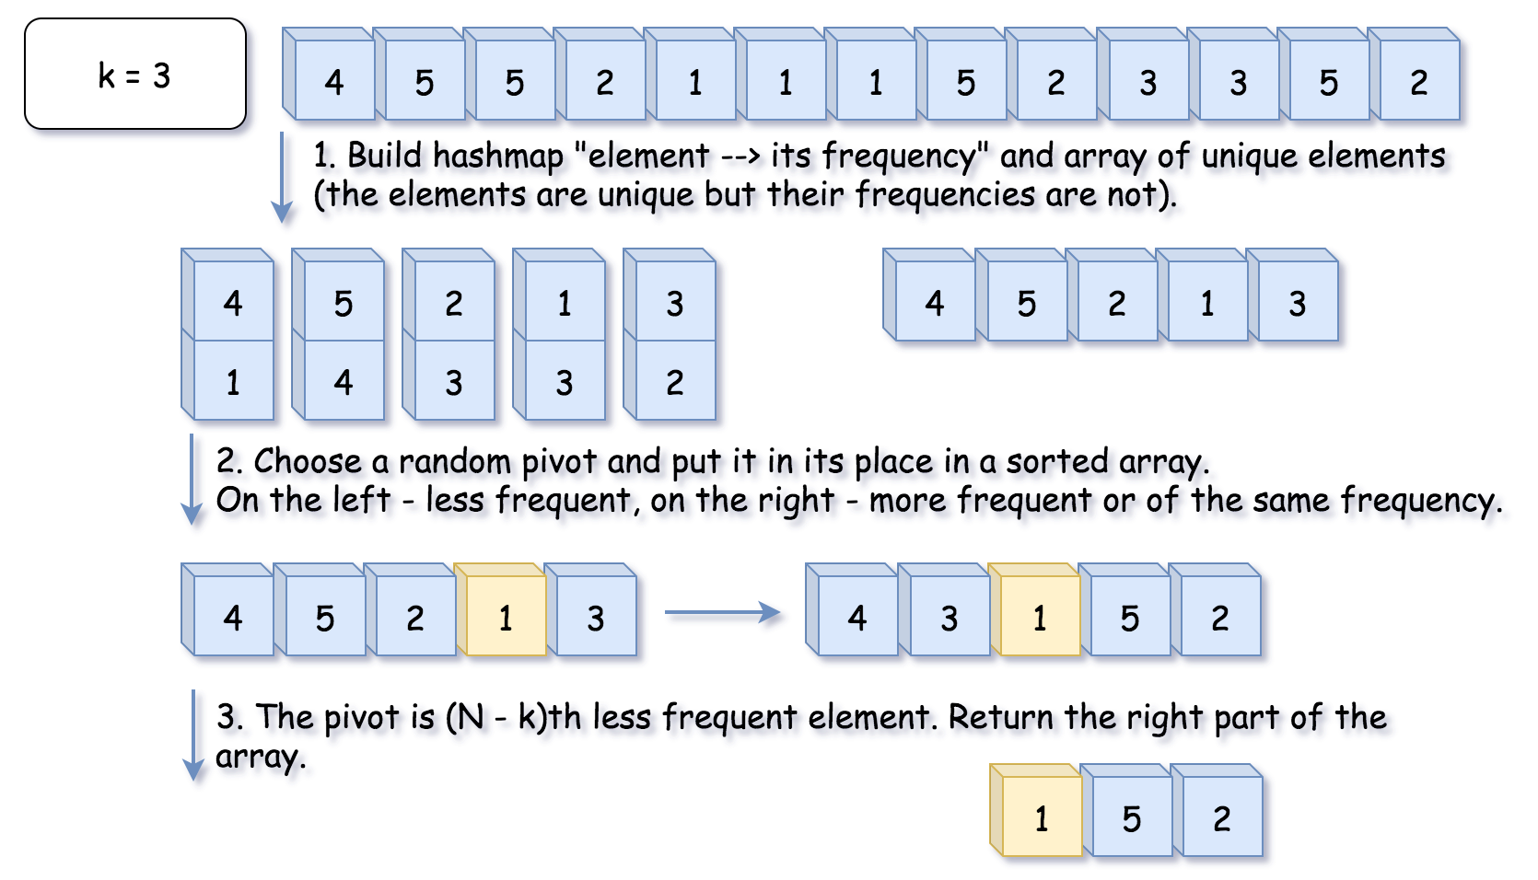

If that were a quicksort algorithm, one would have to process both parts of the array. That would result in O(*N*log*N*) time complexity. In this case, there is no need to deal with both parts since one knows in which part to search for N - kth less frequent element, and that reduces the average time complexity to O(*N*).

**Algorithm**

The algorithm is quite straightforward :

* Build a hash map element -> its frequency and convert its keys into the array unique of unique elements. Note that elements are unique, but their frequencies are not. That means we need a partition algorithm that works fine with duplicates.
* Work with unique array. Use a partition scheme (please check the next section) to place the pivot into its perfect position pivot_index in the sorted array, move less frequent elements to the left of pivot, and more frequent or of the same frequency - to the right.
* Compare pivot_index and N - k.
  + If pivot_index == N - k, the pivot is N - kth most frequent element, and all elements on the right are more frequent or of the same frequency. Return these top k*k* frequent elements.
  + Otherwise, choose the side of the array to proceed recursively.

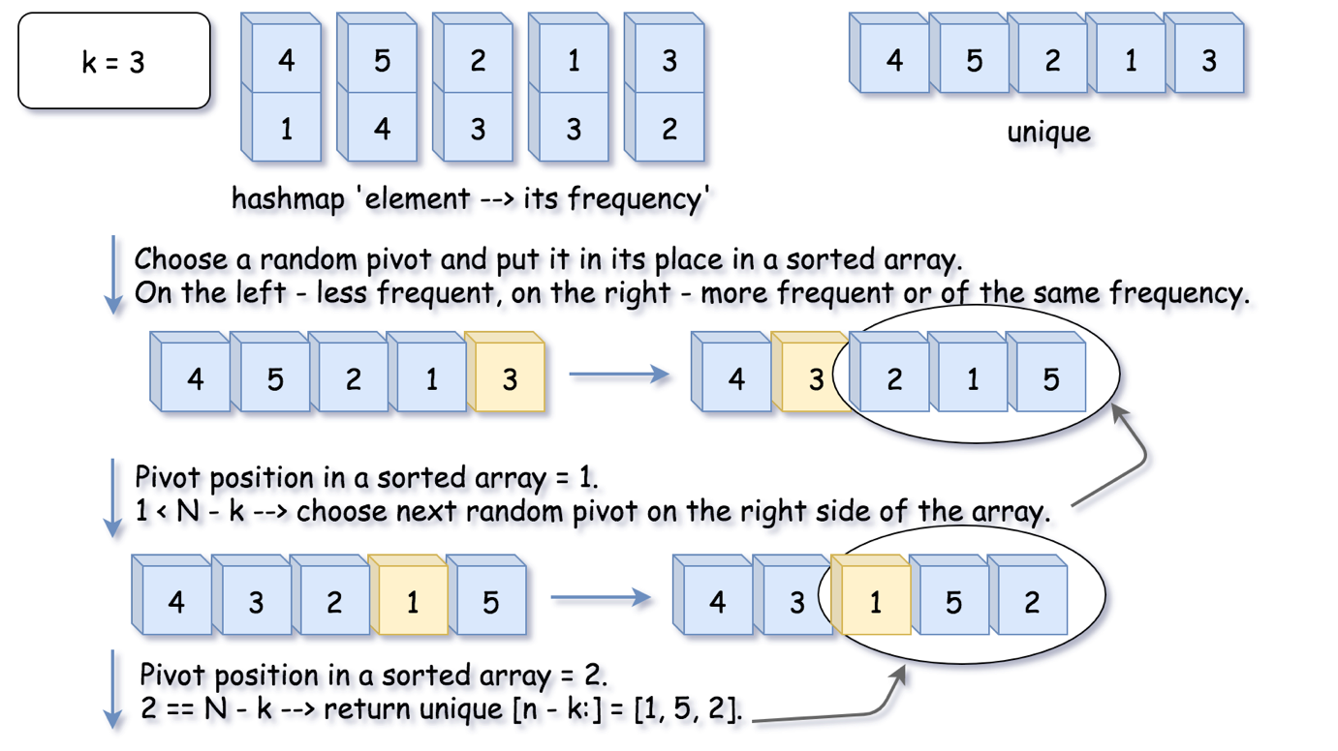

**Hoare's Partition vs Lomuto's Partition**

There is a zoo of partition algorithms. The most simple one is [Lomuto's Partition Scheme](https://en.wikipedia.org/wiki/Quicksort#Lomuto_partition_scheme).

The drawback of Lomuto's partition is it fails with duplicates.

Here we work with an array of unique elements, but they are compared by frequencies, which are not unique. That's why we choose Hoare's Partition here.

Hoare's partition is more efficient than Lomuto's partition because it does three times fewer swaps on average, and creates efficient partitions even when all values are equal.

Here is how it works:

* Move pivot at the end of the array using swap.
* Set the pointer at the beginning of the array store_index = left.
* Iterate over the array and move all less frequent elements to the left swap(store_index, i). Move store_index one step to the right after each swap.
* Move the pivot to its final place, and return this index.

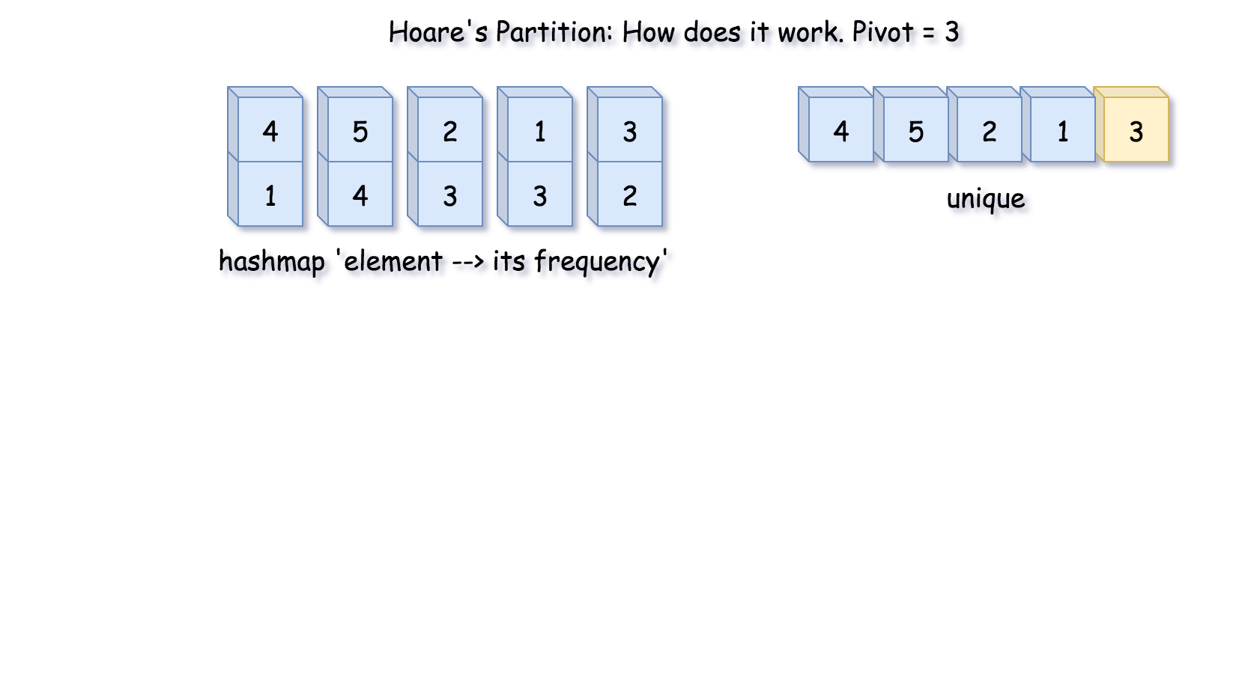

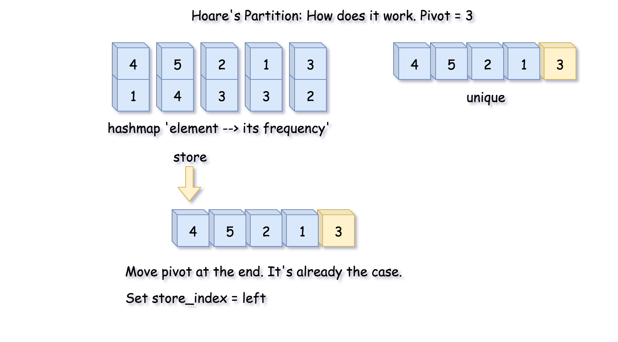

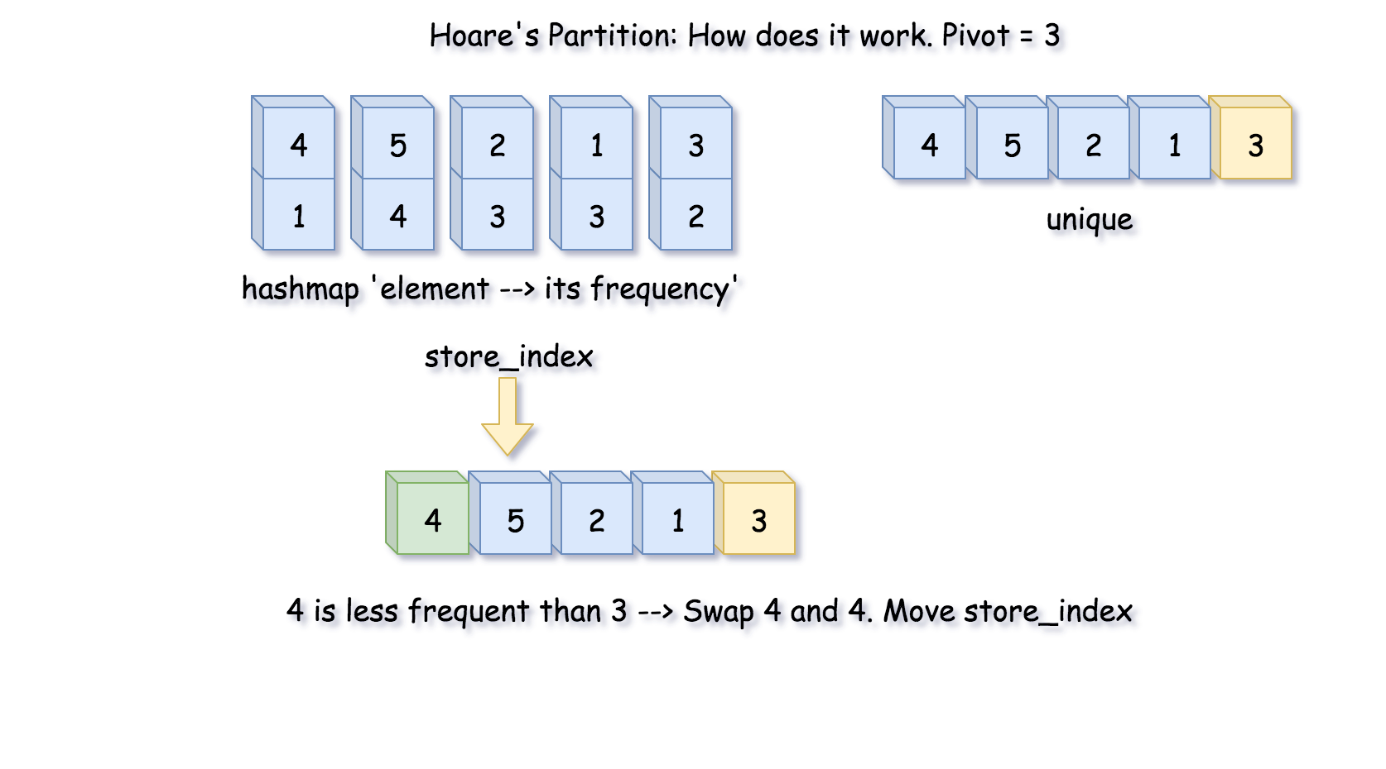

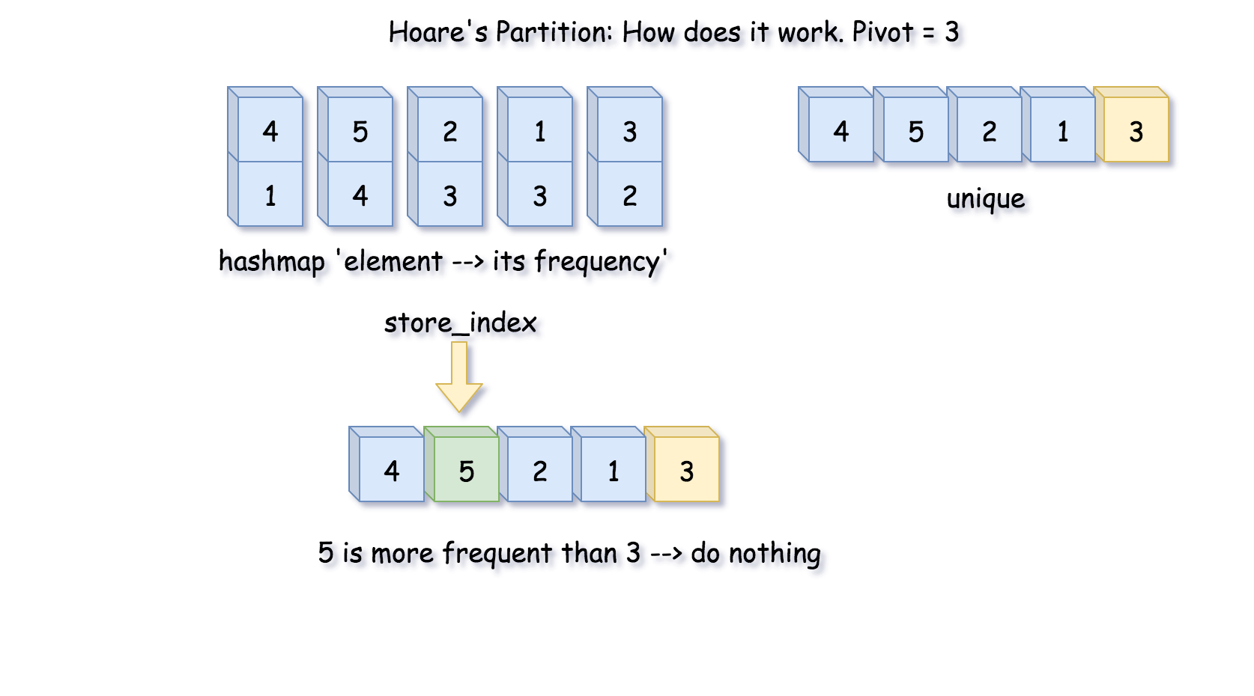

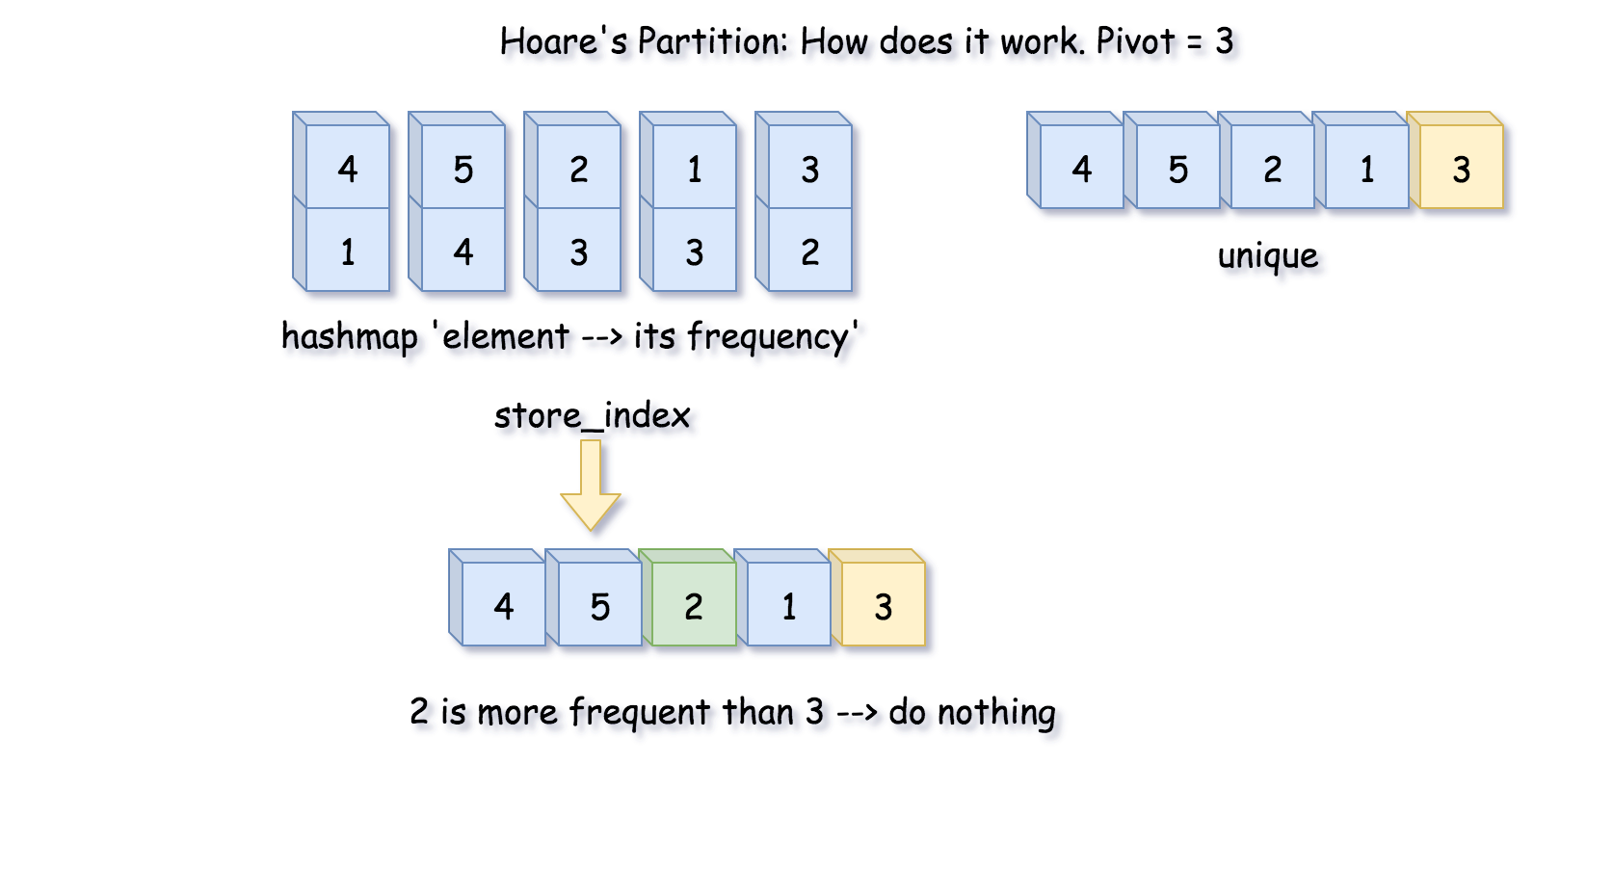

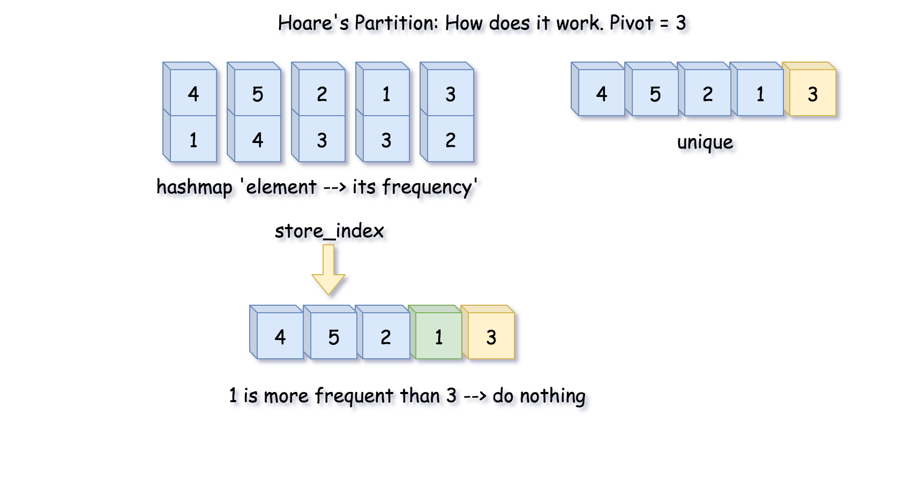

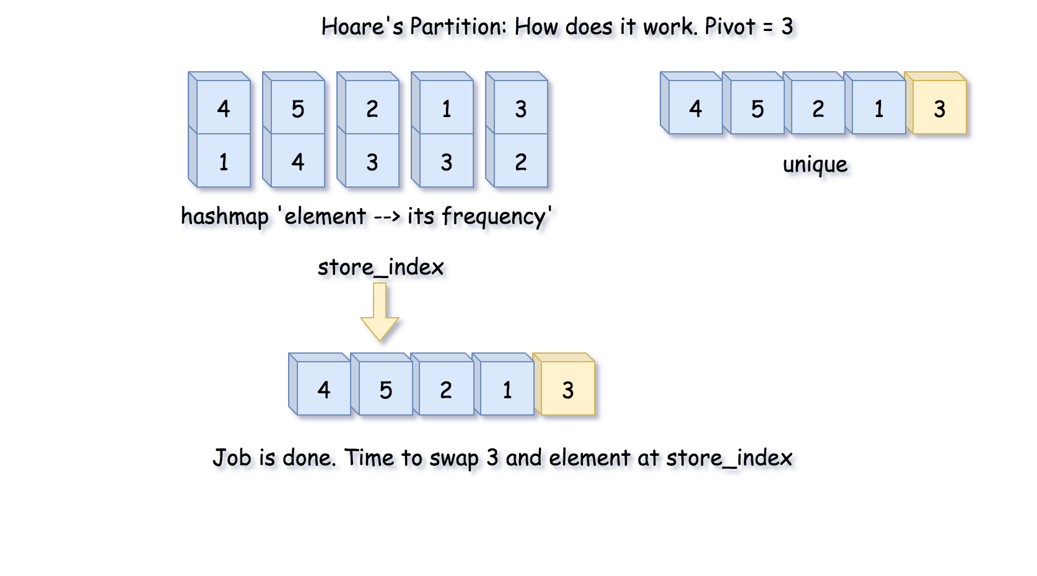

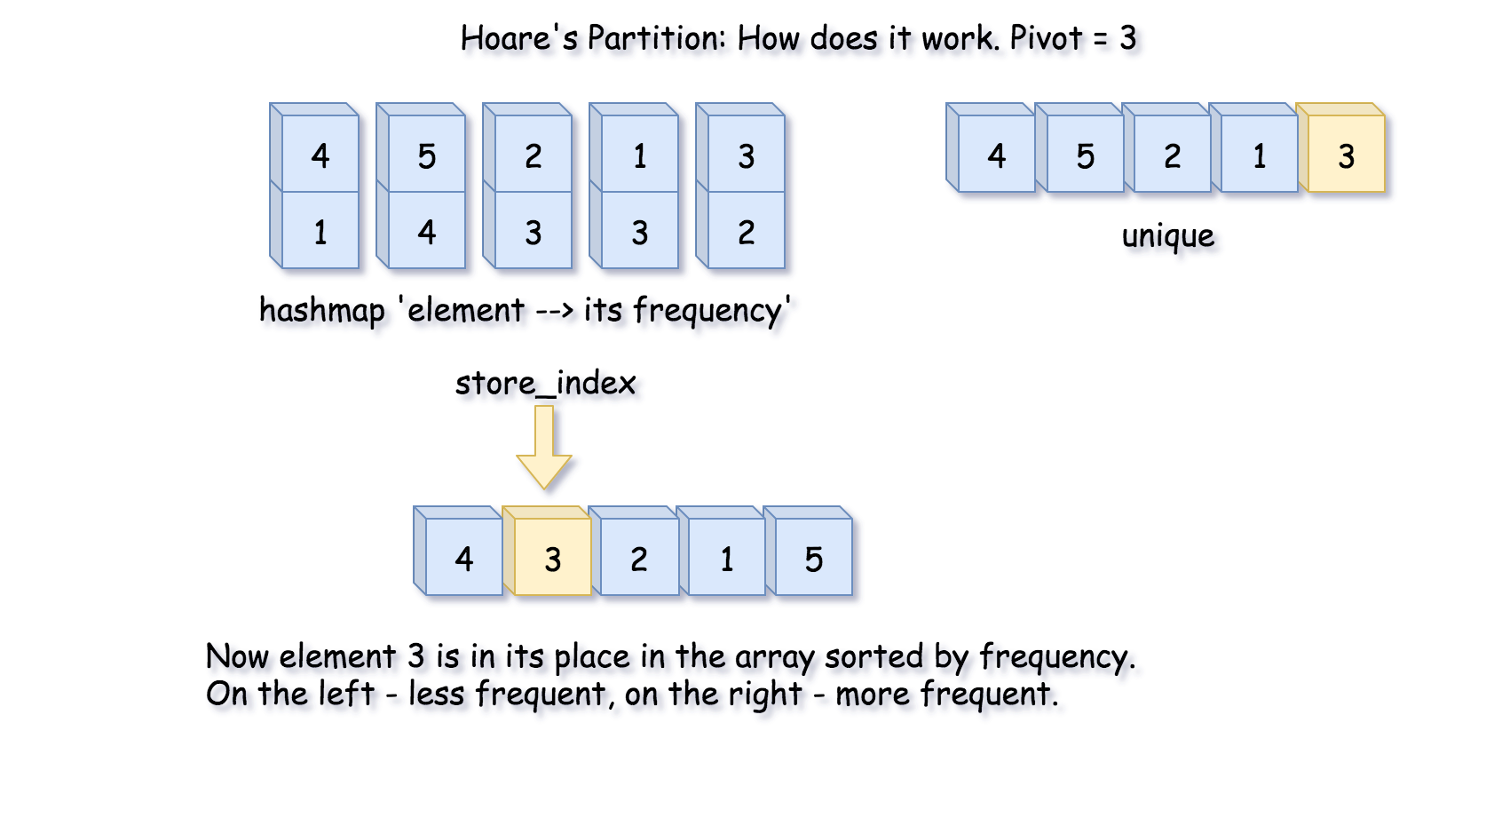

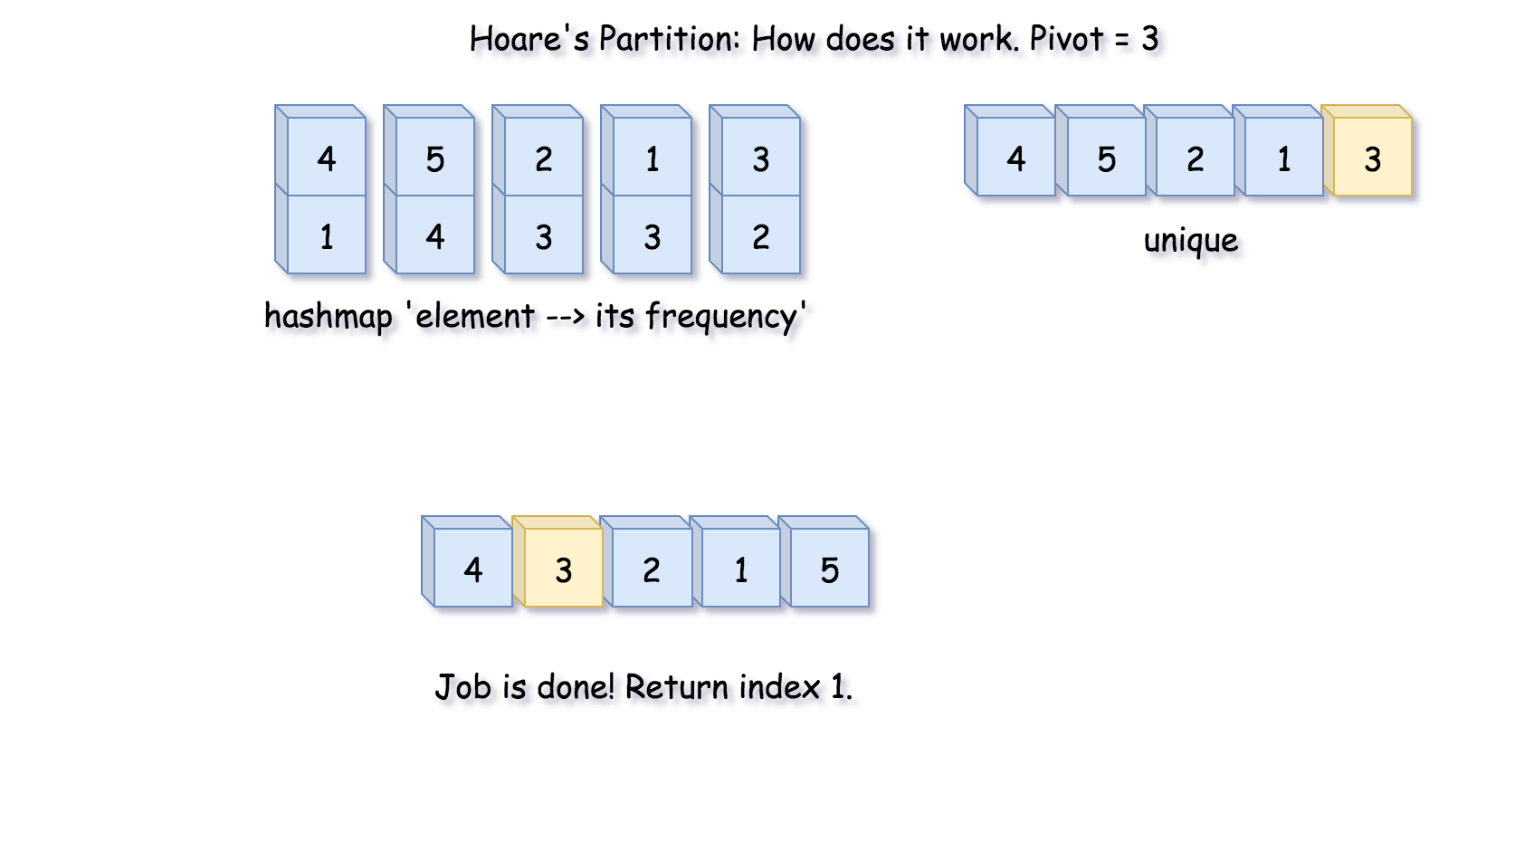

|  |
| --- |
| public int partition(int left, int right, int pivot_index) {  int pivot_frequency = count.get(unique[pivot_index]);  // 1. move pivot to end  swap(pivot_index, right);  int store_index = left;  // 2. move all less frequent elements to the left  for (int i = left; i <= right; i++) {  if (count.get(unique[i]) < pivot_frequency) {  swap(store_index, i);  store_index++;  }  }  // 3. move pivot to its final place  swap(store_index, right);  return store_index;  } |

**Implementation**

Here is a total algorithm implementation.

|  |
| --- |
| class Solution {  int[] unique;  Map<Integer, Integer> count;  public void swap(int a, int b) {  int tmp = unique[a];  unique[a] = unique[b];  unique[b] = tmp;  }  public int partition(int left, int right, int pivot_index) {  int pivot_frequency = count.get(unique[pivot_index]);  // 1. move pivot to end  swap(pivot_index, right);  int store_index = left;  // 2. move all less frequent elements to the left  for (int i = left; i <= right; i++) {  if (count.get(unique[i]) < pivot_frequency) {  swap(store_index, i);  store_index++;  }  }  // 3. move pivot to its final place  swap(store_index, right);  return store_index;  }    public void quickselect(int left, int right, int k_smallest) {  /*  Sort a list within left..right till kth less frequent element  takes its place.  */  // base case: the list contains only one element  if (left == right) return;    // select a random pivot_index  Random random_num = new Random();  int pivot_index = left + random_num.nextInt(right - left);  // find the pivot position in a sorted list  pivot_index = partition(left, right, pivot_index);  // if the pivot is in its final sorted position  if (k_smallest == pivot_index) {  return;  } else if (k_smallest < pivot_index) {  // go left  quickselect(left, pivot_index - 1, k_smallest);  } else {  // go right  quickselect(pivot_index + 1, right, k_smallest);  }  }    public int[] topKFrequent(int[] nums, int k) {  // build hash map : character and how often it appears  count = new HashMap();  for (int num: nums) {  count.put(num, count.getOrDefault(num, 0) + 1);  }    // array of unique elements  int n = count.size();  unique = new int[n];  int i = 0;  for (int num: count.keySet()) {  unique[i] = num;  i++;  }    // kth top frequent element is (n - k)th less frequent.  // Do a partial sort: from less frequent to the most frequent, till  // (n - k)th less frequent element takes its place (n - k) in a sorted array.  // All element on the left are less frequent.  // All the elements on the right are more frequent.  quickselect(0, n - 1, n - k);  // Return top k frequent elements  return Arrays.copyOfRange(unique, n - k, n);  }  } |

**Complexity Analysis**

* Time complexity: O(*N*) in the average case, O(N^2) in the worst case. [Please refer to this card for the good detailed explanation of Master Theorem](https://leetcode.com/explore/learn/card/recursion-ii/470/divide-and-conquer/2871/). Master Theorem helps to get an average complexity by writing the algorithm cost as T(N) = a T(N / b) + f(N). Here we have an example of Master Theorem case III: *T*(*N*)=*T*(N/2​)+*N*, that results in O(*N*) time complexity. That's the case of random pivots.

In the worst-case of constantly bad chosen pivots, the problem is not divided by half at each step, it becomes just one element less, that leads to O(N^2) time complexity. It happens, for example, if at each step you choose the pivot not randomly, but take the rightmost element. For the random pivot choice the probability of having such a worst-case is negligibly small.

* Space complexity: up to O(*N*) to store hash map and array of unique elements.

#### **Further Discussion: Could We Do Worst-Case Linear Time?**

In theory, we could, the algorithm is called [Median of Medians](https://en.wikipedia.org/wiki/Median_of_medians).

This method is never used in practice because of two drawbacks:

* It's outperformer. Yes, it works in a linear time *αN*, but the constant *α* is so large that in practice it often works even slower than N^2.
* It doesn't work with duplicates.

**Kth Largest Element in an Array**

Find the **k**th largest element in an unsorted array. Note that it is the kth largest element in the sorted order, not the kth distinct element.

**Example 1:**

**Input:** [3,2,1,5,6,4] and k = 2

**Output:** 5

**Example 2:**

**Input:** [3,2,3,1,2,4,5,5,6] and k = 4

**Output:** 4

**Note:**  
You may assume k is always valid, 1 ≤ k ≤ array's length.

## Solution

#### **Approach 0: Sort**

The naive solution would be to sort an array first and then return kth element from the end, something like sorted(nums)[-k] on Python. That would be an algorithm of O(*N*log*N*) time complexity and O(1) space complexity. This time complexity is not really exciting so let's check how to improve it by using some additional space.

#### **Approach 1: Heap**

The idea is to init a heap "the smallest element first", and add all elements from the array into this heap one by one keeping the size of the heap always less or equal to k. That would results in a heap containing k largest elements of the array.

The head of this heap is the answer, i.e. the kth largest element of the array.

The time complexity of adding an element in a heap of size k is O(log*k*), and we do it N times that means O(*N*log*k*) time complexity for the algorithm.

In Python there is a method nlargest in heapq library which has the same O(*N*log*k*) time complexity and reduces the code to one line.

This algorithm improves time complexity, but one pays with O(*k*) space complexity.

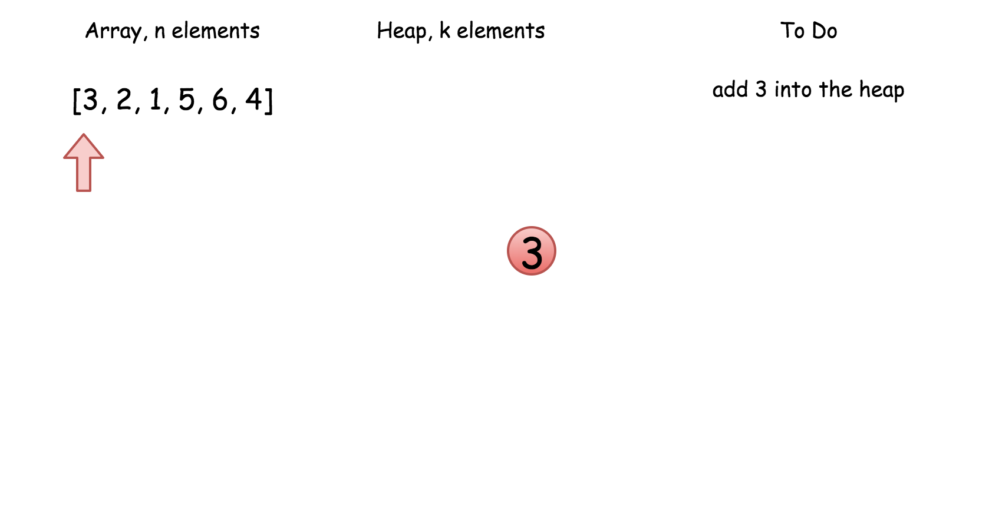

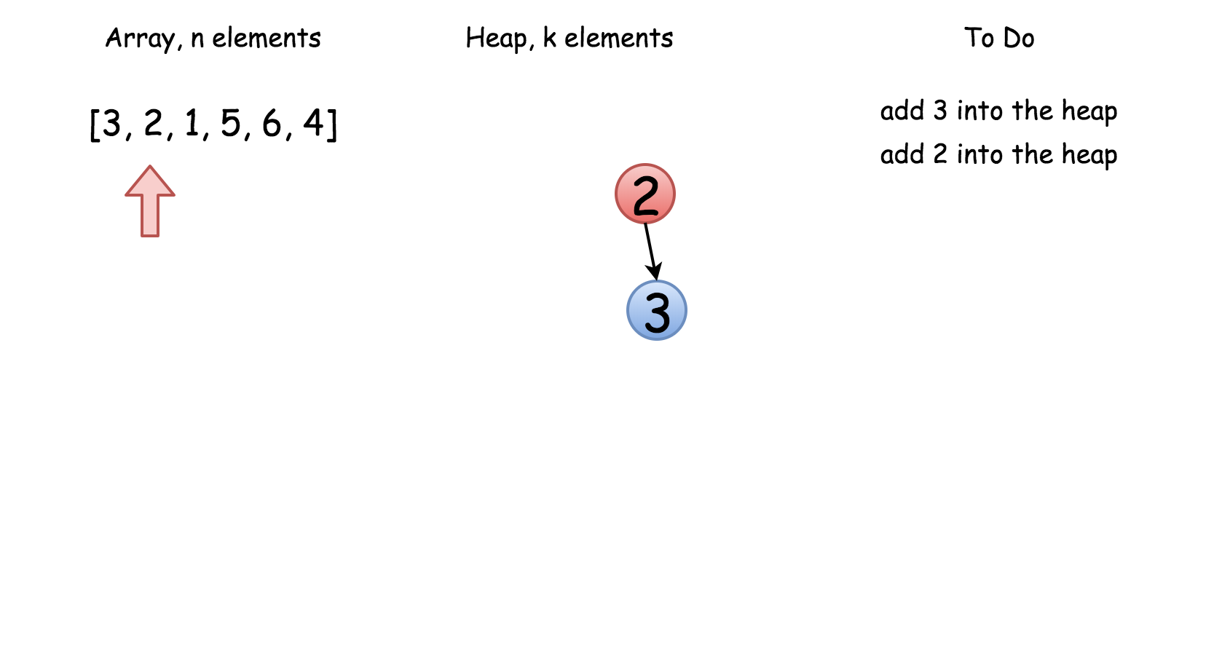

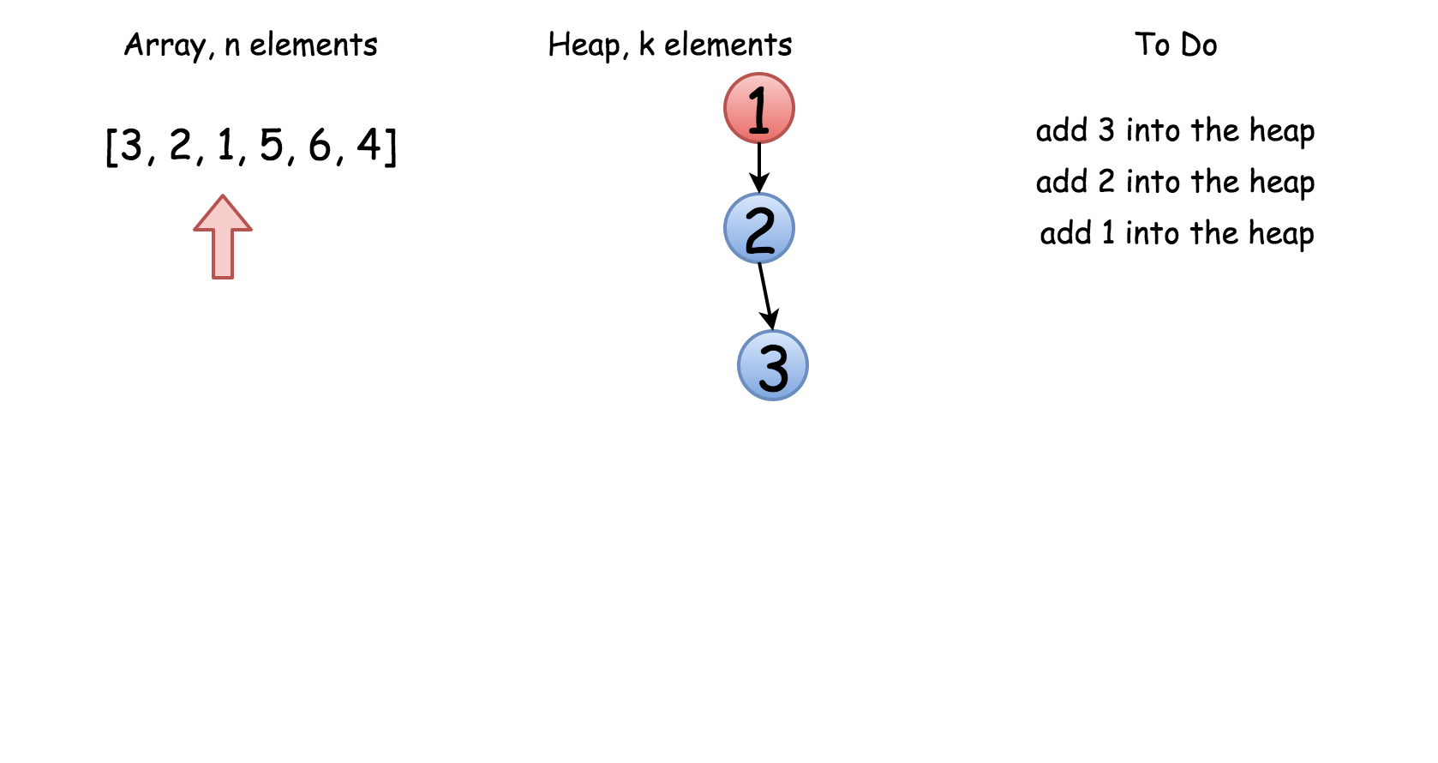

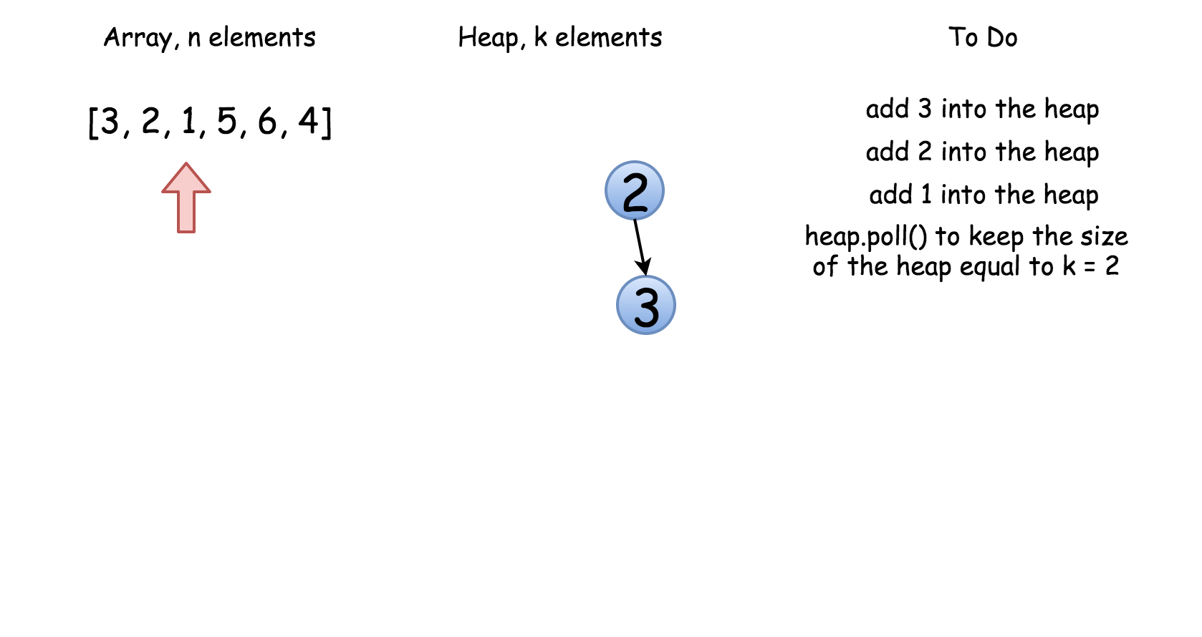

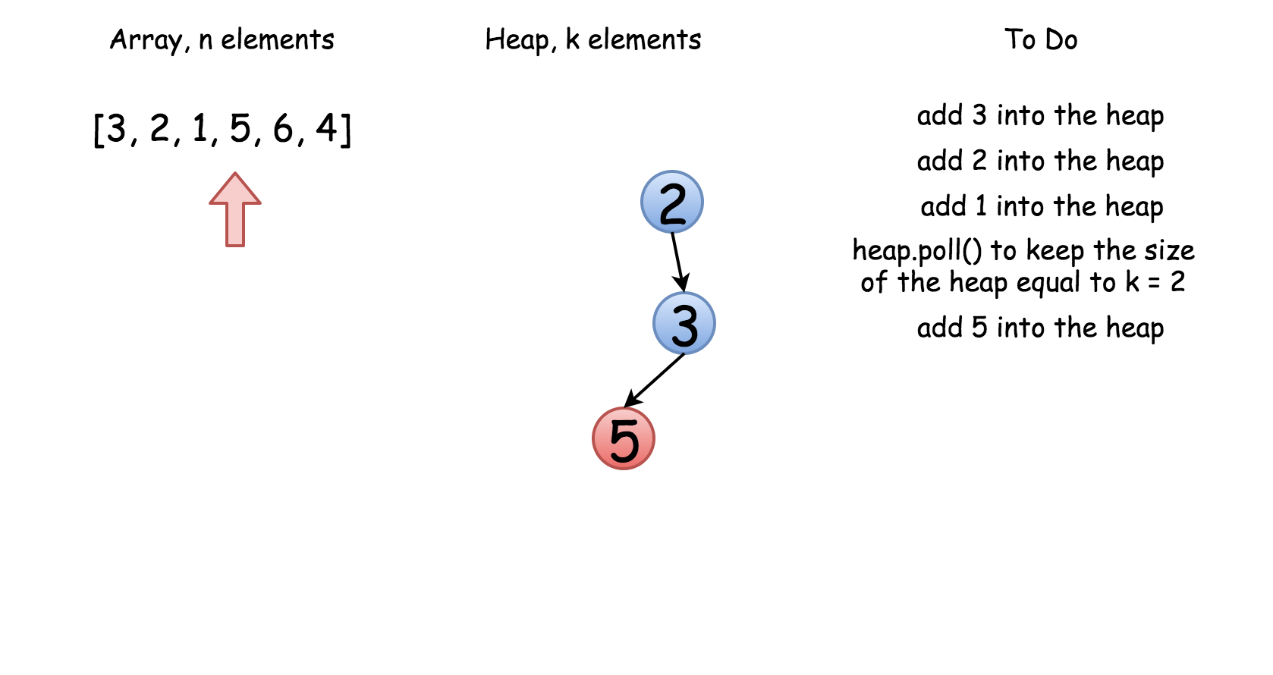

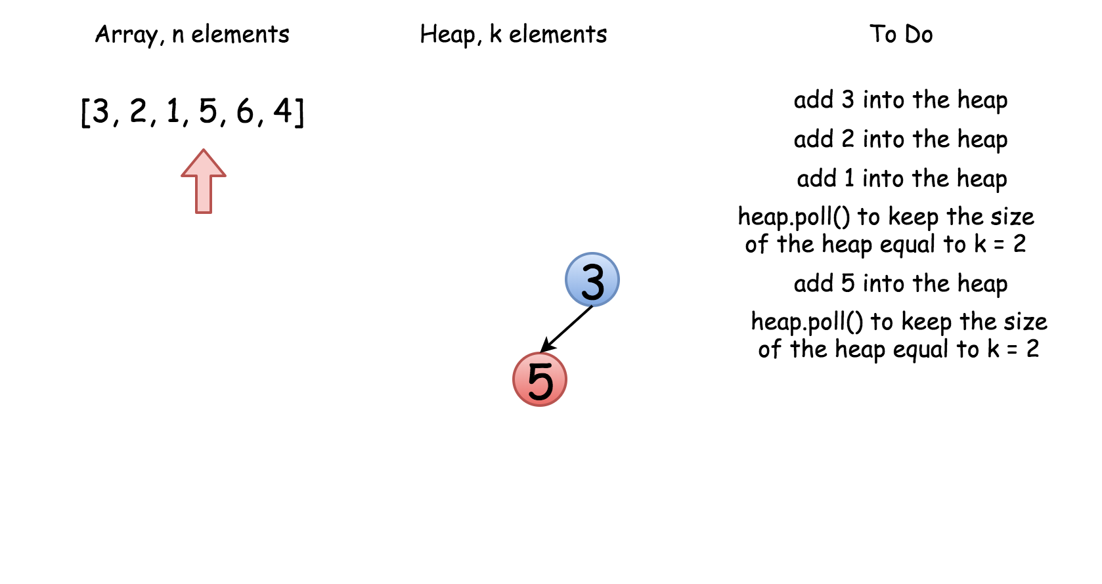

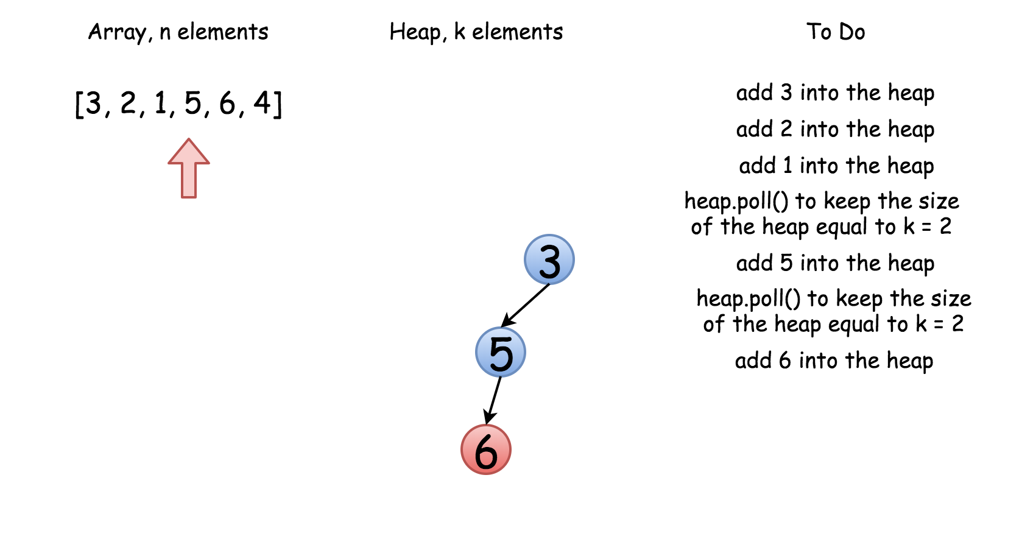

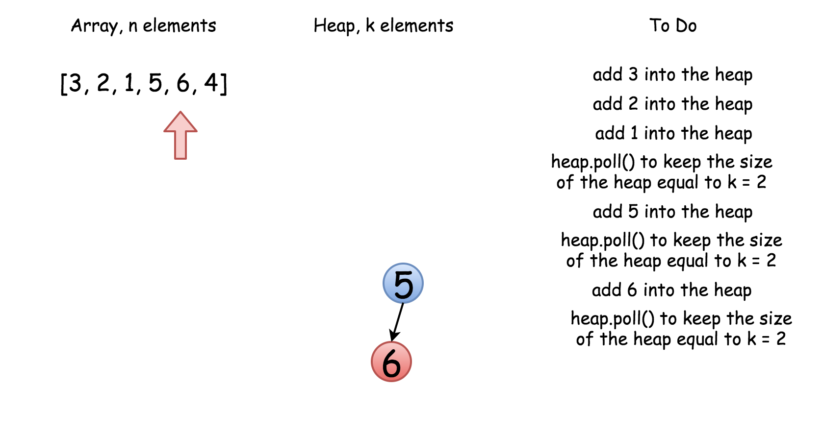

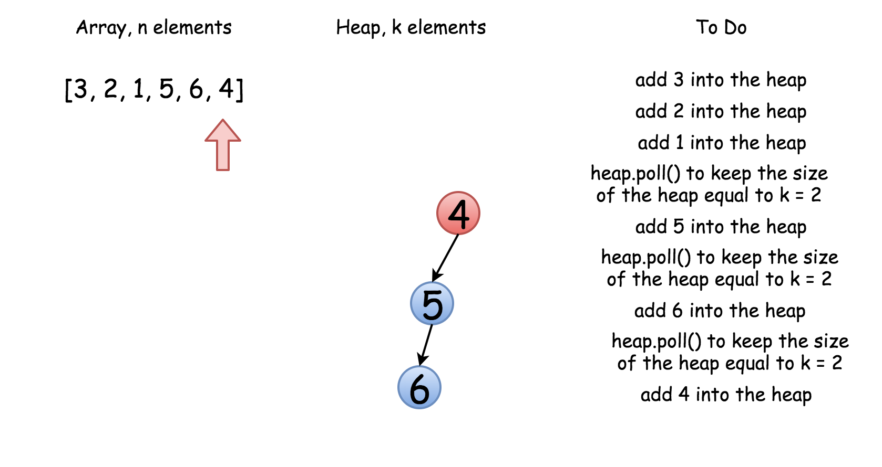

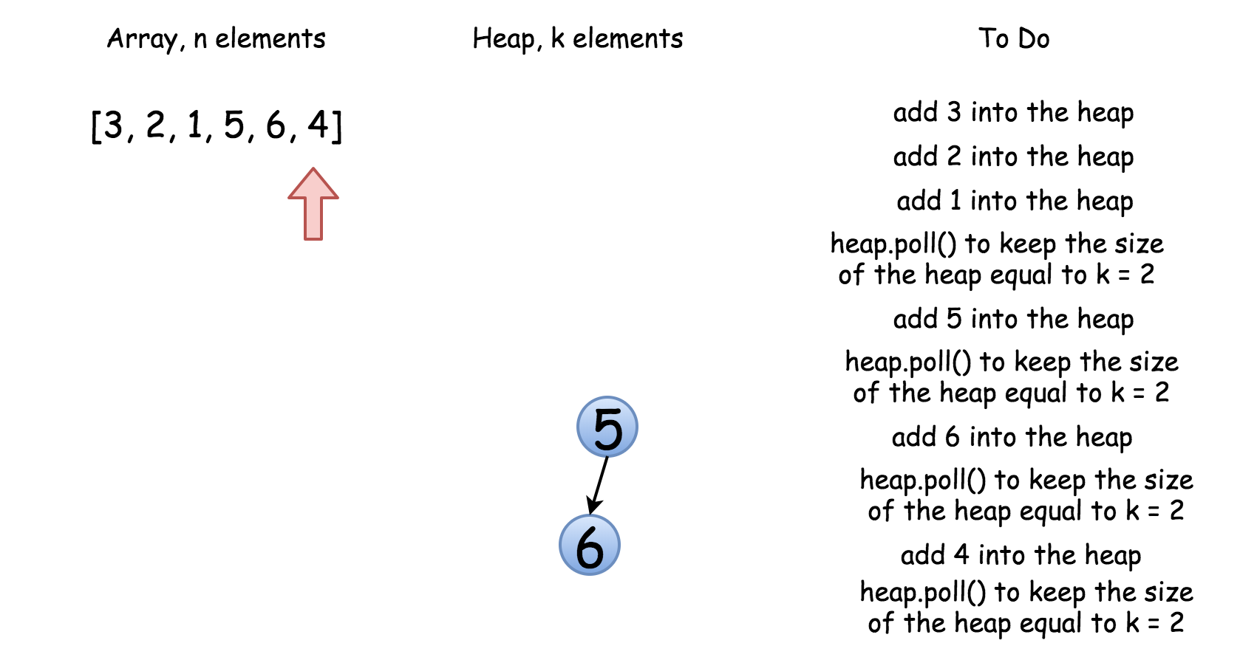

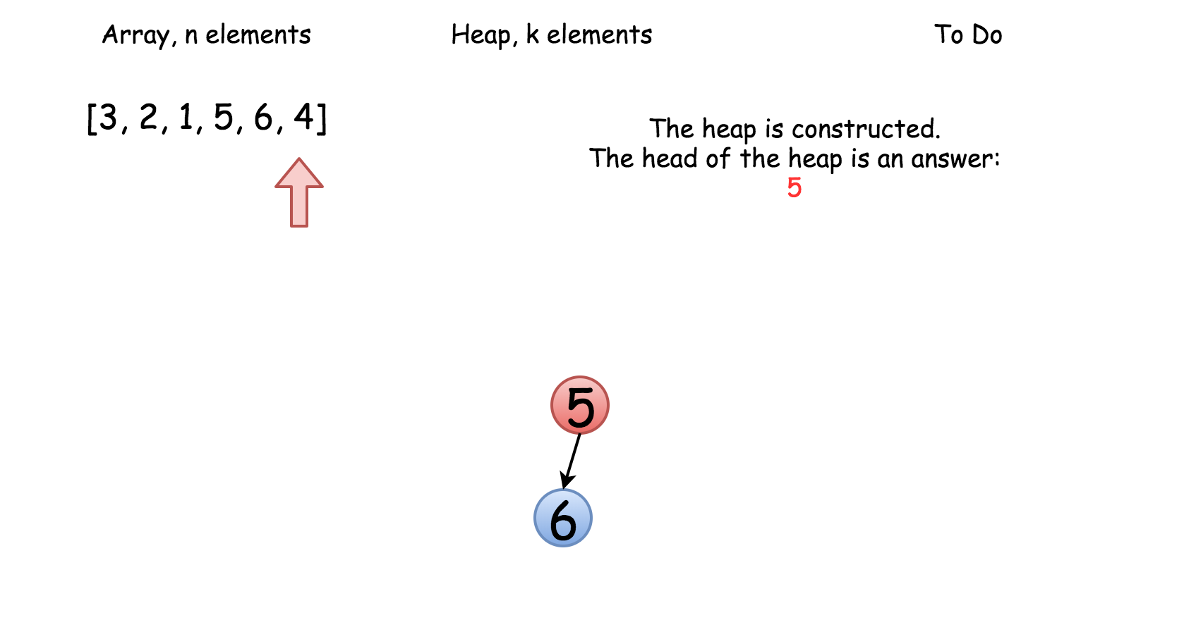

|  |
| --- |
| class Solution {  public int findKthLargest(int[] nums, int k) {  // init heap 'the smallest element first'  PriorityQueue<Integer> heap =  new PriorityQueue<Integer>((n1, n2) -> n1 - n2);  // keep k largest elements in the heap  for (int n: nums) {  heap.add(n);  if (heap.size() > k)  heap.poll();  }  // output  return heap.poll();  }  } |

**Complexity Analysis**

* Time complexity : O(*N*log*k*).
* Space complexity : O(*k*) to store the heap elements.

#### **Approach 2: Quickselect**

This [textbook algorthm](https://en.wikipedia.org/wiki/Quickselect) has O(*N*) average time complexity. Like quicksort, it was developed by Tony Hoare, and is also known as Hoare's selection algorithm.

The approach is basically the same as for quicksort. For simplicity let's notice that kth largest element is the same as N - kth smallest element, hence one could implement kth smallest algorithm for this problem.

First one chooses a pivot, and defines its position in a sorted array in a linear time. This could be done with the help of partition algorithm.

To implement partition one moves along an array, compares each element with a pivot, and moves all elements smaller than pivot to the left of the pivot.

As an output we have an array where pivot is on its perfect position in the ascending sorted array, all elements on the left of the pivot are smaller than pivot, and all elements on the right of the pivot are larger or equal to pivot.

Hence the array is now split into two parts. If that would be a quicksort algorithm, one would proceed recursively to use quicksort for the both parts that would result in O(*N*log*N*) time complexity. Here there is no need to deal with both parts since now one knows in which part to search for N - kth smallest element, and that reduces average time complexity to O(*N*).

Finally the overall algorithm is quite straightforward :

* Choose a random pivot.
* Use a partition algorithm to place the pivot into its perfect position pos in the sorted array, move smaller elements to the left of pivot, and larger or equal ones - to the right.
* Compare pos and N - k to choose the side of array to proceed recursively.

! Please notice that this algorithm works well even for arrays with duplicates.

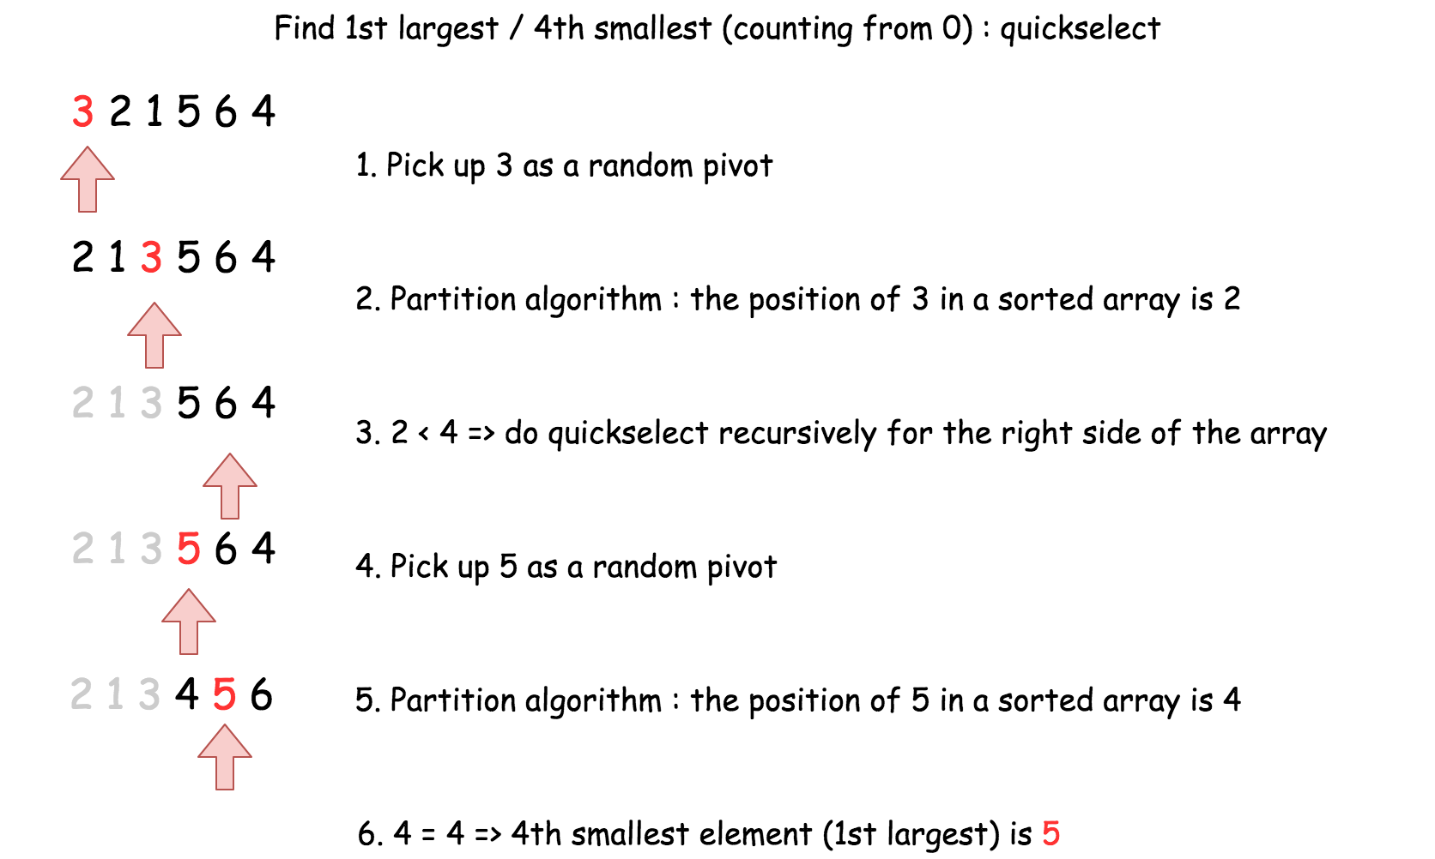

|  |
| --- |
| import java.util.Random;  class Solution {  int [] nums;  public void swap(int a, int b) {  int tmp = this.nums[a];  this.nums[a] = this.nums[b];  this.nums[b] = tmp;  }  public int partition(int left, int right, int pivot_index) {  int pivot = this.nums[pivot_index];  // 1. move pivot to end  swap(pivot_index, right);  int store_index = left;  // 2. move all smaller elements to the left  for (int i = left; i <= right; i++) {  if (this.nums[i] < pivot) {  swap(store_index, i);  store_index++;  }  }  // 3. move pivot to its final place  swap(store_index, right);  return store_index;  }  public int quickselect(int left, int right, int k_smallest) {  /*  Returns the k-th smallest element of list within left..right.  */  if (left == right) // If the list contains only one element,  return this.nums[left]; // return that element  // select a random pivot_index  Random random_num = new Random();  int pivot_index = left + random_num.nextInt(right - left);    pivot_index = partition(left, right, pivot_index);  // the pivot is on (N - k)th smallest position  if (k_smallest == pivot_index)  return this.nums[k_smallest];  // go left side  else if (k_smallest < pivot_index)  return quickselect(left, pivot_index - 1, k_smallest);  // go right side  return quickselect(pivot_index + 1, right, k_smallest);  }  public int findKthLargest(int[] nums, int k) {  this.nums = nums;  int size = nums.length;  // kth largest is (N - k)th smallest  return quickselect(0, size - 1, size - k);  }  } |

* Time complexity : O(*N*) in the average case, O(N^2) in the worst case.
* Space complexity : O(1).

**Find Peak Element**

A peak element is an element that is strictly greater than its neighbors.

Given an integer array nums, find a peak element, and return its index. If the array contains multiple peaks, return the index to **any of the peaks**.

You may imagine that nums[-1] = nums[n] = -∞.

**Example 1:**

**Input:** nums = [1,2,3,1]

**Output:** 2

**Explanation:** 3 is a peak element and your function should return the index number 2.

**Example 2:**

**Input:** nums = [1,2,1,3,5,6,4]

**Output:** 5

**Explanation:** Your function can return either index number 1 where the peak element is 2, or index number 5 where the peak element is 6.

**Constraints:**

* 1 <= nums.length <= 1000
* -231 <= nums[i] <= 231 - 1
* nums[i] != nums[i + 1] for all valid i.

**Follow up:** Could you implement a solution with logarithmic complexity?

## Solution

#### **Approach 1: Linear Scan**

In this approach, we make use of the fact that two consecutive numbers *nums*[*j*] and *nums*[*j*+1] are never equal. Thus, we can traverse over the *nums* array starting from the beginning. Whenever, we find a number *nums*[*i*], we only need to check if it is larger than the next number *nums*[*i*+1] for determining if *nums*[*i*] is the peak element. The reasoning behind this can be understood by taking the following three cases which cover every case into which any problem can be divided.

Case 1. All the numbers appear in a descending order. In this case, the first element corresponds to the peak element. We start off by checking if the current element is larger than the next one. The first element satisfies this criteria, and is hence identified as the peak correctly. In this case, we didn't reach a point where we needed to compare *nums*[*i*] with *nums*[*i*−1] also, to determine if it is the peak element or not.

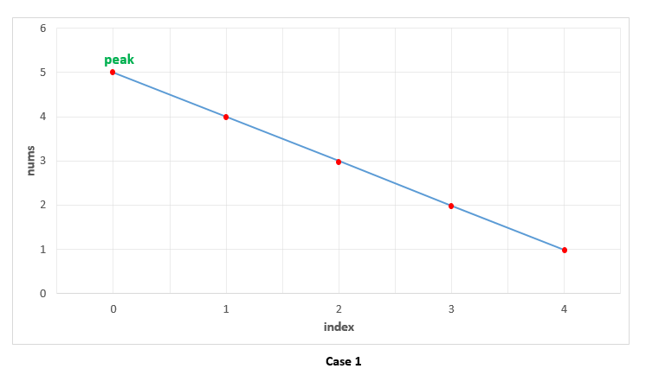

Case 2. All the elements appear in ascending order. In this case, we keep on comparing *nums*[*i*] with *nums*[*i*+1] to determine if *nums*[*i*] is the peak element or not. None of the elements satisfy this criteria, indicating that we are currently on a rising slope and not on a peak. Thus, at the end, we need to return the last element as the peak element, which turns out to be correct. In this case also, we need not compare *nums*[*i*] with *nums*[*i*−1], since being on the rising slope is a sufficient condition to ensure that *nums*[*i*] isn't the peak element.

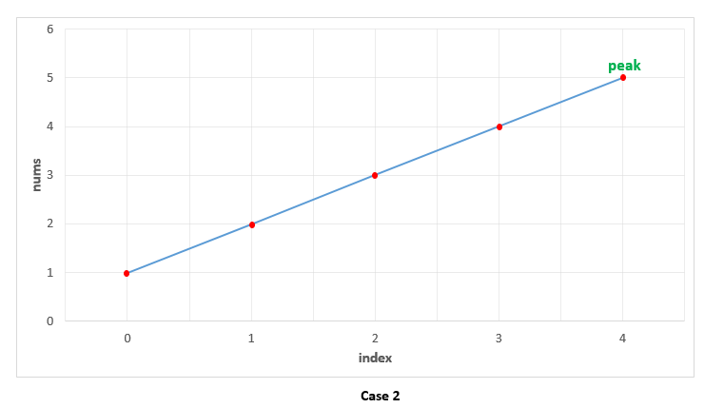

Case 3. The peak appears somewhere in the middle. In this case, when we are traversing on the rising edge, as in Case 2, none of the elements will satisfy *nums*[*i*]>*nums*[*i*+1]. We need not compare *nums*[*i*] with *nums*[*i*−1] on the rising slope as discussed above. When we finally reach the peak element, the condition *nums*[*i*]>*nums*[*i*+1] is satisfied. We again, need not compare *nums*[*i*] with *nums*[*i*−1]. This is because, we could reach *nums*[*i*] as the current element only when the check *nums*[*i*]>*nums*[*i*+1] failed for the previous(*i*−1)*th* element, indicating that *nums*[*i*−1]<*nums*[*i*]. Thus, we are able to identify the peak element correctly in this case as well.

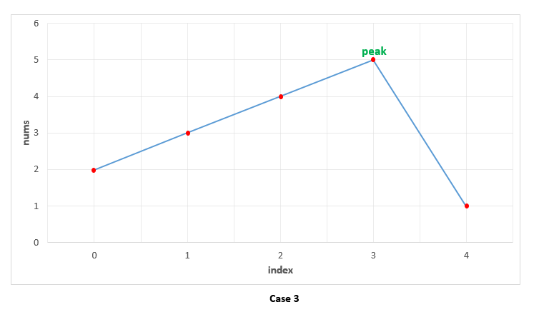

|  |
| --- |
| public class Solution {  public int findPeakElement(int[] nums) {  for (int i = 0; i < nums.length - 1; i++) {  if (nums[i] > nums[i + 1])  return i;  }  return nums.length - 1;  }  } |

**Complexity Analysis**

* Time complexity : O(n)*O*(*n*). We traverse the nums*nums* array of size n*n* once only.
* Space complexity : O(1)*O*(1). Constant extra space is used.

#### **Approach 2: Recursive Binary Search**

**Algorithm**

We can view any given sequence in *nums* array as alternating ascending and descending sequences. By making use of this, and the fact that we can return any peak as the result, we can make use of Binary Search to find the required peak element.

In case of simple Binary Search, we work on a sorted sequence of numbers and try to find out the required number by reducing the search space at every step. In this case, we use a modification of this simple Binary Search to our advantage. We start off by finding the middle element, *mid* from the given *nums* array. If this element happens to be lying in a descending sequence of numbers. or a local falling slope(found by comparing *nums*[*i*] to its right neighbour), it means that the peak will always lie towards the left of this element. Thus, we reduce the search space to the left of *mid*(including itself) and perform the same process on left subarray.

If the middle element, *mid* lies in an ascending sequence of numbers, or a rising slope(found by comparing *nums*[*i*] to its right neighbour), it obviously implies that the peak lies towards the right of this element. Thus, we reduce the search space to the right of *mid* and perform the same process on the right subarray.

In this way, we keep on reducing the search space till we eventually reach a state where only one element is remaining in the search space. This single element is the peak element.

To see how it works, let's consider the three cases discussed above again.

Case 1. In this case, we firstly find 33 as the middle element. Since it lies on a falling slope, we reduce the search space to [1, 2, 3]. For this subarray, 22 happens to be the middle element, which again lies on a falling slope, reducing the search space to [1, 2]. Now, 11 acts as the middle element and it lies on a falling slope, reducing the search space to [1] only. Thus, 11 is returned as the peak correctly.

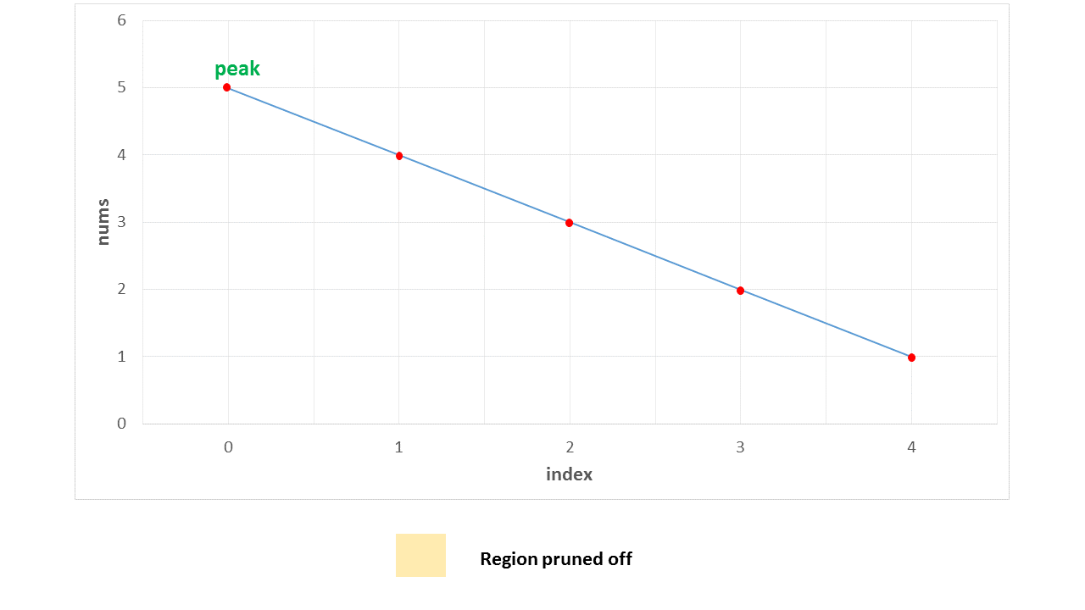

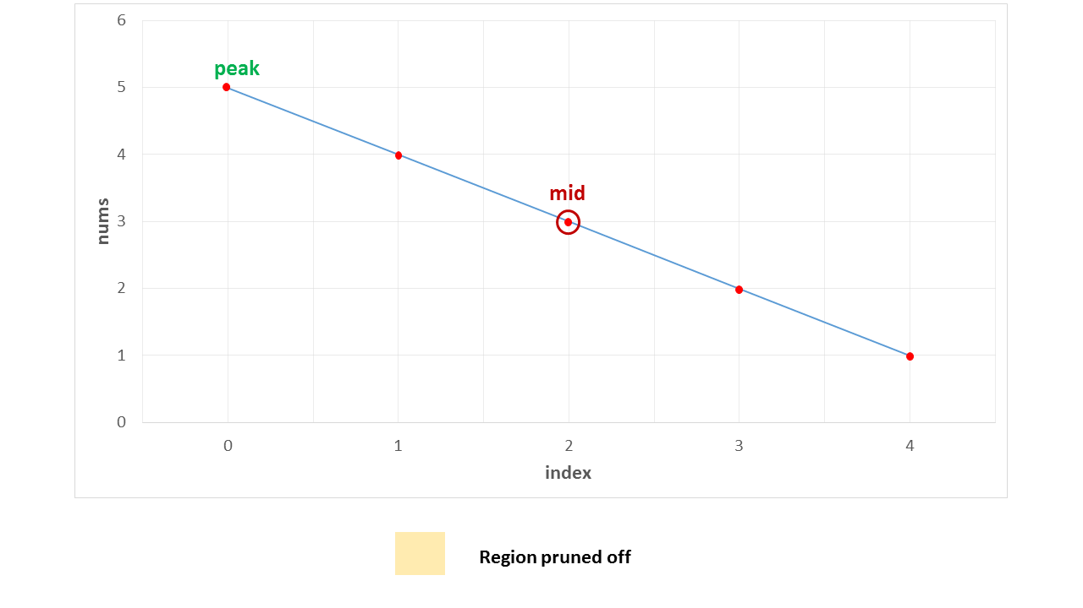

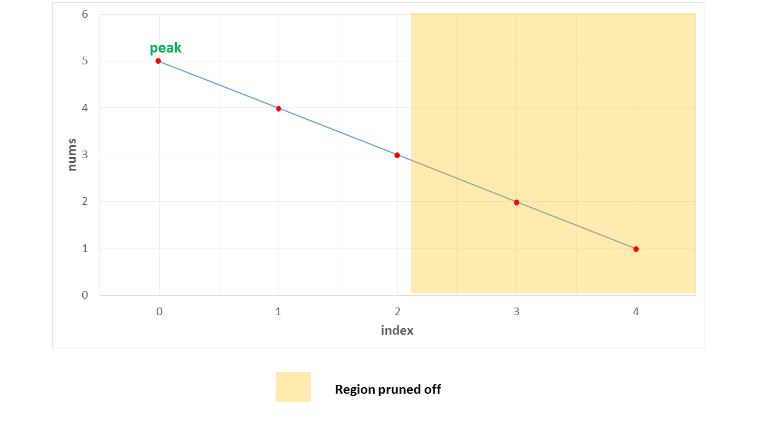

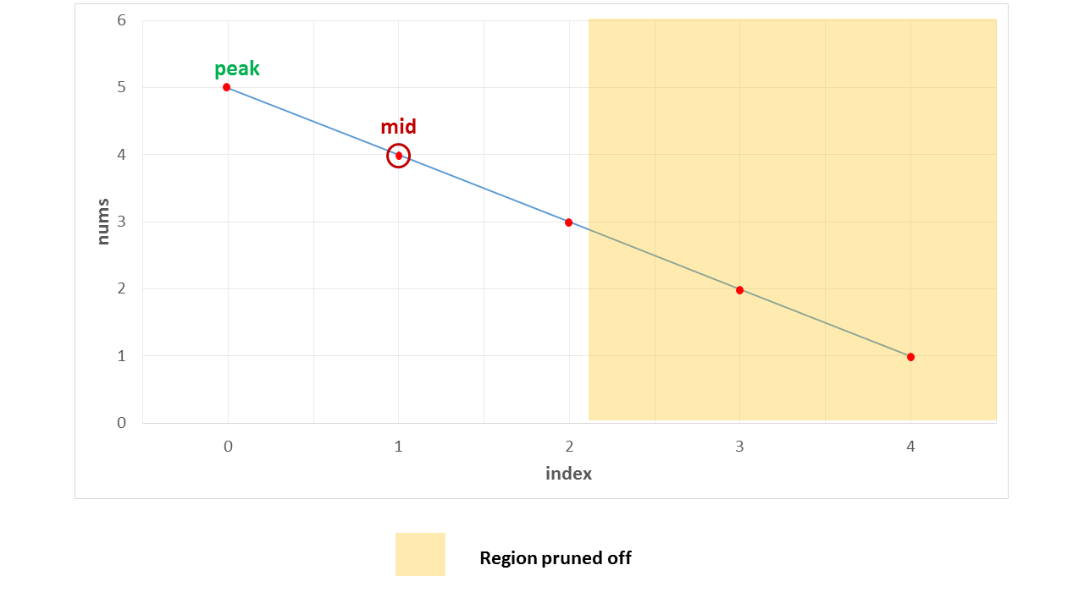

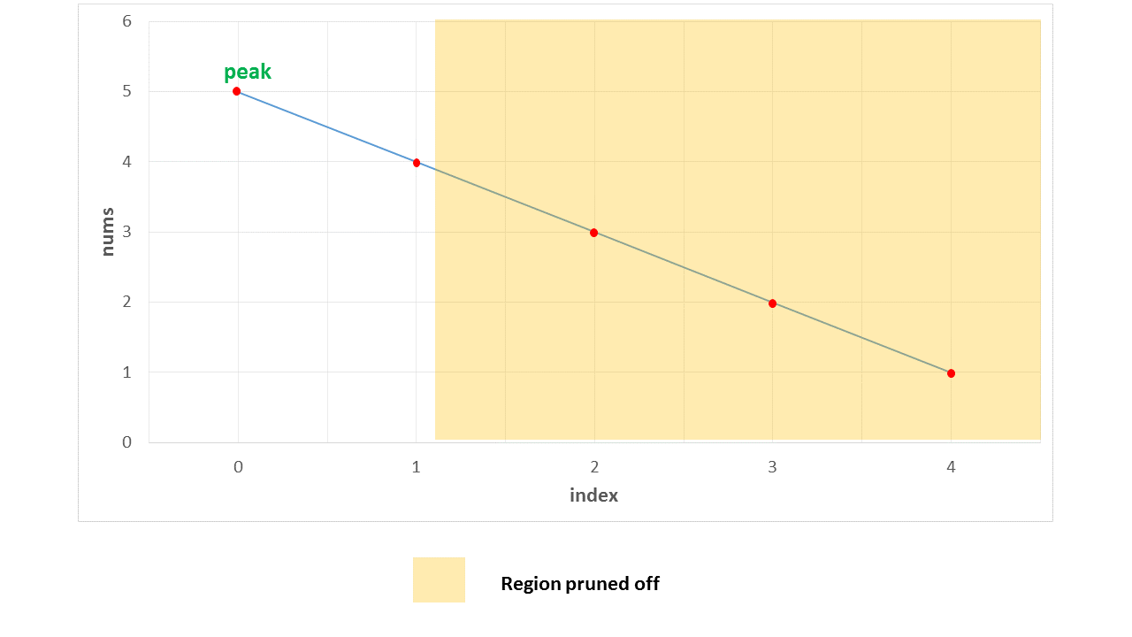

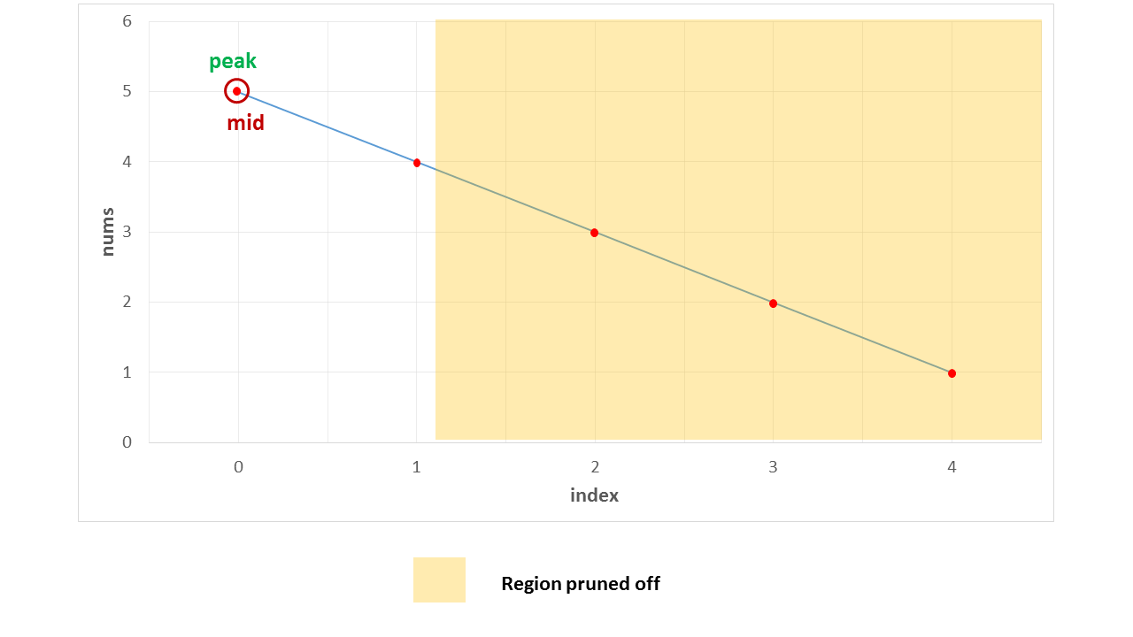

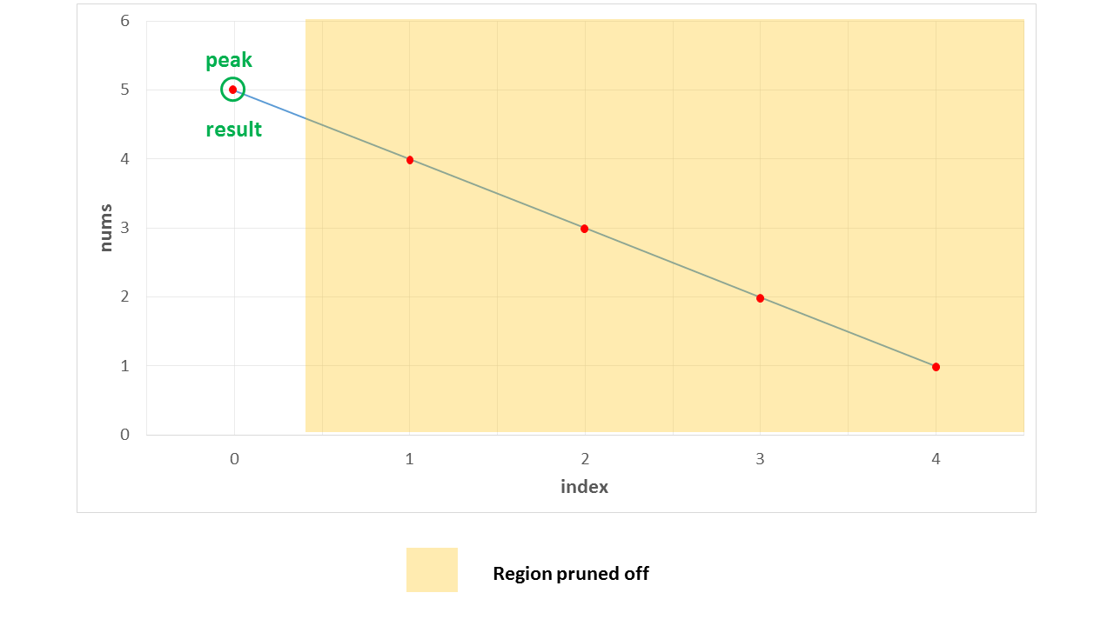

Case 2. In this case, we firstly find 3 as the middle element. Since it lies on a rising slope, we reduce the search space to [4, 5]. Now, 4 acts as the middle element for this subarray and it lies on a rising slope, reducing the search space to [5] only. Thus, 5 is returned as the peak correctly.

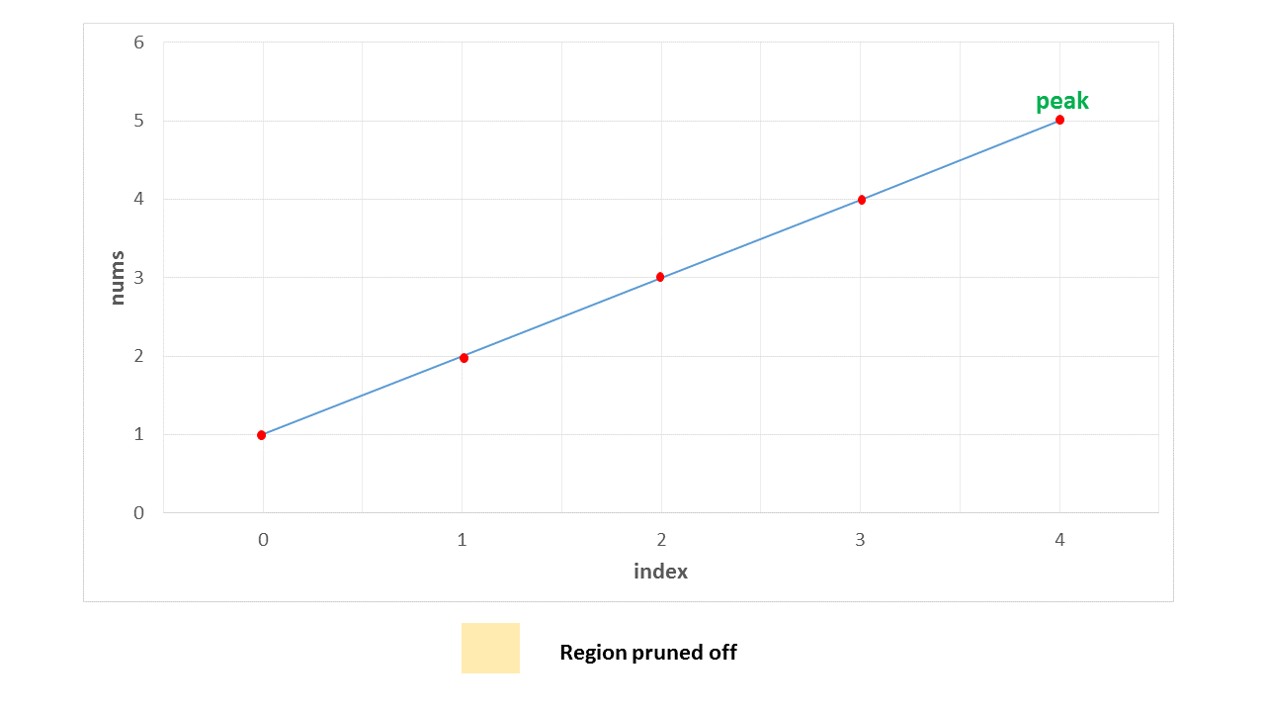

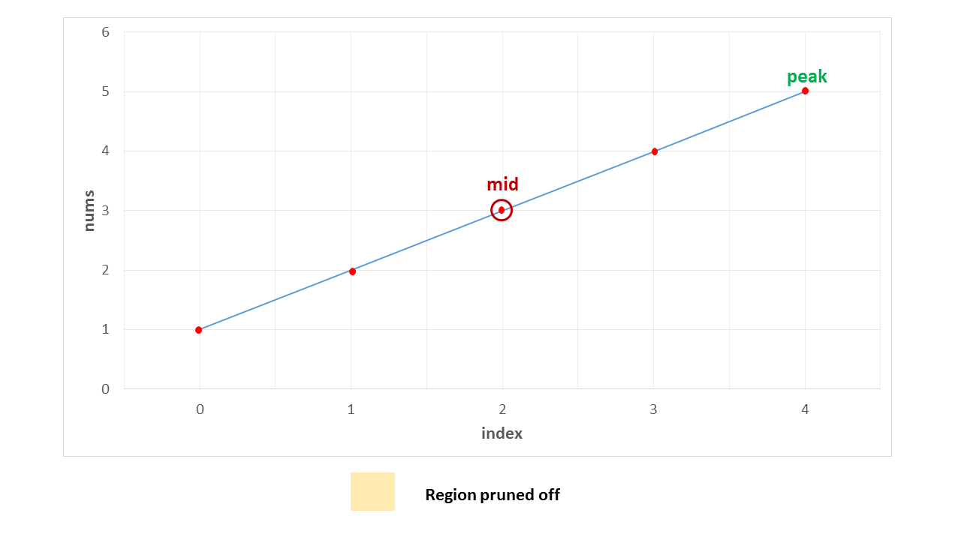

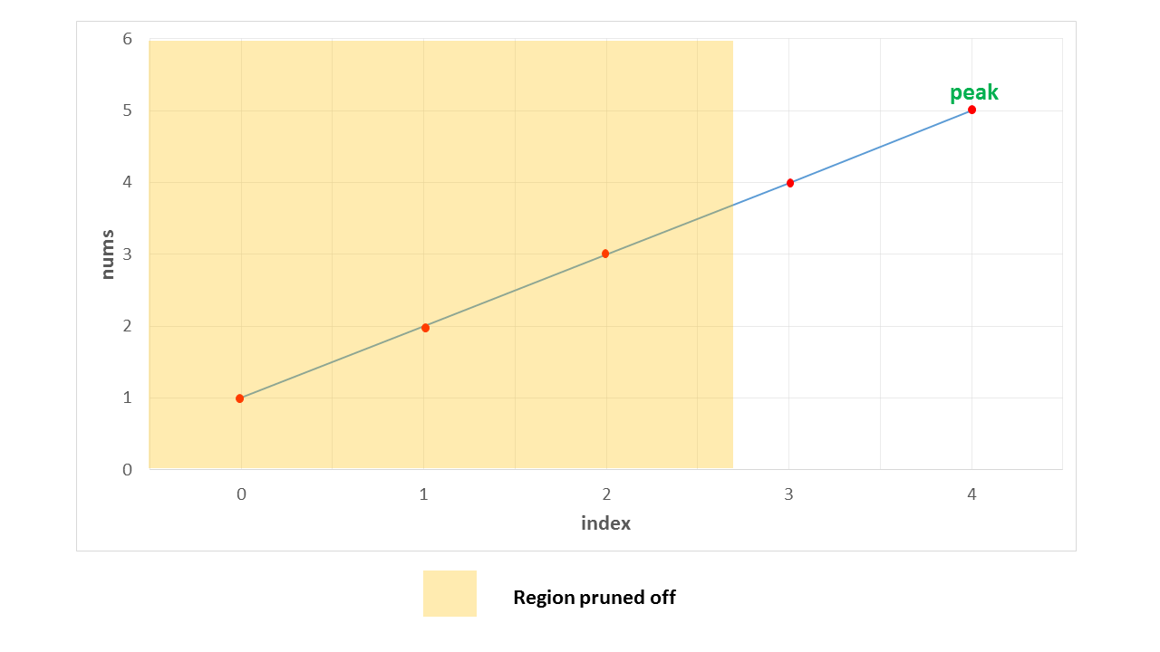

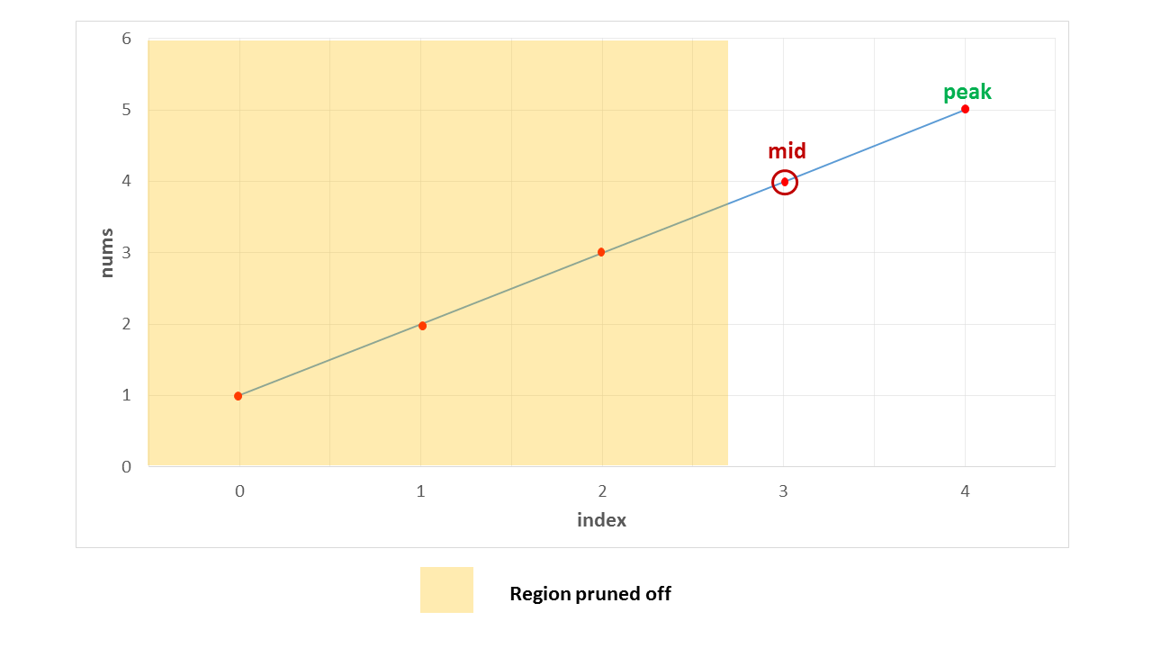

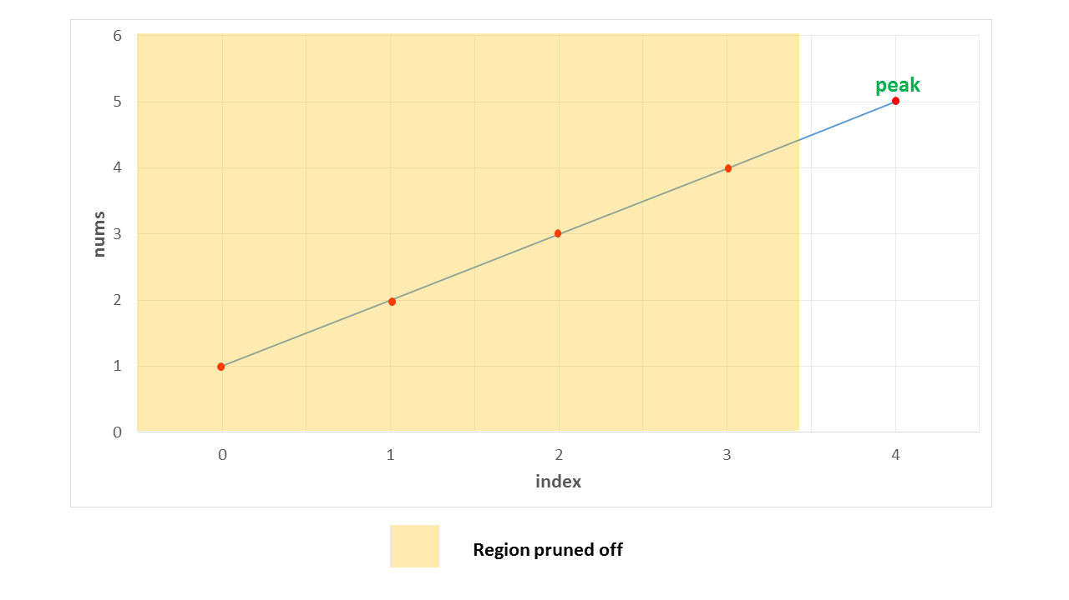

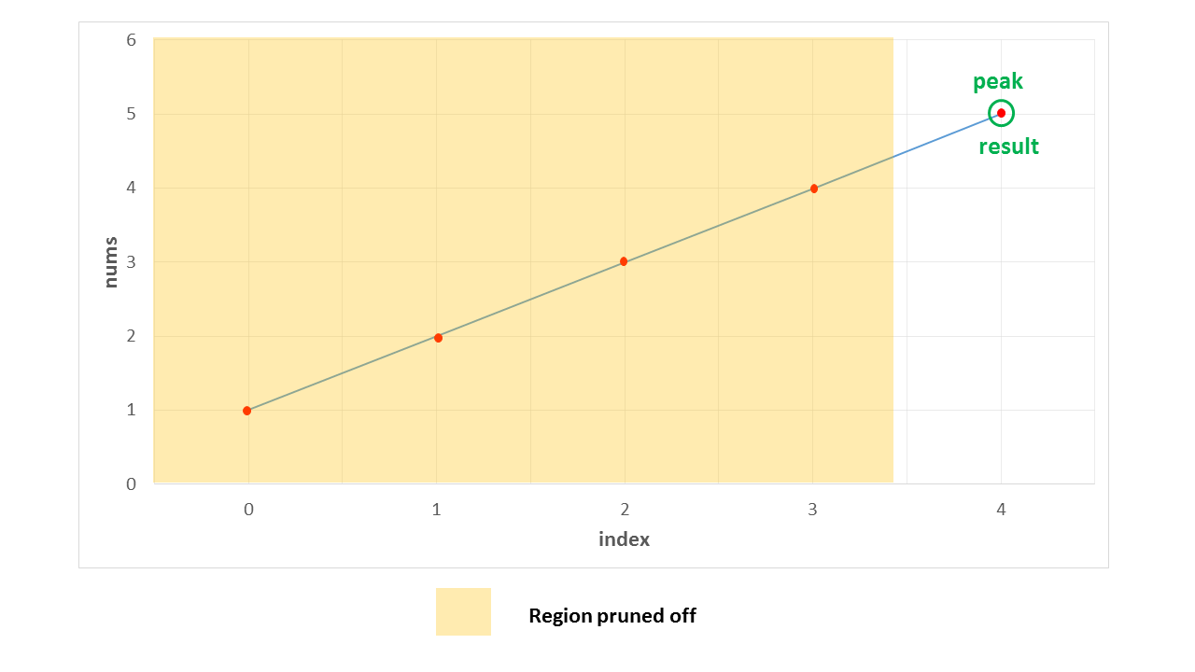

Case 3. In this case, the peak lies somewhere in the middle. The first middle element is 4. It lies on a rising slope, indicating that the peak lies towards its right. Thus, the search space is reduced to [5, 1]. Now, 5 happens to be the on a falling slope(relative to its right neighbour), reducing the search space to [5] only. Thus, 5 is identified as the peak element correctly.

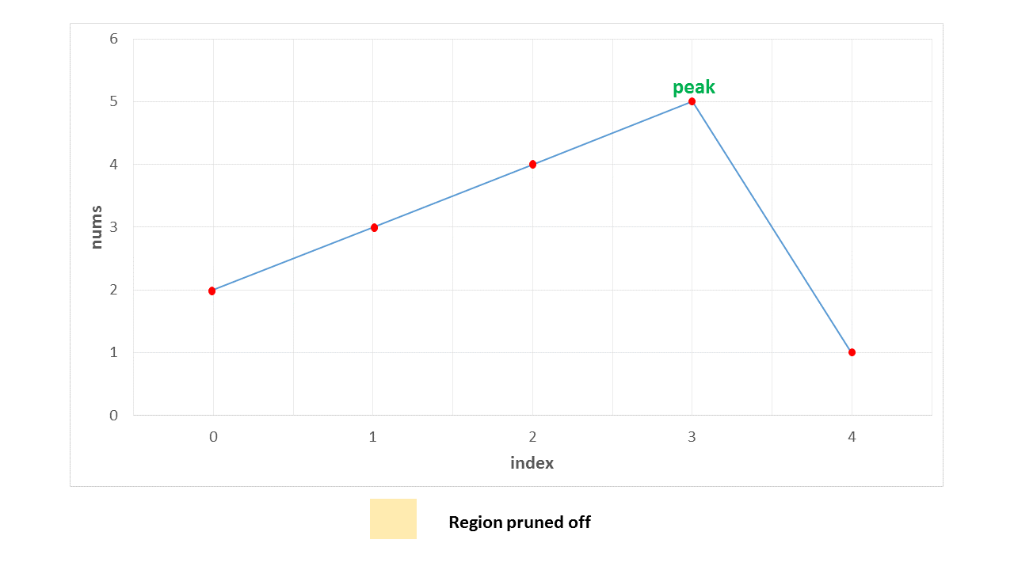

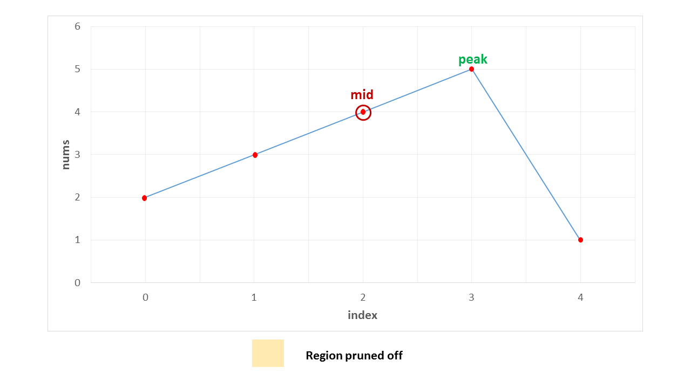

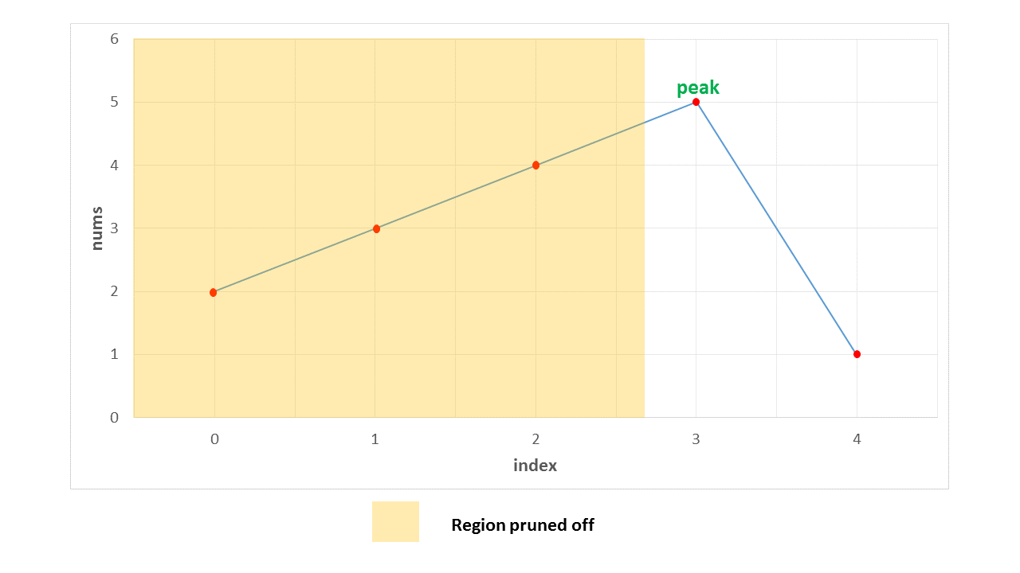

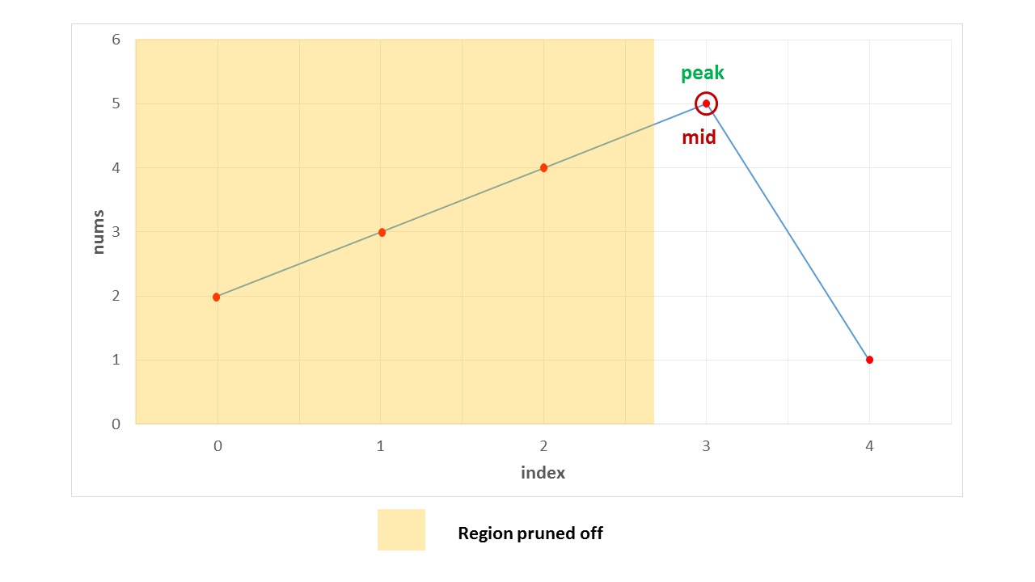

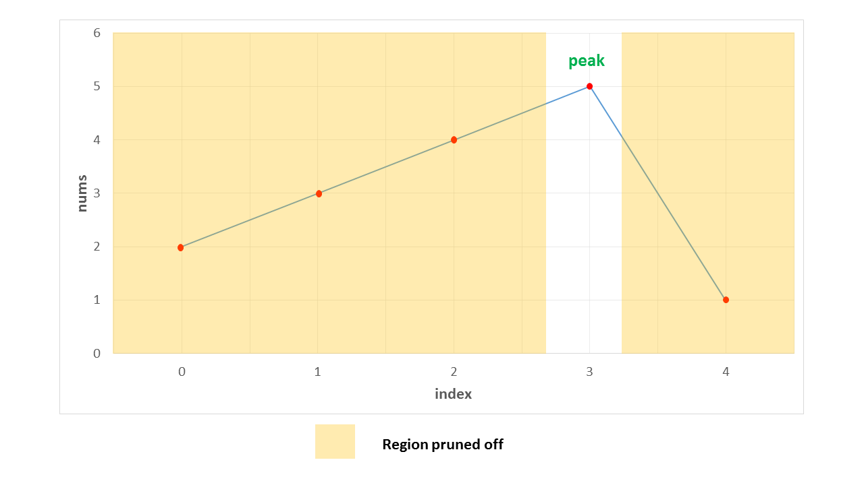

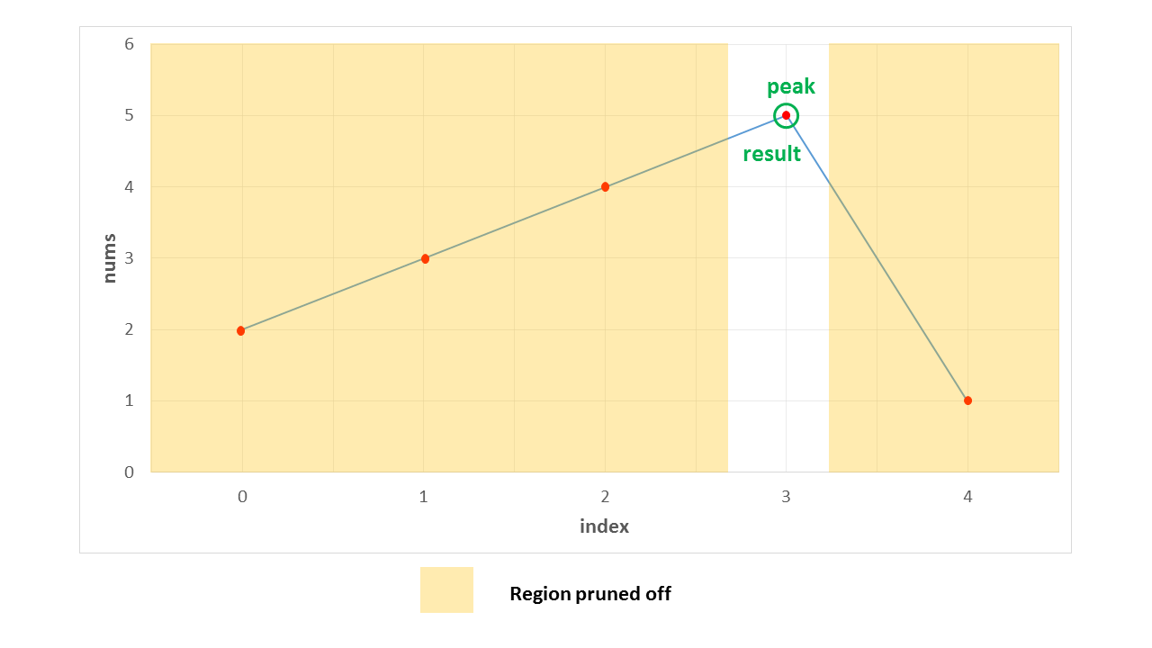

|  |
| --- |
| public class Solution {  public int findPeakElement(int[] nums) {  return search(nums, 0, nums.length - 1);  }  public int search(int[] nums, int l, int r) {  if (l == r)  return l;  int mid = (l + r) / 2;  if (nums[mid] > nums[mid + 1])  return search(nums, l, mid);  return search(nums, mid + 1, r);  }  } |

**Complexity Analysis**

* Time complexity : *O*(*log*2​(*n*)). We reduce the search space in half at every step. Thus, the total search space will be consumed in *log*2​(*n*) steps. Here, *n* refers to the size of *nums* array.
* Space complexity : *O*(*log*2​(*n*)). We reduce the search space in half at every step. Thus, the total search space will be consumed in *log*2​(*n*) steps. Thus, the depth of recursion tree will go upto *log*2​(*n*).

#### **Approach 3: Iterative Binary Search**

**Algorithm**

The binary search discussed in the previous approach used a recursive method. We can do the same process in an iterative fashion also. This is done in the current approach.

|  |
| --- |
| public class Solution {  public int findPeakElement(int[] nums) {  int l = 0, r = nums.length - 1;  while (l < r) {  int mid = (l + r) / 2;  if (nums[mid] > nums[mid + 1])  r = mid;  else  l = mid + 1;  }  return l;  }  } |

**Complexity Analysis**

* Time complexity : *O*(*log*2​(*n*)). We reduce the search space in half at every step. Thus, the total search space will be consumed in *log*2​(*n*) steps. Here, *n* refers to the size of *nums* array.
* Space complexity : *O*(1). Constant extra space is used.

**Search for a Range**

Given an array of integers nums sorted in ascending order, find the starting and ending position of a given target value.

If target is not found in the array, return [-1, -1].

**Follow up:** Could you write an algorithm with O(log n) runtime complexity?

**Example 1:**

**Input:** nums = [5,7,7,8,8,10], target = 8

**Output:** [3,4]

**Example 2:**

**Input:** nums = [5,7,7,8,8,10], target = 6

**Output:** [-1,-1]

**Example 3:**

**Input:** nums = [], target = 0

**Output:** [-1,-1]

**Constraints:**

* 0 <= nums.length <= 105
* -109 <= nums[i] <= 109
* nums is a non-decreasing array.
* -109 <= target <= 109

#### **Approach 1: Linear Scan**

**Intuition**

Checking every index for target exhausts the search space, so it must work.

**Algorithm**

First, we do a linear scan of nums from the left, breaking when we find an instance of target. If we never break, then target is not present, so we can return the "error code" of [-1, -1] early. Given that we did find a valid left index, we can do a second linear scan, but this time from the right. In this case, the first instance of target encountered will be the rightmost one (and because a leftmost one exists, there is guaranteed to also be a rightmost one). We then simply return a list containing the two located indices.

|  |
| --- |
| class Solution {  public int[] searchRange(int[] nums, int target) {  int[] targetRange = {-1, -1};  // find the index of the leftmost appearance of `target`.  for (int i = 0; i < nums.length; i++) {  if (nums[i] == target) {  targetRange[0] = i;  break;  }  }  // if the last loop did not find any index, then there is no valid range  // and we return [-1, -1].  if (targetRange[0] == -1) {  return targetRange;  }  // find the index of the rightmost appearance of `target` (by reverse  // iteration). it is guaranteed to appear.  for (int j = nums.length-1; j >= 0; j--) {  if (nums[j] == target) {  targetRange[1] = j;  break;  }  }  return targetRange;  }  } |

**Complexity Analysis**

* Time complexity : *O*(*n*)

This brute-force approach examines each of the n elements of nums exactly twice, so the overall runtime is linear.

* Space complexity : *O*(1)

The linear scan method allocates a fixed-size array and a few integers, so it has a constant-size memory footprint.

#### **Approach 2: Binary Search**

**Intuition**

Because the array is sorted, we can use binary search to locate the left and rightmost indices.

**Algorithm**

The overall algorithm works fairly similarly to the linear scan approach, except for the subroutine used to find the left and rightmost indices themselves. Here, we use a modified binary search to search a sorted array, with a few minor adjustments. First, because we are locating the leftmost (or rightmost) index containing target (rather than returning true iff we find target), the algorithm does not terminate as soon as we find a match. Instead, we continue to search until lo == hi and they contain some index at which target can be found.

The other change is the introduction of the left parameter, which is a boolean indicating what to do in the event that target == nums[mid]; if left is true, then we "recurse" on the left subarray on ties. Otherwise, we go right. To see why this is correct, consider the situation where we find target at index i. The leftmost target cannot occur at any index greater than i, so we never need to consider the right subarray. The same argument applies to the rightmost index.

The first animation below shows the process for finding the leftmost index, and the second shows the process for finding the index right of the rightmost index.

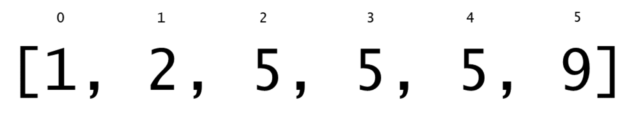

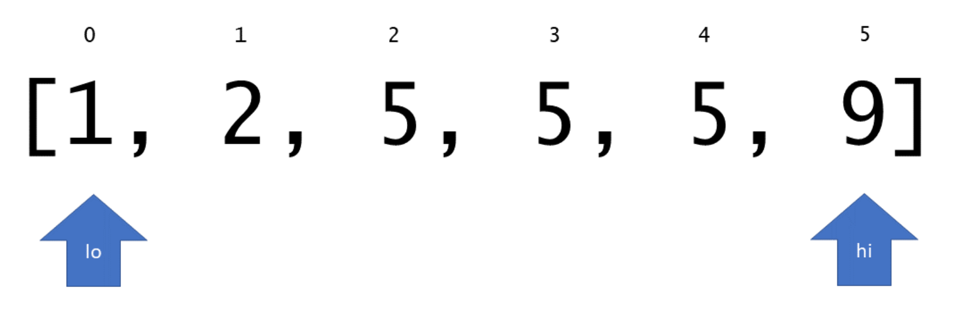

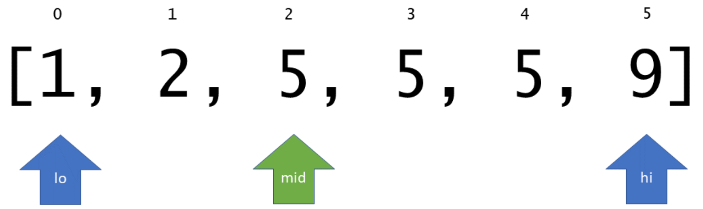

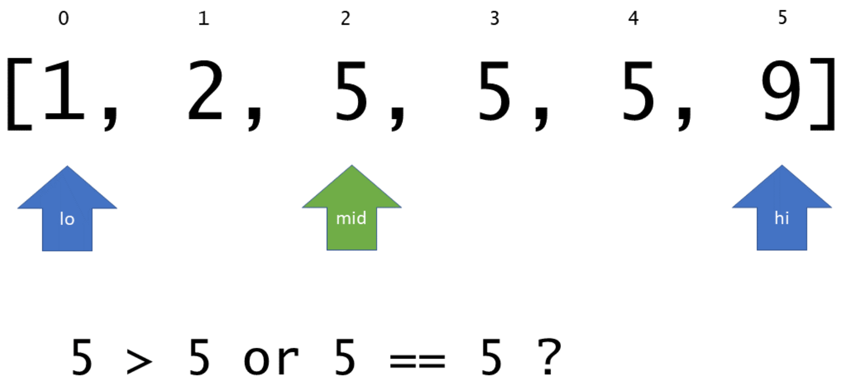

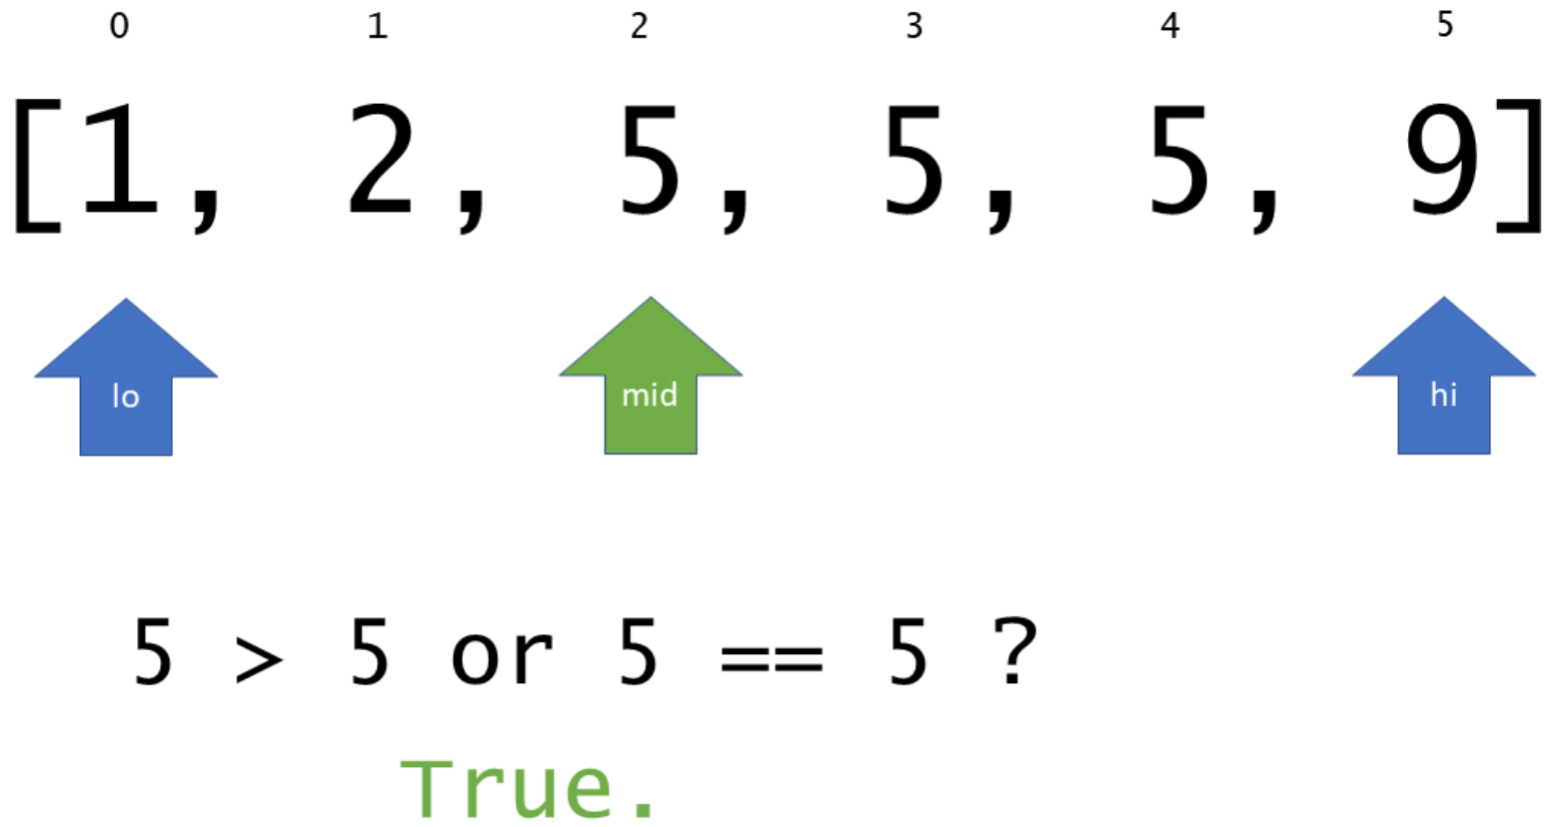

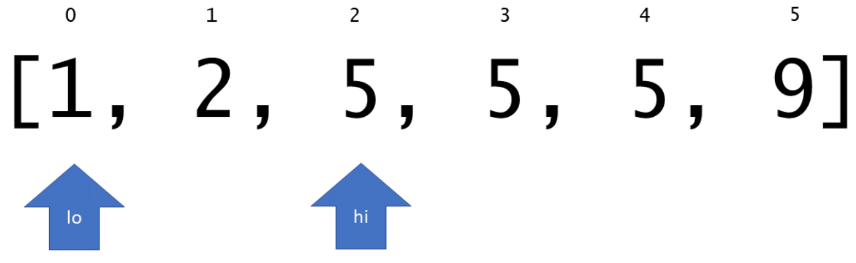

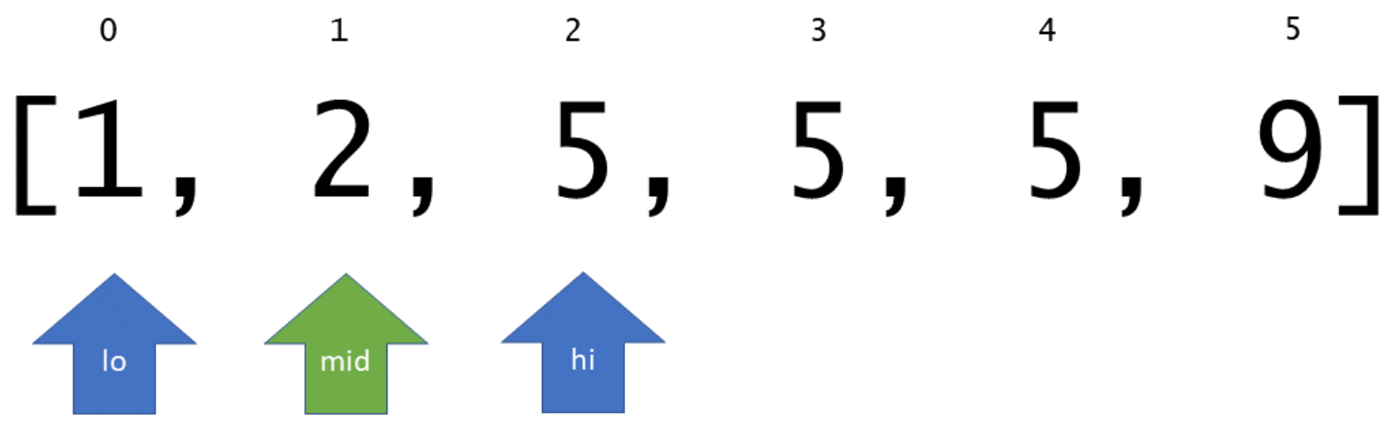

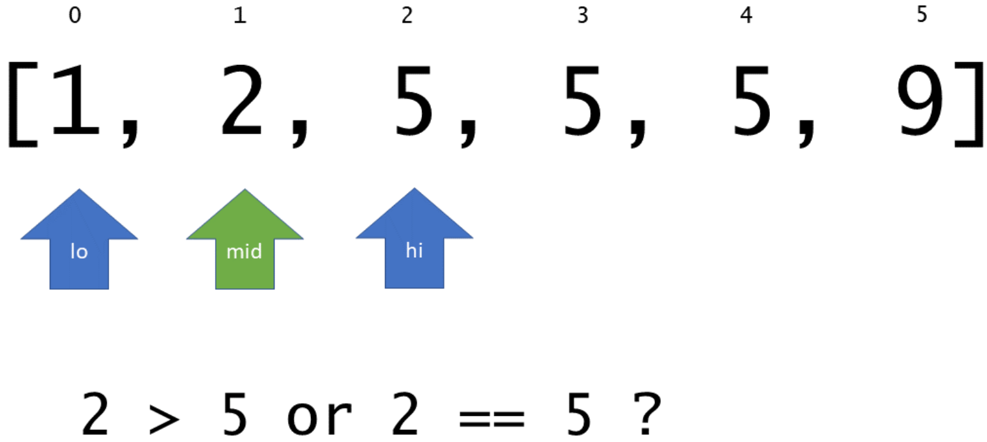

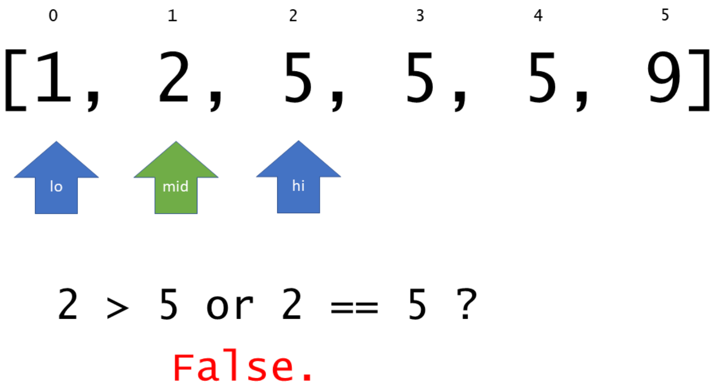

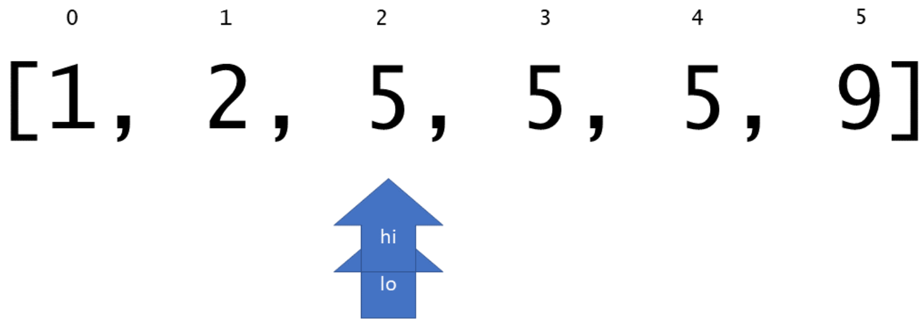

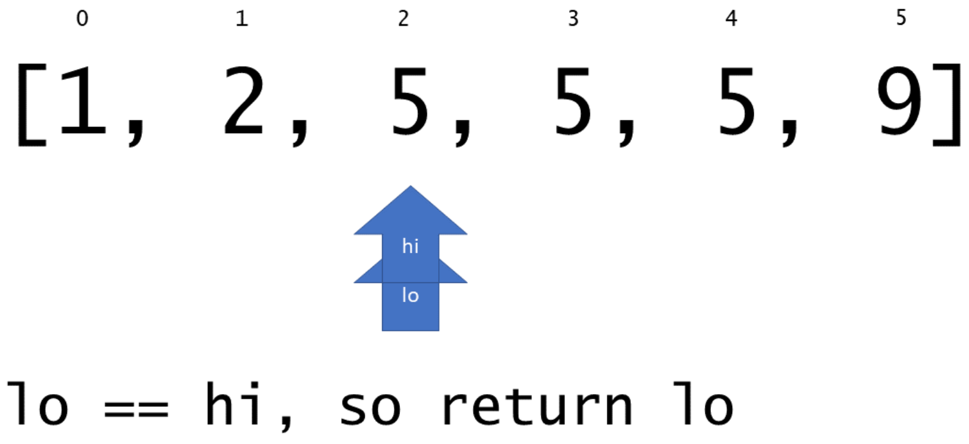

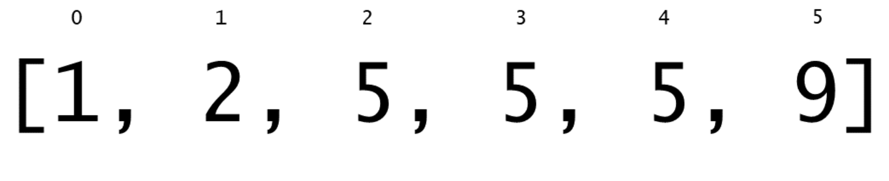

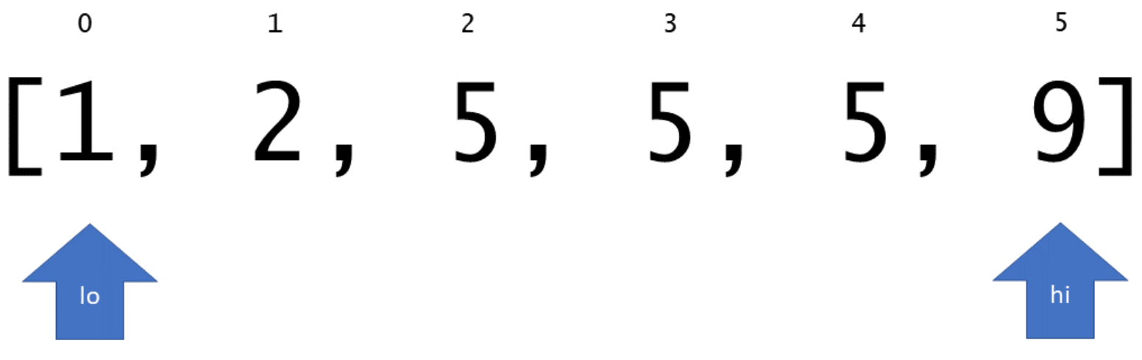

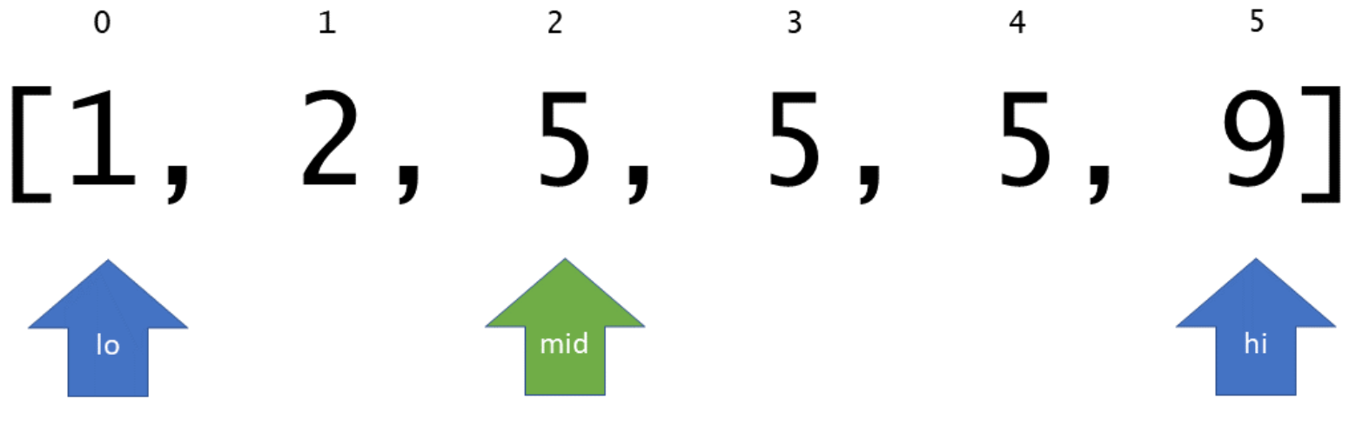

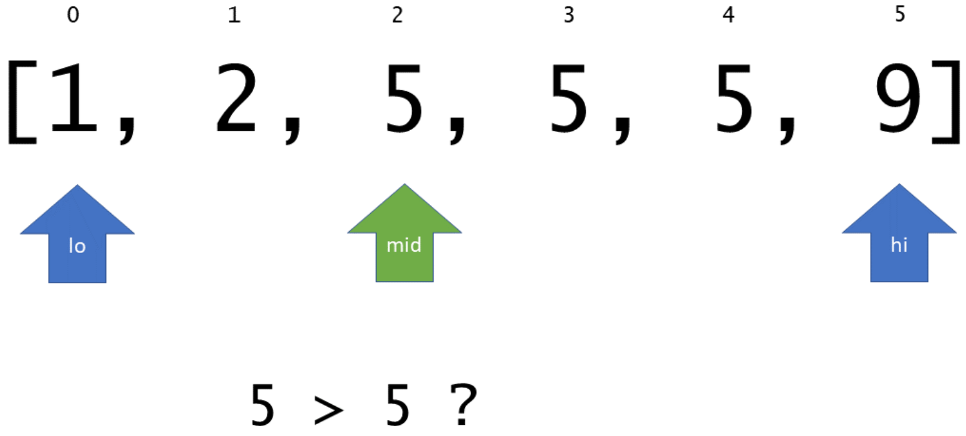

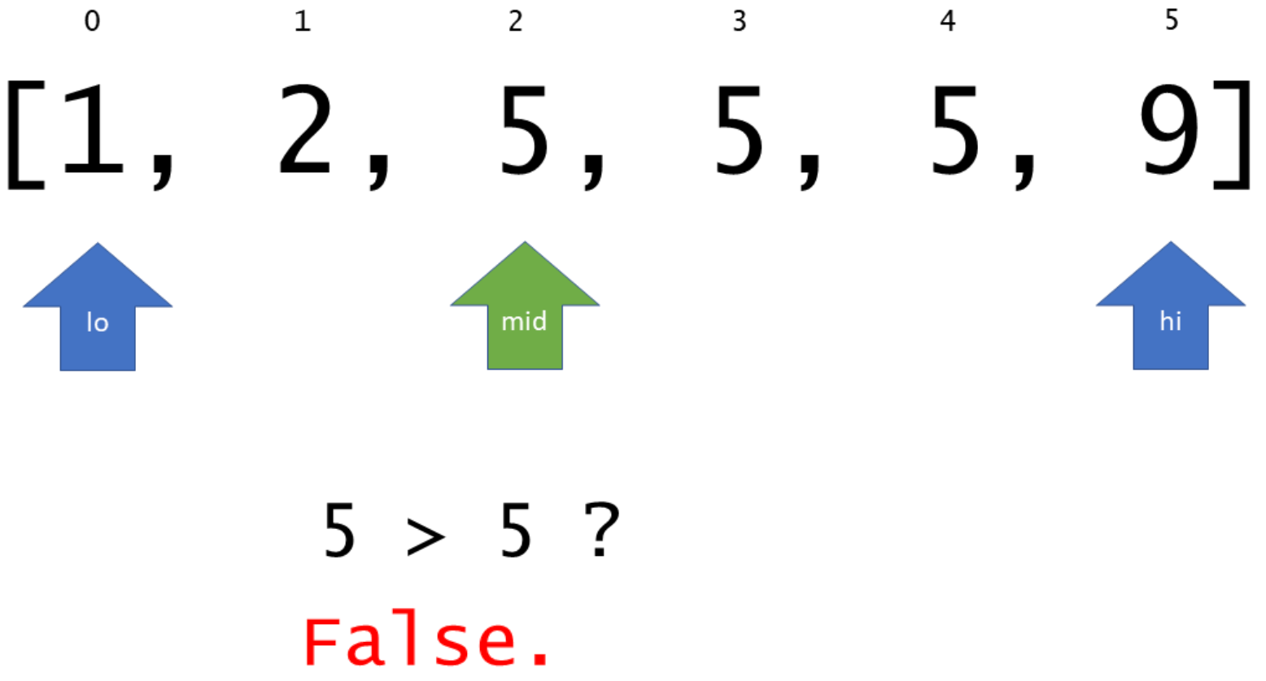

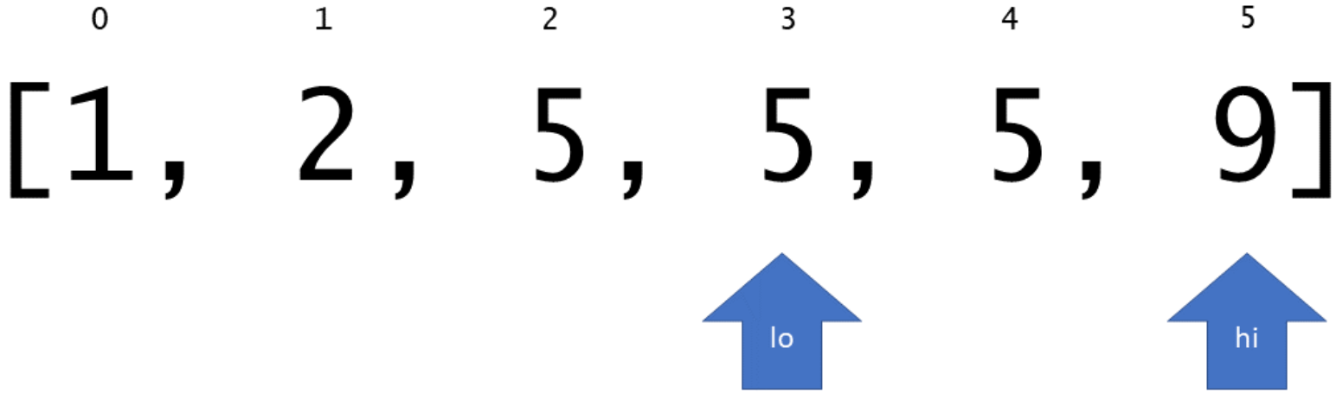

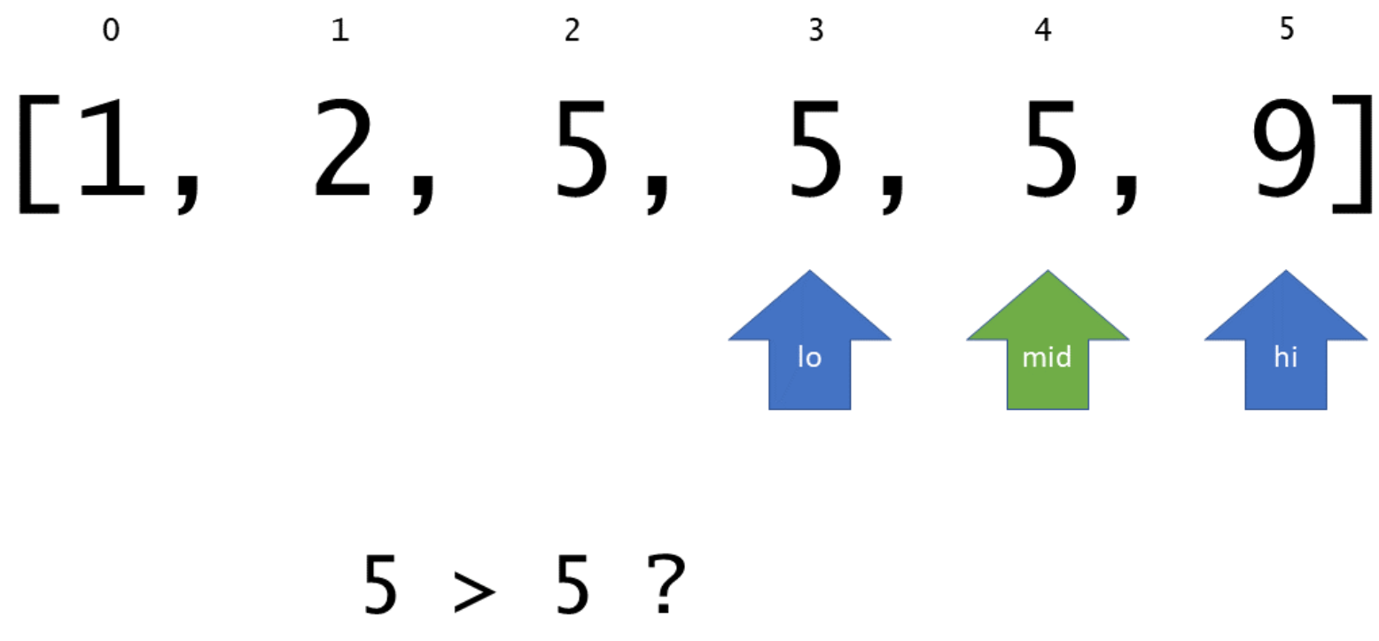

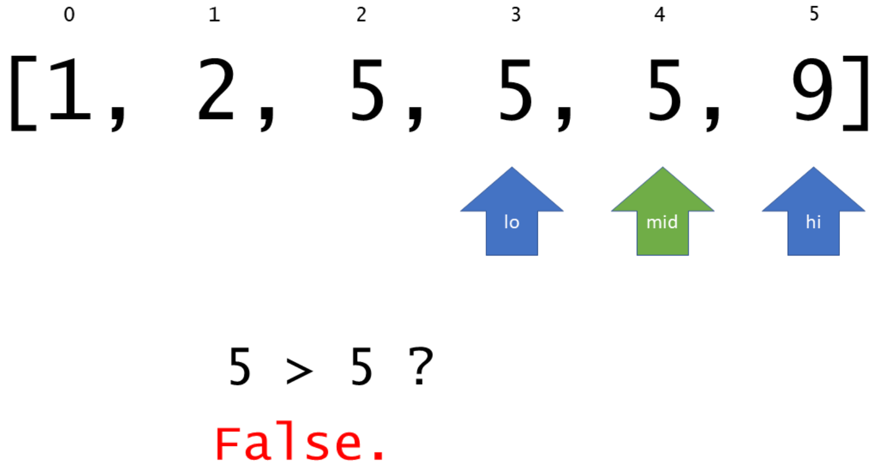

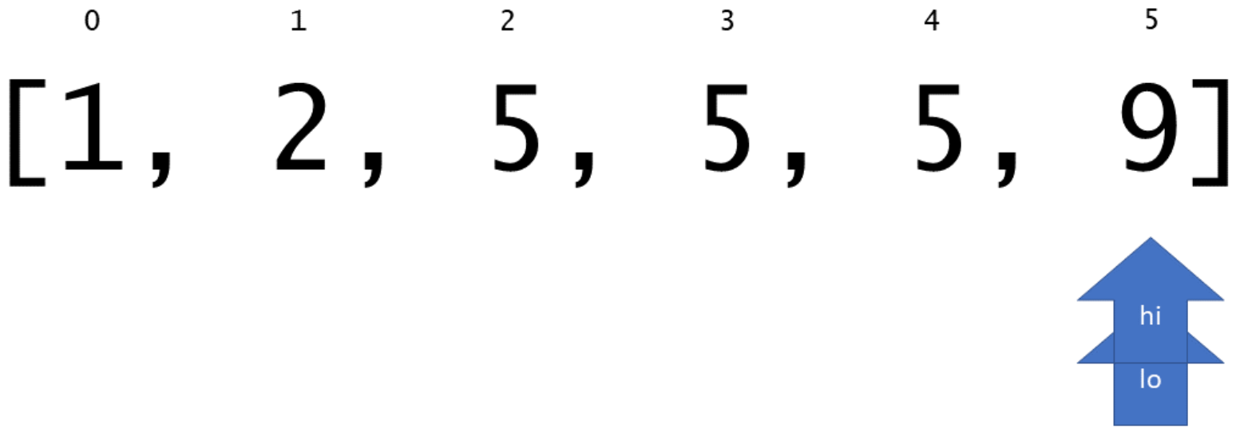

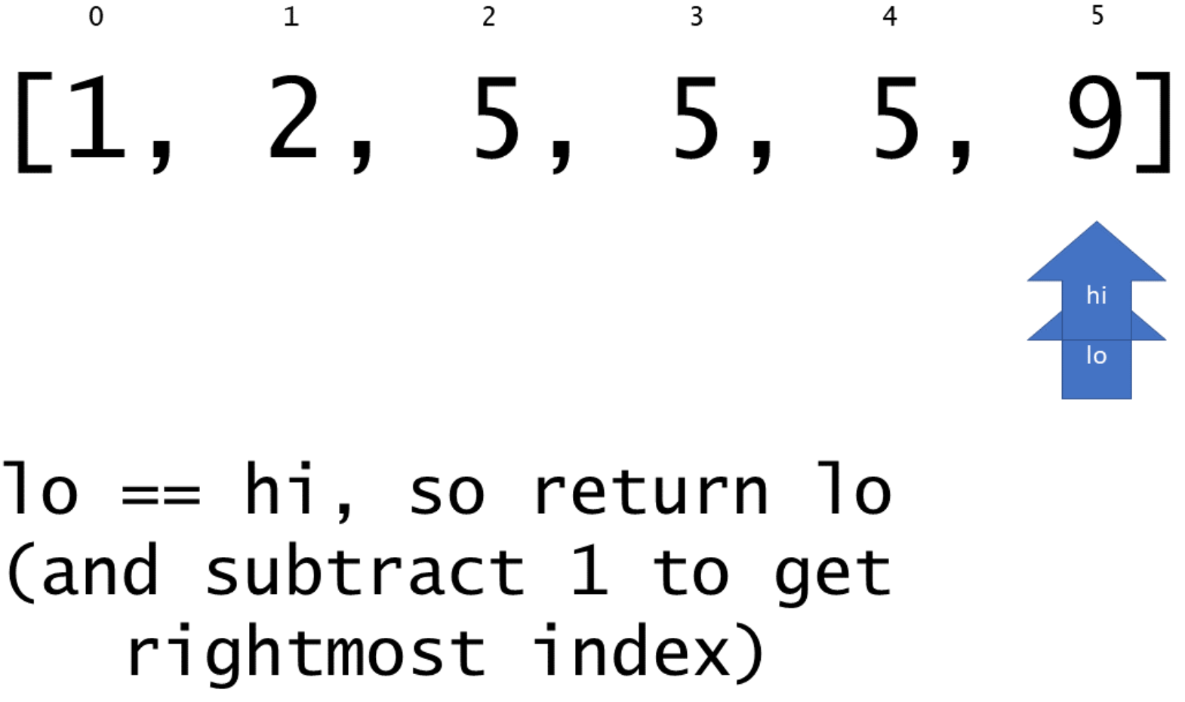

|  |
| --- |
| class Solution {  // returns leftmost (or rightmost) index at which `target` should be  // inserted in sorted array `nums` via binary search.  private int extremeInsertionIndex(int[] nums, int target, boolean left) {  int lo = 0;  int hi = nums.length;  while (lo < hi) {  int mid = (lo + hi) / 2;  if (nums[mid] > target || (left && target == nums[mid])) {  hi = mid;  }  else {  lo = mid+1;  }  }  return lo;  }  public int[] searchRange(int[] nums, int target) {  int[] targetRange = {-1, -1};  int leftIdx = extremeInsertionIndex(nums, target, true);  // assert that `leftIdx` is within the array bounds and that `target`  // is actually in `nums`.  if (leftIdx == nums.length || nums[leftIdx] != target) {  return targetRange;  }  targetRange[0] = leftIdx;  targetRange[1] = extremeInsertionIndex(nums, target, false)-1;  return targetRange;  }  } |

**Complexity Analysis**

* Time complexity : O(log*N*)

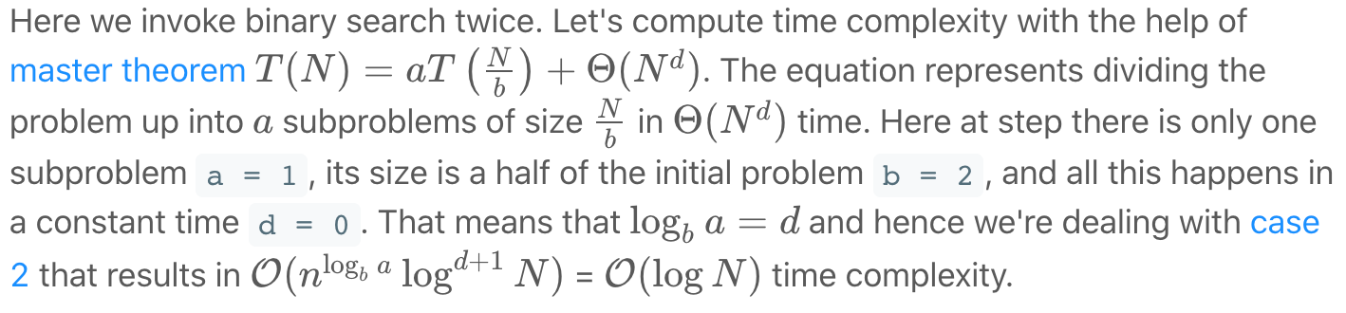

* Space complexity : O(1)

All work is done in place, so the overall memory usage is constant.

**Merge Intervals**

Given an array of intervals where intervals[i] = [starti, endi], merge all overlapping intervals, and return *an array of the non-overlapping intervals that cover all the intervals in the input*.

**Example 1:**

**Input:** intervals = [[1,3],[2,6],[8,10],[15,18]]

**Output:** [[1,6],[8,10],[15,18]]

**Explanation:** Since intervals [1,3] and [2,6] overlaps, merge them into [1,6].

**Example 2:**

**Input:** intervals = [[1,4],[4,5]]

**Output:** [[1,5]]

**Explanation:** Intervals [1,4] and [4,5] are considered overlapping.

**Constraints:**

* 1 <= intervals.length <= 104
* intervals[i].length == 2
* 0 <= starti <= endi <= 104

## Solution Article

#### **Approach 1: Connected Components**

**Intuition**

If we draw a graph (with intervals as nodes) that contains undirected edges between all pairs of intervals that overlap, then all intervals in each connected component of the graph can be merged into a single interval.

**Algorithm**

With the above intuition in mind, we can represent the graph as an adjacency list, inserting directed edges in both directions to simulate undirected edges. Then, to determine which connected component each node is it, we perform graph traversals from arbitrary unvisited nodes until all nodes have been visited. To do this efficiently, we store visited nodes in a Set, allowing for constant time containment checks and insertion. Finally, we consider each connected component, merging all of its intervals by constructing a new Interval with start equal to the minimum start among them and end equal to the maximum end.

This algorithm is correct simply because it is basically the brute force solution. We compare every interval to every other interval, so we know exactly which intervals overlap. The reason for the connected component search is that two intervals may not directly overlap, but might overlap indirectly via a third interval. See the example below to see this more clearly.

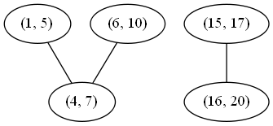

Although (1, 5) and (6, 10) do not directly overlap, either would overlap with the other if first merged with (4, 7). There are two connected components, so if we merge their nodes, we expect to get the following two merged intervals:

(1, 10), (15, 20)

|  |
| --- |
| class Solution {  private Map<int[], List<int[]>> graph;  private Map<Integer, List<int[]>> nodesInComp;  private Set<int[]> visited;  // return whether two intervals overlap (inclusive)  private boolean overlap(int[] a, int[] b) {  return a[0] <= b[1] && b[0] <= a[1];  }  // build a graph where an undirected edge between intervals u and v exists  // iff u and v overlap.  private void buildGraph(int[][] intervals) {  graph = new HashMap<>();  for (int[] interval : intervals) {  graph.put(interval, new LinkedList<>());  }  for (int[] interval1 : intervals) {  for (int[] interval2 : intervals) {  if (overlap(interval1, interval2)) {  graph.get(interval1).add(interval2);  graph.get(interval2).add(interval1);  }  }  }  }  // merges all of the nodes in this connected component into one interval.  private int[] mergeNodes(List<int[]> nodes) {  int minStart = nodes.get(0)[0];  for (int[] node : nodes) {  minStart = Math.min(minStart, node[0]);  }  int maxEnd = nodes.get(0)[1];  for (int[] node : nodes) {  maxEnd = Math.max(maxEnd, node[1]);  }  return new int[] {minStart, maxEnd};  }  // use depth-first search to mark all nodes in the same connected component  // with the same integer.  private void markComponentDFS(int[] start, int compNumber) {  Stack<int[]> stack = new Stack<>();  stack.add(start);  while (!stack.isEmpty()) {  int[] node = stack.pop();  if (!visited.contains(node)) {  visited.add(node);  if (nodesInComp.get(compNumber) == null) {  nodesInComp.put(compNumber, new LinkedList<>());  }  nodesInComp.get(compNumber).add(node);  for (int[] child : graph.get(node)) {  stack.add(child);  }  }  }  }  // gets the connected components of the interval overlap graph.  private void buildComponents(int[][] intervals) {  nodesInComp = new HashMap<>();  visited = new HashSet<>();  int compNumber = 0;  for (int[] interval : intervals) {  if (!visited.contains(interval)) {  markComponentDFS(interval, compNumber);  compNumber++;  }  }  }  public int[][] merge(int[][] intervals) {  buildGraph(intervals);  buildComponents(intervals);  // for each component, merge all intervals into one interval.  List<int[]> merged = new LinkedList<>();  for (int comp = 0; comp < nodesInComp.size(); comp++) {  merged.add(mergeNodes(nodesInComp.get(comp)));  }  return merged.toArray(new int[merged.size()][]);  }  } |

**Complexity Analysis**

* Time complexity : O(n^2)

Building the graph costs O(V + E) = O(V) + O(E) = O(n) + O(n^2) = O(n^2) time, as in the worst case all intervals are mutually overlapping. Traversing the graph has the same cost (although it might appear higher at first) because our visited set guarantees that each node will be visited exactly once. Finally, because each node is part of exactly one component, the merge step costs  *O*(*V*)=*O*(*n*) time. This all adds up as follows:

O(n^2) + O(n^2) + O(n) = O(n^2)

* Space complexity : O(n^2)

As previously mentioned, in the worst case, all intervals are mutually overlapping, so there will be an edge for every pair of intervals. Therefore, the memory footprint is quadratic in the input size.

#### **Approach 2: Sorting**

**Intuition**

If we sort the intervals by their start value, then each set of intervals that can be merged will appear as a contiguous "run" in the sorted list.

**Algorithm**

First, we sort the list as described. Then, we insert the first interval into our merged list and continue considering each interval in turn as follows: If the current interval begins after the previous interval ends, then they do not overlap and we can append the current interval to merged. Otherwise, they do overlap, and we merge them by updating the end of the previous interval if it is less than the end of the current interval.

A simple proof by contradiction shows that this algorithm always produces the correct answer. First, suppose that the algorithm at some point fails to merge two intervals that should be merged. This would imply that there exists some triple of indices *i*, *j*, and k*k* in a list of intervals ints such that *i*<*j*<*k* and (ints[i], ints[k]) can be merged, but neither (ints[i], ints[j]) nor (ints[j], ints[k]) can be merged. From this scenario follow several inequalities:

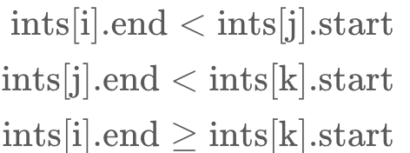

We can chain these inequalities (along with the following inequality, implied by the well-formedness of the intervals: ints[j].start≤ints[j].end) to demonstrate a contradiction:

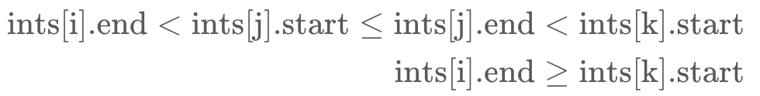​

Therefore, all mergeable intervals must occur in a contiguous run of the sorted list.

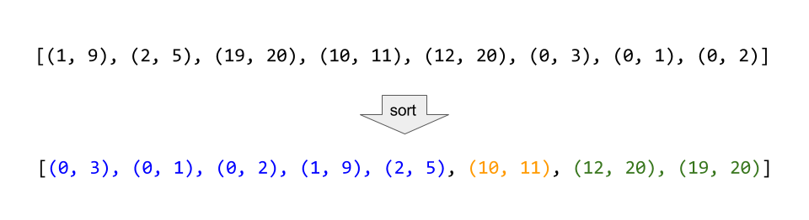

Consider the example above, where the intervals are sorted, and then all mergeable intervals form contiguous blocks.

|  |
| --- |
| class Solution {  public int[][] merge(int[][] intervals) {  Arrays.sort(intervals, (a, b) -> Integer.compare(a[0], b[0]));  LinkedList<int[]> merged = new LinkedList<>();  for (int[] interval : intervals) {  // if the list of merged intervals is empty or if the current  // interval does not overlap with the previous, simply append it.  if (merged.isEmpty() || merged.getLast()[1] < interval[0]) {  merged.add(interval);  }  // otherwise, there is overlap, so we merge the current and previous  // intervals.  else {  merged.getLast()[1] = Math.max(merged.getLast()[1], interval[1]);  }  }  return merged.toArray(new int[merged.size()][]);  }  } |

**Complexity Analysis**

* Time complexity : *O*(*n*log*n*)

Other than the sort invocation, we do a simple linear scan of the list, so the runtime is dominated by the *O*(*n*log*n*) complexity of sorting.

* Space complexity : *O*(log*N*) or *O*(*n*))

If we can sort intervals in place, we do not need more than constant additional space, although the sorting itself takes *O*(log*n*) space. Otherwise, we must allocate linear space to store a copy of intervals and sort that.

**Search in Rotated Sorted Array**

There is an integer array nums sorted in ascending order (with **distinct** values).

Prior to being passed to your function, nums is **rotated** at an unknown pivot index k (0 <= k < nums.length) such that the resulting array is [nums[k], nums[k+1], ..., nums[n-1], nums[0], nums[1], ..., nums[k-1]] (**0-indexed**). For example, [0,1,2,4,5,6,7] might be rotated at pivot index 3 and become [4,5,6,7,0,1,2].

Given the array nums **after** the rotation and an integer target, return *the index of*target*if it is in*nums*, or*-1*if it is not in*nums.

**Example 1:**

**Input:** nums = [4,5,6,7,0,1,2], target = 0

**Output:** 4

**Example 2:**

**Input:** nums = [4,5,6,7,0,1,2], target = 3

**Output:** -1

**Example 3:**

**Input:** nums = [1], target = 0

**Output:** -1

**Constraints:**

* 1 <= nums.length <= 5000
* -104 <= nums[i] <= 104
* All values of nums are **unique**.
* nums is guaranteed to be rotated at some pivot.
* -104 <= target <= 104

**Follow up:** Can you achieve this in O(log n) time complexity?

## Solution

#### **Approach 1: Binary search**

The problem is to implement a search in O(log*N*) time that gives an idea to use a binary search.

The algorithm is quite straightforward :

* Find a rotation index rotation_index, i.e. index of the smallest element in the array. Binary search works just perfect here.
* rotation_index splits array in two parts. Compare nums[0] and target to identify in which part one has to look for target.
* Perform a binary search in the chosen part of the array.

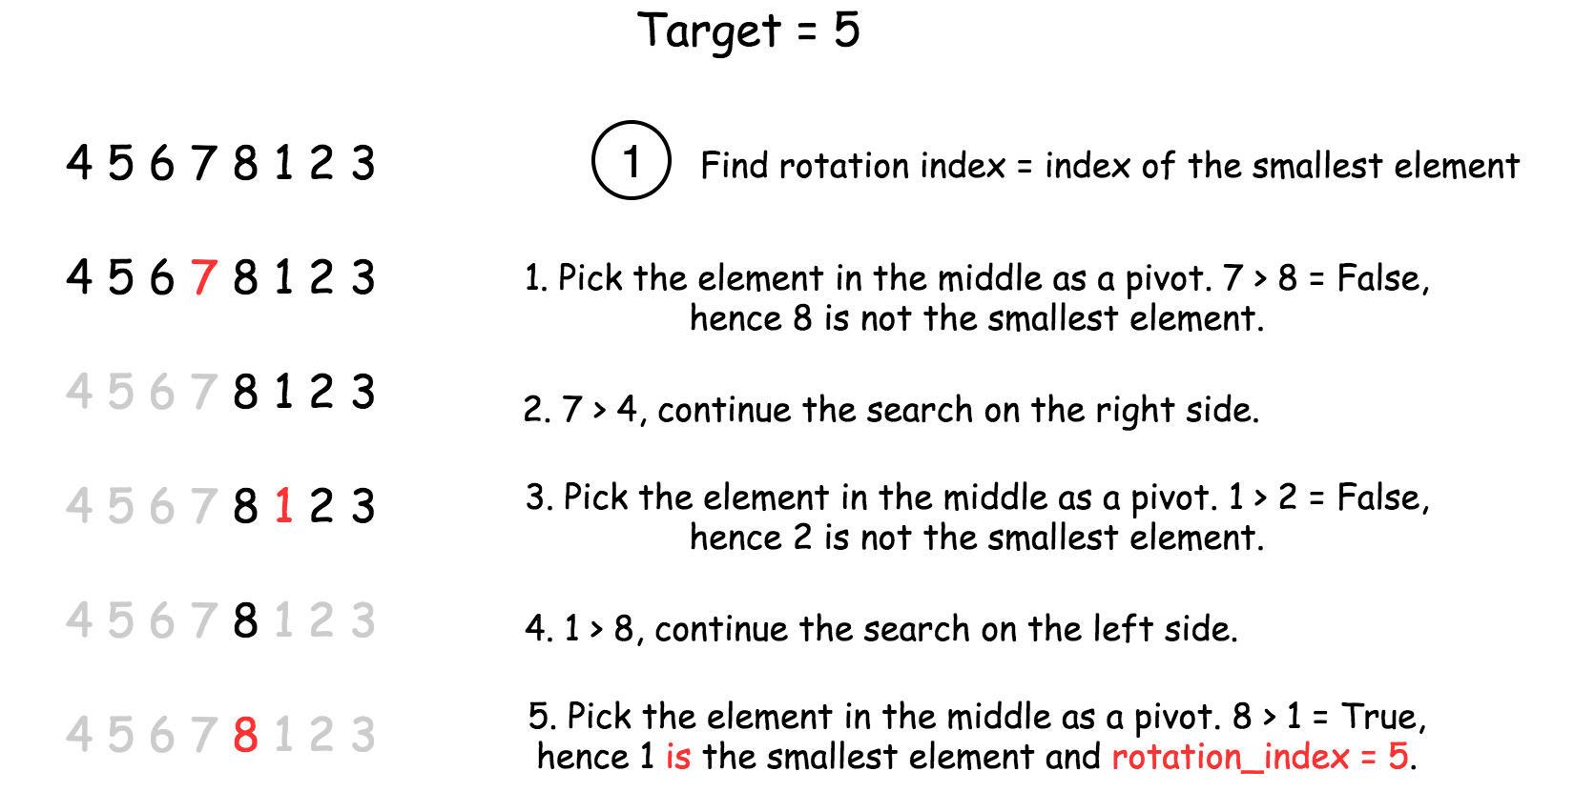

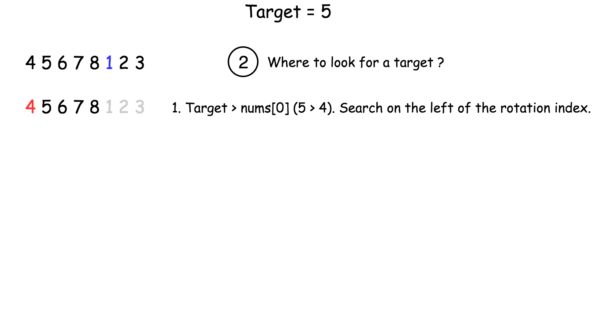

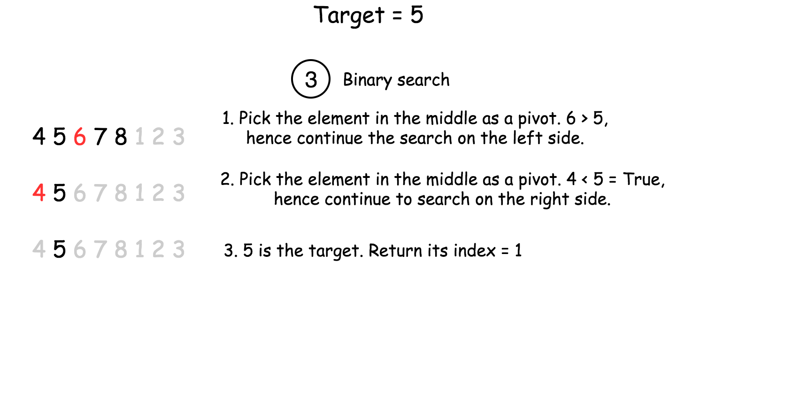

|  |
| --- |
| class Solution {  int [] nums;  int target;  public int find_rotate_index(int left, int right) {  if (nums[left] < nums[right])  return 0;  while (left <= right) {  int pivot = (left + right) / 2;  if (nums[pivot] > nums[pivot + 1])  return pivot + 1;  else {  if (nums[pivot] < nums[left])  right = pivot - 1;  else  left = pivot + 1;  }  }  return 0;  }  public int search(int left, int right) {  /*  Binary search  */  while (left <= right) {  int pivot = (left + right) / 2;  if (nums[pivot] == target)  return pivot;  else {  if (target < nums[pivot])  right = pivot - 1;  else  left = pivot + 1;  }  }  return -1;  }  public int search(int[] nums, int target) {  this.nums = nums;  this.target = target;  int n = nums.length;  if (n == 1)  return this.nums[0] == target ? 0 : -1;  int rotate_index = find_rotate_index(0, n - 1);  // if target is the smallest element  if (nums[rotate_index] == target)  return rotate_index;  // if array is not rotated, search in the entire array  if (rotate_index == 0)  return search(0, n - 1);  if (target < nums[0])  // search in the right side  return search(rotate_index, n - 1);  // search in the left side  return search(0, rotate_index);  }  } |

**Complexity Analysis**

* Time complexity : O(log*N*).
* Space complexity : O(1).

#### **Approach 2: One-pass Binary Search**

Instead of going through the input array in two passes, we could achieve the goal in one pass with an revised binary search.

The idea is that we add some additional condition checks in the normal binary search in order to better narrow down the scope of the search.

**Algorithm**

As in the normal binary search, we keep two pointers (i.e. start and end) to track the search scope. At each iteration, we reduce the search scope into half, by moving either the start or end pointer to the middle (i.e. mid) of the previous search scope.

Here are the detailed breakdowns of the algorithm:

* Initiate the pointer start to 0, and the pointer end to n - 1.
* Perform standard binary search. While start <= end:
  + Take an index in the middle mid as a pivot.
  + If nums[mid] == target, the job is done, return mid.
  + Now there could be two situations:
    - Pivot element is larger than the first element in the array, i.e. the subarray from the first element to the pivot is non-rotated, as shown in the following graph.

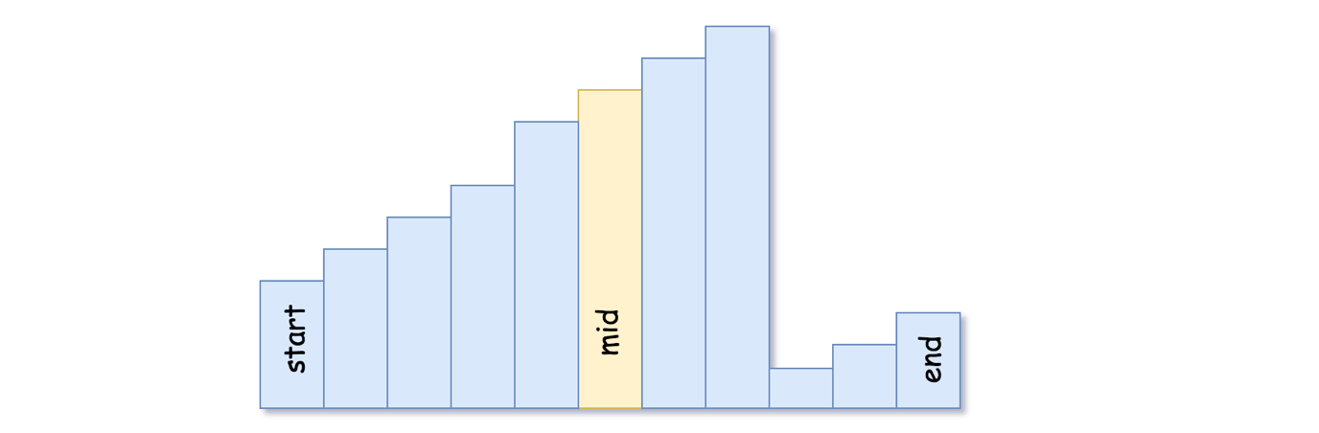

- If the target is located in the non-rotated subarray:

go left: `end = mid - 1`.

- Otherwise: go right: `start = mid + 1`.

* + - Pivot element is smaller than the first element of the array, i.e. the rotation index is somewhere between 0 and mid. It implies that the sub-array from the pivot element to the last one is non-rotated, as shown in the following graph.

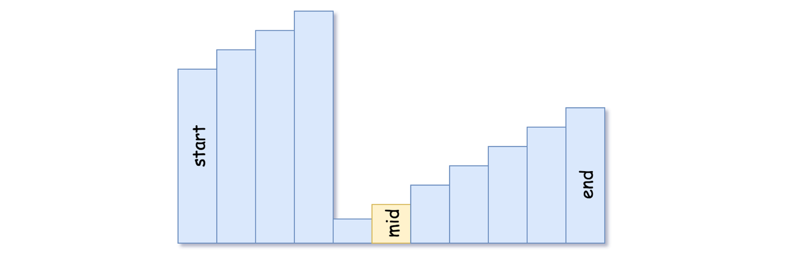

- If the target is located in the non-rotated subarray:

go right: `start = mid + 1`.

- Otherwise: go left: `end = mid - 1`.

* We're here because the target is not found. Return -1.

**Implementation**

|  |
| --- |
| class Solution {  public int search(int[] nums, int target) {  int start = 0, end = nums.length - 1;  while (start <= end) {  int mid = start + (end - start) / 2;  if (nums[mid] == target) return mid;  else if (nums[mid] >= nums[start]) {  if (target >= nums[start] && target < nums[mid]) end = mid - 1;  else start = mid + 1;  }  else {  if (target <= nums[end] && target > nums[mid]) start = mid + 1;  else end = mid - 1;  }  }  return -1;  }  } |

**Complexity Analysis**

* Time complexity: O(log*N*).
* Space complexity: O(1).

**Meeting Rooms II**

Given an array of meeting time intervals intervals where intervals[i] = [starti, endi], return *the minimum number of conference rooms required*.

**Example 1:**

**Input:** intervals = [[0,30],[5,10],[15,20]]

**Output:** 2

**Example 2:**

**Input:** intervals = [[7,10],[2,4]]

**Output:** 1

**Constraints:**

* 1 <= intervals.length <= 104
* 0 <= starti < endi <= 106

  Hide Hint #1

Think about how we would approach this problem in a very simplistic way. We will allocate rooms to meetings that occur earlier in the day v/s the ones that occur later on, right?

   Hide Hint #2

If you've figured out that we have to **sort** the meetings by their start time, the next thing to think about is how do we do the allocation?  
There are two scenarios possible here for any meeting. Either there is no meeting room available and a new one has to be allocated, or a meeting room has freed up and this meeting can take place there.

   Hide Hint #3

An important thing to note is that we don't really care **which** room gets freed up while allocating a room for the current meeting. As long as a room is free, our job is done.  
  
We already know the rooms we have allocated till now and we also know when are they due to get free because of the end times of the meetings going on in those rooms. We can simply check the room which is due to get vacated the earliest amongst all the allocated rooms.

   Hide Hint #4

Following up on the previous hint, we can make use of a min-heap to store the end times of the meetings in various rooms.  
  
So, every time we want to check if any room is free or not, simply check the topmost element of the min heap as that would be the room that would get free the earliest out of all the other rooms currently occupied.  
  
If the room we extracted from the top of the min heap isn't free, then no other room is. So, we can save time here and simply allocate a new room.

## Solution

**Intuition**

This problem is very similar to something that employees of a company can face potentially on daily basis.

Suppose you work at a company and you belong to the IT department and one of your job responsibilities is securing rooms for meetings that are to happen throughout the day in the office.

You have multiple meeting rooms in the office and you want to make judicious use of them. You don't really want to keep people waiting and want to give a group of employees a room to hold the meeting right on time.

At the same time, you don't really want to use too many rooms unless absolutely necessary. It would make sense to hold meetings in different rooms provided that the meetings are colliding with each other, otherwise you want to make use of as less rooms as possible to hold all of the meetings. How do you go about it ?

I just represented a common scenario at an office where given the start and end times for meetings to happen throughout the day, you, as an IT guru need to setup and allocate the room numbers to different teams.

Let's approach this problem from the perspective of a group of people who want to hold a meeting and have not been allocated a room yet. What would they do?

This group would essentially go from one room to another and check if any meeting room is free. If they find a room that is indeed free, they would start their meeting in that room. Otherwise, they would wait for a room to be free. As soon as the room frees up, they would occupy it.

This is the basic approach that we will follow in this question. So, it is a kind of simulation but not exactly. In the worst case we can assign a new room to all of the meetings but that is not really optimal right? Unless of course they all collide with each other.

We need to be able to find out efficiently if a room is available or not for the current meeting and assign a new room only if none of the assigned rooms is currently free.

Let's look at the first approach based on the idea we just discussed.

#### **Approach 1: Priority Queues**

We can't really process the given meetings in any random order. The most basic way of processing the meetings is in increasing order of their start times and this is the order we will follow. After all, it makes sense to allocate a room to the meeting that is scheduled for 9 a.m. in the morning before you worry about the 5 p.m. meeting, right?

Let's do a dry run of an example problem with sample meeting times and see what our algorithm should be able to do efficiently.

We will consider the following meeting times for our example (1, 10), (2, 7), (3, 19), (8, 12), (10, 20), (11, 30). The first part of the tuple is the start time for the meeting and the second value represents the ending time. We are considering the meetings in a sorted order of their start times. The first diagram depicts the first three meetings where each of them requires a new room because of collisions.

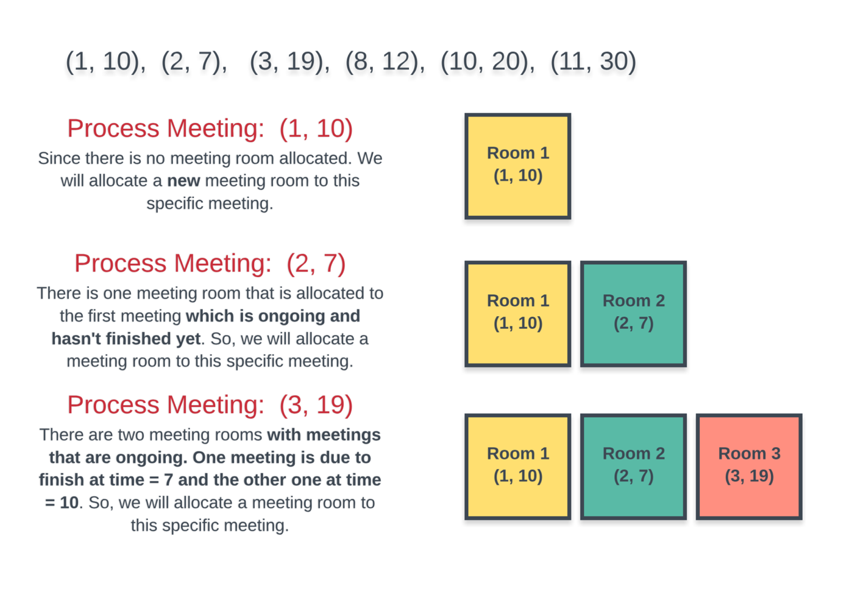

The next 3 meetings start to occupy some of the existing rooms. However, the last one requires a new room altogether and overall we have to use 4 different rooms to accommodate all the meetings.

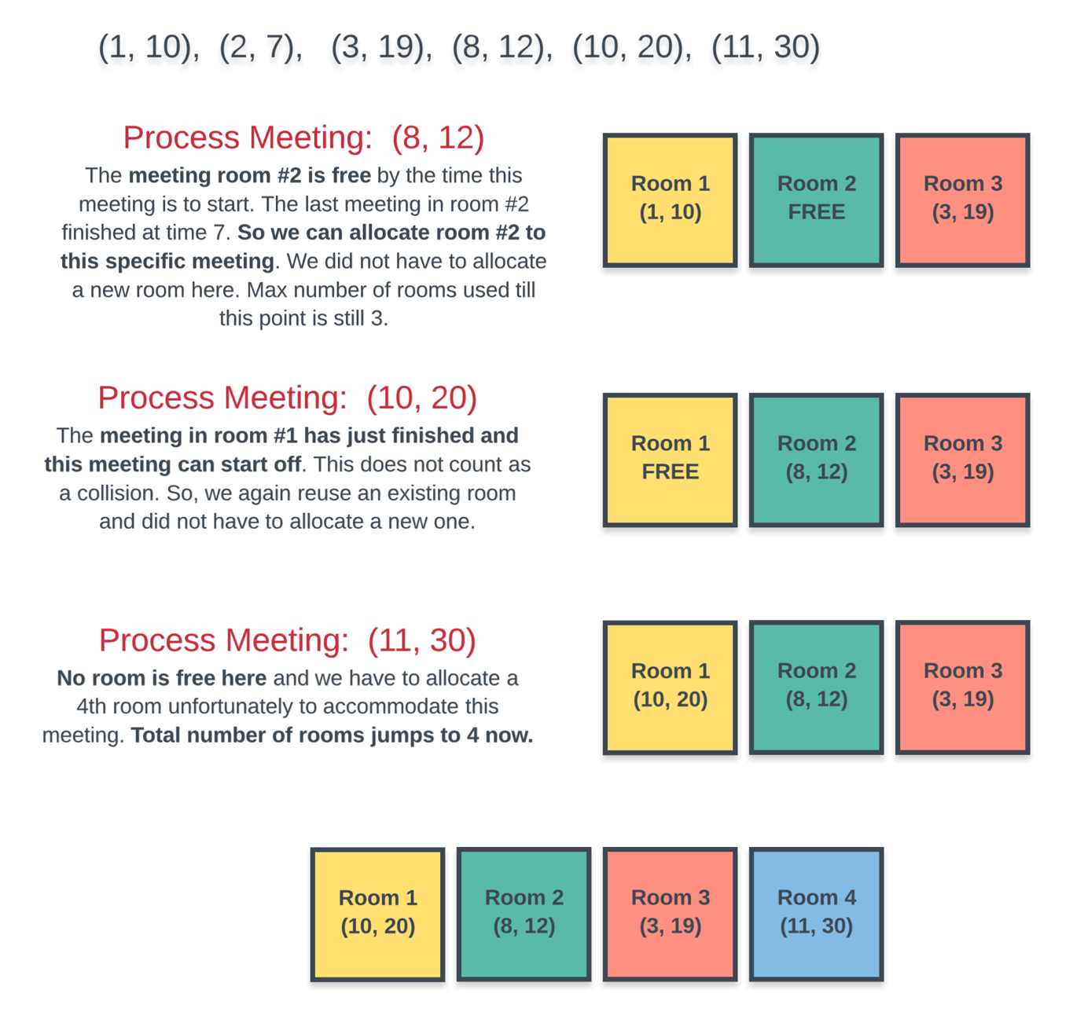

Sorting part is easy, but for every meeting how do we find out efficiently if a room is available or not? At any point in time we have multiple rooms that can be occupied and we don't really care which room is free as long as we find one when required for a new meeting.

A naive way to check if a room is available or not is to iterate on all the rooms and see if one is available when we have a new meeting at hand.

However, we can do better than this by making use of Priority Queues or the Min-Heap data structure.

Instead of manually iterating on every room that's been allocated and checking if the room is available or not, we can keep all the rooms in a min heap where the key for the min heap would be the ending time of meeting.

So, every time we want to check if **any** room is free or not, simply check the topmost element of the min heap as that would be the room that would get free the earliest out of all the other rooms currently occupied.

If the room we extracted from the top of the min heap isn't free, then no other room is. So, we can save time here and simply allocate a new room.

Let us look at the algorithm before moving onto the implementation.

**Algorithm**

1. Sort the given meetings by their start time.
2. Initialize a new min-heap and add the first meeting's ending time to the heap. We simply need to keep track of the ending times as that tells us when a meeting room will get free.
3. For every meeting room check if the minimum element of the heap i.e. the room at the top of the heap is free or not.
4. If the room is free, then we extract the topmost element and add it back with the ending time of the current meeting we are processing.
5. If not, then we allocate a new room and add it to the heap.
6. After processing all the meetings, the size of the heap will tell us the number of rooms allocated. This will be the minimum number of rooms needed to accommodate all the meetings.

Let us not look at the implementation for this algorithm.

|  |
| --- |
| class Solution {  public int minMeetingRooms(int[][] intervals) {    // Check for the base case. If there are no intervals, return 0  if (intervals.length == 0) {  return 0;  }  // Min heap  PriorityQueue<Integer> allocator =  new PriorityQueue<Integer>(  intervals.length,  new Comparator<Integer>() {  public int compare(Integer a, Integer b) {  return a - b;  }  });  // Sort the intervals by start time  Arrays.sort(  intervals,  new Comparator<int[]>() {  public int compare(final int[] a, final int[] b) {  return a[0] - b[0];  }  });  // Add the first meeting  allocator.add(intervals[0][1]);  // Iterate over remaining intervals  for (int i = 1; i < intervals.length; i++) {  // If the room due to free up the earliest is free, assign that room to this meeting.  if (intervals[i][0] >= allocator.peek()) {  allocator.poll();  }  // If a new room is to be assigned, then also we add to the heap,  // If an old room is allocated, then also we have to add to the heap with updated end time.  allocator.add(intervals[i][1]);  }  // The size of the heap tells us the minimum rooms required for all the meetings.  return allocator.size();  }  } |

**Complexity Analysis**

* Time Complexity: *O*(*N*log*N*).
  + There are two major portions that take up time here. One is sorting of the array that takes *O*(*N*log*N*) considering that the array consists of *N* elements.
  + Then we have the min-heap. In the worst case, all *N* meetings will collide with each other. In any case we have *N* add operations on the heap. In the worst case we will have *N* extract-min operations as well. Overall complexity being (*NlogN*) since extract-min operation on a heap takes *O*(log*N*).
* Space Complexity: *O*(*N*) because we construct the min-heap and that can contain *N* elements in the worst case as described above in the time complexity section. Hence, the space complexity is *O*(*N*).

#### **Approach 2: Chronological Ordering**

**Intuition**

The meeting timings given to us define a chronological order of events throughout the day. We are given the start and end timings for the meetings which can help us define this ordering.

Arranging the meetings according to their start times helps us know the natural order of meetings throughout the day. However, simply knowing when a meeting starts doesn't tell us much about its duration.

We also need the meetings sorted by their ending times because an ending event essentially tells us that there must have been a corresponding starting event and more importantly, an ending event tell us that a previously occupied room has now become free.

A meeting is defined by its start and end times. However, for this specific algorithm, we need to treat the start and end times individually. This might not make sense right away because a meeting is defined by its start and end times. If we separate the two and treat them individually, then the identity of a meeting goes away. This is fine because:

When we encounter an ending event, that means that some meeting that started earlier has ended now. We are not really concerned with which meeting has ended. All we need is that **some** meeting ended thus making a room available.

Let us consider the same example as we did in the last approach. We have the following meetings to be scheduled: (1, 10), (2, 7), (3, 19), (8, 12), (10, 20), (11, 30). As before, the first diagram show us that the first three meetings are colliding with each other and they have to be allocated separate rooms.

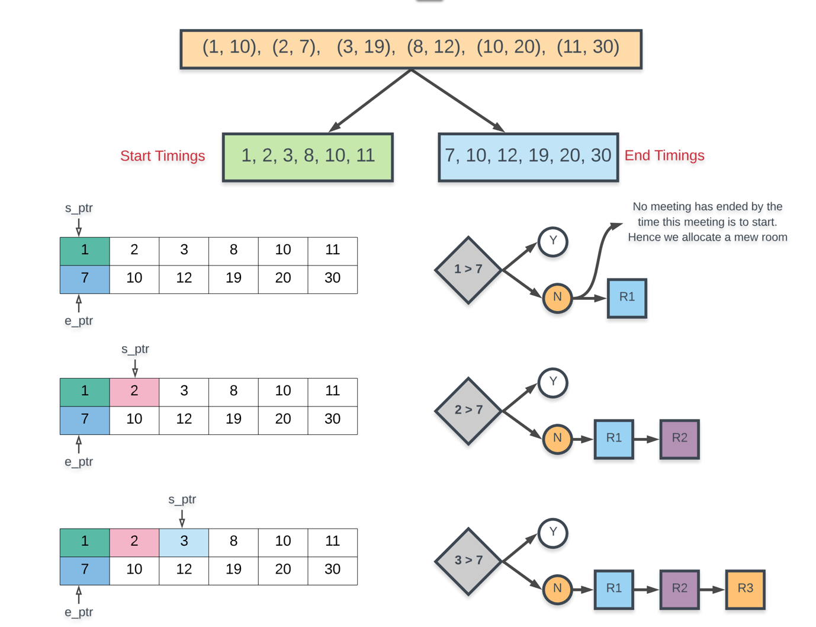

The next two diagrams process the remaining meetings and we see that we can now reuse some of the existing meeting rooms. The final result is the same, we need 4 different meeting rooms to process all the meetings. That's the best we can do here.

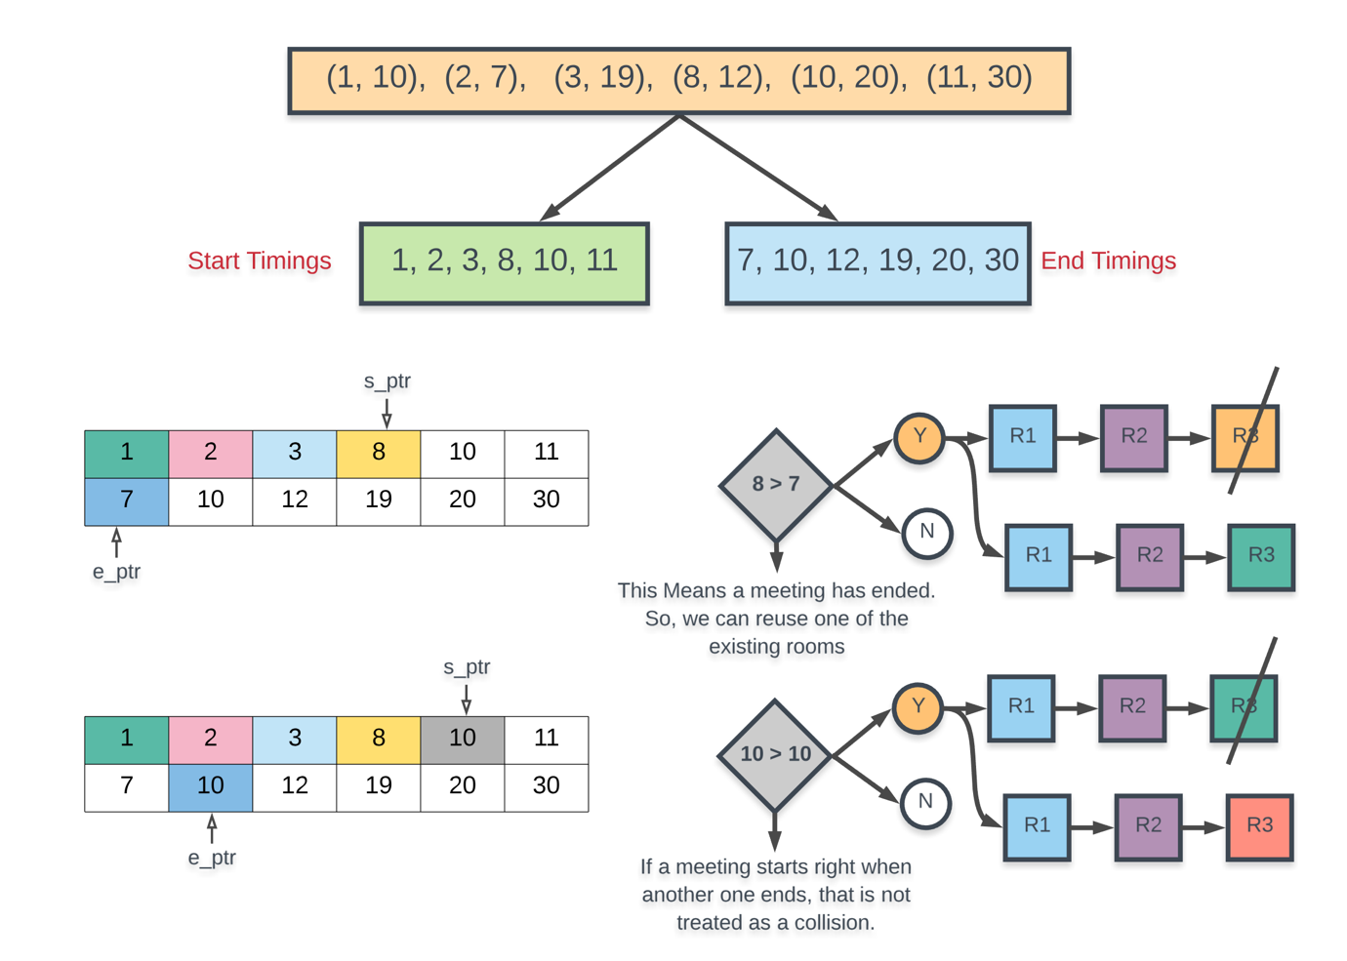

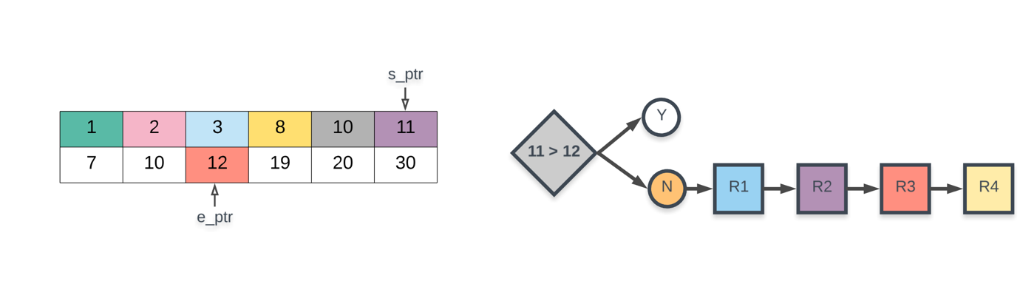

**Algorithm**

1. Separate out the start times and the end times in their separate arrays.
2. Sort the start times and the end times separately. Note that this will mess up the original correspondence of start times and end times. They will be treated individually now.
3. We consider two pointers: s_ptr and e_ptr which refer to start pointer and end pointer. The start pointer simply iterates over all the meetings and the end pointer helps us track if a meeting has ended and if we can reuse a room.
4. When considering a specific meeting pointed to by s_ptr, we check if this start timing is greater than the meeting pointed to by e_ptr. If this is the case then that would mean some meeting has ended by the time the meeting at s_ptr had to start. So we can reuse one of the rooms. Otherwise, we have to allocate a new room.
5. If a meeting has indeed ended i.e. if start[s_ptr] >= end[e_ptr], then we increment e_ptr.
6. Repeat this process until s_ptr processes all of the meetings.

Let us not look at the implementation for this algorithm.

|  |
| --- |
| class Solution {  public int minMeetingRooms(int[][] intervals) {    // Check for the base case. If there are no intervals, return 0  if (intervals.length == 0) {  return 0;  }  Integer[] start = new Integer[intervals.length];  Integer[] end = new Integer[intervals.length];  for (int i = 0; i < intervals.length; i++) {  start[i] = intervals[i][0];  end[i] = intervals[i][1];  }  // Sort the intervals by end time  Arrays.sort(  end,  new Comparator<Integer>() {  public int compare(Integer a, Integer b) {  return a - b;  }  });  // Sort the intervals by start time  Arrays.sort(  start,  new Comparator<Integer>() {  public int compare(Integer a, Integer b) {  return a - b;  }  });  // The two pointers in the algorithm: e_ptr and s_ptr.  int startPointer = 0, endPointer = 0;  // Variables to keep track of maximum number of rooms used.  int usedRooms = 0;  // Iterate over intervals.  while (startPointer < intervals.length) {  // If there is a meeting that has ended by the time the meeting at `start_pointer` starts  if (start[startPointer] >= end[endPointer]) {  usedRooms -= 1;  endPointer += 1;  }  // We do this irrespective of whether a room frees up or not.  // If a room got free, then this used_rooms += 1 wouldn't have any effect. used_rooms would  // remain the same in that case. If no room was free, then this would increase used_rooms  usedRooms += 1;  startPointer += 1;  }  return usedRooms;  }  } |

**Complexity Analysis**

* Time Complexity: *O*(*N*log*N*) because all we are doing is sorting the two arrays for start timings and end timings individually and each of them would contain *N* elements considering there are *N* intervals.
* Space Complexity: *O*(*N*) because we create two separate arrays of size *N*, one for recording the start times and one for the end times.

**Search a 2D Matrix II**

Write an efficient algorithm that searches for a target value in an m x n integer matrix. The matrix has the following properties:

* Integers in each row are sorted in ascending from left to right.
* Integers in each column are sorted in ascending from top to bottom.

**Example 1:**

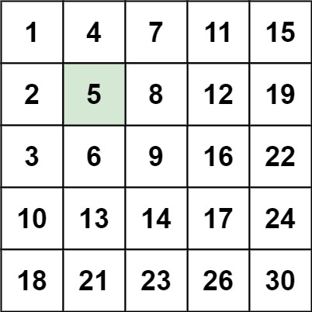

**Input:** matrix = [[1,4,7,11,15],[2,5,8,12,19],[3,6,9,16,22],[10,13,14,17,24],[18,21,23,26,30]], target = 5

**Output:** true

**Example 2:**

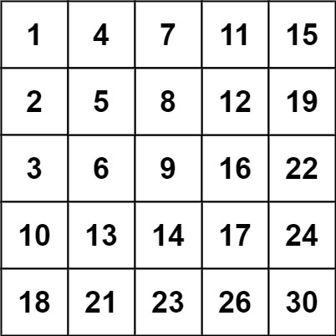

**Input:** matrix = [[1,4,7,11,15],[2,5,8,12,19],[3,6,9,16,22],[10,13,14,17,24],[18,21,23,26,30]], target = 20

**Output:** false

**Constraints:**

* m == matrix.length
* n == matrix[i].length
* 1 <= n, m <= 300
* -109 <= matix[i][j] <= 109
* All the integers in each row are **sorted** in ascending order.
* All the integers in each column are **sorted** in ascending order.
* -109 <= target <= 109

## Solution

#### **Approach 1: Brute Force**

**Intuition**

As a baseline, we can search the 2D array the same way we might search an unsorted 1D array -- by examining each element.

**Algorithm**

The algorithm doesn't really do anything more clever than what is explained by the intuition; we loop over the array, checking each element in turn. If we find it, we return true. Otherwise, if we reach the end of the nested for loop without returning, we return false. The algorithm must return the correct answer in all cases because we exhaust the entire search space.

|  |
| --- |
| class Solution {  public boolean searchMatrix(int[][] matrix, int target) {  for (int i = 0; i < matrix.length; i++) {  for (int j = 0; j < matrix[0].length; j++) {  if (matrix[i][j] == target) {  return true;  }  }  }  return false;  }  } |

**Complexity Analysis**

* Time complexity : O(*nm*)

Becase we perform a constant time operation for each element of an *n*×*m* element matrix, the overall time complexity is equal to the size of the matrix.

* Space complexity : O(1)

The brute force approach does not allocate more additional space than a handful of pointers, so the memory footprint is constant.

#### **Approach 2: Binary Search**

**Intuition**

The fact that the matrix is sorted suggests that there must be some way to use binary search to speed up our algorithm.

**Algorithm**

First, we ensure that matrix is not null and not empty. Then, if we iterate over the matrix diagonals, we can maintain an invariant that the slice of the row and column beginning at the current (row, col)(*row*,*col*) pair is sorted. Therefore, we can always binary search these row and column slices for target. We proceed in a logical fashion, iterating over the diagonals, binary searching the rows and columns until we either run out of diagonals (meaning we can return False) or find target (meaning we can return True). The binarySearch function works just like normal binary search, but is made ugly by the need to search both rows and columns of a two-dimensional array.

|  |
| --- |
| class Solution {  private boolean binarySearch(int[][] matrix, int target, int start, boolean vertical) {  int lo = start;  int hi = vertical ? matrix[0].length-1 : matrix.length-1;  while (hi >= lo) {  int mid = (lo + hi)/2;  if (vertical) { // searching a column  if (matrix[start][mid] < target) {  lo = mid + 1;  } else if (matrix[start][mid] > target) {  hi = mid - 1;  } else {  return true;  }  } else { // searching a row  if (matrix[mid][start] < target) {  lo = mid + 1;  } else if (matrix[mid][start] > target) {  hi = mid - 1;  } else {  return true;  }  }  }  return false;  }  public boolean searchMatrix(int[][] matrix, int target) {  // an empty matrix obviously does not contain `target`  if (matrix == null || matrix.length == 0) {  return false;  }  // iterate over matrix diagonals  int shorterDim = Math.min(matrix.length, matrix[0].length);  for (int i = 0; i < shorterDim; i++) {  boolean verticalFound = binarySearch(matrix, target, i, true);  boolean horizontalFound = binarySearch(matrix, target, i, false);  if (verticalFound || horizontalFound) {  return true;  }  }    return false;  }  } |

**Complexity Analysis**

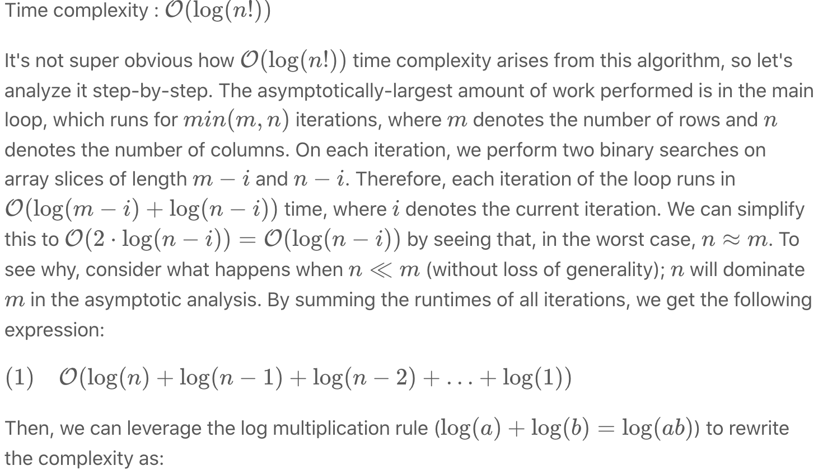

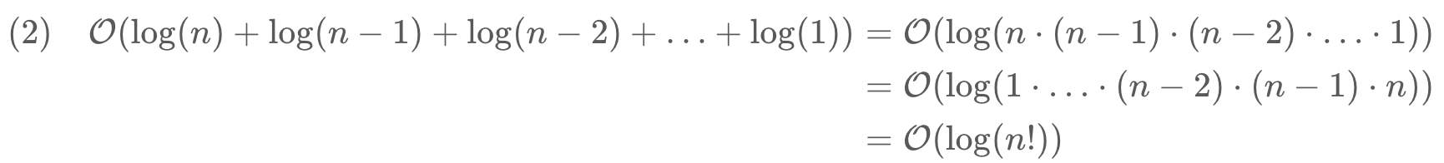

Because this time complexity is fairly uncommon, it is worth thinking about its relation to the usual analyses. For one, log(*n*!)=O(*n*log*n*). To see why, recall step 1 from the analysis above; there are *n* terms, each no greater than log(*n*). Therefore, the asymptotic runtime is certainly no worse than that of an O(*n*log*n*) algorithm.

* Space complexity : O(1)

Because our binary search implementation does not literally slice out copies of rows and columns from matrix, we can avoid allocating greater-than-constant memory.

#### **Approach 3: Divide and Conquer**

**Intuition**

We can partition a sorted two-dimensional matrix into four sorted submatrices, two of which might contain target and two of which definitely do not.

**Algorithm**

Because this algorithm operates recursively, its correctness can be asserted via the correctness of its base and recursive cases.

Base Case

For a sorted two-dimensional array, there are two ways to determine in constant time whether an arbitrary element target can appear in it. First, if the array has zero area, it contains no elements and therefore cannot contain target. Second, if target is smaller than the array's smallest element (found in the top-left corner) or larger than the array's largest element (found in the bottom-right corner), then it definitely is not present.

Recursive Case

If the base case conditions have not been met, then the array has positive area and target could potentially be present. Therefore, we seek along the matrix's middle column for an index row such that *matrix*[*row*−1][*mid*]<*target*<*matrix*[*row*][*mid*] (obviously, if we find target during this process, we immediately return true). The existing matrix can be partitioned into four submatrice around this index; the top-left and bottom-right submatrice cannot contain target (via the argument outlined in Base Case section), so we can prune them from the search space. Additionally, the bottom-left and top-right submatrice are sorted two-dimensional matrices, so we can recursively apply this algorithm to them.

|  |
| --- |
| class Solution {  private int[][] matrix;  private int target;  private boolean searchRec(int left, int up, int right, int down) {  // this submatrix has no height or no width.  if (left > right || up > down) {  return false;  // `target` is already larger than the largest element or smaller  // than the smallest element in this submatrix.  } else if (target < matrix[up][left] || target > matrix[down][right]) {  return false;  }  int mid = left + (right-left)/2;  // Locate `row` such that matrix[row-1][mid] < target < matrix[row][mid]  int row = up;  while (row <= down && matrix[row][mid] <= target) {  if (matrix[row][mid] == target) {  return true;  }  row++;  }  return searchRec(left, row, mid-1, down) || searchRec(mid+1, up, right, row-1);  }  public boolean searchMatrix(int[][] mat, int targ) {  // cache input values in object to avoid passing them unnecessarily  // to `searchRec`  matrix = mat;  target = targ;  // an empty matrix obviously does not contain `target`  if (matrix == null || matrix.length == 0) {  return false;  }  return searchRec(0, 0, matrix[0].length-1, matrix.length-1);  }  } |

**Complexity Analysis**

* Time complexity : O(*n*log*n*), First, for ease of analysis, assume that *n*≈*m*, as in the analysis of approach 2. Also, assign x=n^2=|matrix|; this will make the [master method](https://en.wikipedia.org/wiki/Master_theorem_(analysis_of_algorithms)) easier to apply. Now, let's model the runtime of the divide & conquer approach as a recurrence relation:

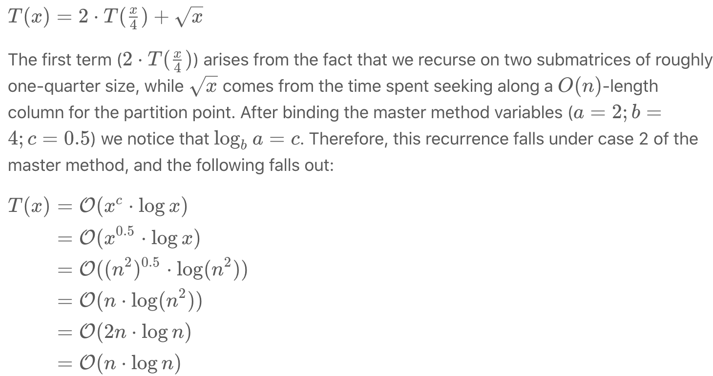

Extension: what would happen to the complexity if we binary searched for the partition point, rather than used a linear scan?

* Space complexity : O(log*n*)

Although this approach does not fundamentally require greater-than-constant addition memory, its use of recursion means that it will use memory proportional to the height of its recursion tree. Because this approach discards half of matrix on each level of recursion (and makes two recursive calls), the height of the tree is bounded by log*n*.

#### **Approach 4: Search Space Reduction**

**Intuition**

Because the rows and columns of the matrix are sorted (from left-to-right and top-to-bottom, respectively), we can prune O(*m*) or O(*n*) elements when looking at any particular value.

**Algorithm**

First, we initialize a (*row*,*col*) pointer to the bottom-left of the matrix.[[1]](https://leetcode.com/problems/search-a-2d-matrix-ii/solution/#fn1) Then, until we find target and return true (or the pointer points to a (*row*,*col*) that lies outside of the dimensions of the matrix), we do the following: if the currently-pointed-to value is larger than target we can move one row "up". Otherwise, if the currently-pointed-to value is smaller than target, we can move one column "right". It is not too tricky to see why doing this will never prune the correct answer; because the rows are sorted from left-to-right, we know that every value to the right of the current value is larger. Therefore, if the current value is already larger than target, we know that every value to its right will also be too large. A very similar argument can be made for the columns, so this manner of search will always find target in the matrix (if it is present).

Check out some sample runs of the algorithm in the animation below:

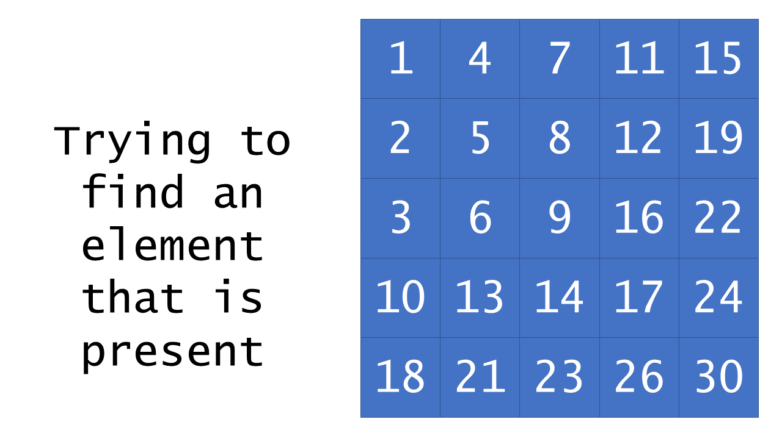 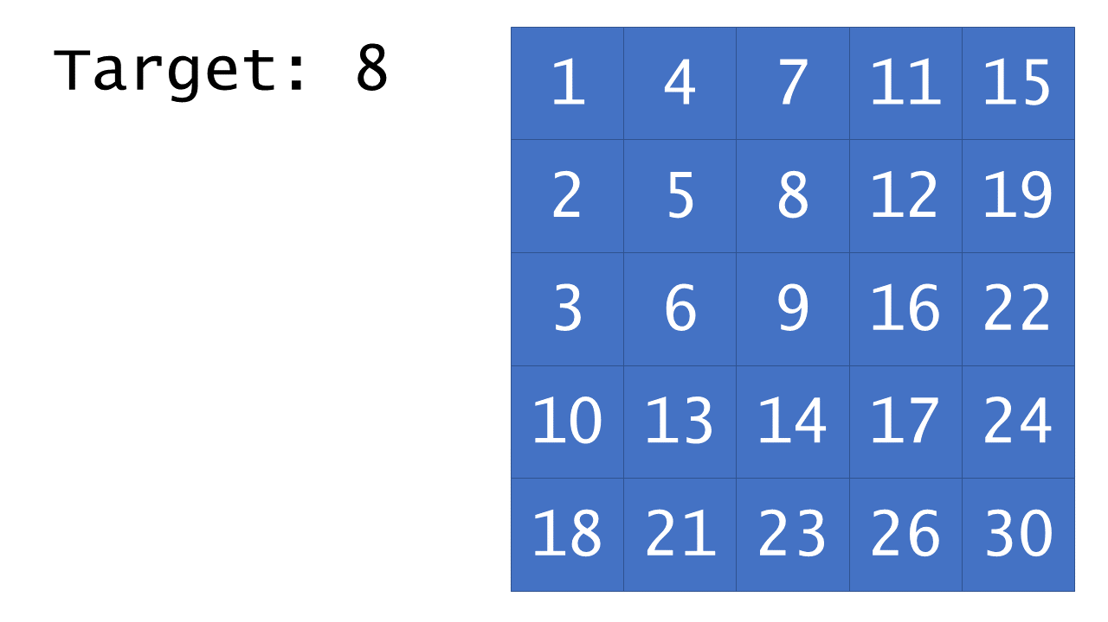

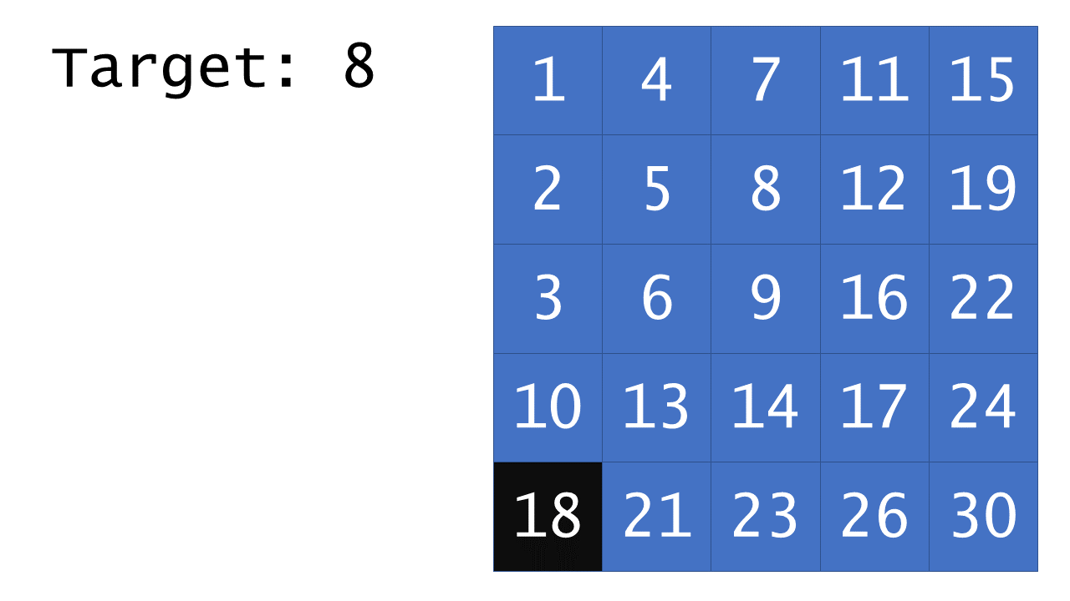

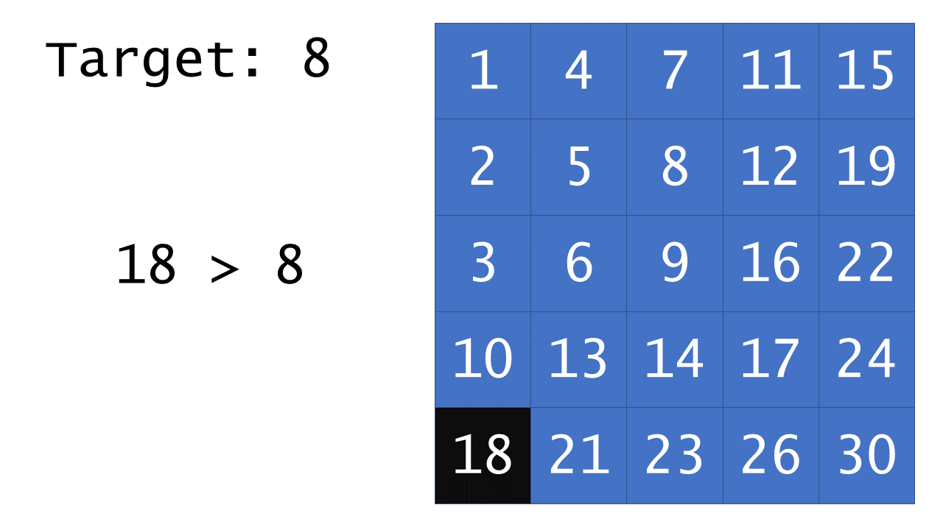

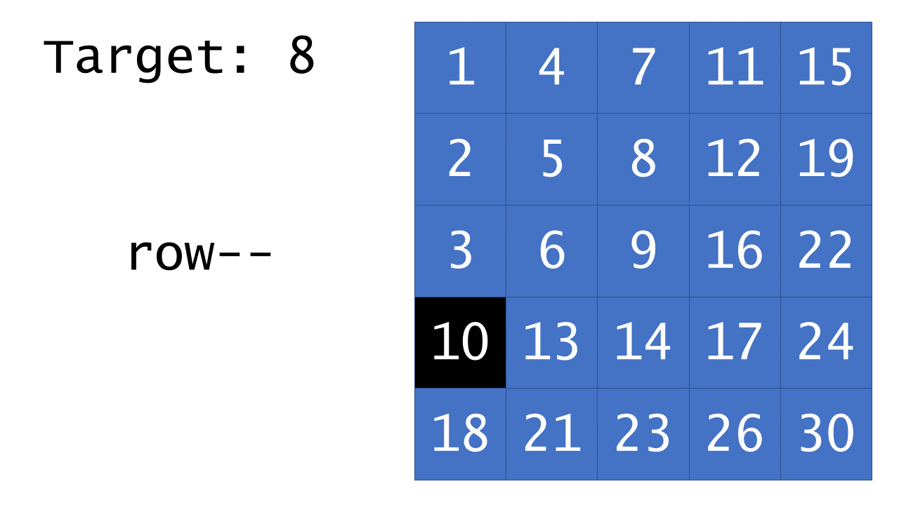

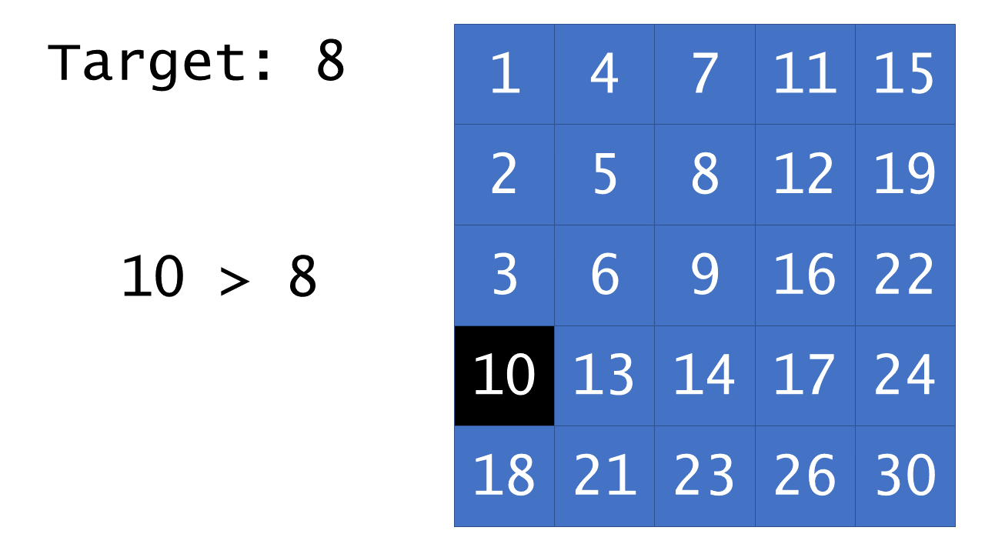

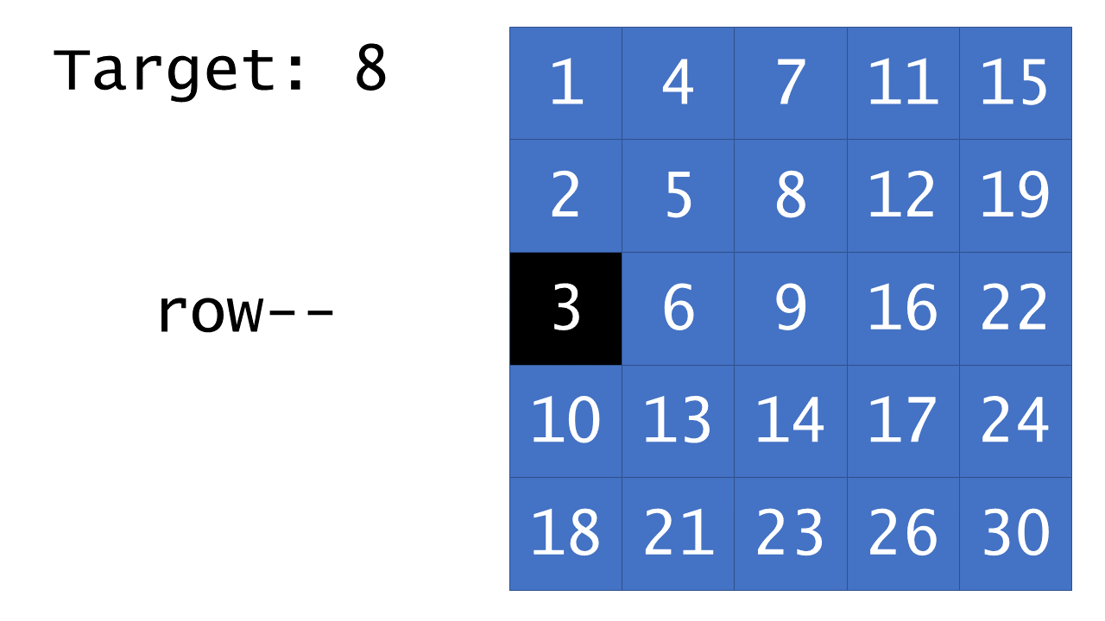

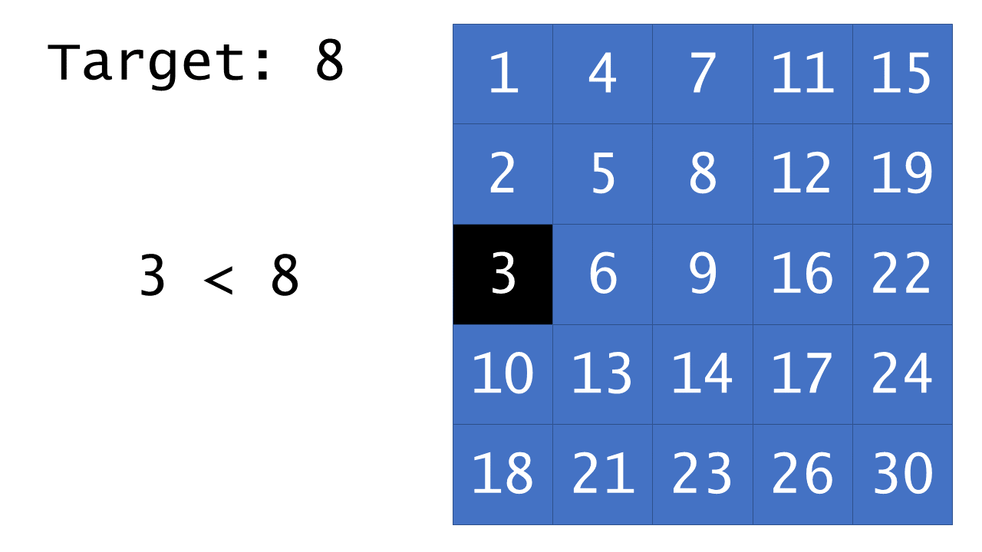

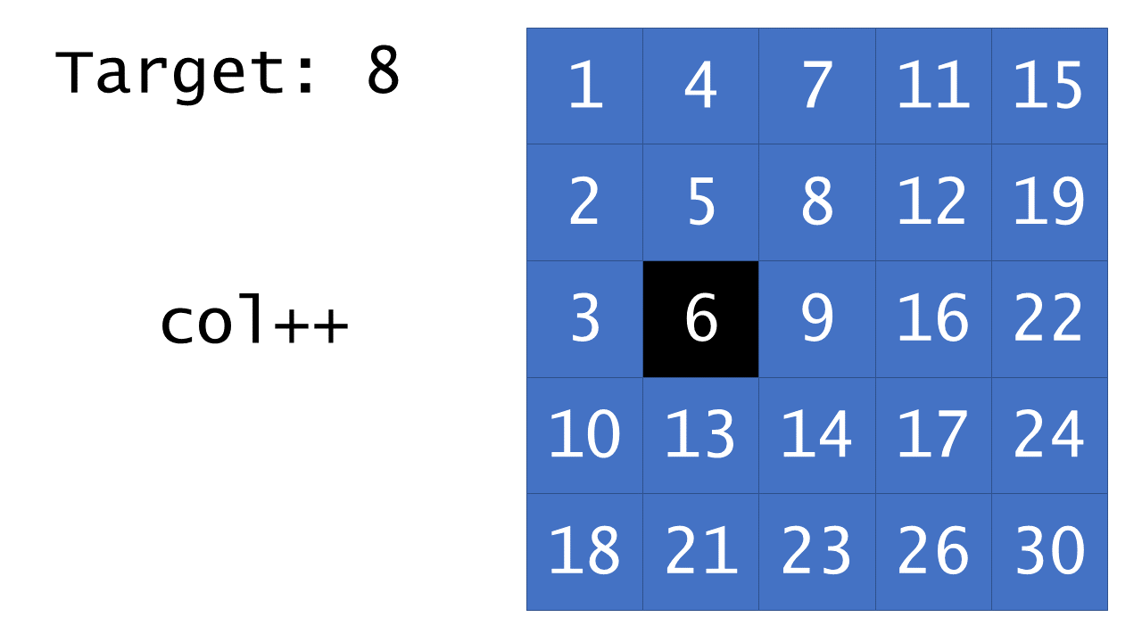

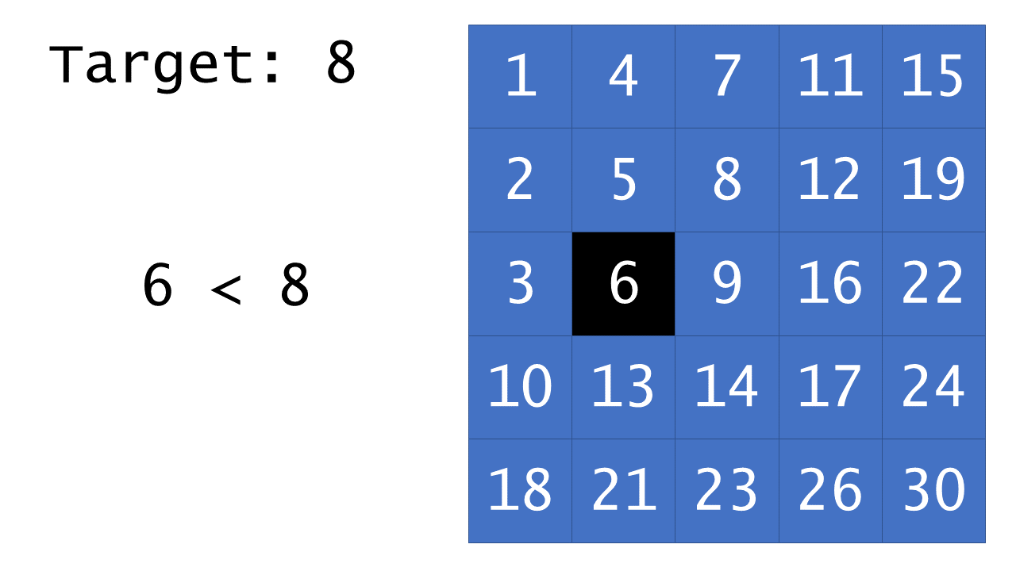

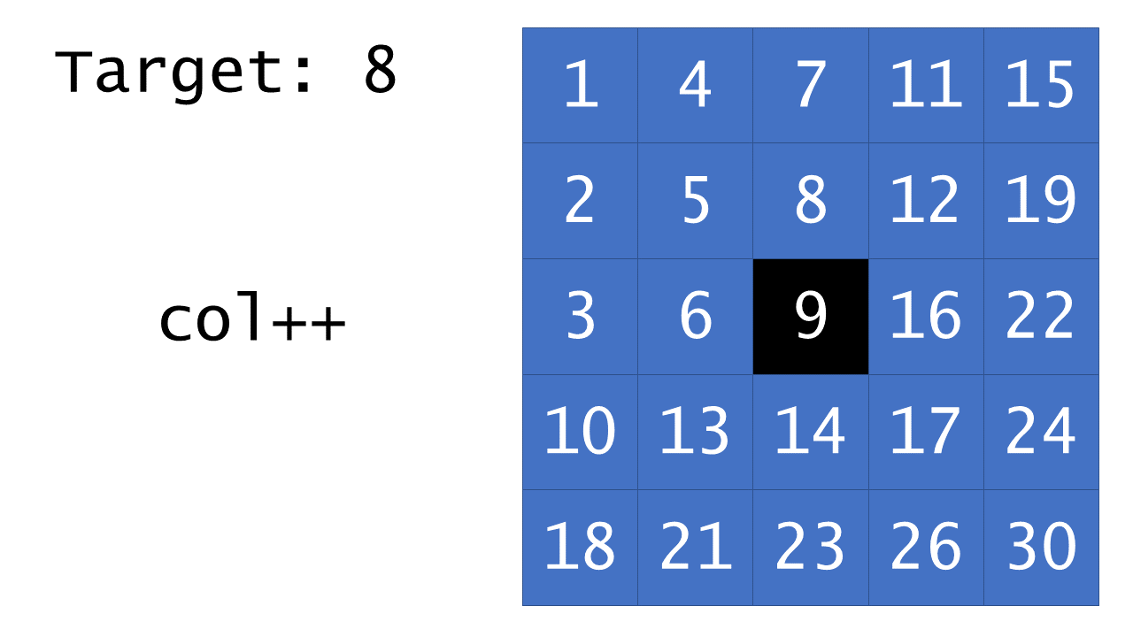

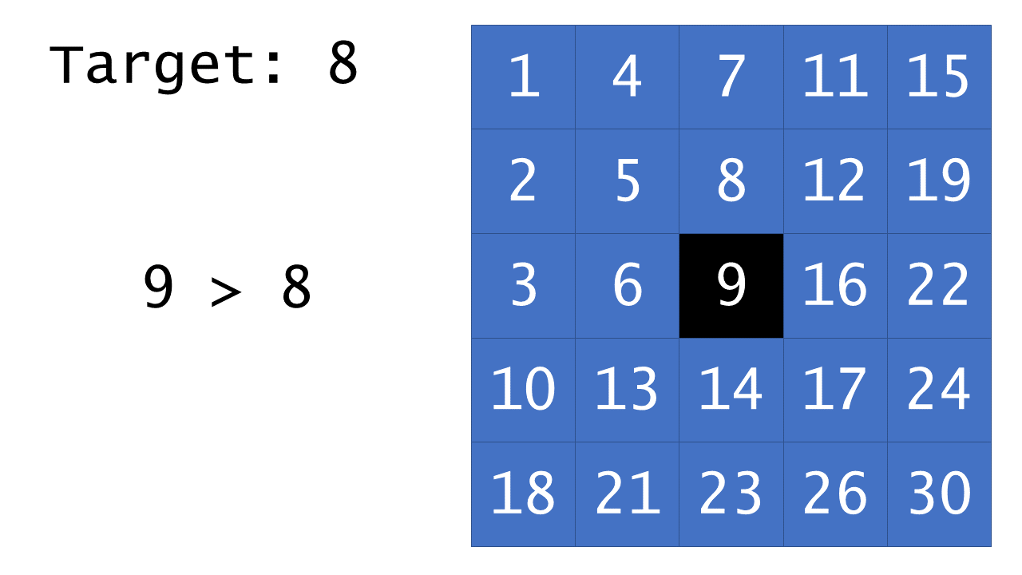

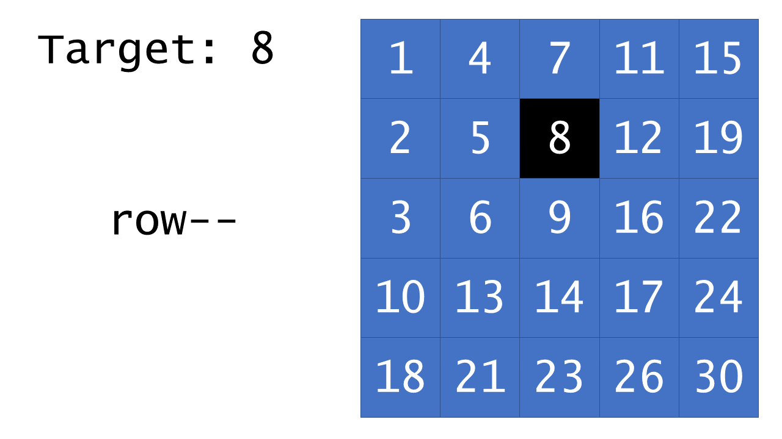

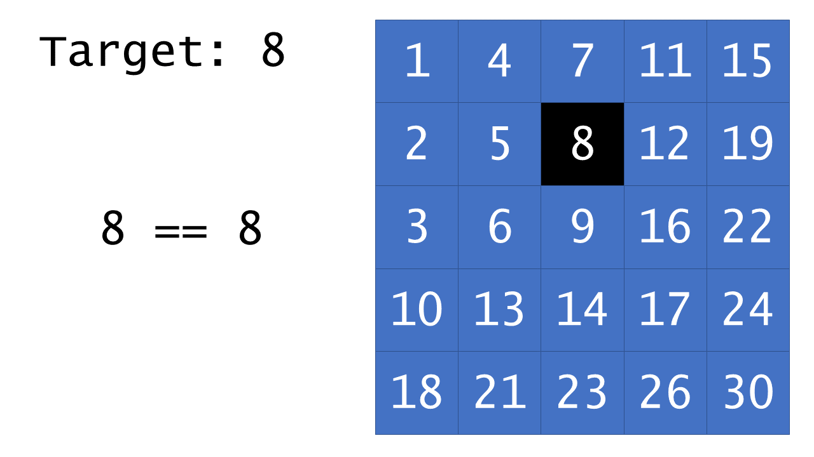

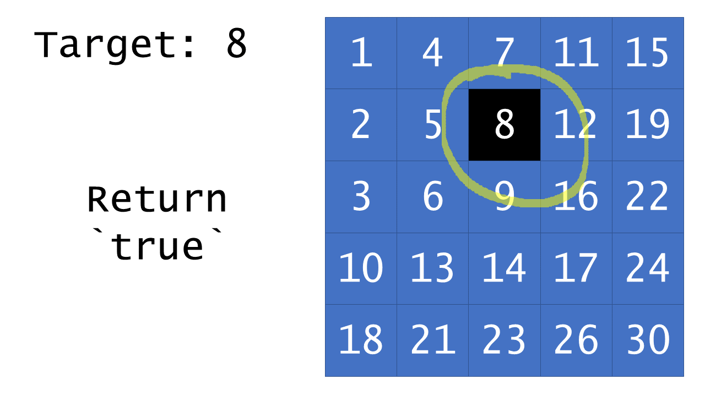

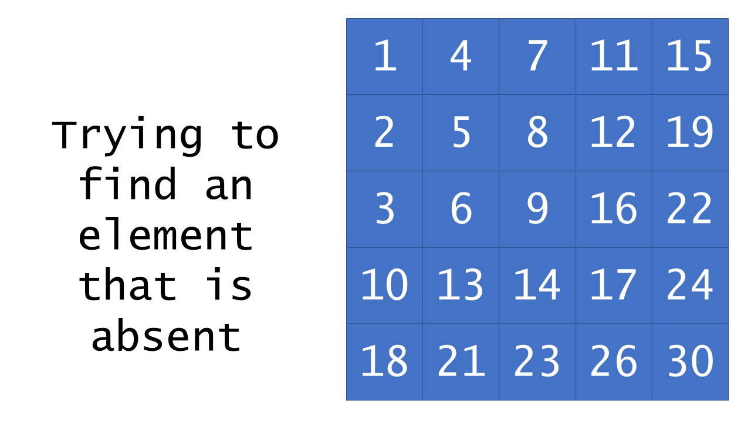

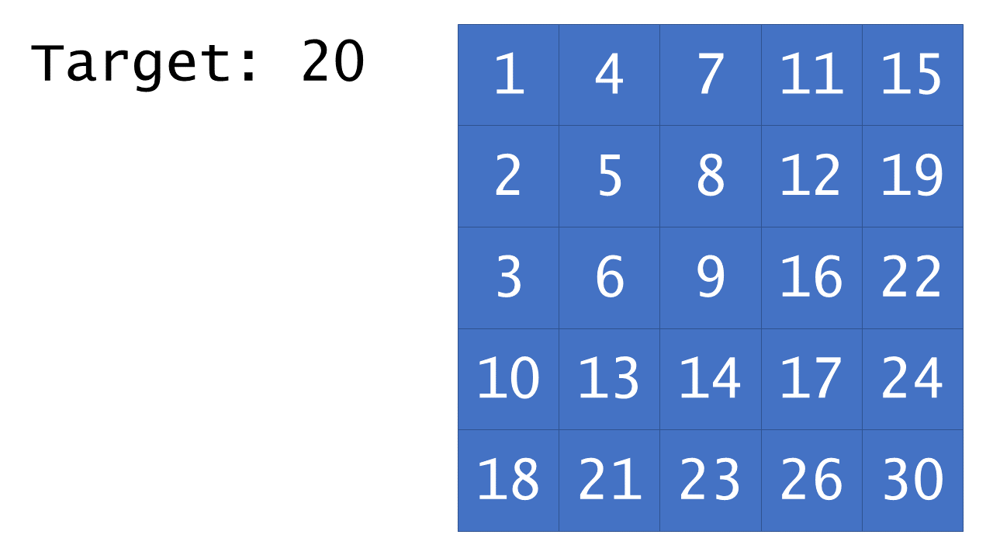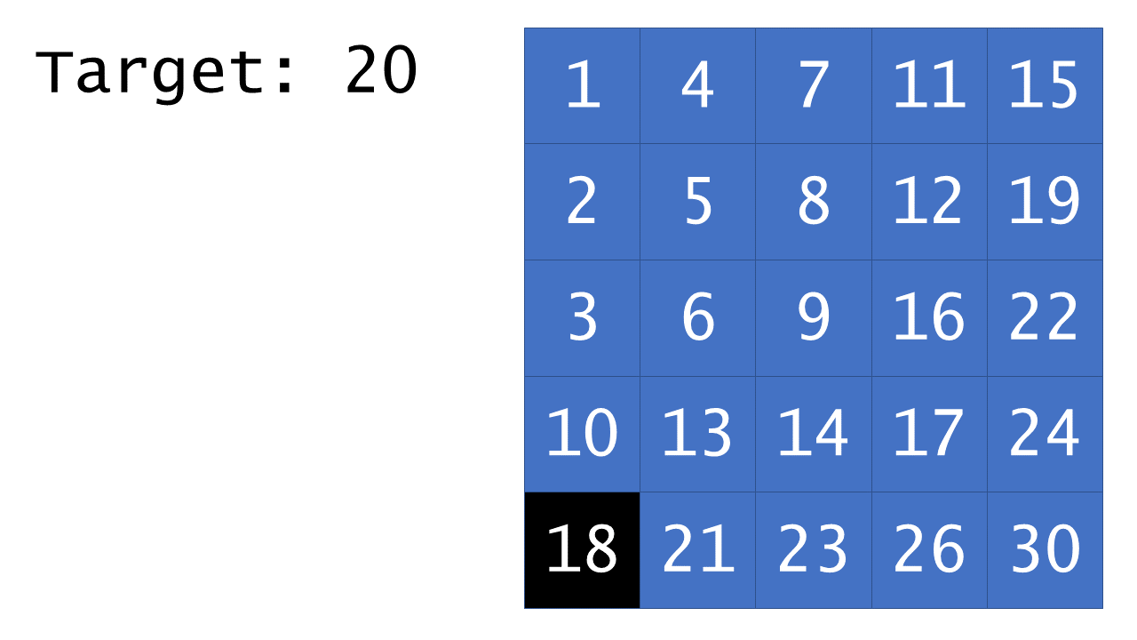

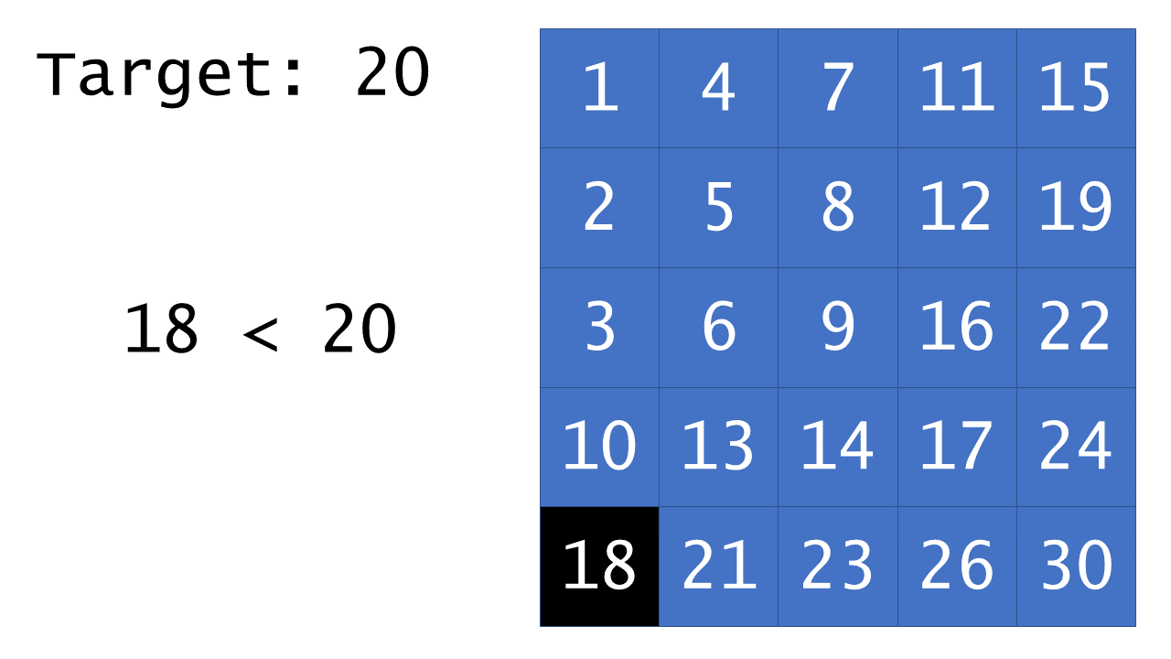

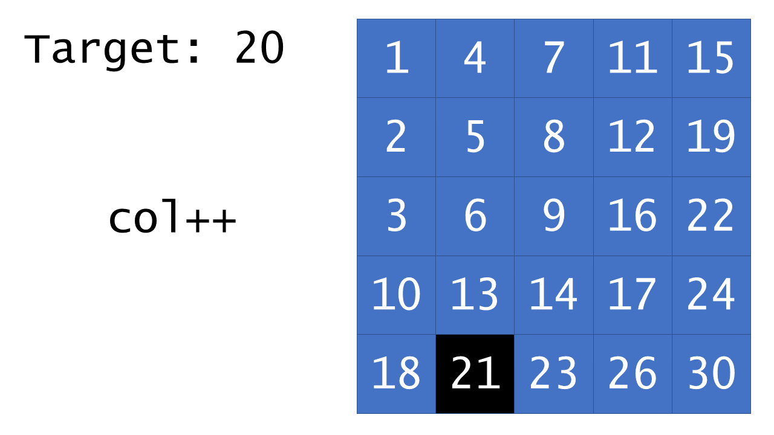

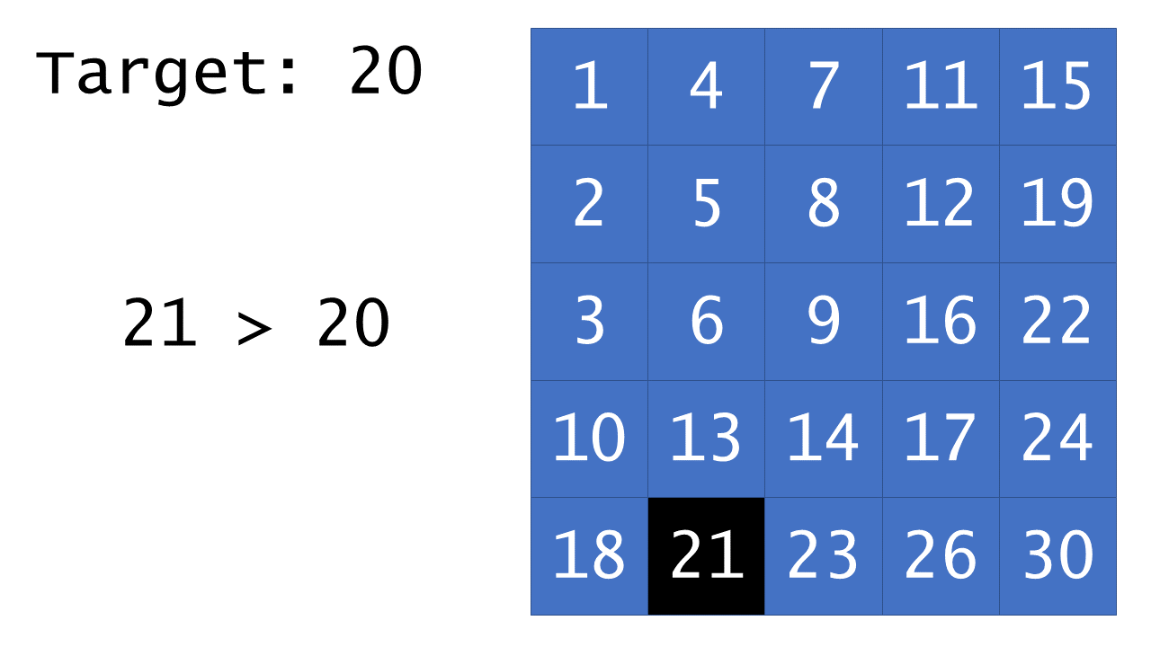

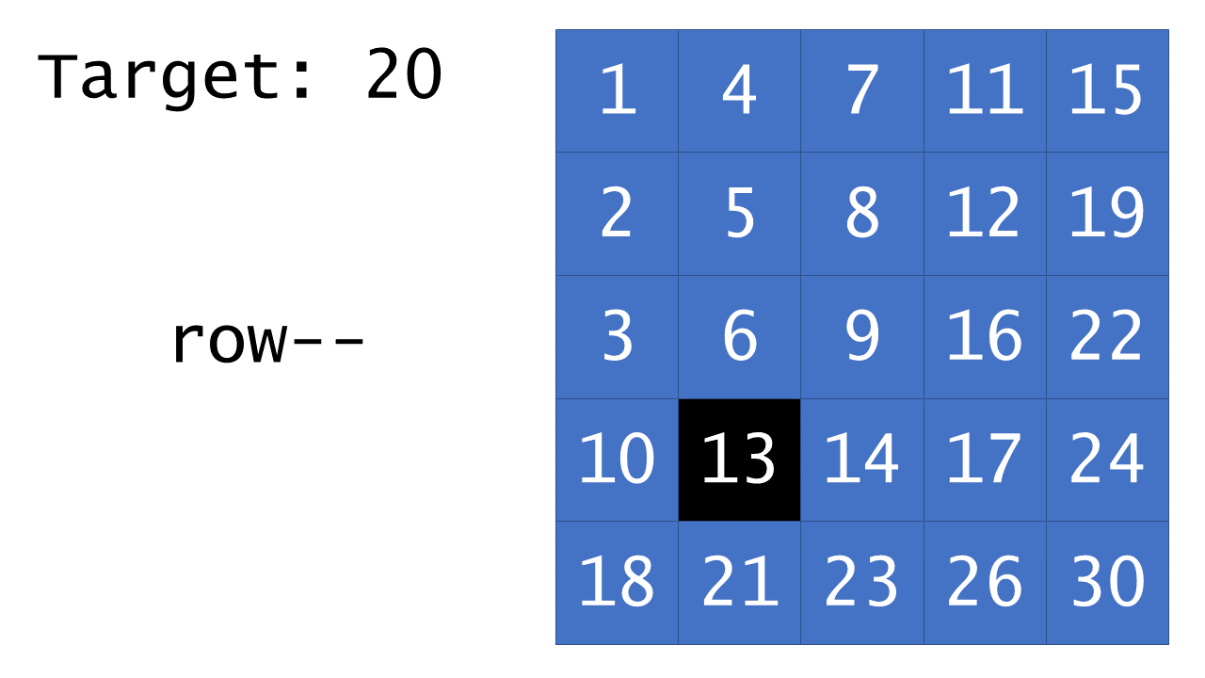

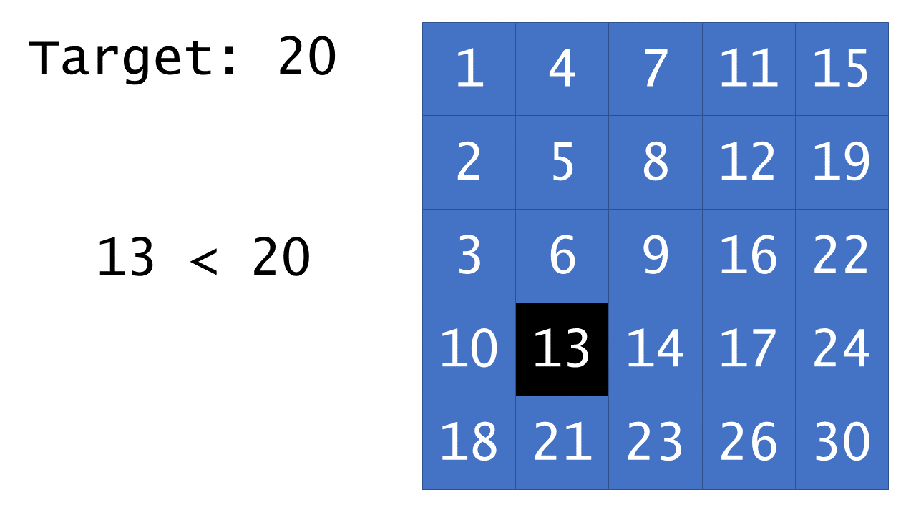

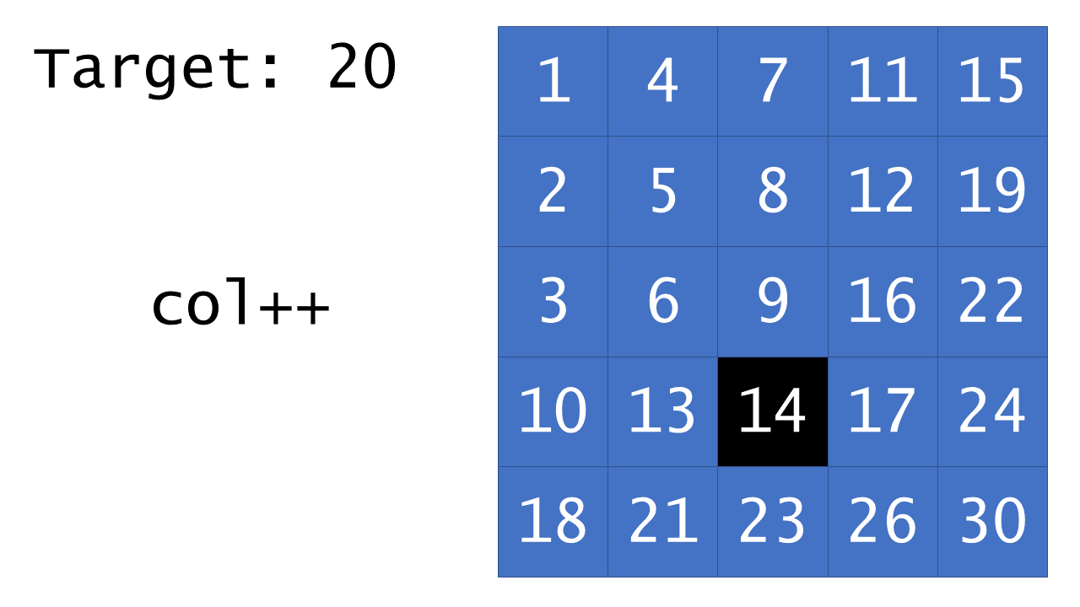

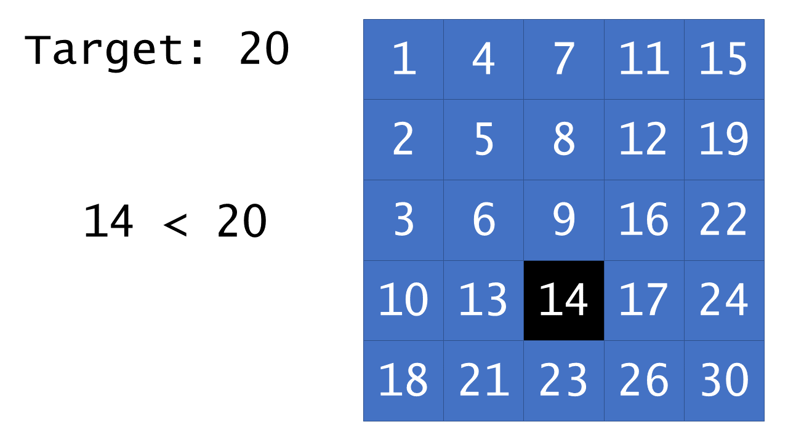

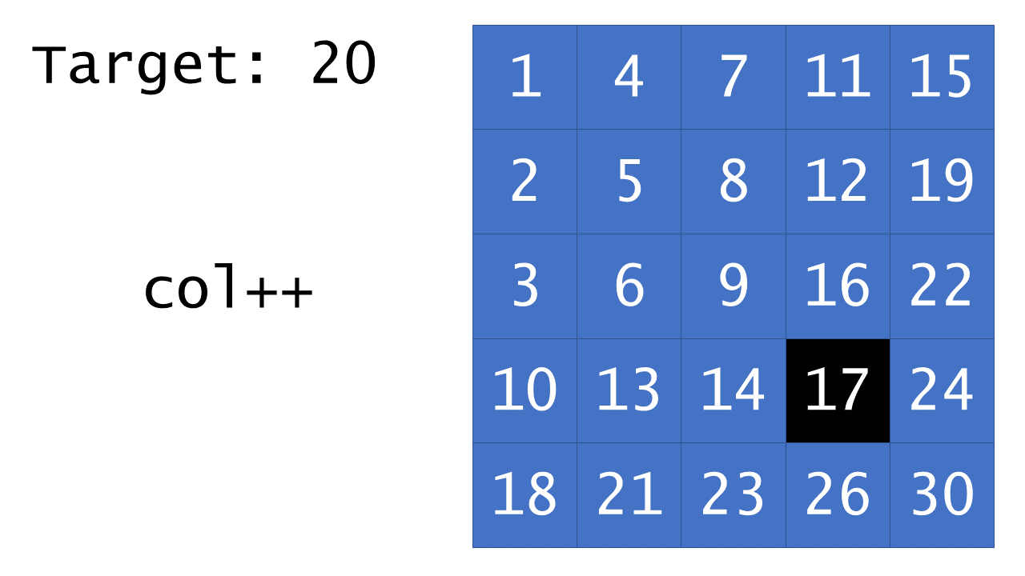

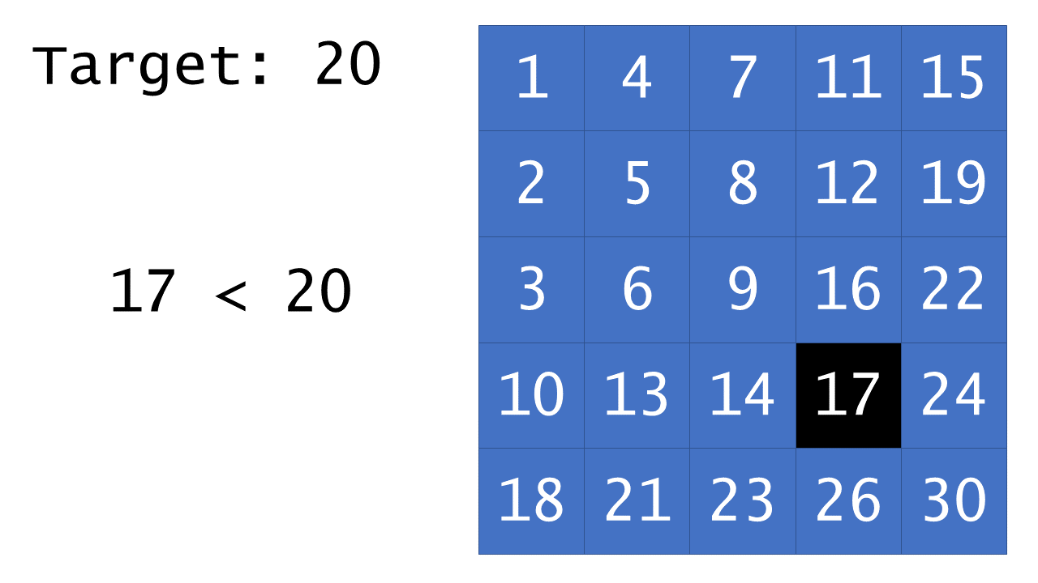

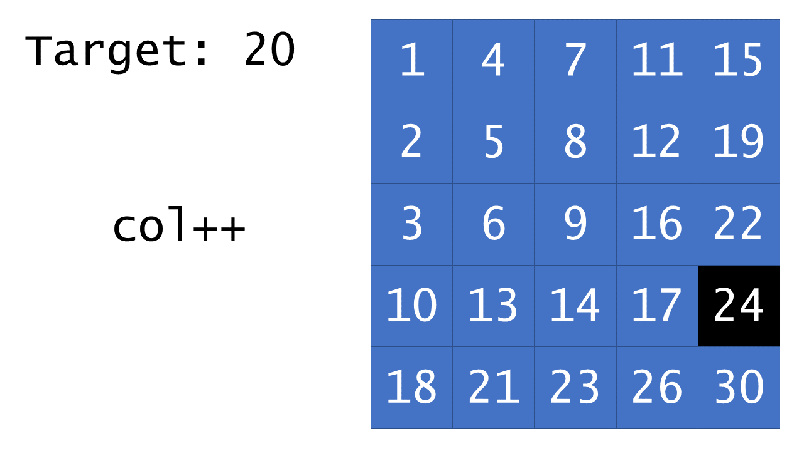

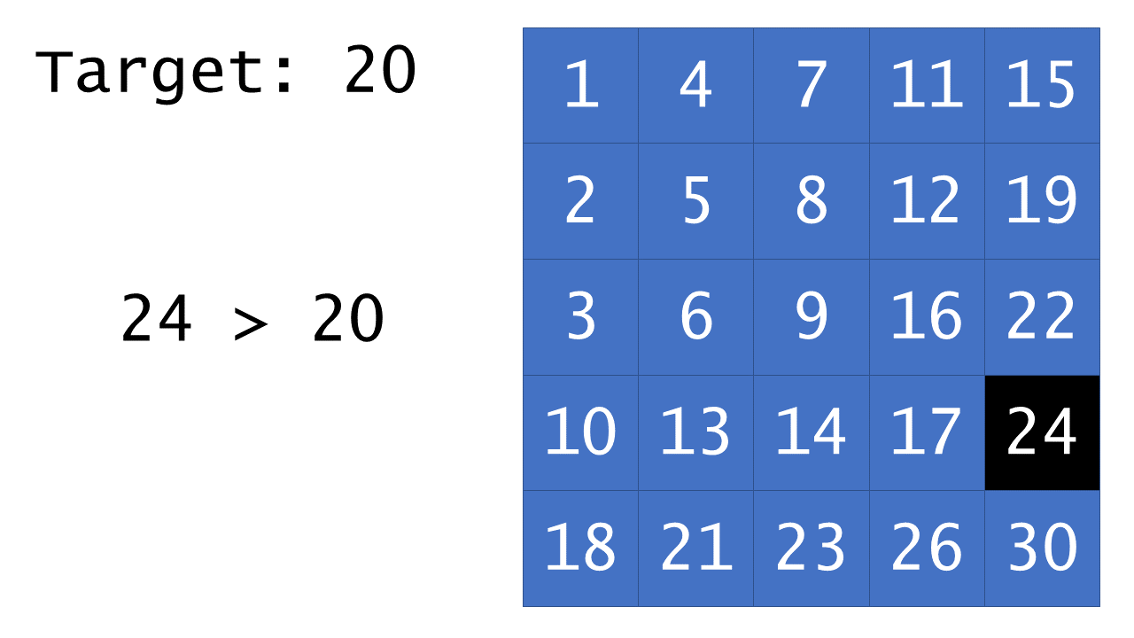

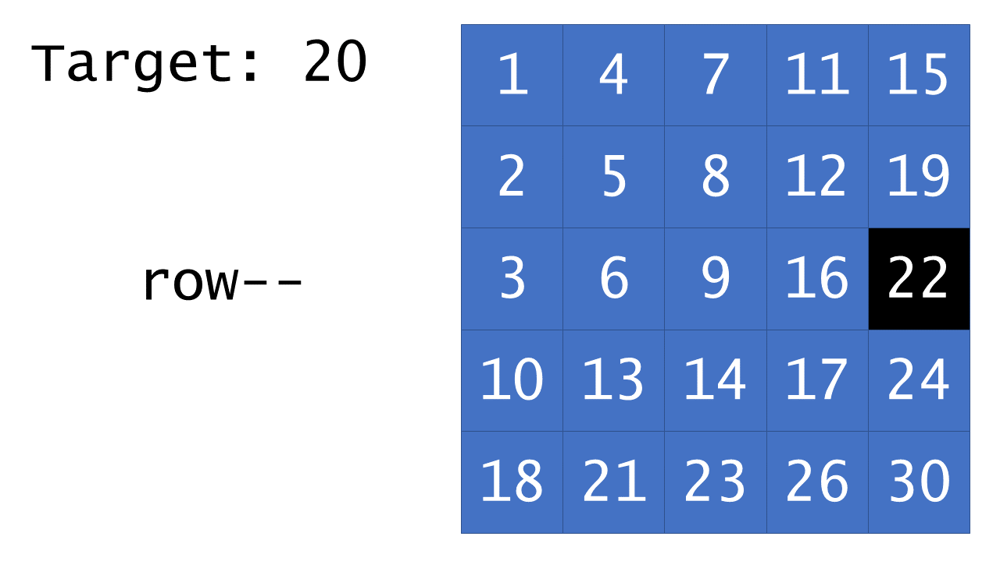

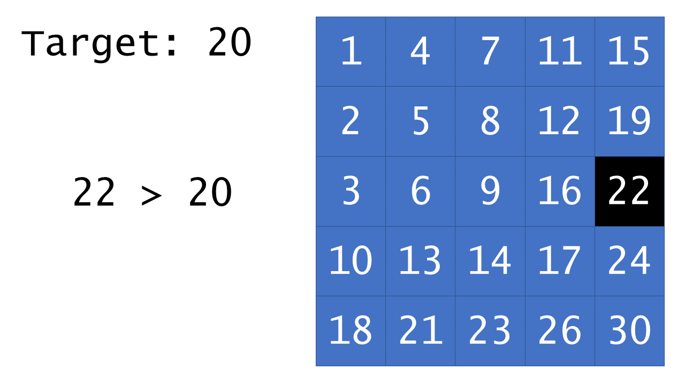

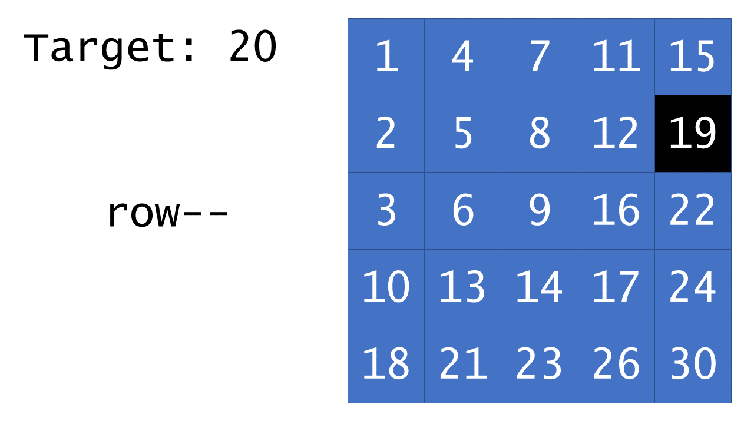

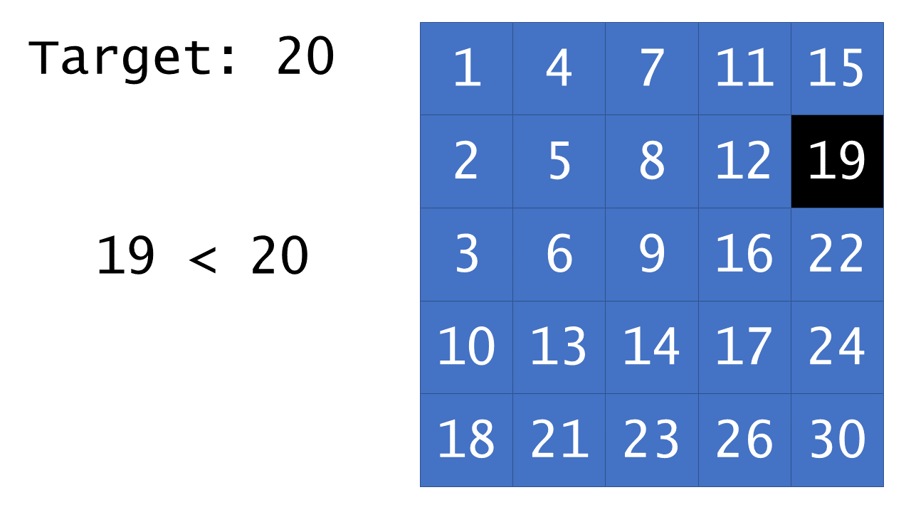

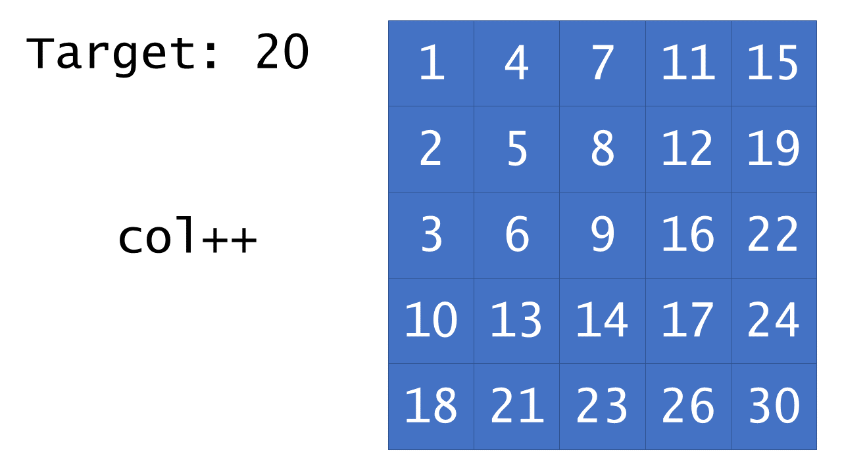

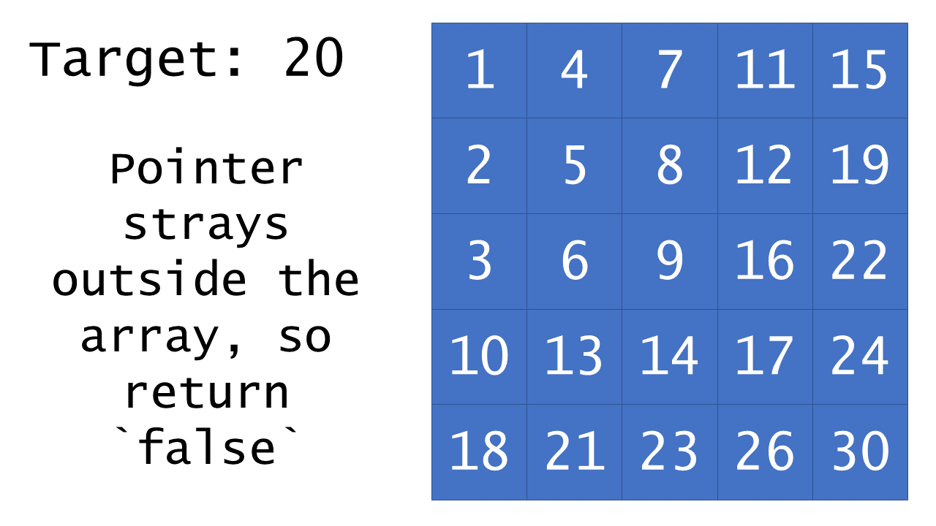

|  |
| --- |
| class Solution {  public boolean searchMatrix(int[][] matrix, int target) {  // start our "pointer" in the bottom-left  int row = matrix.length-1;  int col = 0;  while (row >= 0 && col < matrix[0].length) {  if (matrix[row][col] > target) {  row--;  } else if (matrix[row][col] < target) {  col++;  } else { // found it  return true;  }  }  return false;  }  } |

**Complexity Analysis**

* Time complexity : O(*n*+*m*)

The key to the time complexity analysis is noticing that, on every iteration (during which we do not return true) either row or col is decremented/incremented exactly once. Because row can only be decremented m*m* times and col can only be incremented *n* times before causing the while loop to terminate, the loop cannot run for more than *n*+*m* iterations. Because all other work is constant, the overall time complexity is linear in the sum of the dimensions of the matrix.

* Space complexity : O(1)

Because this approach only manipulates a few pointers, its memory footprint is constant.

#### **Footnotes**

1. This would work equally well with a pointer initialized to the top-right. Neither of the other two corners would work, as pruning a row/column might prevent us from achieving the correct answer. [↩︎](https://leetcode.com/problems/search-a-2d-matrix-ii/solution/#fnref1)

**Dynamic Programming**

Here are some classic Dynamic Programming interview questions.

We recommend: Unique Paths, Coin Change and Longest Increasing Subsequence.

Jump Game

 Unique Paths

 Coin Change

 Longest Increasing Subsequence

**Jump Game**

Given an array of non-negative integers nums, you are initially positioned at the **first index** of the array.

Each element in the array represents your maximum jump length at that position.

Determine if you are able to reach the last index.

**Example 1:**

**Input:** nums = [2,3,1,1,4]

**Output:** true

**Explanation:** Jump 1 step from index 0 to 1, then 3 steps to the last index.

**Example 2:**

**Input:** nums = [3,2,1,0,4]

**Output:** false

**Explanation:** You will always arrive at index 3 no matter what. Its maximum jump length is 0, which makes it impossible to reach the last index.

**Constraints:**

* 1 <= nums.length <= 3 * 104
* 0 <= nums[i] <= 105

## Naming

* We call a position in the array a **"good index"** if starting at that position, we can reach the last index. Otherwise, that index is called a **"bad index"**. The problem then reduces to whether or not index 0 is a "good index".

## Solution

This is a dynamic programming[[1]](https://leetcode.com/problems/jump-game/solution/#fn1) question. Usually, solving and fully understanding a dynamic programming problem is a 4 step process:

1. Start with the recursive backtracking solution
2. Optimize by using a memoization table (top-down[[2]](https://leetcode.com/problems/jump-game/solution/#fn2) dynamic programming)
3. Remove the need for recursion (bottom-up dynamic programming)
4. Apply final tricks to reduce the time / memory complexity

All solutions presented below produce the correct result, but they differ in run time and memory requirements.

#### **Approach 1: Backtracking**

This is the inefficient solution where we try every single jump pattern that takes us from the first position to the last. We start from the first position and jump to every index that is reachable. We repeat the process until last index is reached. When stuck, backtrack.

|  |
| --- |
| public class Solution {  public boolean canJumpFromPosition(int position, int[] nums) {  if (position == nums.length - 1) {  return true;  }  int furthestJump = Math.min(position + nums[position], nums.length - 1);  for (int nextPosition = position + 1; nextPosition <= furthestJump; nextPosition++) {  if (canJumpFromPosition(nextPosition, nums)) {  return true;  }  }  return false;  }  public boolean canJump(int[] nums) {  return canJumpFromPosition(0, nums);  }  } |

One quick optimization we can do for the code above is to check the nextPosition from right to left. The theoretical worst case performance is the same, but in practice, for silly examples, the code might run faster. Intuitively, this means we always try to make the biggest jump such that we reach the end as soon as possible

The change required is:

|  |
| --- |
| // Old  for (int nextPosition = position + 1; nextPosition <= furthestJump; nextPosition++)  // New  for (int nextPosition = furthestJump; nextPosition > position; nextPosition--) |

For instance, in the example below, if we start from index **0**, jump as far as possible and reach **1**, jump as far as possible and reach **6**. By doing so, we determine that **0** is a GOOD index in 3 steps.

| **Index** | **0** | **1** | **2** | **3** | **4** | **5** | **6** |
| --- | --- | --- | --- | --- | --- | --- | --- |
| nums | 1 | 5 | 2 | 1 | 0 | 2 | 0 |

To illustrate the worst case, where this optimization has no effect, take the example below. Index **6** cannot be reached from any position, but all combinations will be tried.

| **Index** | **0** | **1** | **2** | **3** | **4** | **5** | **6** |
| --- | --- | --- | --- | --- | --- | --- | --- |
| nums | 5 | 4 | 3 | 2 | 1 | 0 | 0 |

The first few steps of the backtracking algorithm for the example above are: 0 -> 4 -> 5 -> 4 -> 0 -> 3 -> 5 -> 3 -> 4 -> 5 -> etc.

**Complexity Analysis**

* Time complexity : O(2^n). There are 2^n (upper bound) ways of jumping from the first position to the last, where *n* is the length of array nums. For a complete proof, please refer to Appendix A.
* Space complexity : *O*(*n*). Recursion requires additional memory for the stack frames.

#### **Approach 2: Dynamic Programming Top-down**

Top-down Dynamic Programming can be thought of as optimized backtracking. It relies on the observation that once we determine that a certain index is good / bad, this result will never change. This means that we can store the result and not need to recompute it every time.

Therefore, for each position in the array, we remember whether the index is good or bad. Let's call this array memo and let its values be either one of: GOOD, BAD, UNKNOWN. This technique is called memoization[[3]](https://leetcode.com/problems/jump-game/solution/#fn3).

An example of a memoization table for input array nums = [2, 4, 2, 1, 0, 2, 0] can be seen in the diagram below. We write **G** for a GOOD position and **B** for a BAD one. We can see that we cannot start from indices 2, 3 or 4 and eventually reach last index (6), but we can do that from indices 0, 1, 5 and (trivially) 6.

| **Index** | **0** | **1** | **2** | **3** | **4** | **5** | **6** |
| --- | --- | --- | --- | --- | --- | --- | --- |
| nums | 2 | 4 | 2 | 1 | 0 | 2 | 0 |
| memo | G | G | B | B | B | G | G |

**Steps**

1. Initially, all elements of the memo table are UNKNOWN, except for the last one, which is (trivially) GOOD (it can reach itself)
2. Modify the backtracking algorithm such that the recursive step first checks if the index is known (GOOD / BAD)
   1. If it is known then return True / False
   2. Otherwise perform the backtracking steps as before
3. Once we determine the value of the current index, we store it in the memo table

|  |
| --- |
| enum Index {  GOOD, BAD, UNKNOWN  }  public class Solution {  Index[] memo;  public boolean canJumpFromPosition(int position, int[] nums) {  if (memo[position] != Index.UNKNOWN) {  return memo[position] == Index.GOOD ? true : false;  }  int furthestJump = Math.min(position + nums[position], nums.length - 1);  for (int nextPosition = position + 1; nextPosition <= furthestJump; nextPosition++) {  if (canJumpFromPosition(nextPosition, nums)) {  memo[position] = Index.GOOD;  return true;  }  }  memo[position] = Index.BAD;  return false;  }  public boolean canJump(int[] nums) {  memo = new Index[nums.length];  for (int i = 0; i < memo.length; i++) {  memo[i] = Index.UNKNOWN;  }  memo[memo.length - 1] = Index.GOOD;  return canJumpFromPosition(0, nums);  }  } |

**Complexity Analysis**

* Time complexity : O(n^2)*O*. For every element in the array, say i, we are looking at the next nums[i] elements to its right aiming to find a GOOD index. nums[i] can be at most n*n*, where n*n* is the length of array nums.
* Space complexity : *O*(2*n*)=*O*(*n*). First n originates from recursion. Second n comes from the usage of the memo table.

#### **Approach 3: Dynamic Programming Bottom-up**

Top-down to bottom-up conversion is done by eliminating recursion. In practice, this achieves better performance as we no longer have the method stack overhead and might even benefit from some caching. More importantly, this step opens up possibilities for future optimization. The recursion is usually eliminated by trying to reverse the order of the steps from the top-down approach.

The observation to make here is that we only ever jump to the right. This means that if we start from the right of the array, every time we will query a position to our right, that position has already be determined as being GOOD or BAD. This means we don't need to recurse anymore, as we will always hit the memo table.

|  |
| --- |
| enum Index {  GOOD, BAD, UNKNOWN  }  public class Solution {  public boolean canJump(int[] nums) {  Index[] memo = new Index[nums.length];  for (int i = 0; i < memo.length; i++) {  memo[i] = Index.UNKNOWN;  }  memo[memo.length - 1] = Index.GOOD;  for (int i = nums.length - 2; i >= 0; i--) {  int furthestJump = Math.min(i + nums[i], nums.length - 1);  for (int j = i + 1; j <= furthestJump; j++) {  if (memo[j] == Index.GOOD) {  memo[i] = Index.GOOD;  break;  }  }  }  return memo[0] == Index.GOOD;  }  } |

**Complexity Analysis**

* Time complexity : O(n^2)*O*. For every element in the array, say i, we are looking at the next nums[i] elements to its right aiming to find a GOOD index. nums[i] can be at most *n*, where *n* is the length of array nums.
* Space complexity : *O*(*n*). This comes from the usage of the memo table.

#### **Approach 4: Greedy**

Once we have our code in the bottom-up state, we can make one final, important observation. From a given position, when we try to see if we can jump to a GOOD position, we only ever use one - the first one (see the break statement). In other words, the left-most one. If we keep track of this left-most GOOD position as a separate variable, we can avoid searching for it in the array. Not only that, but we can stop using the array altogether.

Iterating right-to-left, for each position we check if there is a potential jump that reaches a GOOD index (currPosition + nums[currPosition] >= leftmostGoodIndex). If we can reach a GOOD index, then our position is itself GOOD. Also, this new GOOD position will be the new leftmost GOOD index. Iteration continues until the beginning of the array. If first position is a GOOD index then we can reach the last index from the first position.

To illustrate this scenario, we will use the diagram below, for input array nums = [9, 4, 2, 1, 0, 2, 0]. We write **G** for GOOD, **B** for BAD and **U** for UNKNOWN. Let's assume we have iterated all the way to position 0 and we need to decide if index 0 is GOOD. Since index 1 was determined to be GOOD, it is enough to jump there and then be sure we can eventually reach index 6. It does not matter that nums[0] is big enough to jump all the way to the last index. All we need is **one** way.

| **Index** | **0** | **1** | **2** | **3** | **4** | **5** | **6** |
| --- | --- | --- | --- | --- | --- | --- | --- |
| nums | 9 | 4 | 2 | 1 | 0 | 2 | 0 |
| memo | U | G | B | B | B | G | G |

|  |
| --- |
| public class Solution {  public boolean canJump(int[] nums) {  int lastPos = nums.length - 1;  for (int i = nums.length - 1; i >= 0; i--) {  if (i + nums[i] >= lastPos) {  lastPos = i;  }  }  return lastPos == 0;  }  } |

**Complexity Analysis**

* Time complexity : O(n)*O*(*n*). We are doing a single pass through the nums array, hence n*n* steps, where n*n* is the length of array nums.
* Space complexity : O(1)*O*(1). We are not using any extra memory.

## Conclusion

The question left unanswered is how should one approach such a question in an interview scenario. I would say "it depends". The perfect solution is cleaner and shorter than all the other versions, but it might not be so straightforward to figure out.

The (recursive) backtracking is the easiest to figure out, so it is worth mentioning it verbally while warming up for the tougher challenge. It might be that your interviewer actually wants to see that solution, but if not, mention that there might be a dynamic programming solution and try to think how could you use a memoization table. If you figure it out and the interviewer wants you to go for the top-down approach, it will not generally be time to think of the bottom-up version, but I would always mention the advantages of this technique as a final thought in the interview.

Most people are stuck when converting from top-down Dynamic Programming (expressed naturally in recursion) to bottom-up. Practicing similar problems will help bridge this gap.

## Appendix A - Complexity Analysis for [Approach 1](https://leetcode.com/problems/jump-game/solution/#approach-1-backtracking)

**Complexity Analysis**

* Time complexity : O(n)*O*(*n*). We are doing a single pass through the nums array, hence n*n* steps, where n*n* is the length of array nums.
* Space complexity : O(1)*O*(1). We are not using any extra memory.

## Conclusion

The question left unanswered is how should one approach such a question in an interview scenario. I would say "it depends". The perfect solution is cleaner and shorter than all the other versions, but it might not be so straightforward to figure out.

The (recursive) backtracking is the easiest to figure out, so it is worth mentioning it verbally while warming up for the tougher challenge. It might be that your interviewer actually wants to see that solution, but if not, mention that there might be a dynamic programming solution and try to think how could you use a memoization table. If you figure it out and the interviewer wants you to go for the top-down approach, it will not generally be time to think of the bottom-up version, but I would always mention the advantages of this technique as a final thought in the interview.

Most people are stuck when converting from top-down Dynamic Programming (expressed naturally in recursion) to bottom-up. Practicing similar problems will help bridge this gap.

## Appendix A - Complexity Analysis for [Approach 1](https://leetcode.com/problems/jump-game/solution/#approach-1-backtracking)

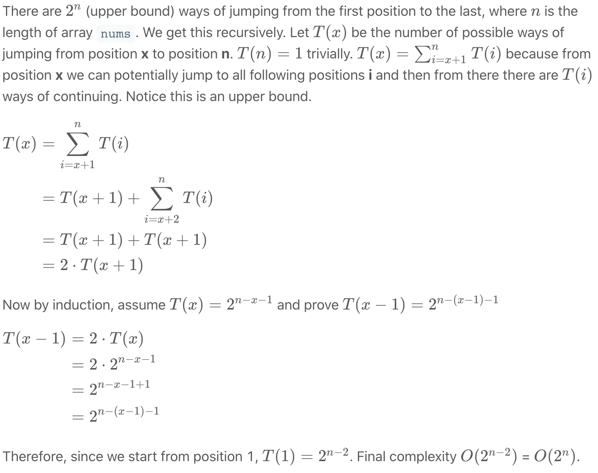

## References

1. <https://en.wikipedia.org/wiki/Dynamic_programming> [↩︎](https://leetcode.com/problems/jump-game/solution/#fnref1)
2. <https://en.wikipedia.org/wiki/Top-down_and_bottom-up_design> [↩︎](https://leetcode.com/problems/jump-game/solution/#fnref2)
3. <https://en.wikipedia.org/wiki/Memoization> [↩︎](https://leetcode.com/problems/jump-game/solution/#fnref3)

**Unique Paths**

A robot is located at the top-left corner of a m x n grid (marked 'Start' in the diagram below).

The robot can only move either down or right at any point in time. The robot is trying to reach the bottom-right corner of the grid (marked 'Finish' in the diagram below).

How many possible unique paths are there?

**Example 1:**

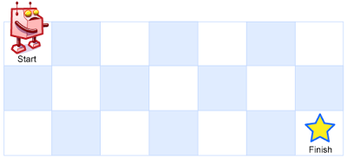

**Input:** m = 3, n = 7

**Output:** 28

**Example 2:**

**Input:** m = 3, n = 2

**Output:** 3

**Explanation:**

From the top-left corner, there are a total of 3 ways to reach the bottom-right corner:

1. Right -> Down -> Down

2. Down -> Down -> Right

3. Down -> Right -> Down

**Example 3:**

**Input:** m = 7, n = 3

**Output:** 28

**Example 4:**

**Input:** m = 3, n = 3

**Output:** 6

**Constraints:**

* 1 <= m, n <= 100
* It's guaranteed that the answer will be less than or equal to 2 * 109.

## Solution

#### **Overview**

Since robot can move either down or right, there is only one path to reach the cells in the first row: right->right->...->right.

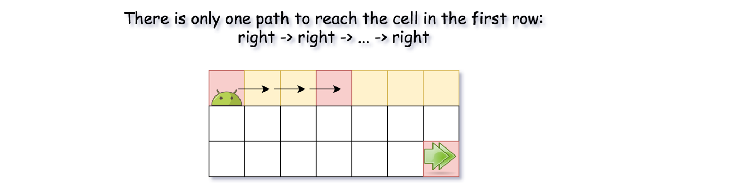

The same is valid for the first column, though the path here is down->down-> ...->down.

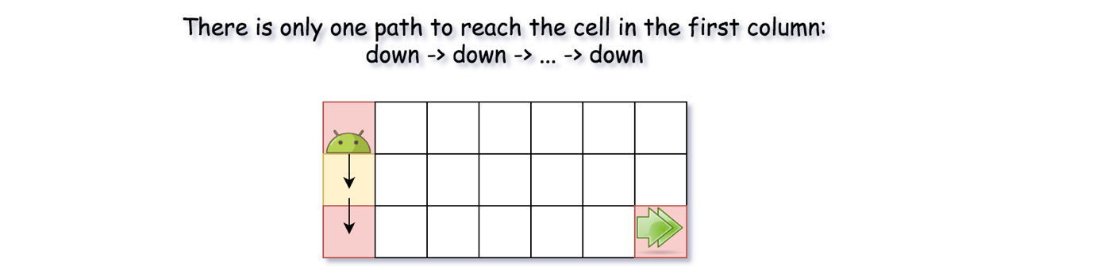

What about the "inner" cells (m, n)? To such cell one could move either from the upper cell (m, n - 1), or from the cell on the right (m - 1, n). That means that the total number of paths to move into (m, n) cell is uniquePaths(m - 1, n) + uniquePaths(m, n - 1).



Now, one could transform these ideas into 3-liner recursive solution:

|  |
| --- |
| class Solution {  public int uniquePaths(int m, int n) {  if (m == 1 || n == 1) {  return 1;  }  return uniquePaths(m - 1, n) + uniquePaths(m, n - 1);  }  } |

This solution is not fast enough to pass all the testcases, though it could be used as a starting point for the DP solution.

#### **Approach 1: Dynamic Programming**

One could rewrite recursive approach into dynamic programming one.

**Algorithm**

* Initiate 2D array d[m][n] = number of paths. To start, put number of paths equal to 1 for the first row and the first column. For the simplicity, one could initiate the whole 2D array by ones.
* Iterate over all "inner" cells: d[col][row] = d[col - 1][row] + d[col][row - 1].
* Return d[m - 1][n - 1].

**Implementation**

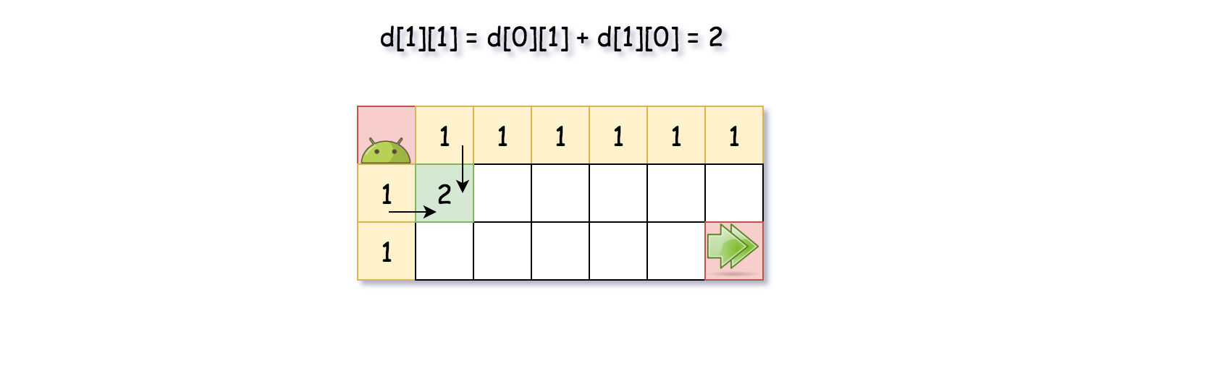

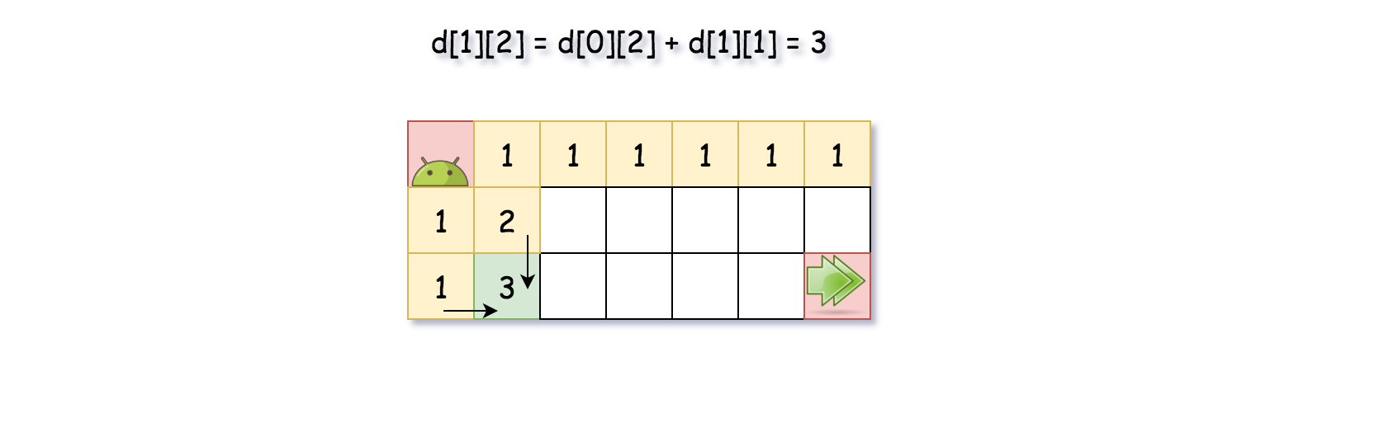

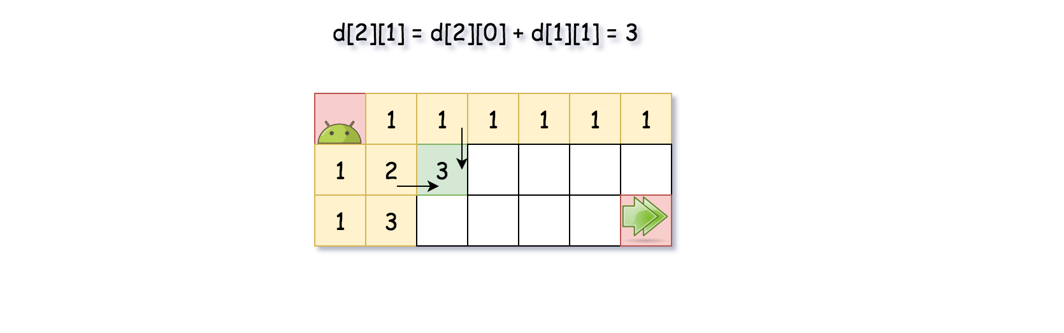

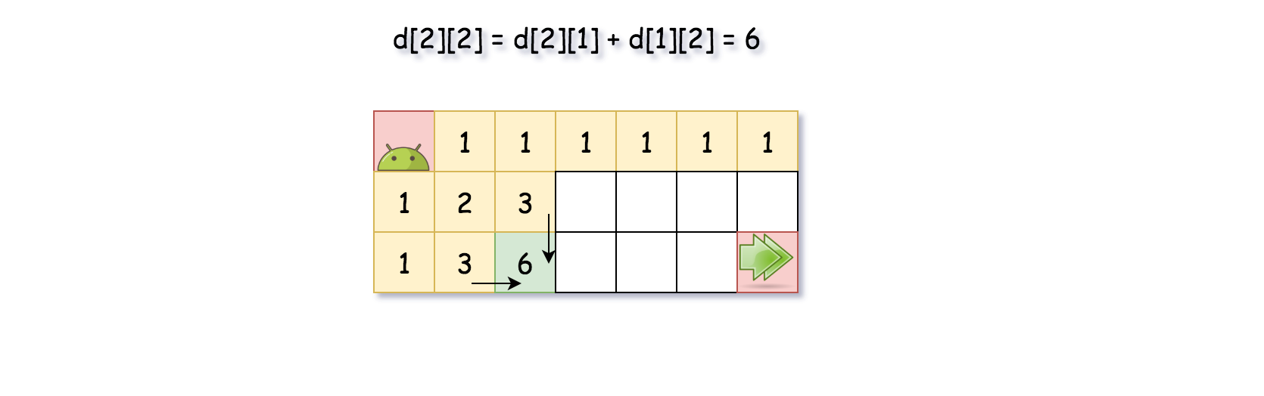

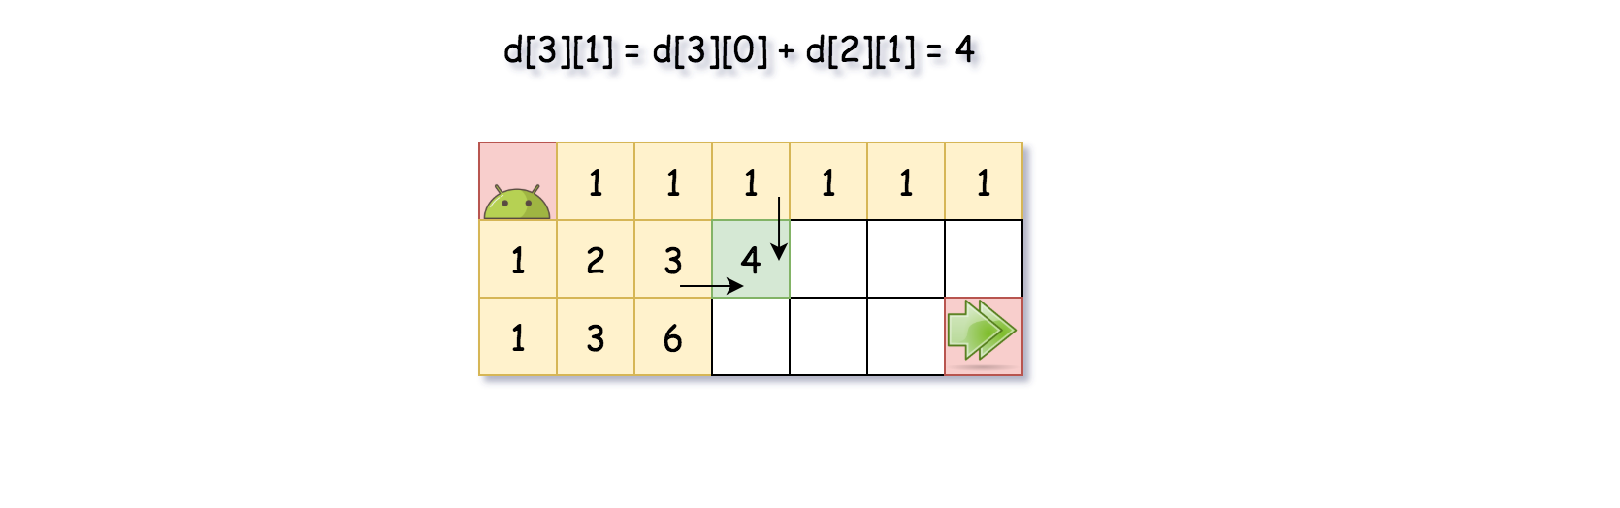

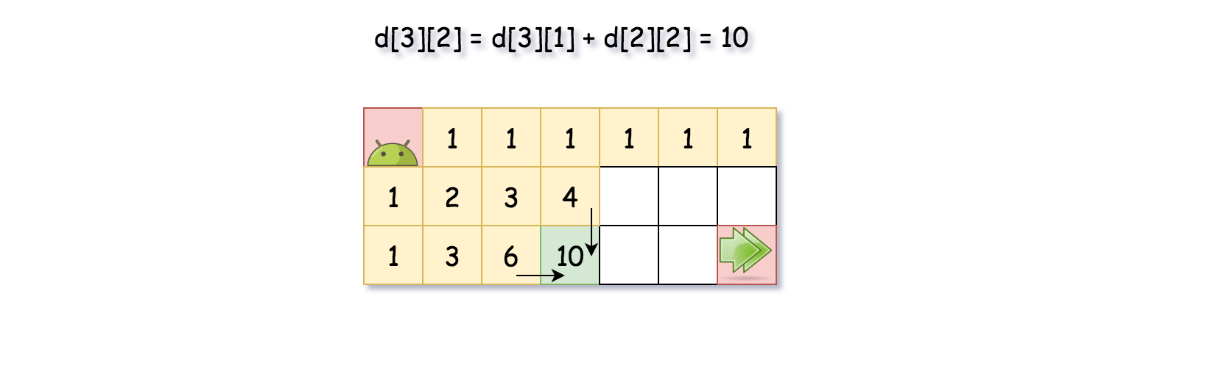

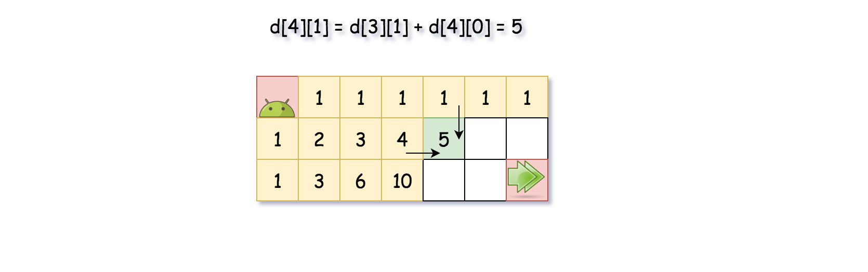

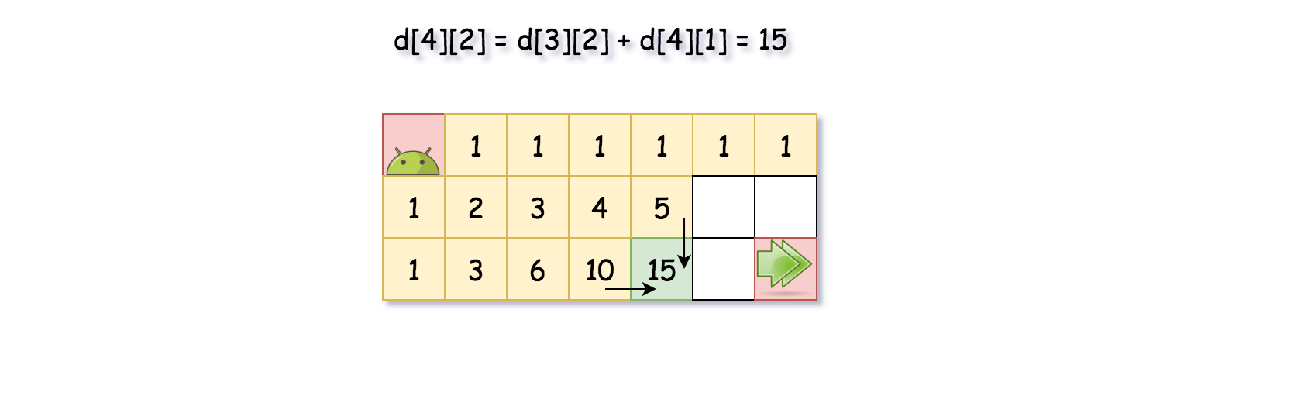

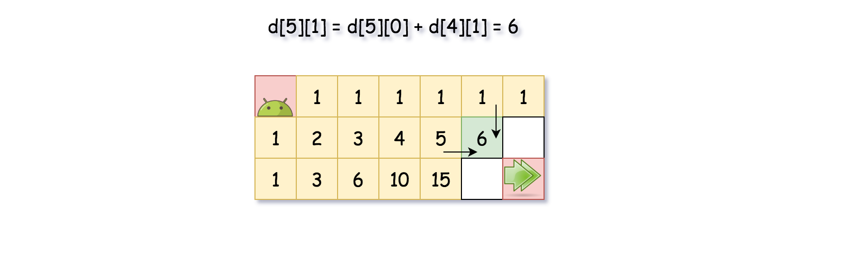

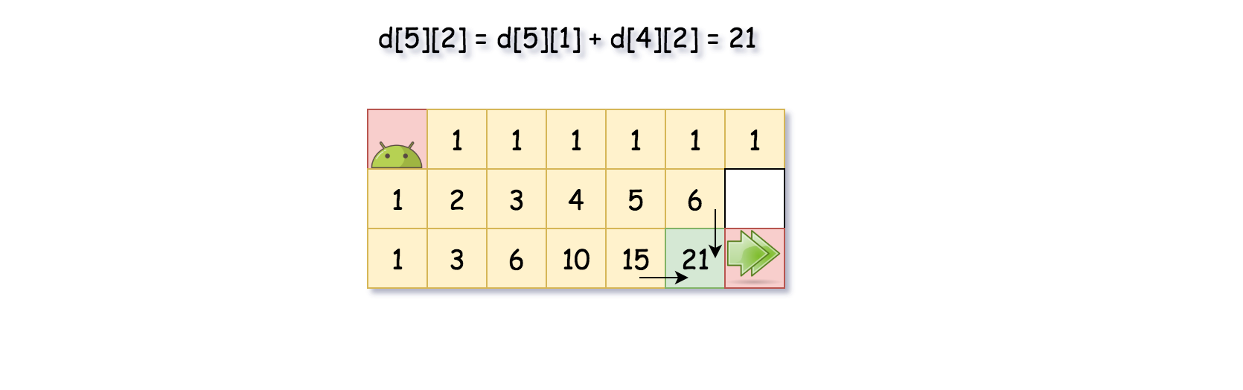

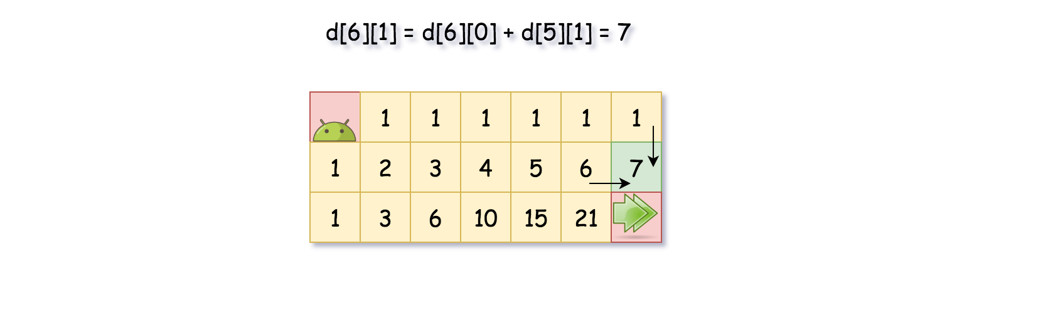

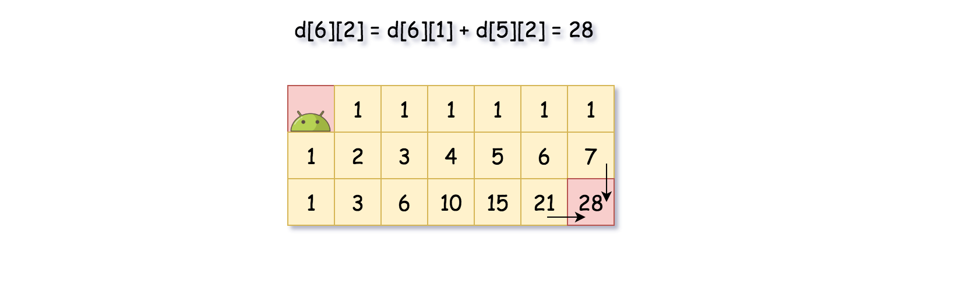

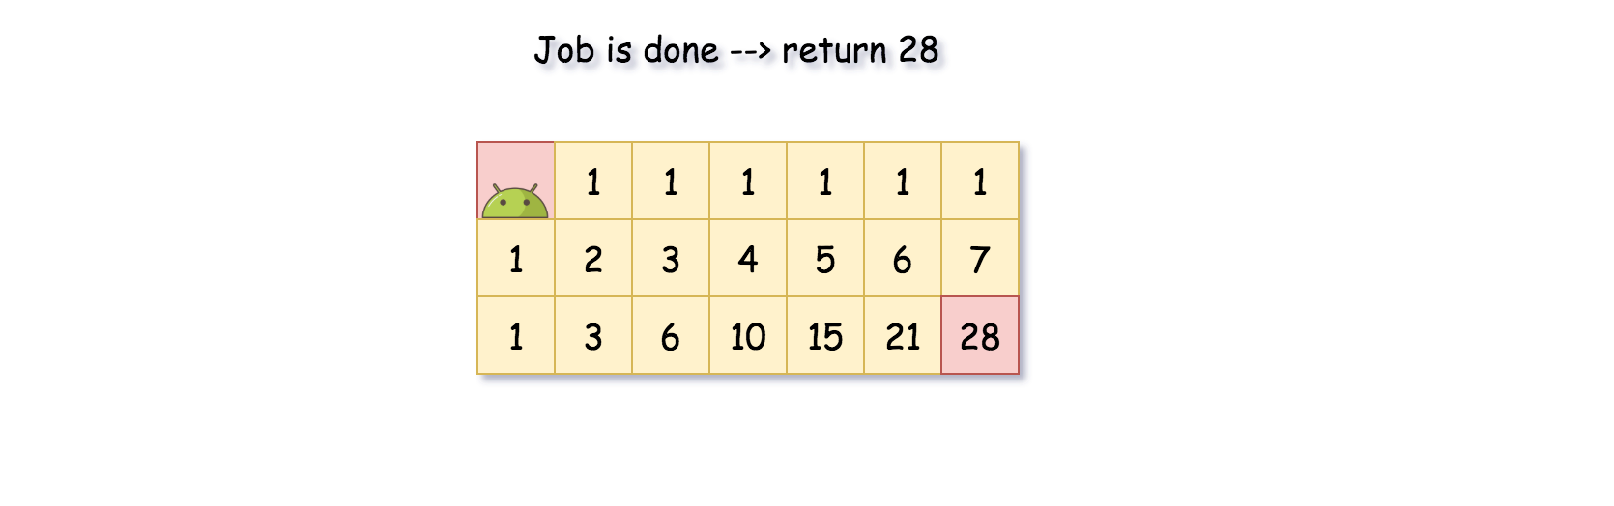

|  |
| --- |
| class Solution {  public int uniquePaths(int m, int n) {  int[][] d = new int[m][n];  for(int[] arr : d) {  Arrays.fill(arr, 1);  }  for(int col = 1; col < m; ++col) {  for(int row = 1; row < n; ++row) {  d[col][row] = d[col - 1][row] + d[col][row - 1];  }  }  return d[m - 1][n - 1];  }  } |

**Complexity Analysis**

* Time complexity: O(*N*×*M*).
* Space complexity: O(*N*×*M*).

**Coin Change**

You are given coins of different denominations and a total amount of money *amount*. Write a function to compute the fewest number of coins that you need to make up that amount. If that amount of money cannot be made up by any combination of the coins, return -1.

You may assume that you have an infinite number of each kind of coin.

**Example 1:**

**Input:** coins = [1,2,5], amount = 11

**Output:** 3

**Explanation:** 11 = 5 + 5 + 1

**Example 2:**

**Input:** coins = [2], amount = 3

**Output:** -1

**Example 3:**

**Input:** coins = [1], amount = 0

**Output:** 0

**Example 4:**

**Input:** coins = [1], amount = 1

**Output:** 1

**Example 5:**

**Input:** coins = [1], amount = 2

**Output:** 2

**Constraints:**

* 1 <= coins.length <= 12
* 1 <= coins[i] <= 231 - 1
* 0 <= amount <= 104

## Solution

#### **Approach #1 (Brute force) [Time Limit Exceeded]**

**Intuition**

The problem could be modeled as the following optimization problem : 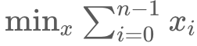 subject to 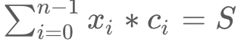

, where *S* is the amount, *ci*​ is the coin denominations, *xi*​ is the number of coins with denominations *ci*​ used in change of amount *S*. We could easily see that  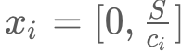

A trivial solution is to enumerate all subsets of coin frequencies [*x*0​…*xn*−1​] that satisfy the constraints above, compute their sums and return the minimum among them.

**Algorithm**

To apply this idea, the algorithm uses backtracking technique to generate all combinations of coin frequencies [*x*0​…*xn*−1​] in the range 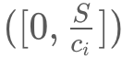 which satisfy the constraints above. It makes a sum of the combinations and returns their minimum or −1 in case there is no acceptable combination.

|  |
| --- |
| public class Solution {  public int coinChange(int[] coins, int amount) {  return coinChange(0, coins, amount);  }  private int coinChange(int idxCoin, int[] coins, int amount) {  if (amount == 0)  return 0;  if (idxCoin < coins.length && amount > 0) {  int maxVal = amount/coins[idxCoin];  int minCost = Integer.MAX_VALUE;  for (int x = 0; x <= maxVal; x++) {  if (amount >= x * coins[idxCoin]) {  int res = coinChange(idxCoin + 1, coins, amount - x * coins[idxCoin]);  if (res != -1)  minCost = Math.min(minCost, res + x);  }  }  return (minCost == Integer.MAX_VALUE)? -1: minCost;  }  return -1;  }  }  // Time Limit Exceeded |

**Complexity Analysis**

* Time complexity : O(S^n). In the worst case, complexity is exponential in the number of the coins *n*. The reason is that every coin denomination *ci*​ could have at most 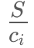​ values. Therefore the number of possible combinations is :

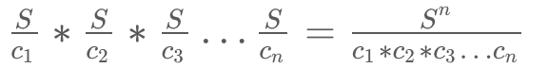

* Space complexity : *O*(*n*). In the worst case the maximum depth of recursion is *n*. Therefore we need *O*(*n*) space used by the system recursive stack.

#### **Approach #2 (Dynamic programming - Top down) [Accepted]**

**Intuition**

Could we improve the exponential solution above? Definitely! The problem could be solved with polynomial time using Dynamic programming technique. First, let's define:

*F*(*S*) - minimum number of coins needed to make change for amount *S* using coin denominations [*c*0​…*cn*−1​]

We note that this problem has an optimal substructure property, which is the key piece in solving any Dynamic Programming problems. In other words, the optimal solution can be constructed from optimal solutions of its subproblems. How to split the problem into subproblems? Let's assume that we know *F*(*S*) where some change *val*1​,*val*2​,… for *S* which is optimal and the last coin's denomination is *C*. Then the following equation should be true because of optimal substructure of the problem:

*F*(*S*)=*F*(*S*−*C*)+1

But we don't know which is the denomination of the last coin *C*. We compute *F*(*S*−*ci*​) for each possible denomination *c*0​,*c*1​,*c*2​…*cn*−1​ and choose the minimum among them. The following recurrence relation holds:

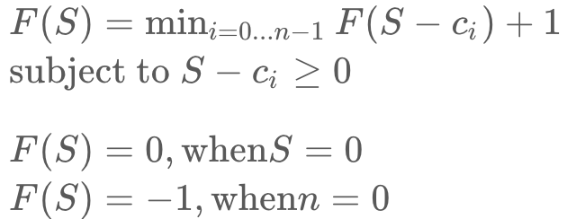

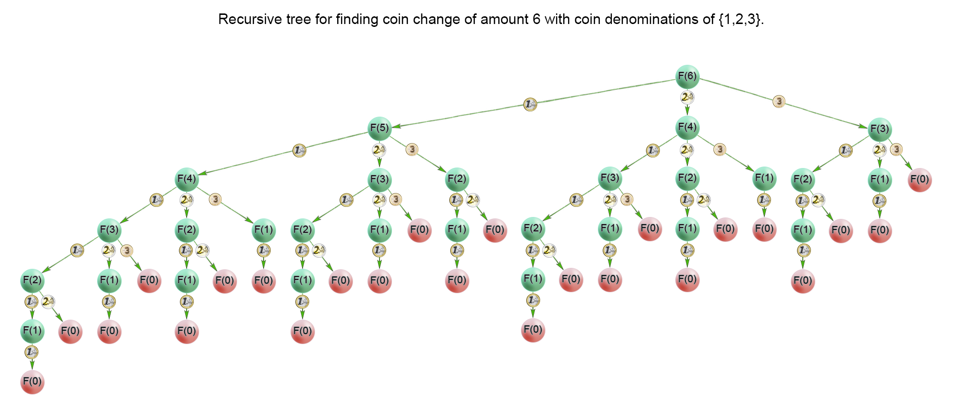

In the recursion tree above, we could see that a lot of subproblems were calculated multiple times. For example the problem *F*(1) was calculated 13 times. Therefore we should cache the solutions to the subproblems in a table and access them in constant time when necessary

**Algorithm**

The idea of the algorithm is to build the solution of the problem from top to bottom. It applies the idea described above. It use backtracking and cut the partial solutions in the recursive tree, which doesn't lead to a viable solution. Тhis happens when we try to make a change of a coin with a value greater than the amount *S*. To improve time complexity we should store the solutions of the already calculated subproblems in a table.

|  |
| --- |
| public class Solution {  public int coinChange(int[] coins, int amount) {  if (amount < 1) return 0;  return coinChange(coins, amount, new int[amount]);  }  private int coinChange(int[] coins, int rem, int[] count) {  if (rem < 0) return -1;  if (rem == 0) return 0;  if (count[rem - 1] != 0) return count[rem - 1];  int min = Integer.MAX_VALUE;  for (int coin : coins) {  int res = coinChange(coins, rem - coin, count);  if (res >= 0 && res < min)  min = 1 + res;  }  count[rem - 1] = (min == Integer.MAX_VALUE) ? -1 : min;  return count[rem - 1];  }  } |

**Complexity Analysis**

* Time complexity : *O*(*S*∗*n*). where S is the amount, n is denomination count. In the worst case the recursive tree of the algorithm has height of *S* and the algorithm solves only *S* subproblems because it caches precalculated solutions in a table. Each subproblem is computed with *n* iterations, one by coin denomination. Therefore there is *O*(*S*∗*n*) time complexity.
* Space complexity : *O*(*S*), where *S* is the amount to change We use extra space for the memoization table.

#### **Approach #3 (Dynamic programming - Bottom up) [Accepted]**

**Algorithm**

For the iterative solution, we think in bottom-up manner. Before calculating *F(i)*, we have to compute all minimum counts for amounts up to i*i*. On each iteration i*i* of the algorithm *F(i)* is computed as 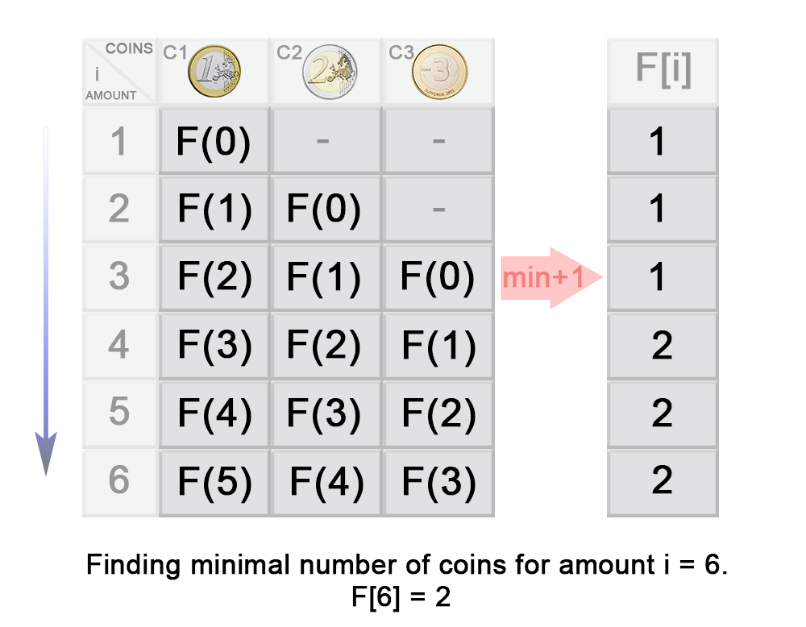

In the example above you can see that:

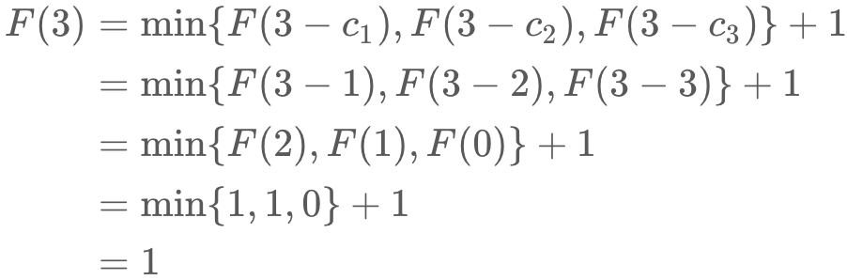

|  |
| --- |
| public class Solution {  public int coinChange(int[] coins, int amount) {  int max = amount + 1;  int[] dp = new int[amount + 1];  Arrays.fill(dp, max);  dp[0] = 0;  for (int i = 1; i <= amount; i++) {  for (int j = 0; j < coins.length; j++) {  if (coins[j] <= i) {  dp[i] = Math.min(dp[i], dp[i - coins[j]] + 1);  }  }  }  return dp[amount] > amount ? -1 : dp[amount];  }  } |

**Complexity Analysis**

* Time complexity : *O*(*S*∗*n*). On each step the algorithm finds the next *F(i)* in *n* iterations, where 1≤*i*≤*S*. Therefore in total the iterations are *S*∗*n*.
* Space complexity : *O*(*S*). We use extra space for the memoization table.

**Longest Increasing Subsequence**

Given an integer array nums, return the length of the longest strictly increasing subsequence.

A **subsequence** is a sequence that can be derived from an array by deleting some or no elements without changing the order of the remaining elements. For example, [3,6,2,7] is a subsequence of the array [0,3,1,6,2,2,7].

**Example 1:**

**Input:** nums = [10,9,2,5,3,7,101,18]

**Output:** 4

**Explanation:** The longest increasing subsequence is [2,3,7,101], therefore the length is 4.

**Example 2:**

**Input:** nums = [0,1,0,3,2,3]

**Output:** 4

**Example 3:**

**Input:** nums = [7,7,7,7,7,7,7]

**Output:** 1

**Constraints:**

* 1 <= nums.length <= 2500
* -104 <= nums[i] <= 104

**Follow up:**

* Could you come up with the O(n2) solution?
* Could you improve it to O(n log(n)) time complexity?

## Solution

#### **Approach 1: Brute Force**

**Algorithm**

The simplest approach is to try to find all increasing subsequences and then returning the maximum length of longest increasing subsequence. In order to do this, we make use of a recursive function \lengthofLIS which returns the length of the LIS possible from the current element(corresponding to *curpos*) onwards(including the current element). Inside each function call, we consider two cases:

1. The current element is larger than the previous element included in the LIS. In this case, we can include the current element in the LIS. Thus, we find out the length of the LIS obtained by including it. Further, we also find out the length of LIS possible by not including the current element in the LIS. The value returned by the current function call is, thus, the maximum out of the two lengths.
2. The current element is smaller than the previous element included in the LIS. In this case, we can't include the current element in the LIS. Thus, we find out only the length of the LIS possible by not including the current element in the LIS, which is returned by the current function call.

|  |
| --- |
| public class Solution {  public int lengthOfLIS(int[] nums) {  return lengthofLIS(nums, Integer.MIN_VALUE, 0);  }  public int lengthofLIS(int[] nums, int prev, int curpos) {  if (curpos == nums.length) {  return 0;  }  int taken = 0;  if (nums[curpos] > prev) {  taken = 1 + lengthofLIS(nums, nums[curpos], curpos + 1);  }  int nottaken = lengthofLIS(nums, prev, curpos + 1);  return Math.max(taken, nottaken);  }  } |

**Complexity Analysis**

* Time complexity : O(2^n). Size of recursion tree will be 2^n.
* Space complexity : O(n^2). *memo* array of size *n*∗*n* is used.

#### **Approach 2: Recursion with Memoization**

**Algorithm**

In the previous approach, many recursive calls had to made again and again with the same parameters. This redundancy can be eliminated by storing the results obtained for a particular call in a 2-d memoization array *memo*. *memo*[*i*][*j*] represents the length of the LIS possible using *nums*[*i*] as the previous element considered to be included/not included in the LIS, with *nums*[*j*] as the current element considered to be included/not included in the LIS. Here, *nums* represents the given array.

|  |
| --- |
| public class Solution {  public int lengthOfLIS(int[] nums) {  int memo[][] = new int[nums.length + 1][nums.length];  for (int[] l : memo) {  Arrays.fill(l, -1);  }  return lengthofLIS(nums, -1, 0, memo);  }  public int lengthofLIS(int[] nums, int previndex, int curpos, int[][] memo) {  if (curpos == nums.length) {  return 0;  }  if (memo[previndex + 1][curpos] >= 0) {  return memo[previndex + 1][curpos];  }  int taken = 0;  if (previndex < 0 || nums[curpos] > nums[previndex]) {  taken = 1 + lengthofLIS(nums, curpos, curpos + 1, memo);  }  int nottaken = lengthofLIS(nums, previndex, curpos + 1, memo);  memo[previndex + 1][curpos] = Math.max(taken, nottaken);  return memo[previndex + 1][curpos];  }  } |

**Complexity Analysis**

* Time complexity : O(n^2). Size of recursion tree can go upto n^2.
* Space complexity : O(n^2). *memo* array of *n*∗*n* is used.

#### **Approach 3: Dynamic Programming**

**Algorithm**

This method relies on the fact that the longest increasing subsequence possible upto the *ith* index in a given array is independent of the elements coming later on in the array. Thus, if we know the length of the LIS upto *ith* index, we can figure out the length of the LIS possible by including the (*i*+1)*th* element based on the elements with indices *j* such that 0≤*j*≤(*i*+1).

We make use of a *dp* array to store the required data. *dp*[*i*] represents the length of the longest increasing subsequence possible considering the array elements up to the *ith* index only ,by necessarily including the *ith* element. In order to find out *dp*[*i*], we need to try to append the current element(*nums*[*i*]) in every possible increasing subsequences upto the (*i*−1)*th* index(including the (*i*−1)*th* index), such that the new sequence formed by adding the current element is also an increasing subsequence. Thus, we can easily determine *dp*[*i*] using:

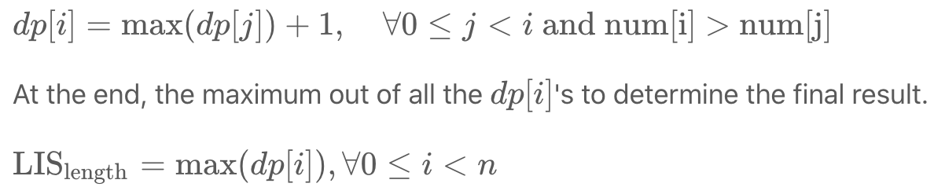

The following animation illustrates the method:

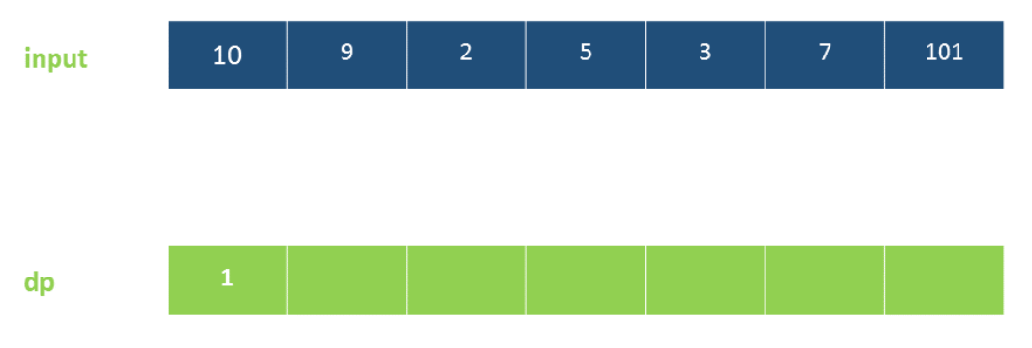

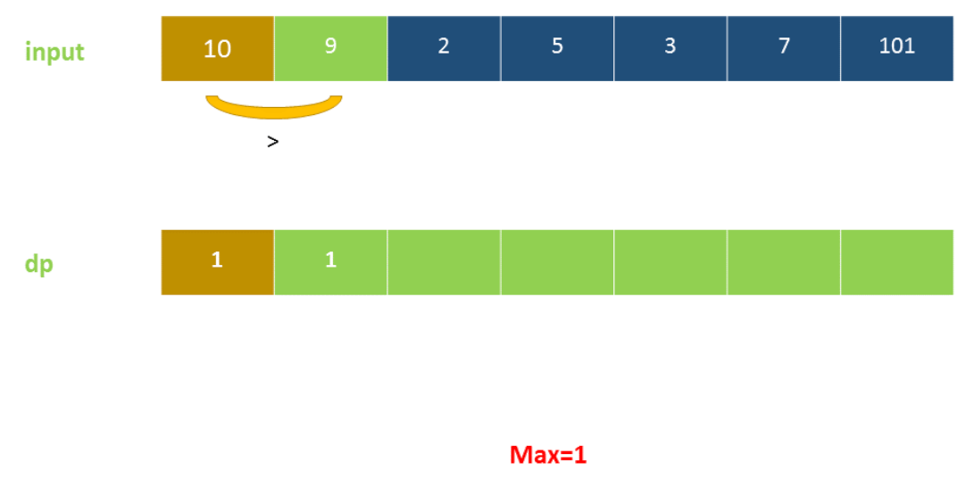

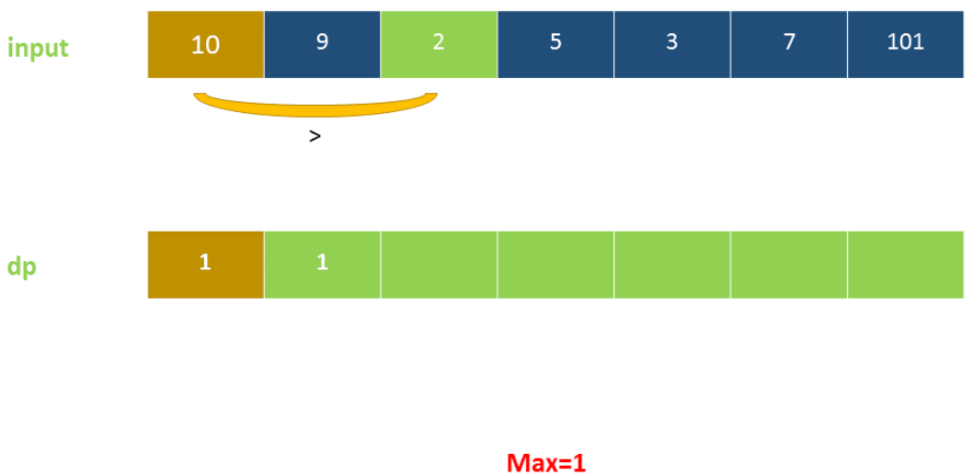

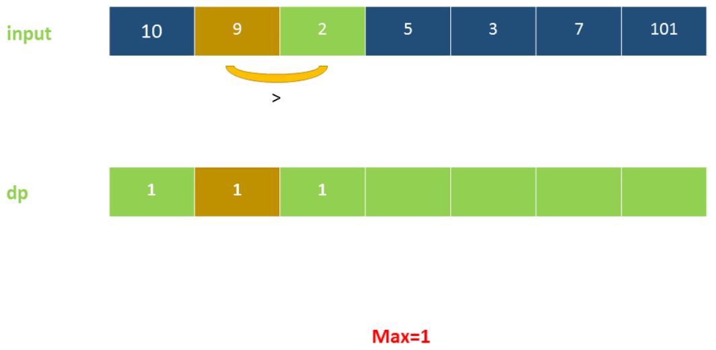

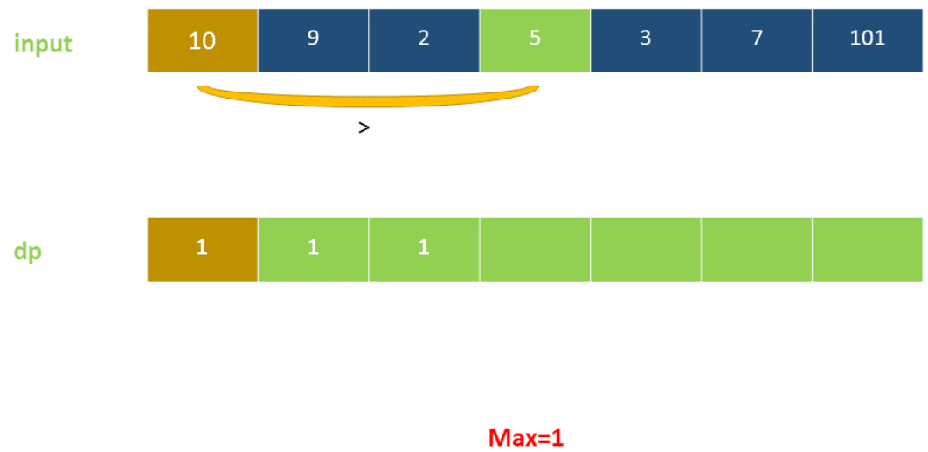

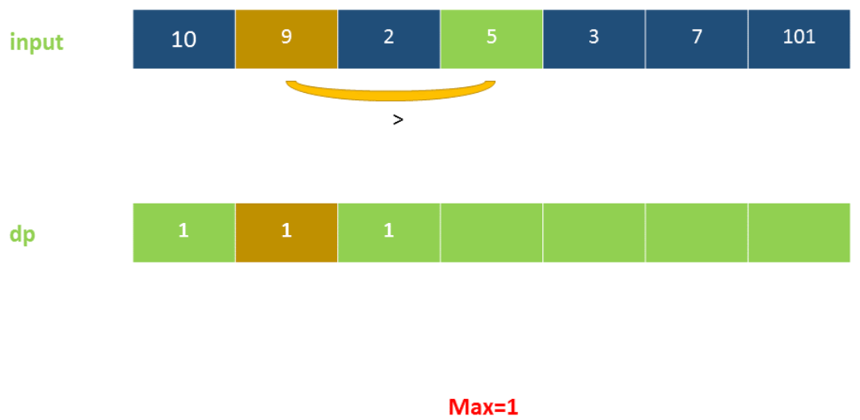

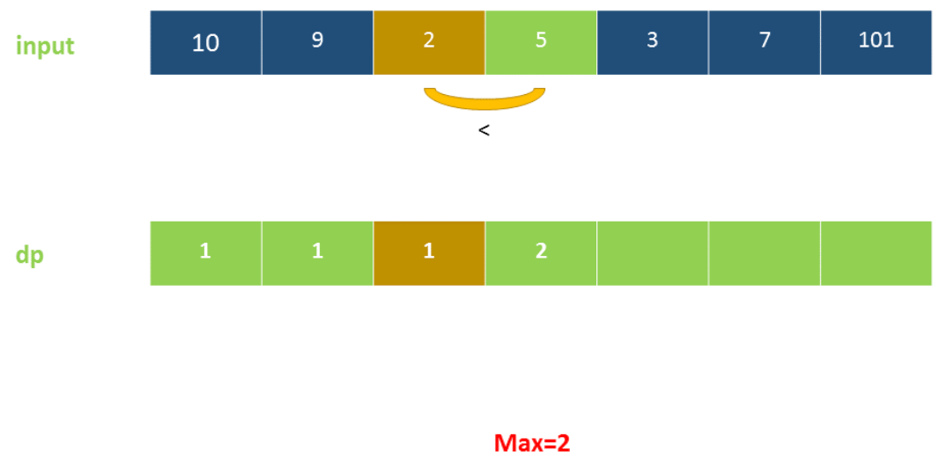

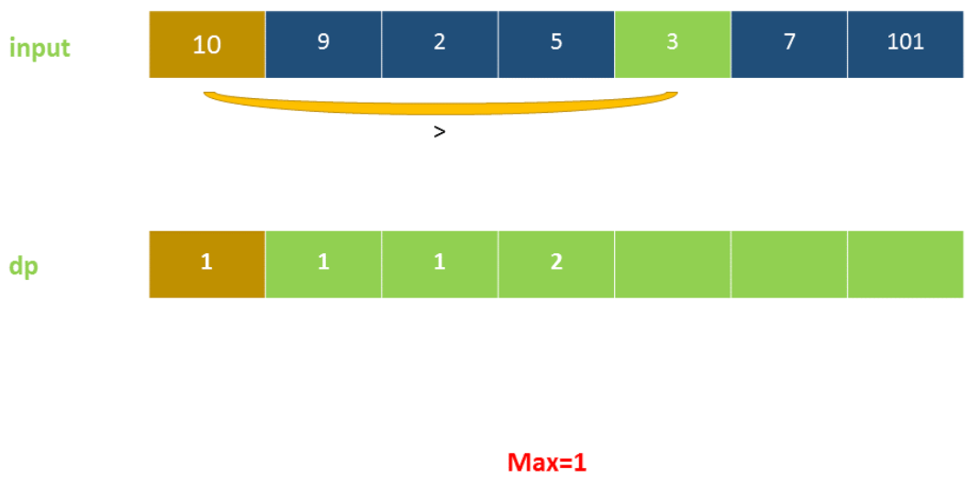

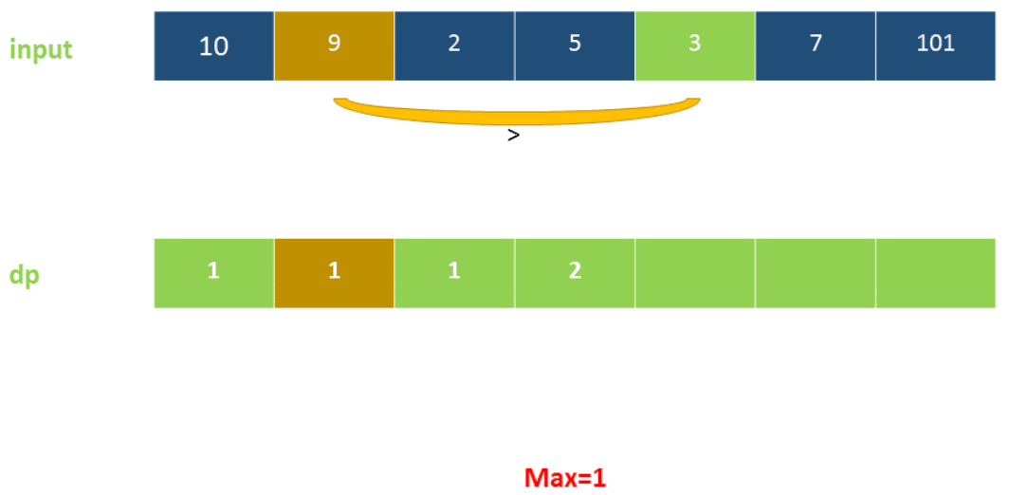

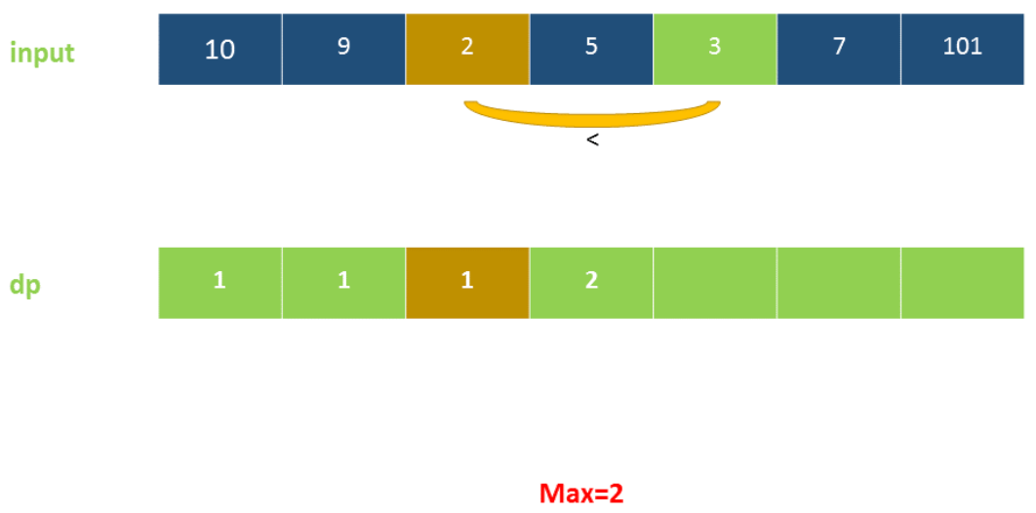

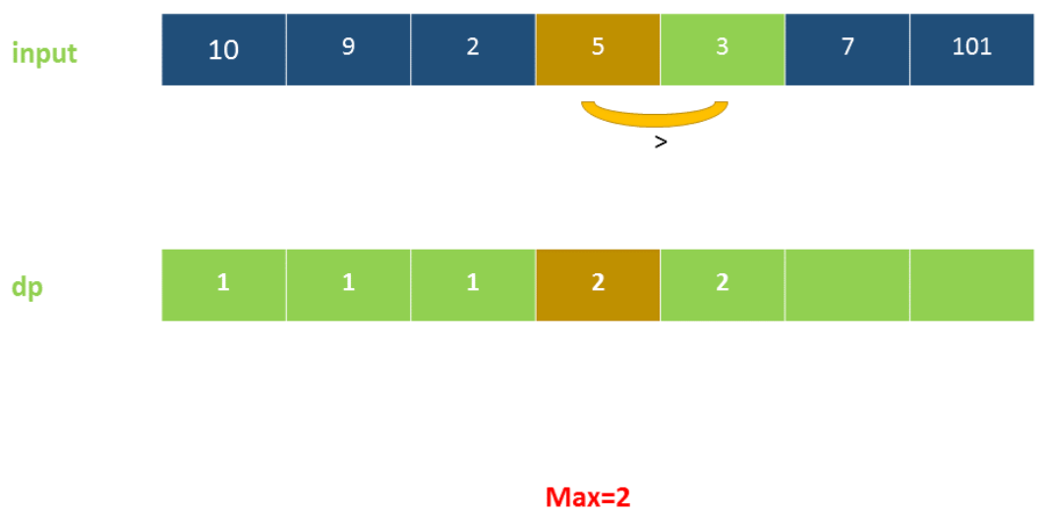

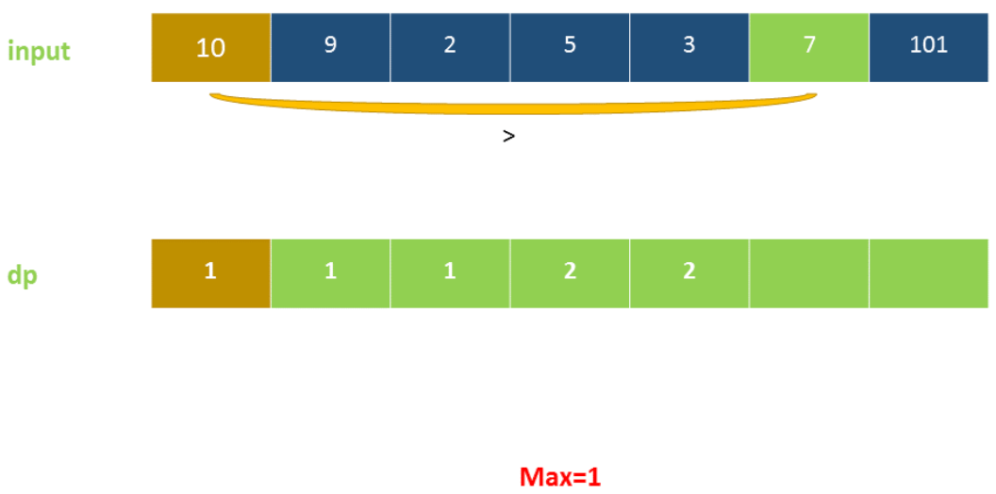

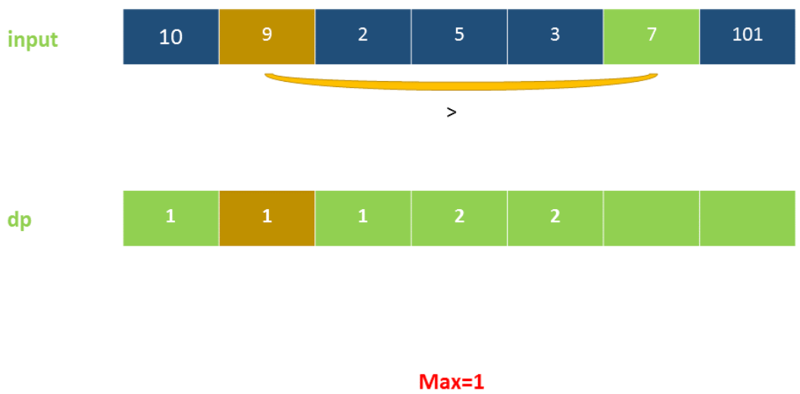

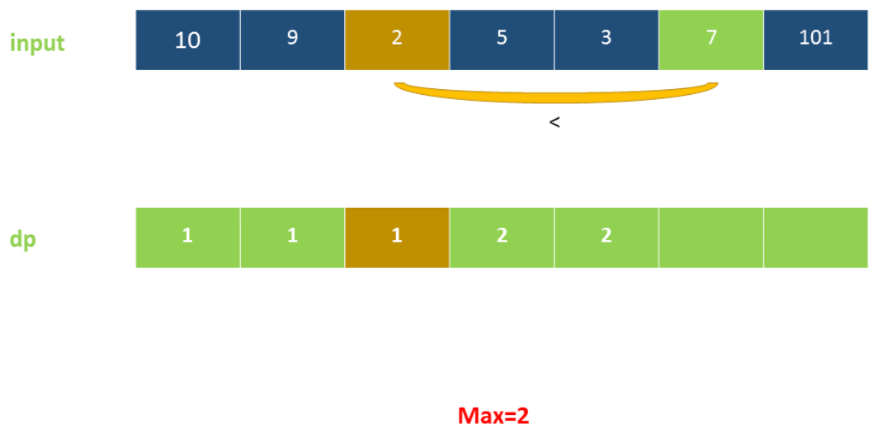

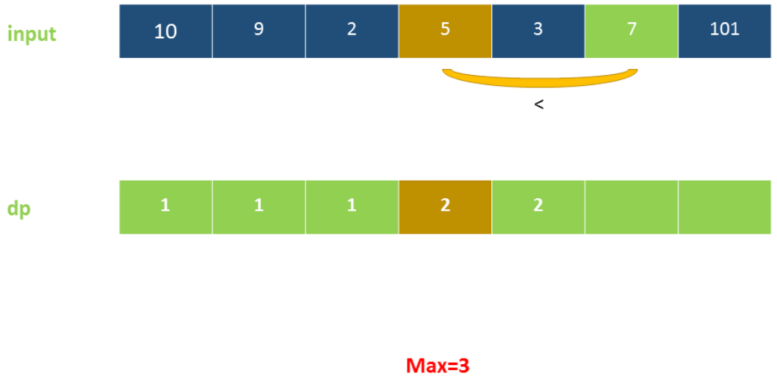

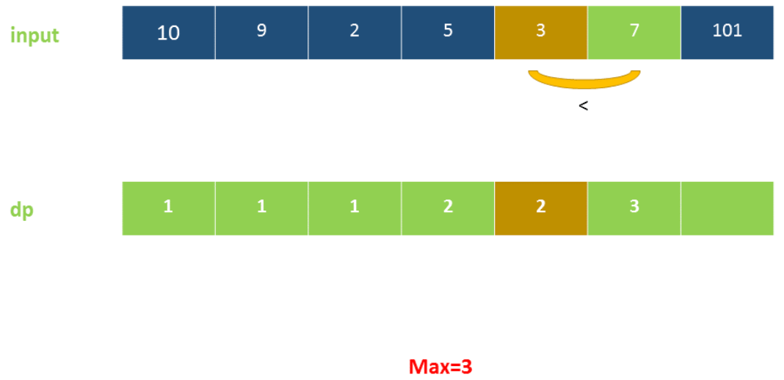

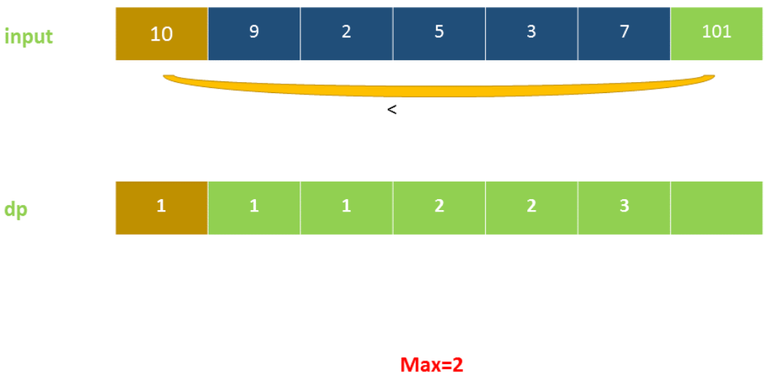

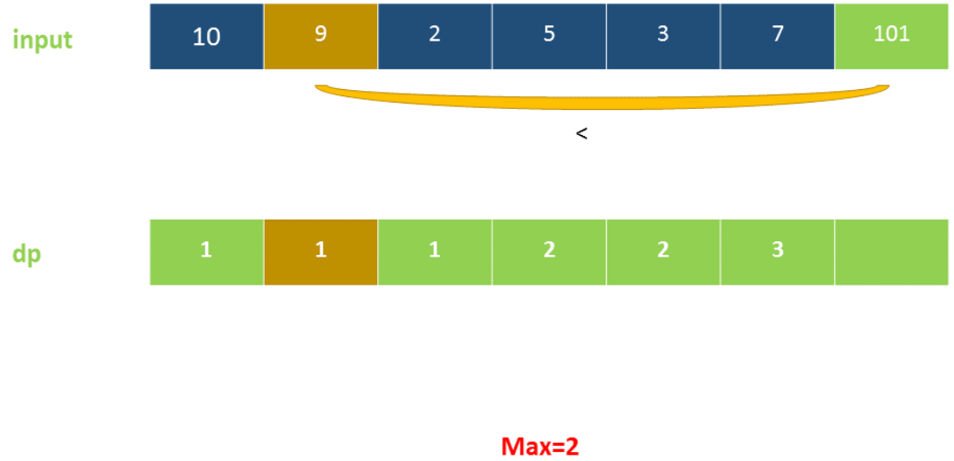

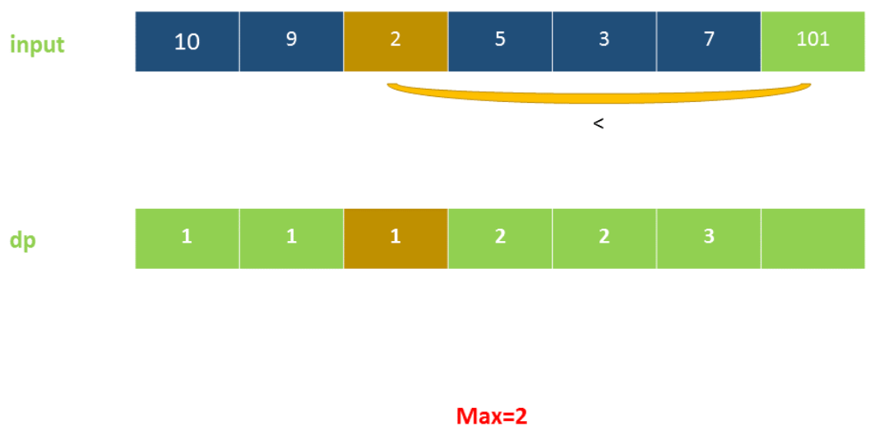

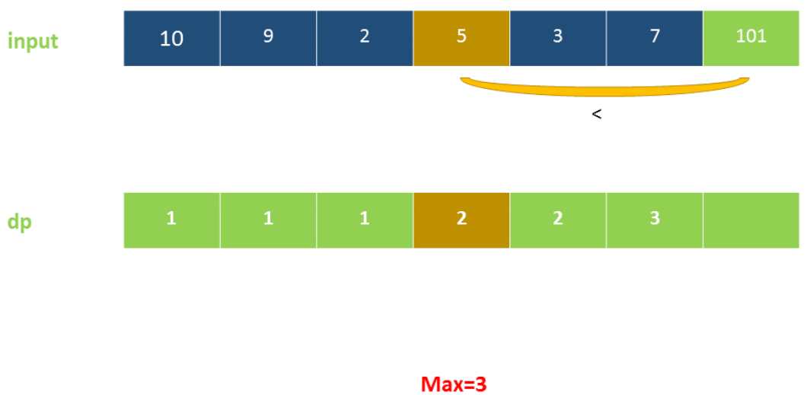

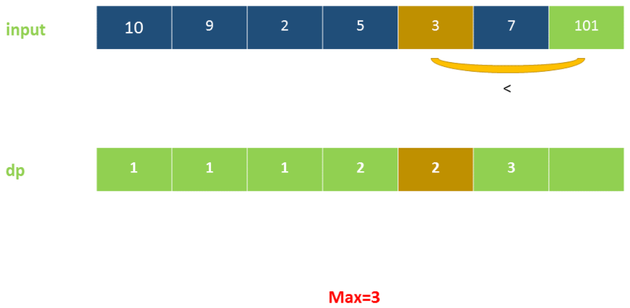

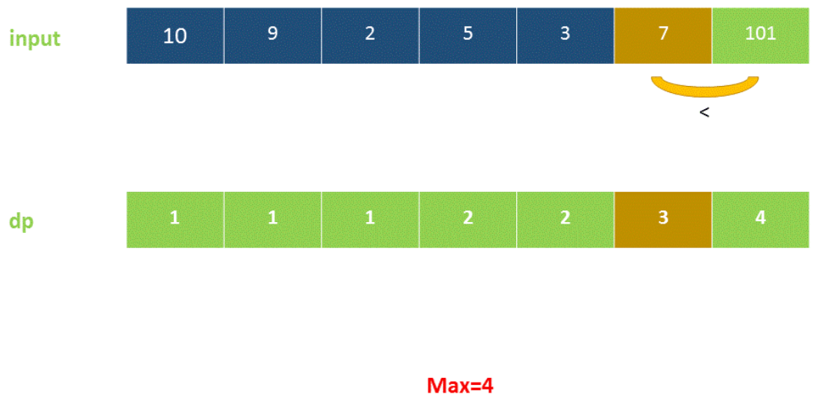

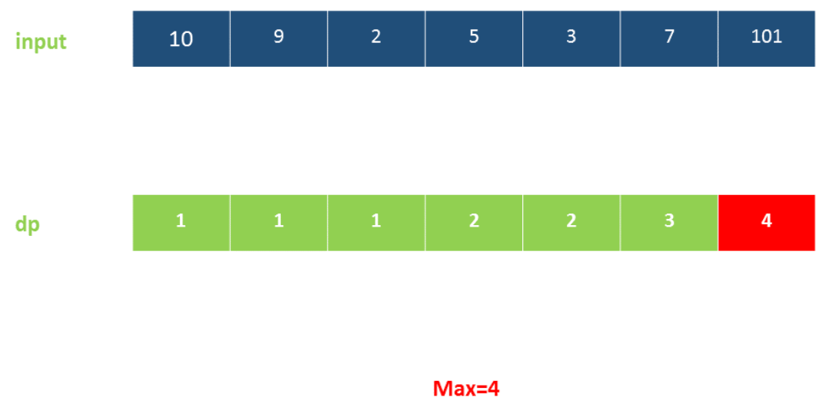

|  |
| --- |
| public class Solution {  public int lengthOfLIS(int[] nums) {  if (nums.length == 0) {  return 0;  }  int[] dp = new int[nums.length];  dp[0] = 1;  int maxans = 1;  for (int i = 1; i < dp.length; i++) {  int maxval = 0;  for (int j = 0; j < i; j++) {  if (nums[i] > nums[j]) {  maxval = Math.max(maxval, dp[j]);  }  }  dp[i] = maxval + 1;  maxans = Math.max(maxans, dp[i]);  }  return maxans;  }  } |

**Complexity Analysis**

* Time complexity : O(n^2). Two loops of *n* are there.
* Space complexity : O(n). *dp* array of size *n* is used.

#### **Approach 4: Dynamic Programming with Binary Search**

**Algorithm**

In this approach, we scan the array from left to right. We also make use of a *dp* array initialized with all 0's. This *dp* array is meant to store the increasing subsequence formed by including the currently encountered element. While traversing the *nums* array, we keep on filling the *dp* array with the elements encountered so far. For the element corresponding to the *jth* index (*nums*[*j*]), we determine its correct position in the *dp* array(say *ith* index) by making use of Binary Search(which can be used since the *dp* array is storing increasing subsequence) and also insert it at the correct position. An important point to be noted is that for Binary Search, we consider only that portion of the *dp* array in which we have made the updates by inserting some elements at their correct positions(which remains always sorted). Thus, only the elements upto the *ith* index in the *dp* array can determine the position of the current element in it. Since, the element enters its correct position(*i*) in an ascending order in the *dp* array, the subsequence formed so far in it is surely an increasing subsequence. Whenever this position index *i* becomes equal to the length of the LIS formed so far(*len*), it means, we need to update the *len* as *len*=*len*+1.

Note: *dp* array does not result in longest increasing subsequence, but length of *dp* array will give you length of LIS.

Consider the example:

input: [0, 8, 4, 12, 2]

dp: [0]

dp: [0, 8]

dp: [0, 4]

dp: [0, 4, 12]

dp: [0 , 2, 12] which is not the longest increasing subsequence, but length of *dp* array results in length of Longest Increasing Subsequence.

|  |
| --- |
| public class Solution {  public int lengthOfLIS(int[] nums) {  int[] dp = new int[nums.length];  int len = 0;  for (int num : nums) {  int i = Arrays.binarySearch(dp, 0, len, num);  if (i < 0) {  i = -(i + 1);  }  dp[i] = num;  if (i == len) {  len++;  }  }  return len;  }  } |

Note: Arrays.binarySearch() method returns index of the search key, if it is contained in the array, else it returns (-(insertion point) - 1). The insertion point is the point at which the key would be inserted into the array: the index of the first element greater than the key, or a.length if all elements in the array are less than the specified key.

**Complexity Analysis**

* Time complexity : *O*(*n*log*n*). Binary search takes log*n* time and it is called *n* times.
* Space complexity : *O*(*n*). *dp* array of size *n* is used.

## Design

These problems may require you to implement a given interface of a class, and may involve using one or more data structures. These are great exercises to improve your data structure skills.

We recommend: Serialize and Deserialize Binary Tree and Insert Delete GetRandom O(1).

 Flatten 2D Vector

 Serialize and Deserialize Binary Tree

 Insert Delete GetRandom O(1)

 Design Tic-Tac-Toe

**Flatten 2D Vector**

Design and implement an iterator to flatten a 2d vector. It should support the following operations: next and hasNext.

**Example:**

Vector2D iterator = new Vector2D([[1,2],[3],[4]]);

iterator.next(); // return 1

iterator.next(); // return 2

iterator.next(); // return 3

iterator.hasNext(); // return true

iterator.hasNext(); // return true

iterator.next(); // return 4

iterator.hasNext(); // return false

**Notes:**

1. Please remember to **RESET** your class variables declared in Vector2D, as static/class variables are **persisted across multiple test cases**. Please see [here](https://leetcode.com/faq/) for more details.
2. You may assume that next() call will always be valid, that is, there will be at least a next element in the 2d vector when next() is called.

**Follow up:**

As an added challenge, try to code it using only [iterators in C++](http://www.cplusplus.com/reference/iterator/iterator/) or [iterators in Java](http://docs.oracle.com/javase/7/docs/api/java/util/Iterator.html).

Hide Hint #1

How many variables do you need to keep track?

   Hide Hint #2

Two variables is all you need. Try with x and y.

   Hide Hint #3

Beware of empty rows. It could be the first few rows.

   Hide Hint #4

To write correct code, think about the [invariant](https://en.wikipedia.org/wiki/Invariant_(computer_science)) to maintain. What is it?

   Hide Hint #5

The invariant is x and y must always point to a valid point in the 2d vector. Should you maintain your invariant *ahead of time* or *right when you need it*?

   Hide Hint #6

Not sure? Think about how you would implement hasNext(). Which is more complex?

   Hide Hint #7

Common logic in two different places should be refactored into a common method.

## Solution

#### **Overview**

This question should be fairly straightforward if you're familiar with what an Iterator is. If you aren't at all familiar with Iterators though, then we suggest having a go at [Peeking Iterator](https://leetcode.com/problems/peeking-iterator/). Additionally, the [Solution Article for Peeking Iterator](https://leetcode.com/problems/peeking-iterator/solution/) has a special introduction section that introduces you to what Iterators are.

Note that this question refers to something called a Vector. A Vector is simply another name for Array. To be consistent with the question, we've chosen to use the term Vector, rather than Array for this article (Sorry in advance for any confusion this causes, C++ programmers).

#### **Approach 1: Flatten List in Constructor**

**Intuition**

***This approach is a bad approach!*** We've included it though, to show what it looks like, and to discuss why it's bad. This will help you to design ***good*** Iterators.

In the constructor, we can iterate over the 2D input vector, putting each integer into a List. Then, the problem simplifies to being a simple List Iterator. Note that the reason we use a List rather than an array (vector) is because we don't know in advance how many integers there might be in total.

Our unpack algorithm would be as follows.

nums = a new List

for each innerVector in the input 2D Vector:

for each number in innerVector:

append number to the end of nums

We'll then need to save this List as a field of our Iterator class, seeing as the next(...) and hasNext(...) methods will need to access it repeatedly. By then also having a position field, we can keep track of where the Iterator is up to.

**Algorithm**

The code shown here makes the position field point at the next element that needs to be returned by *next*. Therefore, the hasNext() method simply needs to check that position is a valid index of nums. A similar variant would be to make position point at the previous value that was returned. This would simplify the next() method, but complicate the hasNext() method.

|  |
| --- |
| import java.util.NoSuchElementException;  class Vector2D {  // Constructor will put all the nums into this list.  private List<Integer> nums = new ArrayList<>();  // Keep track of where the Iterator is up to.  private int position = 0;  public Vector2D(int[][] v) {  // We need to iterate over the 2D vector, getting all the integers  // out of it and putting them into nums (a field).  for (int[] innerVector : v) {  for (int num : innerVector) {  nums.add(num);  }  }  }  public int next() {  // In Java, we throw a NoSuchElementException when next() is called  // on an exhausted Iterator.  if (!hasNext()) throw new NoSuchElementException();  // Store the number we need to return, as we still need to move position forward.  int result = nums.get(position);  // Move the position pointer forward by 1, so that it's ready for  // the next call to next, and gives a correct hasNext result.  position++;  return result;  }  public boolean hasNext() {  // There's nums left as long as position is a valid index of the list.  return position < nums.size();  }  } |

**Complexity Analysis**

Let N*N* be the number of integers within the 2D Vector, and V*V* be the number of inner vectors.

* Time complexity.
  + **Constructor:** *O*(*N*+*V*).

In total, we'll append N*N* integers to the nums list. Each of these appends is an *O*(1) operation. This gives us *O*(*N*).

Something to be cautious of is that inner vectors don't have to contain integers. Think of a test cases such as [[], [2], [], [], []]. For this test case, *N*=1, because there's only one integer within it. However, the algorithm has to loop through all of the empty vectors. The cost of checking all the vectors is *O*(*V*).

Therefore, we get a final time complexity of *O*(*N*+*V*).

* + **next():** *O*(1).

All operations in this method, including getting the integer at a specific index of a list, are *O*(1).

* + **hasNext():** *O*(1).

All operations in this method are *O*(1).

* Space complexity : *O*(*N*).

We're making a new list that contains all of the integers from the 2D Vector. Notice that this is different from the time complexity; in the example of [[], [2], [], [], []], we only store the 2. All information about how many inner vectors there were is discarded.

**Why is this implementation bad?**

This code works, it runs fast here on Leetcode, it seems pretty straightforward to implement.

However, one of the main purposes of an Iterator is to minimize the use of auxiliary space. We should try to utilize the existing data structure as much as possible, only adding as much extra space as needed to keep track of the next value. In some situations, the data structure we want to iterate over is too large to even fit in memory anyway (think of file systems).

In the case of our above implementation, we might as well have just had a single function List<Integer> getFlattenedVector(int[][] v), which would return a List of integers, that could then be iterated over using the List types own standard Iterator.

As a general rule, you should be very cautious of implementing Iterators with a high time complexity in the constructor, with a very low time complexity in the next() and hasNext() methods. If the code using the Iterator only wanted to access the first couple of elements in the iterated collection, then a lot of time (and probably space) has been wasted!

As a side note, modifying the input collection in any way is bad design too. Iterators are only allowed to look at, not change, the collection they've been asked to iterate over.

#### **Approach 2: Two Pointers**

**Intuition**

Like we said above, Approach 1 is bad because it creates a new data structure instead of simply iterating over the given one. Instead, we should find a way to step through the integers one-by-one, keeping track of where we currently are in the 2D vector. The location of each number is represented with 2 indexes; the index of the inner vector, and the index of the integer within its inner vector. Here's an example 2D vector, with the indexes marked on it.

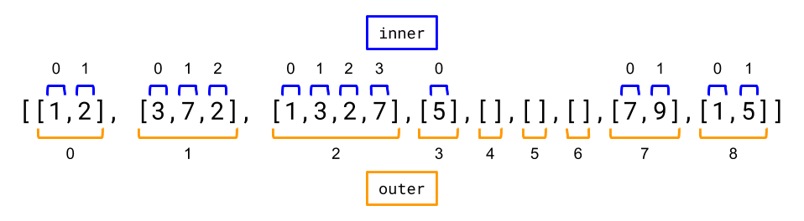

Suppose we are at the following position:

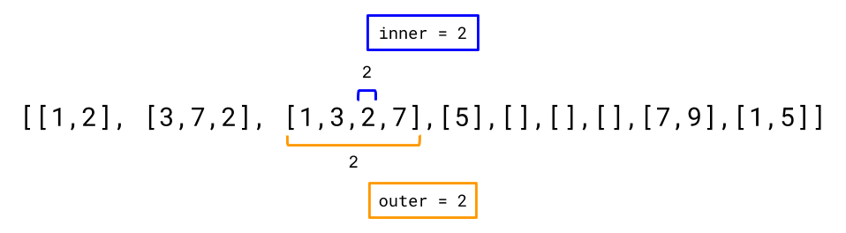

How do we find the next position? Well the current integer has another integer after it, within the same inner vector. Therefore, we can just increment inner index by 1. This gives the next position as shown below.

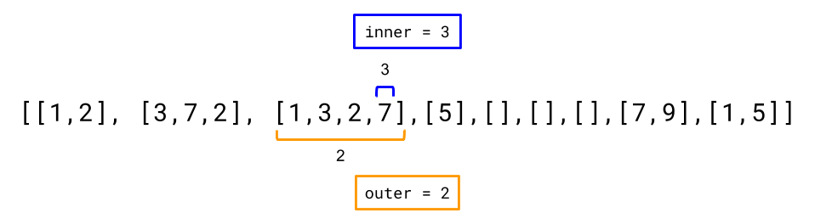

Now inner is at the end of the current inner vector. In order to get to the next integer we'll need to increment outer by 1, and set inner to 0 (as 0 is first index of the new vector).

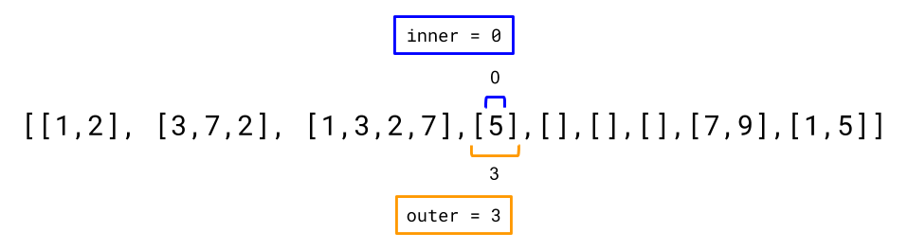

This time, it's a bit trickier, because we need to skip over empty vectors. To do that we repeatedly increment outer until we find an inner vector that is not empty (programmatically, this would be an outer where inner = 0 is valid). Once we find one, we stop and set inner to 0 (the first integer of the inner vector).

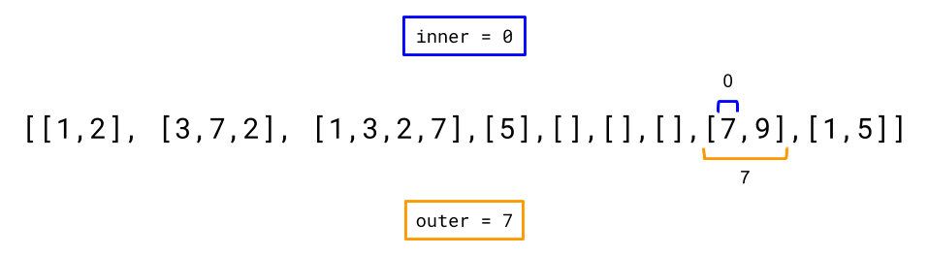

Note that when outer becomes equal to the length of the 2D vector, this means there are no more inner vectors and so there are no more numbers left.

**Algorithm**

In Approach 1, we used *O*(*N*) auxiliary space and *O*(*N*+*V*) time in the constructor. In this approach though, we perform the necessary work incrementally during calls to hasNext() and next(). This means that if the caller stops using the iterator before it's exhausted, we won't have done any unnecessary work.

We'll define an advanceToNext() helper method that checks if the current inner and outer values point to an integer, and if they don't, then it moves them forward until they point to an integer (in the way described above). If outer == vector.length becomes true, then the method terminates (because there's no integers left).

In order to ensure no unnecessary work is done, the constructor doesn't check whether or not vector[0][0] points to an integer. This is because there might be an arbitrary number of empty inner vectors at the start of the input vector; potentially costing up to *O*(*V*) operations to skip past.

Both hasNext() and next() start by calling advanceToNext() to ensure that inner and outer point to an integer, **or** that outer is at its "stop" value of outer = vector.length.

next() returns the integer at vector[inner][outer], and then increments inner by 1, so that the next call to advanceToNext() will start searching from after the integer we've just returned.

It is important to note that calling the hasNext() method will only cause the pointers to move if they don't point to an integer. Once they point to an integer, repeated calls to hasNext() will not move them further. Only next() is able to move them off a valid integer. This design ensures that the client code calling hasNext() multiple times will not have unusual side effects.

|  |
| --- |
| import java.util.NoSuchElementException;  class Vector2D {  private int[][] vector;  private int inner = 0;  private int outer = 0;  public Vector2D(int[][] v) {  // We need to store a *reference* to the input vector.  vector = v;  }  // If the current outer and inner point to an integer, this method does nothing.  // Otherwise, inner and outer are advanced until they point to an integer.  // If there are no more integers, then outer will be equal to vector.length  // when this method terminates.  private void advanceToNext() {  // While outer is still within the vector, but inner is over the  // end of the inner list pointed to by outer, we want to move  // forward to the start of the next inner vector.  while (outer < vector.length && inner == vector[outer].length) {  inner = 0;  outer++;  }  }  public int next() {  // As per Java specs, throw an exception if there's no next.  // This will also ensure the pointers point to an integer otherwise.  if (!hasNext()) throw new NoSuchElementException();  // Return current element and move inner so that is after the current  // element.  return vector[outer][inner++];  }  public boolean hasNext() {  // Ensure the position pointers are moved such they point to an integer,  // or put outer = vector.length.  advanceToNext();  // If outer = vector.length then there are no integers left, otherwise  // we've stopped at an integer and so there's an integer left.  return outer < vector.length;  }  } |

**Complexity Analysis**

Let *N* be the number of integers within the 2D Vector, and *V* be the number of inner vectors.

* Time complexity.
  + **Constructor:** *O*(1).

We're only storing a reference to the input vector—an *O*(1) operation.

* + **advanceToNext():** O(V/N).

If the iterator is completely exhausted, then all calls to advanceToNext() will have performed *O*(*N*+*V*) total operations. (Like in Approach 1, the *V* comes from the fact that we go through all *V* inner vectors, and the *N* comes from the fact we perform one increment for each integer).

However, because we perform *N* advanceToNext() operations in order to exhaust the iterator, the amortized cost of this operation is just 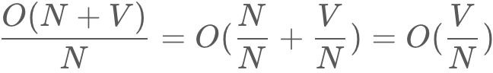

**next() / hasNext():** O(V/N)or *O*(1).

The cost of both these methods depends on how they are called. If we just got a value from next(), then the next call to either method will involve calling advanceToNext(). In this case the time complexity is O(V/N).

However if we call hasNext(), then all successive calls to hasNext(), or the next call to next(), will be *O*(1). This is because advanceToNext() will only perform an *O*(1) check and immediately return.

* Space complexity : *O*(1).

We only use a fixed set of *O*(1) fields (remember vector is a reference, not a copy!). So the space complexity is *O*(1).

**Serialize and Deserialize Binary Tree**

Serialization is the process of converting a data structure or object into a sequence of bits so that it can be stored in a file or memory buffer, or transmitted across a network connection link to be reconstructed later in the same or another computer environment.

Design an algorithm to serialize and deserialize a binary tree. There is no restriction on how your serialization/deserialization algorithm should work. You just need to ensure that a binary tree can be serialized to a string and this string can be deserialized to the original tree structure.

**Clarification:** The input/output format is the same as [how LeetCode serializes a binary tree](https://leetcode.com/faq/#binary-tree). You do not necessarily need to follow this format, so please be creative and come up with different approaches yourself.

**Example 1:**

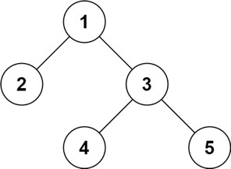

**Input:** root = [1,2,3,null,null,4,5]

**Output:** [1,2,3,null,null,4,5]

**Example 2:**

**Input:** root = []

**Output:** []

**Example 3:**

**Input:** root = [1]

**Output:** [1]

**Example 4:**

**Input:** root = [1,2]

**Output:** [1,2]

**Constraints:**

* The number of nodes in the tree is in the range [0, 104].
* -1000 <= Node.val <= 1000

## Solution

#### **Approach 1: Depth First Search (DFS)**

**Intuition**

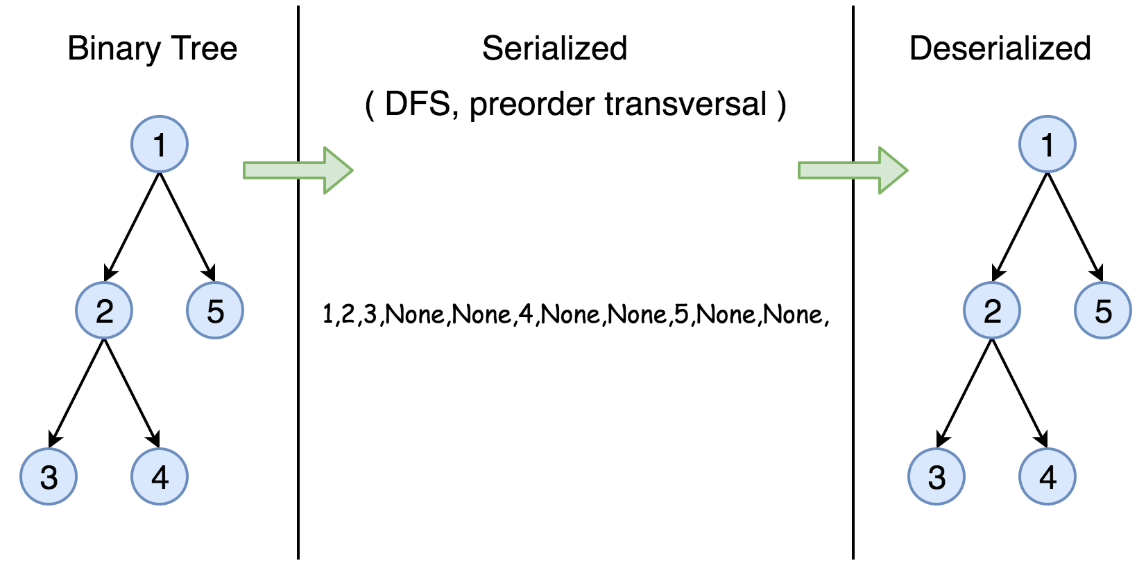

The **serialization** of a Binary Search Tree is essentially to encode its values and more importantly its structure. One can traverse the tree to accomplish the above task. And it is well know that we have two general strategies to do so:

* Breadth First Search (BFS)

We scan through the tree level by level, following the order of height, from top to bottom. The nodes on higher level would be visited before the ones with lower levels.

* Depth First Search (DFS)

In this strategy, we adopt the depth as the priority, so that one would start from a root and reach all the way down to certain leaf, and then back to root to reach another branch.

The DFS strategy can further be distinguished as preorder, inorder, and postorder depending on the relative order among the root node, left node and right node.

In this task, however, the DFS strategy is more adapted for our needs, since the linkage among the adjacent nodes is naturally encoded in the order, which is rather helpful for the later task of **deserialization**.

Therefore, in this solution, we demonstrate an example with the preorder DFS strategy. One can check out more tutorial about Binary Search Tree on the [LeetCode Explore](https://leetcode.com/explore/learn/card/introduction-to-data-structure-binary-search-tree/).

**Algorithm**

First of all, here is the definition of the TreeNode which we would use in the following implementation.

|  |
| --- |
| /* Definition for a binary tree node. */  public class TreeNode {  int val;  TreeNode left;  TreeNode right;  TreeNode(int x) {  val = x;  }  } |

The preorder DFS traverse follows *recursively* the order of  
root -> left subtree -> right subtree.

As an example, let's serialize the following tree. Note that serialization contains information about the node values as well as the information about the tree structure.

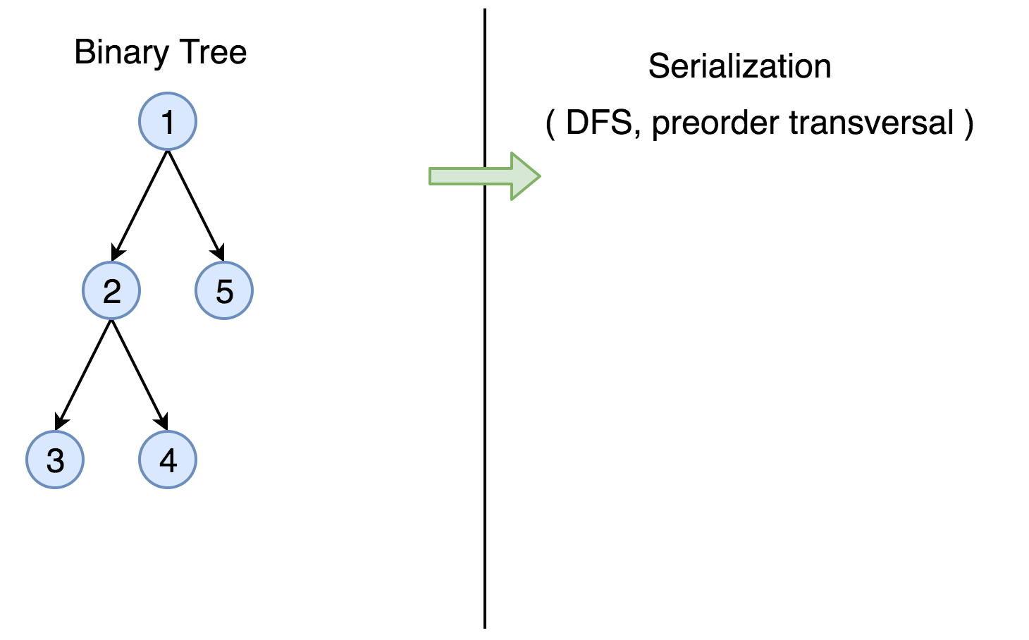

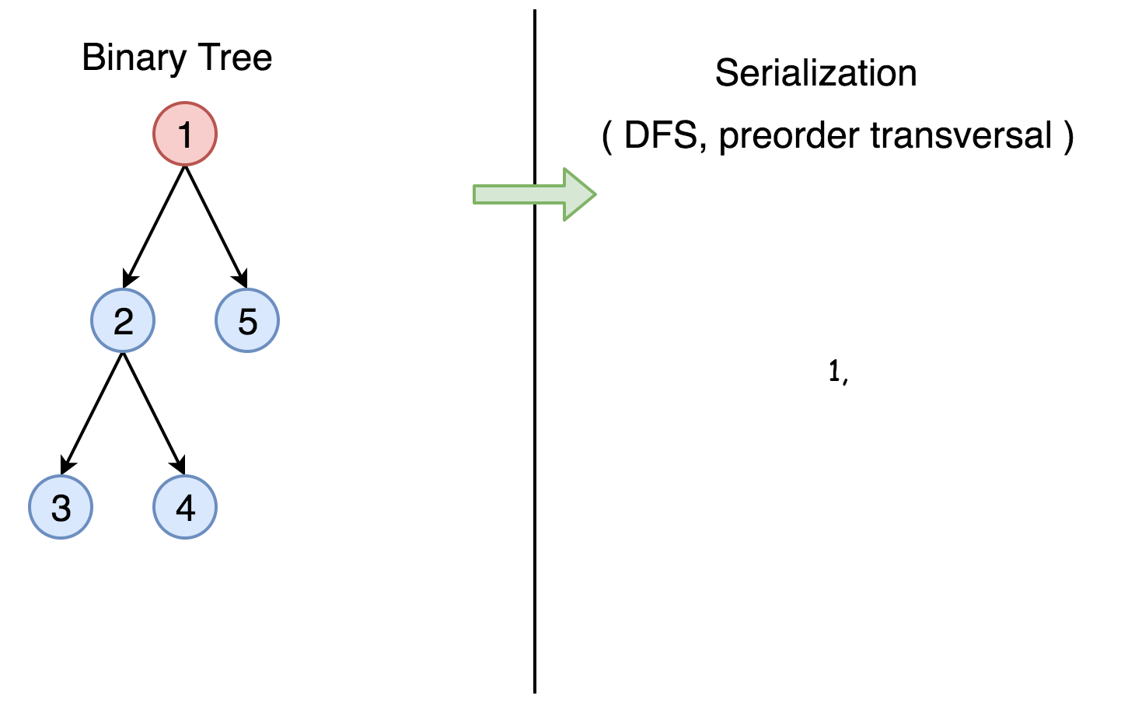

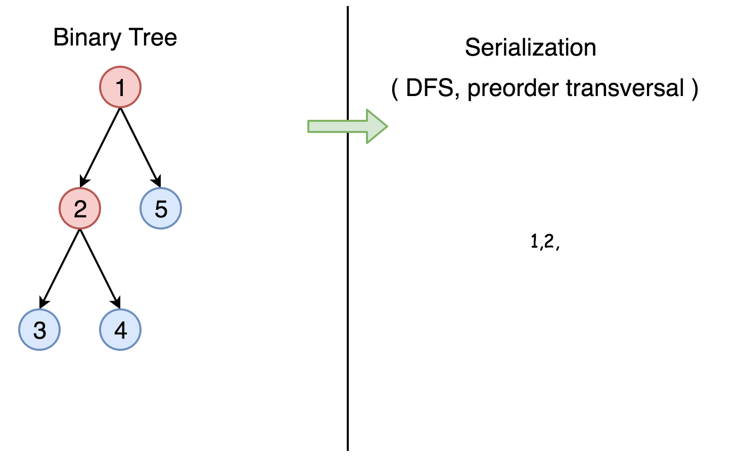

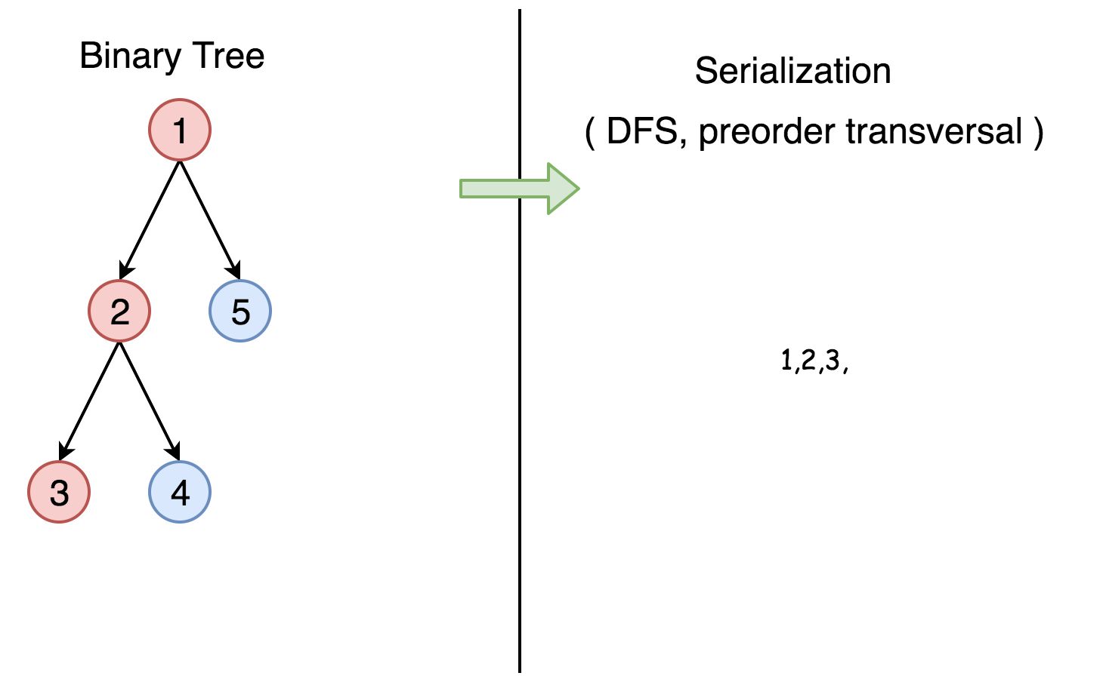

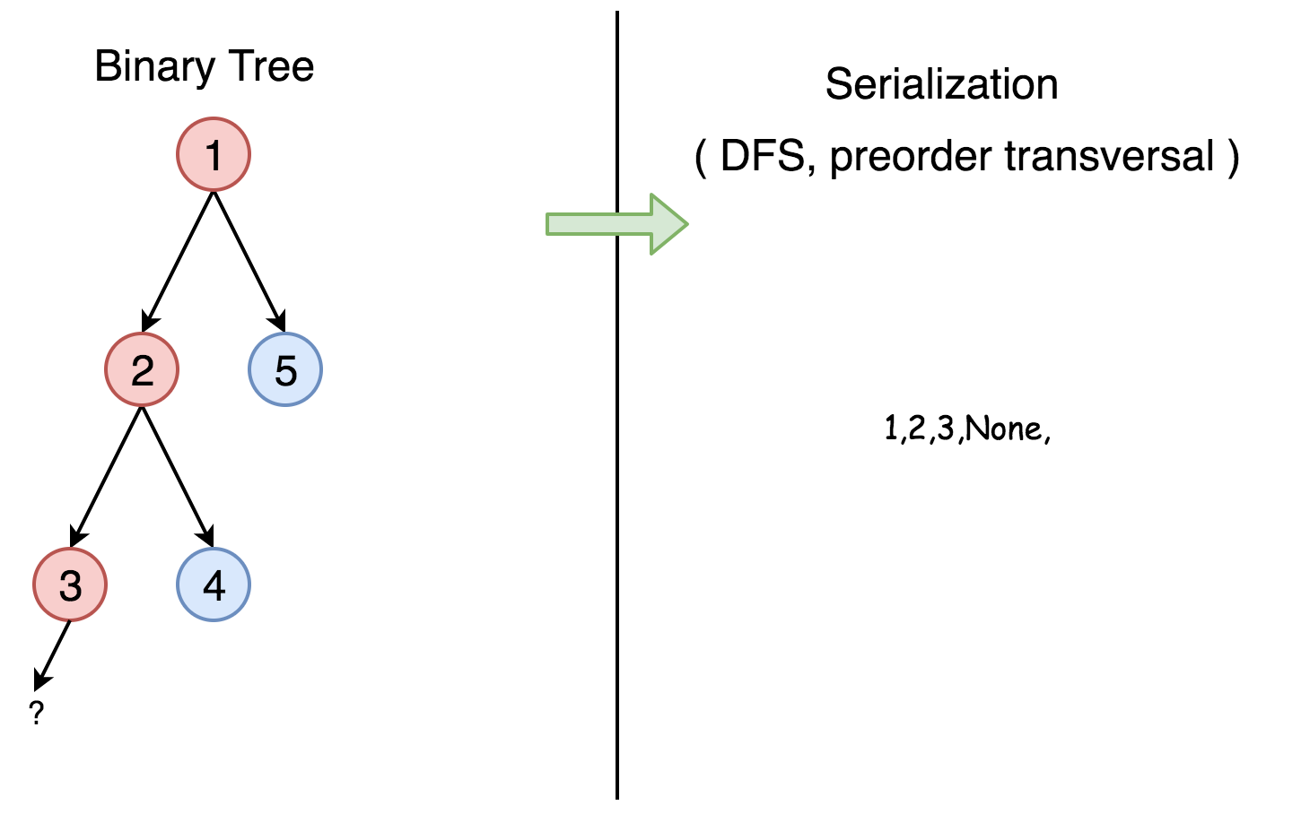

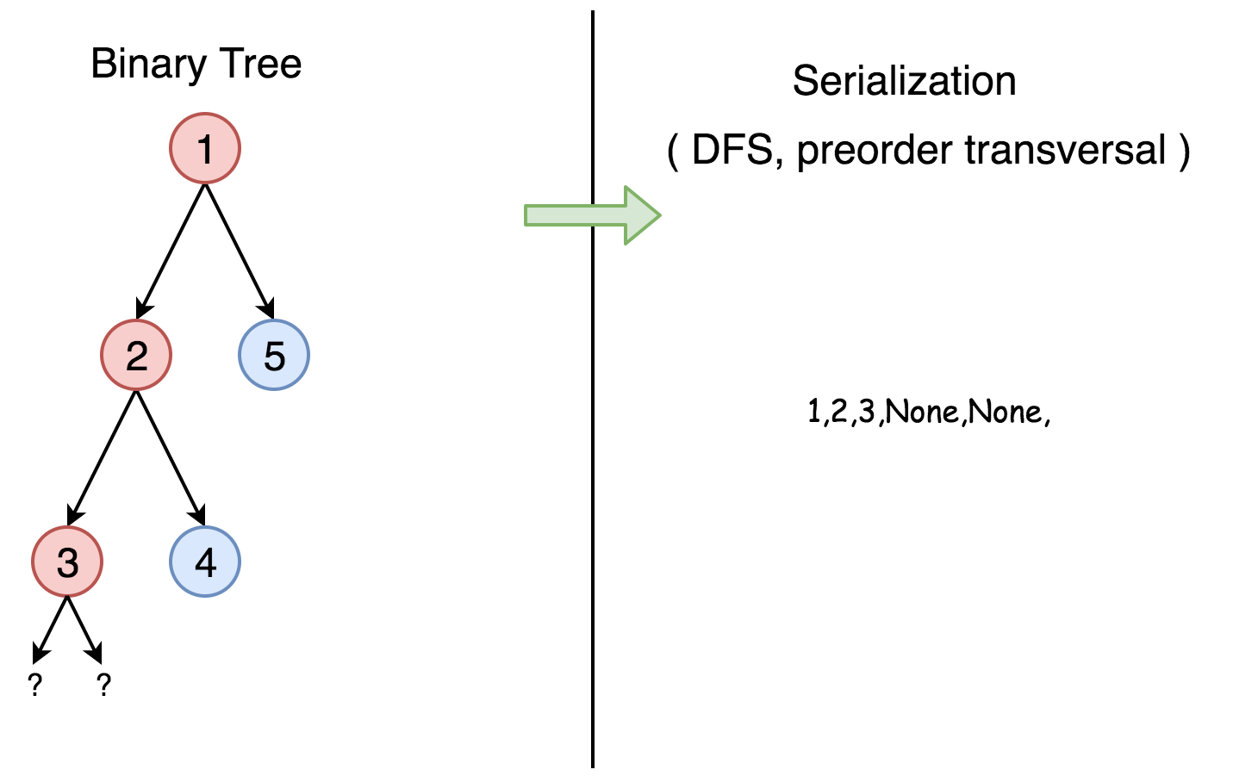

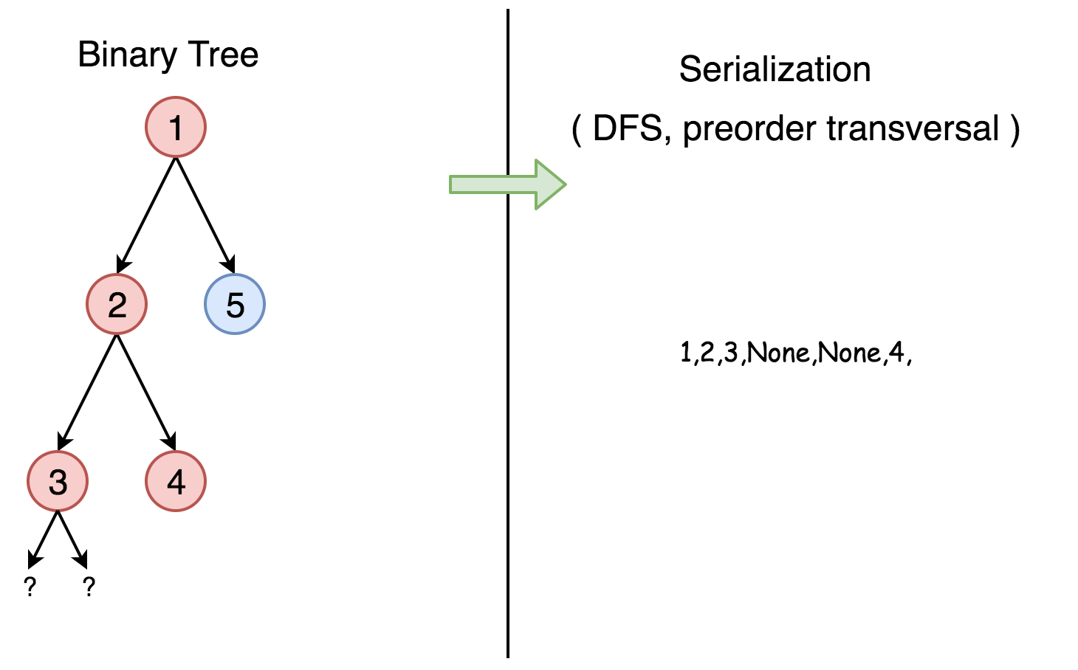

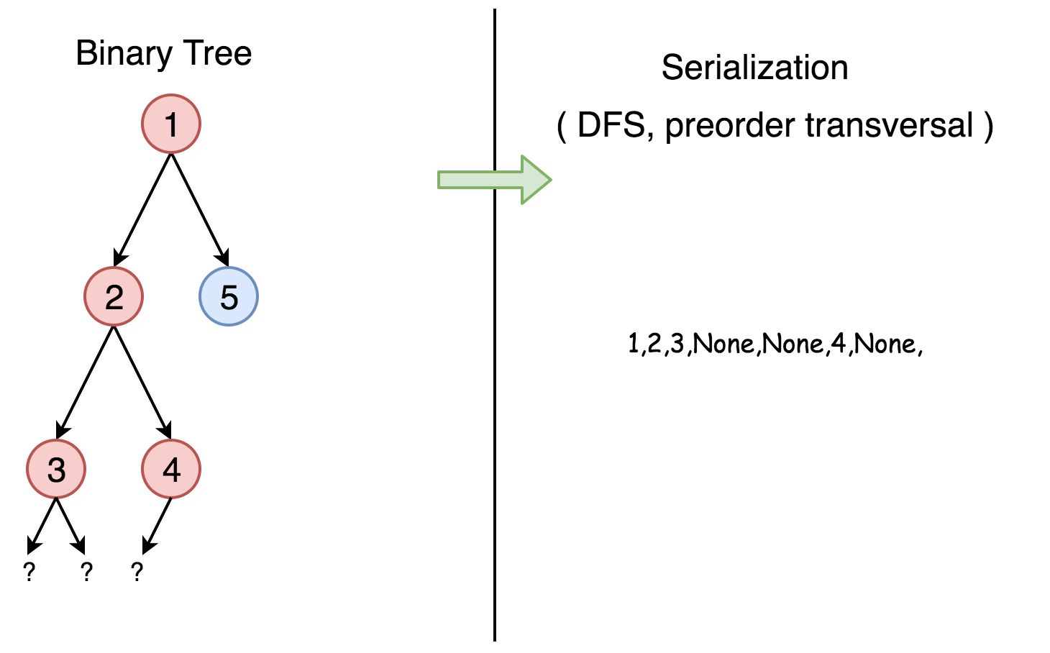

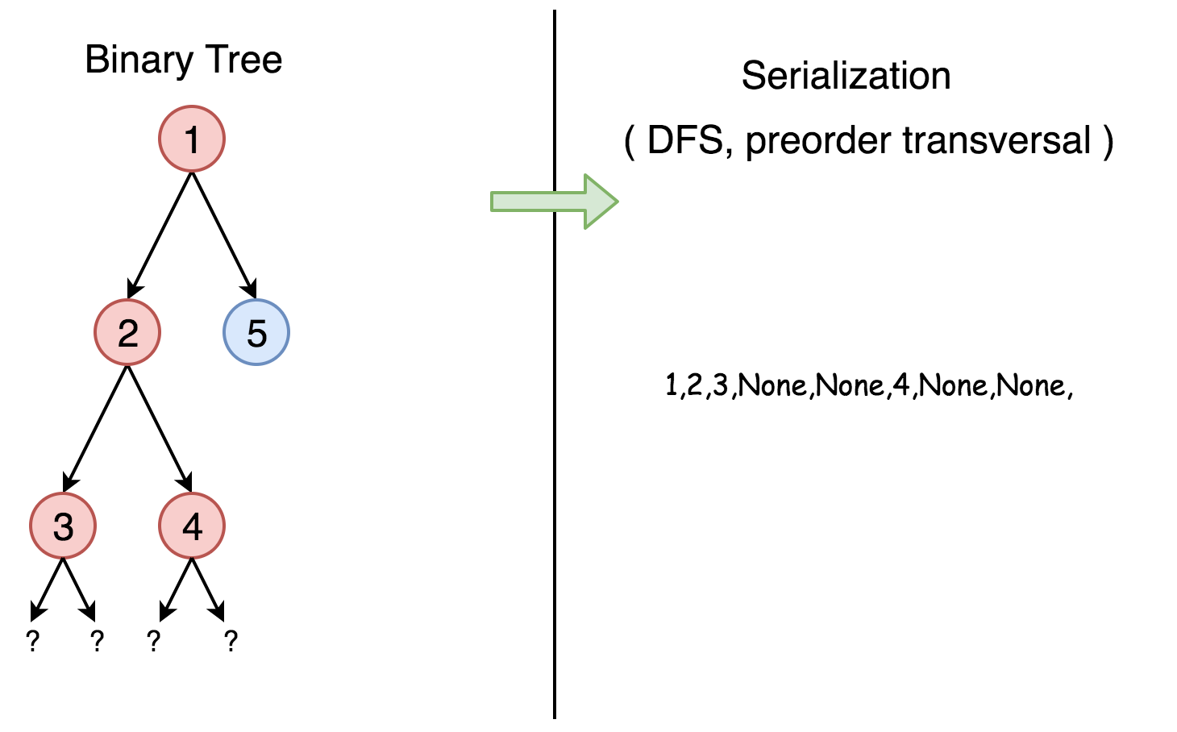

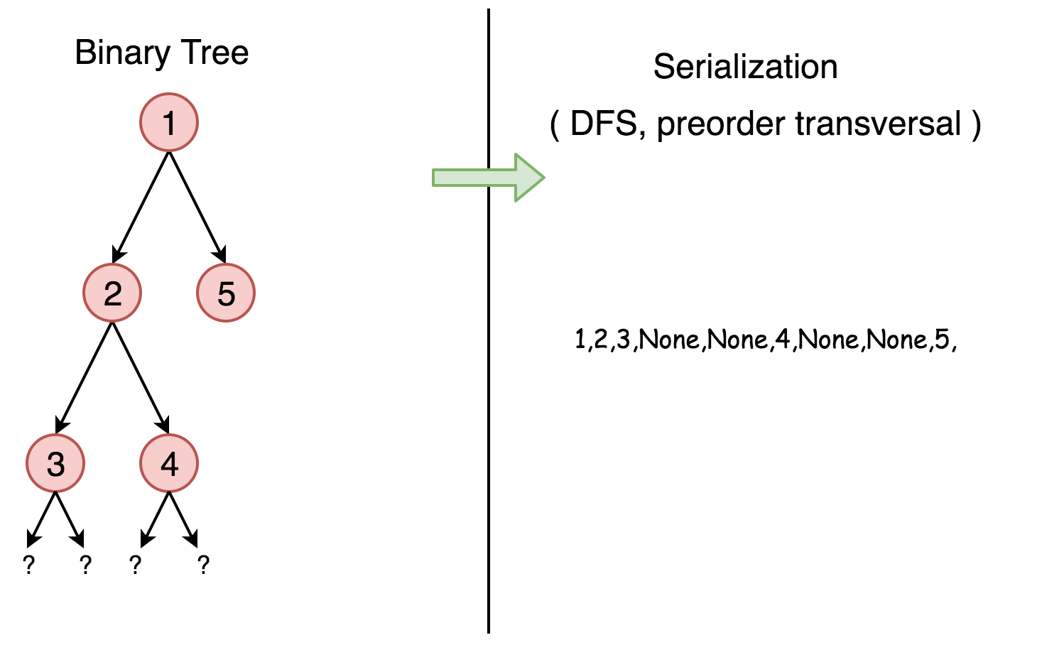

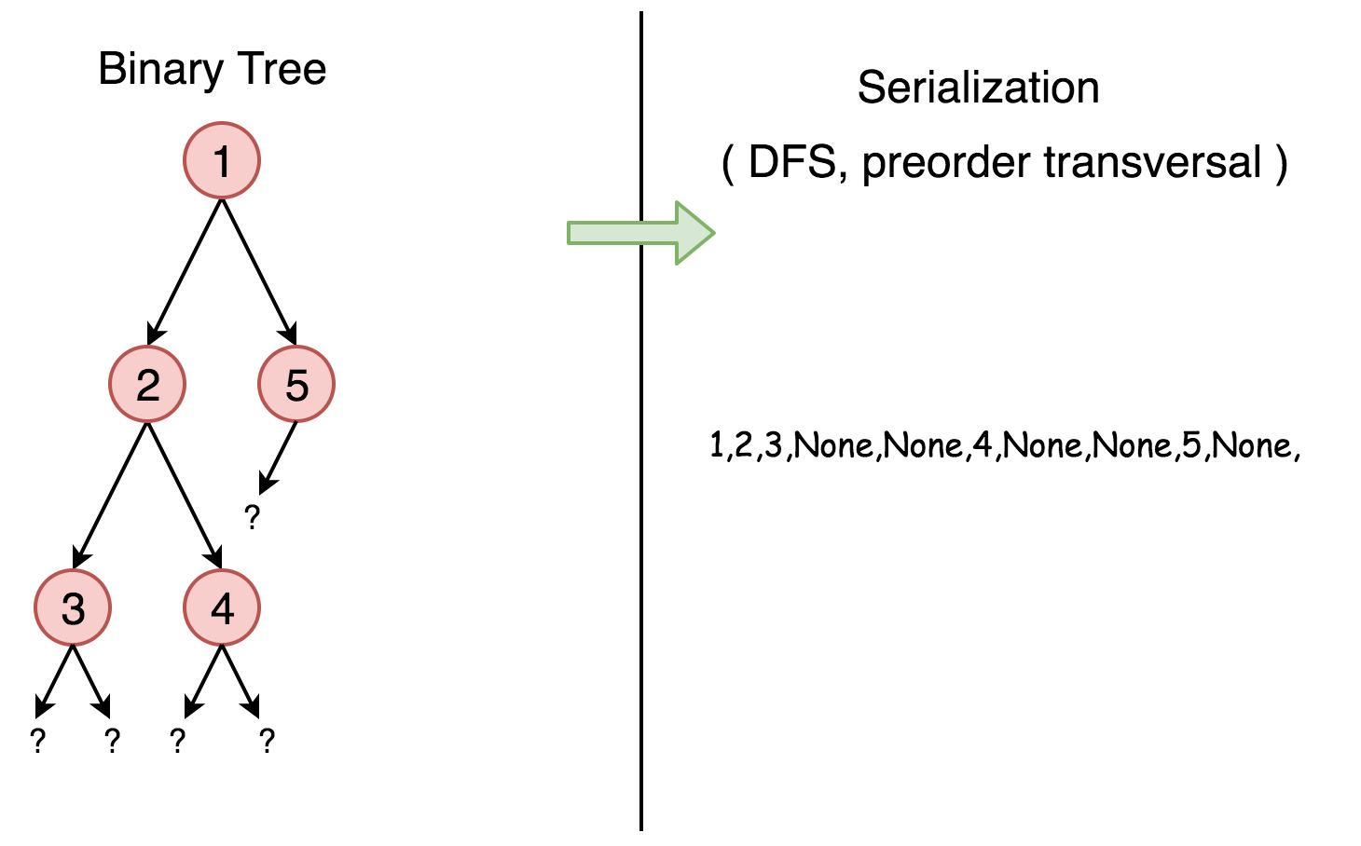

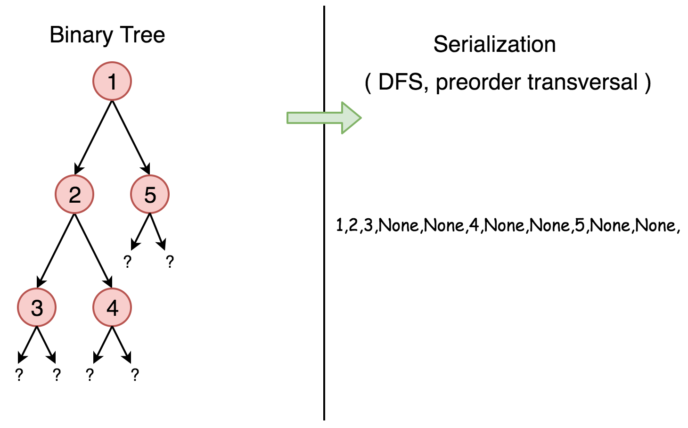

We start from the root, node 1, the serialization string is 1,. Then we jump to its left subtree with the root node 2, and the serialization string becomes 1,2,. Now starting from node 2, we visit its left node 3 (1,2,3,None,None,) and right node 4 (1,2,3,None,None,4,None,None) sequentially. Note that None,None, appears for each leaf to mark the absence of left and right child node, this is how we save the tree structure during the serialization. And finally, we get back to the root node 1 and visit its right subtree which happens to be a leaf node 5. Finally, the serialization string is done as 1,2,3,None,None,4,None,None,5,None,None,.

|  |
| --- |
| // Serialization  public class Codec {  public String rserialize(TreeNode root, String str) {  // Recursive serialization.  if (root == null) {  str += "null,";  } else {  str += str.valueOf(root.val) + ",";  str = rserialize(root.left, str);  str = rserialize(root.right, str);  }  return str;  }  // Encodes a tree to a single string.  public String serialize(TreeNode root) {  return rserialize(root, "");  }  }; |

Now let's deserialize the serialization string constructed above 1,2,3,None,None,4,None,None,5,None,None,. It goes along the string, initiate the node value and then calls itself to construct its left and right child nodes.

|  |
| --- |
| public class Codec {  public TreeNode rdeserialize(List<String> l) {  // Recursive deserialization.  if (l.get(0).equals("null")) {  l.remove(0);  return null;  }  TreeNode root = new TreeNode(Integer.valueOf(l.get(0)));  l.remove(0);  root.left = rdeserialize(l);  root.right = rdeserialize(l);  return root;  }  // Decodes your encoded data to tree.  public TreeNode deserialize(String data) {  String[] data_array = data.split(",");  List<String> data_list = new LinkedList<String>(Arrays.asList(data_array));  return rdeserialize(data_list);  }  }; |

**Complexity Analysis**

* Time complexity : in both serialization and deserialization functions, we visit each node exactly once, thus the time complexity is *O*(*N*), where *N* is the number of nodes, i.e. the size of tree.
* Space complexity : in both serialization and deserialization functions, we keep the entire tree, either at the beginning or at the end, therefore, the space complexity is *O*(*N*).

The solutions with BFS or other DFS strategies normally will have the same time and space complexity.

**Further Space Optimization**

In the above solution, we store the node value and the references to None child nodes, which means *N*⋅*V*+2*N* complexity, where *V* is the size of value. That is called natural serialization, and has was implemented above.

The *N*⋅*V* component here is the encoding of values, can't be optimized further, but there is a way to reduce 2*N* part which is the encoding of the tree structure.

The number of unique binary tree structures that can be constructed using n nodes is *C*(*n*), where *C*(*n*) is the nth Catalan number. Please refer to [this article](https://leetcode.com/articles/unique-binary-search-trees/) for more information.

There are *C*(*n*) possible structural configurations of a binary tree with n nodes, so the largest index value that we might need to store is C(n) - 1. That means storing the index value could require up to 1 bit for *n*≤2, or .

In this way one could reduce the encoding of the tree structure by log*N*. More precisely, the [Catalan numbers](https://en.wikipedia.org/wiki/Catalan_number) grow as 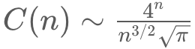​ and hence the theoretical minimum of storage for the tree structure that could be achieved is 

**Insert Delete GetRandom O(1)**

Implement the RandomizedSet class:

* bool insert(int val) Inserts an item val into the set if not present. Returns true if the item was not present, false otherwise.
* bool remove(int val) Removes an item val from the set if present. Returns true if the item was present, false otherwise.
* int getRandom() Returns a random element from the current set of elements (it's guaranteed that at least one element exists when this method is called). Each element must have the **same probability** of being returned.

**Follow up:** Could you implement the functions of the class with each function works in **average** O(1) time?

**Example 1:**

**Input**

["RandomizedSet", "insert", "remove", "insert", "getRandom", "remove", "insert", "getRandom"]

[[], [1], [2], [2], [], [1], [2], []]

**Output**

[null, true, false, true, 2, true, false, 2]

**Explanation**

RandomizedSet randomizedSet = new RandomizedSet();

randomizedSet.insert(1); // Inserts 1 to the set. Returns true as 1 was inserted successfully.

randomizedSet.remove(2); // Returns false as 2 does not exist in the set.

randomizedSet.insert(2); // Inserts 2 to the set, returns true. Set now contains [1,2].

randomizedSet.getRandom(); // getRandom() should return either 1 or 2 randomly.

randomizedSet.remove(1); // Removes 1 from the set, returns true. Set now contains [2].

randomizedSet.insert(2); // 2 was already in the set, so return false.

randomizedSet.getRandom(); // Since 2 is the only number in the set, getRandom() will always return 2.

**Constraints:**

* -231 <= val <= 231 - 1
* At most 105 calls will be made to insert, remove, and getRandom.
* There will be **at least one** element in the data structure when getRandom is called.

## Solution

#### **Overview**

We're asked to implement the structure which provides the following operations in average O(1) time:

* Insert
* Delete
* GetRandom

First of all - why this weird combination? The structure looks quite theoretical, but it's widely used in popular statistical algorithms like [Markov chain Monte Carlo](https://en.wikipedia.org/wiki/Markov_chain_Monte_Carlo) and [Metropolis–Hastings algorithm](https://en.wikipedia.org/wiki/Metropolis%E2%80%93Hastings_algorithm). These algorithms are for sampling from a probability distribution when it's difficult to compute the distribution itself.

Let's figure out how to implement such a structure. Starting from the Insert, we immediately have two good candidates with O(1) [average insert time](https://wiki.python.org/moin/TimeComplexity):

* Hashmap (or Hashset, the implementation is very similar): [Java HashMap](https://docs.oracle.com/javase/8/docs/api/java/util/HashMap.html) / [Python dictionary](https://docs.python.org/3/tutorial/datastructures.html#dictionaries)
* Array List: [Java ArrayList](https://docs.oracle.com/javase/8/docs/api/java/util/LinkedList.html) / [Python list](https://docs.python.org/3/tutorial/datastructures.html)

Let's consider them one by one.

Hashmap provides Insert and Delete in average constant time, although has problems with GetRandom.

The idea of GetRandom is to choose a random index and then to retrieve an element with that index. There is no indexes in hashmap, and hence to get true random value, one has first to convert hashmap keys in a list, that would take linear time. The solution here is to build a list of keys aside and to use this list to compute GetRandom in constant time.

Array List has indexes and could provide Insert and GetRandom in average constant time, though has problems with Delete.

To delete a value at arbitrary index takes linear time. The solution here is to always delete the last value:

* Swap the element to delete with the last one.
* Pop the last element out.

For that, one has to compute an index of each element in constant time, and hence needs a hashmap which stores element -> its index dictionary.

Both ways converge into the same combination of data structures:

* Hashmap element -> its index.
* Array List of elements.

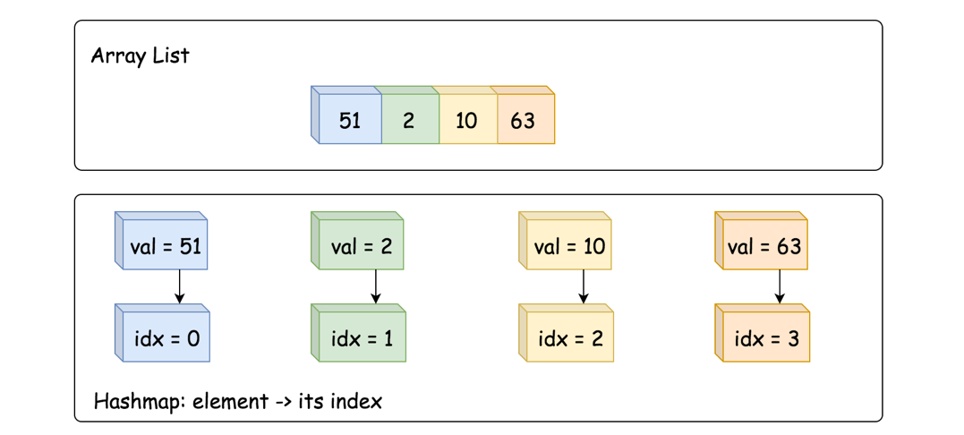

#### **Approach 1: HashMap + ArrayList**

**Insert**

* Add value -> its index into dictionary, average O(1) time.
* Append value to array list, average O(1) time as well.

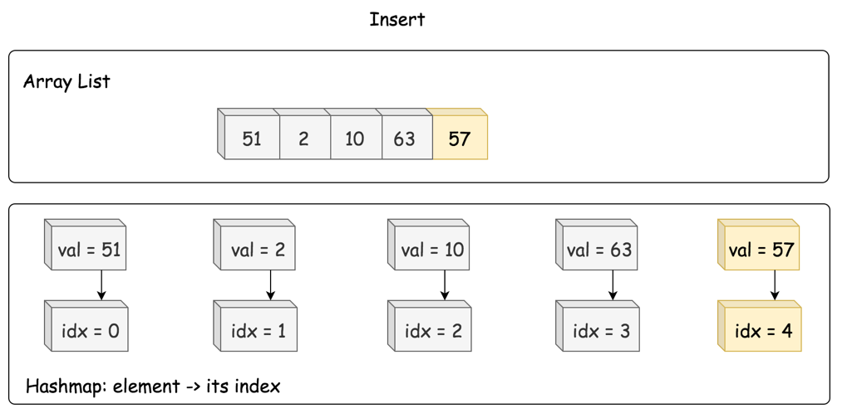

|  |
| --- |
| /** Inserts a value to the set. Returns true if the set did not already contain the specified element. */  public boolean insert(int val) {  if (dict.containsKey(val)) return false;    dict.put(val, list.size());  list.add(list.size(), val);  return true;  } |

**Delete**

* Retrieve an index of element to delete from the hashmap.
* Move the last element to the place of the element to delete, O(1) time.
* Pop the last element out, O(1) time.

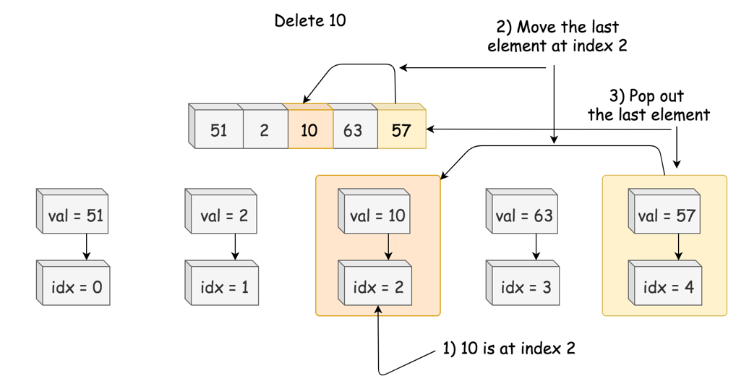

|  |
| --- |
| /** Removes a value from the set. Returns true if the set contained the specified element. */  public boolean remove(int val) {  if (! dict.containsKey(val)) return false;  // move the last element to the place idx of the element to delete  int lastElement = list.get(list.size() - 1);  int idx = dict.get(val);  list.set(idx, lastElement);  dict.put(lastElement, idx);  // delete the last element  list.remove(list.size() - 1);  dict.remove(val);  return true;  } |

**GetRandom**

GetRandom could be implemented in O(1) time with the help of standard random.choice in Python and Random object in Java.

|  |
| --- |
| /** Get a random element from the set. */  public int getRandom() {  return list.get(rand.nextInt(list.size()));  } |

**Implementation**

|  |
| --- |
| class RandomizedSet {  Map<Integer, Integer> dict;  List<Integer> list;  Random rand = new Random();  /** Initialize your data structure here. */  public RandomizedSet() {  dict = new HashMap();  list = new ArrayList();  }  /** Inserts a value to the set. Returns true if the set did not already contain the specified element. */  public boolean insert(int val) {  if (dict.containsKey(val)) return false;  dict.put(val, list.size());  list.add(list.size(), val);  return true;  }  /** Removes a value from the set. Returns true if the set contained the specified element. */  public boolean remove(int val) {  if (! dict.containsKey(val)) return false;  // move the last element to the place idx of the element to delete  int lastElement = list.get(list.size() - 1);  int idx = dict.get(val);  list.set(idx, lastElement);  dict.put(lastElement, idx);  // delete the last element  list.remove(list.size() - 1);  dict.remove(val);  return true;  }  /** Get a random element from the set. */  public int getRandom() {  return list.get(rand.nextInt(list.size()));  }  } |

**Complexity Analysis**

* Time complexity. GetRandom is always O(1). Insert and Delete both have O(1) average time complexity, and O(*N*) in the worst-case scenario when the operation exceeds the capacity of currently allocated array/hashmap and invokes space reallocation.
* Space complexity: O(*N*), to store N elements.

**Design Tic-Tac-Toe**

Assume the following rules are for the tic-tac-toe game on an n x n board between two players:

1. A move is guaranteed to be valid and is placed on an empty block.
2. Once a winning condition is reached, no more moves are allowed.
3. A player who succeeds in placing n of their marks in a horizontal, vertical, or diagonal row wins the game.

Implement the TicTacToe class:

* TicTacToe(int n) Initializes the object the size of the board n.
* int move(int row, int col, int player) Indicates that player with id player plays at the cell (row, col) of the board. The move is guaranteed to be a valid move.

**Follow up:**  
Could you do better than O(*n*2) per move() operation?

**Example 1:**

**Input**

["TicTacToe", "move", "move", "move", "move", "move", "move", "move"]

[[3], [0, 0, 1], [0, 2, 2], [2, 2, 1], [1, 1, 2], [2, 0, 1], [1, 0, 2], [2, 1, 1]]

**Output**

[null, 0, 0, 0, 0, 0, 0, 1]

**Explanation**

TicTacToe ticTacToe = new TicTacToe(3);

Assume that player 1 is "X" and player 2 is "O" in the board.

ticTacToe.move(0, 0, 1); // return 0 (no one wins)

|X| | |

| | | | // Player 1 makes a move at (0, 0).

| | | |

ticTacToe.move(0, 2, 2); // return 0 (no one wins)

|X| |O|

| | | | // Player 2 makes a move at (0, 2).

| | | |

ticTacToe.move(2, 2, 1); // return 0 (no one wins)

|X| |O|

| | | | // Player 1 makes a move at (2, 2).

| | |X|

ticTacToe.move(1, 1, 2); // return 0 (no one wins)

|X| |O|

| |O| | // Player 2 makes a move at (1, 1).

| | |X|

ticTacToe.move(2, 0, 1); // return 0 (no one wins)

|X| |O|

| |O| | // Player 1 makes a move at (2, 0).

|X| |X|

ticTacToe.move(1, 0, 2); // return 0 (no one wins)

|X| |O|

|O|O| | // Player 2 makes a move at (1, 0).

|X| |X|

ticTacToe.move(2, 1, 1); // return 1 (player 1 wins)

|X| |O|

|O|O| | // Player 1 makes a move at (2, 1).

|X|X|X|

**Constraints:**

* 2 <= n <= 100
* player is 1 or 2.
* 1 <= row, col <= n
* (row, col) are **unique** for each different call to move.
* At most n2 calls will be made to move.

   Hide Hint #1

Could you trade extra space such that move() operation can be done in O(1)?

   Hide Hint #2

You need two arrays: int rows[n], int cols[n], plus two variables: diagonal, anti_diagonal.

## Math

Most of the math questions asked in interviews do not require math knowledge beyond middle school level.

We recommend: Excel Sheet Column Number, Pow(x, n) and Divide Two Integers.

 Happy Number

 Factorial Trailing Zeroes

 Excel Sheet Column Number

 Pow(x, n)

 Sqrt(x)

 Divide Two Integers

 Fraction to Recurring Decimal

**Happy Number**

Write an algorithm to determine if a number n is happy.

A **happy number** is a number defined by the following process:

* Starting with any positive integer, replace the number by the sum of the squares of its digits.
* Repeat the process until the number equals 1 (where it will stay), or it **loops endlessly in a cycle** which does not include 1.
* Those numbers for which this process **ends in 1** are happy.

Return true *if* n *is a happy number, and* false *if not*.

**Example 1:**

**Input:** n = 19

**Output:** true

**Explanation:**

12 + 92 = 82

82 + 22 = 68

62 + 82 = 100

12 + 02 + 02 = 1

**Example 2:**

**Input:** n = 2

**Output:** false

**Constraints:**

* 1 <= n <= 231 - 1

|  |
| --- |
| class Solution {  private int getNext(int n) {  int totalSum = 0;  while (n > 0) {  int d = n % 10;  n = n / 10;  totalSum += d * d;  }  return totalSum;  }  public boolean isHappy(int n) {  Set<Integer> seen = new HashSet<>();  while (n != 1 && !seen.contains(n)) {  seen.add(n);  n = getNext(n);  }  return n == 1;  }  } |

|  |
| --- |
| class Solution {  public int getNext(int n) {  int totalSum = 0;  while (n > 0) {  int d = n % 10;  n = n / 10;  totalSum += d * d;  }  return totalSum;  }  public boolean isHappy(int n) {  int slowRunner = n;  int fastRunner = getNext(n);  while (fastRunner != 1 && slowRunner != fastRunner) {  slowRunner = getNext(slowRunner);  fastRunner = getNext(getNext(fastRunner));  }  return fastRunner == 1;  }  } |

|  |
| --- |
| class Solution {  private static Set<Integer> cycleMembers =  new HashSet<>(Arrays.asList(4, 16, 37, 58, 89, 145, 42, 20));  public int getNext(int n) {  int totalSum = 0;  while (n > 0) {  int d = n % 10;  n = n / 10;  totalSum += d * d;  }  return totalSum;  }  public boolean isHappy(int n) {  while (n != 1 && !cycleMembers.contains(n)) {  n = getNext(n);  }  return n == 1;  }  } |

|  |
| --- |
| class Solution {    public int getNext(int n) {  int totalSum = 0;  while (n > 0) {  int d = n % 10;  n = n / 10;  totalSum += d * d;  }  return totalSum;  }    public boolean isHappy(int n) {  while (n != 1 && n != 4) {  n = getNext(n);  }  return n == 1;  }  } |

**Factorial Trailing Zeroes**

Given an integer n, return *the number of trailing zeroes in n!*.

**Follow up:**Could you write a solution that works in logarithmic time complexity?

**Example 1:**

**Input:** n = 3

**Output:** 0

**Explanation:** 3! = 6, no trailing zero.

**Example 2:**

**Input:** n = 5

**Output:** 1

**Explanation:** 5! = 120, one trailing zero.

**Example 3:**

**Input:** n = 0

**Output:** 0

**Constraints:**

* 0 <= n <= 104

## Solution

#### **Approach 1: Compute the Factorial**

**Intuition**

This approach is too slow, but is a good starting point. You wouldn't implement it in an interview, although you might briefly describe it as a possible way of solving the problem.

The simplest way of solving this problem would be to compute *n*! and then count the number of zeroes on the end of it. Recall that factorials are calculated by multiplying all the numbers between 1 and *n*. For example, 10!=10⋅9⋅8⋅7⋅6⋅5⋅4⋅3⋅2⋅1=3,628,800. Therefore, factorials can be calculated iteratively using the following algorithm.

define function factorial(n):

n_factorial = 1

for i from 1 to n (inclusive):

n_factorial = n_factorial * i

return n_factorial

Recall that if a number has a zero on the end of it, then it is divisible by 10. Dividing by 10 will remove that zero, and shift all the other digits to the right by one place. We can, therefore, count the number of zeroes by repeatedly checking if the number is divisible by 10, and if it is then dividing it by 10. The number of divisions we're able to do is equal to the number of 0's on the end of it. This is the algorithm to count the zeroes (assuming *x*≥1, which is fine for this problem, as factorials are always positive integers).

define function zero_count(x):

zero_count = 0

while x is divisible by 10:

zero_count += 1

x = x / 10

return zero_count

By putting these two functions together, we can count the number of zeroes on the end of *n*!.

**Algorithm**

For Java, we need to use BigInteger, because n!*n*! won't fit into a long for even moderately small values of *n*.

|  |
| --- |
| import java.math.BigInteger;  public int trailingZeroes(int n) {    // Calculate n!  BigInteger nFactorial = BigInteger.ONE;  for (int i = 2; i <= n; i++) {  nFactorial = nFactorial.multiply(BigInteger.valueOf(i));  }    // Count how many 0's are on the end.  int zeroCount = 0;    while (nFactorial.mod(BigInteger.TEN).equals(BigInteger.ZERO)) {  nFactorial = nFactorial.divide(BigInteger.TEN);  zeroCount++;  }    return zeroCount;  } |

**Complexity Analysis**

The math involved here is very advanced, however we don't need to be precise. We can get a reasonable approximation with a little mathematical reasoning. An interviewer probably won't expect you to calculate it exactly, or even derive the approximation as carefully as we have here. However, they *might* expect you to at least have some ideas and at least attempt to reason about it. Of course, if you've claimed to be an *expert* in algorithms analysis on your résumé/CV, then they might expect you to derive the entire thing! Our main reason for including it here is because it is a nice example of working with an algorithm that is mathematically challenging to analyse.

Let n*n* be the number we're taking the factorial of.

* Time complexity : Worse than O(n ^ 2).

Computing a factorial is repeated multiplication. Generally when we know multiplications are on numbers within a fixed bit-size (e.g. 32 bit or 64 bit ints), we treat them as *O*(1) operations. However, we can't do that here because the size of the numbers to be multiplied grow with the size of *n*.

So, the first step here is to think about what the cost of multiplication might be, given that we can't assume it's *O*(1). A popular way people multiply two large numbers, that you probably learned in school, has a cost of *O*((log*x*)⋅(log*y*)). We'll use that in our approximation.

Next, let's think about what multiplications we do when calculating n!*n*!. The first few multiplications would be as follows:

1⋅2=2  
2⋅3=6  
6⋅4=24  
24⋅5=120  
120⋅6=720  
......

In terms of cost, these multiplications would have costs of:

log1⋅log2  
log2⋅log3  
log6⋅log4  
log24⋅log5  
log120⋅log6  
......

Recognising that the first column are all logs of factorials, we can rewrite it as follows:

log1!⋅log2  
log2!⋅log3  
log3!⋅log4  
log4!⋅log5  
log5!⋅log6  
......

See the pattern? Each line is of the form (log*k*!)⋅(log*k*+1). What would the *last* line be? Well, the last step in calculating a factorial is to multiply by *n*. Therefore, the last line must be:

log((*n*−1)!)⋅log(*n*)

Because we're doing each of these multiplications one-by-one, we should *add* them to get the total time complexity. This gives us:

log1!⋅log2+log2!⋅log3+log3!⋅log4+⋯+log((*n*−2)!)⋅log(*n*−1)+log((*n*−1)!)⋅log*n*

This sequence is quite complicated to add up; instead of trying to find an exact answer, we're going to now focus on a rough *lower bound* approximation by throwing away the less significant terms. While this is not something you'd do if we needed to find the exact time complexity, it will allow us to quickly see that the time complexity is "too big" for our purposes. Often finding lower (and upper) bounds is enough to decide whether or not an algorithm is worth using. This includes in interviews!

At this point, you'll ideally realise that the algorithm is *worse* than *O*(*n*), as we're adding *n* terms. Given that the question asked us to come up with an algorithm that's no worse than *O*(log*n*), this is definitely not good enough. We're going to explore it a little further, but if you've understood up to this point, you're doing really well! The rest is optional.

Continuing on, notice that log((*n*−1)!) is "a lot bigger" than log*n*. Therefore, we'll just drop all these parts, leaving the logs of factorials. This gives us:

log1!+log2!+log,3!+⋯+log((*n*−2)!)+log((*n*−1)!)

The next part involves a log rule that you might or might not have heard of. It's definitely worth remembering if you haven't heard of it though, as it can be very useful.

*O*(log*n*!)=*O*(*n*log*n*)

So, let's rewrite the sequence using this rule.

1⋅log1+2⋅log2+3⋅log3+⋯+(*n*−2)⋅log(*n*−2)+(*n*−1)⋅log(*n*−1)

Like before, we'll just drop the "small" \loglog terms, and see what we're left with.

1+2+3+...+(*n*−2)+(*n*−1)

This is a very familiar sequence, that you should be familiar with—it describes a cost of O(n^2).

So, what can we conclude? Well, all the discarding of terms leaves us with a time complexity *less* than the real one. In other words, this factorial algorithm must be *slower* than O(n^2).

O(n^2) is *definitely* not good enough!

While this technique of throwing away terms here and there might seem a bit strange, it's very useful to make early decisions quickly, without needing to mess around with advanced math. Only once we had decided we were interested in looking at the algorithm further, would we try to come up with a more exact time complexity. And in this case, our lower bound was enough to convince us that it definitely isn't worth looking at!

The second part, counting the zeroes at the end, is insignificant compared to the first part. There are *O*(log*n*!)=*O*(*n*log*n*) digits, which is smaller than O(n^2). Not to mention, only a few of them will be zeroes!

* Space complexity : *O*(log*n*!)=*O*(*n*log*n*).

In order to store *n*!, we need *O*(log*n*!) bits. As we saw above, this is the same as *O*(*n*log*n*).

#### **Approach 2: Counting Factors of 5**

**Intuition**

This approach is also too slow, however it's a likely step in the problem solving process for coming up with a logarithmic approach.

Instead of computing the factorial like in Approach 1, we can instead recognize that each 0 on the end of the factorial represents a multiplication by 10.

So, how many times do we multiply by 10 while calculating *n*! ? Well, to multiply two numbers, *a* and *b*, we're effectively multiplying all their factors together. For example, to do 42⋅75=3150, we can rewrite it as follows:

42=2⋅3⋅7  
75=3⋅5⋅5

42⋅75=2⋅3⋅7⋅3⋅5⋅5

Now, in order to determine how many zeroes are on the end, we should look at how many complete pairs of 2 and 5 are among the factors. In the case of the example above, we have one 2 and two 5s, giving us **one** complete pair.

So, how does this relate to factorials? Well, in a factorial we're multiplying all the numbers between 1 and *n* together, which is the same as multiplying all the factors of the numbers between 1 and *n*.

For example, if *n*=16, we need to look at the factors of all the numbers between 1 and 16. Keeping in mind that only 2s and 5s are of interest, we'll focus on those factors only. The numbers that contain a factor of 5 are 5,10,15. The numbers that contain a factor of 2 are 2,4,6,8,10,12,14,16. Because there are only three numbers with a factor of 5, we can make three complete pairs, and therefore there must be three zeroes on the end of 16!.

Putting this into an algorithm, we get:

twos = 0

for i from 1 to n inclusive:

if i is divisible by 2:

twos += 1

fives = 0

for i from 1 to n inclusive:

if i is divisible by 5:

fives += 1

tens = min(fives, twos)

This gets us most of the way, but it doesn't consider numbers with more than one factor. For example, if i = 25, then we've only done fives += 1. However, we should've done fives += 2, because 25 has two factors of 5.

Therefore, we need to count the 5 factors in each number. One way we can do this is by having a loop instead of the if statement, where each time we determine i has a 5 factor, we divide that 5 out. The loop will then repeat if there are further remaining 5 factors.

We can do that like this:

twos = 0

for i from 1 to n inclusive:

remaining_i = i

while remaining_i is divisible by 2:

twos += 1

remaining_i = remaining_i / 2

fives = 0

for i from 1 to n inclusive:

remaining_i = i

while remaining_i is divisible by 5:

fives += 1

remaining_i = remaining_i / 5

tens = min(twos, fives)

This gives us the right answer now. However, there are still some improvements we can make.

Firstly, we can notice that twos is **always bigger** than fives. Why? Well, every second number counts for a 2 factor, but only every fifth number counts as a 5 factor. Similarly every 4th number counts as an additional 2 factor, yet only every 25th number counts an additional 5 factor. This goes on and on for each power of 2 and 5. Here's a visualisation that illustrates how the density between 2 factors and 5 factors differs.

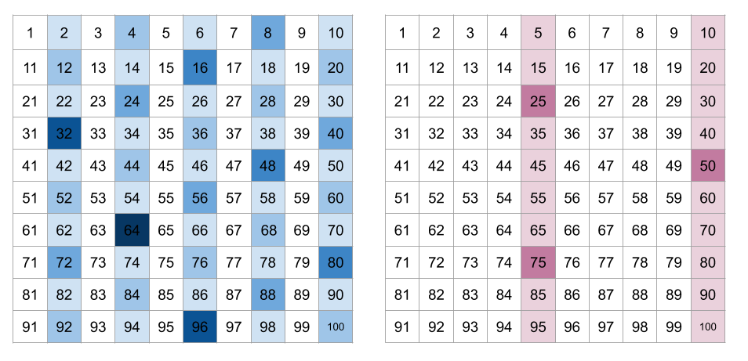

As such, we can simply remove the whole twos calculation, leaving us with:

fives = 0

for i from 1 to n inclusive:

remaining_i = i

while remaining_i is divisible by 5:

fives += 1

remaining_i = remaining_i / 5

tens = fives

There is one final optimization we can do. In the above algorithm, we analyzed every number from 1 to *n*. However, only 5,10,15,20,25,30,...*etc* even have at least one factor of 5. So, instead of going up in steps of 1, we can go up in steps of 5. Making this modification gives us:

fives = 0

for i from 5 to n inclusive in steps of 5:

remaining_i = i

while remaining_i is divisible by 5:

fives += 1

remaining_i = remaining_i / 5

tens = fives

**Algorithm**

Here's the algorithm as we designed it above.

|  |
| --- |
| public int trailingZeroes(int n) {    int zeroCount = 0;  for (int i = 5; i <= n; i += 5) {  int currentFactor = i;  while (currentFactor % 5 == 0) {  zeroCount++;  currentFactor /= 5;  }  }  return zeroCount;  } |

Alternatively, instead of dividing by 5 each time, we can check each power of 5 to count how many times 5 is a factor. This works by checking if i is divisible by 5, then 25, then 125, etc. We stop when this number does not divide into i without leaving a remainder. The number of times we can do this is equivalent to the number of 5 factors in i.

|  |
| --- |
| public int trailingZeroes(int n) {    int zeroCount = 0;  for (int i = 5; i <= n; i += 5) {  int powerOf5 = 5;  while (i % powerOf5 == 0) {  zeroCount += 1;  powerOf5 *= 5;  }  }  return zeroCount;  } |

**Complexity Analysis**

* Time complexity : *O*(*n*).

In Approach 1, we couldn't treat division as *O*(1), because we went well outside the 32-bit integer range. In this Approach though, we stay within it, and so can treat division and multiplication as *O*(1).

To calculate the zero count, we loop through every fifth number from 5 to *n*, this is *O*(*n*) steps (the 1/5​ is treated as a constant).

At each step, while it might look like we do a, *O*(log*n*) operation to count the number of fives, it actually amortizes to *O*(1), because the vast majority of numbers checked only contain a single factor of 5. It can be proven that the total number of fives is less than 2n/5​.

So we get *O*(*n*)⋅*O*(1)=*O*(*n*).

* Space complexity : *O*(1).

We use only a fixed number of integer variables, therefore the space complexity is *O*(1).

#### **Approach 3: Counting Factors of 5 Efficiently**

**Intuition**

In Approach 2, we found a way to count the number of zeroes in the factorial, without actually calculating the factorial. This was by looping over each multiple of 5, from 5 up to *n*, and counting how many factors of 5 were in each multiple of 5. We added all these counts together to get our final result.

However, Approach 2 was still too slow, both for practical means, and for the requirements of the question. To come up with a sufficient algorithm, we need to make one final observation. This observation will allow us to calculate our answer in logarithmic time.

Consider our simplified (but incorrect) algorithm that counted each multiple of 5. Recall that the reason it's incorrect is because it won't count both the 5 factors in numbers such as 25, for example.

fives = 0

for i from 1 to n inclusive:

if i is divisible by 5:

fives += 1

If you think about this overly simplified algorithm a little, you might notice that this is simply an inefficient way of performing integer division for n/5​. Why? Well, by counting the number of multiples of 5 up to *n*, we're just counting how many 5s go into *n*. That's the exact definition of integer division!

So, a way of simplifying the above algorithm is as follows.

fives = n / 5

tens = fives

So, how can we fix the "duplicate factors" problem? Observe that all numbers that have (at least) two factors of 5 are multiples of 25. Like with the 5 factors, we can simply divide by 25 to find how many multiples of 25 are below *n*. Also, notice that because we've already counted the multiples of 25 in n/5​ once, we only need to count n/25*n* extra factors of 5 (not 2n/25), as this is one extra for each multiple of 25.

So combining this together we get:

fives = n / 5 + n / 25

tens = fives

We still aren't there yet though! What about the numbers which contain three factors of 5 (the multiples of 125). We've only counted them twice! In order to get our final result, we'll need to add together all of 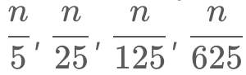 ​, and so on. This gives us:

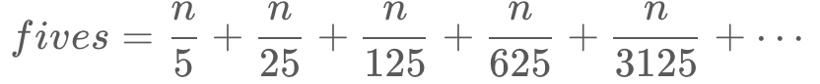

This might look like it goes on forever, but it doesn't! Remember that we're using **integer division**. Eventually, the denominator will be larger than *n*, and so all the terms from there will be 00. Therefore, we can stop once the term is 0.

For example with *n*=12345 we get:



Which is equal to:

*fives*=2469+493+98+19+3+0+0+⋯=3082

In code, we can do this by looping over each power of 5, calculating how many times it divides into *n*, and then adding that to a running fives count. Once we have a power of 5 that's bigger than *n*, we stop and return the final value of fives.

fives = 0

power_of_5 = 5

while n >= power_of_5:

fives += n / power_of_5

power_of_5 *= 5

tens = fives

**Algorithm**

|  |
| --- |
| public int trailingZeroes(int n) {  int zeroCount = 0;  // We need to use long because currentMultiple can potentially become  // larger than an int.  long currentMultiple = 5;  while (n >= currentMultiple) {  zeroCount += (n / currentMultiple);  currentMultiple *= 5;  }  return zeroCount;  } |

An alternative way of writing this algorithm, is instead of trying each power of 5, we can instead divide *n* itself by 5 each time. This works out the same because we wind up with the sequence:

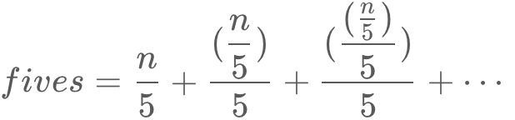

Notice that on the second step, we have (n/5)/5. This is because the previous step divided *n* itself by 5. And so on.

If you're familiar with the rules of fractions, you'll notice that (n/5)/5​ is just the same thing as 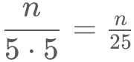​. This means the sequence is exactly the same as:

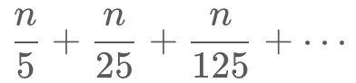

So, this alternative way of writing the algorithm is equivalent.

|  |
| --- |
| public int trailingZeroes(int n) {  int zeroCount = 0;  long currentMultiple = 5;  while (n > 0) {  n /= 5;  zeroCount += n;  }  return zeroCount;  } |

**Complexity Analysis**

* Time complexity : *O*(log*n*). In this approach, we divide *n* by each power of 5. By definition, there are log5​*n* powers of 5 less-than-or-equal-to *n*. Because the multiplications and divisions are within the 32-bit integer range, we treat these calculations as *O*(1). Therefore, we are doing log5​*n*⋅*O*(1)=log*n* operations (keeping in mind that log bases are insignificant in big-oh notation).
* Space complexity : *O*(1). We use only a fixed number of integer variables, therefore the space complexity is *O*(1).

**Excel Sheet Column Number**

Given a column title as appear in an Excel sheet, return its corresponding column number.

For example:

A -> 1

B -> 2

C -> 3

...

Z -> 26

AA -> 27

AB -> 28

...

**Example 1:**

**Input:** "A"

**Output:** 1

**Example 2:**

**Input:** "AB"

**Output:** 28

**Example 3:**

**Input:** "ZY"

**Output:** 701

**Constraints:**

* 1 <= s.length <= 7
* s consists only of uppercase English letters.
* s is between "A" and "FXSHRXW".

## Solution

This problem can be solved as if it is a problem of converting base-26 number system to base-10 number system.

#### **Approach 1: Right to Left**

**Intuition**

Let's tabulate the titles of an excel sheet in a table. There will be 26 rows in each column. Each cell in the table represents an excel sheet title.

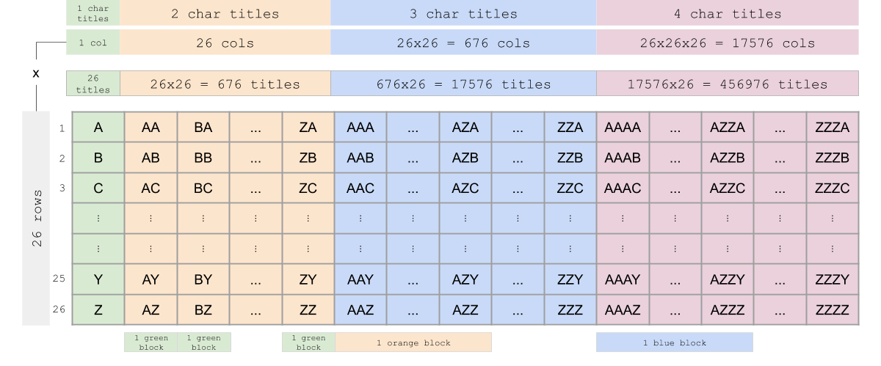

Pay attention to the "1 green block", "1 orange block" and "1 blue block" in the figure. These tell how bigger blocks are composed of smaller blocks. For example, blocks of 2-character titles are composed of 1-character blocks and blocks of 3-character titles are composed of 2-character blocks. This information is useful for finding a general pattern when calculating the values of titles.

Let's say we want to get the value of title **AZZC**. This can be broken down as 'A***' + 'Z**' + 'Z*' + 'C'. Here, the *s represent smaller blocks. * means a block of 1-character titles. ** means a block of 2-character titles. There are 261 titles in a block of 1-character titles. There are 262 titles in a block of 2-character titles.

Scanning **AZZC** from right to left while accumulating results:

1. First, ask the question, what the value of 'C' is:
   * 'C' = 3 x 260 = 3 x 1 = 3
   * result = 0 + 3 = **3**
2. Then, ask the question, what the value of 'Z*' is:
   * 'Z*' = 26 x 261 = 26 x 26 = 676
   * result = **3** + 676 = **679**
3. Then, ask the question, what the value of 'Z**' is:
   * 'Z**' = 26 x 262 = 26 x 676 = 17576
   * result = **679** + 17576 = **18255**
4. Finally, ask the question, what the value of 'A***' is:
   * 'A***' = 1 x 263 = 1 x 17576 = 17576
   * result = **18255** + 17576 = 35831

**Algorithm**

* To get indices of alphabets, create a mapping of alphabets and their corresponding values. (1-indexed)
* Initialize an accumulator variable result.
* Starting from right to left, calculate the value of the character associated with its position and add it to result.

**Implementation**

|  |
| --- |
| class Solution {  public int titleToNumber(String s) {  int result = 0;  Map < Character, Integer > alpha_map = new HashMap < > ();  for (int i = 0; i < 26; i++) {  int c = i + 65; // Decimal 65 in ASCII corresponds to char 'A'  alpha_map.put((char) c, i + 1);  }  int n = s.length();  for (int i = 0; i < n; i++) {  char cur_char = s.charAt(n - 1 - i);  result += (alpha_map.get(cur_char) * (Math.pow(26, i)));  }  return result;  }  } |

**Complexity Analysis**

* Time complexity : *O*(*N*) where *N* is the number of characters in the input string.
* Space complexity : *O*(1). Even though we have an alphabet to index mapping, it is always constant.

#### **Approach 2: Left to Right**

**Intuition**

Rather than scanning from right to left as described in Approach 1, we can also scan the title from left to right.

For example, if we want to get the decimal value of string "1337", we can iteratively find the result by scanning the string from left to right as follows:

1. '1' = **1**
2. '13' = (**1** x 10) + 3 = **13**
3. '133' = (**13** x 10) + 3 = **133**
4. '1337' = (**133** x 10) + 7 = 1337

Instead of base-10, we are dealing with base-26 number system. Based on the same idea, we can just replace 10s with 26s and convert alphabets to numbers.

For a title "LEET":

1. L = **12**
2. E = (**12** x 26) + 5 = **317**
3. E = (**317** x 26) + 5 = **8247**
4. T = (**8247** x 26) + 20 = 214442

In Approach 1, we have built a mapping of alphabets to numbers. There is another way to get the number value of a character without building an alphabet mapping. You can do this by converting a character to its ASCII value and subtracting ASCII value of character 'A' from that value. By doing so, you will get results from 0 (for A) to 25 (for Z). Since we are indexing from 1, we can just add 1 up to the result. This eliminates a loop where you create an alphabet to number mapping which was done in Approach 1.

**Implementation**

|  |
| --- |
| class Solution {  public int titleToNumber(String s) {  int result = 0;  int n = s.length();  for (int i = 0; i < n; i++) {  result = result * 26;  // In Java, subtracting characters is subtracting ASCII values of characters  result += (s.charAt(i) - 'A' + 1);  }  return result;  }  } |

**Complexity Analysis**

* Time complexity : *O*(*N*) where *N* is the number of characters in the input string.
* Space complexity : *O*(1).

**Pow(x, n)**

Implement [pow(x, n)](http://www.cplusplus.com/reference/valarray/pow/), which calculates x raised to the power n (i.e. xn).

**Example 1:**

**Input:** x = 2.00000, n = 10

**Output:** 1024.00000

**Example 2:**

**Input:** x = 2.10000, n = 3

**Output:** 9.26100

**Example 3:**

**Input:** x = 2.00000, n = -2

**Output:** 0.25000

**Explanation:** 2-2 = 1/22 = 1/4 = 0.25

**Constraints:**

* -100.0 < x < 100.0
* -231 <= n <= 231-1
* -104 <= xn <= 104

#### **Approach 1: Brute Force**

**Intuition**

Just simulate the process, multiply x for n times.

If *n*<0, we can substitute *x*,*n* with 1/x, −*n* to make sure *n*≥0. This restriction can simplify our further discussion.

But we need to take care of the corner cases, especially different range limits for negative and positive integers.

**Algorithm**

We can use a straightforward loop to compute the result.

|  |
| --- |
| class Solution {  public double myPow(double x, int n) {  long N = n;  if (N < 0) {  x = 1 / x;  N = -N;  }  double ans = 1;  for (long i = 0; i < N; i++)  ans = ans * x;  return ans;  }  }; |

**Complexity Analysis**

* Time complexity : *O*(*n*). We will multiply x for n times.
* Space complexity : *O*(1). We only need one variable to store the final product of x.

#### **Approach 2: Fast Power Algorithm Recursive**

**Intuition**

Assuming we have got the result of x ^ n, how can we get x ^ {2 * n} ? Obviously we do not need to multiply x for another n times. Using the formula (x ^ n) ^ 2 = x ^ {2 * n}, we can get x ^ {2 * n} at the cost of only one computation. Using this optimization, we can reduce the time complexity of our algorithm.

**Algorithm**

Assume we have got the result of x ^ {n / 2}, and now we want to get the result of x ^ n. Let A be result of x ^ {n / 2}, we can talk about x ^ n based on the parity of n respectively. If n is even, we can use the formula (x ^ n) ^ 2 = x ^ {2 * n} to get x ^ n = A * A. If n is odd, then A * A = x ^ {n - 1}. Intuitively, We need to multiply another *x* to the result, so x ^ n = A * A * x. This approach can be easily implemented using recursion. We call this method "**Fast Power**", because we only need at most *O*(log*n*) computations to get x ^ n.

|  |
| --- |
| class Solution {  private double fastPow(double x, long n) {  if (n == 0) {  return 1.0;  }  double half = fastPow(x, n / 2);  if (n % 2 == 0) {  return half * half;  } else {  return half * half * x;  }  }  public double myPow(double x, int n) {  long N = n;  if (N < 0) {  x = 1 / x;  N = -N;  }  return fastPow(x, N);  }  }; |

**Complexity Analysis**

* Time complexity : *O*(log*n*). Each time we apply the formula (x ^ n) ^ 2 = x ^ {2 * n}, *n* is reduced by half. Thus we need at most *O*(log*n*) computations to get the result.
* Space complexity : *O*(log*n*). For each computation, we need to store the result of x ^ {n / 2}. We need to do the computation for *O*(log*n*) times, so the space complexity is *O*(log*n*).

#### **Approach 3: Fast Power Algorithm Iterative**

**Intuition**

Using the formula x ^ {a + b} = x ^ a * x ^ b, we can write n as a sum of positive integers, 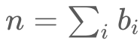 If we can get the result of x ^ {bi} quickly, the total time for computing x ^ n will be reduced.

**Algorithm**

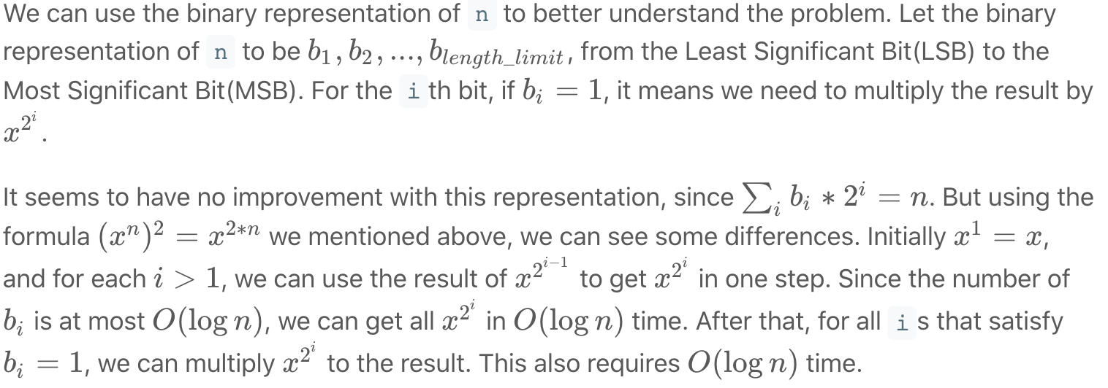

Using fast power recursively or iteratively are actually taking different paths towards the same goal. For more information about fast power algorithm, you can visit its wiki[[1]](https://leetcode.com/problems/powx-n/solution/#fn1).

|  |
| --- |
| class Solution {  public double myPow(double x, int n) {  long N = n;  if (N < 0) {  x = 1 / x;  N = -N;  }  double ans = 1;  double current_product = x;  for (long i = N; i > 0; i /= 2) {  if ((i % 2) == 1) {  ans = ans * current_product;  }  current_product = current_product * current_product;  }  return ans;  }  }; |

**Complexity Analysis**

* Time complexity : *O*(log*n*). For each bit of n 's binary representation, we will at most multiply once. So the total time complexity is *O*(log*n*).
* Space complexity : *O*(1). We only need two variables for the current product and the final result of x.

**Footnotes**

1. <https://en.wikipedia.org/wiki/Exponentiation_by_squaring> [↩︎](https://leetcode.com/problems/powx-n/solution/#fnref1)

**Sqrt(x)**

Given a non-negative integer x, compute and return the square root of x.

Since the return type is an integer, the decimal digits are **truncated**, and only **the integer part** of the result is returned.

**Example 1:**

**Input:** x = 4

**Output:** 2

**Example 2:**

**Input:** x = 8

**Output:** 2

**Explanation:** The square root of 8 is 2.82842..., and since the decimal part is truncated, 2 is returned.

**Constraints:**

* 0 <= x <= 231 - 1

   Hide Hint #1

Try exploring all integers. (Credits: @annujoshi)

   Hide Hint #2

Use the sorted property of integers to reduced the search space. (Credits: @annujoshi)

## Solution

#### **Integer Square Root**

The value a*a* we're supposed to compute could be defined as a^2 \le x < (a + 1)^2*a*2≤*x*<(*a*+1)2. It is called integer square root. From geometrical points of view, it's the side of the largest integer-side square with a surface less than x.

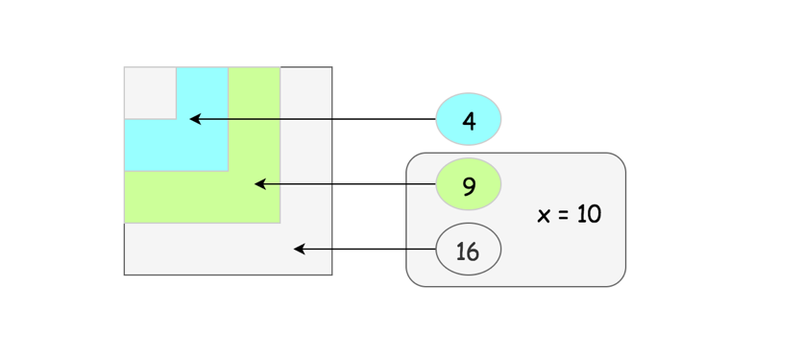

#### **Approach 1: Pocket Calculator Algorithm**

Before going to the serious stuff, let's first have some fun and implement the [algorithm used by the pocket calculators](https://en.wikipedia.org/wiki/Methods_of_computing_square_roots#Exponential_identity).

Usually a pocket calculator computes well exponential functions and natural logarithms by having logarithm tables hardcoded or by the other means. Hence the idea is to reduce the square root computation to these two algorithms as well

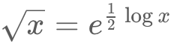

That's some sort of cheat because of non-elementary function usage but it's how that actually works in a real life.

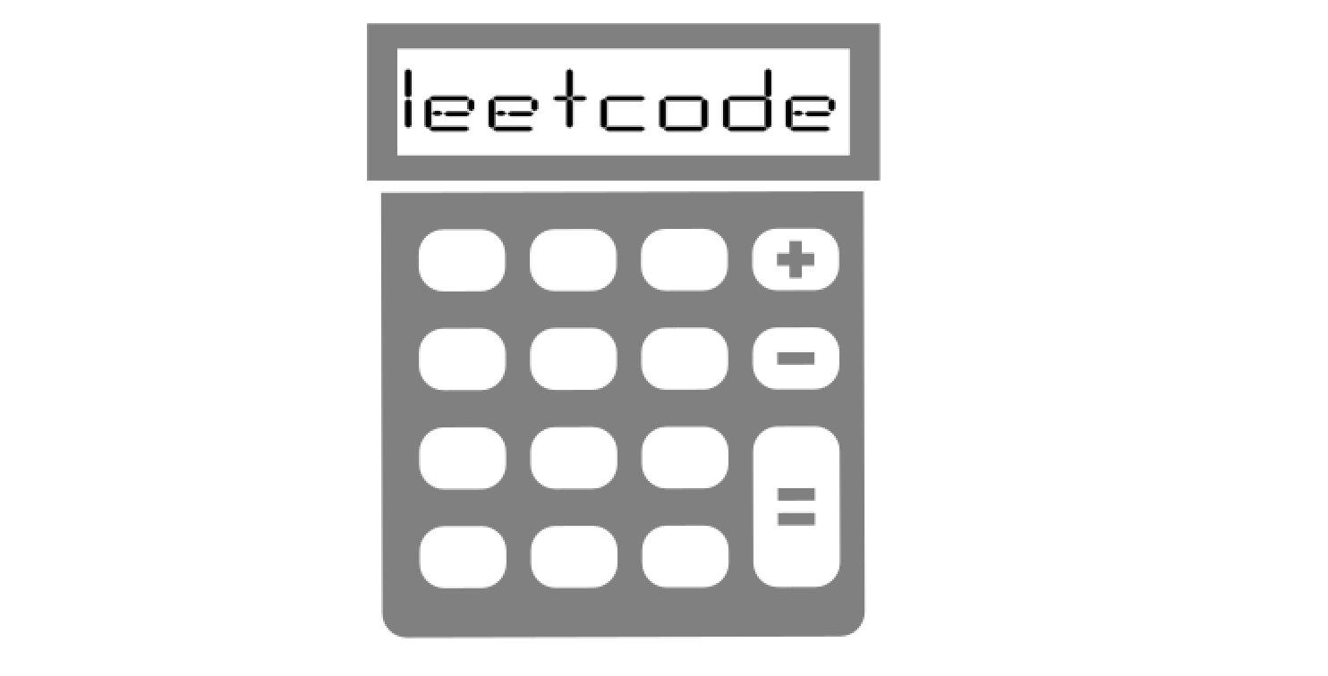

**Implementation**

|  |
| --- |
| class Solution {  public int mySqrt(int x) {  if (x < 2) return x;  int left = (int)Math.pow(Math.E, 0.5 * Math.log(x));  int right = left + 1;  return (long)right * right > x ? left : right;  }  } |

**Complexity Analysis**

* Time complexity : O(1).
* Space complexity : O(1).

#### **Approach 2: Binary Search**

**Intuition**

Let's go back to the interview context. For *x*≥2 the square root is always smaller than *x*/2 and larger than 0 : 0<*a*<*x*/2.  
Since *a* is an integer, the problem goes down to the iteration over the sorted set of integer numbers. Here the binary search enters the scene.

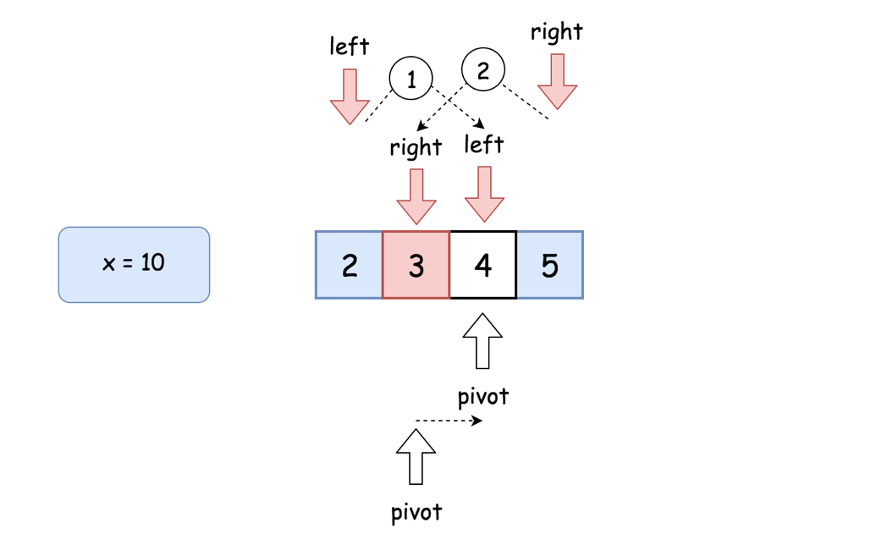

**Algorithm**

* If x < 2, return x.
* Set the left boundary to 2, and the right boundary to x / 2.
* While left <= right:
  + Take num = (left + right) / 2 as a guess. Compute num * num and compare it with x:
    - If num * num > x, move the right boundary right = pivot -1
    - Else, if num * num < x, move the left boundary left = pivot + 1
    - Otherwise num * num == x, the integer square root is here, let's return it
* Return right

**Implementation**

|  |
| --- |
| class Solution {  public int mySqrt(int x) {  if (x < 2) return x;  long num;  int pivot, left = 2, right = x / 2;  while (left <= right) {  pivot = left + (right - left) / 2;  num = (long)pivot * pivot;  if (num > x) right = pivot - 1;  else if (num < x) left = pivot + 1;  else return pivot;  }  return right;  }  } |

**Complexity Analysis**

* Time complexity : O(log*N*).
* Space complexity : O(1).

#### **Approach 3: Recursion + Bit Shifts**

**Intuition**

Let's use recursion. Bases cases are sqrt{x} = x for *x*<2. Now the idea is to decrease *x* recursively at each step to go down to the base cases.

How to go down?

For example, let's notice that 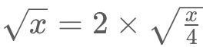​​, and hence square root could be computed recursively as

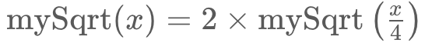

One could already stop here, but let's use [left and right shifts](https://wiki.python.org/moin/BitwiseOperators), which are quite fast manipulations with bits

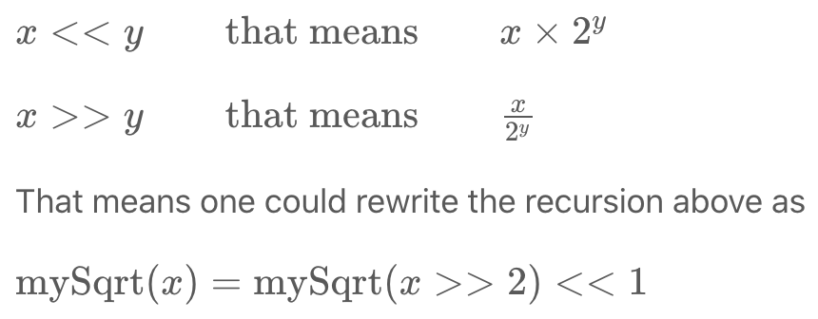

in order to fasten up the computations.

**Implementation**

|  |
| --- |
| class Solution {  public int mySqrt(int x) {  if (x < 2) return x;  int left = mySqrt(x >> 2) << 1;  int right = left + 1;  return (long)right * right > x ? left : right;  }  } |

**Complexity Analysis**

* Time complexity : O(log*N*).
* Space complexity : O(log*N*) to keep the recursion stack.

#### **Approach 4: Newton's Method**

**Intuition**

One of the best and widely used methods to compute sqrt is [Newton's Method](https://en.wikipedia.org/wiki/Newton%27s_method). Here we'll implement the version without the seed trimming to keep things simple. However, seed trimming is a bit of math and lot of fun, so [here is a link](https://en.wikipedia.org/wiki/Methods_of_computing_square_roots#Rough_estimation) if you'd like to dive in.

Let's keep the [mathematical proofs](https://en.wikipedia.org/wiki/Newton%27s_method) outside of the article and just use the textbook fact that the set

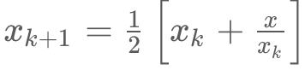

converges to 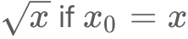. Then the things are straightforward: define that error should be less than 1 and proceed iteratively.

**Implementation**

|  |
| --- |
| class Solution {  public int mySqrt(int x) {  if (x < 2) return x;  double x0 = x;  double x1 = (x0 + x / x0) / 2.0;  while (Math.abs(x0 - x1) >= 1) {  x0 = x1;  x1 = (x0 + x / x0) / 2.0;  }  return (int)x1;  }  } |

**Complexity Analysis**

* Time complexity : O(log*N*) since the set converges quadratically.
* Space complexity : O(1).

#### **Compare Approaches 2, 3 and 4**

Here we have three algorithms with a time performance O(log*N*), and it's a bit confusing.

Which one is performing less iterations?

Let's run tests for the range of x in order to check that. Here are the results. The best one is Newton's method.

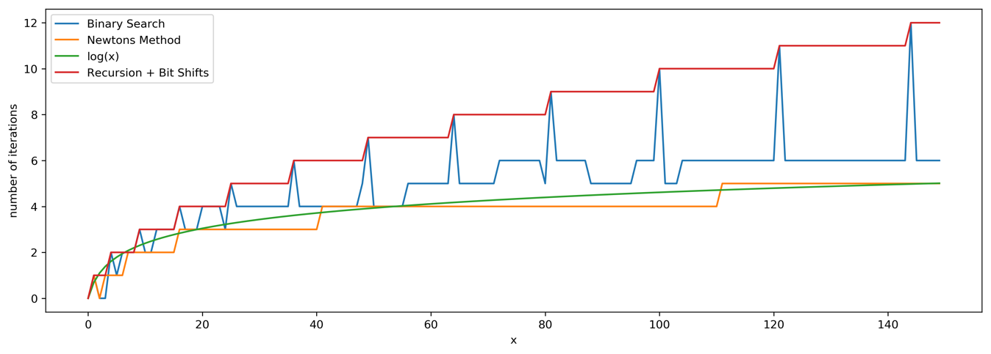

**Divide Two Integers**

Given two integers dividend and divisor, divide two integers without using multiplication, division, and mod operator.

Return the quotient after dividing dividend by divisor.

The integer division should truncate toward zero, which means losing its fractional part. For example, truncate(8.345) = 8 and truncate(-2.7335) = -2.

**Note:**

* Assume we are dealing with an environment that could only store integers within the 32-bit signed integer range: [−231,  231 − 1]. For this problem, assume that your function **returns 231 − 1 when the division result overflows**.

**Example 1:**

**Input:** dividend = 10, divisor = 3

**Output:** 3

**Explanation:** 10/3 = truncate(3.33333..) = 3.

**Example 2:**

**Input:** dividend = 7, divisor = -3

**Output:** -2

**Explanation:** 7/-3 = truncate(-2.33333..) = -2.

**Example 3:**

**Input:** dividend = 0, divisor = 1

**Output:** 0

**Example 4:**

**Input:** dividend = 1, divisor = 1

**Output:** 1

**Constraints:**

* -231 <= dividend, divisor <= 231 - 1
* divisor != 0

## Solution

#### **Overview**

Before we get started on the actual approaches, let's cover a few other important things.

Doing this question "properly", following all the rules given, makes this one of our most difficult medium-level questions.

**Don't panic, you don't need to know all the approaches**

We have provided a lot of different approaches to show how many different ways there are of solving this question. Approach 1 is a brute-force, and then Approaches 2 to 4 build on each other, and Approach 5 is similar, but approaches the thinking from a very different angle. If you only want to study the first 2 approaches, then that's fine. Approach 2 should be sufficient for an interview. However, we hope you enjoy learning about this question enough that you'll keep reading! :-)

**Make sure you read the question carefully**

This question was designed with fixed-sized integers in mind. Some languages, such as Python and JavaScript, only have arbitrary-precision integers (meaning they can go huge, probably as big as you'll ever need!). Depending on which programming languages you're familiar with, the requirements of this question might seem a little tedious and silly to you. We recommend using a language such as C, C++, or Java for it if you're familiar with them. Otherwise, you'll just need to be really careful and think very carefully about whether or not your algorithm would work in a 32-bit-signed-integer environment. Unfortunately, Leetcode doesn't currently enforce these requirements in languages such as Python, so it's up to you to determine whether or not your solution really is a "correct" one. Hint: Throw heaps of assert statements into your code.

Most of the upvoted posts on the discussion forum aren't following the rules specified in the question. Here are some of the problems I've seen:

* The use of long in Java or long long in C++ is not allowed, because the question states that we're working in an environment where we only have integers within the range [−2^{31}, 2^{31} − 1].
* The use of abs in Python (and other arbitrary-precision integer languages) needs to be considered carefully, because abs(-2^{31}) = 2^{31}, which is ***outside*** the allowed range by 1.
* While you might be tempted to use multiplication and division for a few "simple" tasks, this is unnecessary. Here are some alternatives:
  + Instead of a = a * -1 for making numbers negative, use a = -a.
  + Instead of using a / 2 for dividing by 2, use the right shift operator; a >> 1.
  + Instead of using a * 2 for doubling, use a = a + a, a += a, or even the left shift operator; a << 1.

Additionally, we strongly advise against allowing overflows to happen at all. For some compilers/interpreters/languages, INT_MAX + 1 ≡ INT_MIN. For others, INT_MAX + 1 ≡ INT_MAX. And for others again, it is undefined or ***crash***. Some people on the discussion forum have written code that actually relies on specific overflow behaviour for correctness. While this can be quite "clever", it's not portable at all. For code like that to be shippable, you'd need to be certain of the behaviour of the specific system it is to run on, and that no future system upgrade would change the behaviour. If it works on your machine, but not on Leetcode's machine, it's incorrect code.

In this article, we'll be looking at a few techniques that can solve the problem elegantly and are portable.

**In what cases will the final result be out of range?**

We're told the following about overflow in the problem description:

For the purpose of this problem, assume that your function returns 31−1 when the division result overflows.

So, keeping in mind that our integer range is [−2^{31}, 2^{31} − 1], in what cases could we have an end result outside of this range?

Well, when we do a / b = c, where a and b are both positive integers, we know that c ≤ a. In other words, the answer (c) cannot end up bigger than the thing we divided (the dividend, a).

Something similar happens even when one or both of them are negative. In that case, abs(a) ≤ abs(c). Another way of thinking about it is that c will always be closer to zero than a is (or, they could also be equal).

Therefore, for a and b within the range [−2^{31} + 1, 2^{31} − 1], the result a / b will be closer to zero, so has to be fine.

However, notice we left -2^{31} out of the above range. This is because there's a special case of -2^{31} / -1, which has an answer of 2^{31}. But 2^{31} is outside of the integer range! So instead we return 2^{31}-1 for this case (which is in range).

Most algorithms for this question simply check for the case -2^{31} / -1 at the start, returning 2^{31} - 1 if they detect it. This is a sensible approach.

#### **Approach 1: Repeated Subtraction**

**Intuition**

This approach won't pass the large test cases. However, we'll use it as a starting point, and to introduce a key idea we'll be using for all the approaches—doing ***all*** intermediate working with negative numbers.

Think about what it means to divide two integers. In order to divide, say, 15 by 5, we ask how many times we can put 5 into 15. The simplest way of doing this is to subtract 5 from 15 repeatedly until we can no longer do so.

15 - 5 = 10

10 - 5 = 5

5 - 5 = 0

Because we were able to do 3 subtractions, we know the answer to 15 / 5 is 3.

As another example, consider dividing 20 by 3.

20 - 3 = 17

17 - 3 = 14

14 - 3 = 11

11 - 3 = 8

8 - 3 = 5

5 - 3 = 2

We had to stop when we got to 2, because 3 is bigger than 2. So, because we were able to do 6 subtractions, we know the answer to 20 / 3 is 6.

In the example above, we call 20 the dividend and 3 the divisor (2 is the remainder, which we ignore for this question). The result of dividing the dividend by the divisor is the number of times we could subtract the divisor from the dividend. A commonly used name for this result is the quotient.

Therefore, our first algorithm will simply subtract the divisor from the dividend repeatedly until doing so would push it below 0. It will keep count of the number of these subtractions done, so that it can return it at the end.

Assuming that both the dividend and divisor are positive, here is a code snippet for this process.

public int divide(int dividend, int divisor) {

int quotient = 0;

while (dividend - divisor >= 0) {

quotient++;

dividend -= divisor;

}

return quotient;

}

This doesn't work if one, or both, of the dividend or divisor are negative—the dividend will head away from zero! Trying to generalise this code to handle all four of the possible sign combinations is problematic, because some are repeated addition instead of subtraction, and some have a <= 0 continuation case instead of >= 0.

A logical solution here is to simply convert any negative inputs to positives, and then put a negative sign back on at the end if needed. Recall that positive * negative = negative, and negative * negative = positive. In other words, if there was exactly one negative sign in the inputs, the final result is negative. Otherwise, it's positive.

For example:

60 / 10 = 6

-60 / 10 = -6

60 / -10 = -6

-60 / -10 = 6

We'll avoid using abs (it causes overflows, that we'll talk more about soon). So for now, let's just use some conditionals so that we can count the negative signs at the same time as making the numbers positive. At the end, we'll then need to put the sign back on if needed.

public int divide(int dividend, int divisor) {

// Count the number of negatives + convert parameters to positives.

int negatives = 0;

if (dividend < 0) {

negatives++;

dividend = -dividend;

}

if (divisor < 0) {

negatives++;

divisor = -divisor;

}

// Count the number of subtractions.

int subtractions = 0;

while (dividend - divisor >= 0) {

subtractions++;

dividend -= divisor;

}

// Convert back to negative if needed.

if (negatives == 1) {

subtractions = -subtractions;

}

return subtractions;

}

However, there are still a couple of issues here.

Firstly, we haven't handled the -2147483648 / -1 case. Like we said in the Overview section, this case is best handled as a special case at the start of the algorithm.

if (dividend == -2147483648 && divisor == -1) {

return 2147483647;

}

The second issue doesn't happen in Java, but it will happen with the same algorithm in C—an integer overflow. In Java, the math happens to combine perfectly with Java's overflow behaviour to give the correct answers. Because our goal for this solution article is to develop portable algorithms that work with any compiler/interpreter/language, we still want to fix this (and will need this same idea for our other approaches anyway). Specifically, the potentially problematic code is on these lines:

dividend = -dividend;

and

divisor = -divisor;

If dividend = -2147483648, then converting it to a positive number will behave differently depending on the language/compiler/interpreter you're using. This is because the positive form (2147483648) is outside of the 32-bit signed integer range.

Treating this as an edge case is impractical—it affects billions of cases. We'll need a better way.

The key observation to make is that the problems are occurring because there are more negative signed 32-bit integers than there are positive signed 32-bit integers. Each positive signed 32-bit integer has a corresponding negative signed 32-bit integer. However, the same is not true for negative signed 32-bit integers. The smallest one, -2147483648, is alone. It is this number that causes the problems.

The best solution is to work with negative, instead of positive, numbers. This is allows us to use the largest possible range of numbers, and it covers all the ones we need.

At the start of the algorithm, we'll instead convert both inputs to negative. Then, we'll need to modify the loop so that it subtracts the negative divisor from the negative dividend. At the end, we'll need to convert the result back to a positive if the number of negative signs in the input was not 1.

The code for this is our complete approach 1, and can be found in the code box below.

**Algorithm**

Remember that we're converting the inputs to negative numbers. This is because we don't want separate code for all the possible combinations of positive/negative divisor and dividend. We converted them to negative instead of positive because the range of valid negative numbers is bigger, and therefore overflows can be cleanly avoided.

The looping condition is while (dividend - divisor <= 0) because the difference is moving towards zero from the negative side. Therefore, we want to continue while it is still under it. Once it goes over, we know we're done.

|  |
| --- |
| public int divide(int dividend, int divisor) {  // Special case: overflow.  if (dividend == Integer.MIN_VALUE && divisor == -1) {  return Integer.MAX_VALUE;  }  /* We need to convert both numbers to negatives  * for the reasons explained above.  * Also, we count the number of negatives signs. */  int negatives = 2;  if (dividend > 0) {  negatives--;  dividend = -dividend;  }  if (divisor > 0) {  negatives--;  divisor = -divisor;  }  /* Count how many times the divisor has to be added  * to get the dividend. This is the quotient. */  int quotient = 0;  while (dividend - divisor <= 0) {  quotient--;  dividend -= divisor;  }  /* If there was originally one negative sign, then  * the quotient remains negative. Otherwise, switch  * it to positive. */  if (negatives != 1) {  quotient = -quotient;  }  return quotient;  } |

**Complexity Analysis**

Let *n* be the absolute value of *dividend*.

* Time Complexity : *O*(*n*).

Consider the worst case where the divisor is 1. For any dividend *n*, we'll need to subtract 1 a total of n*n* times to get to 00. Therefore, the time complexity is *O*(*n*) in the worst case.

* Space Complexity : *O*(1).

We only use a fixed number of integer variables, so the space complexity is *O*(1).

Seeing as n*n* can be up to 2^{31}, this algorithm is **too slow** on the largest test cases. We'll need to do better!

#### **Approach 2: Repeated Exponential Searches**

**Intuition**

Linear Search is too slow because at each step, we only subtract one copy of the divisor from the dividend. A better way would be to try and subtract multiple copies of the divisor each time.

One way of quickly increasing numbers, without using multiplication, is to double them repeatedly. So let's try doubling the divisor until it no longer fits into the dividend.

It'll be easiest to understand with an example, so let's say we have a dividend of 93706 and a divisor of 157. We'll now just see what happens when we repeatedly double 157 until it's bigger than 93706.

157

314

628

1256

2512

5024

10048

20096

40192

80384

160768 # Too big

From this, we know that we can fit 80384 into 93706, and that 80384 must be a multiple of 157. But how many copies of 157 is this?

Well, each time we double a number we also double the amount of copies of the original number. So because we doubled 157 nine times, we must have had 2⁹ copies of 157. Indeed, 2⁹ · 157 = 80384. Yay!

But, we still have some left over—in fact we have 93706 - 80384 = 13322 left over! That's still a lot of copies of 157 we haven't counted! So what could we do about this? Well, if we work out how many times 157 fits into 13322, we could just add that to 512 to get our result.

How can we work out how many times 157 fits into 13322? Well, we just repeat the same process, adding to the result as we go, until there's nothing left for 157 to fit into.

If we do this, we'll find that 157 · 2⁶ = 10048 is the highest power that fits into 13322, leaving us with 13322 - 10048 = 3274 and a quotient so far of 2⁶ + 2⁹ = 576 (if you noticed that 10048 looks very familiar, well done. We'll be looking at this in approach 3).

We repeat this process until the dividend is less than 157.

Here is the algorithm in code (for this example we're pretending the numbers are positive, and we're ignoring the "overflow" case. In the actual code, we use negatives numbers to prevent the overflow).

int quotient = 0;

/* Once the divisor is bigger than the current dividend,

* we can't fit any more copies of the divisor into it. */

while (dividend >= divisor) {

/* Now that we're in the loop, we know it'll fit at least once as

* divivend >= divisor */

int powerOfTwo = 1;

int value = divisor;

/* Check if double the current value is too big. If not, continue doubling.

* If it is too big, stop doubling and continue with the next step */

while (value + value < dividend) {

value += value;

powerOfTwo += powerOfTwo;

}

// We have been able to subtract divisor another powerOfTwo times.

quotient += powerOfTwo;

// Remove value so far so that we can continue the process with remainder.

dividend -= value;

}

return quotient;

This algorithm is known as exponential search and is commonly used for searching sorted spaces of unknown size for the first value that past a particular condition. It it a lot like binary search, having the same time complexity of *O*(log*n*). I believe this is why this question is tagged as binary search (there is technically a way of using binary search, but it is a lot more complicated and gives no real efficiency gain, and so we won't be talking about it in this article.)

Here's an animation of using this algorithm to do divide(93706, 157).

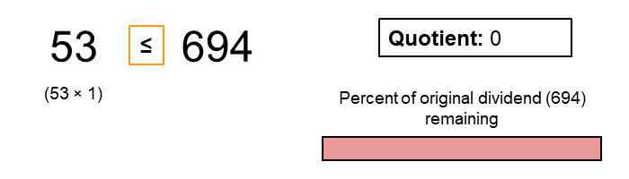

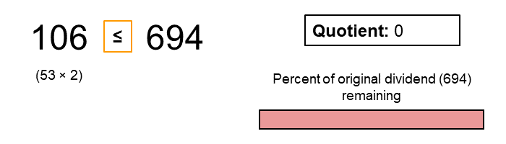

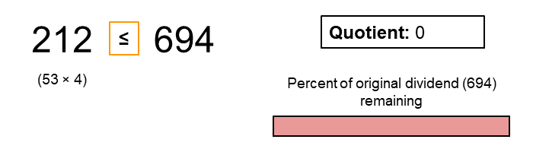

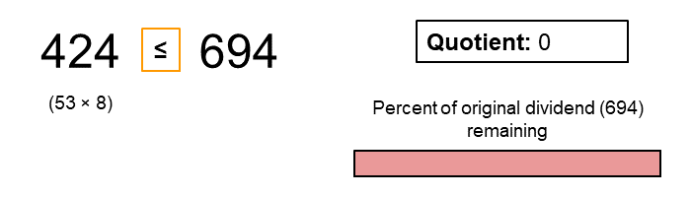

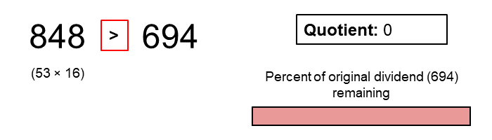

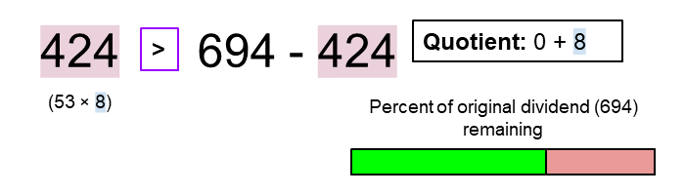

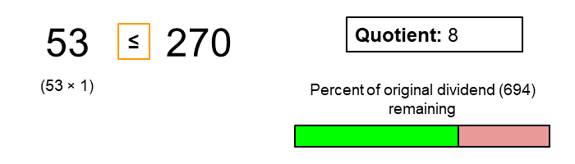

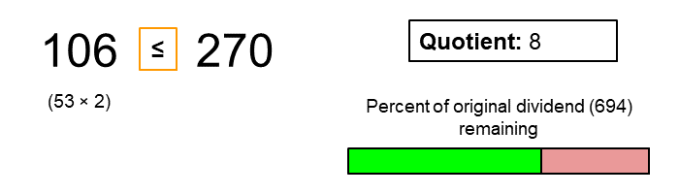

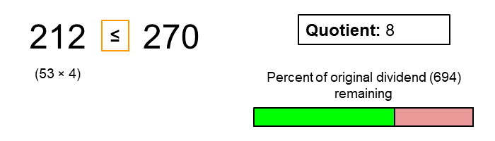

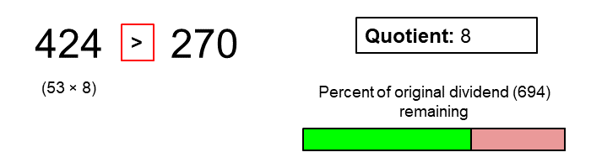

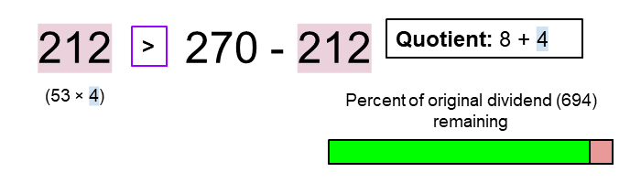

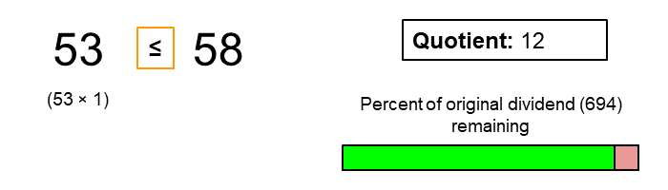

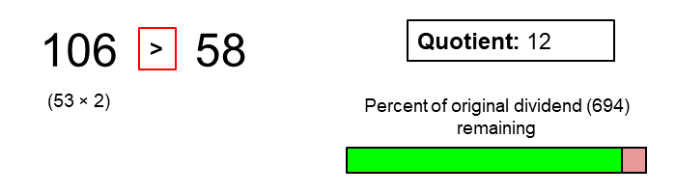

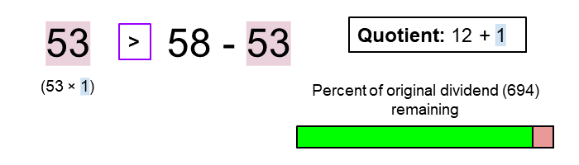

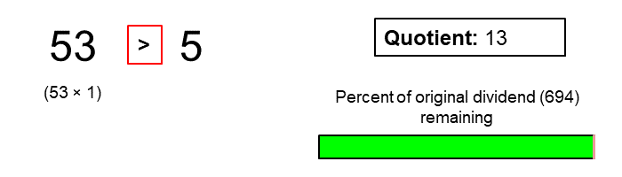

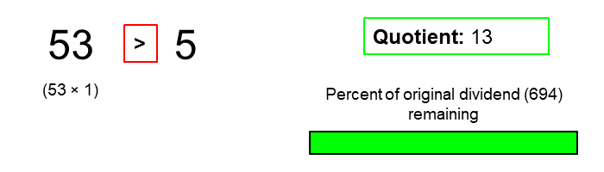

**Algorithm**

In Approach 1, we used negative numbers due to their larger range avoiding overflow problems. We do the same here.

Again, some of the conditions might initially seem like they're around the wrong way. Think carefully about them, and remember that we're *working entirely with negative numbers*.

|  |
| --- |
| private static int HALF_INT_MIN = -1073741824;  public int divide(int dividend, int divisor) {  // Special case: overflow.  if (dividend == Integer.MIN_VALUE && divisor == -1) {  return Integer.MAX_VALUE;  }  /* We need to convert both numbers to negatives.  * Also, we count the number of negatives signs. */  int negatives = 2;  if (dividend > 0) {  negatives--;  dividend = -dividend;  }  if (divisor > 0) {  negatives--;  divisor = -divisor;  }  int quotient = 0;  /* Once the divisor is bigger than the current dividend,  * we can't fit any more copies of the divisor into it. */  while (divisor >= dividend) {  /* We know it'll fit at least once as divivend >= divisor.  * Note: We use a negative powerOfTwo as it's possible we might have  * the case divide(INT_MIN, -1). */  int powerOfTwo = -1;  int value = divisor;  /* Check if double the current value is too big. If not, continue doubling.  * If it is too big, stop doubling and continue with the next step */  while (value >= HALF_INT_MIN && value + value >= dividend) {  value += value;  powerOfTwo += powerOfTwo;  }  // We have been able to subtract divisor another powerOfTwo times.  quotient += powerOfTwo;  // Remove value so far so that we can continue the process with remainder.  dividend -= value;  }  /* If there was originally one negative sign, then  * the quotient remains negative. Otherwise, switch  * it to positive. */  if (negatives != 1) {  return -quotient;  }  return quotient;  } |

**Complexity Analysis**

Let *n* be the absolute value of *dividend*.

* Time Complexity : *O*(log2*n*).

We started by performing an exponential search to find the biggest number that fits into the current dividend. This search took *O*(log*n*) operations.

After doing this search, we updated the dividend by subtracting the number we found. In the worst case, we were left with a dividend slightly less than half of the previous dividend (if it was more than half, then we couldn't have found the maximum number that fit in by doubling!).

So how many of these searches did we need to do? Well, with the dividend at least halving after each one, there couldn't have been more than *O*(log*n*) of them.

So combined together, in the worst case, we have *O*(log*n*) searches with each search taking *O*(log*n*) time. This gives us  as our total time complexity.

* Space Complexity : *O*(1).

Because only a constant number of single-value variables are used, the space complexity is *O*(1).

#### **Approach 3: Adding Powers of Two**

**Intuition**

In the previous approach, we did repeated exponential searches for the largest value that would fit into the current dividend.

However, notice that each time we do a search, we repeatedly go through the same doubles to find the largest. For example, consider the first and second step of our previous example: divide(93706, 157).

On the first step we did this:

157

314

628

1256

2512

5024

10048

20096

40192

80384

160768 # Too big

This left us with a difference of 93706 - 80384 = 13322.

On the second step we repeated this process again with 13322:

157

314

628

1256

2512

5024

10048

20096 # Too big

Notice that we've just recomputed the first seven terms of the doubles again!

Instead of doing this, we should find a way so that we can compute the sequence just once and then use the results from this to compute our quotient.

In order to do this, we need to notice one more property about the difference. That property is that the difference will always be less than the previous doubling of the divisor that fits into it. Why? Well, if it were equal, or bigger, than the largest doubling, then we must've stopped doubling too soon. So, the difference is always less than the biggest doubling.

So to use these properties, we'll put all the "doubles" of 157 into a List. Then we'll iterate backwards over the list taking all the numbers that will fit into the dividend. Here's an animation of the algorithm.

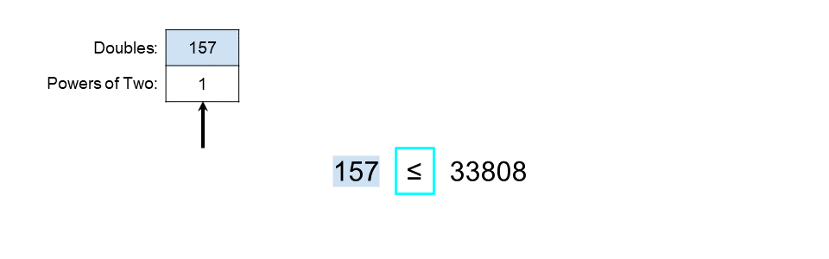

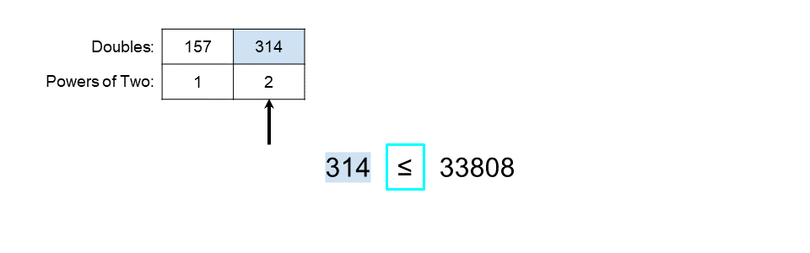

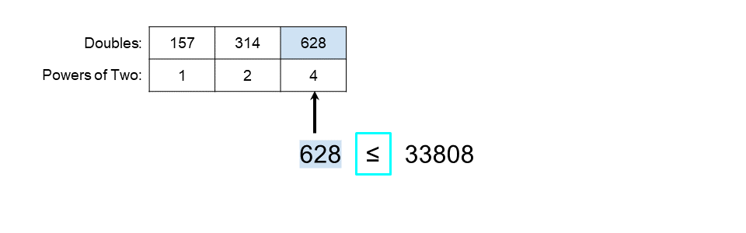

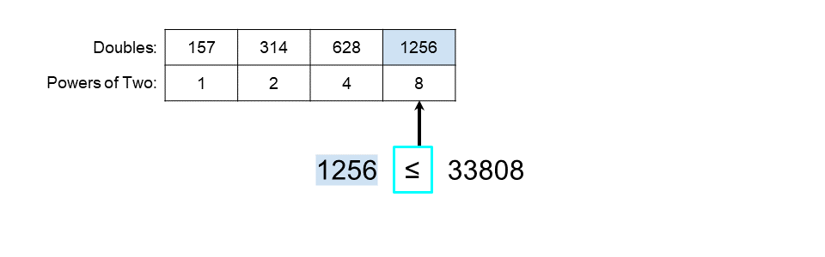

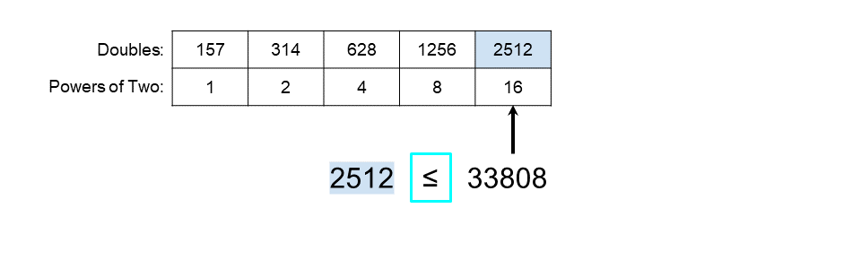

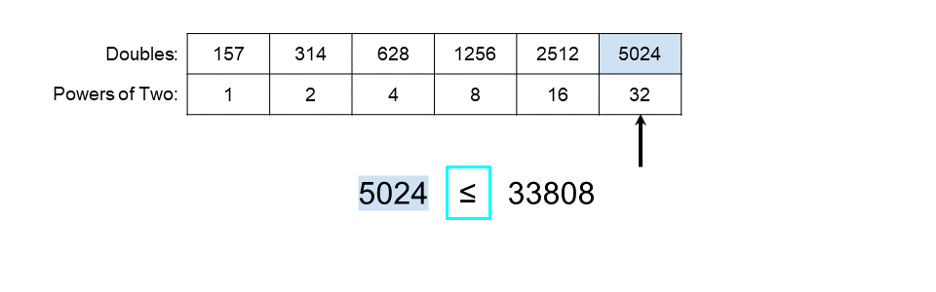

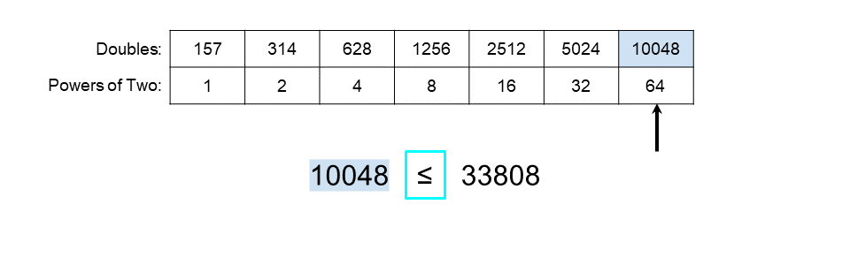

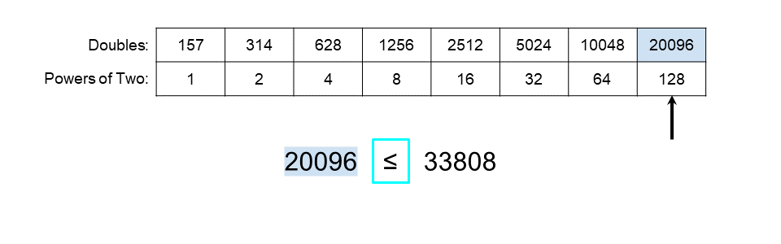

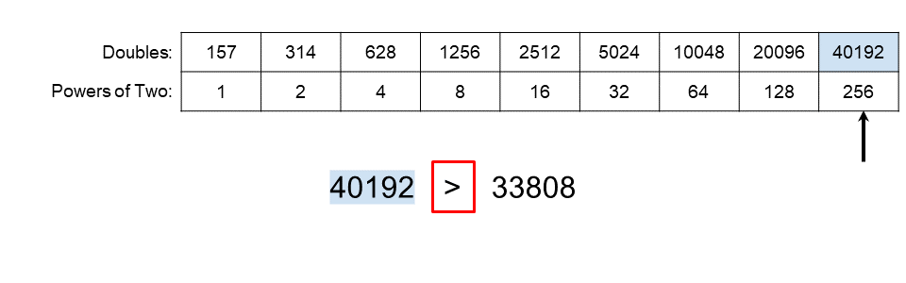

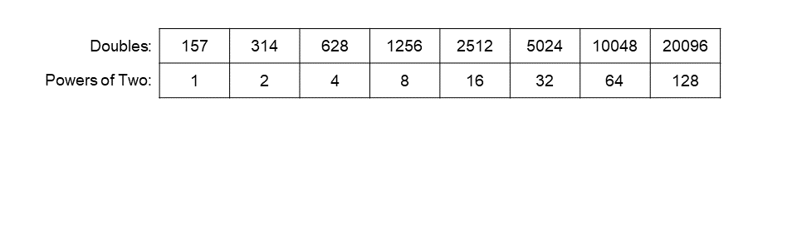

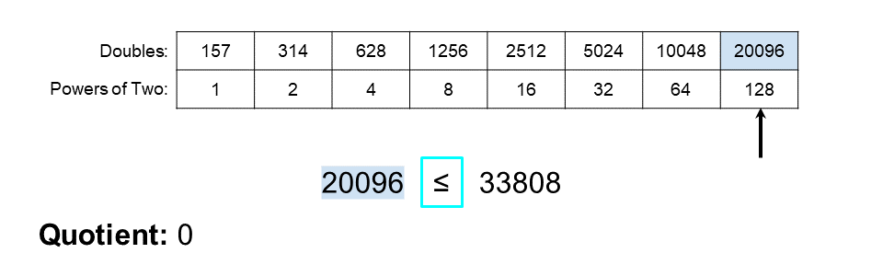

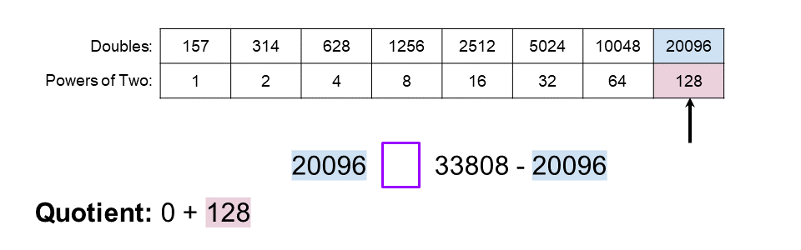

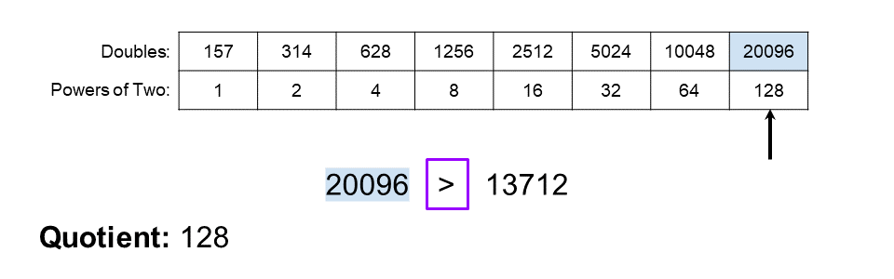

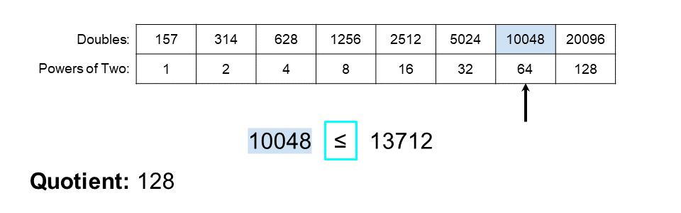

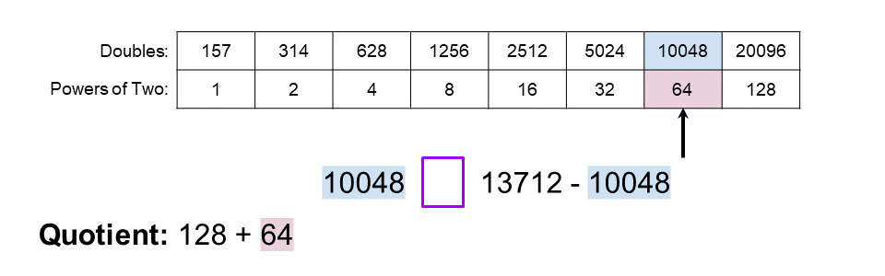

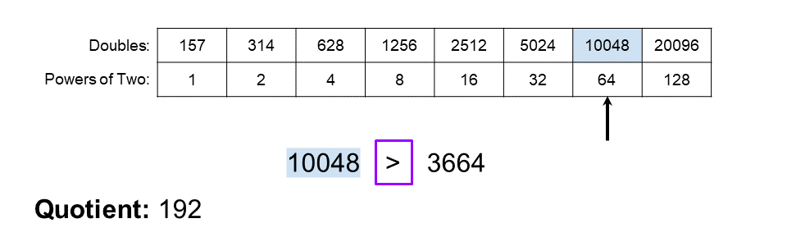

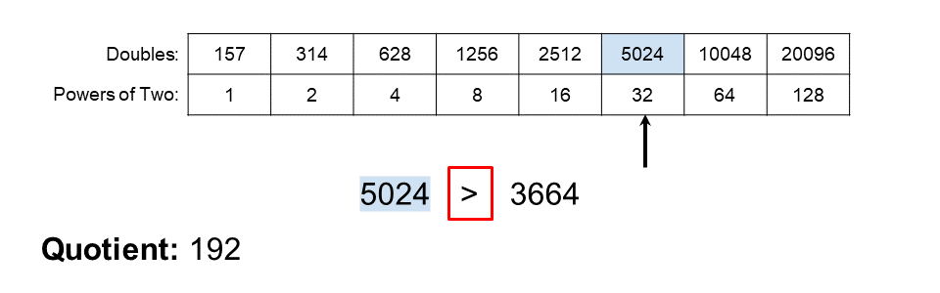

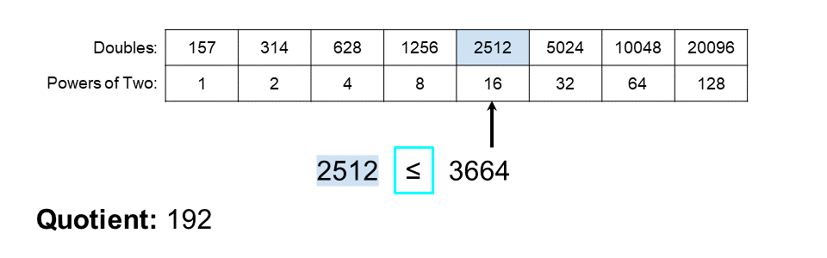

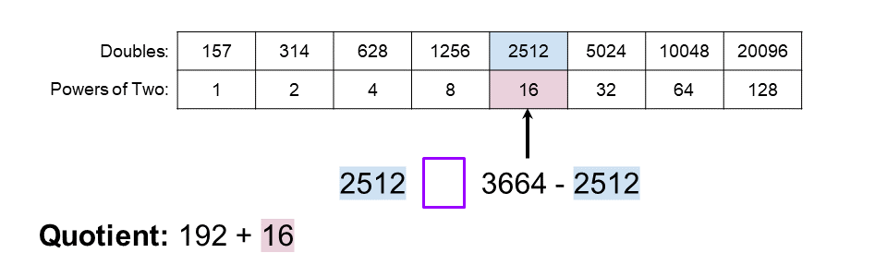

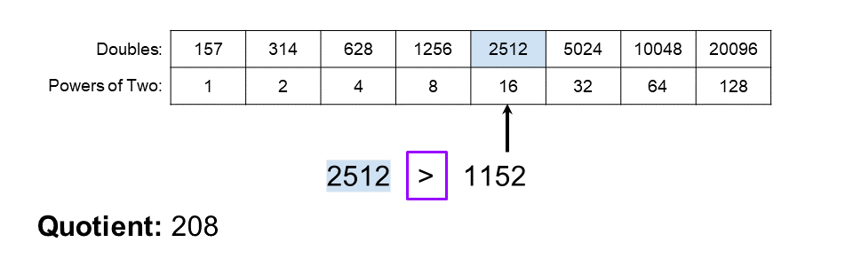

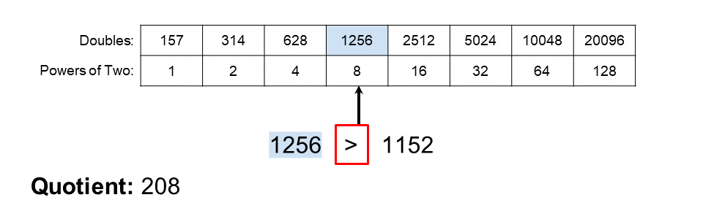

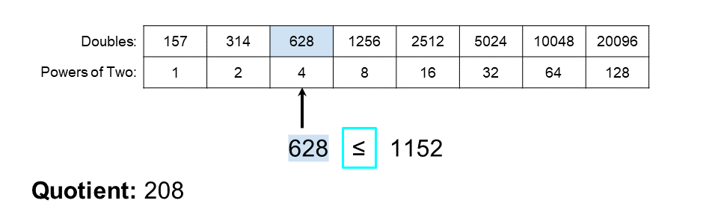

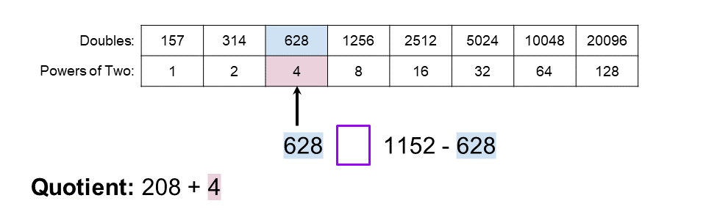

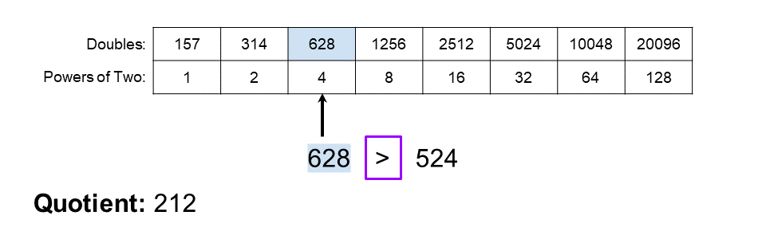

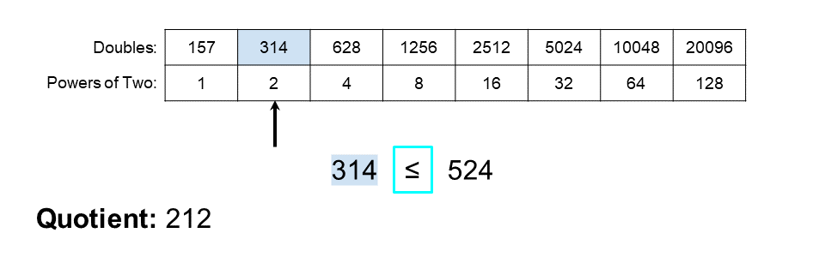

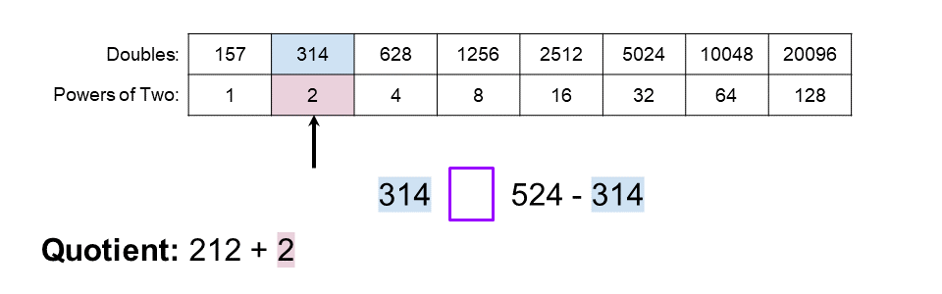

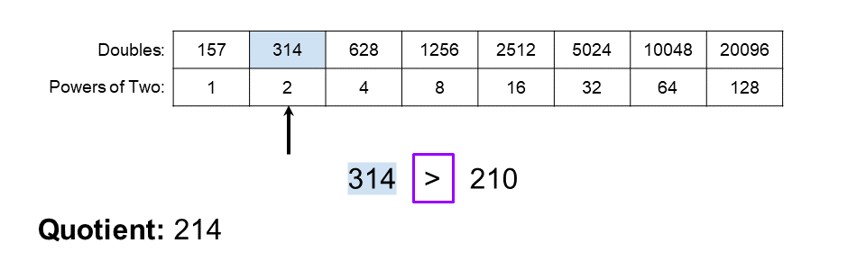

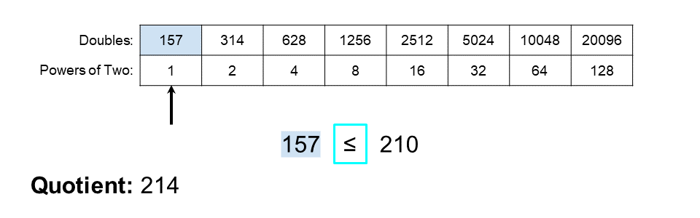

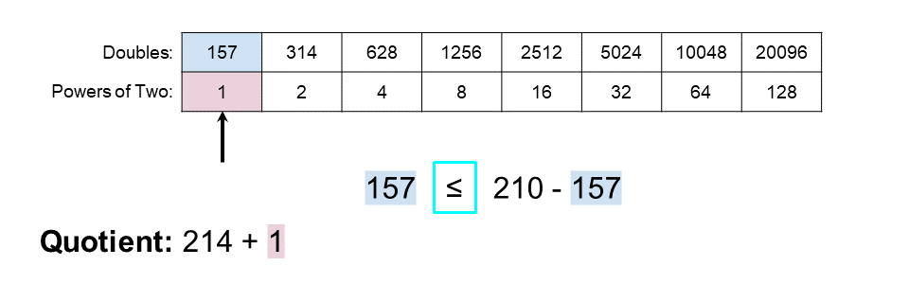

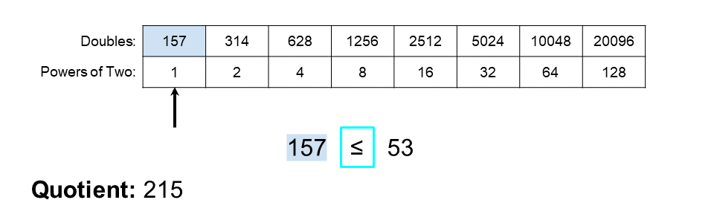

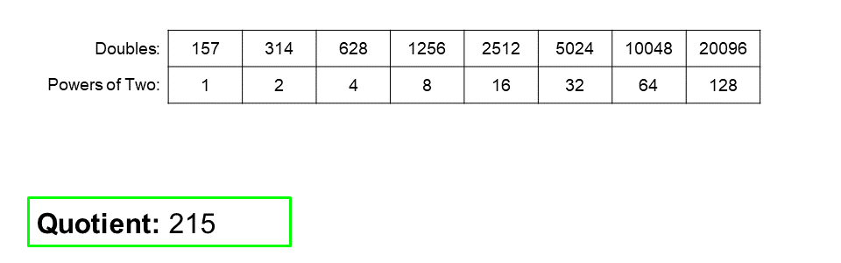

Here is the algorithm in code (like before, we're showing this example with positive inputs and pretending overflow doesn't exist, as our focus right now is on the approach and not the implementation. We'll do it correctly in the actual code of course!).

List<Integer> doubles = new ArrayList<>();

List<Integer> powersOfTwo = new ArrayList<>();

int powerOfTwo = 1;

/* Nothing too exciting here, we're just making a list of doubles of 1 and

* the divisor. This is pretty much the same as Approach 2, except we're

* actually storing the values this time. */

while (divisor <= dividend) {

powersOfTwo.add(powerOfTwo);

doubles.add(divisor);

powerOfTwo += powerOfTwo;

divisor += divisor;

}

int quotient = 0;

/* Go from largest double to smallest, checking if the current double fits.

* into the remainder of the dividend */

for (int i = doubles.size() - 1; i >= 0; i--) {

if (doubles[i] <= dividend) {

// If it does fit, add the current powerOfTwo to the quotient.

quotient += powersOfTwo.get(i);

// Update dividend to take into account the bit we've now removed.

dividend -= doubles.get(i);

}

}

We also saved the powers of two, as we need to know which corresponded with each multiple of 157.

**Algorithm**

Again, we work with negative numbers to elegantly avoid overflow issues.

Hopefully you're getting the hang of the conditionals that have to work with negative, instead of positive, numbers!

|  |
| --- |
| private static int HALF_INT_MIN = -1073741824;// -2**30;  public int divide(int dividend, int divisor) {  // Special case: overflow.  if (dividend == Integer.MIN_VALUE && divisor == -1) {  return Integer.MAX_VALUE;  }  /* We need to convert both numbers to negatives.  * Also, we count the number of negatives signs. */  int negatives = 2;  if (dividend > 0) {  negatives--;  dividend = -dividend;  }  if (divisor > 0) {  negatives--;  divisor = -divisor;  }  ArrayList<Integer> doubles = new ArrayList<>();  ArrayList<Integer> powersOfTwo = new ArrayList<>();  /* Nothing too exciting here, we're just making a list of doubles of 1 and  * the divisor. This is pretty much the same as Approach 2, except we're  * actually storing the values this time. */  int powerOfTwo = -1;  while (divisor >= dividend) {  doubles.add(divisor);  powersOfTwo.add(powerOfTwo);  // Prevent needless overflows from occurring...  if (divisor < HALF_INT_MIN) {  break;  }  divisor += divisor;  powerOfTwo += powerOfTwo;  }  int quotient = 0;  /* Go from largest double to smallest, checking if the current double fits.  * into the remainder of the dividend. */  for (int i = doubles.size() - 1; i >= 0; i--) {  if (doubles.get(i) >= dividend) {  // If it does fit, add the current powerOfTwo to the quotient.  quotient += powersOfTwo.get(i);  // Update dividend to take into account the bit we've now removed.  dividend -= doubles.get(i);  }  }  /* If there was originally one negative sign, then  * the quotient remains negative. Otherwise, switch  * it to positive. */  if (negatives != 1) {  return -quotient;  }  return quotient;  } |

**Complexity Analysis**

Let *n* be the absolute value of *dividend*.

* Time Complexity : *O*(log*n*).

We take *O*(log*n*) time in the first loop to create our list of doubles (and powers of two).

For the second loop, because there's *O*(log*n*) items in the list of doubles, it only takes *O*(log*n*)time for this loop as well.

Combined, our total time complexity is just *O*(log*n*+log*n*)=*O*(log*n*).

* Space Complexity : *O*(log*n*).

The length of the list of doubles of the divisor is proportional to *O*(log*n*) so our space complexity is *O*(log*n*).

This approach is interesting in that the time complexity is lower than the previous one, but it requires a bit of space. Trading off space for time is very common practice.

However, as we'll see in the next approach, we can modify the algorithm so that we don't need *O*(log*n*) space at all!

#### **Approach 4: Adding Powers of Two with Bit-Shifting**

**Intuition**

In Approach 3 we put doubles of the divisor, and powers of two into lists. This was so that we could easily refer back to them.

However, we don't need to save them—we can simply find the largest double, along with it's corresponding power of two, and then generate the rest by dividing by two repeatedly. But we can't divide by two, that breaks the rules..., you might be thinking. The solution is to use the **right-shift** bitwise operator!

int a = 1020;

a = a >> 1;

System.out.println(a);

// Prints 510.

One potential pitfall with the right-shift operator is using it on negative odd numbers. Two's complement makes the result one-off what you would expect/ probably wanted. This happens in all the programming languages we've checked, although there could be a few that behave differently.

int a = -1020;

a = a >> 1;

System.out.println(a);

// Prints -510. Great!

int b = -1021;

b = b >> 1;

System.out.println(b);

// Prints -511. Ugghh.

The solution is to add 1 before doing the bit-shift on a negative number. This way, it'll be "correct" regardless of whether the number was odd or even.

int a = -1020;

a = (a + 1) >> 1;

System.out.println(a);

// Prints -510. Great!

int b = -1021;

b = (b + 1) >> 1;

System.out.println(b);

// Prints -510. Yay!

The reason we brought this up is because it's a pitfall you might encounter with your own code, and potentially be driven crazy by, if you have limited experience working with bitwise operators. It turns out we can completely ignore the issue for the algorithm we've got here, as we know the numbers we're right shifting happen to always be even. This is because of the way they were generated.

Here is the algorithm, again using only positive numbers (like before, check the next section to see the actual implementations).

/* In the first loop, we simply find the largest double of divisor. This is

* very similar to the start of what we did in Approach 2. */

int highestDouble = divisor;

int highestPowerOfTwo = 1;

while (highestDouble + highestDouble <= dividend) {

highestPowerOfTwo += highestPowerOfTwo;

highestDouble += highestDouble;

}

/* In the second loop, we work out which powers of two fit in, by

* halving highestDouble and highestPowerOfTwo repeatedly. */

int quotient = 0;

while (divisor <= dividend) {

if (dividend >= highestDouble) {

quotient += highestPowerOfTwo;

dividend += highestDouble;

}

highestPowerOfTwo >>= 1;

highestDouble >>= 1;

}

return quotient;

**Algorithm**

Again, this algorithm works with negative numbers.

|  |
| --- |
| private static int HALF_INT_MIN = -1073741824;  public int divide(int dividend, int divisor) {  // Special case: overflow.  if (dividend == Integer.MIN_VALUE && divisor == -1) {  return Integer.MAX_VALUE;  }  /* We need to convert both numbers to negatives.  * Also, we count the number of negatives signs. */  int negatives = 2;  if (dividend > 0) {  negatives--;  dividend = -dividend;  }  if (divisor > 0) {  negatives--;  divisor = -divisor;  }  /* In the first loop, we simply find the largest double of divisor  * that fits into the dividend.  * The >= is because we're working in negatives. In essence, that  * piece of code is checking that we're still nearer to 0 than we  * are to INT_MIN. */  int highestDouble = divisor;  int highestPowerOfTwo = -1;  while (highestDouble >= HALF_INT_MIN && dividend <= highestDouble + highestDouble) {  highestPowerOfTwo += highestPowerOfTwo;  highestDouble += highestDouble;  }  /* In the second loop, we work out which powers of two fit in, by  * halving highestDouble and highestPowerOfTwo repeatedly.  * We can do this using bit shifting so that we don't break the  * rules of the question :-) */  int quotient = 0;  while (dividend <= divisor) {  if (dividend <= highestDouble) {  quotient += highestPowerOfTwo;  dividend -= highestDouble;  }  /* We know that these are always even, so no need to worry about the  * annoying "bit-shift-odd-negative-number" case. */  highestPowerOfTwo >>= 1;  highestDouble >>= 1;  }  /* If there was originally one negative sign, then  * the quotient remains negative. Otherwise, switch  * it to positive. */  if (negatives != 1) {  return -quotient;  }  return quotient;  } |

**Complexity Analysis**

Let *n* be the absolute value of *dividend*.

* Time Complexity : *O*(log*n*).

Same as Approach 3, except instead of looping over a generated array, we simply perform an *O*(1) halving operation to get the next values we need.

* Space Complexity : *O*(1).

We only use a fixed number of integer variables, so the space complexity is *O*(1).

#### **Approach 5: Binary Long Division**

**Intuition**

The previous approaches are all fine for an interview. We provide this approach as an alternate way of thinking about the problem, that some people might relate better to.

Anyway, another way we could divide two integers is to consider how we do division in math.

One of the common ways, which you may or may not have learned in school, is called long division.

Like the previous two approaches, long division works by find a large multiple of the divisor which fits into the dividend. Then it subtracts this from the dividend and repeats the process.

***Long Division in Base-10***

If you're familiar with long division feel free to skip this next bit.

Let's go through an example of long division. We'll start with a divisor of 379 and dividend of 872703948. To perform division, we go through each digit looking at whether or not 379 fits into the right-most digits we've looked at so far.

Let's start with the first digit:



Clearly 379 does not fit into 8, so we put a 0 and continue to the next digit.



Same thing again, 379 doesn't fit into 87, so we put a 0 and continue to the next digit.



Finally we find 379 does fit into 872 (because 379 ≤ 872, it must fit in). Because it fits in two times we put the digit 2 onto our result. Don't worry about the multiplication we just referred to, we have a solution for that shortly!



At this point, you might wonder why we divide to see how many times 379 goes into 872. This is because what it actually means is how many times 379000000 goes into 872703948. It goes in 2 times. Okay, let's continue on.

However 379000000 doesn't go into 872703948 exactly 2 times; 379000000 * 2 = 758000000.

758000000 is quite a bit short of 872703948. In fact, there's still 872703948 - 758000000 = 114703948 left over.

We now need to find how many times 379 goes into 114703948.

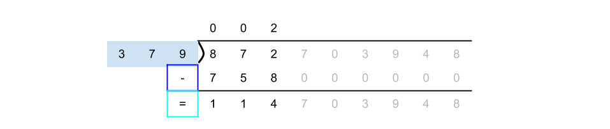

Now we simply repeat the process again with the difference. Let's start with the first digit again.

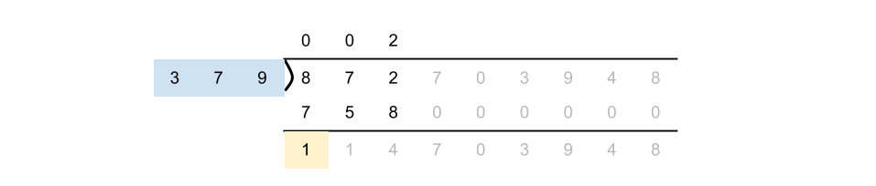

Like before, 379 doesn't fit into 1. Repeating this again, we'll see that it doesn't go into 11 or 114 either. In fact, it's impossible for it to fit until the digit after the one where we placed our 2. This shouldn't be too surprising—if it did fit into the first three digits, we should've had a 3 (or higher) instead of a 2.

As such, we can simply continue the process from the digit position after the 2. Doing so, we discover that 379 goes into 1147 a total of 3 times. Let's add that to our result.

(Remember this means 37900000 goes into 114703948 at most 3 times).

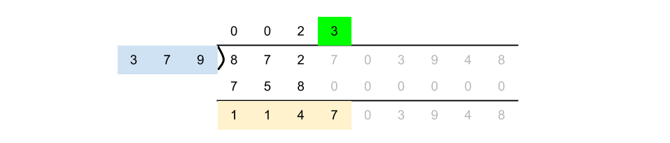

We continue to repeat this process. Eventually, we'll run out of digits and wind up with our final result.

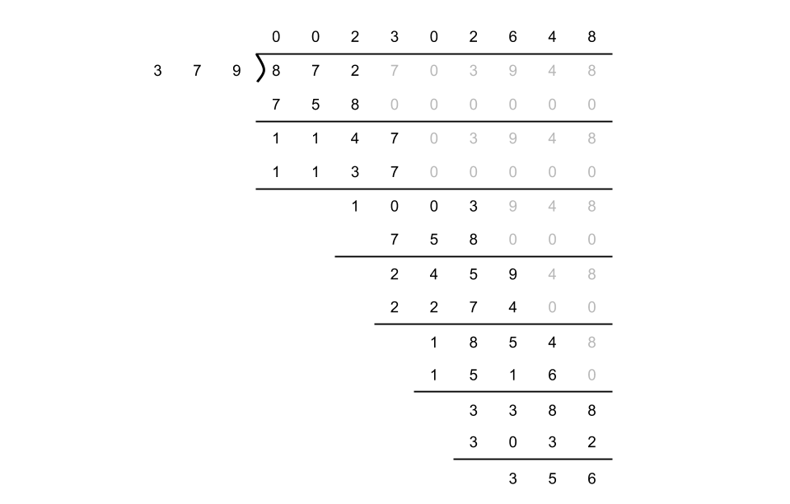

With this final result, we now know that 379 goes into 114703948 a total of 2302648 times.

***Long Division in Base-2***

One of the problems with using base-10 division for this problem is that in order to perform the algorithm, we'd need to be able to add the necessary 0s onto the end of the divisor. Given that we aren't allowed to use multiplication, this would prove to be a bit of a challenge!

Additionally, the current divisor could fit into the current dividend up to 10 times. Again, without multiplication, this is a bit annoying to calculate.

There are ways we can hack around these problems, but a far better way is to simply do the division in base-2 so that we can use bitwise operators.

In base-2, division works exactly the same way. However, because there are only two digits (1 and 0), we can simply check if the divisor-padded-with-zeroes is greater than the current dividend, and then if it is, add a 0 digit to the quotient, otherwise add a 1 digit.

Here's an animation showing base-2 long division.

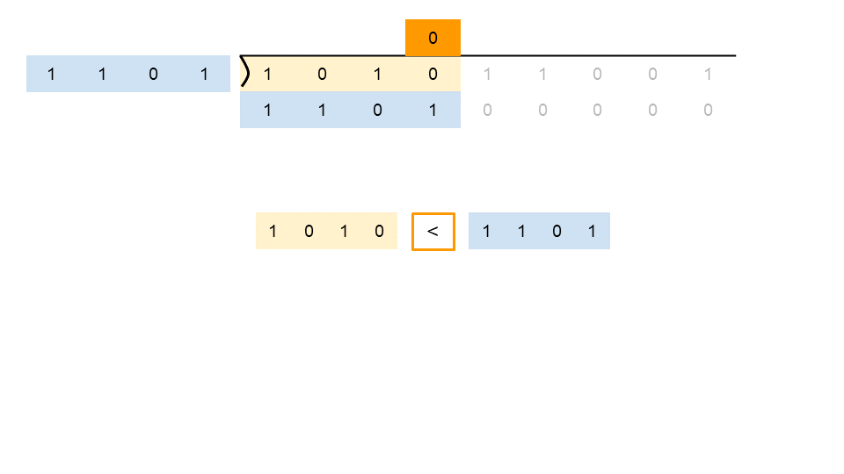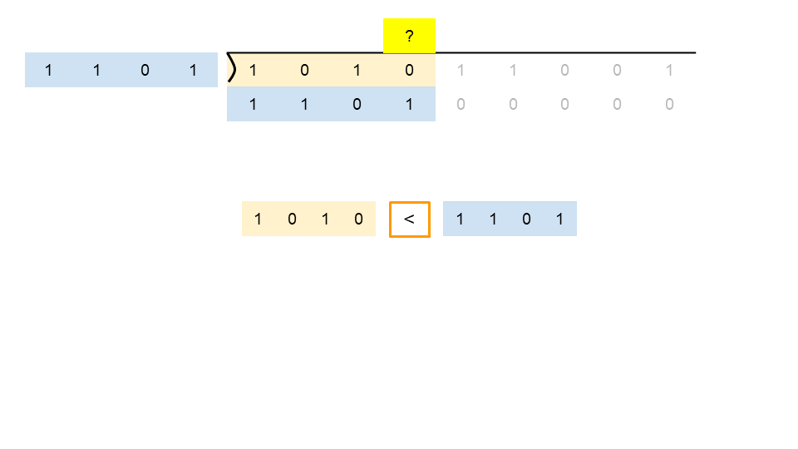

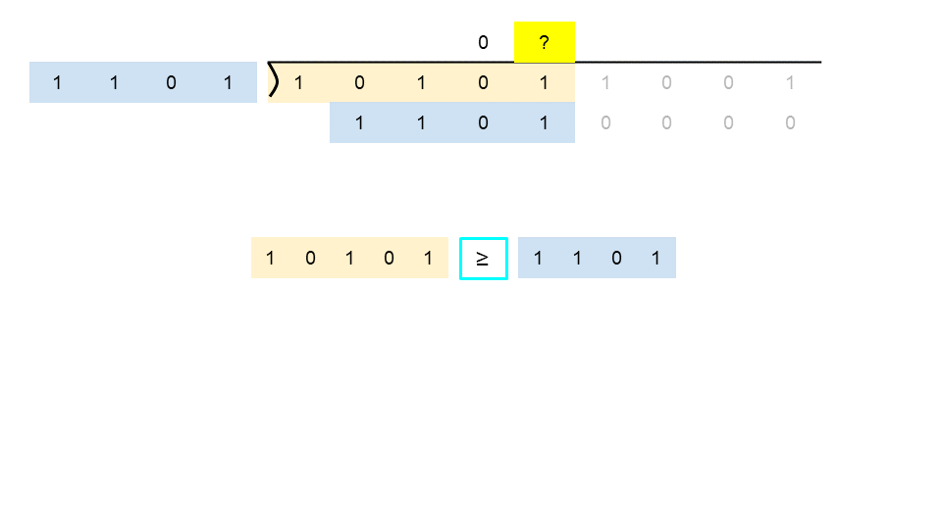

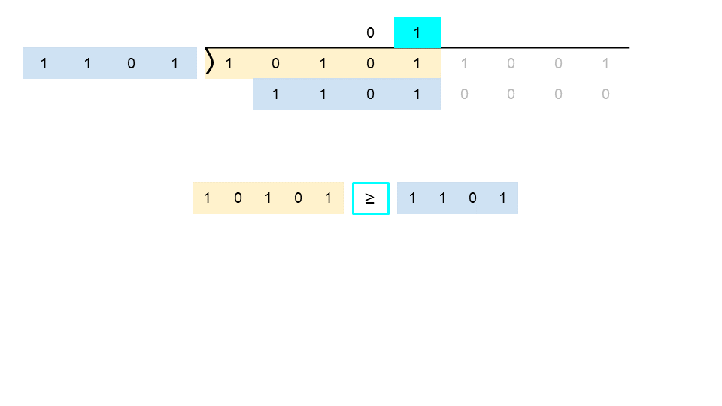

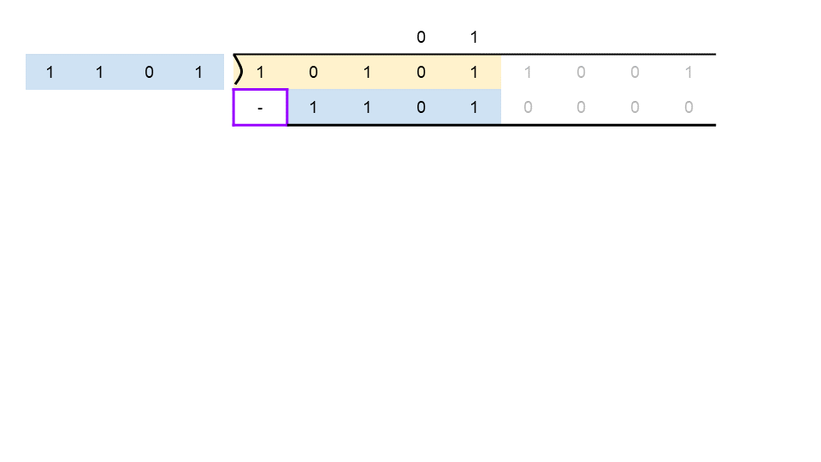

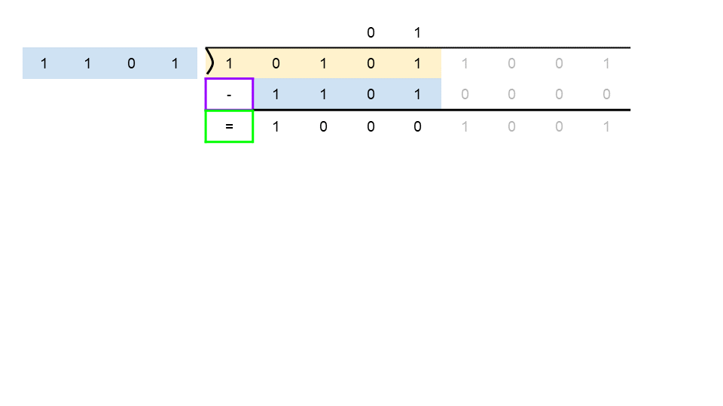

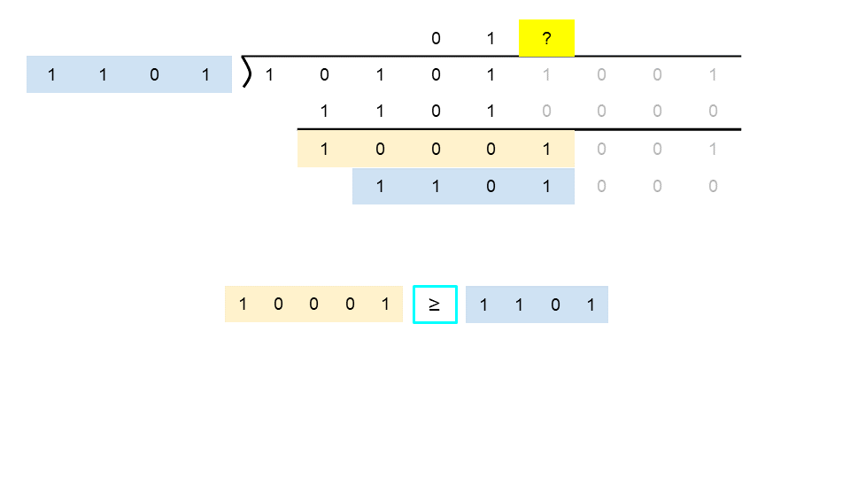

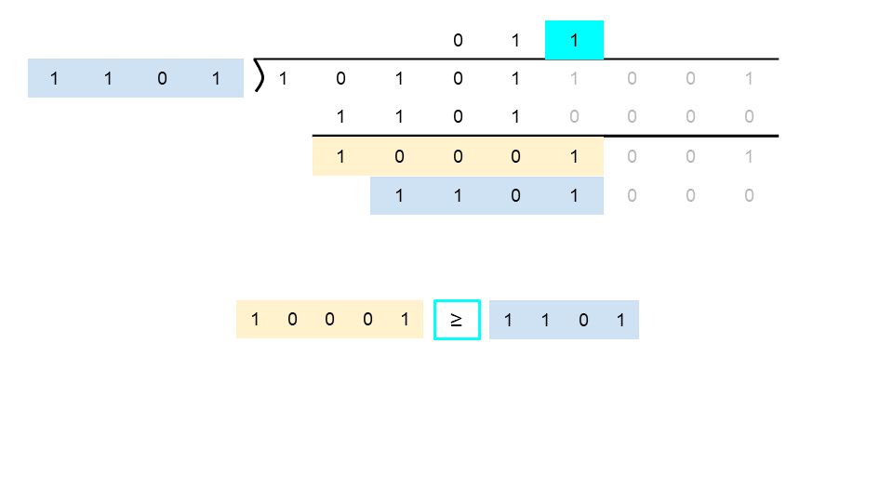

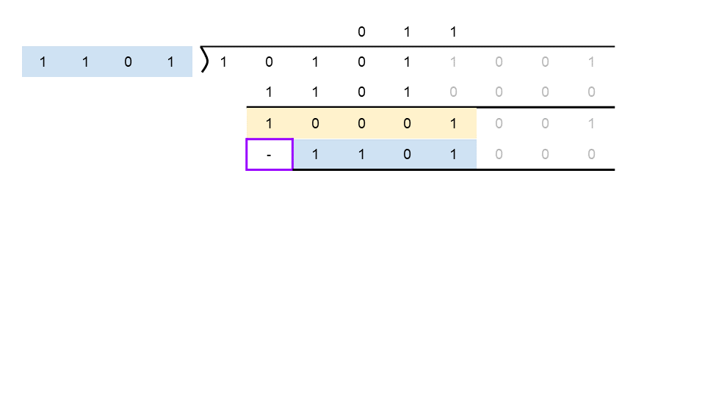

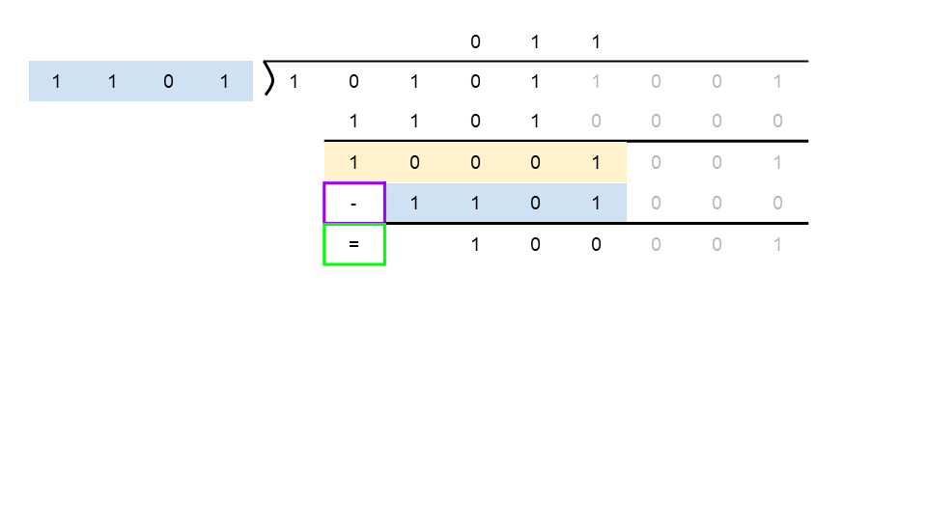

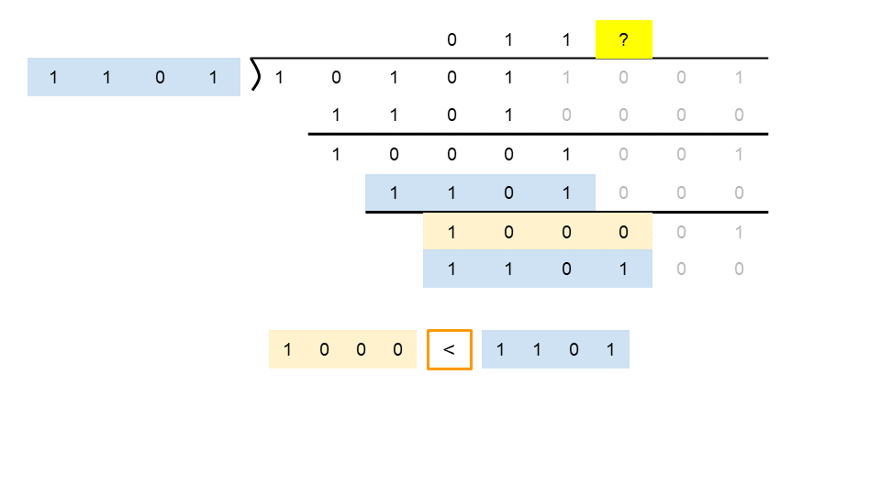

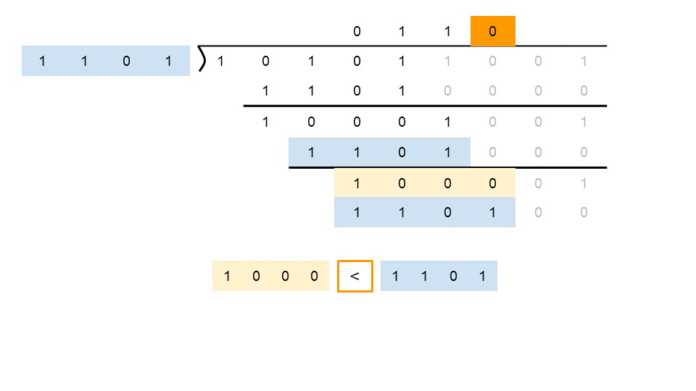

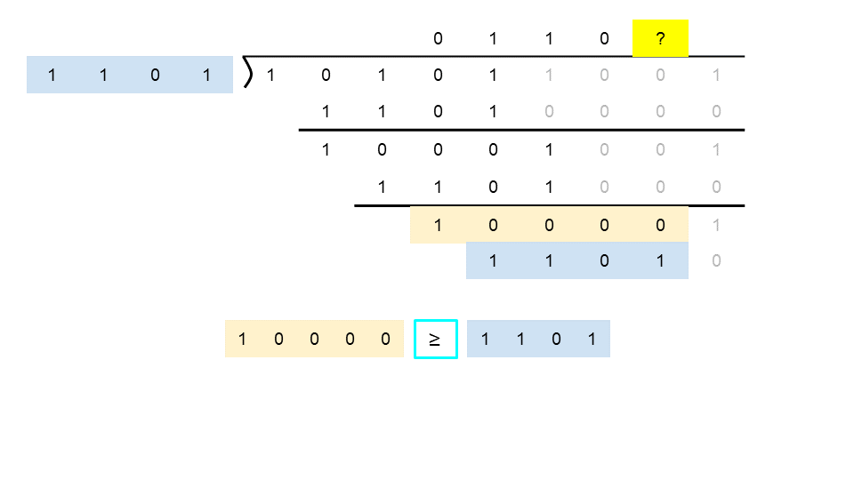

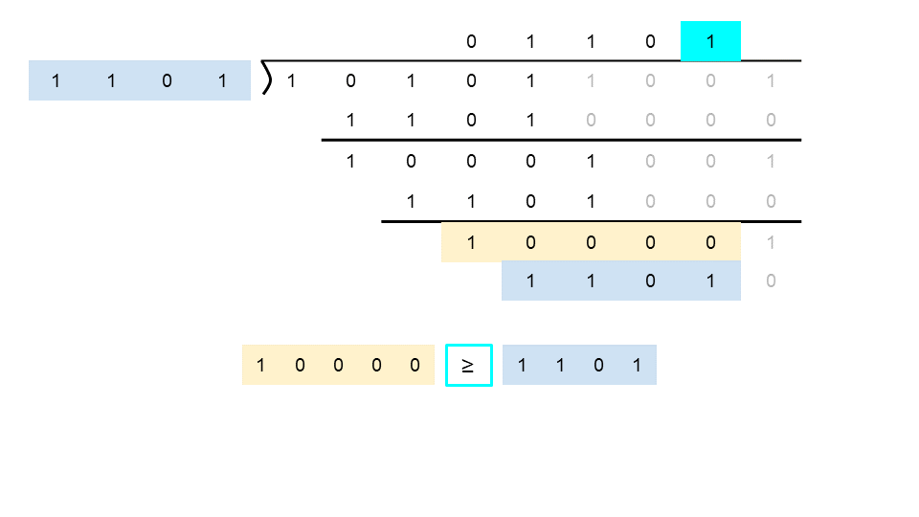

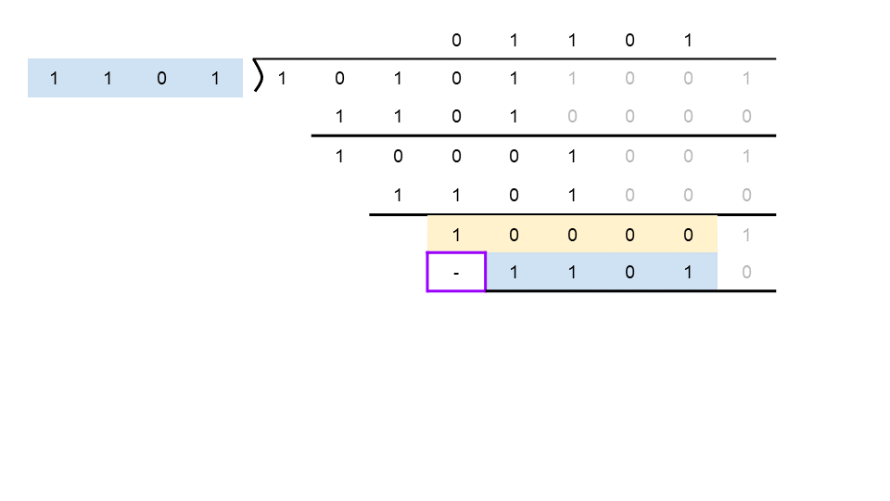

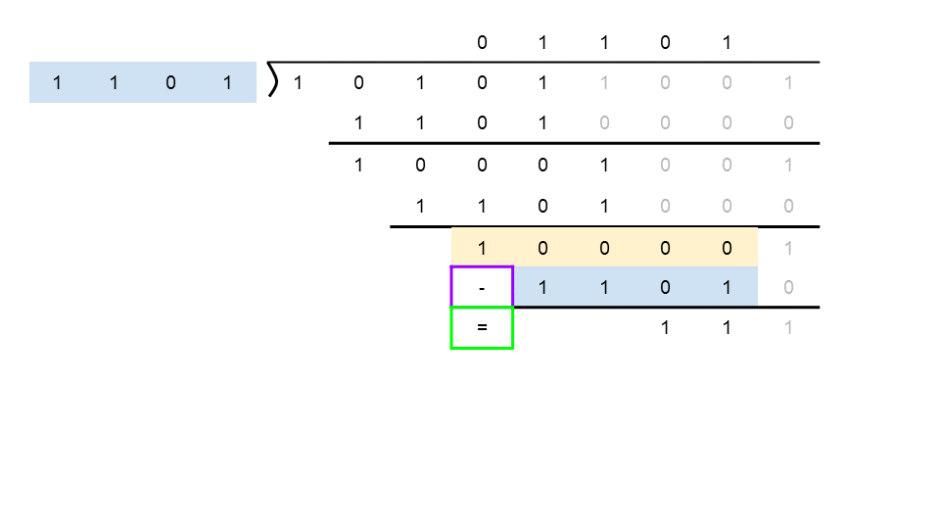

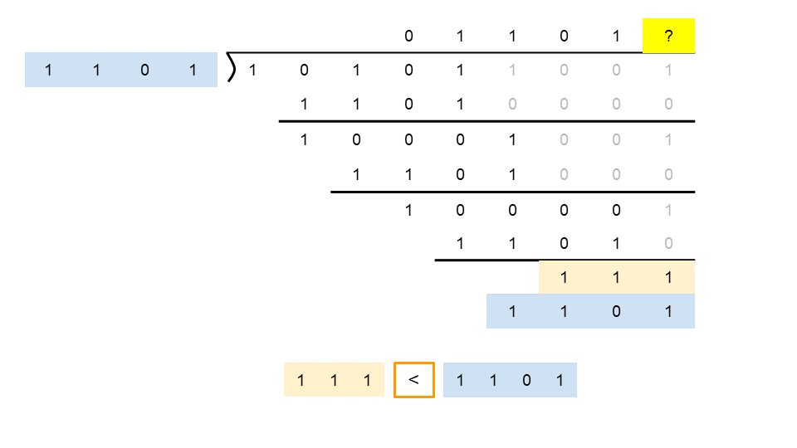

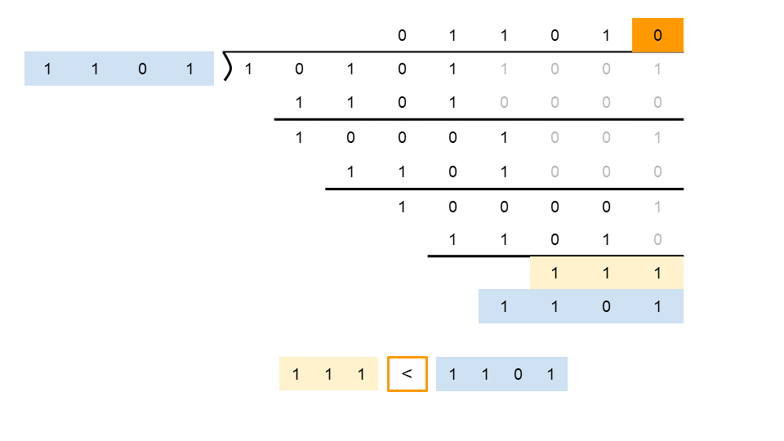

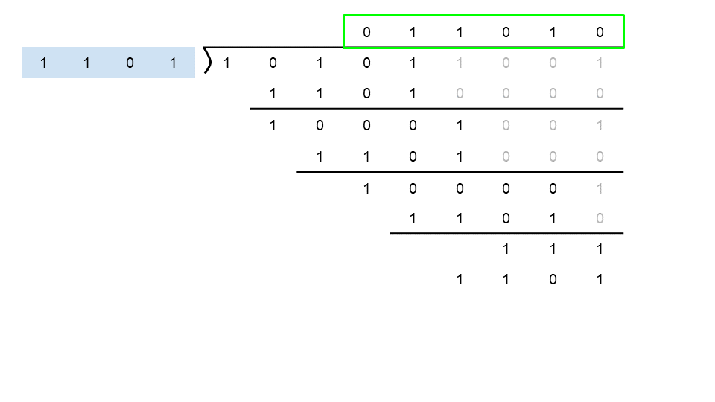

**Algorithm**

Like other approaches we use negative numbers so that the maximum possible range of numbers is available to us.

We can no longer assume the divisor, that we're right shifting, is always an *even* number. Therefore, we need to add 1 before doing the right shift. Otherwise, it could be off by 1: (divisor + 1) >> 1;.

Not all programming languages support *left* shifting with negative numbers. In those that do, we need to be really careful with overflows.

|  |
| --- |
| private static int HALF_INT_MIN = -1073741824;  public int divide(int dividend, int divisor) {  // Special cases: overflow.  if (dividend == Integer.MIN_VALUE && divisor == -1) {  return Integer.MAX_VALUE;  }  if (dividend == Integer.MIN_VALUE && divisor == 1) {  return Integer.MIN_VALUE;  }  /* We need to convert both numbers to negatives.  * Also, we count the number of negatives signs. */  int negatives = 2;  if (dividend > 0) {  negatives--;  dividend = -dividend;  }  if (divisor > 0) {  negatives--;  divisor = -divisor;  }  /* We want to find the largest doubling of the divisor in the negative 32-bit  * integer range that could fit into the dividend.  * Note if it would cause an overflow by being less than HALF_INT_MIN,  * then we just stop as we know double it would not fit into INT_MIN anyway. */  int maxBit = 0;  while (divisor >= HALF_INT_MIN && divisor + divisor >= dividend) {  maxBit += 1;  divisor += divisor;  }  int quotient = 0;  /* We start from the biggest bit and shift our divisor to the right  * until we can't shift it any further */  for (int bit = maxBit; bit >= 0; bit--) {  /* If the divisor fits into the dividend, then we should set the current  * bit to 1. We can do this by subtracting a 1 shifted by the appropriate  * number of bits. */  if (divisor >= dividend) {  quotient -= (1 << bit);  /* Remove the current divisor from the dividend, as we've now  * considered this part. */  dividend -= divisor;  }  /* Shift the divisor to the right so that it's in the right place  * for the next positon we're checking at. */  divisor = (divisor + 1) >> 1;  }  /* If there was originally one negative sign, then  * the quotient remains negative. Otherwise, switch  * it to positive. */  if (negatives != 1) {  quotient = -quotient;  }  return quotient;  } |

**Complexity Analysis**

Let *n* be the absolute value of *dividend*.

* Time Complexity : *O*(log*n*).

As we loop over the bits of our dividend, performing an *O*(1) operation each time, the time complexity is just the number of bits of the dividend: *O*(log*n*).

* Space Complexity : *O*(1).

We only use a fixed number of int variables, so the space complexity is *O*(1).

#### **Final Words**

This question is quite difficult, and is one many people fear getting in an interview. If you get a question like this though, don't panic, but instead just work through it step-by-step.

A good strategy for this particular question could be to first develop your algorithm to work with positive integers. In fact, you might like to even assume that the inputs could only possibly be positive integers. This removes a **lot** of the code at the start of the algorithm (remember how about half of most of the approaches was literally just generalising all the numbers to negatives?!).

Once you feel you have your approach working with positive integers, think about how you could adapt it to work with any integer inputs, and then to avoid overflow issues.

**Fraction to Recurring Decimal**

Given two integers representing the numerator and denominator of a fraction, return the fraction in string format.

If the fractional part is repeating, enclose the repeating part in parentheses.

If multiple answers are possible, return **any of them**.

It is **guaranteed** that the length of the answer string is less than 104 for all the given inputs.

**Example 1:**

**Input:** numerator = 1, denominator = 2

**Output:** "0.5"

**Example 2:**

**Input:** numerator = 2, denominator = 1

**Output:** "2"

**Example 3:**

**Input:** numerator = 2, denominator = 3

**Output:** "0.(6)"

**Example 4:**

**Input:** numerator = 4, denominator = 333

**Output:** "0.(012)"

**Example 5:**

**Input:** numerator = 1, denominator = 5

**Output:** "0.2"

**Constraints:**

* -231 <= numerator, denominator <= 231 - 1
* denominator != 0

 Hide Hint #1

No scary math, just apply elementary math knowledge. Still remember how to perform a *long division*?

   Hide Hint #2

Try a long division on 4/9, the repeating part is obvious. Now try 4/333. Do you see a pattern?

   Hide Hint #3

Notice that once the remainder starts repeating, so does the divided result.

   Hide Hint #4

Be wary of edge cases! List out as many test cases as you can think of and test your code thoroughly.

## Summary

This is a straight forward coding problem but with a fair amount of details to get right.

## Hints

1. No scary math, just apply elementary math knowledge. Still remember how to perform a *long division*?
2. Try a long division on 4/9​, the repeating part is obvious. Now try 4/333​. Do you see a pattern?
3. Be wary of edge cases! List out as many test cases as you can think of and test your code thoroughly.

## Solution

#### **Approach 1: Long Division**

**Intuition**

The key insight here is to notice that once the remainder starts repeating, so does the divided result.

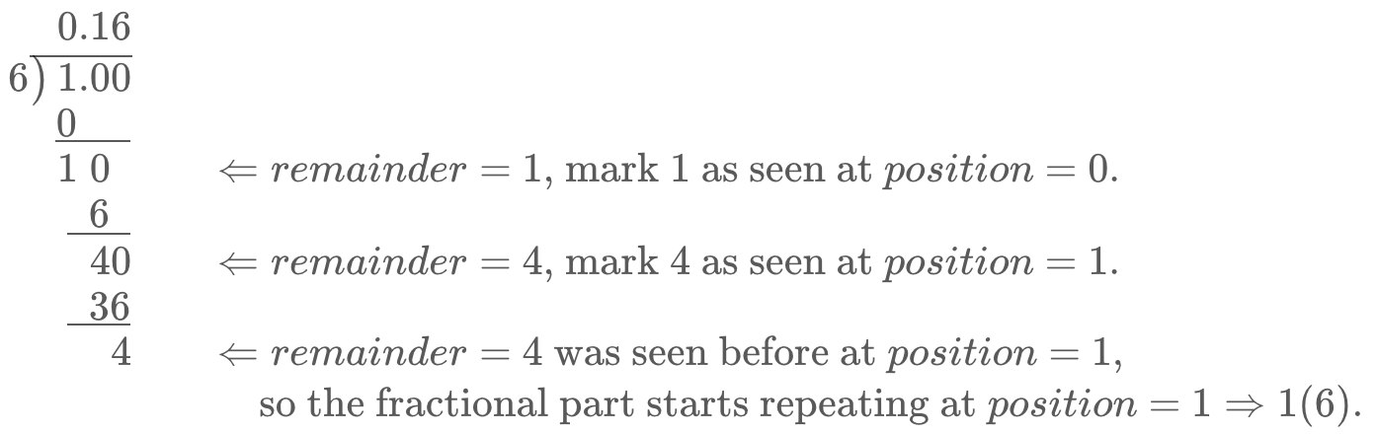

**Algorithm**

You will need a hash table that maps from the remainder to its position of the fractional part. Once you found a repeating remainder, you may enclose the reoccurring fractional part with parentheses by consulting the position from the table.

The remainder could be zero while doing the division. That means there is no repeating fractional part and you should stop right away.

Just like the question [Divide Two Integers](https://leetcode.com/problems/divide-two-integers/), be wary of edge cases such as negative fractions and nasty extreme case such as -2147483648/-1

Here are some good test cases:

| **Test case** | **Explanation** |
| --- | --- |
| 0/1​ | Numerator is zero. |
| 1/0​ | Divisor is 0, should handle it by throwing an exception but here we ignore for simplicity sake. |
| 20/4​ | Answer is a whole integer, should not contain the fractional part. |
| 1/2​ | Answer is 0.5, no recurring decimal. |
| -1/4​ or 1/-4​ | One of the numerator or denominator is negative, fraction is negative. |
| -1/-4​ | Both numerator and denominator are negative, should result in positive fraction. |
| -2147483648/-1 | Beware of overflow if you cast to positive. |

|  |
| --- |
| public String fractionToDecimal(int numerator, int denominator) {  if (numerator == 0) {  return "0";  }  StringBuilder fraction = new StringBuilder();  // If either one is negative (not both)  if (numerator < 0 ^ denominator < 0) {  fraction.append("-");  }  // Convert to Long or else abs(-2147483648) overflows  long dividend = Math.abs(Long.valueOf(numerator));  long divisor = Math.abs(Long.valueOf(denominator));  fraction.append(String.valueOf(dividend / divisor));  long remainder = dividend % divisor;  if (remainder == 0) {  return fraction.toString();  }  fraction.append(".");  Map<Long, Integer> map = new HashMap<>();  while (remainder != 0) {  if (map.containsKey(remainder)) {  fraction.insert(map.get(remainder), "(");  fraction.append(")");  break;  }  map.put(remainder, fraction.length());  remainder *= 10;  fraction.append(String.valueOf(remainder / divisor));  remainder %= divisor;  }  return fraction.toString();  } |

## Others

Here are some other questions that do not fit in other categories.

We recommend: Majority Element, Find the Celebrity and Task Scheduler.

 Sum of Two Integers

 Evaluate Reverse Polish Notation

 Majority Element

 Find the Celebrity

 Task Scheduler

**Sum of Two Integers**

Calculate the sum of two integers *a* and *b*, but you are **not allowed** to use the operator + and -.

**Example 1:**

**Input:** a = 1, b = 2

**Output:** 3

**Example 2:**

**Input:** a = -2, b = 3

**Output:** 1

## Solution

#### **Overview**

Approach 1 is a detailed explanation of bit manipulation basics. Approach 2 is a language-specific discussion of a possible follow-up and mainly written for fun.

#### **Approach 1: Bit Manipulation: Easy and Language-Independent**

That's an extremely popular Facebook problem designed to check your knowledge of [bitwise operators](https://wiki.python.org/moin/BitwiseOperators):

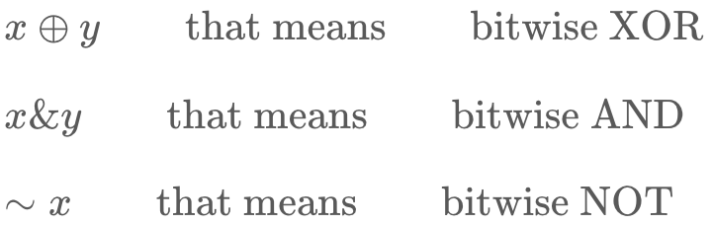

**Reduce the Number of Use Cases**

First of all, there are too many use cases here: both a*a* and b*b* could be positive or negative, abs(a) could be greater or less than abs(b). In total, that results in 2×2×2=8 use cases.

Let's start by reducing the problem down to two simple cases:

* Sum of two positive integers: *x*+*y*, where *x*>*y*.
* Difference of two positive integers: *x*−*y*, where *x*>*y*.

|  |
| --- |
| class Solution {  public int getSum(int a, int b) {  int x = Math.abs(a), y = Math.abs(b);  // ensure that abs(a) >= abs(b)  if (x < y) return getSum(b, a);    // abs(a) >= abs(b) -->  // a determines the sign  int sign = a > 0 ? 1 : -1;    if (a * b >= 0) {  // sum of two positive integers x + y  // where x > y    // TODO  }  } else {  // difference of two positive integers x - y  // where x > y    // TODO  }  }    return x * sign;  }  } |

**Interview Tip for Bit Manipulation Problems: Use XOR**

How to start? There is an interview tip for bit manipulation problems: if you don't know how to start, start from computing XOR for your input data. Strangely, that helps out for quite a lot of problems, [Single Number II](https://leetcode.com/articles/single-number-ii/), [Single Number III](https://leetcode.com/articles/single-number-iii/), [Maximum XOR of Two Numbers in an Array](https://leetcode.com/articles/maximum-xor-of-two-numbers-in-an-array/), [Repeated DNA Sequences](https://leetcode.com/articles/repeated-dna-sequences/), [Maximum Product of Word Lengths](https://leetcode.com/articles/maximum-product-of-word-lengths/), etc.

What is XOR?

XOR of zero and a bit results in that bit.

0⊕*x*=*x*

XOR of two equal bits (even if they are zeros) results in a zero.

*x*⊕*x*=0

**Sum of Two Positive Integers**

Now let's use this tip for the first use case: the sum of two positive integers. Here XOR is a key as well because it's a sum of two integers in the binary form without taking carry into account. In other words, XOR is a sum of bits of x and y where at least one of the bits is not set.

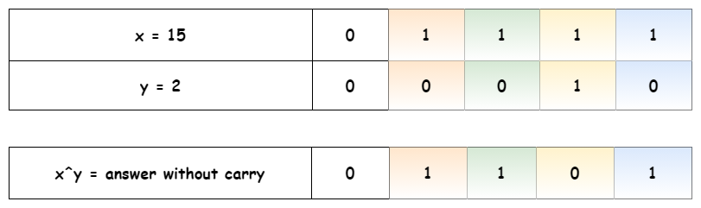

The next step is to find the carry. It contains the common set bits of x and y, shifted one bit to the left. I.e. it's logical AND of two input numbers, shifted one bit to the left: carry=(*x*&*y*)<<1.

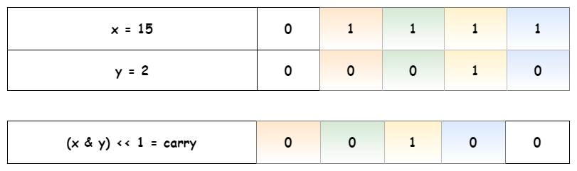

The problem is reduced down to find the sum of the answer without carry and the carry.

Technically, it's the same problem: to sum two numbers, and hence one could solve it in a loop with the condition statement "while carry is not equal to zero".

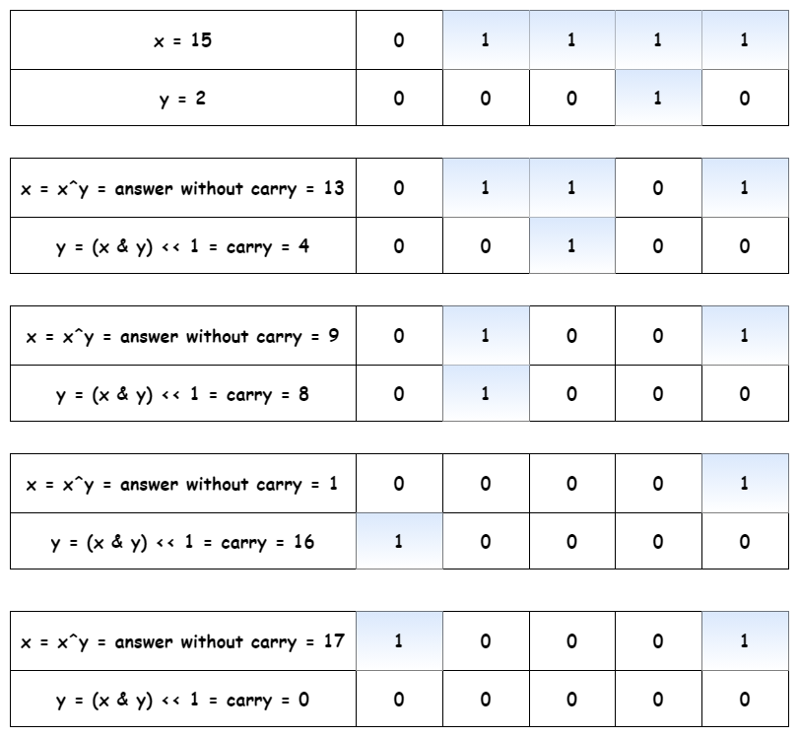

**Difference of Two Positive Integers**

As for addition, XOR is a difference of two integers without taking borrow into account.

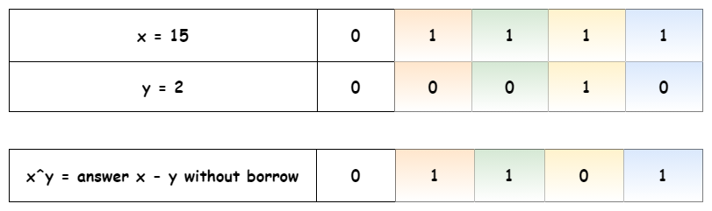

The next step is to find the borrow. It contains common set bits of *y* and unset bits of x*x*, i.e. borrow=((∼*x*)&*y*)<<1.

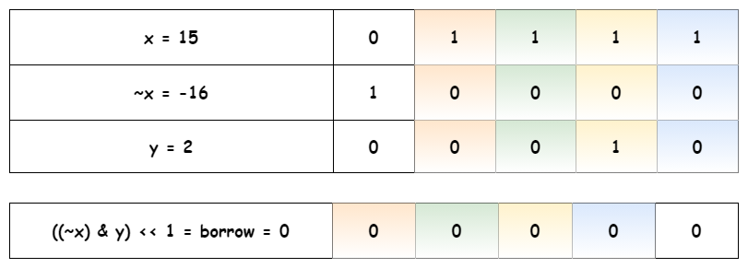

The problem is reduced down to the subtraction of the borrow from the answer without borrow. As for the sum, it could be solved recursively or in a loop with the condition statement "while borrow is not equal to zero".

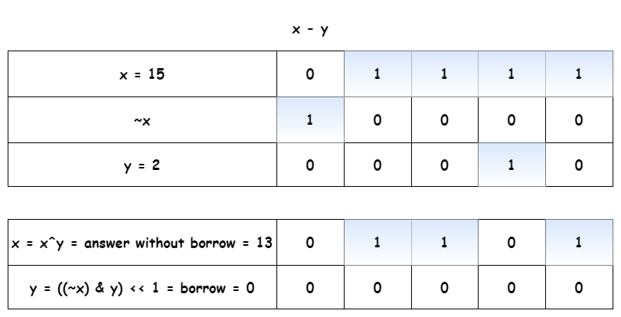

**Algorithm**

* Simplify problem down to two cases: sum or subtraction of two positive integers: *x*±*y*, where *x*>*y*. Save down the sign of the result.
* If one has to compute the sum:
  + While carry is nonzero: y != 0:
    - Current answer without carry is XOR of x and y: answer = x^y.
    - Current carry is left-shifted AND of x and y: carry = (x & y) << 1.
    - Job is done, prepare the next loop: x = answer, y = carry.
  + Return x * sign.
* If one has to compute the difference:
  + While borrow is nonzero: y != 0:
    - Current answer without borrow is XOR of x and y: answer = x^y.
    - Current borrow is left-shifted AND of NOT x and y: borrow = ((~x) & y) << 1.
    - Job is done, prepare the next loop: x = answer, y = borrow.
  + Return x * sign.

**Implementation**

|  |
| --- |
| class Solution {  public int getSum(int a, int b) {  int x = Math.abs(a), y = Math.abs(b);  // ensure that abs(a) >= abs(b)  if (x < y) return getSum(b, a);    // abs(a) >= abs(b) -->  // a determines the sign  int sign = a > 0 ? 1 : -1;    if (a * b >= 0) {  // sum of two positive integers x + y  // where x > y  while (y != 0) {  int answer = x ^ y;  int carry = (x & y) << 1;  x = answer;  y = carry;  }  } else {  // difference of two positive integers x - y  // where x > y  while (y != 0) {  int answer = x ^ y;  int borrow = ((~x) & y) << 1;  x = answer;  y = borrow;  }  }  return x * sign;  }  } |

**Complexity Analysis**

* Time complexity: O(1) because each integer contains 32 bits.
* Space complexity: O(1) because we don't use any additional data structures.

#### **Approach 2: Bit Manipulation: Short Language-Specific Solution**

Approach 1 is easy to attack during the follow-up:

Please don't use multiplication to manage negative numbers and make a clean bitwise solution.

Let's be honest, it's a trap. Once you start to manage negative numbers using bit manipulation, your solution becomes language-specific.

**Different languages represent negative numbers differently.**

**Java**

For example, Java integer is a number of 32 bits. 31 bits are used for the value. The first bit is used for the sign: if it's equal to 1, the number is negative, if it's equal to 0, the number is positive.

And now the fun starts. Does it mean that

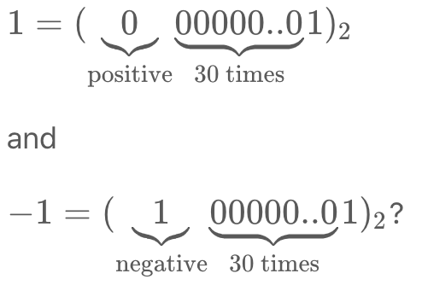

No!

For the representation of a negative number Java uses the so-called "two's complement":

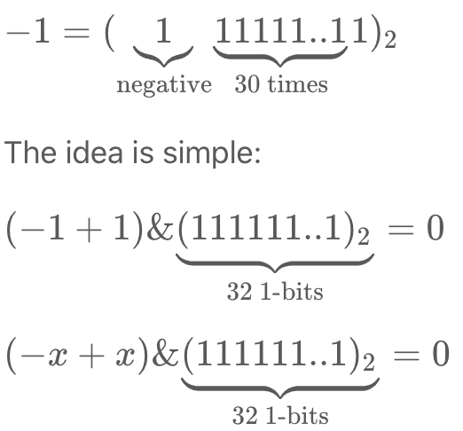

The main goal of "two's complement" is to decrease the complexity of bit manipulations. How does Java compute "two's complement" and manage 32-bits limit? Here is how:

* After each operation we have an invisible & mask, where mask = 0xFFFFFFFF, i.e. bitmask of 32 1-bits.
* The overflow, i.e. the situation of x > 0x7FFFFFFF (bitmask of 31 1-bits), is managed as x --> ~(x ^ 0xFFFFFFFF).

At this point, we could come back to approach 1 and, surprisingly, all management of negative numbers, signs, and subtractions Java already does for us. That simplifies the solution to the computation of a sum of two positive integers. That's how the magic of "two's complement" works!

|  |
| --- |
| class Solution {  public int getSum(int a, int b) {  while (b != 0) {  int answer = a ^ b;  int carry = (a & b) << 1;  a = answer;  b = carry;  }    return a;  }  } |

**Implementation**

Each language has its beauty.

|  |
| --- |
| class Solution {  public int getSum(int a, int b) {  while (b != 0) {  int answer = a ^ b;  int carry = (a & b) << 1;  a = answer;  b = carry;  }    return a;  }  } |

**Complexity Analysis**

* Time complexity: O(1).
* Space complexity: O(1).

**Evaluate Reverse Polish Notation**

Evaluate the value of an arithmetic expression in [Reverse Polish Notation](http://en.wikipedia.org/wiki/Reverse_Polish_notation).

Valid operators are +, -, *, /. Each operand may be an integer or another expression.

**Note:**

* Division between two integers should truncate toward zero.
* The given RPN expression is always valid. That means the expression would always evaluate to a result and there won't be any divide by zero operation.

**Example 1:**

**Input:** ["2", "1", "+", "3", "*"]

**Output:** 9

**Explanation:** ((2 + 1) * 3) = 9

**Example 2:**

**Input:** ["4", "13", "5", "/", "+"]

**Output:** 6

**Explanation:** (4 + (13 / 5)) = 6

**Example 3:**

**Input:** ["10", "6", "9", "3", "+", "-11", "*", "/", "*", "17", "+", "5", "+"]

**Output:** 22

**Explanation:**

((10 * (6 / ((9 + 3) * -11))) + 17) + 5

= ((10 * (6 / (12 * -11))) + 17) + 5

= ((10 * (6 / -132)) + 17) + 5

= ((10 * 0) + 17) + 5

= (0 + 17) + 5

= 17 + 5

= 22

## Solution

If you've attempted this question and can't figure out why you're getting wrong answers, here are a couple of things to check before reading the article:

1. Reverse Polish Notation **is not a "reverse" form of Polish Notation**. It is a bit different.
2. If you're using Java, note that **the input type is an array of strings**, not an array of chars. This means that you should be comparing them with .equals(...), not ==. If your code is working on your computer but not on Leetcode, this is probably why. It is a bug in your code, not in the Leetcode platform.
3. **Some programming languages** (e.g. Python, but not C++ and Java) **do not truncate towards 0 with division**, so you'll need to figure out how to make them do so (we'll discuss ways in the article). For example, if we put -121 // 7 into Python, we get -18, but we actually wanted -17. If unsure about your programming language, either check the documentation or simply write a program that does -121 / 7 (as integer division) and see which result you get.
4. **Did you put numbers around the correct way?** e.g. the test case ["12", "7", "-"] means you should calculate 12 - 7 = 5, and ***not*** 7 - 12 = -5. In most implementations, getting them the correct way around is not immediately obvious. If you aren't certain you have it right, try this test case (["12", "7", "-]) and check whether you get 5 or -5.
5. At the time of writing this solution article, the Wikipedia article has a number of errors and sections that are confusing (in particular, parsing the list in reverse). Try to understand how Reverse Polish Notation works and then design an algorithm yourself rather than following the provided pseudocode too closely. The Introduction section of this solution article also explains how Reverse Polish Notation works.

#### **Introduction**

We'll start with looking at what it means for integer division to truncate towards zero, and then at what Reverse Polish Notation is. Feel free to skip these sections if you already know this stuff.

**Division between two integers should truncate towards zero**

Early on in your programming career, you probably learned about integer division. When dividing 2 positive numbers, we always truncate down to the nearest integer. The non-integer values are in parenthesis afterwards for reference.

6 / 2 = 3 (3.0)

11 / 5 = 2 (2.2)

9 / 5 = 1 (1.8)

Most programming languages do integer division by default (as opposed to float division, where decimal places are kept), and this is how they handle positive integers. Both of the following definitions could be (and are) used to describe the truncation.

1. The result is truncated to a less than or equal number. i.e. 1 is less than 1.8.
2. The truncation is towards zero, i.e. 1 is closer to zero than 1.8 is.

For negative numbers however, it is impossible to satisfy both of these, so one or the other has to be picked. For example, consider the following:

-9 / 5 = ? (-1.8)

1. If we wanted the truncated result to be smaller, we'd have to go to -2, as -2 < -1.
2. If we wanted the truncated result to be nearer to zero, we'd have to go to -1 as -1 is nearer to zero than -2 is.

Some programming languages go with the first definition, and others go with the second. For this problem, you are expected to go with the second definition, regardless of what your chosen programming language uses.

Python, for example, goes with the first definition. This means that we need to find a way of doing the division. Luckily, the int(...) function does truncate towards zero, and therefore we can use the int(a / b) trick. Note that this is not the same as int(a // b). We haven't checked what all the programming languages available on Leetcode do, so if your chosen programming language is not truncating division towards zero, have a look in the math libraries for your chosen programming language or do a web search.

**What is Infix Notation?**

Analysing Infix Notation provides some great context for understanding Reverse Polish Notation.

Most people know how to read expressions written using Infix Notation. Evaluating the following expression is something you will have learned to do in elementary school.

3 + 1 + 9 - 5 = 8

This isn't too difficult. However, many of you will also have seen viral posts circulating social media websites, such as Facebook, that challenge you to evaluate an expression like:

5 * 4 + 9 - 2 / 3 + 1 = ?

When you check the comments, among many other strange answers, you'll probably see people arguing about whether the answer is 10, 28.33, or 29.33.

The reason for the disagreement is because different people have different understandings about how such an expression should be evaluated.

Those who say the answer is 10 evaluated it strictly from left to right, with the following steps:

5 * 4 = 20

20 + 9 = 29

29 - 2 = 27

27 / 3 = 9

9 + 1 = 10

Those who say the answer is 28.33 follow a rule where we evaluate operations in the following order; division, multiplication, addition, and subtraction. This method comes from a common misunderstanding of the widely used mnemonics: PEMDAS/BODMAS/BEDMAS. The steps with this method are as follows:

= 5 * 4 + 9 - 0.66 + 1 (Do division first.)

= 20 + 9 - 0.66 + 1 (Do multiplication second.)

= 29 - 1.66 (Do the additions third.)

= 28.33 (Do the subtraction fourth.)

Those who say the answer is 29.33 use the rules most programming languages use, and that is also the correct interpretation of the mnemonics (PEMDAS/BODMAS/BEDMAS). That is to do division and multiplication first, in order from left to right, and then addition and subtraction, in order from left to right. Their steps are as follows:

= 20 + 9 - 2 / 3 + 1 (Do the multiplication.)

= 20 + 9 - 0.66 + 1 (Do the division.)

= 29 - 0.66 + 1 (Do the first addition.)

= 28.33 + 1 (Do the subtraction, as it's next.)

= 29.33 (Do the last addition.)

Most mathematicians would agree that the correct answer is 29.33. Yet, this is probably not the answer you'd get if you asked a random sample of people in the general public (just look at the Facebook posts!). In school for example, I was taught the method that gives 28.33. It wasn't until I learned programming in university that I learned the correct way!

When we want to do the operations in a different order, we use parenthesis (brackets) around the parts to do first. The parts in parenthesis are always done before the parts outside.

The big disadvantage of **Infix Notation** is hopefully clear now. The rules for evaluating it are surprisingly complex, cause a lot of confusion, and in fact most people don't understand them properly. Additionally, the need to use parentheses correctly adds another layer of complexity.

As we move towards understanding what **Reverse Polish Notation** is, keep in mind that while it seems a bit strange and un-intuitive (at first!), that **Infix Notation** is actually more confusing. The only reason Infix Notation seems intuitive is because you've probably been using it all your life and so it is now second nature to you. People who use Reverse Polish Notation on a daily basis find it very intuitive! Some hand-held calculators still use it!

**What is Reverse Polish Notation?**

Just like Infix Notation, or in fact any other notation, **Reverse Polish Notation** has rules for how to evaluate it. You'll need to know these rules before you can write an algorithm. The rules could either be prior knowledge or supplied by an interviewer.

While there are operators remaining in the list, find the left-most operator. Apply it to the 2 numbers immediately before it, and replace all 3 tokens (the operator and 2 numbers) with the result.

For example in the most simplest case of 3 4 + when we reach + we can replace 3 4 + with it's result 7.

As long as the input was valid, this rule will always work and leave a single number that should be returned. The leftmost operator that hasn't yet been removed will always have 2 numbers immediately before it.

Here is an animation showing a more complicated example.

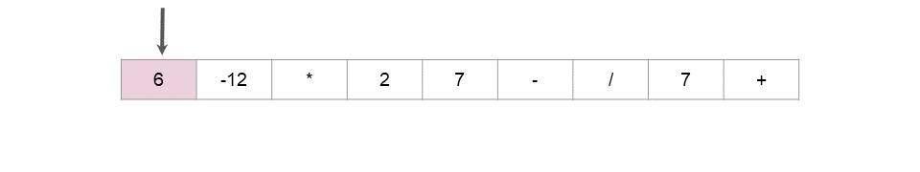

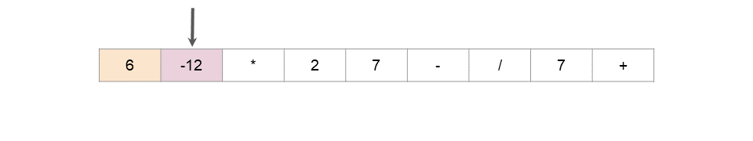

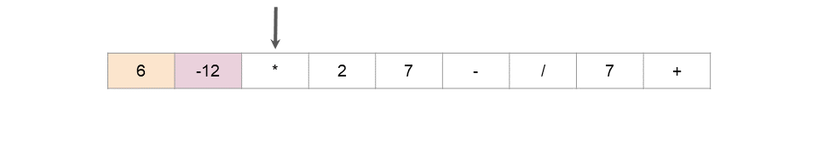

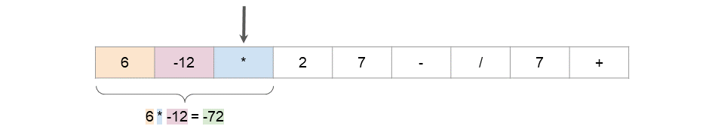

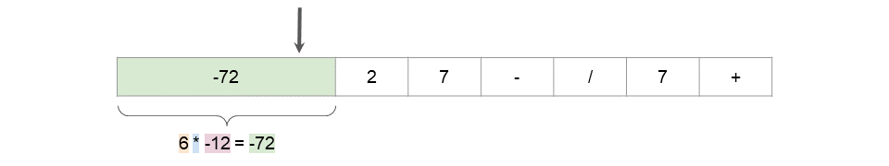

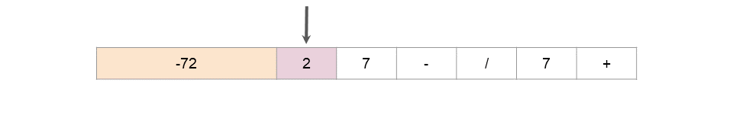

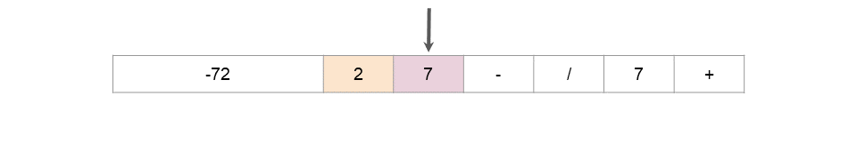

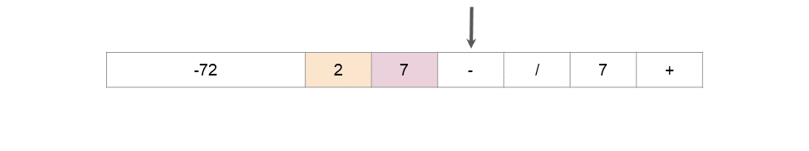

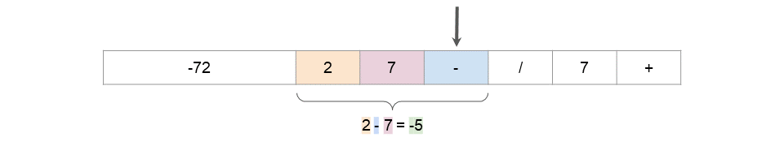

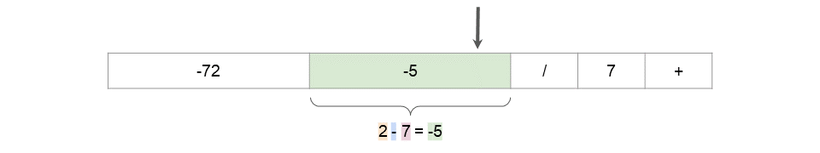

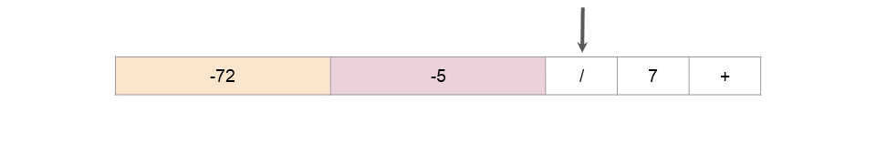

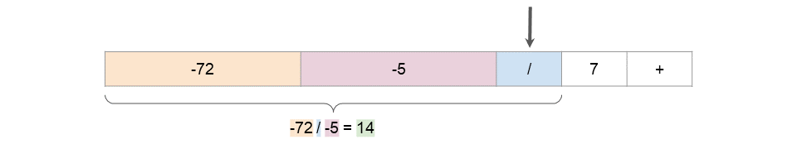

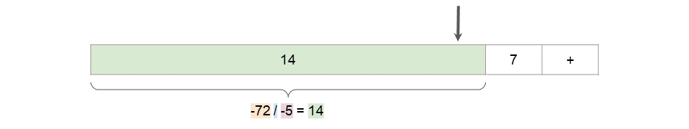

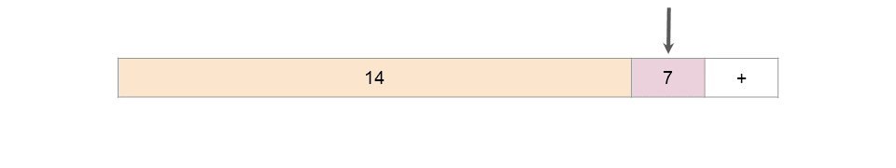

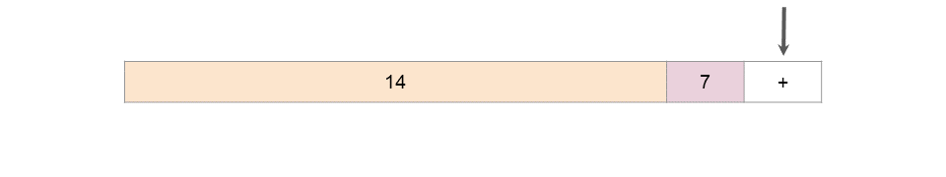

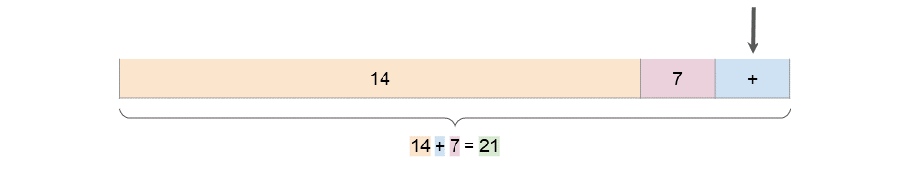

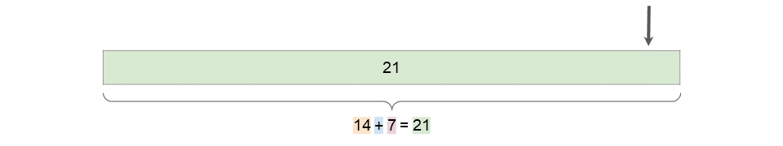

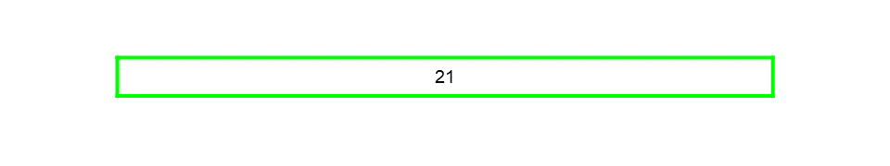

Hopefully the advantage is obvious now. Reverse Polish Notation doesn't require brackets, and the rules for evaluating it are far simpler. In-fact, our [equivalent question for Infix Notation](https://leetcode.com/problems/basic-calculator-iii/) is much more difficult than this one!

#### **Approach 1: Reducing the List In-place**

**Intuition**

This approach literally follows the animation above. A pointer is used to step through the list, and each time an operator (`+-*/) is found, that operator is then applied to the 2 values before it (which are always numbers, as long as the original input was valid). The 3 values are then replaced with the result. This process is repeated until the list is of length 1, containing a single number that is the answer to be returned.

**Algorithm**

The code is simpler for Python than Java. For Java (and other languages where the input type is a fixed size array), we have to define our own method to delete values from an array. This is done by shuffling the other elements down into the gap. Of course, you could start by copying the input into an ArrayList (so that you could then use its delete method), but then the algorithm would require *O*(*n*) space instead of *O*(1) space.

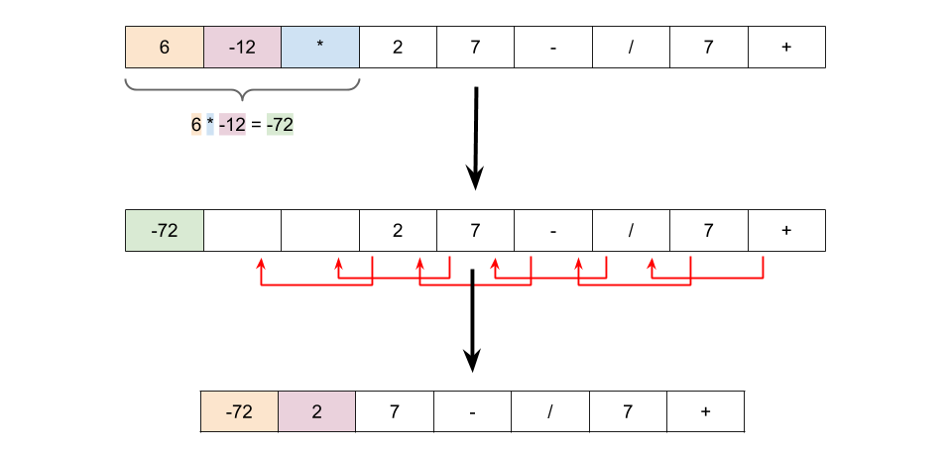

We have to be a little careful about the types in the Python code, as in the middle of processing the list, some numbers will be represent as strings, and others as ints. Additionally, we also need to be aware that python division does not truncate towards zero. We can instead use int(a / b) to achieve the desired result. Note that this is not the same as int(a // b).

In the Java code, we have to convert ints back to Strings, because Java doesn't support mixed lists of Strings and ints.

Finally, If you know how to use lambda functions in your chosen programming language, an ideal solution would use them to elegantly handle the 4 operations (+-*/). The first set of solutions here use lambda functions. If you aren't familiar with lambda functions though (or your chosen programming language doesn't support them), that's fine. You'll get a chance to learn them when you're ready! Scroll down a little more, as we have also provided solutions that don't use them.

|  |
| --- |
| class Solution {    private static final Map<String, BiFunction<Integer, Integer, Integer>> OPERATIONS = new HashMap<>();    // Ensure this only gets done once for ALL test cases.  static {  OPERATIONS.put("+", (a, b) -> a + b);  OPERATIONS.put("-", (a, b) -> a - b);  OPERATIONS.put("*", (a, b) -> a * b);  OPERATIONS.put("/", (a, b) -> a / b);  }    public int evalRPN(String[] tokens) {    int currentPosition = 0;  int length = tokens.length; // We need to keep track of this ourselves.    while (length > 1) {    // Move the position pointer to the next operator token.  while (!OPERATIONS.containsKey(tokens[currentPosition])) {  currentPosition++;  }    // Extract the operation and numbers to apply operation too.  String operation = tokens[currentPosition];  int number1 = Integer.parseInt(tokens[currentPosition - 2]);  int number2 = Integer.parseInt(tokens[currentPosition - 1]);    // Calculate the result to overwrite the operator with.  BiFunction<Integer, Integer, Integer> operator = OPERATIONS.get(operation);  int value = operator.apply(number1, number2);  tokens[currentPosition] = Integer.toString(value);    // Delete numbers and point pointers correctly.  delete2AtIndex(tokens, currentPosition - 2, length);  currentPosition--;  length -= 2;  }    return Integer.parseInt(tokens[0]);  }    private void delete2AtIndex(String[] tokens, int d, int length) {  for (int i = d; i < length - 2; i++) {  tokens[i] = tokens[i + 2];  }  }  } |

Here are the solutions without the use of lambda functions.

|  |
| --- |
| class Solution {  public int evalRPN(String[] tokens) {    int currentPosition = 0;  int length = tokens.length; // We will need to keep track of this ourselves.    while (length > 1) {    // Move the position pointer to the next operator token.  while (!"+-*/".contains(tokens[currentPosition])) {  currentPosition++;  }    // Extract the numbers.  int number1 = Integer.parseInt(tokens[currentPosition - 2]);  int number2 = Integer.parseInt(tokens[currentPosition - 1]);    // Calculate the result to overwrite the operator with.  int newValue = 0;  switch (tokens[currentPosition]) {  case "+":  newValue = number1 + number2;  break;  case "-":  newValue = number1 - number2;  break;  case "*":  newValue = number1 * number2;  break;  case "/":  newValue = number1 / number2;  break;  }  tokens[currentPosition] = Integer.toString(newValue);    // Delete numbers and point pointers correctly.  delete2AtIndex(tokens, currentPosition - 2, length);  currentPosition--;  length -= 2;  }    return Integer.parseInt(tokens[0]);  }    private void delete2AtIndex(String[] tokens, int d, int length) {  for (int i = d; i < length - 2; i++) {  tokens[i] = tokens[i + 2];  }  }  } |

**Complexity Analysis**

Let *n* be the length of the list.

* Time Complexity : O(n^2).

Firstly, it helps to calculate how many operators and how many numbers are in the initial list. Each step of the algorithm removes 1 operator, 2 numbers, and adds back 1 number. This is an overall loss of 1 number and 1 operator per step. At the end, we have 1 number left. Therefore, we can infer that at the start, there must always be **exactly 1 more number than there is operators**.

The big inefficiency of this approach is more obvious in the Java code than the Python. Deleting an item from an ArrayList or Array is O(n), because all the items after have to be shuffled down one place to fill in the gap. The number of these deletions we need to do is the same as the number of operators, which is proportional to *n*. Therefore, the cost of the deletions is O(n^2).

This is more obvious in the Java code, because we had to define the deletion method ourselves. However, the Python deletion method works the same way, it's just that you can't see it because it's hidden in a library function call. It's important to always be aware of the cost of library functions as they can sometimes look like they're O(1) when they're not!

* Space Complexity : *O*(1).

The only extra space used is a constant number of single-value variables. Therefore, the overall algorithm requires *O*(1) space.

Interestingly, this approach could be adapted to work with a **Double-Linked List**. It would require *O*(*n*) space to create the list, and then take *O*(*n*) time to process it using a similar algorithm to above. This works because the algorithm is traversing the list in a linear fashion and modifications only impact the tokens immediately to the left of the current token.

#### **Approach 2: Evaluate with Stack**

**Intuition**

The first approach worked, but O(n^2) is too slow for large *n*. As hinted at above, a **Double-Linked List** could be an option. However, it requires a lot of set-up code, and in practice requires more space than the elegant **Stack** approach we're going to look at now.

We don't want to repeatedly delete items from the middle of a list, as this inevitably leads to O(n^2) time performance. So recall that the above algorithm scanned through the list from left to right, and each time it reached an operator, it'd replace the operator and the 2 numbers immediately before it with the result of applying the operator to the 2 numbers.

The two key steps of the above algorithm were:

1. Visit each operator, in linear order. Finding these can be done with a linear search of the original list.
2. Get the 2 most recently seen numbers that haven't yet been replaced. These could be tracked using a **Stack**.

The algorithm would be as follows:

stack = new Stack()

for each token in tokens:

if token is a number:

stack.push(token)

else (token is operator):

number_2 = stack.pop()

number_1 = stack.pop()

result = apply_operator(token, number_1, number_2)

stack.push(result)

return stack.pop()

Here is an animation showing the algorithm.

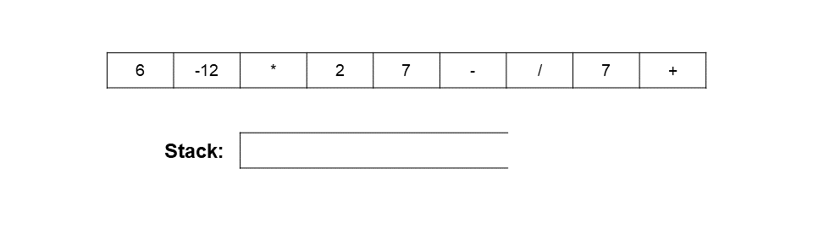

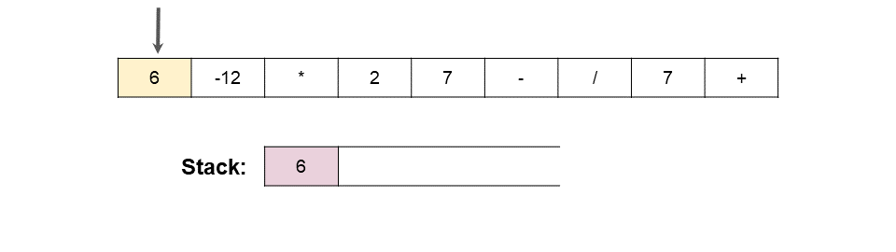

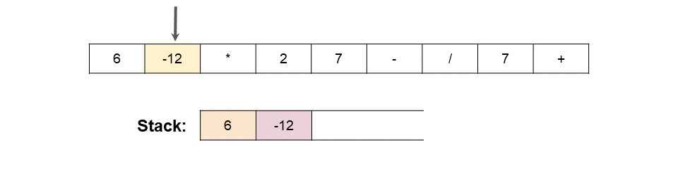

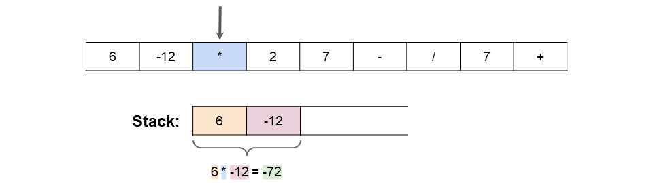

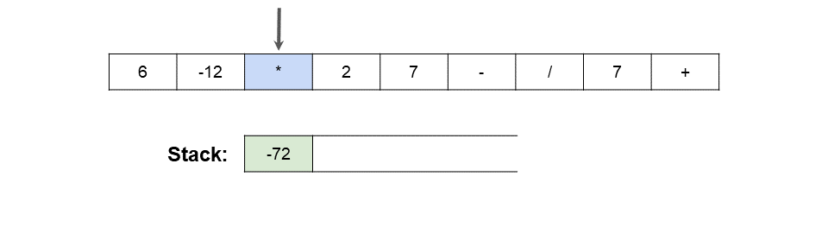

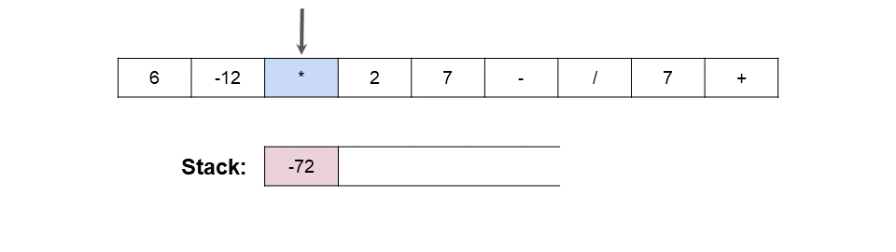

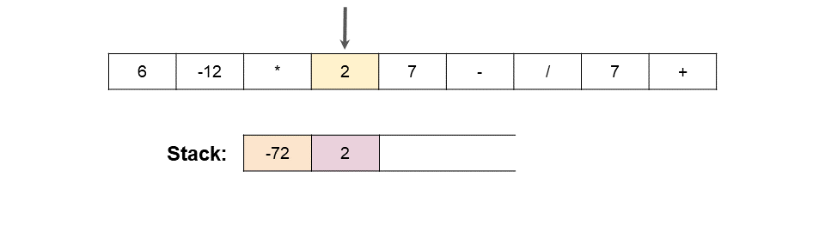

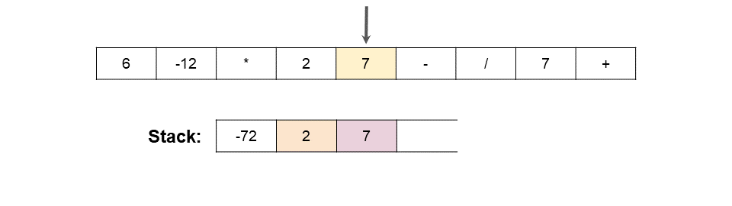

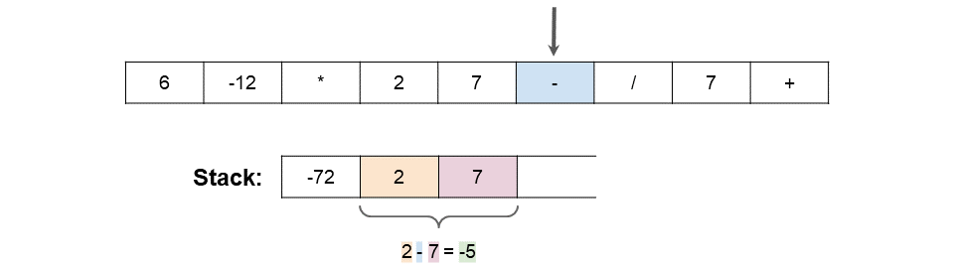

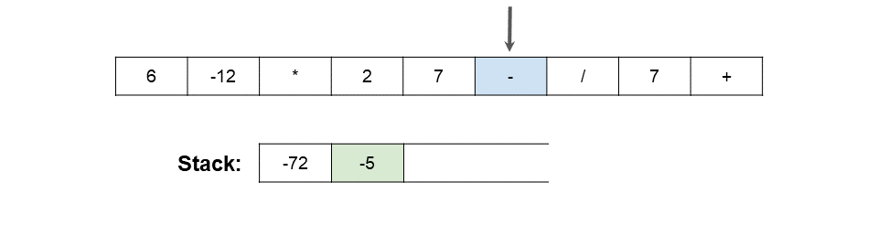

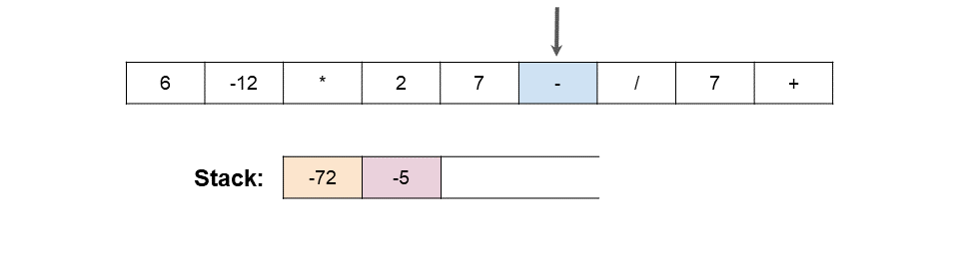

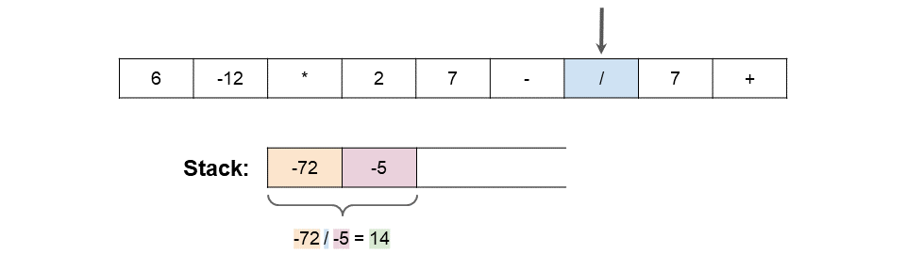

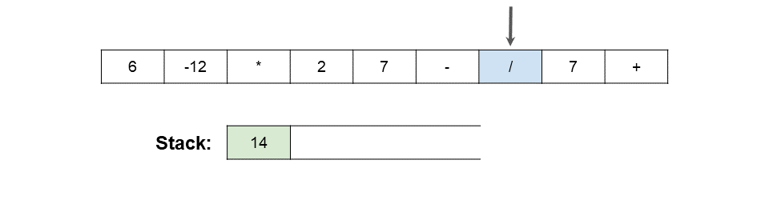

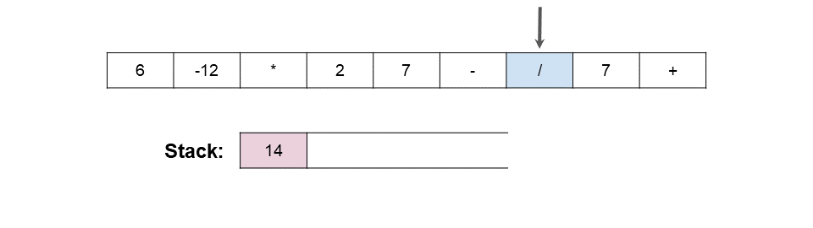

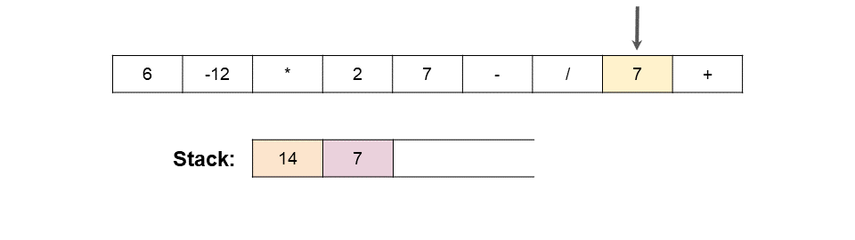

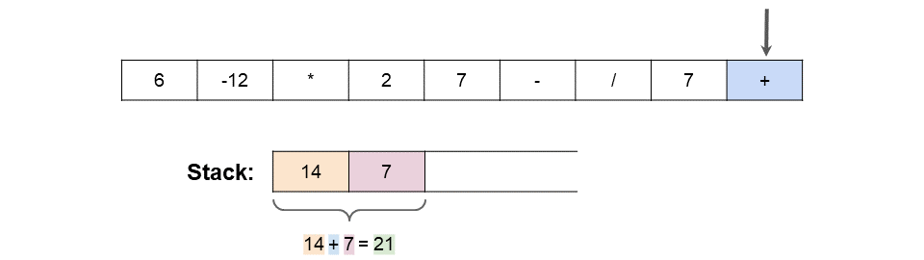

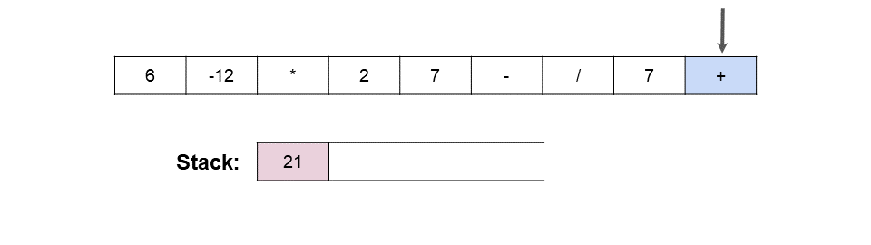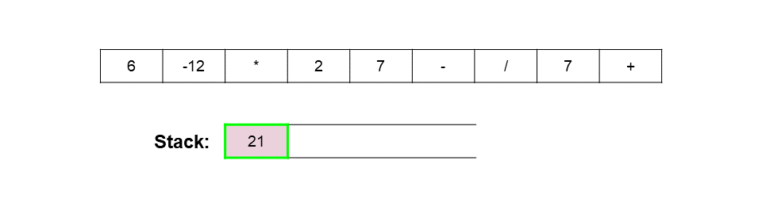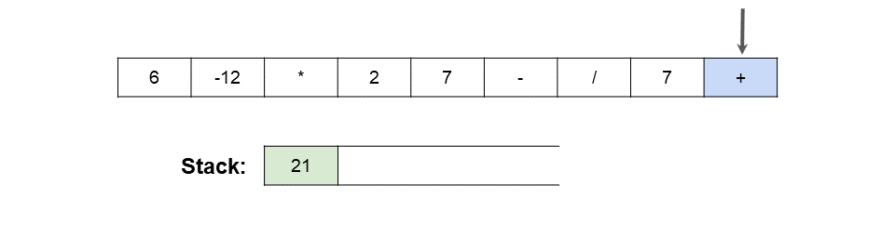

You might have noticed the following 2 lines of the pseudocode could look like they're around the wrong way.

number_2 = stack.pop()

number_1 = stack.pop()

They are correct though. Remember that for division and subtraction, the order of the numbers matters. i.e. 7 - 5 ≠ 5 - 7. On the Stack, we have the *second* on the top. So we need to reverse them before applying the operator.

**Algorithm**

Here is code that uses lambda functionality. Scroll down for code that doesn't.

|  |
| --- |
| class Solution {    private static final Map<String, BiFunction<Integer, Integer, Integer>> OPERATIONS = new HashMap<>();    // Ensure this only gets done once for ALL test cases.  static {  OPERATIONS.put("+", (a, b) -> a + b);  OPERATIONS.put("-", (a, b) -> a - b);  OPERATIONS.put("*", (a, b) -> a * b);  OPERATIONS.put("/", (a, b) -> a / b);  }    public int evalRPN(String[] tokens) {  Stack<Integer> stack = new Stack<>();  for (String token : tokens) {    if (!OPERATIONS.containsKey(token)) {  stack.push(Integer.valueOf(token));  continue;  }    int number2 = stack.pop();  int number1 = stack.pop();  BiFunction<Integer, Integer, Integer> operation;  operation = OPERATIONS.get(token);  int result = operation.apply(number1, number2);  stack.push(result);  }    return stack.pop();    }  } |

Here are the solutions without lambda.

|  |
| --- |
| class Solution {    public int evalRPN(String[] tokens) {    Stack<Integer> stack = new Stack<>();    for (String token : tokens) {    if (!"+-*/".contains(token)) {  stack.push(Integer.valueOf(token));  continue;  }    int number2 = stack.pop();  int number1 = stack.pop();    int result = 0;    switch (token) {  case "+":  result = number1 + number2;  break;  case "-":  result = number1 - number2;  break;  case "*":  result = number1 * number2;  break;  case "/":  result = number1 / number2;  break;  }    stack.push(result);    }    return stack.pop();  }  } |

**Complexity Analysis**

Let n*n* be the length of the list.

* Time Complexity : *O*(*n*).

We do a linear search to put all numbers on the stack, and process all operators. Processing an operator requires removing 2 numbers off the stack and replacing them with a single number, which is an *O*(1) operation. Therefore, the total cost is proportional to the length of the input array. Unlike before, we're no longer doing expensive deletes from the middle of an Array or List.

* Space Complexity : *O*(*n*).

In the worst case, the stack will have all the numbers on it at the same time. This is never more than half the length of the input array.

**Majority Element**

Given an array nums of size n, return the majority element.

The majority element is the element that appears more than ⌊n / 2⌋ times. You may assume that the majority element always exists in the array.

**Example 1:**

**Input:** nums = [3,2,3]

**Output:** 3

**Example 2:**

**Input:** nums = [2,2,1,1,1,2,2]

**Output:** 2

**Constraints:**

* n == nums.length
* 1 <= n <= 5 * 104
* -231 <= nums[i] <= 231 - 1

**Follow-up:** Could you solve the problem in linear time and in O(1) space?

#### **Approach 1: Brute Force**

**Intuition**

We can exhaust the search space in quadratic time by checking whether each element is the majority element.

**Algorithm**

The brute force algorithm iterates over the array, and then iterates again for each number to count its occurrences. As soon as a number is found to have appeared more than any other can possibly have appeared, return it.

|  |
| --- |
| class Solution {  public int majorityElement(int[] nums) {  int majorityCount = nums.length/2;  for (int num : nums) {  int count = 0;  for (int elem : nums) {  if (elem == num) {  count += 1;  }  }  if (count > majorityCount) {  return num;  }  }  return -1;  }  } |

**Complexity Analysis**

* Time complexity : O(n^2)

The brute force algorithm contains two nested for loops that each run for n*n* iterations, adding up to quadratic time complexity.

* Space complexity : O(1)

The brute force solution does not allocate additional space proportional to the input size.

#### **Approach 2: HashMap**

**Intuition**

We know that the majority element occurs more than floor⌊ n/2 ​⌋ times, and a HashMap allows us to count element occurrences efficiently.

**Algorithm**

We can use a HashMap that maps elements to counts in order to count occurrences in linear time by looping over nums. Then, we simply return the key with maximum value.

|  |
| --- |
| class Solution {  private Map<Integer, Integer> countNums(int[] nums) {  Map<Integer, Integer> counts = new HashMap<Integer, Integer>();  for (int num : nums) {  if (!counts.containsKey(num)) {  counts.put(num, 1);  }  else {  counts.put(num, counts.get(num)+1);  }  }  return counts;  }  public int majorityElement(int[] nums) {  Map<Integer, Integer> counts = countNums(nums);  Map.Entry<Integer, Integer> majorityEntry = null;  for (Map.Entry<Integer, Integer> entry : counts.entrySet()) {  if (majorityEntry == null || entry.getValue() > majorityEntry.getValue()) {  majorityEntry = entry;  }  }  return majorityEntry.getKey();  }  } |

**Complexity Analysis**

* Time complexity : O(n)

We iterate over nums once and make a constant time HashMap insertion on each iteration. Therefore, the algorithm runs in *O*(*n*) time.

* Space complexity : O(n)  
  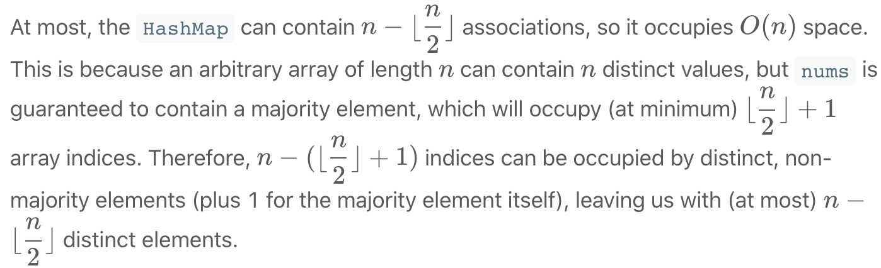

#### **Approach 3: Sorting**

**Intuition**

If the elements are sorted in monotonically increasing (or decreasing) order, the majority element can be found at 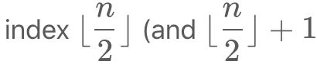, incidentally, if *n* is even).

**Algorithm**

For this algorithm, we simply do exactly what is described: sort nums, and return the element in question. To see why this will always return the majority element (given that the array has one), consider the figure below (the top example is for an odd-length array and the bottom is for an even-length array):

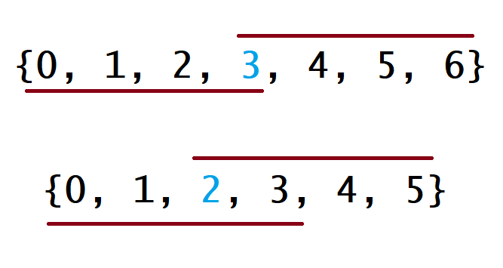

For each example, the line below the array denotes the range of indices that are covered by a majority element that happens to be the array minimum. As you might expect, the line above the array is similar, but for the case where the majority element is also the array maximum. In all other cases, this line will lie somewhere between these two, but notice that even in these two most extreme cases, they overlap at index floor⌊ n/2 ​⌋ for both even- and odd-length arrays. Therefore, no matter what value the majority element has in relation to the rest of the array, returning the value at floor⌊ n/2 ​⌋ will never be wrong.

|  |
| --- |
| class Solution {  public int majorityElement(int[] nums) {  Arrays.sort(nums);  return nums[nums.length/2];  }  } |

**Complexity Analysis**

* Time complexity : *O*(*nlgn*)

Sorting the array costs *O*(*nlgn*) time in Python and Java, so it dominates the overall runtime.

* Space complexity : *O*(1) or *O*(*n*))

We sorted nums in place here - if that is not allowed, then we must spend linear additional space on a copy of nums and sort the copy instead.

#### **Approach 4: Randomization**

**Intuition**

Because more than floor⌊ n/2 ​⌋  array indices are occupied by the majority element, a random array index is likely to contain the majority element.

**Algorithm**

Because a given index is likely to have the majority element, we can just select a random index, check whether its value is the majority element, return if it is, and repeat if it is not. The algorithm is verifiably correct because we ensure that the randomly chosen value is the majority element before ever returning.

|  |
| --- |
| class Solution {  private int randRange(Random rand, int min, int max) {  return rand.nextInt(max - min) + min;  }  private int countOccurences(int[] nums, int num) {  int count = 0;  for (int i = 0; i < nums.length; i++) {  if (nums[i] == num) {  count++;  }  }  return count;  }  public int majorityElement(int[] nums) {  Random rand = new Random();  int majorityCount = nums.length/2;  while (true) {  int candidate = nums[randRange(rand, 0, nums.length)];  if (countOccurences(nums, candidate) > majorityCount) {  return candidate;  }  }  }  } |

**Complexity Analysis**

* Time complexity : *O*(∞)

It is technically possible for this algorithm to run indefinitely (if we never manage to randomly select the majority element), so the worst possible runtime is unbounded. However, the expected runtime is far better - linear, in fact. For ease of analysis, convince yourself that because the majority element is guaranteed to occupy *more* than half of the array, the expected number of iterations will be less than it would be if the element we sought occupied exactly *half* of the array. Therefore, we can calculate the expected number of iterations for this modified version of the problem and assert that our version is easier.

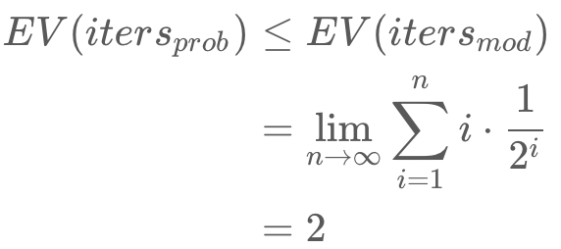

Because the series converges, the expected number of iterations for the modified problem is constant. Based on an expected-constant number of iterations in which we perform linear work, the expected runtime is linear for the modifed problem. Therefore, the expected runtime for our problem is also linear, as the runtime of the modifed problem serves as an upper bound for it.

* Space complexity : O(1)

Much like the brute force solution, the randomized approach runs with constant additional space.

#### **Approach 5: Divide and Conquer**

**Intuition**

If we know the majority element in the left and right halves of an array, we can determine which is the global majority element in linear time.

**Algorithm**

Here, we apply a classical divide & conquer approach that recurses on the left and right halves of an array until an answer can be trivially achieved for a length-1 array. Note that because actually passing copies of subarrays costs time and space, we instead pass lo and hi indices that describe the relevant slice of the overall array. In this case, the majority element for a length-1 slice is trivially its only element, so the recursion stops there. If the current slice is longer than length-1, we must combine the answers for the slice's left and right halves. If they agree on the majority element, then the majority element for the overall slice is obviously the same[[1]](https://leetcode.com/problems/majority-element/solution/#fn1). If they disagree, only one of them can be "right", so we need to count the occurrences of the left and right majority elements to determine which subslice's answer is globally correct. The overall answer for the array is thus the majority element between indices 0 and *n*.

|  |
| --- |
| class Solution {  private int countInRange(int[] nums, int num, int lo, int hi) {  int count = 0;  for (int i = lo; i <= hi; i++) {  if (nums[i] == num) {  count++;  }  }  return count;  }  private int majorityElementRec(int[] nums, int lo, int hi) {  // base case; the only element in an array of size 1 is the majority  // element.  if (lo == hi) {  return nums[lo];  }  // recurse on left and right halves of this slice.  int mid = (hi-lo)/2 + lo;  int left = majorityElementRec(nums, lo, mid);  int right = majorityElementRec(nums, mid+1, hi);  // if the two halves agree on the majority element, return it.  if (left == right) {  return left;  }  // otherwise, count each element and return the "winner".  int leftCount = countInRange(nums, left, lo, hi);  int rightCount = countInRange(nums, right, lo, hi);  return leftCount > rightCount ? left : right;  }  public int majorityElement(int[] nums) {  return majorityElementRec(nums, 0, nums.length-1);  }  } |

**Complexity Analysis**

* Time complexity : *O*(*nlgn*)

Each recursive call to majority_element_rec performs two recursive calls on subslices of size n/2​ and two linear scans of length *n*. Therefore, the time complexity of the divide & conquer approach can be represented by the following recurrence relation:

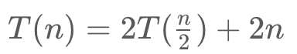

By the [master theorem](https://en.wikipedia.org/wiki/Master_theorem_(analysis_of_algorithms)), the recurrence satisfies case 2, so the complexity can be analyzed as such:

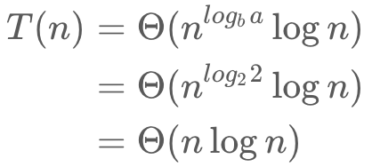

* Space complexity : O(lgn)

Although the divide & conquer does not explicitly allocate any additional memory, it uses a non-constant amount of additional memory in stack frames due to recursion. Because the algorithm "cuts" the array in half at each level of recursion, it follows that there can only be *O*(*lgn*) "cuts" before the base case of 1 is reached. It follows from this fact that the resulting recursion tree is balanced, and therefore all paths from the root to a leaf are of length *O*(*lgn*). Because the recursion tree is traversed in a depth-first manner, the space complexity is therefore equivalent to the length of the longest path, which is, of course, *O*(*lgn*).

#### **Approach 6: Boyer-Moore Voting Algorithm**

**Intuition**

If we had some way of counting instances of the majority element as +1 and instances of any other element as −1, summing them would make it obvious that the majority element is indeed the majority element.

**Algorithm**

Essentially, what Boyer-Moore does is look for a suffix *suf* of nums where *suf*[0] is the majority element in that suffix. To do this, we maintain a count, which is incremented whenever we see an instance of our current candidate for majority element and decremented whenever we see anything else. Whenever count equals 0, we effectively forget about everything in nums up to the current index and consider the current number as the candidate for majority element. It is not immediately obvious why we can get away with forgetting prefixes of nums - consider the following examples (pipes are inserted to separate runs of nonzero count).

[7, 7, 5, 7, 5, 1 | 5, 7 | 5, 5, 7, 7 | 7, 7, 7, 7]

Here, the 7 at index 0 is selected to be the first candidate for majority element. count will eventually reach 0 after index 5 is processed, so the 5 at index 6 will be the next candidate. In this case, 7 is the true majority element, so by disregarding this prefix, we are ignoring an equal number of majority and minority elements - therefore, 7 will still be the majority element in the suffix formed by throwing away the first prefix.

[7, 7, 5, 7, 5, 1 | 5, 7 | 5, 5, 7, 7 | **5, 5, 5, 5**]

Now, the majority element is 5 (we changed the last run of the array from 7s to 5s), but our first candidate is still 7. In this case, our candidate is not the true majority element, but we still cannot discard more majority elements than minority elements (this would imply that count could reach -1 before we reassign candidate, which is obviously false).

Therefore, given that it is impossible (in both cases) to discard more majority elements than minority elements, we are safe in discarding the prefix and attempting to recursively solve the majority element problem for the suffix. Eventually, a suffix will be found for which count does not hit 0, and the majority element of that suffix will necessarily be the same as the majority element of the overall array.

|  |
| --- |
| class Solution {  public int majorityElement(int[] nums) {  int count = 0;  Integer candidate = null;  for (int num : nums) {  if (count == 0) {  candidate = num;  }  count += (num == candidate) ? 1 : -1;  }  return candidate;  }  } |

**Complexity Analysis**

* Time complexity : *O*(*n*)

Boyer-Moore performs constant work exactly n*n* times, so the algorithm runs in linear time.

* Space complexity : *O*(1)

Boyer-Moore allocates only constant additional memory.

**Find the Celebrity**

Suppose you are at a party with n people (labeled from 0 to n - 1), and among them, there may exist one celebrity. The definition of a celebrity is that all the other n - 1 people know him/her, but he/she does not know any of them.

Now you want to find out who the celebrity is or verify that there is not one. The only thing you are allowed to do is to ask questions like: "Hi, A. Do you know B?" to get information about whether A knows B. You need to find out the celebrity (or verify there is not one) by asking as few questions as possible (in the asymptotic sense).

You are given a helper function bool knows(a, b) which tells you whether A knows B. Implement a function int findCelebrity(n). There will be exactly one celebrity if he/she is in the party. Return the celebrity's label if there is a celebrity in the party. If there is no celebrity, return -1.

**Example 1:**

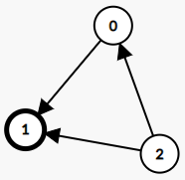

**Input:** graph = [[1,1,0],[0,1,0],[1,1,1]]

**Output:** 1

**Explanation:** There are three persons labeled with 0, 1 and 2. graph[i][j] = 1 means person i knows person j, otherwise graph[i][j] = 0 means person i does not know person j. The celebrity is the person labeled as 1 because both 0 and 2 know him but 1 does not know anybody.

**Example 2:**

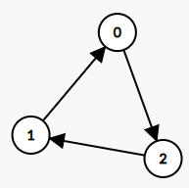

**Input:** graph = [[1,0,1],[1,1,0],[0,1,1]]

**Output:** -1

**Explanation:** There is no celebrity.

**Constraints:**

* n == graph.length
* n == graph[i].length
* 2 <= n <= 100
* graph[i][j] is 0 or 1.
* graph[i][i] == 1

**Follow up:** If the maximum number of allowed calls to the API knows is 3 * n, could you find a solution without exceeding the maximum number of calls?

   Hide Hint #1

The best hint for this problem can be provided by the following figure:  
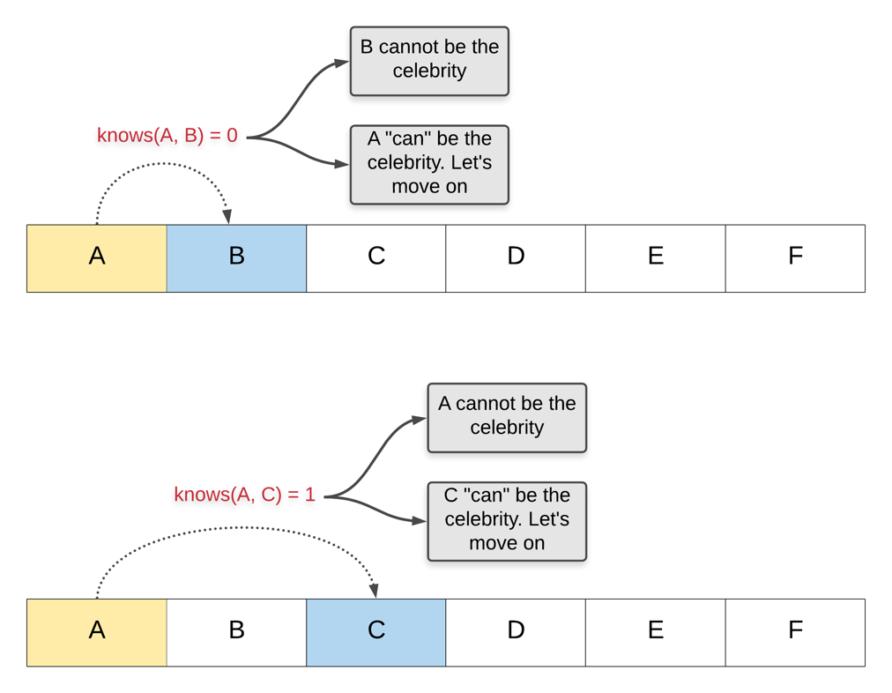

   Hide Hint #2

Well, if you understood the gist of the above idea, you can extend it to find a candidate that can possibly be a celebrity. Why do we say a "candidate"? That is for you to think. This is clearly a greedy approach to find the answer. However, there is some information that would still remain to be verified without which we can't obtain an answer with certainty. To get that stake in the ground, we would need some more calls to the knows API.

## Solution

#### **Approach 1: Brute Force**

**Intuition**

As per the problem statement, for a given person i, we can check whether or not i is a celebrity by using the knows(...) API to see if everybody knows i, and that i know nobody.

Therefore, the simplest way of solving this problem is to go through each of the people in turn, and check whether or not they are a celebrity.

**Algorithm**

It's best to define a separate isCelebrity(...) function that takes the id number of a specific person and returns true if they are a celebrity and false if not. This avoids the need for complex loop-break conditions, thus keeping the code cleaner.

One edge case we need to be cautious of is not asking person i if they know themselves. This can be handled by a check for i == j at the start of the main loop of isCelebrity(...) and then simply continue-ing when it is true.

|  |
| --- |
| public class Solution extends Relation {    private int numberOfPeople;    public int findCelebrity(int n) {  numberOfPeople = n;  for (int i = 0; i < n; i++) {  if (isCelebrity(i)) {  return i;  }  }  return -1;  }    private boolean isCelebrity(int i) {  for (int j = 0; j < numberOfPeople; j++) {  if (i == j) continue; // Don't ask if they know themselves.  if (knows(i, j) || !knows(j, i)) {  return false;  }  }  return true;  }  } |

**Complexity Analysis**

We don't know what time and space the knows(...) API uses. Because it's not our concern, we'll assume it's *O*(1) for the purpose of analysing our algorithm.

* Time Complexity : O(n^2).

For each of the *n* people, we need to check whether or not they are a celebrity.

Checking whether or not somebody is a celebrity requires making 2 API calls for each of the *n*−1 other people, for a total of 2⋅(*n*−1)=2⋅*n*−2 calls. In big-oh notation, we drop the constants, leaving *O*(*n*).

So each of the n*n* celebrity checks will cost *O*(*n*), giving a total of O(n^2).

* Space Complexity : O(1).

Our code only uses constant extra space. The results of the API calls are not saved.

#### **Approach 2: Logical Deduction**

**Intuition**

We can do far better than the above approach. Let's start by looking at another way of representing the problem, which is a great way for approaching it in an interview. What we actually have in this problem is a **graph**, where a directed edge going from person A to person B means that we have confirmed that A knows B.

For example, here is a possible graph. Assume that we have made all possible calls to the knows(...) API to find these edges. Is there a celebrity here? If so, who is it?

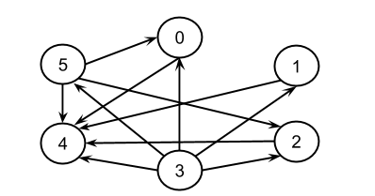

What about in this graph?

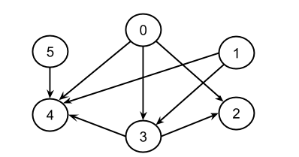

And this one?

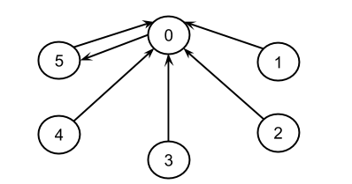

On the graph representation, a celebrity is a person who has exactly n - 1 directed edges going in (everybody knows them) and 0 edges going out (they know nobody).

On the first example we looked at above, person 4 is a celebrity because they have 5 directed edges going in, which is n - 1. They have no directed edges going out. Note that 3 is not a celebrity because they have 5 outgoing edges, not 5 ingoing.

On the second example, there is no celebrity. Person 4 is not a celebrity, because person 2 doesn't know them. There are only n - 2 directed edges going into 4.

On the third example, there is also no celebrity. Person 0 is not a celebrity, because they know person 5, as represented by the directed edge going from 0 to 5.

At the start, we only know the nodes of the graph. The edges are all hidden. We can "uncover" edges by making calls to the knows(...) API. In the first approach, we uncovered all the edges this way. So, the question we need to ask now is... was it actually necessary to uncover all of them? A good way to answer this question in an interview is to work through an example on the whiteboard, where you decide which edges you want to ask for, and then draw them as you go.

When you do your own example, you'll of course need to know what the full graph behind your example is, or at least the important aspects of it, but you also need to focus on what information you've "uncovered" by using the knows(...) API.

Here is an animation of an example. To distinguish between not (A knows B) and we-haven't-yet-asked if A knows B, we use a green solid arrow to show A knows B, a red dotted arrow to show not (A knows B) and no arrow if we haven't yet asked.

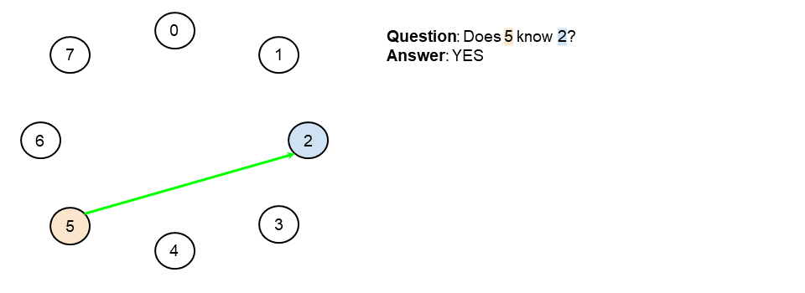

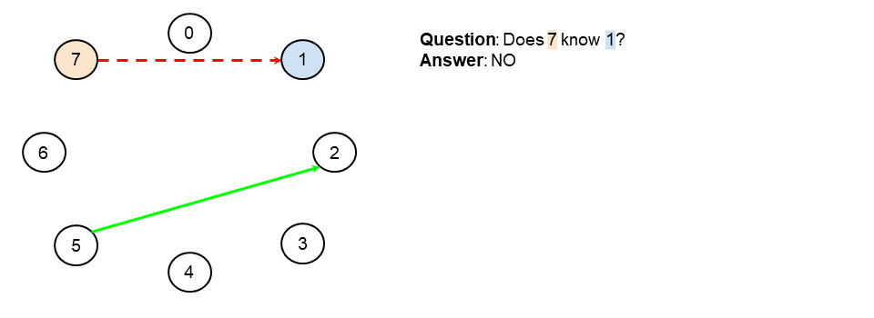

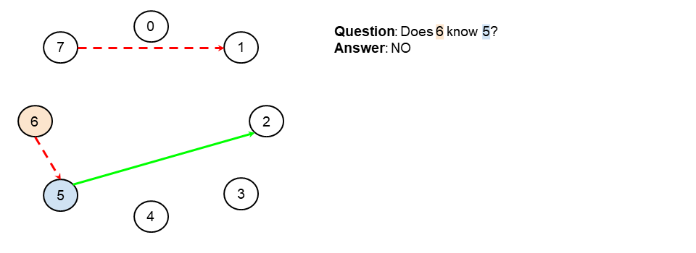

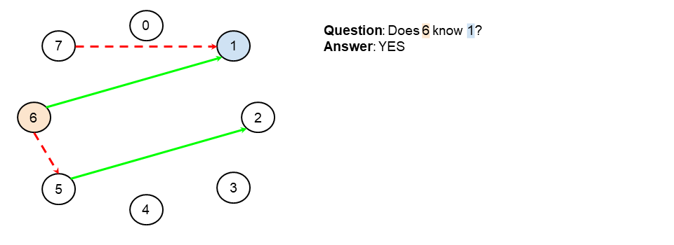

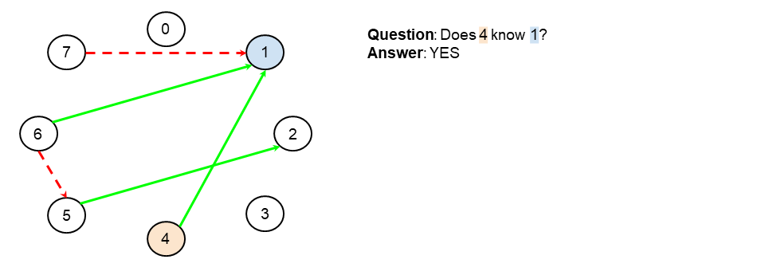

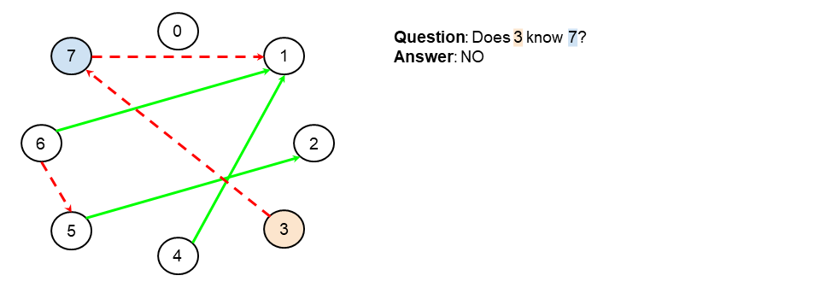

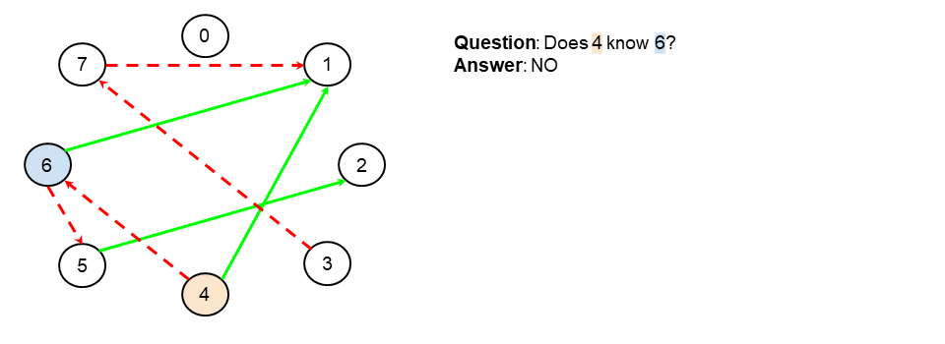

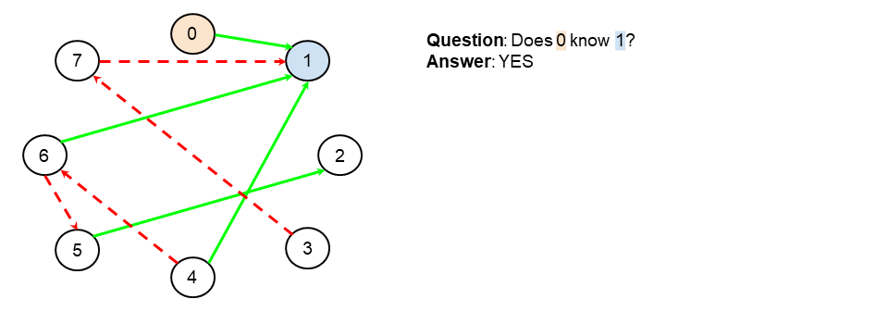

During the example in the animation, we asked if 4 knows 6. Why was this question not necessary to identify the celebrity?

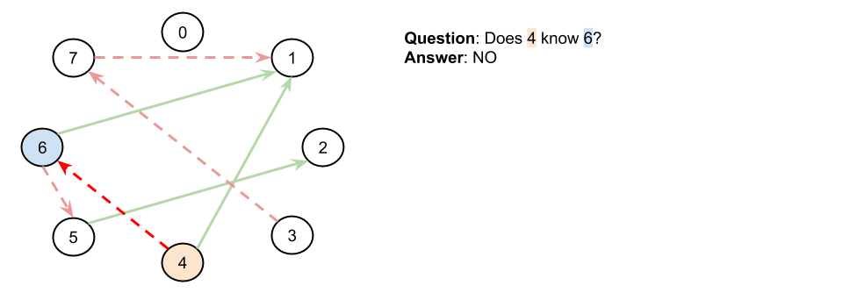

Well, because we already know that both 4 and 6 know at least one other person, this means that neither of them could be the celebrity! Therefore, we've already ruled them out, there was no need to investigate them further.

So, what can we conclude from the result of an A knows B check? If the result was true, could A be the celebrity? What about B?

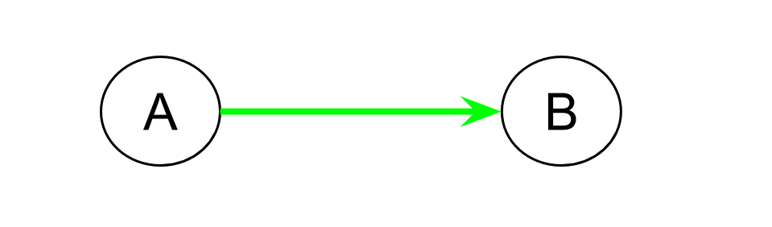

And what about if A knows B returned false? Who couldn't be a celebrity now?

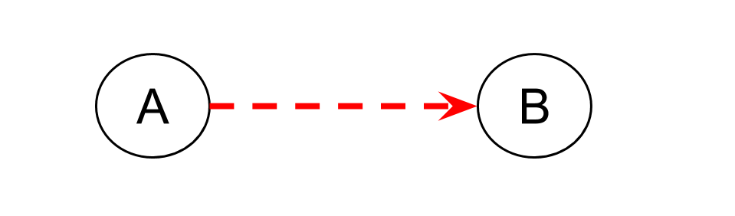

In the first example, we know that A can't be a celebrity, because A knows somebody, namely B. In the second example, we know that B can't be a celebrity, because A, doesn't know him/her.

Therefore, with each call to knows(...), we can conclusively determine that exactly **1** of the people is not a celebrity!

The following algorithm can, therefore, be used to rule out n - 1 of the people in O(n)*O*(*n*) time. We start by guessing that 0 might be a celebrityCandidate, and then we check if 0 knows 1 (within the loop). If true, then we know 0 isn't a celebrity (they know somebody), but 1 might be. We update the celebrityCandidate variable to 1 to reflect this. Otherwise, we know 1 is not a celebrity (somebody doesn't know them), but we haven't ruled out 0, yet, so keep them as the celebrityCandidate. Whoever we kept is then asked if they know 2, and so forth.

celebrity_candidate = 0

for i in range(1, n):

if knows(celebrity_candidate, i):

celebrity_candidate = i

At the end, the only person we haven't ruled out is in the celebrityCandidate variable.

Here is an animation of the algorithm.

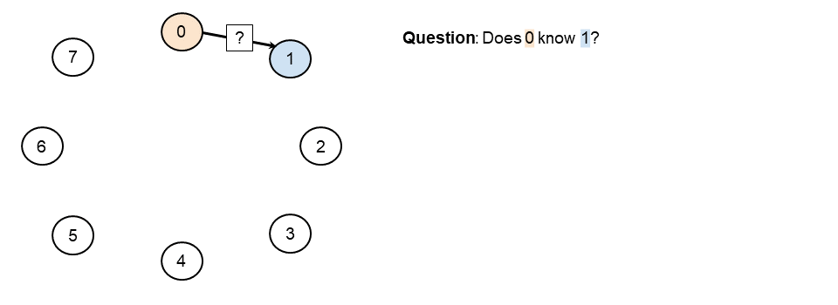

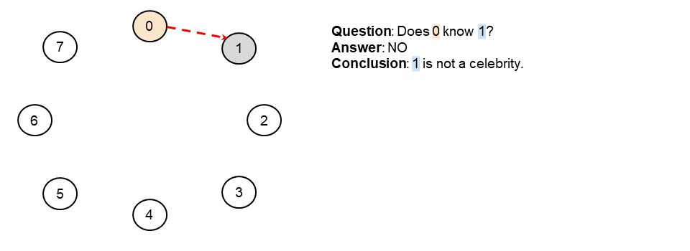

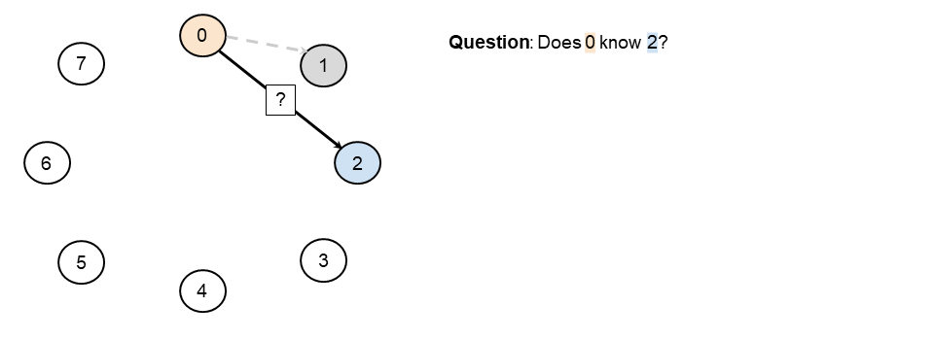

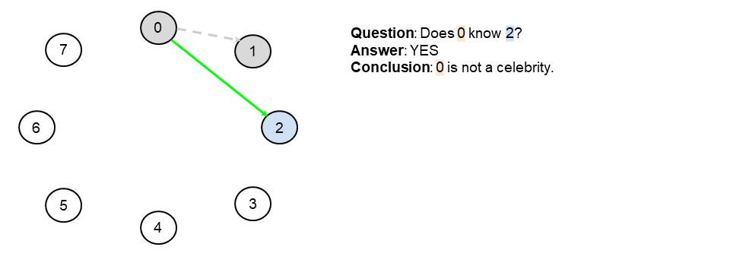

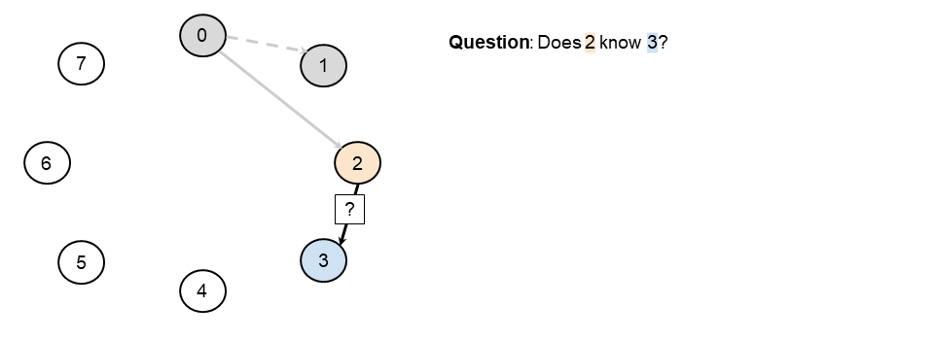

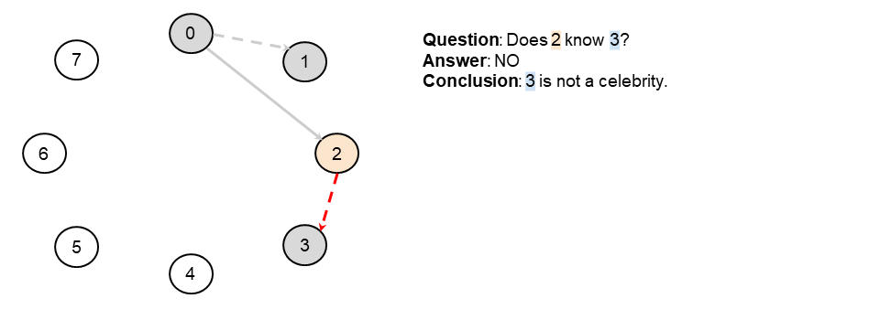

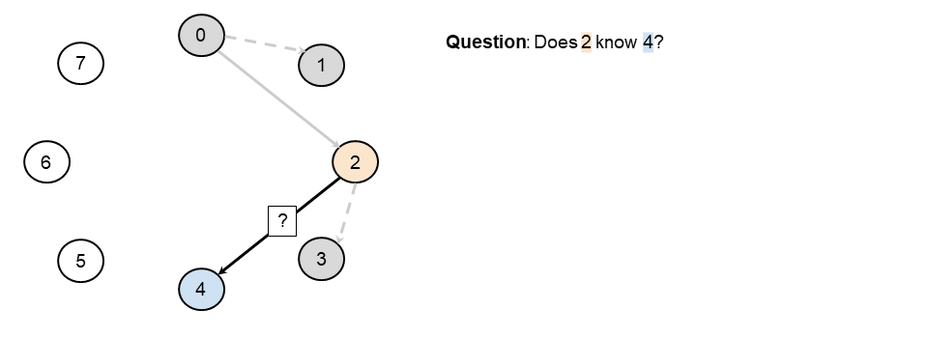

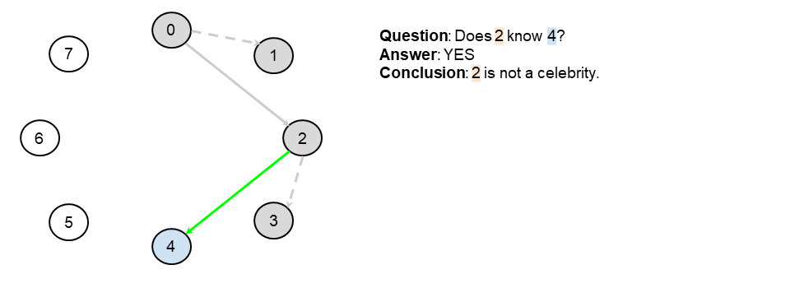

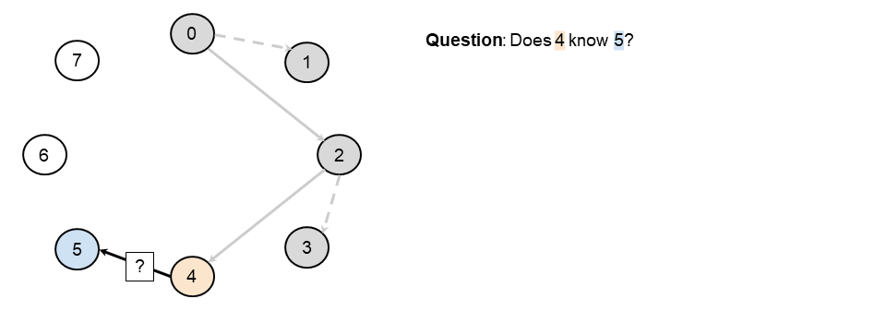

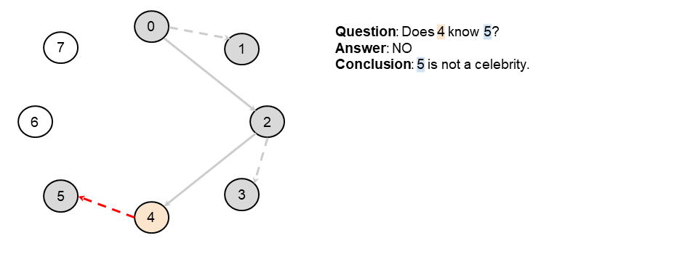

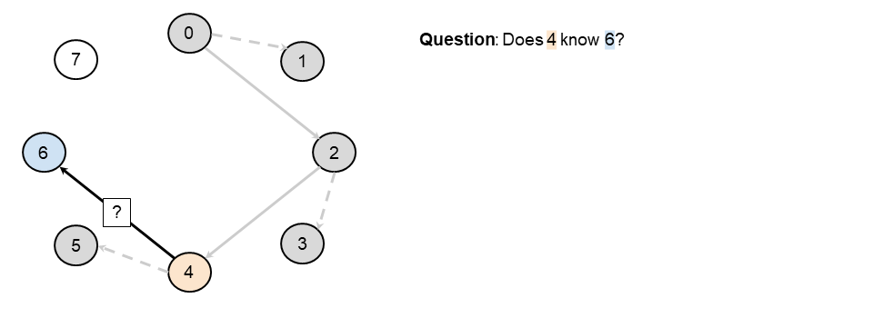

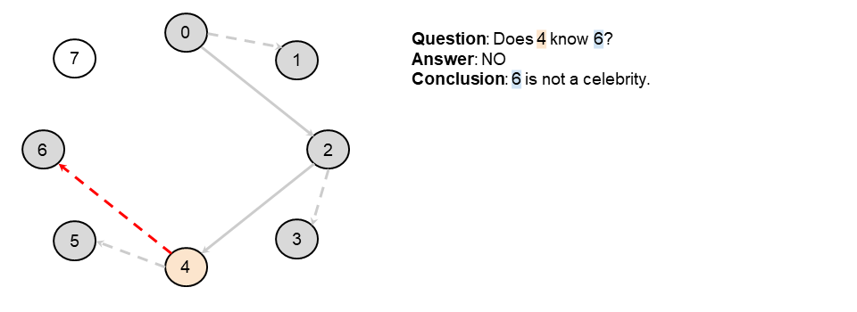

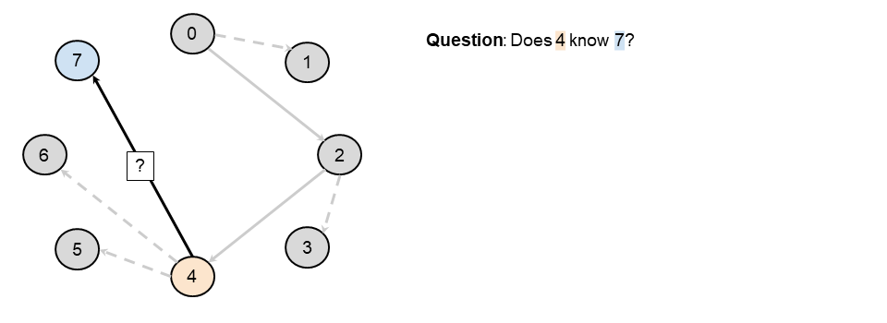

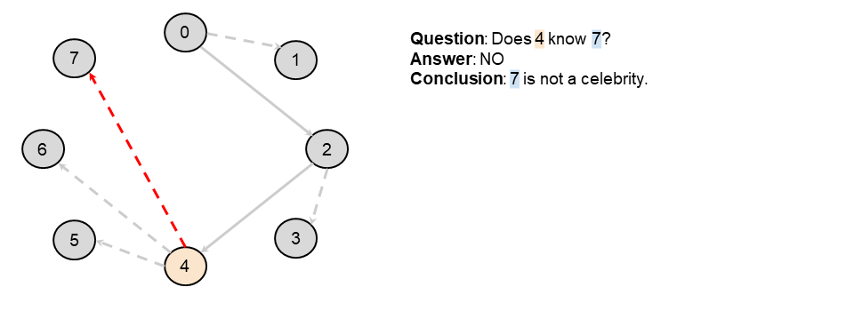

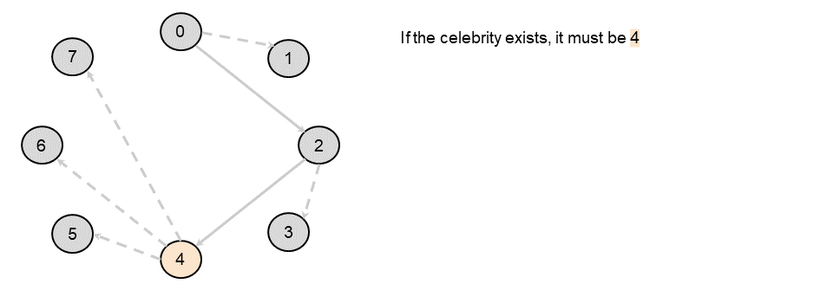

At the end of the example in the animation, this is how our graph looked. The person who we haven't ruled out is 4.

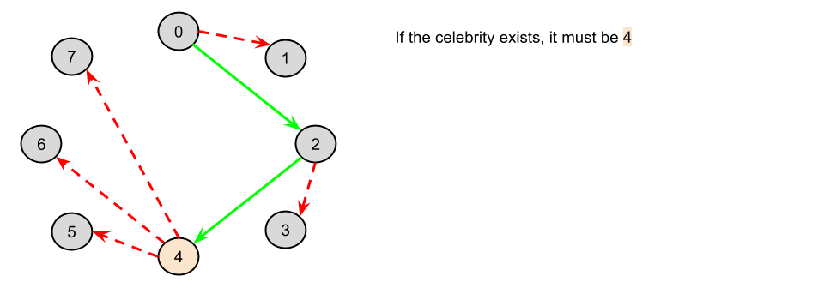

But do we actually know for sure that this person is a celebrity? (Remember, it's possible there's no celebrity, in which case we'd return -1).

Nope! It's still possible that 0 doesn't know 4, or perhaps 4 knows 3. We can't rule these possibilities out from the information we have uncovered so far.

So, what can we do? We can use our isCelebrity(...) function on 4 to check whether or not they are a celebrity. If they are, our function will return 4. If not, then it should return -1.

**Algorithm**

Our algorithm firstly narrows the people down to a single celebrityCandidate using the algorithm just above, and then it checks whether or not that candidate is a celebrity using the isCelebrity(...).

|  |
| --- |
| public class Solution extends Relation {    private int numberOfPeople;    public int findCelebrity(int n) {  numberOfPeople = n;  int celebrityCandidate = 0;  for (int i = 0; i < n; i++) {  if (knows(celebrityCandidate, i)) {  celebrityCandidate = i;  }  }  if (isCelebrity(celebrityCandidate)) {  return celebrityCandidate;  }  return -1;  }    private boolean isCelebrity(int i) {  for (int j = 0; j < numberOfPeople; j++) {  if (i == j) continue; // Don't ask if they know themselves.  if (knows(i, j) || !knows(j, i)) {  return false;  }  }  return true;  }  } |

**Complexity Analysis**

* Time Complexity : O(n).

Our code is split into 2 parts.

The first part finds a celebrity candidate. This requires doing *n*−1 calls to knows(...) API, and so is *O*(*n*).

The second part is the same as before—checking whether or not a given person is a celebrity. We determined that this is *O*(*n*).

Therefore, we have a total time complexity of *O*(*n*+*n*)=*O*(*n*).

* Space Complexity : *O*(1).

Same as above. We are only using constant extra space.

#### **Approach 3: Logical Deduction with Caching**

**Intuition**

You probably won't need to implement this approach in an interview, however, I wouldn't be surprised if discussing these ideas was a follow up question. For that reason, we'll take a quick look at it!

Have a look at our example from above again. These are the calls to the knows(...) API that were made to identify that 4 is a celebrity candidate.



Now, these are the calls that our Approach 2 would have made in the second phase to check whether or not our celebrity candidate, 4, actually is a celebrity.

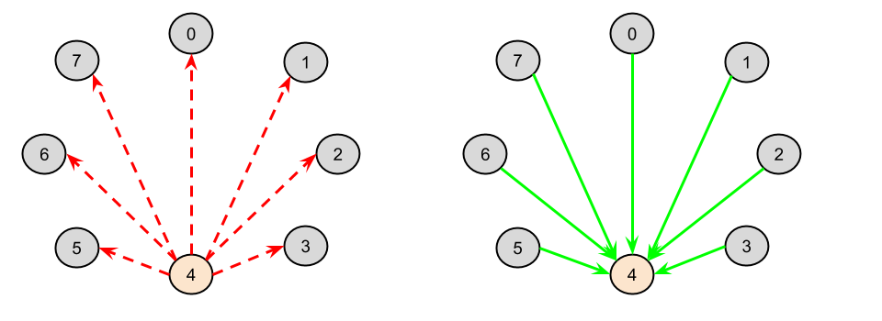

As shown in the above images, we made some of the same calls twice! The lower the number of the celebrity candidate, the more of these duplicated calls there will be, because the celebrity candidate spent longer in the celebrityCandidate variable, and so was involved in a lot more of the initial "questioning". Is this actually wasteful though?

We know that the best possible time complexity we could ever achieve in the average/ worst case is *O*(*n*). The easiest way of proving this to point out that confirming that somebody is a celebrity requires *O*(*n*) checks. There's simply no way around it, if you miss just one of those checks, it could have been the one that showed they were not.

So, because we can never do better than *O*(*n*) anyway, surely it really doesn't matter?

Yes and no! It's possible that calls to the knows(...) API could be really expensive (i.e. slow). For example, in the scenario presented in the question, you need to ask the question to people and then listen for their answer. This is time consuming! As a computer-based example, what if the knows(...) API was retrieving its answers from a really slow web service on the other side of the world? What if somebody was having to sit in front of their computer, waiting patiently for this algorithm to finish running? They would definitely appreciate it taking 5 seconds instead of 10 seconds, even if that difference is constant.

The cost of this, however, is space. We will now need to store the results of n - 1 calls the the knows(...) API.

This is similar to how web browsers cache data. Often, the cost of retrieving a page again is considered to more expensive than the cost of caching a page.

**Algorithm**

For Java and JavaScript, we'll store our cache in a HashMap. For Python, we'll use lru_cache in the functools library. Other than that, the code is the same as

|  |
| --- |
| public class Solution extends Relation {    private int numberOfPeople;  private Map<Pair<Integer, Integer>, Boolean> cache = new HashMap<>();    @Override  public boolean knows(int a, int b) {  if (!cache.containsKey(new Pair(a, b))) {  cache.put(new Pair(a, b), super.knows(a, b));  }  return cache.get(new Pair(a, b));  }    public int findCelebrity(int n) {  numberOfPeople = n;  int celebrityCandidate = 0;  for (int i = 0; i < n; i++) {  if (knows(celebrityCandidate, i)) {  celebrityCandidate = i;  }  }  if (isCelebrity(celebrityCandidate)) {  return celebrityCandidate;  }  return -1;  }    private boolean isCelebrity(int i) {  for (int j = 0; j < numberOfPeople; j++) {  if (i == j) continue; // Don't ask if they know themselves.  if (knows(i, j) || !knows(j, i)) {  return false;  }  }  return true;  }  } |

**Complexity Analysis**

* Time Complexity : *O*(*n*).

The time complexity is still *O*(*n*). The only difference is that sometimes we're retrieving data from a cache inside our code instead of from the API.

* Space Complexity : *O*(*n*).

We're storing the results of the *n*−1 calls to the know(...) API we made while finding a candidate.

We could optimize the space complexity slightly, by dumping the cached contents each time the celebrityCandidate variable changes, which would be *O*(1) in the best case (which happens to be the worst case for reducing number of API calls) but it's still *O*(*n*) space in the worst case and probably not worth the extra code complexity as the algorithm still ultimately requires the memory/ disk space needed for the worst case.

**Task Scheduler**

Given a characters array tasks, representing the tasks a CPU needs to do, where each letter represents a different task. Tasks could be done in any order. Each task is done in one unit of time. For each unit of time, the CPU could complete either one task or just be idle.

However, there is a non-negative integer n that represents the cooldown period between two **same tasks** (the same letter in the array), that is that there must be at least n units of time between any two same tasks.

Return *the least number of units of times that the CPU will take to finish all the given tasks*.

**Example 1:**

**Input:** tasks = ["A","A","A","B","B","B"], n = 2

**Output:** 8

**Explanation:**

A -> B -> idle -> A -> B -> idle -> A -> B

There is at least 2 units of time between any two same tasks.

**Example 2:**

**Input:** tasks = ["A","A","A","B","B","B"], n = 0

**Output:** 6

**Explanation:** On this case any permutation of size 6 would work since n = 0.

["A","A","A","B","B","B"]

["A","B","A","B","A","B"]

["B","B","B","A","A","A"]

...

And so on.

**Example 3:**

**Input:** tasks = ["A","A","A","A","A","A","B","C","D","E","F","G"], n = 2

**Output:** 16

**Explanation:**

One possible solution is

A -> B -> C -> A -> D -> E -> A -> F -> G -> A -> idle -> idle -> A -> idle -> idle -> A

**Constraints:**

* 1 <= task.length <= 104
* tasks[i] is upper-case English letter.
* The integer n is in the range [0, 100].

#### **Overview**

We're asked to execute all the tasks in the input array. The main problem is the presence of cooling interval between the same tasks.

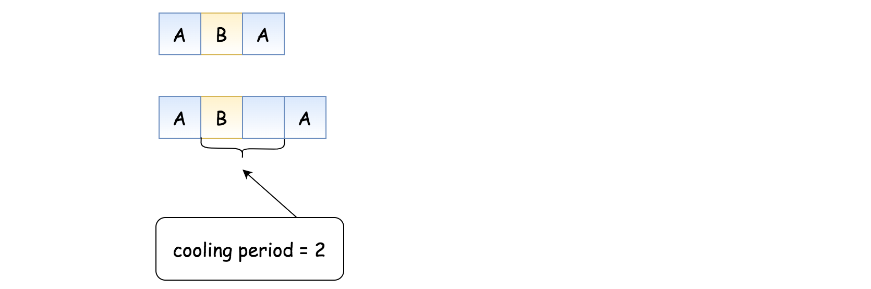

#### **Approach 1: Greedy**

**Intuition**

The total number of CPU intervals we need consists of busy and idle slots. Number of busy slots is defined by the number of tasks to execute: len(tasks). The problem is to compute a number of idle slots.

Maximum possible number of idle slots is defined by the frequency of the most frequent task: idle_time <= (f_max - 1) * n.

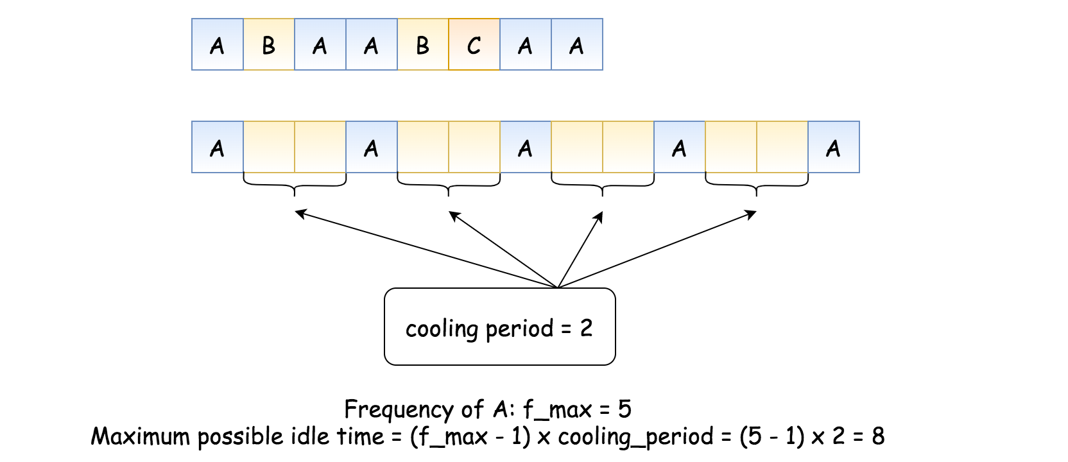

This maximum could be decreased because one doesn't need to keep the CPU idle during cooling periods. It could execute different tasks as well.

To compute the minimum number of idle slots, one could use a greedy strategy. The idea is to sort the tasks by frequency in the descending order and fulfill as many idle slots as one could.

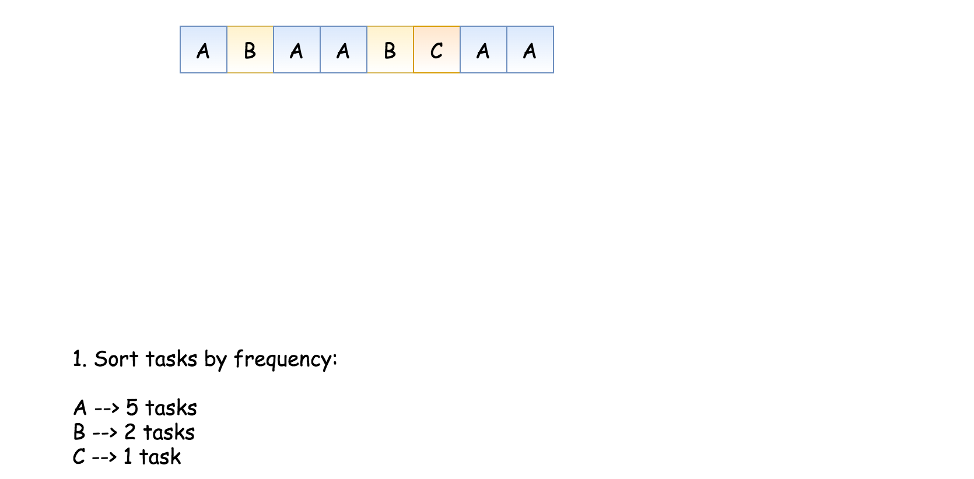

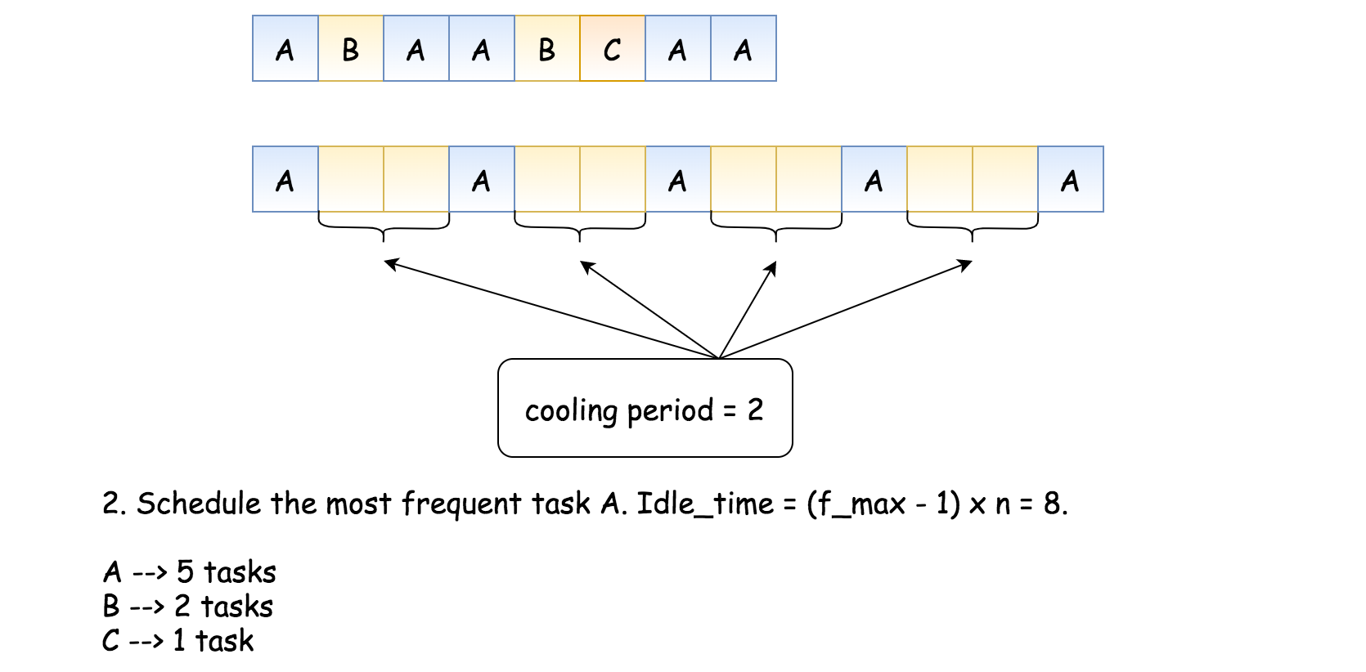

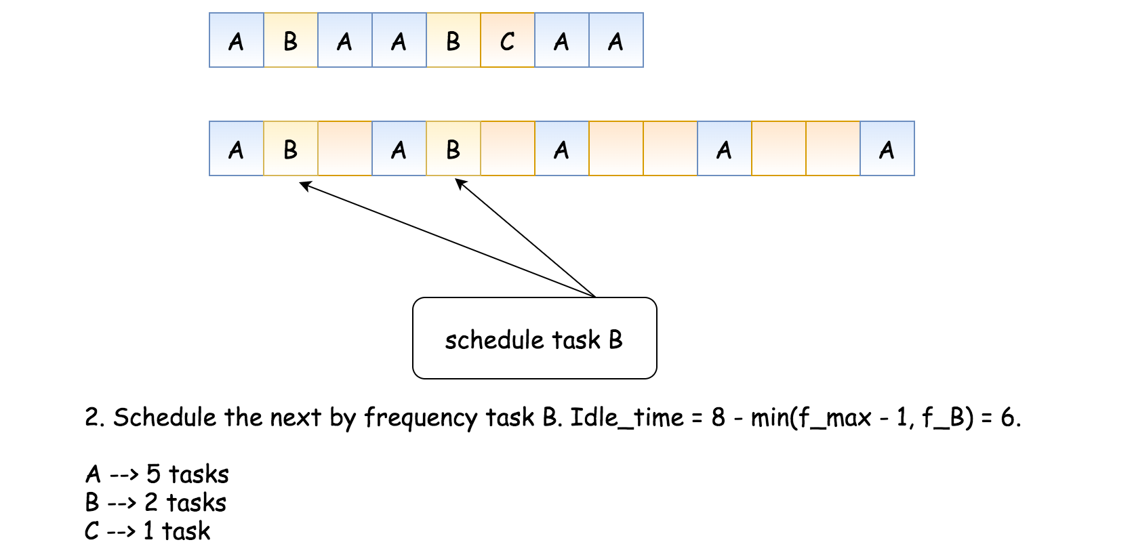

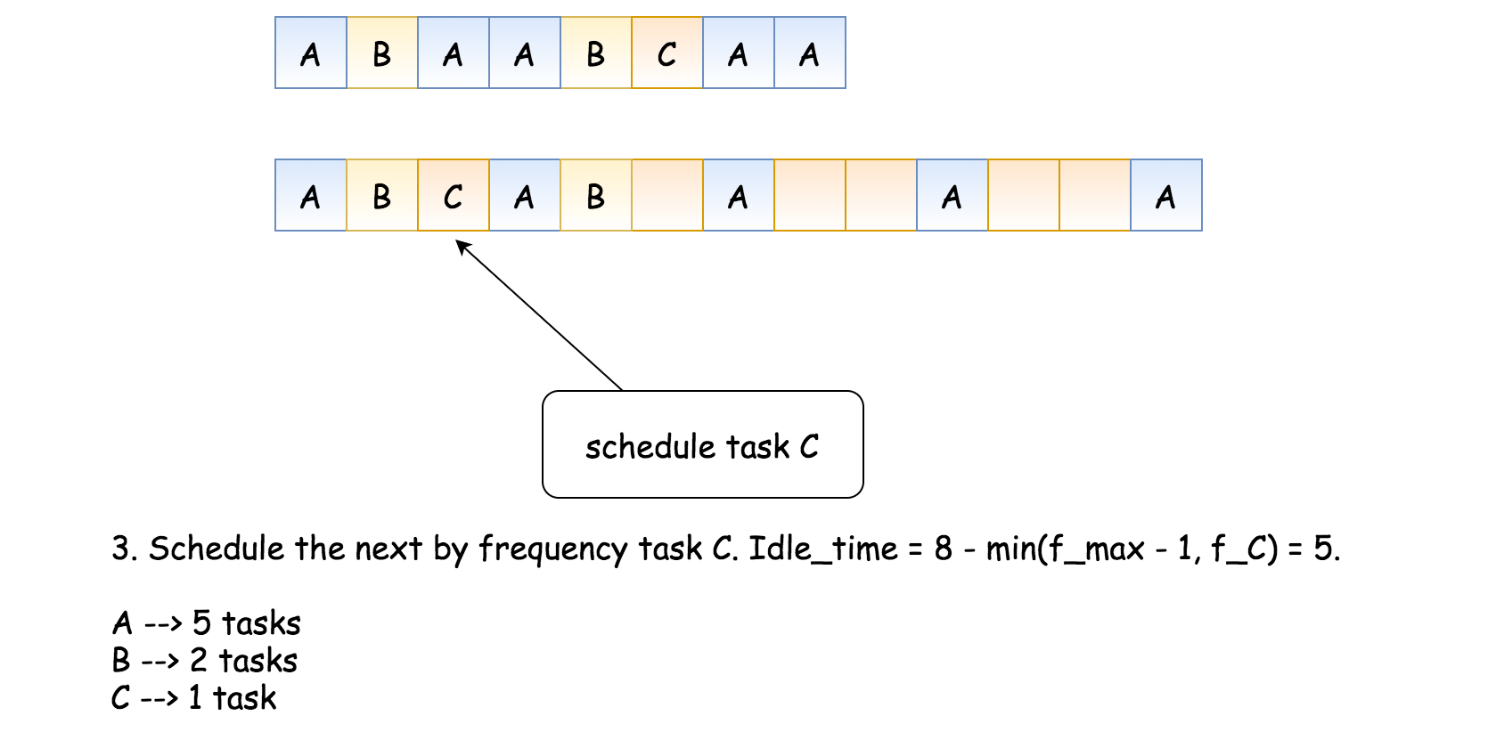

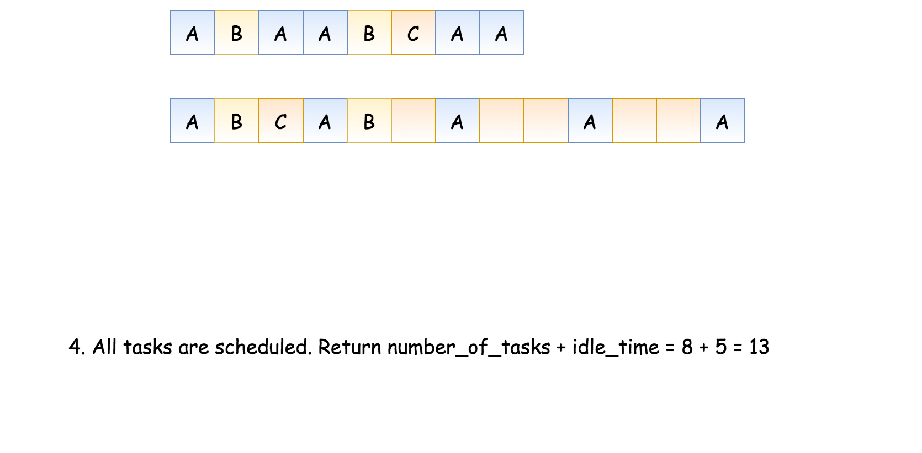

**Algorithm**

* The maximum number of tasks is 26. Let's allocate an array frequencies of 26 elements to keep the frequency of each task.
* Iterate over the input array and store the frequency of task A at index 0, the frequency of task B at index 1, etc.
* Sort the array and retrieve the maximum frequency f_max. This frequency defines the max possible idle time: idle_time = (f_max - 1) * n.
* Pick the elements in the descending order one by one. At each step, decrease the idle time by min(f_max - 1, f) where f is a current frequency. Remember, that idle_time is greater or equal to 0.
* Return busy slots + idle slots: len(tasks) + idle_time.

**Implementation**

|  |
| --- |
| class Solution {  public int leastInterval(char[] tasks, int n) {  // frequencies of the tasks  int[] frequencies = new int[26];  for (int t : tasks) {  frequencies[t - 'A']++;  }  Arrays.sort(frequencies);  // max frequency  int f_max = frequencies[25];  int idle_time = (f_max - 1) * n;    for (int i = frequencies.length - 2; i >= 0 && idle_time > 0; --i) {  idle_time -= Math.min(f_max - 1, frequencies[i]);  }  idle_time = Math.max(0, idle_time);  return idle_time + tasks.length;  }  } |

**Complexity Analysis**

* Time Complexity: O(Ntotal), where *Ntotal*​ is a number of tasks to execute. This time is needed to iterate over the input array tasks and compute the array frequencies. Array frequencies contains 26 elements, and hence all operations with it takes constant time.
* Space Complexity: *O*(1), to keep the array frequencies of 26 elements.

#### **Approach 2: Math**

**Intuition**

Let's use some math to compute the answer. There are two possible situations:

* The most frequent task is not frequent enough to force the presence of idle slots.

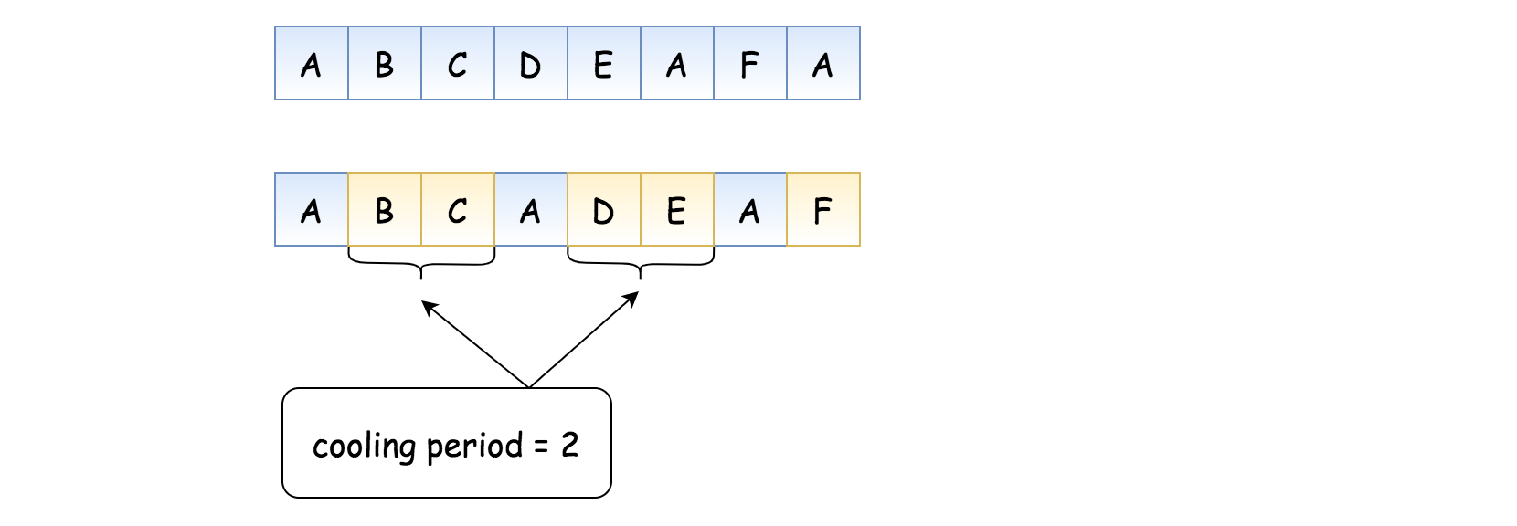

* The most frequent task is frequent enough to force some idle slots.

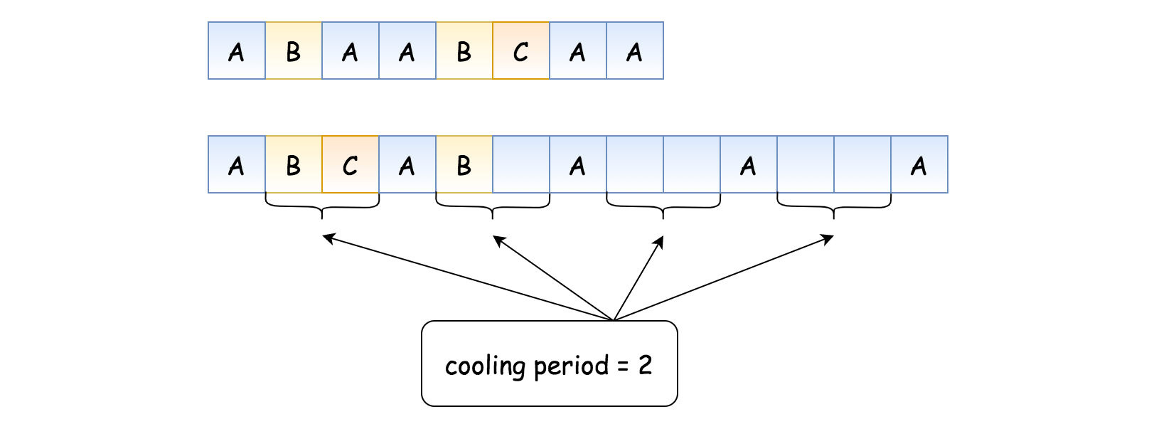

The answer is the maximum between these two.

The first situation is straightforward because the total number of slots is defined by the number of tasks: len(tasks).

The second situation is a bit more tricky and requires to know the number n_max and the frequency f_max of the most frequent tasks.

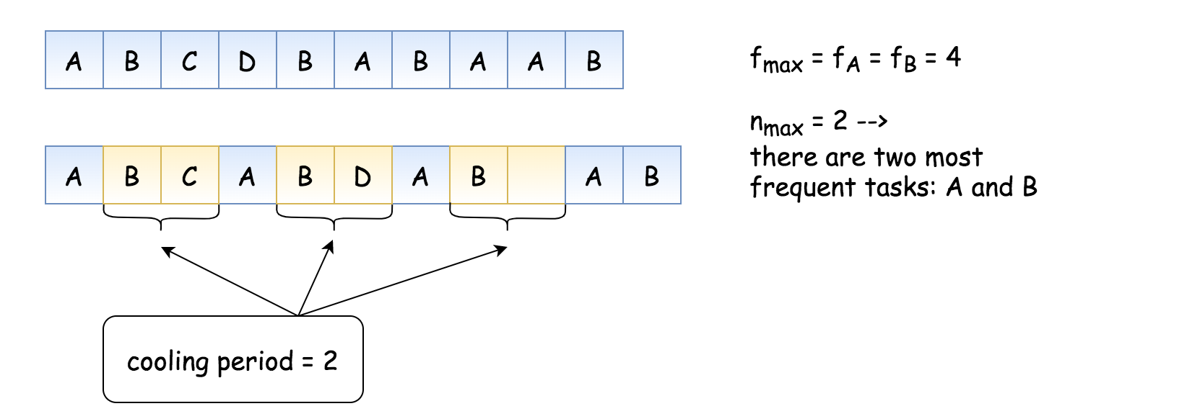

Now it's easy to compute:

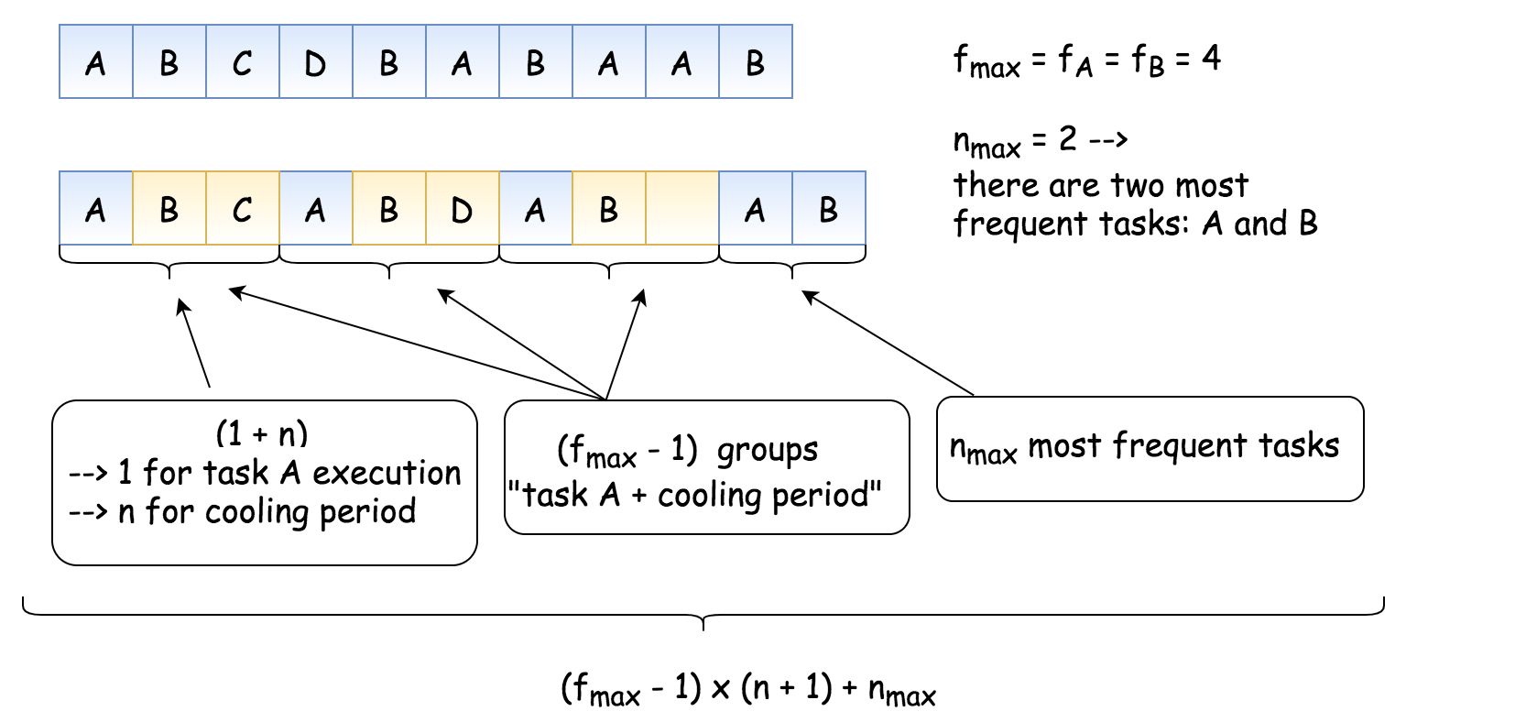

**Algorithm**

* The maximum number of tasks is 26. Let's allocate an array frequencies of 26 elements to keep the frequency of each task.
* Iterate over the input array and store the frequency of task A at index 0, the frequency of task B at index 1, etc.
* Find the maximum frequency: f_max = max(frequencies).
* Find the number of tasks which have the max frequency: n_max = frequencies.count(f_max).
* If the number of slots to use is defined by the most frequent task, it's equal to (f_max - 1) * (n + 1) + n_max.
* Otherwise, the number of slots to use is defined by the overall number of tasks: len(tasks).
* Return the maximum of these two: max(len(tasks), (f_max - 1) * (n + 1) + n_max).

**Implementation**

|  |
| --- |
| class Solution {  public int leastInterval(char[] tasks, int n) {  // frequencies of the tasks  int[] frequencies = new int[26];  for (int t : tasks) {  frequencies[t - 'A']++;  }  // max frequency  int f_max = 0;  for (int f : frequencies) {  f_max = Math.max(f_max, f);  }    // count the most frequent tasks  int n_max = 0;  for (int f : frequencies) {  if (f == f_max) n_max++;  }    return Math.max(tasks.length, (f_max - 1) * (n + 1) + n_max);  }  } |

**Complexity Analysis**

* Time Complexity: O(*Ntotal*​), where *Ntotal*​ is a number of tasks to execute. This time is needed to iterate over the input array tasks and to compute the array frequencies. Array frequencies contains 26 elements, and hence all operations with it takes constant time.
* Space Complexity: *O*(1), to keep the array frequencies of 26 elements.